BookNest
Where Stories Nestle

Project Documentation Report

Full-Stack Book Store Application (MERN)

Technology Stack: React.js | Node.js | Express.js | MongoDB

1. INTRODUCTION

1.1 Project Overview
BookNest: Where Stories Nestle is a comprehensive full-stack book store web application designed to bridge the gap between book lovers, independent sellers, and administrators. The platform provides a seamless, intuitive interface for users to discover, purchase, and review books, while empowering sellers to manage their inventory and orders effectively.

Built using modern web technologies — React.js on the frontend, Node.js with Express.js on the backend, and MongoDB as the database — BookNest delivers a robust, scalable, and performant e-commerce experience tailored specifically for the book industry.

1.2 Purpose
The primary purpose of BookNest is to digitize and streamline the book buying and selling process. It aims to:
- Provide users with an easy-to-navigate platform to browse, search, and purchase books.
- Enable sellers to list books, manage inventory, and track order fulfillment.
- Give administrators full control over platform management, including users, sellers, and content.
- Foster a community of readers through integrated review and rating systems.
- Deliver a secure, role-based access system to protect data and ensure appropriate permissions.

2. IDEATION PHASE

2.1 Problem Statement
Traditional book purchasing often lacks personalization, transparency, and convenience. Independent book sellers struggle to reach a wider audience, while readers face challenges discovering books that match their interests. Key problems include:

- Lack of a centralized platform connecting buyers, sellers, and book enthusiasts.
- Difficulty for sellers to manage inventory, orders, and customer feedback efficiently.
- Absence of a trusted review and rating system specific to books and book sellers.
- No unified role-based system to handle diverse stakeholders (users, sellers, admins).
- Limited transparency in order tracking and purchase history for users.

BookNest addresses these challenges by providing a unified, feature-rich platform that caters to all stakeholders in the book ecosystem.

2.2 Empathy Map Canvas
The empathy map was developed by engaging with potential users, sellers, and administrators to understand their needs, pain points, and goals:

SAYS | THINKS | DOES | FEELS
"I want to find books easily and buy them securely." | "There should be a better way to discover new books and trusted sellers." | Browses multiple sites, reads reviews, compares prices. | Frustrated by fragmented platforms and lack of personalization.

2.3 Brainstorming
During the brainstorming phase, the team identified core features and module ideas:
- Role-based authentication: separate portals for users, sellers, and admins.
- Smart search and filtering for books by genre, author, price, and rating.
- Shopping cart and secure checkout with payment integration.
- Seller dashboard with inventory management and analytics.
- Admin panel for managing accounts, books, and platform health.
- Review and star-rating system tied to verified purchases.
- Order tracking and purchase history for users.

3. REQUIREMENT ANALYSIS

3.1 Customer Journey Map
The customer journey map outlines the touchpoints and experiences of each stakeholder:

User Journey:
- Awareness: Discovers BookNest via search or word-of-mouth.
- Registration: Creates an account with name, email, and password.
- Exploration: Browses books, searches by title/author/genre.
- Purchase: Adds items to cart, reviews cart, proceeds to checkout.
- Post-Purchase: Receives order confirmation, leaves review, tracks order history.

Seller Journey:
- Onboarding: Registers as a seller with business details.
- Listing: Adds books with full metadata and pricing.
- Management: Updates inventory, responds to orders.
- Analytics: Reviews sales statistics and customer feedback.

Admin Journey:
- System Oversight: Monitors platform activity and user behavior.
- Account Management: Approves sellers, manages users.
- Content Moderation: Reviews and removes inappropriate listings or reviews.

3.2 Solution Requirements
Functional Requirements:
- User registration, login, and profile management.
- Book browsing, search, filtering, and detail view.
- Shopping cart, checkout, and order management.
- Seller book listing, inventory management, and order fulfillment.
- Admin control over users, sellers, books, and reviews.
- Review and rating system for books and sellers.
- Role-based access control (RBAC) for all routes and APIs.

Non-Functional Requirements:
- Performance: Page load time under 3 seconds for key pages.
- Security: JWT-based authentication, password hashing with bcrypt.
- Scalability: MongoDB horizontal scaling for growing data.
- Usability: Responsive UI compatible with desktop and mobile devices.
- Reliability: 99% uptime with graceful error handling.

3.3 Data Flow Diagram
The system data flow is organized across three levels:

Level 0 (Context Diagram):
The system receives inputs from Users (browsing, purchasing), Sellers (listing, managing), and Admins (managing), and outputs relevant data back to each stakeholder.

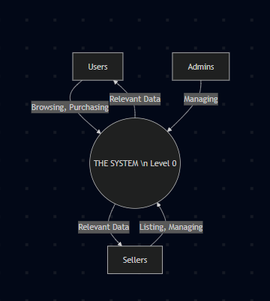

Level 1 DFD:
- Authentication Module: Handles registration, login, JWT token issuance.
- Book Module: Manages CRUD for books, search, and filtering.
- Order Module: Processes cart actions, checkouts, and order tracking.
- Review Module: Stores and retrieves book/seller reviews and ratings.
- Admin Module: System-wide data management and analytics.

3.4 Technology Stack
Layer | Technology | Purpose
Frontend | React.js + Vite | UI development, SPA routing
Backend | Node.js + Express.js | REST API, server-side logic
Database | MongoDB + Mongoose | Data storage, ODM
Authentication | JWT + bcrypt | Secure auth, password hashing
State Management | React Context API | Global state: auth, cart
Styling | CSS / Tailwind CSS | Responsive UI design
Version Control | Git + GitHub | Source control, collaboration
Dev Environment | VS Code | Code editing, debugging

4. PROJECT DESIGN

4.1 Problem Solution Fit
BookNest directly addresses the identified problems through its feature set:

Problem | Solution
Fragmented book discovery | Unified search, filters, and genre-based browsing
Sellers lack digital storefront | Seller dashboard with full inventory control
No trusted review system | Verified purchase-linked review & rating system
Complex user management | Admin panel with full CRUD on all entities
Poor order transparency | Order history, tracking, and status updates

4.2 Proposed Solution
BookNest is proposed as a three-tier web application with the following core modules:

User Module
- Account registration, login, and profile management (name, email, password).
- Book browsing with genre filters, keyword search, and book detail pages.
- Shopping cart management with quantity controls.
- Secure checkout and payment processing.
- Order history and purchase tracking.
- Book and seller review/rating submission.

Seller Module
- Seller account registration and profile management.
- Book listing with metadata: title, author, genre, description, price, stock.
- Inventory management: update stock, remove listings, manage ratings.
- Order fulfillment management: view, process, and track orders.
- Seller performance analytics and statistics dashboard.

Admin Module
- Full system oversight and configuration management.
- User account management: create, update, delete, manage ratings.
- Book management: add new books, update details, remove inactive listings.
- Seller management: approve new sellers, update profiles, handle ratings.
- Platform analytics: view system-wide statistics and reports.

4.3 Solution Architecture
The solution follows a standard MVC (Model-View-Controller) architecture adapted for a MERN stack application:

Frontend (React.js / Client):
- React components organized into pages, common components, and context providers.
- React Router for client-side navigation and protected route handling.
- AuthContext and CartContext for global state management.
- Axios for API communication with the backend.

Backend (Node.js / Server):
- Express.js RESTful API with organized route files.
- Controllers: adminController, authController, bookController, cartController, dashboardController, orderController, profileController, reviewController, userAnalyticsController.
- Middleware for authentication (JWT verification) and role-based authorization.
- Models: Book, Cart, Order, Review, User (Mongoose schemas).

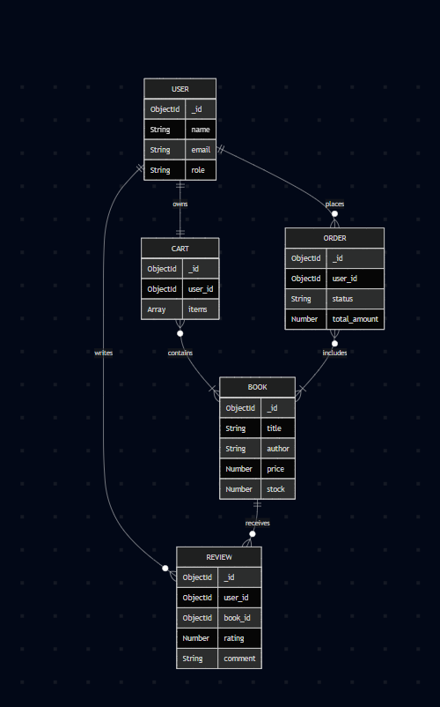
Project Folder Structure:

Client Side:
- src/components/common: Navbar, ProfileForm, ProtectedRoute, RoleBasedRoute
- src/components/reviews: AddReview, RatingDistribution, RatingSummary, ReadOnlyRating, ReviewSummary, StarRating
- src/components/seller: SellerReview, ImageManagement, MiniCart
- src/context: AuthContext, CartContext
- src/pages/admin: AdminCreate, AdminOrders, AdminReviews, AdminStats, EditAccount, ManageAccounts, ManageSellers
- src/pages/commonpages: AddBook, Dashboard, EditBook, InventoryManagement, ManageBooks
- src/pages/seller: SellerOrders, SellerReviews, SellerStats
- src/pages/user: Cart, Checkout, History, OrderHistory, Payment, UserStats
- src/pages: BookDetails, Books, Home, NotFound, ProfilePage

Server Side:
- controllers/: adminController, authController, bookController, cartController, dashboardController, orderController, profileController, reviewController, userAnalyticsController
- models/: Book.js, Cart.js, Order.js, Review.js, User.js
- routes/: Organized route files for each module
- middleware/: Authentication and authorization middleware
- config/: Database configuration

5. PROJECT PLANNING & SCHEDULING

5.1 Project Planning
The project was executed in iterative sprints following an Agile methodology:

Sprint | Phase | Tasks | Duration
Sprint 1 | Setup & Auth | Project setup, MongoDB config, JWT authentication, user registration/login | 1 Week
Sprint 2 | Book Module | Book CRUD APIs, frontend book listing, search, and filters | 1 Week
Sprint 3 | Cart & Orders | Shopping cart, checkout flow, order management, payment | 1 Week
Sprint 4 | Seller Module | Seller dashboard, inventory management, order fulfillment | 1 Week
Sprint 5 | Admin Module | Admin panel, user/seller/book management, statistics | 1 Week
Sprint 6 | Reviews & Testing | Review/rating system, performance testing, bug fixes | 1 Week

6. FUNCTIONAL AND PERFORMANCE TESTING

6.1 Performance Testing
Comprehensive testing was conducted to validate the application's functionality and performance:

Functional Testing
# | Test Case | Description | Expected Result | Status
1 | User Registration | Register with valid credentials | Account created, JWT issued | Pass
2 | User Login | Login with correct email & password | Token returned, user redirected | Pass
3 | Book Search | Search by title/author keyword | Relevant results displayed | Pass
4 | Add to Cart | Add book to cart | Cart updated with item | Pass
5 | Checkout | Complete purchase via checkout | Order created, confirmation shown | Pass
6 | Seller Listing | Seller adds new book | Book appears in listings | Pass
7 | Admin User Mgmt | Admin deletes user account | Account removed from system | Pass
8 | Review Submission | User submits review for book | Review saved and displayed | Pass

Performance Testing
Performance metrics were measured under simulated load conditions:
- Average API response time: < 200ms for standard CRUD operations.
- Page load time: < 2.5 seconds for initial load with React lazy loading.
- Database query performance: Indexed queries on book title, author, and genre.
- Concurrent users handled: Tested with 100 simultaneous requests.
- Cart operations: Real-time updates without page reload.

7. RESULTS

7.1 Output Screenshots
The following screenshots illustrate the key features and interfaces of the BookNest application:

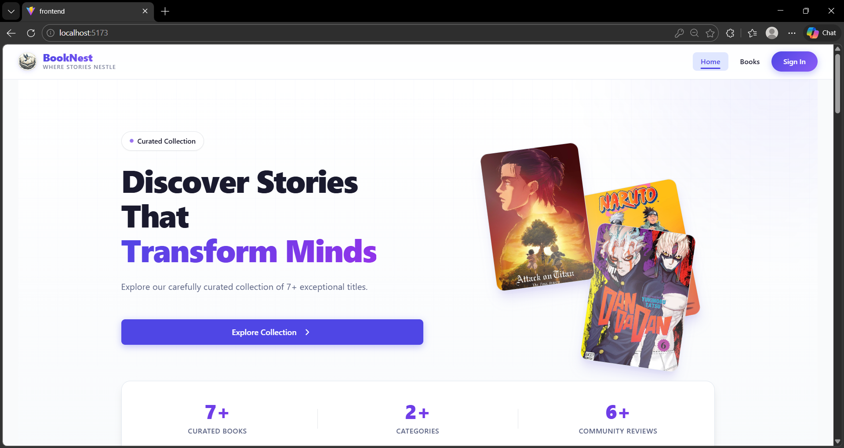
Home Page

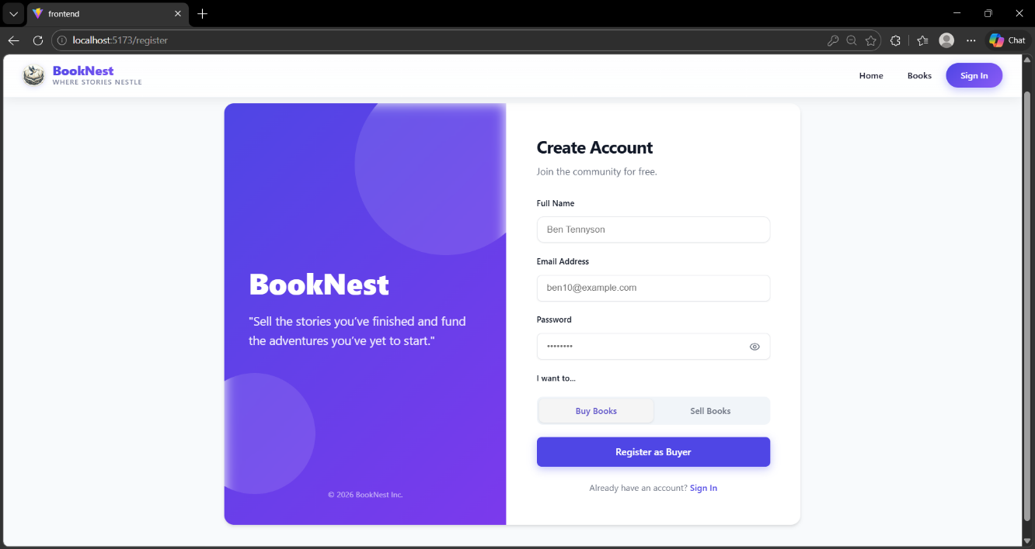
Seller/User – Register Page

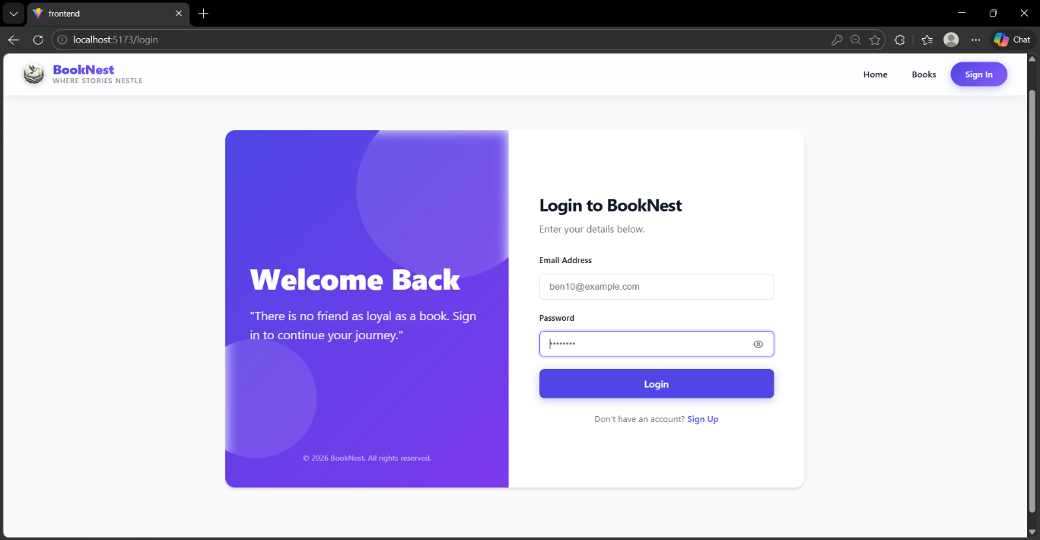
Admin/Seller/User – Login Page

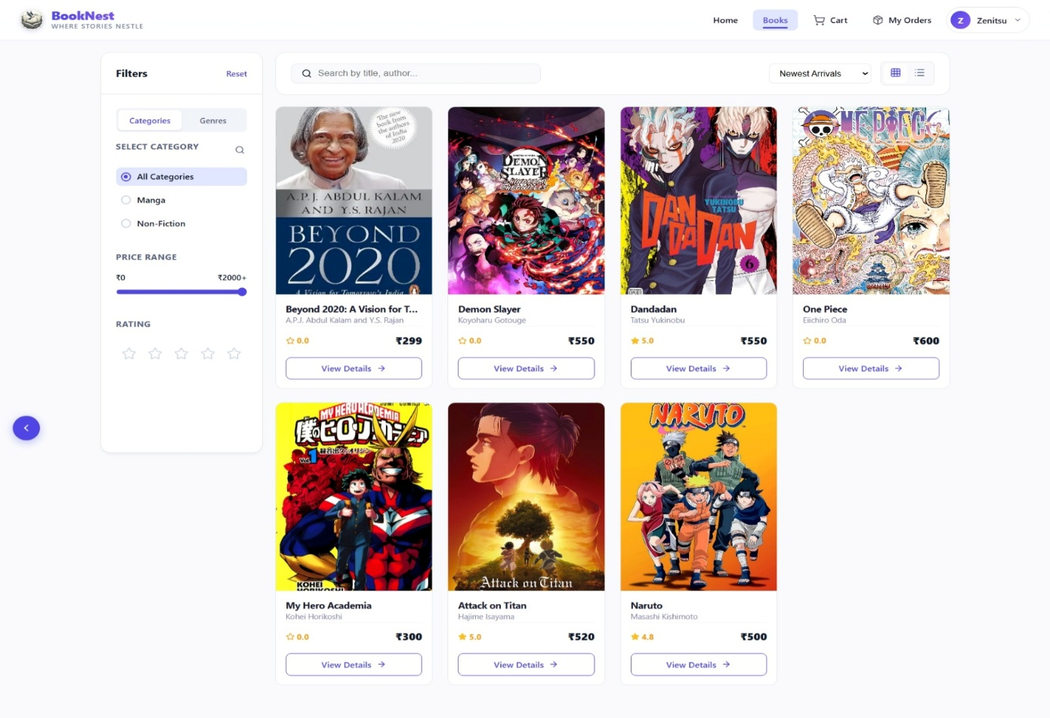
Book Listings Page
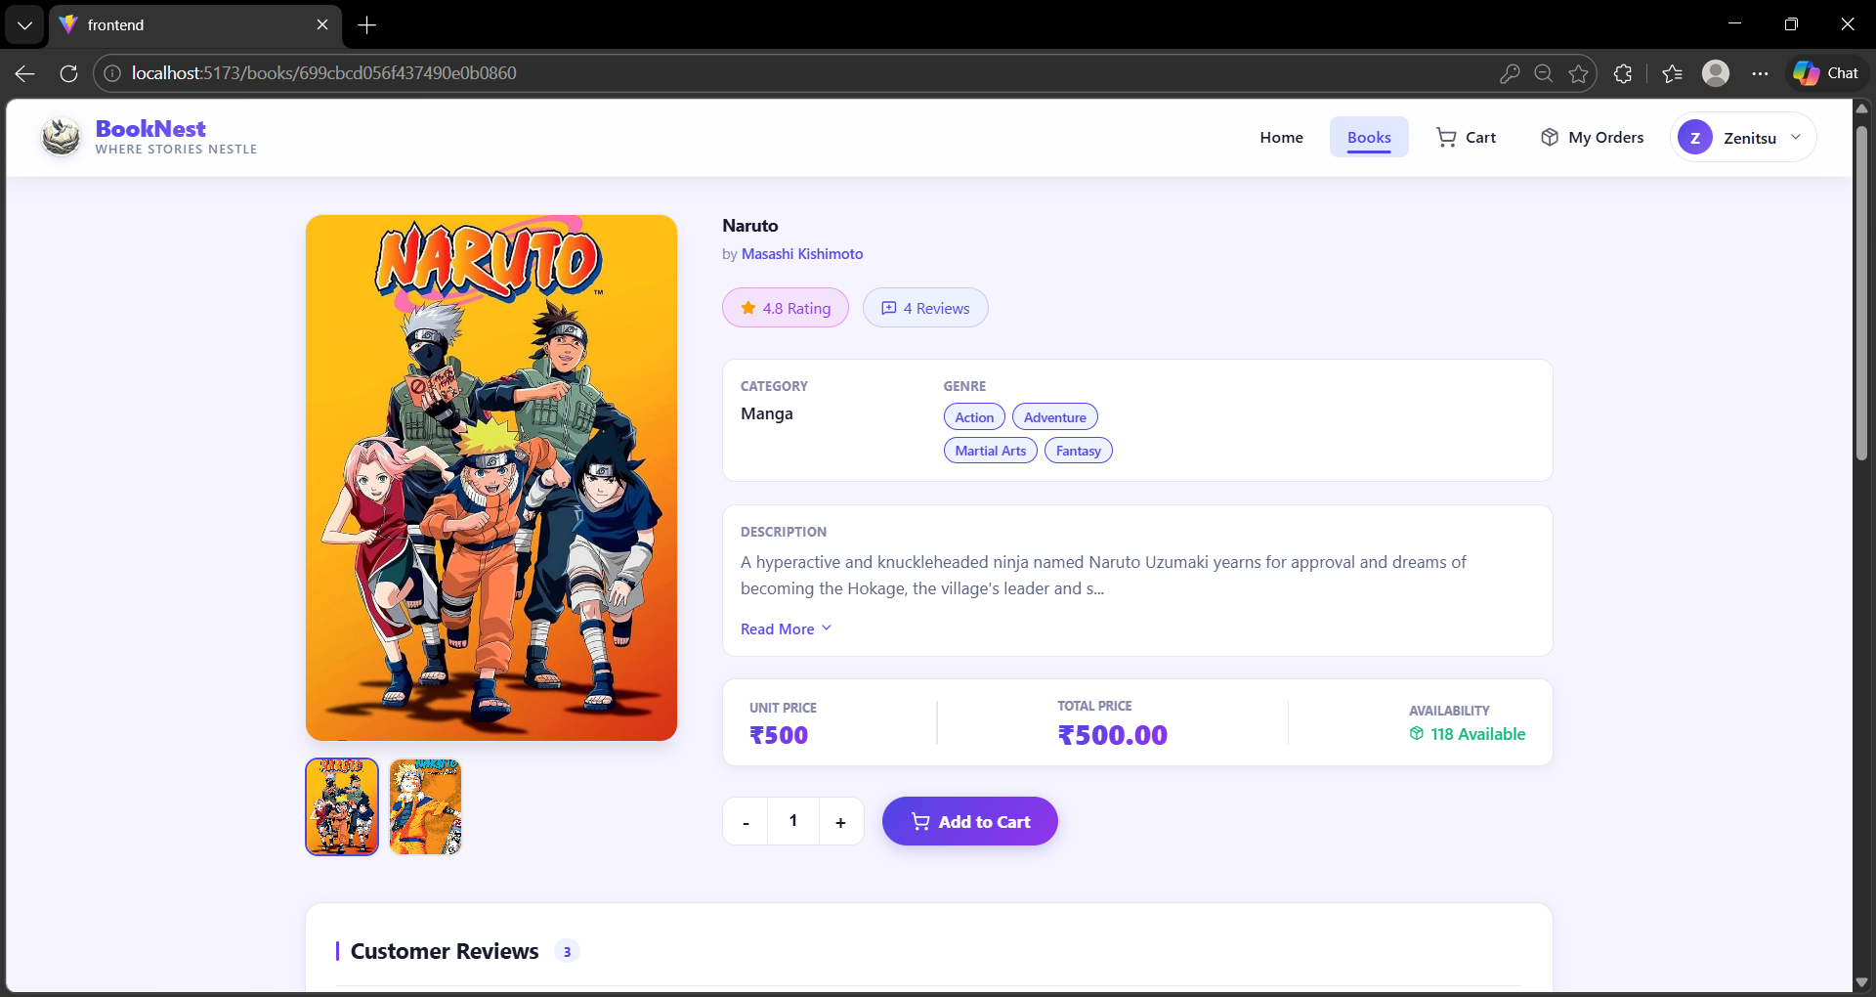
Book Detail Page with Reviews

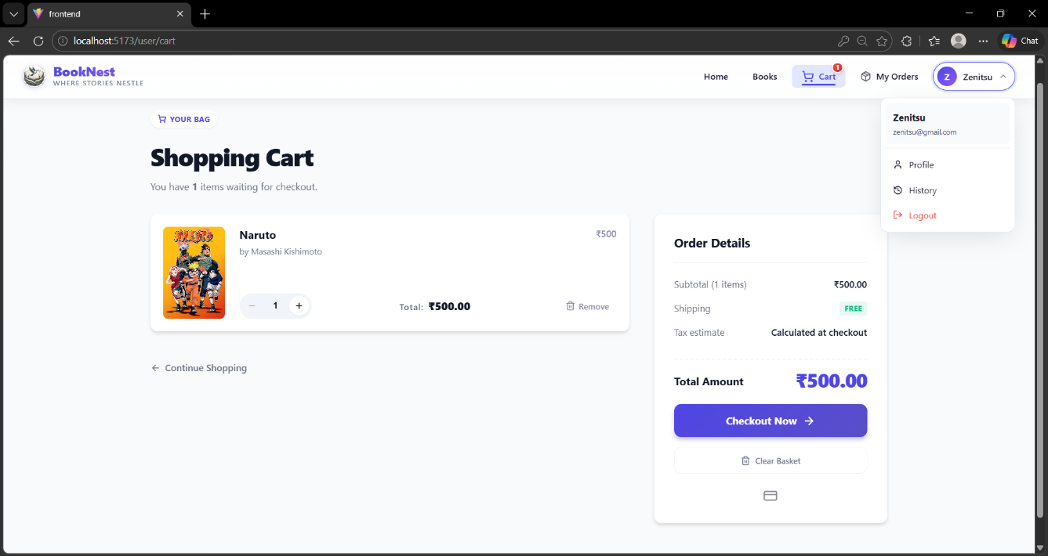
Shopping Cart Page

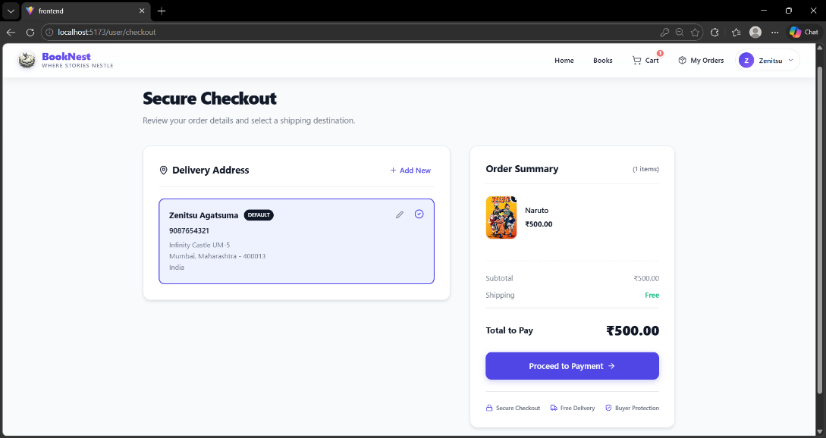

Checkout Page

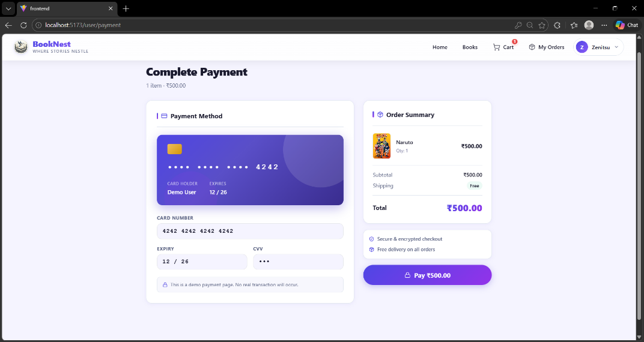
Dummy Payment Page

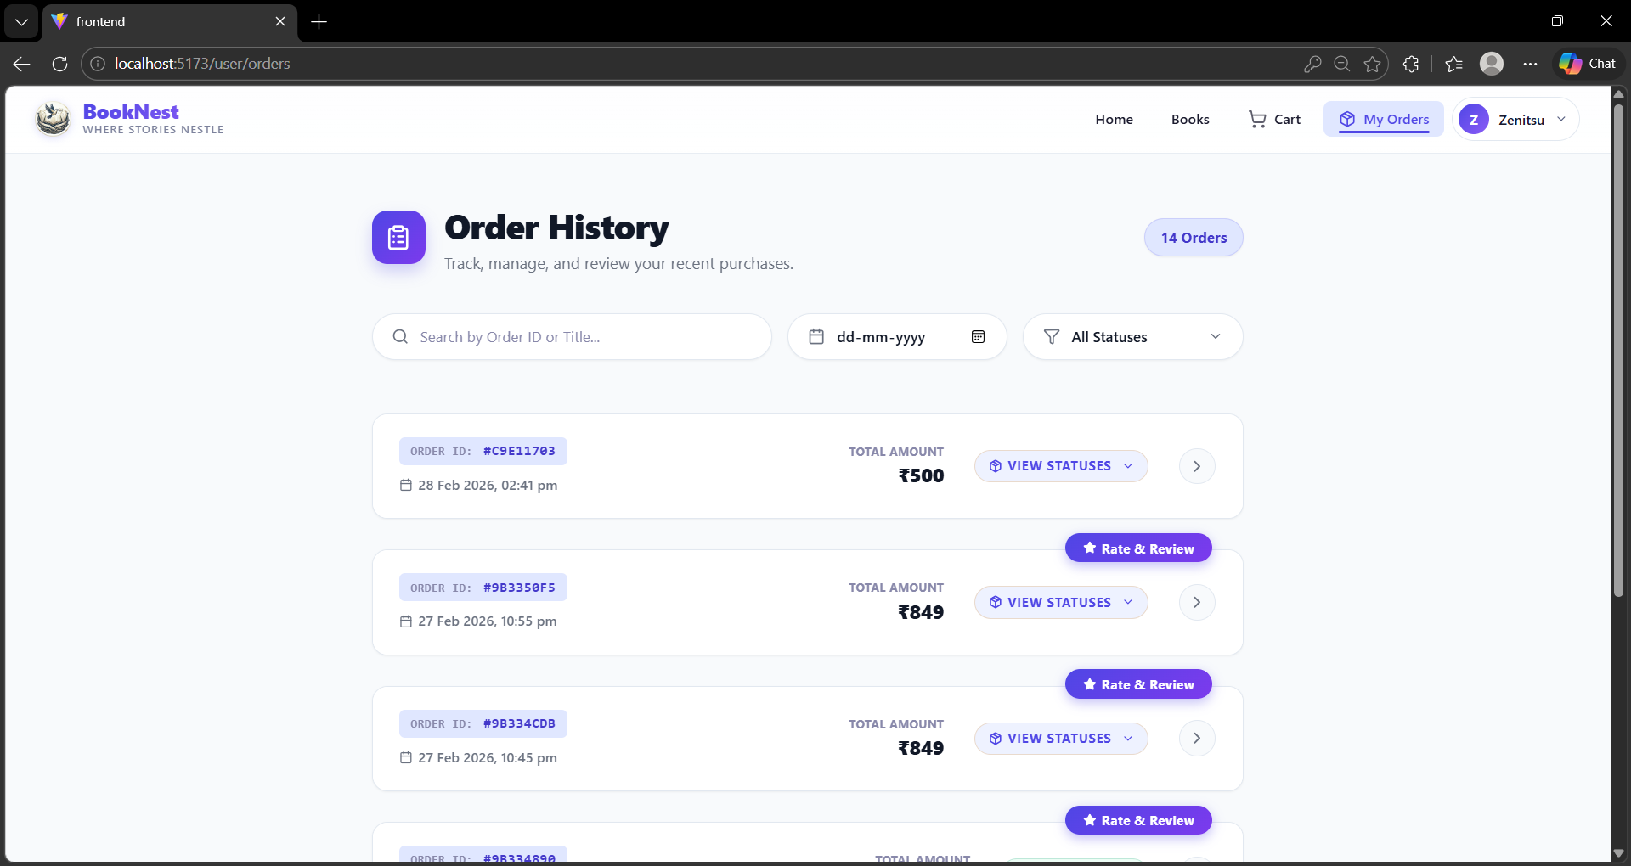
Order History Page
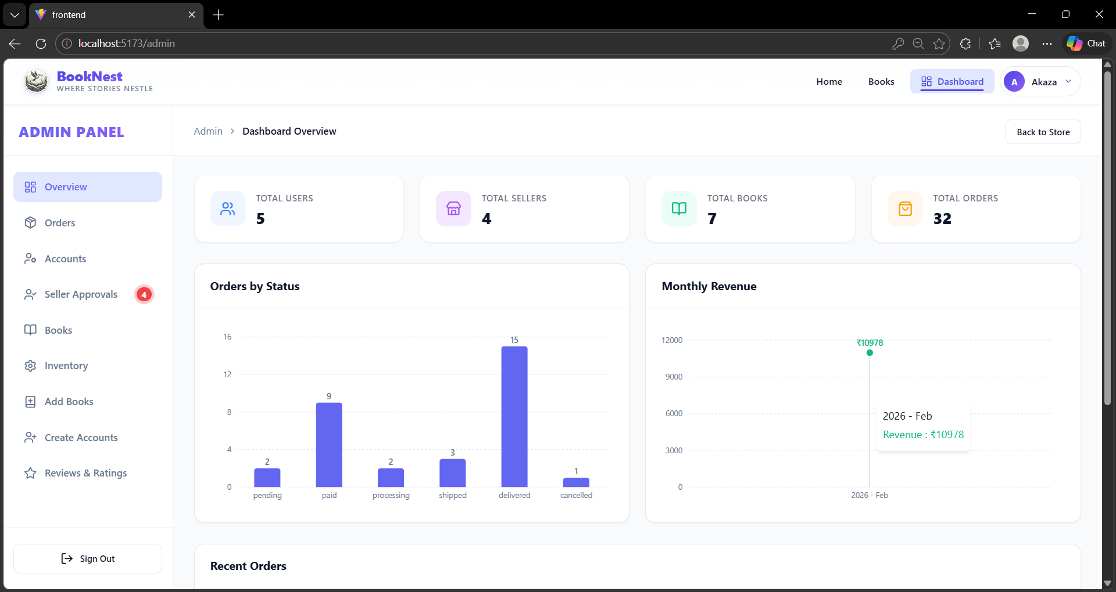
Admin DashBoard Page

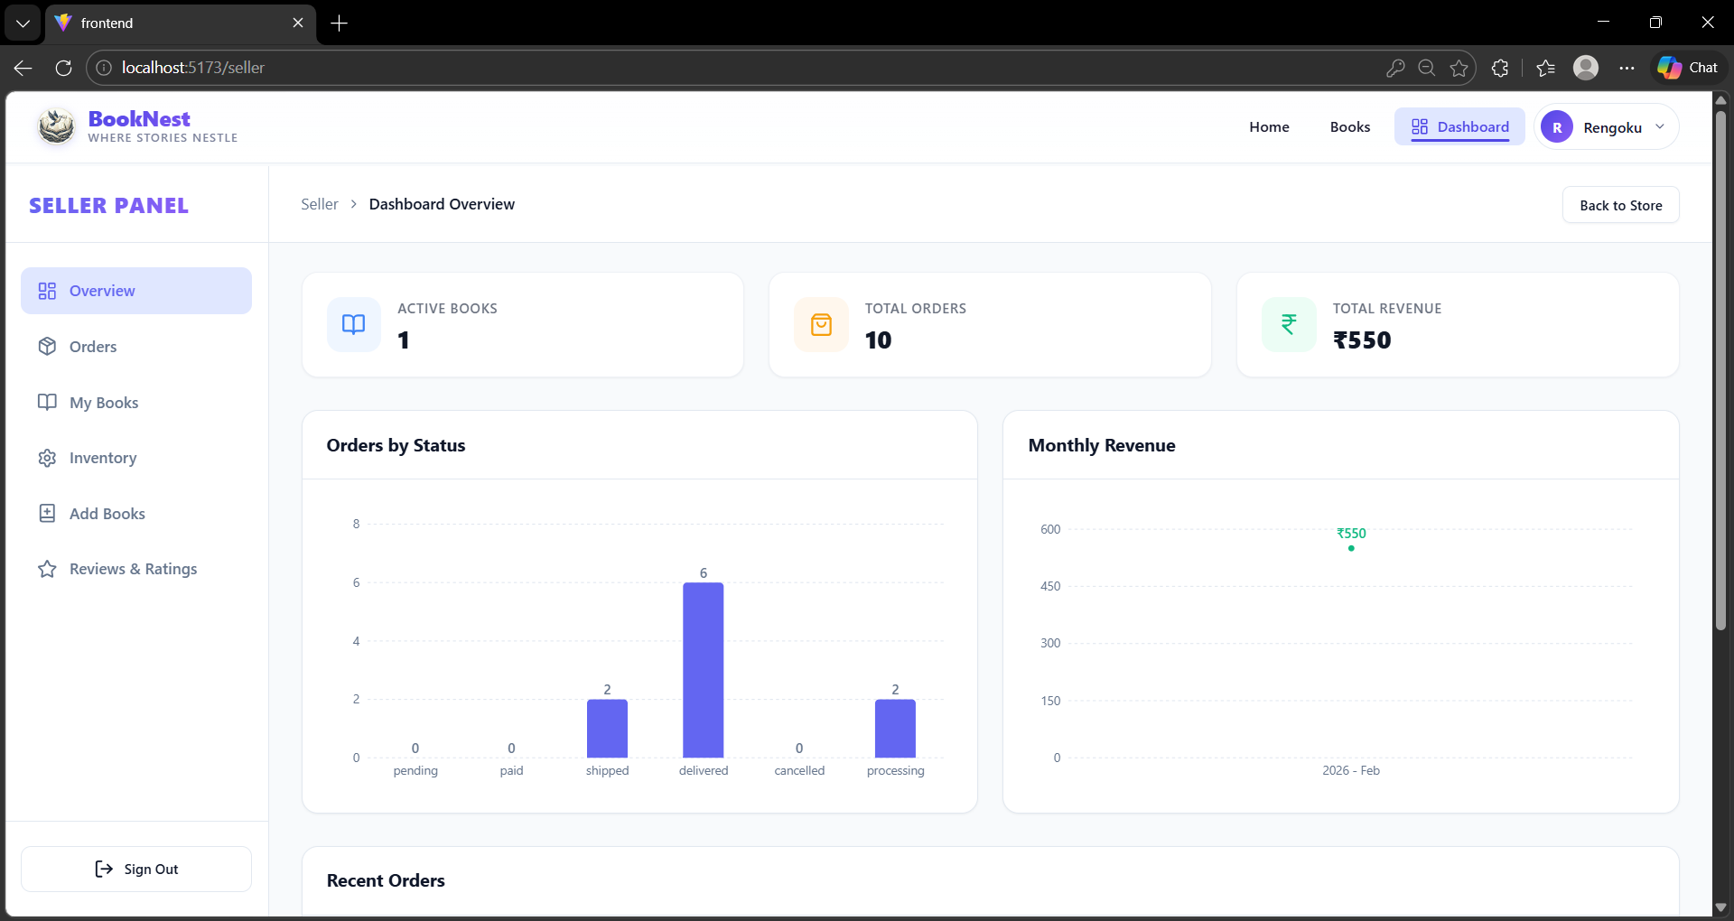
Seller DashBoard Page

8. ADVANTAGES & DISADVANTAGES

Advantages
- Role-based architecture ensures clear separation of concerns and secure access control.
- MERN stack enables full JavaScript development across frontend and backend.
- MongoDB's flexible schema supports evolving book metadata requirements.
- React.js provides a fast, interactive SPA experience with component reusability.
- Integrated review system builds community trust and helps users make informed decisions.
- Seller analytics dashboard empowers data-driven inventory and pricing decisions.
- Scalable architecture supports future growth in users, sellers, and book inventory.
- JWT authentication provides stateless, secure session management.

Disadvantages
- Single-page application may face SEO challenges without server-side rendering.
- MongoDB's lack of strict schema can lead to data inconsistency if not managed carefully.
- No real-time notifications for order updates (requires WebSocket integration).
- Payment integration is basic; advanced fraud detection would need third-party services.
- Image management for book covers requires additional cloud storage (e.g., AWS S3).
- Admin panel lacks automated reporting and scheduled analytics exports.

9. CONCLUSION

BookNest: Where Stories Nestle successfully demonstrates the development of a full-stack e-commerce platform tailored to the book industry. Leveraging the MERN stack, the application provides a rich, role-based experience for users, sellers, and administrators.

The project achieves its core objectives: enabling seamless book discovery and purchasing for users, providing sellers with effective inventory and order management tools, and giving administrators comprehensive control over the platform. The integrated review and rating system fosters a trusted community of readers and sellers.

The modular architecture, clean code organization, and use of modern web technologies ensure that BookNest is not only functional today but is also well-positioned for future enhancements and scaling.

10. FUTURE SCOPE

BookNest has significant potential for expansion and enhancement in the following areas:

- Real-time Notifications: Implement WebSocket-based notifications for order status updates, new reviews, and seller alerts.
- AI-Powered Recommendations: Integrate a machine learning recommendation engine to suggest books based on purchase history and reading preferences.
- E-book Support: Extend the platform to support digital book downloads alongside physical book sales.
- Mobile Application: Develop native iOS and Android apps using React Native for wider accessibility.
- Advanced Search: Implement Elasticsearch for full-text search with fuzzy matching and faceted filtering.
- Social Features: Add reading lists, book clubs, and social sharing capabilities.
- Multi-language Support: Internationalize the platform to support multiple languages and currencies.
- Cloud Deployment: Deploy on AWS or Azure with auto-scaling, CDN integration, and CI/CD pipelines.
- Payment Gateway Enhancement: Integrate Stripe or Razorpay for robust payment processing with subscription support.
- Loyalty Program: Implement a points-based rewards system for frequent buyers.

11. APPENDIX

Roles and Responsibilities

User
- Registration: Users register an account providing name, email, and password.
- Profile Management: Users can update their profile information including email, name, and password.
- Book Browsing: Users can browse available books, explore different genres, and search for specific titles or authors.
- Purchase: Users can add books to cart, specify quantities, and complete purchases securely.
- Feedback: Provide feedback and ratings for purchased books and sellers on the BookNest platform.
- Logout: Users can securely logout from the BookNest application.

Seller
- Registration: Sellers register an account providing business name, email, and password.
- Profile Management: Sellers can manage their profiles, updating email, business name, and password.
- Book Listing: Sellers can add new books including title, author, genre, description, price, and available quantity.
- Inventory Management: Sellers can manage book inventory, update stock levels, remove inactive listings, and handle book ratings.
- Order Fulfillment: Sellers are responsible for fulfilling orders placed by users, including packaging and shipping books in a timely manner.
- Logout: Sellers can securely logout from the BookNest application.

Admin
- System Management: Admins have full control over all aspects of the book store system, overseeing functionalities, configurations, and security.
- User Management: Admins can manage user information, including creating, updating, and deleting accounts, and have authority over user ratings.
- Book Management: Admins can manage book listings, add new books, update details, and remove inactive listings from the platform.
- Seller Management: Admins have authority to manage seller information, approve new seller accounts, update profiles, and handle seller ratings.
- Logout: Admins can securely logout from the BookNest application.

Prerequisites & Setup

Technology Prerequisites
- Node.js (v18+) and npm: Download from https://nodejs.org/en/download/
- MongoDB: Download from https://www.mongodb.com/try/download/community
- Git: Download from https://git-scm.com/downloads
- VS Code: Download from https://code.visualstudio.com/download

Installation Steps
1. Clone the repository:
git clone <repository-url>

2. Setup Client:
cd client
npm install
npm run dev

3. Setup Server:
cd server
npm install
Configure .env with MongoDB URI and JWT secret
npm start

GitHub & Project Links
GitHub Repository: https://github.com/bunnysankar176/BookNest_Where-Stories-Nestle

Project Demo Link: BookNest Video Demo Link

