GOVERNMENT OF TELANGANA
DEPARTMENT OF TECHNICAL EDUCATION, TELANGANA


A Project Report on
SMART FARMING COMPANION-AGRISAATHI
Submitted to the State Board of Technical Education & Training (TG), Hyderabad
In partial fulfilment of the requirement for the award of
DIPLOMA IN COMPUTER SCIENCE & ENGINEERING
(2026-2027)
Submitted by
24189-cs-009 | S.SARIKA
24189-cs-015 | T.NAGI REDDY
24189-cs-026 | A.SANDHYA
24189-cs-034 | B.SATHWIKA REDDY
24189-cs-041 | R.VIJENDER DHAS
24189-cs-052 | B.SONY
Under the Guidance of
Dr.V. RAMA KRISHNA, M.Tech., Ph.D
SENIOR LECTURER



DEPARTMENTOFCOMPUTERSCIENCE&ENGINEERING

GOVERNMENT POLYTECHNIC, SIDDIPET
2026-27

DEPARTMENT OF COMPUTER SCIENCE ENGINEERING

GOVERNMENT POLYTECHNIC, SIDDIPET
(Affiliated To SBTET-TS, Hyderabad)
(Vill: Rajgopalpet, Mdl: Nangunoor , Dist: Siddipet)



CERTIFICATE
This is to certify that the project report entitled “AGRISAATHI-SMART FARMING COMPANION” submitted to the State Board of Technical Education & Training, Telangana, Hyderabad, in partial fulfillment of the requirements for the award of the Diploma in Computer Science and Engineering, is a record of bonafide work carried out by the following students under our supervision and guidance. The results embodied in this project report have not been submitted to any other Board or Institution for the award of a Diploma.

24189-cs-008 | S.SARIKA
24189-cs-015 | T.NAGI REDDY
24189-cs-026 | A.SANDHYA
24189-cs-034 | B.SATHWIKA REDDY
24189-cs-041 | R.VIJENDER DHAS
24189-cs-052 | B.SONY

PROJECT GUIDE HOD
Dr.V.RAMAKRISHNA ,Phd B. ABHINAV, B. Tech

EXTERNAL EXAMINER PRINCIPAL

B. ABHINAV,

ACKNOWLEDGEMENT
We express our sincere gratitude to our Principal, Mr. SRI B. ABHINAV, for providing the necessary facilities, encouragement, and administrative support to complete this project successfully.

We extend our heartfelt thanks to our Head of Department, Mr. SRI B. ABHINAV, for his motivation, valuable suggestions, and academic guidance throughout the development of this project.

We are deeply grateful to our project guide, Mr. SRI Dr . V .RAMAKRISHNA, for his continuous supervision, technical support, and constructive feedback. His guidance helped us understand the concepts clearly and complete the project with confidence.

We would also like to thank all the teaching and non-teaching staff of the Computer Science and Engineering Department for their cooperation and support. Finally, we express our heartfelt gratitude to our families and friends for their constant encouragement and support throughout the development of this project.

ABSTRACT

AgriSaathi – Smart Farming Companion is a web-based application developed to support farmers by providing essential agricultural information and services through a single digital platform. Farmers often face difficulties accessing reliable information about weather conditions, crop diseases, market prices, government schemes, and agricultural resources. Managing these activities through different sources can be time-consuming and challenging. This project aims to simplify farming-related activities by providing an integrated, user-friendly platform that helps farmers make informed agricultural decisions.

The system provides various features, including farmer registration and profile management, live weather information based on the farmer's location, crop disease identification, market price updates, local agricultural markets, government scheme information, order management, and nearby agricultural services. It also includes a voice-based AI assistant that allows farmers to interact with the application in their preferred language. Dealers can manage products and orders, while farmers can place orders and track their delivery status. The application maintains relevant farmer and service information in a centralized database, making information management and retrieval easier.

By integrating multiple agricultural services into one platform, AgriSaathi aims to improve accessibility, save farmers' time, and support better decision-making. The application is designed to be responsive, user-friendly, and accessible through mobile phones and desktop devices. Overall, AgriSaathi provides a digital approach to agricultural assistance by connecting farmers with useful information, services, and resources, contributing towards smarter and more efficient farming practice

LIST OF FIGURES

S.NO | FIGURE NO. | Description | Page no.
1 | 5.1 | Entity Relationship (ER) Diagram | 22
2 | 5.2 | System Architecture Diagram | 23
3 | 5.3 | System Workflow Flowchart | 107
4 | 8.1 | Home Page | 107
5 | 8.2 | Farmer Registration Page | 107
6 | 8.3 | Farm Farmer Registration Page Login Page | 108
7 | 8.4 | Farmer Dashboard | 109
8 | 8.5 | Farmer Profile Page | 109
9 | 8.6 | Weather Information Page | 110
10 | 8.7 | Ask AgriSaathi Voice Assistant | 111
11 | 8.8 | Crop Disease Detection Page | 112
12 | 8.9 | Market Prices Page
13 | 8.10 | Local Market Page
14 | 8.11 | Government Schemes Page
15 | 8.12 | Community Page
16 | 8.13 | Nearby Services Page
17 | 8.14 | Farmer Order Management Page
18 | 8.15 | Dealer Registration and Login Page

CONTENTS
- INTRODUCTION----------------------------------------()
1.1 Existing System
1.2 Proposed System
1.3 Problem Definition
1.4 Objectives
1.5 Scope of the Project
1.6 Requirements
- SOFTWARE AND HARDWARE REQUIREMENTS---------------------()
2.1 Hardware Requirements
2.2 Software Requirements
2.3 Configuration Requirements
- CLIENT-SERVER TECHNOLOGIES--------------------------------()
3.1 Overview
3.2 Frontend Technologies
3.3 Backend and Cloud Technologies
3.4 Database Technologies
3.5 Android and Mobile Technologies
3.6 External Services and APIs
- SYSTEM OVERVIEW--------------------------------------------()
4.1 Objectives
4.2 User Roles
4.3 Farmer Features
4.4 Dealer and Administrator Features
4.5 Benefits

- SYSTEM DESIGN-----------------------------------------------()
5.1 System Architecture Overview
5.2 Logical Firebase Data Model
5.3 Overall Workflow Diagram
5.4 System Workflow Explanation
5.5 Data Flow and Security
- FEASIBILITY STUDY--------------------------------------------()
6.1 Operational Feasibility
6.2 Technical Feasibility
6.3 Economic Feasibility
6.4 Feasibility Study Conclusion
7. CODING AND IMPLEMENTATION----------------------------------()

7.1 Introduction to Coding
7.2 Frontend Code
7.2.1 Application Entry and Route Management
7.2.2 Login, Registration and Role Selection
7.2.3 Farmer Dashboard and Service Pages
7.2.4 Dealer Pages
7.2.5 Administrator Pages
7.2.6 Language and Voice Assistant
7.3 Firebase and Cloud Function Code
7.3.1 Firebase Initialization
7.3.2 Market Price Retrieval
7.3.3 Order Updates and WhatsApp Notifications
7.3.4 Push Notification Registration
7.4 Python Image Enhancement API
7.5 Data Storage Structure

- SCREENSHOTS AND INTERFACE---------------------------------()
8.1 Splash and Role Selection
8.2 Login and Registration
8.3 Farmer Dashboard
8.4 Weather Page
8.5 Market Prices Page
8.6 Crop and Land Analysis
8.7 Government Schemes and Community
8.8 Nearby Services and Voice Assistant
8.9 Farmer Products and Orders
8.10 Dealer Dashboard and Product Management
8.11 Dealer Orders and Sales
8.12 Administrator Pages
- TESTING-----------------------------------------------------()
9.1 Unit Testing
9.2 Integration Testing
9.3 System Testing
9.4 Test Results and Conclusion
10 . CONCLUSION------------------------------------------------()
10.1 Conclusion
10.2 Future Scope

I.INTRODUCTION

CHAPTER 1 – INTRODUCTION

1.1 Existing System
Farmers often need information from several different sources when making decisions about their crops and farm activities. Weather forecasts, market price reports, crop-health guidance, government scheme details, agricultural products, and nearby services may each be accessed through a different website, office, dealer, or contact.
When these activities are handled separately, farmers may need to repeatedly search for information or contact different people to get updates. Dealers may manage product stock and farmer orders through separate records or messages. Administrators may also need to use different processes to review farmer details, dealer requests, products, orders, and scheme information.
This fragmented approach can make it harder to find relevant information in one place. It may also make it difficult for farmers and dealers to follow the progress of a product reservation or order. Users who prefer a regional language or voice interaction may face additional challenges when using digital services.

1.2 Proposed System
AgriSaathi is a smart farming companion application that brings together selected agricultural information and services in one platform. It provides separate workflows for farmers, dealers, and administrators.
Farmers can create a profile with information about their location, crops, land, soil, and preferred language. Based on the application’s available features, they can view weather forecasts, browse reported market prices, receive crop and land guidance, review government schemes, find nearby agricultural services, participate in community posts, and browse products offered by dealers. Farmers can also create product reservations, follow order updates, and use the multilingual voice assistant.
Dealers can manage their profiles, product listings, stock, sales, and farmer orders. Administrators can review and manage farmer and dealer records, dealer requests, products, orders, government schemes, market data, and reports.
The application is built with React and Vite and can be packaged for Android using Capacitor. Firebase services support user authentication and application data. External services provide weather, market-price, location, voice, image-analysis, and messaging functions where configured.
The crop page includes profile-based crop suggestions and image-based crop and land analysis. The separate Python service enhances uploaded images before analysis. The irrigation page and standalone Python model files are empty in the supplied project, so they are not described as working features in this chapter.

1.3 Problem Definition
Farmers need convenient access to relevant agricultural information and services, but these may be spread across separate systems and communication channels. Dealers and administrators also need ways to manage product availability, farmer reservations, dealer requests, and other application records.
The problem addressed by AgriSaathi is the lack of a single, role-based application that brings these selected workflows together. The project aims to provide one platform where farmers can access agricultural information and services, dealers can manage products and orders, and administrators can oversee key records.
AgriSaathi is intended to improve access and coordination by organizing these workflows in one application. The availability of external information and features depends on the required service configuration, internet access, Firebase setup, and device permissions.

1.4 Requirements
The project requirements are divided into functional and non-functional requirements.

1.4.1 Functional Requirements
The system should provide the following functions:

User roles and account access

  - Allow users to select a role such as farmer, dealer, or administrator.
  - Support account login and farmer registration.
  - Provide password recovery and account verification workflows.
  - Review dealer registration requests through the administrative workflow.

Farmer profile management

  - Record farmer contact and location details.
  - Store selected crops, land size, soil information, irrigation type, cultivation status, and preferred language.
  - Make profile information available to relevant farmer features.

Weather information

  - Request weather information using the device’s location.
  - Display current weather conditions and an hourly forecast.
  - Show an appropriate message when location or weather information is unavailable.

Market-price information

  - Retrieve reported AGMARKNET market-price records through data.gov.in when configured.
  - Allow location-based filtering, including state and district selection.
  - Display an error when required service configuration is missing.

Crop and land support

  - Suggest crops using profile information such as soil, water availability, climate, and land type.
  - Support land-photo analysis and crop-image analysis through the configured Gemini service.
  - Enhance crop images through the separate Python image-enhancement service when available.

Government schemes and nearby services

  - Display government scheme information and profile-based eligibility guidance.
  - Search for nearby agriculture-related services using location information.

Community and voice features

  - Allow users to view and search community posts.
  - Provide voice interaction using supported browser speech features, local voice commands, and the configured response service.
  - Support the language options provided by the application.

Dealer products and orders

  - Allow farmers to browse dealer products and reserve selected quantities.
  - Allow dealers to manage products, stock, and order status.
  - Provide order information and notifications to the relevant users.

Administration

  - Support administrative management of farmers, dealers, dealer requests, products, orders, schemes, market data, and reports.

1.4.2 Non-Functional Requirements
The system should meet the following non-functional requirements:
- Usability: Provide clear, role-specific screens and understandable navigation.
- Accessibility: Support the application’s language selection and voice features where the device or browser allows them.
- Responsiveness: Present the web interface across supported screen sizes and provide an Android application through Capacitor.
- Reliability: Show useful loading, error, and retry states when data or external services are unavailable.
- Security: Use Firebase Authentication and server-side functions for operations that require protected server credentials. Database and storage access also depend on correctly configured Firebase security rules.
- Performance: Load application pages and data efficiently, while recognizing that external API response times depend on network and provider availability.
- Maintainability: Organize the application into separate modules for farmer, dealer, administrator, and shared services.
- Scalability: Use the Firebase-backed architecture to support growth, subject to appropriate database rules, service configuration, and usage limits.

II.SOFTWARE &
HARDWARE

REQUIREMENTS

CHAPTER 2 - SOFTWARE & HARDWARE REQUIREMENTS

2.1 Hardware Requirements
AgriSaathi is a web application that can also be packaged for Android. The hardware required depends on whether the system is used, developed, or deployed.

Client-Side Hardware
The client-side device is used by farmers, dealers, and administrators to access the application.
- Computer or laptop: Required to access the web application through a modern web browser.
- Android phone or tablet: Required to use and verify the Android application.
- Location hardware: GPS or device location services are required for location-based weather and nearby-service features.
- Microphone: Required for voice input on supported devices and browsers.
- Camera or image access: Required to capture or select crop and land images for analysis.
- Network connection: Internet access is required for Firebase and external services.

Development Hardware
Development requires a computer capable of running the project’s JavaScript tools. Android development also requires a system capable of running Android Studio and the Android SDK. The optional image-enhancement service requires a system capable of running Python and OpenCV.

Server-Side Hardware
Firebase Authentication, Realtime Database, Storage, Firestore, and Cloud Functions are cloud services, so a dedicated physical server is not required for those components. If the image-enhancement API is used, it must run on a computer or host that can run the Python service and communicate with the application.

2.2 Software Requirements

Frontend Software
The frontend provides the screens used by farmers, dealers, and administrators.
- React: Used to build the application interface.
- JavaScript: Used for application logic and interactive features.
- Vite: Used for development and production builds.
- React Router: Used to navigate between application pages.
- Tailwind CSS and project CSS: Used to style the interface.
- Lucide React: Used for interface icons.
- Web browser: A current browser is required to use the web application.

Backend and Database Software
Firebase and Cloud Functions support authentication, application data, and server-side operations.
- Firebase Authentication: Manages user sign-in and account access.
- Firebase Realtime Database: Stores application records such as profiles, products, orders, community posts, schemes, and notifications.
- Firebase Storage: Initialized for application use.
- Cloud Firestore: Stores WhatsApp delivery event records.
- Firebase Cloud Functions: Handles market-price requests and order-status messaging.
- Node.js 20: Runtime specified for the Firebase Cloud Functions.

Android Software
- Capacitor: Packages the web application for Android and provides access to native device features.
- Android Studio and Android SDK: Required to build and run the Android application.
- Capacitor Geolocation: Provides access to device location for supported features.

Python Image-Enhancement Software
The optional image-enhancement service uses the following software:
- Python
- FastAPI and Uvicorn
- NumPy
- OpenCV
- Python Multipart

External Services and Configuration
Some application features require external services and configuration:
- Open-Meteo: Provides weather forecast data.
- data.gov.in AGMARKNET resource: Provides reported market-price records. Android use requires the configured Firebase Function secret.
- Google Gemini: Supports voice responses and image-based crop and land analysis. The required API key must be configured.
- OpenStreetMap services and BigDataCloud: Support nearby-service searches and location lookup.
- WhatsApp Business Cloud API: Supports optional order updates when the required server configuration and farmer opt-in are present.
- Firebase project configuration: Required to connect the application to its authentication, database, storage, and cloud services.

2.3 Development Tools
The following tools are used to develop and maintain AgriSaathi:
- Visual Studio Code or another code editor: Used to edit the application source files.
- Node.js and npm: Used to install frontend dependencies and run Vite scripts.
- Vite: Used to start the development server and build the web application.
- Android Studio and Android SDK Platform 36: Used to build and run the Android application.
- Firebase CLI: Used to deploy and manage Firebase Cloud Functions.
- Python and pip: Used to install dependencies and run the image-enhancement service.
- Web browser: Used to access and review the web application.
- Git: Can be used for source-code version control.

2.4 Operating System
AgriSaathi development can be carried out on a desktop operating system that supports Node.js and the required development tools, such as Windows, macOS, or Linux.
The web application can be accessed through a current web browser. The Android application requires an Android device or emulator compatible with the Android configuration used to build the project. Android Studio and Android SDK Platform 36 are required for the documented Android build workflow.

III.CLIENT-SERVER

TECHNOLOGIES

CHAPTER 3 – CLIENT-SERVER TECHNOLOGIES

3.1 Overview
Client-server architecture allows an application’s user interface, application services, and data storage to work together. The client sends requests to services, which process them and return the required information.
In AgriSaathi:
- The client is the web or Android application used by farmers, dealers, and administrators.
- Application services handle account access, application operations, and communication with data providers.
- The database services store profiles, products, orders, community posts, scheme information, and other application records.
- External services provide weather forecasts, reported market prices, location information, voice responses, image analysis, and optional WhatsApp messages.
- Communication uses network requests between the application, Firebase, and external services. Secure hosted services use HTTPS; local development may use localhost.
Benefits of the client-server architecture include:
- Makes the application available through a web browser or Android device.
- Provides shared application data for different user roles.
- Separates interface code from data and server-side operations.
- Allows services and application modules to be maintained separately.
- Supports integration with external agricultural information services.

3.2 Frontend Technologies
The frontend is the visual and interactive part of AgriSaathi. It provides the pages, forms, menus, dashboards, product listings, and controls used by farmers, dealers, and administrators.

Technologies Used
1. HTML
HTML provides the structure of the web pages. React uses HTML-like JSX elements to organize headings, forms, buttons, navigation, cards, and data displays.

2. CSS
CSS controls the appearance and layout of the application. AgriSaathi uses project styles and Tailwind CSS to apply colors, spacing, responsive layouts, and other interface styling.
3. JavaScript
JavaScript implements the interactive behavior of the application. It manages user input, page state, navigation actions, data requests, and responses from Firebase and external services.
4. React
React is used to build the interface from reusable components. The application has separate pages and components for farmer, dealer, and administrator workflows.
5. React Router
React Router manages navigation between application pages, including account, farmer, dealer, and administrator routes.
6. Vite
Vite provides the local development server and builds the frontend application for deployment.
7. Tailwind CSS and Lucide React
Tailwind CSS supports responsive interface styling. Lucide React provides icons used in navigation, buttons, and information panels.

Importance of Frontend Technologies
The frontend allows users to access AgriSaathi’s features through organized pages. It provides farmers with access to weather, market prices, crop and land support, schemes, nearby services, community posts, voice features, products, and orders. Dealer pages provide access to product, stock, and order workflows. Administrator pages provide management and reporting interfaces.

3.3 Backend Technologies
The backend processes selected application operations, manages access to data, and communicates with Firebase and external services.

Major Backend Components
1. Firebase Authentication
Firebase Authentication manages user sign-in and account identity. The application uses the signed-in user’s identity in its farmer, dealer, and administrator workflows.
2. Firebase Cloud Functions
Firebase Cloud Functions run server-side operations using Node.js 20. AgriSaathi uses functions to retrieve market-price records for the Android application and to handle eligible WhatsApp order-status updates.
3. FastAPI Image-Enhancement Service
The Python image service uses FastAPI to receive image uploads. It can resize an image, improve brightness and contrast, reduce noise, and sharpen it before returning the enhanced image. Crop and land image analysis is handled separately by the configured Gemini service.
4. External Service Connections
AgriSaathi communicates with external providers for selected functions:
- Open-Meteo provides weather forecast data.
- data.gov.in provides AGMARKNET market-price records.
- Google Gemini supports voice responses and crop or land image analysis.
- OpenStreetMap services support nearby agricultural-service searches and location lookups.
- WhatsApp Business Cloud API supports optional order-status messages when configured.

Why These Technologies Are Suitable
- React supports reusable components and separate role-based application pages.
- Vite provides development and production-build tools for the web client.
- Firebase provides managed authentication, database, messaging, and cloud-function services.
- Cloud Functions run selected operations on the server, including requests that use protected API credentials.
- FastAPI provides a separate service for image enhancement using Python libraries.
- Capacitor packages the web client for Android and provides access to native device features.

3.4 Database Technologies
AgriSaathi uses Firebase services to manage user identity and application data. It does not use a MySQL database or a relational SQL schema.
Firebase Realtime Database: Stores application records such as user and farmer profiles, dealer requests, dealer products, orders, community posts, government schemes, crop-analysis summaries, and notification tokens.
Cloud Firestore: Stores WhatsApp delivery event records used by the server function.
- Firebase Authentication: Manages account identity and sign-in; it is separate from the application database.
- Firebase Storage: The Storage service is initialized in the application.
- CRUD operations: The application reads, creates, updates, and removes records through Firebase database operations.
- Data organization: Records are organized under named paths and user, product, and order identifiers rather than relational tables.
- Data validation: Application code validates selected inputs and request parameters before processing them. Access control also depends on the Firebase security rules configured for the deployed project.
These technologies allow AgriSaathi’s client, cloud services, and data storage to work together across farmer, dealer, and administrator workflows.

IV. SYSTEM OVERVIEW

CHAPTER 4 – SYSTEM OVERVIEW

4.1 Objectives
The primary goal of AgriSaathi is to provide farmers with a convenient digital platform for accessing agricultural information and services. It also connects farmers with dealers and gives administrators tools to manage the system.

Key Objectives
- To provide farmers with access to weather information and agricultural market prices.
- To offer crop and disease assistance using available farmer profile details and image analysis.
- To provide voice-based interaction and language options for using the application.
- To help farmers find government scheme information and nearby agricultural services.
- To connect farmers with dealers through product browsing and order reservations.
- To give dealers tools to manage products, stock, orders and sales.
- To provide administrators with tools to manage users, dealer requests, products, orders, schemes and reports.
- To make the application available through web and Android platforms.
These objectives aim to make agricultural information and related services easier to access and manage through one system.

4.2 Features
AgriSaathi includes features for farmers, dealers and administrators.

Major Features of the System
1. User Registration and Login
- Provides account registration, login and password recovery.
- Provides separate access for farmers, dealers and administrators.
- Directs users to features associated with their role.
2. Farmer Profile and Dashboard
- Allows farmers to maintain personal and farming details.
- Stores information such as location, crops, land area, soil, irrigation type and preferred language.
- Provides a dashboard for accessing the main farming services.
3. Weather Information
- Uses the farmer’s location to display weather information and forecasts.
- Supports location access through the device or browser, subject to user permission.
4. Market Prices
- Displays agricultural market price records sourced from AGMARKNET through data.gov.in.
- Supports access to market information from the farmer interface.
5. Crop and Disease Assistance
- Provides crop suggestions based on available profile information.
- Supports image-based land assessment and crop disease analysis through the configured image analysis service.
6. Voice Assistant and Language Options
- Provides voice interaction using supported device or browser speech capabilities.
- Offers language options within the application.
7. Government Schemes and Nearby Services
- Displays information about government schemes for farmers.
- Provides profile-based scheme guidance.
- Helps farmers search for nearby agricultural services using location-based search.
8. Farmer Community
- Provides a community area where users can access posts.
9. Dealer Product and Order Management
- Allows farmers to browse dealer products, view product details and reserve orders.
- Allows dealers to manage product listings, stock, orders and sales.
- Provides order notifications and optional WhatsApp order updates when configured and enabled by the farmer.
10. Administration and Reports
- Allows administrators to view farmer information and manage dealer records and requests.
- Provides tools to manage products, orders, market information and government schemes.
- Displays reports and system statistics.
These features support agricultural information access, farmer-dealer interaction and system administration.

4.3 Benefits
The benefits of AgriSaathi extend to farmers, dealers and administrators.

Benefits to Farmers
- Provides access to multiple agricultural services through one application.
- Makes weather and market price information easier to access.
- Offers crop and disease assistance and information about government schemes.
- Helps farmers find nearby agricultural services and browse dealer products.
- Provides order updates and community access.
- Supports voice interaction and language options.

Benefits to Dealers
- Provides a digital platform for displaying products to farmers.
- Simplifies product and stock management.
- Helps dealers review and manage farmer orders.
- Provides access to sales information and notifications.

Benefits to Administration
- Provides centralized tools for managing farmer and dealer information.
- Simplifies the review of dealer requests and the management of products and orders.
- Supports the management of schemes and market information.
- Provides reports and statistics for monitoring system activity.
These benefits help bring farmers, dealers and administrators together in one platform and support more organized access to agricultural services.

V.SYSTEM DESIGN

CHAPTER 5 – SYSTEM DESIGN

5.1 System Architecture Overview
AgriSaathi follows a client-server architecture organized into three main layers. The layers separate the user interface, application processing and data services.

1. Presentation Layer
- Developed using React and Vite.
- Provides the user interface for farmers, dealers and administrators.
- Displays role-based dashboards and features.
- Uses Capacitor to support the Android application.

2. Application Layer
- Contains the application logic for user accounts, farmer services, dealer operations and administration.
- Communicates with Firebase services for authentication and application data.
- Connects with external services for features such as weather information, market prices and location-based search.
- Uses Firebase Cloud Functions for supported server-side operations, including configured WhatsApp order updates.

3. Data and Services Layer
- Uses Firebase Authentication to support user registration and login.
- Uses Firebase Realtime Database for application information such as user profiles, dealer products, orders, notifications and other system records.
- Uses Firebase Storage for supported file storage.
- Uses Firestore in the configured WhatsApp delivery function.
- Connects to external data and location services where required.
This architecture allows the application interface to communicate with Firebase and external services to retrieve or update information.

5.2 ER Diagrams (Entity-wise)
The Entity Relationship (ER) diagram represents the main data entities in AgriSaathi and their relationships. AgriSaathi uses Firebase Realtime Database, which stores data as structured records rather than as relational database tables. Therefore, the diagram presents a conceptual view of the application data.
The main entities represented in the diagram are:
- Users – Stores account details and the user’s role.
- Farmer Profiles – Stores a farmer’s location and farming details, such as crops, land area, soil and irrigation information.
- Dealer Profiles – Stores dealer and business details, including approval information.
- Dealer Requests – Stores dealer registration requests for administrative review.
- Dealer Products – Stores products listed by dealers, including product details and stock information.
- Orders – Stores farmer order reservations, associated dealer information, product details, quantities and order status.
- Notifications – Stores in-app notifications associated with users.
- Community Posts – Stores posts created by users in the community feature.
- Government Schemes – Stores scheme information displayed to farmers and managed through the administrator area.
The relationships between these entities connect user accounts with their profiles, dealers with their products, and farmers and dealers with order records.

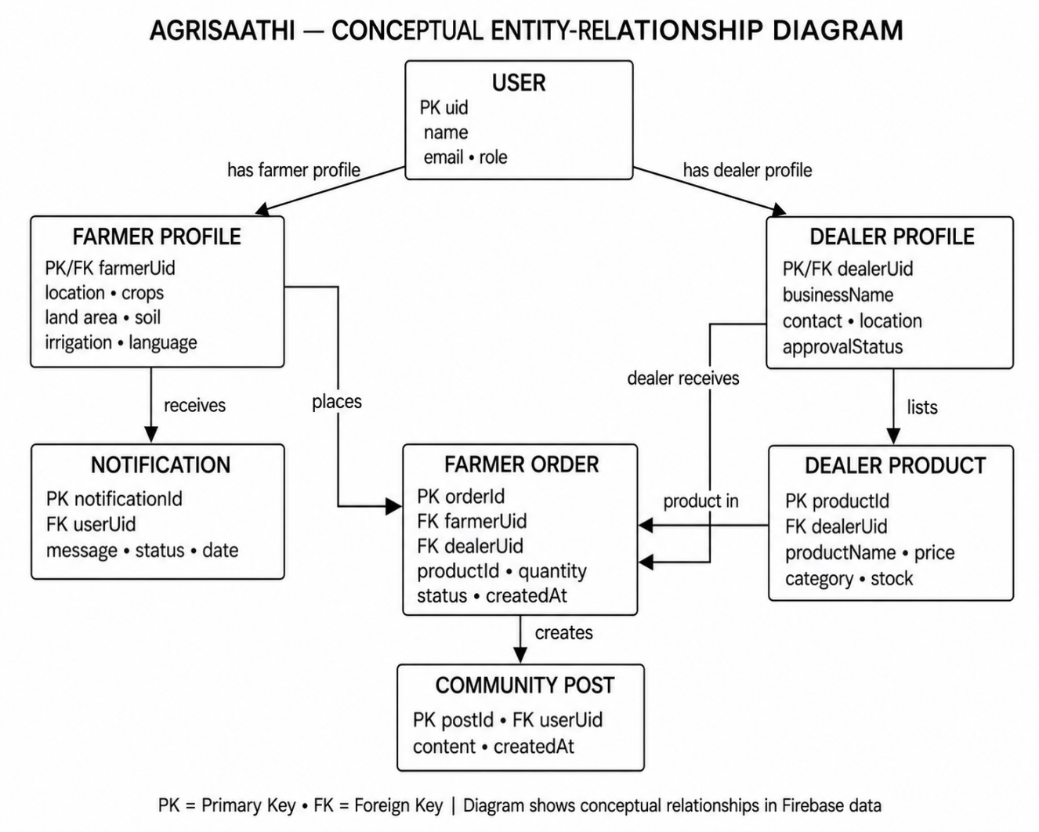

5.3.Overall Workflow Flowchart

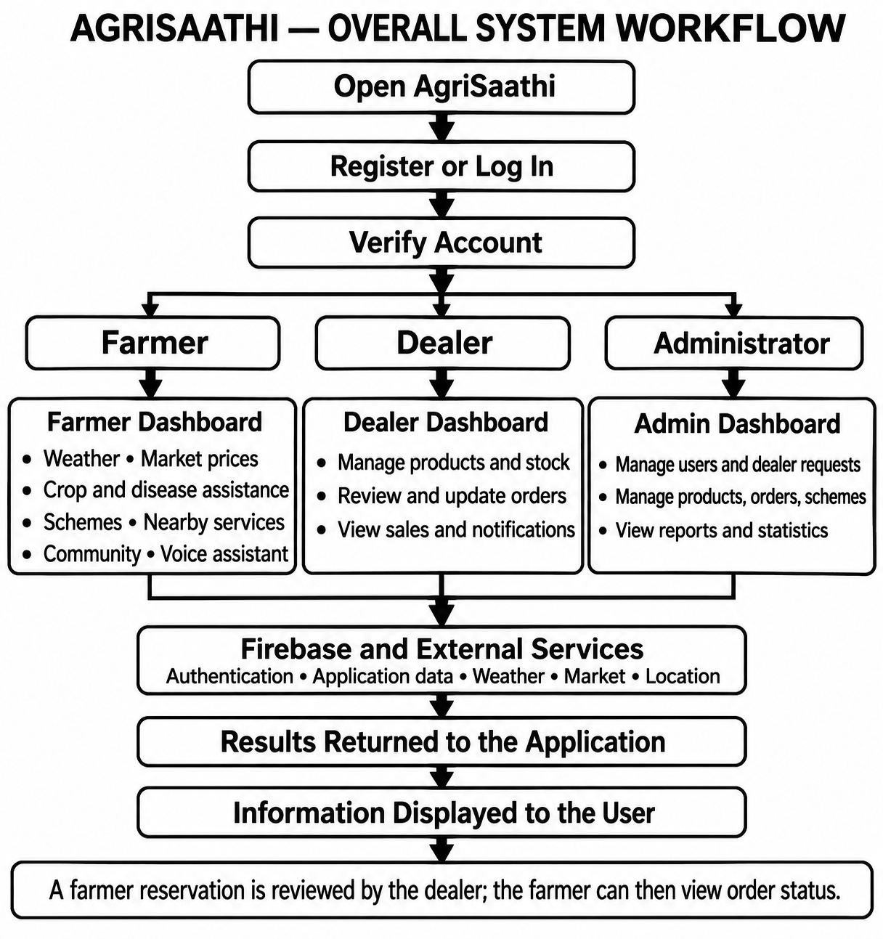

5.4 System Workflow (Explained Briefly)

Step 1 – User Registration and Login
- The user opens the AgriSaathi application.
- The user registers a new account or logs in with an existing account.
- Firebase Authentication supports account authentication.
- The user accesses features associated with their role.

Step 2 – Farmer Profile and Services
- The farmer enters or updates profile details, including location and farming information.
- The farmer dashboard provides access to weather, market prices, crop and disease assistance, schemes, nearby services, community and marketplace features.
- Location-based features use the device or browser location when permission is available.

Step 3 – Dealer Profile and Product Management
- The dealer registers or maintains dealer details.
- Dealer requests can be reviewed through the administrator area.
- The dealer adds or updates product listings and stock.
- Products are made available for farmers to browse through the marketplace.

Step 4 – Farmer Order Reservation
- The farmer browses dealer products and views product details.
- The farmer submits an order reservation.
- The dealer views the order and updates its status through the dealer area.
- The farmer can view order information and receive in-app notifications. WhatsApp updates depend on service configuration and the farmer enabling them.

Step 5 – Administration
- The administrator reviews farmer and dealer information.
- The administrator can manage dealer requests, products, orders, schemes and market information.
- Reports and statistics are available through the administration area.

Step 6 – External Services and Information Display
- The application requests information from Firebase or the relevant external service when a feature requires it.
- The service returns data to the application.
- AgriSaathi displays the available result to the user.

VI.FEASIBILITY STUDY

CHAPTER 6 – FEASIBILITY STUDY

6.1 Operational Feasibility
Operational feasibility evaluates whether AgriSaathi can be used effectively by farmers, dealers and administrators. The application provides role-based areas for accessing agricultural services, managing products and orders, and administering system information.

Key Points
- Ease of Use
The application groups features into dashboards for farmers, dealers and administrators. Users can access the functions relevant to their role through the corresponding area of the application.
2. Support for Different User Roles
Farmers can access agricultural information and marketplace features. Dealers can manage products, stock, orders and sales. Administrators can manage user and dealer information, products, orders, schemes and reports.
3. Access to Agricultural Information
Farmers can access weather information, market prices, crop and disease assistance, government scheme information, nearby agricultural services and community features in one application.
4. Farmer-Dealer Interaction
Farmers can browse dealer products and reserve orders. Dealers can review and update orders, while farmers can view order information and receive in-app notifications.
5. Mobile and Web Access
AgriSaathi is developed as a web application and includes an Android application. Users can access the system through a compatible browser or the Android app, subject to deployment and device requirements.
6. Operational Dependencies
Some features depend on an internet connection, location permission, external service availability and correct Firebase configuration. Location-based features require location access from the user’s device or browser.
Thus, AgriSaathi is operationally feasible for its intended user groups because it brings several agricultural services and management functions together in one role-based application. Its effectiveness depends on the availability of network access and the services required by each feature.

6.2 Technical Feasibility
Technical feasibility evaluates whether the technologies and equipment required to develop and operate AgriSaathi are available and suitable for the project.
AgriSaathi uses widely available web and mobile development technologies. Its client application is built with React and Vite, Firebase provides authentication and data services, and Capacitor supports Android deployment. The project also includes Firebase Cloud Functions and a Python service for image-related processing.

Technology Suitability
1. React and JavaScript
React is used to build the application interface and its role-based pages. JavaScript supports the application logic and interaction with Firebase and external services.
2. Vite
Vite is used as the development and build tool for the web application.
3. Tailwind CSS
Tailwind CSS is used to style the application interface.
4. Firebase Services
Firebase Authentication supports account access. Firebase Realtime Database, Storage and Cloud Functions support application data and configured backend operations. The WhatsApp delivery function also uses Firestore.
5. Capacitor and Android
Capacitor provides the Android application layer. Android Studio and the Android SDK are used for Android development and deployment.
6. Python Image Service
The project includes a Python service using FastAPI and OpenCV for image-related processing.
7. External Services
The application connects to external services for weather information, market price records, location search and configured image analysis. The availability of these features depends on the corresponding service and required configuration.

System Requirements
The following are suitable general requirements for development and basic use. Actual requirements depend on the development setup and deployment environment.

Hardware Requirements
- Desktop computer or laptop for development.
- Android phone or emulator for testing the Android application.
- Sufficient RAM and storage to run the code editor, browser, Android Studio and development tools.
- Internet connection for Firebase and external services.
- Location-enabled device for testing location-based features.
Software Requirements
- Windows, macOS or Linux operating system for web development.
- Node.js for the JavaScript application and Firebase Functions.
- Visual Studio Code or another compatible code editor.
- Google Chrome, Microsoft Edge, Mozilla Firefox or another compatible browser.
- Android Studio and Android SDK for Android development.
- Python and the required packages for the image-processing service.
- Firebase project configuration and credentials for the Firebase features.

Technical Advantages
1. Use of Common Development Technologies
The project uses React, JavaScript, Firebase, Capacitor and Python, which are supported by established development tools and documentation.
2. Modular Application Structure
The application separates authentication, farmer, dealer and administrator features into different modules. This organization supports maintenance and future development.
3. Web and Android Support
The project supports browser access and provides an Android application through Capacitor.
4. Integration with External Services
The system can retrieve information and support features through external services, subject to connectivity, availability and configuration.
5. Configuration Requirements
Some operations require Firebase configuration, database access rules, deployed Cloud Functions and service credentials. API keys and other secrets must be configured appropriately for the services that need them.
AgriSaathi is technically feasible because its development technologies and tools are available for web and Android development. Successful operation depends on suitable configuration of Firebase, external services and the development environment.

6.3 Economic Feasibility
Economic feasibility considers the costs involved in developing, deploying and maintaining AgriSaathi and the potential benefits of using the application.

Cost Considerations
1. Development Cost
The project uses commonly available development tools and open-source libraries. Development costs depend on the time and resources required to build, maintain and extend the application.
2. Deployment Cost
The web and Android applications require suitable hosting and deployment arrangements. Firebase and external services may have usage limits or charges depending on the selected plans and the number of users or requests.
3. Maintenance Cost
Maintenance may include updating dependencies, managing Firebase configuration, maintaining Cloud Functions, monitoring external service integrations and correcting application issues.
4. Infrastructure Cost
Developers need a computer and internet connection. Android development also requires Android Studio and the Android SDK. Testing location features requires a suitable device or emulator setup.
5. Service and API Cost
The cost of Firebase, market data access, image analysis, messaging and other external services depends on their provider terms, usage and configuration. Actual costs should be reviewed before deployment.

Potential Benefits
1. Centralized Access to Services
AgriSaathi brings several farming information and service features together in one application.
2. Reduced Manual Coordination
Digital product listings and order reservations can help organize communication between farmers and dealers.
3. Easier Information Access
Farmers can use the application to access available weather, market, scheme and nearby-service information.
4. Organized Administration
The administrator area provides tools for managing user and dealer information, products, orders, schemes and reports.
The actual economic value depends on the number of users, service usage, deployment choices and the costs charged by external providers. AgriSaathi is economically feasible when its deployment and ongoing service costs are appropriate for the intended use.

6.4 Feasibility Study Conclusion
The feasibility study indicates that AgriSaathi is suitable for development and operation as a web and Android application.
- Operational feasibility: The role-based application provides features for farmers, dealers and administrators, with some services depending on internet access, permissions and external systems.
- Technical feasibility: The project uses available web, mobile, Firebase and Python technologies, with configuration required for Firebase and external services.
- Economic feasibility: Development uses commonly available tools, while deployment and operating costs depend on hosting, Firebase usage and external service plans.
Overall, AgriSaathi provides a technical foundation for delivering agricultural information and supporting farmer-dealer interaction. Its operating requirements and service costs should be considered when preparing it for deployment.

VII.CODING

CHAPTER 7 – CODING

7.1 Introduction to Coding Section
Coding is the stage in which the AgriSaathi design is implemented as a working application. The project includes features for farmers, dealers and administrators. Its code supports account access, farmer services, dealer product and order management, and administrative functions.
The web application is built with React and JavaScript. React components organize the pages, Vite supports development and building, and Tailwind CSS is used for styling. Capacitor provides support for the Android application. Firebase provides authentication and data services, while Firebase Cloud Functions handle selected server-side operations. External services supply information for features such as weather, market prices and image analysis.
The code is organized into modules for authentication, farmer services, dealer services, administration, shared components and service integrations. This chapter describes representative code from those areas and explains how it contributes to the application. The excerpts are selected from the existing project files.

7.2 Frontend Code
The frontend is the part of AgriSaathi that users see and interact with. It provides the application pages, forms, dashboards, navigation and feature controls. The application uses React Router to map URLs to the appropriate pages, and React components to implement those pages.

7.2.1 Splash and Role-Selection Interface

A. Splash Screen
Code – SplashPage.jsx
import { useEffect } from "react";
import { useNavigate } from "react-router-dom";

export default function SplashPage() {
const navigate = useNavigate();

useEffect(() => {
const timer = setTimeout(() => {
navigate("/role-selection");
}, 2000);

return () => clearTimeout(timer);
}, [navigate]);

return (
<div className="min-h-screen bg-white flex items-center justify-center p-6">
<img
src="/agrisathi-logo.png"
alt="AgriSaathi — Smart Farming Companion"
className="block w-full max-w-sm sm:max-w-md h-auto object-contain"
/>
</div>
);
}

Explanation
- useEffect and useNavigate are imported from React and React Router.
- useNavigate provides the function used to move to another application route.
- When the splash page loads, setTimeout starts a two-second timer.
- After the timer completes, navigate("/role-selection") opens the role-selection page.
- The cleanup function clears the timer if the component is removed before the timer completes.
- The returned JSX displays the AgriSaathi logo, centered in a full-screen container.
- Tailwind CSS classes control the layout, spacing and responsive image size.

Working of the Splash Screen
- The application opens the splash page.
- The splash page displays the AgriSaathi logo.
- A two-second timer runs.
- The application navigates to the role-selection page.

B. Role-Selection Page
The role-selection page lets a user choose whether to continue as a farmer, dealer or administrator. It also provides a language selector. The selected role is saved in the browser session before the user proceeds to login.
Code – Role definitions
const roles = [
{
id: "farmer",
icon: "👨‍🌾",
titleKey: "roleFarmer",
descriptionKey: "roleFarmerDescription",
},
{
id: "dealer",
icon: "🏪",
titleKey: "roleDealer",
descriptionKey: "roleDealerDescription",
},
{
id: "admin",
icon: "🛡️",
titleKey: "roleAdmin",
descriptionKey: "roleAdminDescription",
},
];
Explanation
- The roles array contains the role identifiers, icons and translation keys used by the interface.
- Each role has a unique id.
- The title and description keys are passed to the language utility so that the displayed text follows the selected language.
The page maintains state for the selected role, language and entrance animation.
const [selectedRole, setSelectedRole] = useState("");
const [isVisible, setIsVisible] = useState(false);
const [language, setCurrentLanguage] = useState(getLanguage());
- selectedRole stores the role selected by the user.
- isVisible controls the entrance animation of the page content.
- language stores the currently selected interface language.
The page subscribes to language changes and cleans up its timer and subscription when it is removed.
useEffect(() => {
const unsubscribe = subscribeLanguageChange(setCurrentLanguage);
const timer = window.setTimeout(() => {
setIsVisible(true);
}, 100);

return () => {
window.clearTimeout(timer);
unsubscribe();
};
}, []);

Selecting a Role
Code – Role selection handler
function selectRole(role) {
setSelectedRole(role);

sessionStorage.setItem("role", role);

window.setTimeout(() => {
navigate("/login");
}, 350);
}
Explanation
- The selected role is saved in the page state.
- sessionStorage.setItem stores the role in the current browser session.
- A short delay allows the selection animation to begin.
- navigate("/login") takes the user to the login page.

Displaying the Role Cards
The role cards are generated from the roles array. Each card is a button that calls selectRole when clicked.
{roles.map((role, index) => {
const isSelected = selectedRole === role.id;
const roleTitle = t(role.titleKey, {}, language);

return (
<button
key={role.id}
type="button"
onClick={() => selectRole(role.id)}
disabled={Boolean(selectedRole)}
aria-label={t(
"continueAsRole",
{ role: roleTitle },
language
)}
>
{role.icon}
{roleTitle}
{t(role.descriptionKey, {}, language)}
</button>
);
})}
Explanation
- map creates one button for each role.
- isSelected checks whether the role is the one selected by the user.
- t retrieves translated text using the selected language.
- The click handler passes the role identifier to selectRole.
- The buttons are disabled after a role is selected, preventing another selection during navigation.
- aria-label provides an accessible label for the button.
The page uses Tailwind CSS classes for responsive layout, spacing, color, focus indication and selection animation. The role cards are arranged in a single column on small screens and in three columns on wider screens.

Working of the Role-Selection Page
- The page loads the user’s current language.
- The page displays the language selector and the three role cards.
- The user may select another language; the page updates its displayed text.
- The user selects a role.
- The selected role is stored in sessionStorage.
- The application navigates to the login page.
Summary
The splash and role-selection screens form the entry point to AgriSaathi. The splash screen displays the application logo and then opens role selection. The role-selection page provides language selection and lets users choose a role before continuing to login.

7.2.2 Login and Registration Interface
AgriSaathi provides separate login and registration interfaces. The login page authenticates an existing user and checks the user’s profile and role. Farmer registration uses a multi-step form to collect account and farm details.

A. Login Interface
The login page accepts the registered email address and password. It also provides a password recovery option and a way to return to role selection.
Code – Login form
<form
onSubmit={handleLogin}
className="space-y-5"
>
<label htmlFor="login-email">
Email Address
</label>

<input
id="login-email"
type="email"
value={email}
autoComplete="email"
onChange={(event) => {
setEmail(event.target.value);
clearMessage();
}}
placeholder="Enter your registered email"
/>
</form>
Explanation
- onSubmit={handleLogin} calls the login handler when the form is submitted.
- The email input is controlled by the React state variable email.
- autoComplete="email" identifies the expected value to the browser.
- onChange updates the email state as the user types and clears any previous message.
- The form also includes a password input and a Forgot Password? button.
Code – Firebase login and profile lookup
await setPersistence(auth, browserSessionPersistence);

const credential = await signInWithEmailAndPassword(
auth,
normalizedEmail,
password
);

const uid = credential.user.uid;

const userSnapshot = await get(
ref(database, `users/${uid}`)
);
Explanation
- The handler sets browser-session persistence for the Firebase account.
- signInWithEmailAndPassword checks the email and password using Firebase Authentication.
- On successful authentication, Firebase returns the user’s account information.
- The handler obtains the account’s unique uid.
- The uid is used to retrieve the user profile from the users path in Firebase Realtime Database.
- If a profile is missing, the login code checks for a pending request and displays an appropriate message.
- The profile’s role is used to determine access to the corresponding application area.
The login page displays error or warning messages for unsuccessful login attempts and account issues. It also allows users to return to role selection. Depending on the selected role, the page provides the relevant account creation or dealer approval request option.
Working of the Login Interface
- The user selects a role and opens the login page.
- The user enters their registered email and password.
- The form calls the handleLogin function.
- Firebase Authentication validates the credentials.
- The application retrieves the user profile using the Firebase uid.
- The application uses the profile and role to continue the login process or displays a relevant message.

B. Farmer Registration Interface
The farmer registration interface collects both account information and agricultural profile details. Registration is organized into three steps: crop selection, personal and farm details, and a review of the entered information.
Code – Registration form and step selection
<form
onSubmit={handleRegister}
className="p-5 md:p-7 space-y-6"
>
{onboardingStep === 1 ? (
<CropSelector
selectedCrops={selectedCrops}
onChange={setSelectedCrops}
disabled={loading}
/>
) : onboardingStep === 3 ? (
<section aria-labelledby="registration-review-title">
<h2 id="registration-review-title">
Review your details
</h2>
</section>
) : (
<section>
<h2>Personal Details</h2>
</section>
)}
</form>
Explanation
- The form calls handleRegister when submitted.
- onboardingStep determines which registration step is displayed.
- Step 1 displays the crop selector.
- Step 2 displays personal and farm details.
- Step 3 displays a review of the information entered by the farmer.
- The page includes navigation controls so the user can move back to an earlier step.
Code – Step validation

if (onboardingStep === 1) {
if (!selectedCrops.length) {
showMessage("warning", "Select at least one crop to continue.");
return;
}

setForm((current) => ({
...current,
mainCrop: selectedCrops[0],
otherCrops: selectedCrops.slice(1).join(", "),
}));

setOnboardingStep(2);
return;
}
Explanation
- The handler first prevents normal browser form submission and clears any previous message.
- On the crop-selection step, it checks that at least one crop has been selected.
- If no crop is selected, a warning is shown and registration does not proceed.
- When crops are selected, the first crop is stored as the main crop and the remaining selections are stored as other crops.
- The form then advances to the next step.
The registration page also checks that land, crop and soil area values are valid. It prevents the combined allocated crop or soil area from exceeding the entered land size.
Code – Creating the farmer account

const credential = await createUserWithEmailAndPassword(
auth,
normalizedEmail,
form.password
);

createdUser = credential.user;

const farmerData = {
uid: createdUser.uid,
name: form.name.trim(),
email: normalizedEmail,
phone,
village: form.village.trim(),
district: form.district.trim(),
state: form.state.trim(),
mainCrop: form.mainCrop.trim(),
selectedCrops,
landSize: form.landSize
? Number(form.landSize)
: 0,
landUnit: form.landUnit,
irrigationType: form.irrigationType,
preferredLanguage: form.preferredLanguage,
role: "farmer",
status: "active",
};
Explanation
- createUserWithEmailAndPassword creates the farmer’s Firebase Authentication account.
- The returned account provides a unique uid.
- The registration code uses that uid in the farmer profile.
- The profile stores information entered during registration, including name, contact and location details, crop selections, land size, irrigation type and preferred language.
- The profile marks the account role as farmer and sets its status as active.
After preparing the profile, the registration handler writes it to the database and attempts to send an email verification message.
await update(ref(database), {
[`users/${createdUser.uid}`]: farmerData,
[`farmers/${createdUser.uid}`]: farmerData,
});

await sendEmailVerification(createdUser);

Working of the Registration Interface
- The farmer selects one or more crops.
- The form checks that at least one crop is selected.
- The farmer enters personal and farm details.
- The form validates the entered land, crop and soil areas.
- The farmer reviews the information.
- The form creates a Firebase Authentication account.
- The profile is saved under the farmer’s uid in the users and farmers database paths.
- The application attempts to send an email verification message.

C. Dealer Registration Request
The login page offers a dealer registration request option for users who want to register as dealers. Dealer requests are handled through a separate dealer registration flow and can be reviewed by an administrator. They are distinct from the farmer registration form described above.
Summary
The login interface authenticates users through Firebase Authentication and retrieves their profiles to determine their role. Farmer registration collects crop, personal and farm details through a multi-step form, validates the entries, creates the account and saves the profile in Firebase Realtime Database.

7.3 Backend Code
The reference project uses PHP and MySQL for backend processing and database connections. AgriSaathi uses Firebase services instead. Its client application connects to Firebase Authentication, Realtime Database, Storage and Cloud Functions. Some application logic runs in React modules, while selected operations are handled by Firebase Cloud Functions.

7.3.1 Firebase Configuration and Service Initialization
AgriSaathi initializes Firebase in a shared module so that its pages and service modules can access the configured Firebase services.
Code – Firebase service initialization (src/firebase.js)

import { initializeApp } from "firebase/app";
import {
browserSessionPersistence,
initializeAuth,
} from "firebase/auth";
import { getDatabase } from "firebase/database";
import { getStorage } from "firebase/storage";
import { getFunctions } from "firebase/functions";

const app = initializeApp(firebaseConfig);

export const auth = initializeAuth(app, {
persistence: browserSessionPersistence,
});

export const database = getDatabase(app);
export const storage = getStorage(app);
export const functions = getFunctions(app, "asia-southeast1");
Explanation
- initializeApp creates the Firebase application instance using the project configuration.
- initializeAuth initializes Firebase Authentication.
- browserSessionPersistence keeps the Firebase login session associated with the browser session.
- getDatabase initializes Firebase Realtime Database.
- getStorage initializes Firebase Storage.
- getFunctions connects the application to Cloud Functions in the configured region.
- The export statements allow other modules to import and use these shared Firebase services.
The project configuration object contains the settings that identify the Firebase project and its services. It is passed to initializeApp and is not repeated in the example above.
Code – Waiting for Firebase to restore the signed-in user

export async function getAuthUser() {
await auth.authStateReady();
return auth.currentUser;
}
Explanation
- auth.authStateReady() waits until Firebase has restored the authentication state.
- auth.currentUser returns the signed-in user after the authentication state is ready.
- Pages can call getAuthUser() before treating a missing user as signed out. This helps prevent the page from making an access decision before Firebase has finished restoring the session.

Working of Firebase Initialization
- The module imports the Firebase initialization functions.
- The application is initialized with the project configuration.
- Authentication, Realtime Database, Storage and Cloud Functions are initialized.
- The initialized services are exported for use by the application modules.
- When a page needs the current account, it can wait for Firebase to restore the authentication state before reading the user.
Conclusion
The Firebase initialization module provides the shared connection between AgriSaathi and its Firebase services. It allows the application modules to use authentication, database, storage and cloud functions without initializing a separate Firebase application in each module.

7.3.2 Login and Role Validation
In the reference project, this section explains how the backend validates a login and creates an administrator session. AgriSaathi uses Firebase Authentication for account verification and Firebase Realtime Database for user profiles. After authentication, the application checks the selected role against the role stored in the profile.

1. Validating the Login Form
Before attempting authentication, the login handler prevents the browser’s default form submission, clears old messages, and checks that a role, email and password have been entered.
async function handleLogin(event) {
event.preventDefault();

clearMessage();

if (!selectedRole || !roleDetails) {
showMessage("warning", "Select your role before logging in.");
return;
}

if (!normalizedEmail) {
showMessage("warning", "Enter your email address.");
return;
}

if (!password.trim()) {
showMessage("warning", "Enter your password.");
return;
}

// Authentication continues after validation.
}
Explanation
- event.preventDefault() stops the browser from reloading the page when the form is submitted.
- clearMessage() removes an earlier error or warning from the interface.
- selectedRole must contain a role selected on the previous screen.
- normalizedEmail must contain an email address.
- The password check prevents an empty password from being submitted.
- return stops processing when a required value is missing.

2. Authenticating with Firebase
After validating the form, the handler configures session persistence and passes the credentials to Firebase Authentication.
await setPersistence(auth, browserSessionPersistence);

const credential = await signInWithEmailAndPassword(
auth,
normalizedEmail,
password
);

const uid = credential.user.uid;
Explanation
- setPersistence configures the browser-session behavior for the account.
- signInWithEmailAndPassword asks Firebase Authentication to verify the email and password.
- If authentication succeeds, Firebase returns a credential containing the signed-in user.
- credential.user.uid provides the unique ID used to locate the user’s application profile.

3. Retrieving the User Profile
AgriSaathi stores application profile data separately from the Firebase Authentication credentials. The login handler reads the profile from the Realtime Database using the authenticated user’s uid.
const userSnapshot = await get(
ref(database, `users/${uid}`)
);

if (!userSnapshot.exists()) {
const pendingRequest = await checkPendingRequest(uid);

if (pendingRequest) {
showMessage("warning", pendingRequest.text);
return;
}

showMessage(
"error",
"Your account profile was not found. Contact the administrator."
);
return;
}
Explanation
- ref identifies the users/{uid} database location.
- get retrieves the profile record.
- exists() checks whether the requested profile was found.
- If no profile exists, checkPendingRequest checks whether there is a pending account request.
- The handler shows an appropriate message and stops the login process when no usable profile is available.

4. Checking the Registered Role
Once a profile is found, the handler reads and normalizes its role value.
const userData = userSnapshot.val();

const registeredRole = String(userData.role || "")
.trim()
.toLowerCase();

if (
!registeredRole ||
!ROLE_CONFIG[registeredRole]
) {
showMessage(
"error",
"This account has an invalid role configuration."
);
return;
}
Explanation
- userSnapshot.val() returns the profile data.
- String, trim and toLowerCase normalize the role value before it is checked.
- ROLE_CONFIG contains the roles supported by the login interface.
- If the role is missing or not recognized, the handler displays an error and stops.

5. Matching the Selected Role and Checking Account Status
The handler compares the role selected by the user with the role saved in the account profile. It also checks for account statuses that prevent access.
if (registeredRole !== selectedRole) {
showMessage(
"warning",
`This account is registered as ${
ROLE_CONFIG[registeredRole].title.replace(" Login", "")
}. Change the selected role and log in again.`
);

return;
}

const accountStatus = String(userData.status || "")
.trim()
.toLowerCase();

if (
registeredRole === "dealer" &&
["suspended", "deactivated", "blocked", "disabled"]
.includes(accountStatus)
) {
showMessage(
"error",
"Your dealer account is suspended. Contact the administrator."
);
return;
}
Explanation
- The selected role must match the role stored in the profile.
- If the roles differ, the user is asked to change the selected role and try again.
- The dealer account status is checked against the statuses that prevent dealer access.
- The login handler also checks whether an account has been disabled.
- When a check fails, the handler displays a message and stops before opening a dashboard.

6. Saving the Role and Opening the Dashboard
After the authentication, profile and role checks succeed, the verified role is stored in the browser session. The user is then routed to the dashboard configured for that role.
sessionStorage.setItem("role", registeredRole);

await new Promise((resolve) =>
window.setTimeout(resolve, 350)
);

navigate(
ROLE_CONFIG[registeredRole].path,
{ replace: true }
);
Explanation
- sessionStorage.setItem stores the verified role for the current browser session.
- The short delay provides time for the interface to show feedback.
- ROLE_CONFIG[registeredRole].path supplies the dashboard route for the verified role.
- replace: true replaces the login page in the browser’s navigation history.

7. Handling Login Errors
The login process is inside a try/catch/finally structure.
- try contains the authentication and profile checks.
- catch logs the error and displays a user-friendly message through getFriendlyAuthError.
- finally sets the loading state back to false, whether the login succeeds or fails.
The loading state allows the interface to indicate that authentication is in progress and helps prevent repeated submissions.

8. Protecting Dealer Pages
The project also includes a DealerAccessGuard component. It listens for Firebase Authentication state changes, reads the user profile, and checks whether the account has the dealer role and an allowed status.
const unsubscribe = onAuthStateChanged(auth, async (user) => {
if (!user) {
if (active) setAccessState("denied");
return;
}

const userSnapshot = await get(
ref(database, `users/${user.uid}`)
);

const userData = userSnapshot.exists()
? userSnapshot.val()
: null;

const role = String(userData?.role || "")
.trim()
.toLowerCase();

const status = String(userData?.status || "")
.trim()
.toLowerCase();

if (role !== "dealer" || SUSPENDED_STATUSES.has(status)) {
if (active) setAccessState("denied");
return;
}

if (active) setAccessState("allowed");
});
Explanation
- onAuthStateChanged monitors whether a Firebase user is signed in.
- If there is no signed-in user, dealer access is denied.
- The guard retrieves the user profile and checks the role and account status.
- If the role is not dealer, or the status is blocked, the guard denies access.
- If the checks pass, the guarded dealer page is displayed.
- While access is being checked, the component shows a loading message.
If Firebase cannot be reached, the guard displays an unavailable message and provides a retry option. It does not treat a temporary database error as proof that the user is signed out.

Working of Login and Role Validation
- The user selects a role and submits the login form.
- The application checks that the role, email and password have been entered.
- Firebase Authentication verifies the email and password.
- The application reads the profile associated with the Firebase uid.
- The login handler checks that the profile exists and contains a supported role.
- It compares the selected role with the registered role and checks relevant account status.
- The verified role is stored in the browser session.
- The application opens the dashboard associated with that role.
- Dealer pages additionally use DealerAccessGuard to check the signed-in user’s dealer role and status.
Conclusion
AgriSaathi uses Firebase Authentication to verify login credentials and a Realtime Database profile to determine the user’s role and account status. The login handler routes an eligible user to the appropriate dashboard, while DealerAccessGuard checks access to dealer pages.

7.3.3 Farmer and User Management Logic
The reference project’s student-management section describes how records are added, updated, deleted and displayed. AgriSaathi manages farmer accounts and profiles instead. The administrator can view and search farmer records and enable or disable accounts. Farmers can update their own profile information.

1. Loading Farmer Records
The administrator’s farmer-management page reads the users records from Firebase Realtime Database, filters for accounts whose role is farmer, and sorts them by name.
Code – Reading and filtering farmer records (FarmersListPage.jsx)

const snapshot = await get(
ref(database, "users")
);

if (!snapshot.exists()) {
setFarmers([]);
return;
}

const users = snapshot.val();

const farmerList = Object.entries(users || {})
.filter(([, user]) => {
return (
user &&
typeof user === "object" &&
normalize(user.role) === "farmer"
);
})
.map(([uid, user]) => ({
uid,
...user,
}))
.sort((first, second) =>
getFarmerName(first).localeCompare(
getFarmerName(second)
)
);

setFarmers(farmerList);
Explanation
- ref(database, "users") identifies the user records in Firebase Realtime Database.
- get retrieves the records.
- snapshot.exists() checks whether any data was returned.
- Object.entries converts the user records into key-value pairs.
- The filter keeps records whose role is farmer.
- map adds each database key as the farmer’s uid.
- sort orders the resulting farmer list by name.
- setFarmers stores the list in React state for display.
If the database read fails, the page catches the error, displays an error message and resets its loading state.

2. Searching and Filtering Farmers
The farmer-management page supports searching and status filtering. The searchable details include farmer name, email, phone number, village, district, crop, gender, age and farmer ID. The status filter can display all farmers or a selected status.
The page also calculates totals for all, active and disabled farmer accounts. These totals are generated from the farmer records currently loaded into the page.

3. Enabling or Disabling a Farmer Account
An administrator can request a status change for a farmer and confirm the action. The handler determines the next status and writes the change to the selected farmer’s user record.
Code – Updating farmer account status

const currentStatus = getFarmerStatus(farmer);

const nextStatus =
currentStatus === "disabled"
? "approved"
: "disabled";

const updatedAt = new Date().toISOString();

await update(
ref(database, `users/${farmer.uid}`),
{
status: nextStatus,
statusUpdatedAt: updatedAt,
}
);
Explanation
- getFarmerStatus obtains the farmer’s current status.
- If the farmer is disabled, the code sets the next status to approved; otherwise, it sets it to disabled.
- updatedAt records the time of the status change.
- update writes the new status and timestamp to the selected user’s database record.
- After a successful database update, the page updates its local state so the displayed farmer list reflects the change.

4. Loading a Farmer’s Profile
The farmer profile page reads the account information from both the users and farmers database paths.
Code – Reading the profile records (FarmerProfilePage.jsx)

const [userSnapshot, farmerSnapshot] = await Promise.all([
get(ref(database, `users/${uid}`)),
get(ref(database, `farmers/${uid}`)),
]);

if (!userSnapshot.exists()) {
setFarmer(null);
showMessage("error", "Farmer account was not found.");
return;
}

const userData = userSnapshot.val();
const farmerData = farmerSnapshot.exists()
? farmerSnapshot.val()
: {};

if (userData.role !== "farmer") {
navigate("/role-selection", { replace: true });
return;
}
Explanation
- The code requests the account record and farmer profile at the same time using Promise.all.
- If the users record is missing, the page reports that the account was not found.
- The farmer profile is read when available; otherwise, an empty object is used.
- The page checks the role and redirects users whose account is not registered as a farmer.
- The profile page combines the user and farmer records for display and editing.

5. Validating and Saving Profile Changes
Before saving profile changes, the page checks required values such as farmer name, phone number, district, state and main crop. It also validates the phone number format and land size.
Code – Validating selected profile fields

const name = form.name.trim();
const phone = form.phone.trim();
const district = form.district.trim();
const state = form.state.trim();

if (!name) {
showMessage("warning", "Enter farmer name.");
return;
}

if (!/^[6-9]\d{9}$/.test(phone)) {
showMessage("warning", "Enter a valid 10-digit mobile number.");
return;
}

if (!district || !state) {
showMessage("warning", "Enter district and state.");
return;
}
Once validation passes, the page prepares an update object containing the modified personal and farm details. It then updates the farmer record in both profile paths.
await update(ref(database), {
[`users/${currentUser.uid}`]: {
...updates,
role: "farmer",
email: farmer.email || currentUser.email || "",
},
[`farmers/${currentUser.uid}`]: farmerUpdates,
});
Explanation
- update writes the changed fields using the current account’s uid.
- The code preserves the farmer role and email information.
- After a successful write, the page updates its local profile state, exits edit mode and displays a success message.
- If Firebase denies the update or another error occurs, the page displays an error message.

Working of Farmer Management
- The administrator page reads records from the users database path.
- The page filters the records to show farmer accounts.
- The administrator can search, filter, view details and request an account-status change.
- The status change is written to the selected farmer’s database record.
- A farmer can open their own profile page and load the corresponding user and farmer records.
- The profile page validates changes before writing updated details to Firebase.
- The application displays a success or error message based on the result.
Conclusion
The farmer-management features provide administrators with tools to view, search and manage farmer account status. The profile module allows farmers to review and update their farming and contact details. These operations use Firebase Realtime Database records associated with each user’s uid.

7.3.4 Dealer Management Logic
The reference project’s hall-management module maintains examination hall records. The closest AgriSaathi equivalent is dealer management: administrators review dealer registration requests, view dealer profiles and product counts, and suspend or restore dealer accounts.

1. Loading Dealer Registration Requests
The administrator page reads dealer requests from the dealerRequests path and displays the pending requests.
Code – Loading dealer requests (DealerRequestsPage.jsx)

const snapshot = await get(
ref(database, "dealerRequests")
);

setRequests(
getPendingRequests(
snapshot.exists() ? snapshot.val() : null
)
);
Explanation
- ref identifies the dealerRequests database path.
- get retrieves the dealer request records.
- snapshot.exists() checks whether request data is available.
- getPendingRequests prepares the request records for display.
- The result is saved in React state using setRequests.
If an error occurs while reading the database, the page displays a message asking the administrator to check the connection and try again.

2. Approving a Dealer Request
When the administrator approves a request, the code validates the request and its account identifier, checks for an existing account with the same ID, and updates the user and request records.
Code – Validating and approving a dealer request

const requestKey = request.requestKey;
const uid = cleanValue(request.uid) || requestKey;

if (!requestKey || !uid) {
setMessage({
type: "error",
text: "This dealer request is missing its account identifier and cannot be accepted.",
});
return;
}

const existingUser = await get(
ref(database, `users/${uid}`)
);

if (
existingUser.exists() &&
normalize(existingUser.val()?.role) !== "dealer"
) {
throw new Error(
"An account with this identifier already exists and is not a dealer."
);
}
Explanation
- requestKey identifies the dealer request record.
- The code uses the request’s uid when available, otherwise it uses the request key.
- If either identifier is missing, the request cannot be processed.
- The code checks whether a user record already exists at users/{uid}.
- If the existing record belongs to a non-dealer role, the approval is stopped to avoid replacing that account with a dealer profile.
After validation, the administrator’s approval is saved.
const approvedAt = new Date().toISOString();
const profile = { ...request };
delete profile.requestKey;

await update(ref(database), {
[`users/${uid}`]: {
...profile,
uid,
role: "dealer",
status: "approved",
approvedAt,
},
[`dealerRequests/${requestKey}/status`]: "approved",
[`dealerRequests/${requestKey}/approvedAt`]: approvedAt,
});
Explanation
- approvedAt records when the request was approved.
- The request data is copied into profile; requestKey is removed from the profile fields.
- The users/{uid} record is written with the dealer role and approved status.
- The request record is also updated with its new status and approval time.
- After a successful update, the approved request is removed from the list of pending requests and a success message is displayed.

3. Loading Dealer Records
The dealer-management page reads user records, filters them to include dealer accounts and retrieves each dealer’s product records to calculate a product count.
Code – Reading dealer profiles
const usersSnapshot = await get(
ref(database, "users")
);

if (!usersSnapshot.exists()) {
setDealers([]);
return;
}

const usersData = usersSnapshot.val();

const dealerEntries = Object.entries(usersData).filter(
([, user]) => {
if (!user || typeof user !== "object") {
return false;
}

return normalize(user.role) === "dealer";
}
);
Explanation
- The module reads the users database path.
- If no user records are found, it clears the dealer list.
- Object.entries turns the user records into key-value pairs.
- The filter retains records whose role is dealer.
For each dealer, the module reads the dealer’s products.
const productsSnapshot = await get(
ref(database, `dealerProducts/${uid}`)
);

if (productsSnapshot.exists()) {
const products = productsSnapshot.val();

if (
products &&
typeof products === "object" &&
!Array.isArray(products)
) {
productCount = Object.keys(products).length;
}
}
Explanation
- dealerProducts/{uid} identifies products associated with a dealer.
- Object.keys(products).length counts the product records.
- The count is added to the dealer information shown in the administrator area.
- Dealer records are sorted by name before being saved in the page state.

4. Suspending or Restoring a Dealer Account
The administrator can change a dealer’s status. The code changes a suspended dealer’s status to approved, or an approved dealer’s status to suspended.
Code – Updating dealer status

const currentStatus = getDealerStatus(dealer);

const nextStatus =
currentStatus === "suspended"
? "approved"
: "suspended";

const updatedAt = new Date().toISOString();

await update(ref(database, `users/${dealer.uid}`), {
status: nextStatus,
updatedAt,
});
Explanation
- getDealerStatus obtains the dealer’s current status.
- nextStatus determines whether the account will be suspended or restored.
- updatedAt records when the status was changed.
- update writes the new status to the selected dealer’s user record.
- After the database update succeeds, the local dealer list and selected dealer details are updated to reflect the new status.

Working of Dealer Management
- The administrator opens dealer requests and the system reads pending records.
- The administrator selects a request for approval.
- The system checks that the request has a usable account identifier.
- It checks for an existing account with a conflicting role.
- On approval, the dealer profile and request status are updated in Firebase Realtime Database.
- The dealer-management page loads dealer profiles and counts their listed products.
- The administrator can suspend or restore a dealer account.
- The page displays a success or error message based on the database operation.
Conclusion
The dealer-management module supports administrative review of dealer registration requests and management of approved dealer accounts. It stores dealer profiles and request statuses in Firebase Realtime Database and can display each dealer’s product count.

7.3.5 Dealer Product Management Logic
The reference project’s examination-management module adds, updates, deletes, validates and displays examination records. AgriSaathi’s equivalent is dealer product management. Dealers can list products, edit product details, maintain stock information and remove eligible products.

1. Loading Dealer Products
The dealer product page first checks whether a user is signed in. It then reads the current dealer’s products from Firebase Realtime Database.
Code – Loading products (DealerProductsPage.jsx)
const currentUser = auth.currentUser;

if (!currentUser) {
navigate("/login", {
replace: true,
});

return;
}

const snapshot = await get(
ref(
database,
`dealerProducts/${currentUser.uid}`
)
);

if (!snapshot.exists()) {
setProducts([]);
return;
}

const list = Object.entries(snapshot.val())
.map(([id, value]) => ({
id,
...value,
}));

setProducts(list);
Explanation
- auth.currentUser identifies the currently signed-in Firebase user.
- If there is no signed-in user, the page redirects to login.
- The database path includes the dealer’s uid, so the page reads products belonging to that dealer.
- snapshot.exists() checks whether product records were found.
- Object.entries converts the product records into an array.
- Each product’s database key is added to its data as id.
- setProducts stores the resulting list in React state for display.
If the database request fails, the module logs the error and displays a message indicating that products could not be loaded.

2. Entering Product Details
The product form collects the product name, category, brand, price, quantity, unit, low-stock level, description and optional image. The selected category is chosen from the categories provided by the project, including seeds, fertilizer, pesticide, tools, irrigation, organic inputs, animal feed and crop protection.
Form inputs are controlled through React state. When the user changes a field, the form state is updated.
function handleChange(event) {
const { name, value } = event.target;

setForm((current) => ({
...current,
[name]: value,
}));
}
Explanation
- event.target identifies the form field that changed.
- name identifies the corresponding property in the product form.
- value contains the new value.
- The state update preserves the other form values and replaces the changed field.

3. Validating a Product Image
The product page accepts JPG, PNG and WEBP images. It rejects unsupported file types and images larger than 5 MB.
if (!allowedImageTypes.includes(file.type)) {
showMessage(
"warning",
"Select a JPG, PNG or WEBP image."
);

event.target.value = "";
return;
}

if (file.size > 5 * 1024 * 1024) {
showMessage(
"warning",
"Product image must be smaller than 5 MB."
);

event.target.value = "";
return;
}

setImageFile(file);
setImagePreview(URL.createObjectURL(file));
Explanation
- file.type is checked against the supported image types.
- file.size is compared with the 5 MB limit.
- When either check fails, the page displays a warning and clears the file input.
- If the image passes validation, it is stored in state and a preview URL is created.

4. Uploading the Product Image
The project uploads product images to Cloudinary. The cloud name and upload preset are read from the application environment configuration.
const cloudName =
import.meta.env.VITE_CLOUDINARY_CLOUD_NAME;

const uploadPreset =
import.meta.env.VITE_CLOUDINARY_UPLOAD_PRESET;

if (!cloudName || !uploadPreset) {
throw new Error(
"Cloudinary configuration is missing."
);
}

const formData = new FormData();
formData.append("file", file);
formData.append("upload_preset", uploadPreset);

const response = await fetch(
`https://api.cloudinary.com/v1_1/${cloudName}/image/upload`,
{
method: "POST",
body: formData,
}
);
Explanation
- The Cloudinary settings are read from environment variables.
- The code checks that both required configuration values are present.
- FormData packages the image file and upload preset for the request.
- fetch sends the image to Cloudinary.
- After a successful response, the module stores the secure image URL and public ID with the product record.

5. Validating Product Information
Before saving, the product form checks that the product name, category and unit have been entered. It also validates the price, quantity and low-stock level.
const productName = form.productName.trim();
const category = form.category.trim();
const unit = form.unit.trim();
const price = Number(form.price);
const quantity = Number(form.quantity);
const lowStockLevel = Number(form.lowStockLevel);

if (!productName) {
showMessage("warning", "Enter the product name.");
return;
}

if (!category) {
showMessage("warning", "Select a category.");
return;
}

if (!Number.isFinite(price) || price < 0) {
showMessage("warning", "Enter a valid price.");
return;
}

if (!Number.isInteger(quantity) || quantity < 0) {
showMessage(
"warning",
"Quantity must be a whole number."
);
return;
}
Explanation
- trim() removes spaces at the beginning and end of the product name, category and unit.
- Number() converts price and quantity input values into numbers.
- The price must be a valid, non-negative number.
- The quantity must be a whole number and cannot be negative.
- The complete handler also checks that the unit is entered and that the low-stock level is a valid non-negative whole number.
- If validation fails, the code shows a warning and stops before writing to Firebase.

6. Adding a Product
When a new product is saved, the module creates a unique product reference under the signed-in dealer’s record. It then uploads the selected image, if there is one, and saves the product data.
const productReference = push(
ref(
database,
`dealerProducts/${currentUser.uid}`
)
);

const uploadedImage =
await uploadImageToCloudinary(imageFile);

await set(productReference, {
productName,
category,
brand: form.brand.trim(),
price,
quantity,
unit,
lowStockLevel,
description: form.description.trim(),
imageUrl: uploadedImage.imageUrl || "",
imagePublicId: uploadedImage.imagePublicId || "",
dealerUid: currentUser.uid,
reservedQuantity: 0,
soldQuantity: 0,
status: quantity > 0
? "available"
: "out_of_stock",
createdAt: now,
updatedAt: now,
});
Explanation
- push creates a unique database key for the product.
- The key is created beneath dealerProducts/{dealerUid}.
- uploadImageToCloudinary uploads the image and returns its URL and public ID.
- set writes the product details to Firebase Realtime Database.
- New products start with zero reserved and sold quantities.
- The initial status is set to available when quantity is above zero, otherwise out_of_stock.
- Creation and update timestamps are stored with the product.
After a successful save, the module displays a success message, closes the product form and reloads the dealer’s products.

7. Updating a Product
When a dealer edits an existing product, the module uses that product’s database path and updates its details.
await update(
ref(
database,
`dealerProducts/${currentUser.uid}/${editingId}`
),
{
productName,
category,
brand: form.brand.trim(),
price,
quantity,
unit,
lowStockLevel,
description: form.description.trim(),
imageUrl: uploadedImage.imageUrl || "",
imagePublicId: uploadedImage.imagePublicId || "",
dealerUid: currentUser.uid,
updatedAt: now,
}
);
Explanation
- editingId identifies the selected product.
- The path includes the current dealer’s ID and the product ID.
- update changes the product fields at that location.
- The update handler preserves existing reserved and sold quantity values when assembling the complete product update.
- The product status is recalculated from the current quantity.
- The page displays a success message and reloads the product list after the update.

8. Deleting a Product
The product page prevents deletion when a product has accepted orders. If deletion is allowed, the page removes the product record from Firebase Realtime Database.
if (Number(product.reservedQuantity || 0) > 0) {
showMessage(
"warning",
"This product has accepted orders and cannot be deleted."
);

return;
}

await remove(
ref(
database,
`dealerProducts/${currentUser.uid}/${deleteTarget.id}`
)
);
Explanation
- The code first checks the product’s reserved quantity.
- If the quantity indicates accepted orders, deletion is stopped and a warning is displayed.
- Otherwise, remove deletes the selected product record using the dealer and product IDs.
- After deletion, the page closes the related form if necessary, displays a success message and reloads the product list.

Working of Dealer Product Management
- The dealer opens the product page.
- The application checks that the dealer is signed in.
- Existing products are retrieved from dealerProducts/{dealerUid}.
- The dealer can enter a new product or select an existing product for editing.
- The form validates the product information and optional image.
- The image is uploaded to Cloudinary when one is selected.
- The product data is added to or updated in Firebase Realtime Database.
- A product with no stock is marked out_of_stock; a product with stock is marked available.
- A product with reserved quantity cannot be deleted.
- The page reloads the list and displays a success or error message.

Conclusion
The dealer product-management module supports product listing, image upload, validation, editing and deletion. It stores product records under the dealer’s database path and uses the product’s quantity to determine its availability status.

7.3.6 Order Processing Logic
The reference project’s seat-allocation module selects records, checks constraints, presents a preview and saves the confirmed result. AgriSaathi’s corresponding process is the marketplace order workflow: farmers reserve dealer products, and dealers review and accept or reject the requests.

1. Creating an Order Reservation
A farmer must be signed in and have a loaded profile to place an order. The application validates the requested quantity and checks it against the product’s displayed stock.
const currentUser = auth.currentUser;

if (!currentUser || !farmer) {
navigate("/login", { replace: true });
return;
}

const quantity = getQuantity(product);
const availableQuantity = Number(product.quantity || 0);

if (!Number.isInteger(quantity) || quantity <= 0) {
showMessage("warning", "Choose a valid quantity.");
return;
}

if (quantity > availableQuantity) {
showMessage(
"warning",
`Only ${availableQuantity} ${product.unit || "units"} are available.`
);
return;
}
Explanation
- The order is stopped if the farmer is not signed in or the farmer profile is unavailable.
- getQuantity retrieves the quantity selected for the product.
- The requested quantity must be a positive whole number.
- The quantity cannot exceed the product’s currently available stock.
The application then creates a unique order record in the dealerOrders path.
const orderReference = push(
ref(database, "dealerOrders")
);

await set(orderReference, {
farmerUid: currentUser.uid,
farmerName: farmer.fullName || farmer.name || "Farmer",
dealerUid: product.dealerUid,
dealerName: product.dealerName,
productId: product.id,
productName: product.productName,
price,
quantity,
totalAmount: price * quantity,
paymentMode: "Cash on Delivery",
status: "pending",
stockReserved: false,
farmerReceived: false,
dealerPaymentReceived: false,
saleRecorded: false,
});
Explanation
- push generates a unique key for the new order.
- The order stores the farmer, dealer, product, quantity and price information needed by the order-management pages.
- totalAmount is calculated from the product price and requested quantity.
- The payment mode is recorded as Cash on Delivery.
- The order starts with the status pending.
- The initial stockReserved value is false: stock is not reserved until the dealer accepts the request.
The order record also includes delivery address details and other fields used by the marketplace. After saving, the farmer sees a success message that the order request was sent.

2. Setting the Dealer Response Deadline
New orders receive an acceptance deadline. The project sets the window to 24 hours and obtains a server time offset when available.
export const ORDER_ACCEPTANCE_WINDOW_MS =
24 * 60 * 60 * 1000;

const createdAtMs = Date.now() + serverOffset;

return {
createdAt: serverTimestamp(),
acceptanceDeadlineAt:
createdAtMs + ORDER_ACCEPTANCE_WINDOW_MS,
updatedAt: serverTimestamp(),
};

Explanation
- ORDER_ACCEPTANCE_WINDOW_MS represents a 24-hour period in milliseconds.
- serverOffset helps align the deadline with Firebase server time when that offset is available.
- The creation and update times use Firebase’s server timestamp.
- The order page checks the deadline before accepting a pending request.
Pending orders that pass their deadline can be changed to cancelled with a dealer_acceptance_timeout cancellation reason.

3. Loading Orders for the Dealer
The dealer orders page queries the dealerOrders path and, for a dealer account, filters the orders by the current dealer’s uid.
const ordersQuery =
role === "dealer" && currentUser?.uid
? query(
ref(database, "dealerOrders"),
orderByChild("dealerUid"),
equalTo(currentUser.uid)
)
: ref(database, "dealerOrders");
Explanation
- ref identifies the orders database path.
- orderByChild("dealerUid") selects the order field used for filtering.
- equalTo(currentUser.uid) limits the results to orders for the signed-in dealer.
- The page loads and displays the resulting orders for review.

4. Validating an Order Before Acceptance
Before accepting an order, the dealer orders module checks that the order exists, is still pending and has not passed its acceptance deadline. It then verifies the quantity, resolves the product, checks that it belongs to the dealer and confirms that enough stock remains.
A core stock check is shown below.
const availableQuantity = getProductQuantity(product);
const reservedQuantity = getReservedQuantity(product);
const soldQuantity = getSoldQuantity(product);

if (availableQuantity < quantity) {
setMessage({
type: "error",
text: `Insufficient stock. Available: ${availableQuantity}, requested: ${quantity}.`,
});

return;
}

const newQuantity = availableQuantity - quantity;
const newReservedQuantity = reservedQuantity + quantity;
Explanation
- getProductQuantity, getReservedQuantity and getSoldQuantity read the product’s inventory values.
- The order cannot be accepted if available stock is below the requested quantity.
- If sufficient stock exists, available quantity is reduced and reserved quantity is increased.
- The acceptance logic also verifies that required product information, including product name, category, unit and valid price, is present.

5. Accepting an Order and Reserving Stock
Once validation succeeds, the application updates the order and product records in Firebase Realtime Database.
updates[
`dealerProducts/${dealerUid}/${productId}/quantity`
] = newQuantity;

updates[
`dealerProducts/${dealerUid}/${productId}/reservedQuantity`
] = newReservedQuantity;

updates[
`dealerOrders/${order.id}/status`
] = "accepted";

updates[
`dealerOrders/${order.id}/acceptedAt`
] = now;

await update(ref(database), updates);
Explanation
- The dealer’s product record receives the new available quantity.
- Its reserved quantity is increased by the order quantity.
- The order status is changed to accepted.
- acceptedAt records when the dealer accepted the request.
- update submits the related path changes together.
- After the update succeeds, the order and product values in the page state are refreshed and a success message is shown.

6. Rejecting an Order
A dealer can reject an order that is still pending and within its acceptance window.
await update(ref(database), {
[`dealerOrders/${order.id}/status`]: "rejected",
[`dealerOrders/${order.id}/rejectedAt`]: now,
[`dealerOrders/${order.id}/updatedAt`]: now, });
Explanation
- The order status is changed to rejected.
- The rejection time and latest update time are recorded.
- The page updates its displayed order state and shows the result to the dealer.

7. Completing the Order Lifecycle
The dealer order module supports additional order states used during fulfillment, including ready-for-pickup or delivery-related statuses. It also provides actions for recording a farmer’s receipt and the dealer’s payment status. When the payment is marked received, the order can be set to completed and relevant timestamps and payment fields are updated.
Working of Order Processing
- The farmer selects a product and enters a quantity.
- The application checks that the farmer is signed in and that the quantity is valid and available.
- A new pending order is written to Firebase Realtime Database with its 24-hour acceptance deadline.
- The dealer views orders associated with their account.
- Before acceptance, the application checks the order status, deadline, product and available stock.
- If the dealer accepts, product availability and reserved quantity are updated and the order becomes accepted.
- If the dealer rejects, the order status and rejection time are saved.
- Pending orders that pass their deadline can be cancelled by the expiration logic.
- The dealer can update later fulfillment and payment information as the order progresses.
Conclusion
AgriSaathi’s order-processing logic links farmer requests with dealer products and inventory. It validates orders, applies a response deadline, reserves stock on acceptance and records status changes throughout the order lifecycle.

7.3.7 Farmer Order History and Notification Logic
The reference project’s attendance module records and displays students’ attendance for examinations. AgriSaathi has no attendance feature. The corresponding farmer-facing workflow is viewing order status and history, cancelling eligible pending orders, and viewing notifications derived from order updates.

1. Loading Orders for the Signed-In Farmer
The farmer orders page listens for Firebase Authentication changes. After confirming that a user is signed in, it checks that the user has a farmer profile and retrieves orders associated with that user.
Code – Querying orders by farmer ID (FarmerOrdersPage.jsx)

const ordersQuery = query(
ref(database, "dealerOrders"),
orderByChild("farmerUid"),
equalTo(uid)
);

const snapshot = await get(ordersQuery);
Explanation
- ref identifies the dealerOrders path.
- orderByChild("farmerUid") selects the order field used to find a farmer’s orders.
- equalTo(uid) restricts the results to the signed-in farmer.
- get retrieves the matching records.
- Returned orders are converted into a list and sorted by date for display.
The page checks the user’s profile role before loading orders. If the account is not a farmer, it redirects the user to role selection.

2. Receiving Live Order Updates
After the initial load, the farmer order page subscribes to the matching order query using Firebase’s onValue listener.
unsubscribeOrders = onValue(
ordersQuery,
async (snapshot) => {
const sortedOrderList = snapshot.exists()
? sortOrdersNewestFirst(
Object.entries(snapshot.val()).map(
([id, value]) => ({ id, ...value })
)
)
: [];

setOrders(sortedOrderList);
}
);

Explanation
- onValue listens for changes to the queried order records.
- When an order changes, the callback receives an updated snapshot.
- Object.entries converts the records into an array and attaches each database key as the order ID.
- sortOrdersNewestFirst sorts the orders for display.
- setOrders updates the page state, refreshing the visible information.
- The listener is unsubscribed when the page no longer needs it.

3. Separating Active Orders and Order History
The page classifies orders according to their status. It provides filters for active orders, accepted orders and order history. Completed, rejected, cancelled and expired orders can be displayed in history.
const FILTERS = [
{ value: "active", label: "Active Orders" },
{ value: "accepted", label: "Accepted Orders" },
{ value: "history", label: "Order History" },
];

const TERMINAL_STATUSES = [
"completed",
"complete",
"rejected",
"reject",
"cancelled",
"canceled",
"expired",
];
Explanation
- FILTERS defines the main order views available to the farmer.
- TERMINAL_STATUSES lists statuses that are treated as completed or ended for history filtering.
- The page also tracks payment and fulfillment-related statuses to organize orders into the appropriate view.

4. Cancelling a Pending Order
Farmers can cancel eligible pending orders. The page checks that the user and order are available, that the user has selected a cancellation reason, and that the order is still pending.
Code – Updating a pending order through a transaction

const result = await runTransaction(
ref(database, `dealerOrders/${order.id}`),
(current) => {
if (
!current ||
current.farmerUid !== user.uid ||
getNormalizedOrderStatus(current) !== "pending"
) {
return;
}

return {
...current,
status: "cancelled",
cancellationReason,
cancelledBy: "farmer",
cancelledAt: serverTimestamp(),
updatedAt: serverTimestamp(),
};
},
{ applyLocally: false }
);
Explanation
- runTransaction checks the current order record before committing a change.
- The order must belong to the signed-in farmer and still have the pending status.
- If these conditions are not met, the transaction does not apply the update.
- A successful cancellation stores the cancellation status, reason, user who cancelled it, and timestamps.
- The page moves the cancelled order into the order-history view and displays a confirmation message.
Pending orders have a 24-hour dealer-acceptance window. If that deadline has passed, the order expiration logic updates the order instead of allowing it to be cancelled as a normal pending request.

5. Generating Farmer Notifications from Order Status
The farmer notifications page reads the farmer’s orders and creates notification entries for supported order statuses. Examples include an order being accepted or rejected, a product being marked delivered, delivery being confirmed, payment being received and an order being completed.
Code – Preparing order notifications

const ordersQuery = query(
ref(database, "dealerOrders"),
orderByChild("farmerUid"),
equalTo(uid)
);

const snapshot = await get(ordersQuery);
const orderNotifications = [];

if (snapshot.exists()) {
Object.entries(snapshot.val()).forEach(
([id, order]) => {
const notification = createOrderNotification({
id,
...order,
});

if (notification) {
orderNotifications.push(notification);
}
}
);
}
Explanation
- The query retrieves only orders associated with the farmer’s uid.
- Each order is passed to createOrderNotification.
- The function maps supported order statuses to notification titles, descriptions, categories, icons and dates.
- Orders with statuses that do not have a notification mapping do not produce a notification entry.
- The notification list is sorted by date before it is displayed.

6. Saving Notification Read and Delete State
The notification page uses browser localStorage to remember notification IDs that have been marked as read or deleted for a particular farmer.
function saveReadIds(uid, ids) {
localStorage.setItem(
`farmerNotificationReads_${uid}`,
JSON.stringify(ids)
);
}

function saveDeletedIds(uid, ids) {
localStorage.setItem(
`farmerNotificationDeletes_${uid}`,
JSON.stringify(ids)
);
}
Explanation
- The storage keys include the farmer’s uid, keeping the saved notification state associated with that account in the browser.
- JSON.stringify converts the arrays of IDs into strings for storage.
- The page filters out notification IDs that have been deleted locally.
- The read and deletion state is stored in the browser and is separate from the order records in Firebase.

7. Opening an Order Notification
When a farmer opens a notification linked to an order, the page marks it as read and navigates to the relevant order view.
if (notification.orderId) {
const orderFilter =
["accepted", "rejected"].includes(
notification.orderStatus
)
? "active"
: "history";

navigate(
orderFilter === "active"
? "/farmer/orders"
: "/farmer/orders?filter=history"
);
}
Explanation
- The code checks whether the notification is associated with an order.
- Accepted and rejected order notifications open the active order view.
- Other order notifications open the history view.
- The farmer can then view the order and its current status.

Working of Farmer Order History and Notifications
- The farmer opens the order or notification page while signed in.
- The application checks the account role and retrieves orders associated with the farmer’s uid.
- The orders page listens for changes and updates when order records change.
- Orders are organized into active, accepted and history views according to their status.
- The farmer can cancel an eligible pending order before the dealer’s acceptance deadline.
- The notifications page converts supported order-status changes into notification entries.
- Read and deleted notification IDs are saved in browser storage.
- Opening an order notification takes the farmer to the related order view.
Conclusion
AgriSaathi’s farmer order and notification features provide a way to review order progress and history. Orders are retrieved by farmer ID, updated records are reflected through a Firebase listener, and notifications are generated from supported order statuses.

7.3.8 Reports and Statistics Logic
The reference project generates printable seating and hall-allocation reports. AgriSaathi’s administrator reports module instead gathers Firebase records and displays live platform statistics, inventory summaries, order information and dealer-request counts. It does not use the reference project’s printable report format.

1. Loading Report Data
The reports page reads user, dealer-request, product, order and scheme records from Firebase Realtime Database.
Code – Reading report data (ReportsStatisticsPage.jsx)

const usersSnapshot = await get(
ref(database, "users")
);

const dealerRequestsSnapshot = await get(
ref(database, "dealerRequests")
);

const productsSnapshot = await get(
ref(database, "dealerProducts")
);
Explanation
- ref identifies the Firebase database path for each data group.
- get retrieves the records required for the report.
- The page converts Firebase records into arrays that can be counted, filtered and displayed.
- Product records are nested under dealer IDs, so the page processes each dealer’s product list separately.
Orders and schemes are read from the project’s supported database paths:
const ordersData = await readFirstExisting([
"dealerOrders",
"orders",
]);

const schemesData = await readFirstExisting([
"governmentSchemes",
"schemes",
]);
The order reader checks dealerOrders first and uses orders as a fallback. The scheme reader checks governmentSchemes first and then schemes. Loaded orders are flattened into a list for report calculations.

2. Calculating User Statistics
The page counts users according to their roles. Dealer and administrator counts include accounts considered active by the status value.
let farmers = 0;
let dealers = 0;
let admins = 0;

loadedUsers.forEach((user) => {
const role = normalize(user.role);
const status = normalize(user.status);

const active =
!status ||
status === "approved" ||
status === "active";

if (role === "farmer") {
farmers++;
}

if (role === "dealer" && active) {
dealers++;
}

if (role === "admin" && active) {
admins++;
}
});
Explanation
- normalize standardizes the role and status text before comparison.
- Every farmer account contributes to the farmer count.
- Dealer and administrator accounts contribute to their counts when their status is blank, approved or active.
- The page also calculates the total number of loaded user records.

3. Calculating Product and Stock Statistics
Product records are processed to calculate the number of available, low-stock and out-of-stock products, along with total, reserved and sold quantities.
loadedProducts.forEach((product) => {
const quantity = getProductQuantity(product);
const reserved = getReservedQuantity(product);
const sold = getSoldQuantity(product);

const lowStockLevel =
Number(product.lowStockLevel ?? 5);

totalStock += quantity;
reservedStock += reserved;
soldStock += sold;

if (quantity > 0) {
availableProducts++;
} else {
outOfStockProducts++;
}

if (quantity <= lowStockLevel) {
lowStockProducts++;
}
});
Explanation
- The product helper functions retrieve the product’s available, reserved and sold quantities.
- If a product does not specify a low-stock level, the calculation uses the default value of 5.
- A product with quantity greater than zero is counted as available.
- A product with zero quantity is counted as out of stock.
- Products whose quantity is at or below their low-stock level are counted as low stock.

4. Saving the Report Totals
After loading and processing the records, the page saves the data collections and the calculated totals in React state.
setUsers(loadedUsers);
setProducts(loadedProducts);
setOrders(loadedOrders);
setDealerRequests(loadedDealerRequests);
setSchemes(loadedSchemes);

setReport({
farmers,
dealers,
admins,
totalUsers: loadedUsers.length,
dealerRequests: loadedDealerRequests.length,
products: loadedProducts.length,
orders: loadedOrders.length,
schemes: loadedSchemes.length,
availableProducts,
outOfStockProducts,
lowStockProducts,
totalStock,
reservedStock,
soldStock,
});
Explanation
- The page stores each loaded data group for use in report sections.
- The report state contains counts and stock totals used by the dashboard cards.
- If loading fails, the page logs the error, displays a message and restores its loading state.

5. Generating Order Summaries
The reports page calculates order statistics from the loaded order records. It classifies orders by status and calculates total and completed order values.
const totalOrderValue = useMemo(
() =>
orders.reduce(
(total, order) =>
total + getOrderAmount(order),
0
),
[orders]
);

const completedOrderValue = useMemo(
() =>
completedOrders.reduce(
(total, order) =>
total + getOrderAmount(order),
0
),
[completedOrders]
);
Explanation
- getOrderAmount obtains the order amount used in the calculation.
- reduce adds the order amounts to produce a total.
- useMemo recalculates the values when the order data changes.
- The page separately calculates total order value and completed order value.
The order section also displays status counts. The administrator can open the orders view, search by relevant order or user information, and filter by status.

6. Displaying Product Categories and Low-Stock Items
The page groups products by category and counts the number of products in each group. It also identifies products at or below their low-stock threshold and orders them by available quantity.
These values are displayed in the report interface alongside product counts and stock summaries, helping administrators review inventory status.

7. Displaying Statistics and Refreshing Reports
The report interface displays summary cards for registered accounts, dealer products, orders and schemes. Additional sections show user-role statistics, dealer requests, product stock and order details.
The page provides a refresh action that runs the report-loading function again. The interface displays loading and error states while retrieving data.

Working of the Reports and Statistics Module
- The administrator opens the reports and statistics page.
- The page reads users, dealer requests, products, orders and schemes from Firebase.
- Product records nested under dealer IDs are combined into a product list.
- The page calculates user counts based on role and account status.
- It calculates product availability, low-stock counts and stock totals.
- It calculates order counts, order statuses and order values.
- The page displays the results in summary cards and report sections.
- The administrator can refresh the data or open and filter the order information.
Conclusion
AgriSaathi’s reports module processes Firebase records to display platform counts, user roles, inventory information, dealer requests and order summaries. Its reporting is presented within the administrator interface and is based on the data currently retrieved from the configured Firebase paths.

7.4 Database Code
The reference project uses MySQL/MariaDB and an SQL database-creation script. AgriSaathi uses Firebase Realtime Database instead. Its database is associated with the Firebase project and is accessed by the application through the Firebase JavaScript SDK. Therefore, the project does not contain a MySQL CREATE DATABASE script or an SQL export to import through phpMyAdmin.

7.4.1 Firebase Database Setup
The Firebase configuration in src/firebase.js identifies the Firebase project and the services used by the application. The database service is initialized from the shared Firebase application instance.
Code – Initializing the Realtime Database

const app = initializeApp(firebaseConfig);

export const database = getDatabase(app);
Explanation
- firebaseConfig contains the configuration values that identify the Firebase project.
- initializeApp(firebaseConfig) initializes the Firebase application.
- getDatabase(app) connects the application to the Realtime Database associated with that Firebase project.
- export makes the initialized database service available to other application modules.
The database URL is included in the Firebase configuration and points to the project’s Realtime Database instance. Feature modules import the shared database object and use it with Firebase Database functions such as ref, get, set, update, remove and onValue.
The Firebase project configuration also initializes other services used by AgriSaathi, including Authentication, Storage and Cloud Functions. Firebase Functions are configured separately in the project’s firebase.json file.

Setting Up the Project Database
AgriSaathi does not require running a SQL database-creation command. Its database setup is based on the Firebase project configuration:
- The Firebase project must be available and configured for the application.
- The Firebase client configuration must identify that project and its Realtime Database.
- The application initializes Firebase and obtains the Realtime Database service.
- Application modules read or write data through Firebase database references.
- Firebase access depends on the database instance and its configured access rules.
The firebase.json file in the project configures the Cloud Functions codebase and runtime; it does not contain a MySQL schema or SQL import script.

Working of Database Initialization
- The application imports the Firebase initialization module.
- The module initializes Firebase using firebaseConfig.
- getDatabase(app) obtains the Realtime Database service.
- Application pages import the shared database object.
- Each feature uses database references to access the data required for its operation.
Conclusion
AgriSaathi’s database connection is initialized through Firebase rather than through a local MySQL server. The application uses the Firebase project configuration to connect to Realtime Database, so there is no SQL database-creation or phpMyAdmin import procedure for this project.

7.4.2 Realtime Database Data Structure
The reference project defines SQL tables for its entities. AgriSaathi stores data as records in Firebase Realtime Database instead. The application groups records under named paths, and uses a Firebase user ID or generated database key to identify each record.
The following paths represent the main data groups used by the project:
users/{uid}
farmers/{uid}
dealerRequests/{uid}
dealerProducts/{dealerUid}/{productId}
dealerOrders/{orderId}
communityPosts/{postId}
diseaseReports/{reportId}
governmentSchemes/{schemeId}
sales/{dealerUid}/{saleId}
notificationTokens/{uid}/{tokenKey}

1. User Profiles – users/{uid}
This path stores the application profile associated with a Firebase Authentication account.
Typical profile information includes:
- User ID, name and email
- Contact and location information
- Application role, such as farmer, dealer or admin
- Account status
- Profile and registration timestamps
The role and status values are used by application pages to determine how a user may proceed.

2. Farmer Profiles – farmers/{uid}
This path stores farming information associated with a farmer’s account.
The profile can include:
- Main crop and selected crops
- Land size and unit
- Crop-area information
- Soil type and soil distribution
- Irrigation type
- Preferred language
- Farmer contact and location information
The Firebase user ID links the farmer profile to the corresponding account in users/{uid}. During farmer registration and profile updates, the project writes relevant profile data to both paths.

3. Dealer Requests – dealerRequests/{uid}
This path stores dealer registration requests before or during administrative review. The administrator can retrieve requests, approve them and update request status. Approved dealer details are also written to users/{uid} with the dealer role and account status.

4. Dealer Products – dealerProducts/{dealerUid}/{productId}
Products are grouped under the ID of the dealer who listed them. A product record can include:
- Product name, category and brand
- Price, quantity and unit
- Low-stock level and description
- Image URL and image identifier
- Dealer ID
- Available, reserved and sold quantities
- Product availability status
- Creation and update timestamps
This structure lets the dealer manage their own product records while farmer and administrator pages can retrieve product listings.

5. Orders – dealerOrders/{orderId}
Each order is stored under a unique order key. The record connects the farmer, dealer and product and can include:
- Farmer ID and farmer contact or delivery information
- Dealer ID and dealer information
- Product ID and product description
- Quantity, price and total amount
- Payment mode and payment status
- Order status and related timestamps
- Stock reservation and fulfillment information
The farmer, dealer and administrator order pages use this path to read and update order records.

6. Community Posts – communityPosts/{postId}
This path stores posts submitted through the community feature. A post may include the author’s user ID, name and role, location details, title, content, category, crop and creation time.

7. Disease Reports – diseaseReports/{reportId}
The crop assistance module can store disease-report records under this path. Each record is created with a generated key and contains information collected by the crop disease reporting feature.

8. Government Schemes – governmentSchemes/{schemeId}
This path stores government scheme records managed through the administrator interface and displayed in the farmer schemes feature. The application can also read from the schemes path as a fallback in supported report-loading logic.

9. Sales – sales/{dealerUid}/{saleId}
Sales records are grouped under a dealer’s ID. The dealer sales feature uses sale records to present sales information for that dealer.

10. Notification Tokens – notificationTokens/{uid}/{tokenKey}
This path stores notification tokens associated with a user account and token key. The application uses these records as part of its push-notification support.

Example Realtime Database Structure

{
"users": {
"USER_ID": {
"name": "Farmer Name",
"email": "farmer@example.com",
"role": "farmer",
"status": "active"
}
},
"farmers": {
"USER_ID": {
"mainCrop": "Example Crop",
"landSize": 2,
"landUnit": "acres",
"irrigationType": "Rainfed",
"preferredLanguage": "English"
}
},
"dealerProducts": {
"DEALER_UID": {
"PRODUCT_ID": {
"productName": "Example Product",
"category": "Seeds",
"price": 100,
"quantity": 20,
"unit": "kg",
"status": "available"
}
}
},
"dealerOrders": {
"ORDER_ID": {
"farmerUid": "USER_ID",
"dealerUid": "DEALER_UID",
"productId": "PRODUCT_ID",
"quantity": 2,
"status": "pending"
}
}
}
This JSON is an illustrative representation of the project’s data organization. Firebase Realtime Database stores records as JSON nodes rather than as SQL tables with fixed columns.
Conclusion
AgriSaathi organizes its database around user profiles, farming profiles, dealer requests, products, orders, community posts, disease reports, schemes, sales and notification tokens. Firebase paths and keys connect related records, such as a farmer’s orders or a dealer’s products, without using the relational table definitions in the reference project.

7.4.3 Record Keys and Data Relationships
The reference project uses SQL primary keys, unique keys and auto-increment fields. AgriSaathi uses Firebase identifiers and nested paths instead. Firebase Authentication provides a uid for each account, while Realtime Database’s push function creates a unique key for new records such as orders, community posts and disease reports.

1. Firebase User ID
Farmer registration uses the account ID returned by Firebase Authentication as the profile key.
const credential = await createUserWithEmailAndPassword(
auth,
normalizedEmail,
form.password );

const createdUser = credential.user;

await update(ref(database), {
[`users/${createdUser.uid}`]: farmerData,
[`farmers/${createdUser.uid}`]: farmerData,
});
Explanation
- createdUser.uid is the Firebase Authentication ID for the account.
- The same ID identifies the profile under both users and farmers.
- This provides a consistent way for the application to find the profile associated with the signed-in user.
- The project does not use an auto-incrementing integer for these account records.

2. Generated Keys for New Records
When a farmer creates an order, the application calls push to create a new record key.
const orderReference = push(
ref(database, "dealerOrders")
);

await set(orderReference, {
farmerUid: currentUser.uid,
dealerUid: product.dealerUid,
productId: product.id,
quantity,
status: "pending",
});
Explanation
- ref(database, "dealerOrders") identifies the parent path for order records.
- push creates a unique child location under that path.
- set writes the order record to the generated location.
- The order stores the farmer, dealer and product identifiers so that the application can relate it to the corresponding records.
The project uses the same push pattern when creating records under paths such as communityPosts and diseaseReports.

3. Relationships Between Database Records
AgriSaathi represents relationships by storing identifiers in record fields and by organizing records under parent paths.
- A farmer profile uses the same uid as the corresponding user account.
- A dealer’s products are grouped under dealerProducts/{dealerUid}.
- An order stores the farmerUid, dealerUid and productId for the related farmer, dealer and product.
- A community post stores the author’s user ID.
- A disease report stores the farmer’s user ID.
These identifiers allow modules to retrieve related records. For example, the farmer orders page queries orders by farmerUid, while the dealer orders page queries by dealerUid.
Firebase Realtime Database does not define SQL primary-key, foreign-key or auto-increment constraints for these relationships. The application uses Firebase IDs, generated record keys, database paths and record fields to identify and connect data.

Coding Chapter Conclusion
AgriSaathi’s coding structure uses React pages and modules for its user interfaces, Firebase services for authentication and data access, and Cloud Functions for selected server-side operations. Its Realtime Database stores records in JSON paths rather than SQL tables. Firebase user IDs and generated record keys identify records, while IDs stored in profile, product and order records connect related data.

7.5 Additional AgriSaathi Feature Code

7.5.1 Weather Information Service
The weather feature obtains the user’s location, requests current and forecast data, and displays the results on the farmer’s weather page. It also requests a place name for the coordinates. Before loading weather information, the page checks that the signed-in user has a farmer profile.

Checking the User and Farmer Profile

const currentUser = await getAuthUser();

if (!currentUser) {
navigate("/login", { replace: true });
return;
}

const profileSnapshot = await get(
ref(database, `users/${currentUser.uid}`)
);

if (
!profileSnapshot.exists() ||
profileSnapshot.val().role !== "farmer"
) {
navigate("/role-selection", { replace: true });
return;
}
Explanation
- getAuthUser() waits for Firebase Authentication to restore the current account.
- If there is no signed-in user, the page redirects to login.
- The page reads the account profile from users/{uid}.
- The weather page continues only when the profile exists and its role is farmer.

2. Obtaining the User’s Location
The weather page calls the location service to obtain coordinates for the weather request.
const deviceLocation = await getCurrentLocation();

setLocation(
locationFromCoordinates(
null,
deviceLocation,
language
)
);
The location service requests a high-accuracy position first. If that is unavailable, it can try a lower-accuracy position and, in supported browser contexts, an approximate IP-based location. Location access depends on device or browser permissions. The project README describes the Android app’s location permission requirements.

3. Validating Coordinates and Preparing the Weather Request
The weather service converts the supplied coordinates to numbers and validates that they are within valid latitude and longitude ranges.
const lat = Number(latitude);
const lon = Number(longitude);

if (
!Number.isFinite(lat) ||
!Number.isFinite(lon) ||
lat < -90 || lat > 90 ||
lon < -180 || lon > 180
) {
const error = new Error(
"Valid device coordinates are required for weather."
);
error.code = "INVALID_COORDINATES";
throw error;
}
Explanation
- Number converts the coordinate values to numbers.
- Number.isFinite rejects missing or invalid numeric values.
- The latitude must be between -90 and 90.
- The longitude must be between -180 and 180.
- If a coordinate is invalid, the service throws an error before making a network request.
The service then requests current and hourly weather fields from Open-Meteo.
const params = new URLSearchParams({
latitude: String(lat),
longitude: String(lon),
current: CURRENT_FIELDS.join(","),
hourly: HOURLY_FIELDS.join(","),
timezone: "auto",
forecast_days: "2",
});

const response = await fetch(
`${FORECAST_URL}?${params}`
);

if (!response.ok) {
throw new Error(
`Weather request failed (${response.status}).`
);
}

const forecast = await response.json();
return forecast;
The current fields include information such as temperature, humidity, precipitation, weather code and wind speed. Hourly fields include temperature, precipitation probability, rainfall and wind speed. The request asks for a two-day forecast using the location’s automatic time zone.

4. Selecting the Next Twelve Hours
The service prepares hourly forecast data for the page by locating the current time in the forecast and selecting the next twelve entries.
export function selectNextTwelveHours(forecast) {
const hourly = forecast?.hourly;

if (!Array.isArray(hourly?.time)) {
return [];
}

const currentTime = String(
forecast?.current?.time || ""
);

let startIndex = hourly.time.findIndex(
(time) => time >= currentTime
);

if (startIndex < 0) startIndex = 0;

return hourly.time
.slice(startIndex, startIndex + 12)
.map((time, offset) => {
const index = startIndex + offset;

return {
time,
temperature: hourly.temperature_2m?.[index],
precipitationProbability:
hourly.precipitation_probability?.[index],
weatherCode: hourly.weather_code?.[index],
windSpeed: hourly.wind_speed_10m?.[index],
};
});
}
Explanation
- If hourly time data is missing, the function returns an empty list.
- The function finds the first forecast time at or after the current forecast time.
- It selects up to twelve hourly entries.
- For each selected hour, it returns the time and the available weather values needed by the interface.

5. Converting Coordinates to a Place Name
After obtaining coordinates, the page requests reverse-geocoding information to display a readable location alongside the forecast.
const [weatherResult, placeResult] =
await Promise.allSettled([
fetchWeatherForecast(deviceLocation),
reverseGeocodeCoordinates(deviceLocation),
]);
Explanation
- Promise.allSettled allows the weather request and place-name request to run at the same time.
- If the weather request fails, the page reports the weather error.
- If reverse geocoding succeeds, the page displays the returned place details.
- If reverse geocoding fails but the forecast succeeds, the page can show the coordinates and a location message.

Working of the Weather Feature
- The farmer opens the weather page.
- The application waits for the authentication state and checks the farmer profile.
- The location service requests the user’s coordinates.
- The weather service validates the coordinates.
- The application requests current and forecast information from Open-Meteo.
- The location service requests a readable place name from the coordinates.
- The forecast and location information are displayed on the page.
- If location or network requests fail, the page displays an appropriate message.

Conclusion
The weather feature combines farmer account validation, location retrieval, weather-service requests and reverse geocoding. It validates coordinates before requesting data and prepares current and hourly forecast information for display.

7.5.2 Market Price Data Service
The market prices feature retrieves AGMARKNET records through data.gov.in and displays them on the farmer’s market page. The page can filter and group records by crop and location. The service uses different request routes for Android and web development, and includes pagination, retries and caching.

1. Preparing the Market Request
The service requires a state and can also use a district. It normalizes the district name, creates a cache key and checks whether suitable cached results are available.
export async function fetchGovernmentMarketPrices({
state,
district,
signal,
forceRefresh = false,
} = {}) {
if (!state) {
throw new Error("MARKET_STATE_REQUIRED");
}

const normalizedDistrict = String(district || "")
.replace(/\s+district$/i, "")
.trim();

const key = makeCacheKey(state, normalizedDistrict);
const cached = readCache(key);
}
Explanation
- The service rejects a request if no state is supplied.
- The district name is normalized before use.
- makeCacheKey creates a key for the selected state and district.
- readCache checks the in-memory cache and browser localStorage.
- forceRefresh allows the caller to request updated data instead of using a recent cache result.

2. Requesting Market Records
The service builds requests with a page size of 1,000 records and retrieves multiple pages when needed. It sends requests through a Firebase callable function on the native app and through a Vite proxy in the web development environment.
if (Capacitor.isNativePlatform()) {
const fetchMarketPricePage = httpsCallable(
functions,
"fetchMarketPricePage",
{ timeout: 20000 }
);

const callableResult = await fetchMarketPricePage({
parameters: Object.fromEntries(parameters.entries()),
});

response = {
ok: true,
status: 200,
json: async () => callableResult.data,
};
} else {
response = await fetch(
`/api/market-prices?${parameters}`,
{ signal: controller.signal }
);
}
Explanation
- Capacitor.isNativePlatform() determines whether the application is running as a native app.
- The native app calls the fetchMarketPricePage Firebase function.
- In the web development environment, the request goes through /api/market-prices.
- The Android function uses a server-side data.gov.in API key; the key is not included in this code excerpt.

3. Pagination and Filtering
The service sends the state as a filter and includes the district when one is supplied.
const parameters = new URLSearchParams({
format: "json",
limit: String(PAGE_SIZE),
offset: String(offset),
"filters[state]": String(state).trim(),
});

if (district) {
parameters.set("filters[district]", district);
}
The service adds records from each page until fewer than 1,000 records are returned, the reported total has been reached, or the configured page limit is reached.

4. Handling Retries and Errors
The market service uses a timeout and makes up to three attempts for eligible failed requests. It can retry selected server errors and network timeouts. It maps failures to error codes so the market page can display a suitable message.
Examples include:
- Missing data.gov.in API configuration.
- Invalid or rejected requests.
- Rate limits.
- A timeout or network connection failure.
- An unreadable response from the provider.

5. Caching Market Records
Successful results are saved in memory and, when browser storage is available, in localStorage. Recently retrieved data can be reused to avoid an unnecessary request. If a live request fails, the service can use cached results up to its configured cache age.
The result identifies whether the data came from the live request or cache and includes the retrieval time. The page uses this information for its source and freshness details.

6. Preparing Records for the Interface
After fetching results, the market page prepares fields such as state, district, market, commodity, variety, unit, grade and arrival date. It groups records by commodity and calculates highest, lowest and average modal prices for the available records.
const average =
records.reduce(
(sum, item) => sum + item.modalPrice,
0
) / records.length;

return {
...group,
highest,
lowest,
average,
marketsCount: new Set(
records.map((item) => item.market)
).size,
};
Explanation
- The average is calculated from the modal prices in the group.
- highest and lowest identify the records with the largest and smallest modal prices.
- marketsCount counts the distinct markets represented in the group.
- The resulting summary is used by the market page alongside individual records.

Working of the Market Price Feature
- The farmer selects or provides a state and, optionally, a district.
- The market page calls fetchGovernmentMarketPrices.
- The service checks its cache unless a forced refresh is requested.
- It requests paginated AGMARKNET records using the Android function or web development proxy.
- The service validates the response and applies retries for eligible failures.
- Successful records are cached with their retrieval time.
- The market page prepares the records and calculates commodity summaries.
- The results are displayed with their source and retrieval information.
Conclusion
The market-price service retrieves and prepares government market records for the AgriSaathi interface. It supports location filters, pagination, cache reuse and error handling, while keeping the Android API-key request on the Firebase function route.

7.5.3 Crop Recommendations and Image-Based Assistance
AgriSaathi’s crop assistance page provides profile-based crop recommendations and two image-based features: farmland/soil image analysis and crop disease analysis. Crop recommendations use a rule-based scoring method. Image analysis uses the configured Gemini service, and the crop disease workflow can use the project’s Python image-enhancement service.

1. Profile-Based Crop Recommendations
The recommendation function compares each crop’s requirements with the farmer’s profile and selected values. It evaluates soil, water availability, climate and land type, and assigns points when the requirements match.
const soilScore = soilMatches ? 5 : 0;
const waterScore = crop.water.includes(waterLevel) ? 4 : 0;
const climateScore = crop.climate.includes(climateZone) ? 3 : 0;
const landScore = crop.land.includes(landType) ? 2 : 0;

const totalScore =
soilScore + waterScore + climateScore + landScore;
The function creates a list of recommendations, removes crops with no matching score, sorts the remaining crops by score and returns up to four results.
return cropRecommendations
.filter((crop) => crop.totalScore > 0)
.sort((first, second) => second.totalScore - first.totalScore)
.slice(0, 4);
The result includes reasons such as soil or water suitability when those factors matched. This is a rule-based recommendation calculated from the available profile information.

2. Farmland and Soil Photo Analysis
The farmer can provide a photo of farmland or soil. The page checks for a valid image and limits its size to 10 MB. The image is prepared for analysis and converted to base64 before being sent with a prompt to the configured Gemini service.
The prompt asks for a JSON response describing visible soil type, land type, confidence and observations. It also directs the service to flag images that do not show farmland or soil and to state uncertainty.
const response = await fetch(
`https://generativelanguage.googleapis.com/v1beta/models/${model}:generateContent?key=${apiKey}`,
{
method: "POST",
headers: { "Content-Type": "application/json" },
signal: controller.signal,
body: JSON.stringify({
contents: [{
role: "user",
parts: [
{
inline_data: {
mime_type: mimeType || "image/jpeg",
data: base64,
},
},
{ text: prompt },
],
}],
generationConfig: {
temperature: 0.2,
responseMimeType: "application/json",
maxOutputTokens: 256,
},
}),
}
);
Explanation
- The image is included as inline data together with the analysis prompt.
- The request asks for JSON output for processing by the application.
- The request is aborted if it exceeds the configured timeout.
- The page parses and validates the returned fields before displaying the result.
- If the result indicates that the image does not show farmland or soil, the page asks the farmer to select a suitable image.
- Recognized soil and land types can be applied to the recommendation inputs.

3. Preparing a Crop Image for Disease Analysis
Before disease analysis, the page attempts to improve the selected crop image through the Python service. The image is uploaded as multipart form data to the /enhance-image endpoint.
const formData = new FormData();
formData.append("file", file);

const response = await fetch(
`${pythonApiUrl}/enhance-image`,
{
method: "POST",
body: formData,
signal: controller.signal,
}
);

const data = await response.json();

if (!response.ok || !data?.success) {
throw new Error(
data?.detail ||
data?.message ||
"Python image enhancement failed."
);
}
If the enhancement service returns an image, the page uses the returned image for disease analysis. If enhancement is unavailable, the page displays a message and continues with the original photo.

4. Python Image-Enhancement Service
The project’s Python service is built with FastAPI and uses OpenCV and NumPy for image processing. It accepts JPG, JPEG, PNG and WEBP files up to 10 MB.
The /enhance-image endpoint validates the image, decodes it, resizes it when needed, adjusts brightness and contrast, reduces noise, sharpens the image and returns the processed image as base64 data.
resized_image = resize_image(original_image)
enhanced_image = improve_brightness_and_contrast(resized_image)
enhanced_image = reduce_noise(enhanced_image)
enhanced_image = sharpen_image(enhanced_image)

enhanced_base64 = encode_image_as_base64(enhanced_image)

return {
"success": True,
"image": {
"mimeType": "image/jpeg",
"base64": enhanced_base64,
},
"information": image_information,
}
The returned information includes image measurements such as dimensions, brightness and sharpness. The service enhances the image for analysis; it does not itself identify the crop disease.

5. Crop Disease Analysis
The page sends the prepared plant image to the configured Gemini model for analysis. Its prompt requests structured JSON containing the plant/crop identification, disease, confidence, symptoms, causes, immediate actions, treatment, prevention and expert advice. The prompt also directs the service to avoid inventing a disease when the image is unclear, and to provide general safety guidance without pesticide or fertilizer dosage.
The analysis handler validates the response before the page uses it. If a model is temporarily unavailable, the code can retry or try another configured model. If the image is not recognized as a plant, the page displays an error instead of showing a diagnosis.

6. Matching Dealer Products
After a successful disease analysis, the page loads dealer products if they are not already available. It compares the analysis’s fertilizer and pesticide recommendations with product records and displays matching products where matches are found.
This connects the crop assistance feature with the dealer marketplace data. It does not automatically purchase or apply products.

7. Saving a Disease Report
When a signed-in farmer completes disease analysis, the application can save a report under diseaseReports.
const reportReference = push(
ref(database, "diseaseReports")
);

await set(reportReference, {
farmerId: currentUser.uid,
crop: analysis.crop || cropName.trim() || "Unknown",
disease: analysis.disease || "Unknown",
confidence: analysis.confidence || "low",
imageEnhanced: Boolean(enhanced),
createdAt: Date.now(),
});
The saved record contains the farmer ID, crop and disease labels, confidence, whether the image was enhanced, and the creation time.

Working of Crop and Image Assistance
- The farmer opens the crop assistance page.
- Profile details and selected inputs are used to score crop recommendations.
- For farmland analysis, the farmer selects an image and the page requests a structured soil and land assessment.
- For crop disease analysis, the page validates the plant image and attempts to enhance it using the Python service.
- The prepared image is sent to the configured Gemini service for disease analysis.
- The page validates and displays the analysis, then searches dealer product records for matching recommendations.
- A disease report is saved for the signed-in farmer.
Conclusion
The crop assistance feature combines rule-based crop scoring with image-based farmland and disease analysis. The Python service enhances images, while the configured Gemini service returns analysis results. The application validates image inputs and service responses before presenting results.

7.5.4 Voice Assistant
AgriSaathi’s voice assistant lets farmers speak in a selected language, receive a spoken response, and navigate to supported app pages using voice commands. The implementation is in VoiceAssistantPage.jsx. It uses the browser’s Speech Recognition API to capture speech and speech output utilities to read responses aloud.

1. Speech Recognition Setup
The assistant checks whether the browser supports SpeechRecognition or its WebKit version. It then configures recognition for the selected language and processes one spoken request at a time.
const SpeechRecognition =
window.SpeechRecognition ||
window.webkitSpeechRecognition;

if (!SpeechRecognition) {
setError(
interfaceText[languageRef.current]?.speechNotSupported ||
interfaceText.en.speechNotSupported
);
setStatus("idle");
return;
}

const recognition = new SpeechRecognition();
recognition.lang =
speechLocales[languageRef.current] ||
speechLocales.en;

recognition.continuous = false;
recognition.interimResults = false;
recognition.maxAlternatives = 1;

Explanation:
- The browser’s supported speech recognition interface is selected.
- If speech recognition is unavailable, the assistant displays a localized error.
- recognition.lang sets the recognition language using the selected language’s locale.
- continuous = false ends recognition after the current spoken request.
- interimResults = false waits for the completed speech result.
- maxAlternatives = 1 requests one recognized version of the speech.

2. Speaking a Response
The speak() function sends the response to the project’s localized speech output utility. It updates the assistant’s status while speech is being generated and displays a message if speech output is unsupported or fails.
function speak(text, code = languageRef.current, onFinished) {
if (!text) {
onFinished?.();
return;
}

stopRecognition();
speakingRef.current = true;
setStatus("speaking");

speakLocalizedText(text, code, {
rate: 0.94,
pitch: 1,
volume: 1,
onStart: () => setStatus("speaking"),
}).then((result) => {
if (result.status === "cancelled") return;

if (
result.status === "voice-unavailable" ||
result.status === "unsupported" ||
result.status === "cloud-error" ||
result.status === "error"
) {
setError(
result.status === "cloud-error"
? t("speechGenerationFailed", {}, code)
: result.status === "unsupported"
? currentInterface.speechUnsupported
: currentInterface.voiceUnavailable
);
}

speakingRef.current = false;
onFinished?.();
});
}

Explanation:
- The function returns immediately when there is no response text.
- Speech recognition is stopped before the assistant speaks.
- The assistant’s status changes to speaking.
- The selected language and speech settings are passed to speakLocalizedText().
- Errors are displayed using messages for the selected language.

3. Local Voice Commands
Before sending a request to the AI service, the assistant checks whether it matches a locally supported command. The input is normalized to make matching less sensitive to capitalization, whitespace, and Unicode differences.
async function handleLocalCommand(text) {
const normalizedCommand = String(text || "")
.normalize("NFC")
.toLocaleLowerCase()
.replace(/\s+/g, " ")
.trim();

const result = detectLocalVoiceCommand(
text,
languageRef.current
);

if (!result) {
return false;
}

// The detected command is handled using its registered action
// and route in the voice assistant.
}
Explanation:
- normalize("NFC") standardizes the text representation.
- The command is converted to lowercase and repeated spaces are reduced.
- detectLocalVoiceCommand() checks the spoken request against supported local commands.
- If no command matches, the function returns false so the assistant can continue to the next response method.

4. Processing a Farmer’s Request
The assistant records the farmer’s message, tries a local command first, and then checks for a small-talk response before using the AI response service.
async function respondToFarmer(spokenText) {
if (!spokenText || !activeRef.current) return;
if (responseInProgressRef.current) return;

responseInProgressRef.current = true;
stopRecognition();
setError("");
setStatus("thinking");

addMemory("farmer", spokenText);
addConversationMessage("farmer", spokenText);

try {
const handled = await handleLocalCommand(spokenText);

if (handled) {
return;
}

const smallTalkReply = getVoiceSmallTalkReply(
spokenText,
languageRef.current
);

// If there is no local command or small-talk response,
// the request proceeds to the assistant response handling.
}
}
Explanation:
- Empty requests and requests made while the assistant is inactive are ignored.
- responseInProgressRef prevents multiple responses from running at the same time.
- The assistant stops listening and changes its status to thinking.
- The farmer’s request is added to conversation memory.
- A local command is handled first; small talk is checked next.

5. AI Request and Navigation Actions
When the request needs an AI response, the assistant prepares a prompt containing the selected response language, current app route, farmer profile when available, conversation history, and relevant order details. The prompt requires a JSON response and provides the registered navigation actions.
const prompt = `
You are AgriSaathi, an agriculture-focused voice assistant
for Indian farmers.

Current response language:
${languageName}

Current farmer page:
${location.pathname}

Reply in the same language requested by the current language code.
Keep responses concise because they will be spoken aloud.

Return ONLY valid JSON:
{
"reply": "short spoken response",
"languageCode": "${currentLanguage}",
"action": "none",
"searchQuery": ""
}

If the farmer clearly asks to open or find a page,
set action to exactly one registered action.
If the request could refer to more than one page,
ask a short clarification question and set action to "none".
Do not invent live local weather, market prices,
diagnoses, or scheme eligibility.

Farmer's new request:
${userText}
`;

const result = await requestVoiceAssistantResponse({
prompt,
languageCode: currentLanguage,
supportedLanguages: Object.keys(speechLocales),
signal: requestControllerRef.current.signal,
});
Explanation:
- The prompt requests a concise spoken answer in the selected language.
- Registered actions allow the assistant to respond with supported app navigation.
- Ambiguous requests are handled by asking the farmer for clarification.
- The prompt directs the assistant not to invent live weather, market prices, diagnoses, or scheme eligibility.
- The response service receives the prompt, selected language, supported languages, and an abort signal.

6. Product Search and Navigation
For product-related voice requests, the assistant reads dealer product data from Firebase and filters out inactive products and items with no available quantity before matching the requested search text.
const productsSnapshot = await get(
ref(database, "dealerProducts")
);

if (productsSnapshot.exists()) {
Object.entries(productsSnapshot.val()).forEach(
([dealerUid, dealerProducts]) => {
Object.entries(dealerProducts || {}).forEach(
([productId, product]) => {
if (
!product ||
typeof product !== "object" ||
product.status === "inactive" ||
Number(product.quantity || 0) <= 0
) {
return;
}

const searchableText = [
product.productName || product.name,
product.brand,
product.category,
product.description,
]
.filter(Boolean)
.join(" ")
.normalize("NFC")
.toLocaleLowerCase();

if (searchableText.includes(normalizedQuery)) {
// The matching product can be used for the requested action.
}
}
);
}
);
}
Explanation:
- Product records are read from the Firebase dealerProducts path.
- Unavailable, inactive, or invalid product records are skipped.
- Product name, brand, category, and description are combined into searchable text.
- The requested query is compared with the normalized product information.

Voice Assistant Workflow
- The farmer selects a language and speaks a request.
- Speech recognition converts the request into text.
- The assistant checks local voice commands.
- Small-talk responses are checked when no local command matches.
- Other requests are sent to the AI response service with relevant context.
- The assistant speaks the response and performs a supported navigation action when requested.

7.5.5 Government Schemes Module
The Government Schemes module displays scheme information to farmers and compares available eligibility rules with the farmer’s saved profile. Farmers can search the directory, view personalized matches, filter schemes by assessment status, review application information, and listen to scheme details. Scheme administration is restricted to administrators.

1. Loading Scheme Records
The module first resolves which Firebase Realtime Database path contains the scheme records. It subscribes to that path and updates the displayed schemes when the database changes.
export async function resolveGovernmentSchemesPath() {
const current = await get(ref(database, "governmentSchemes"));

if (current.exists()) {
return "governmentSchemes";
}

const legacy = await get(ref(database, "schemes"));
return legacy.exists() ? "schemes" : "governmentSchemes";
}

export function subscribeToGovernmentSchemes(path, onSchemes, onError) {
return onValue(ref(database, path), (snapshot) => {
const value = snapshot.val() || {};

const schemes = Object.entries(value)
.filter(([, scheme]) => scheme && typeof scheme === "object")
.map(([id, scheme]) => ({ id, ...scheme }));

onSchemes(schemes, value._initialized === true || schemes.length > 0);
}, onError);
}
Explanation:
- The current database path is governmentSchemes.
- If that path has no data, the service checks the legacy schemes path.
- onValue() subscribes to database changes.
- Each scheme record is converted into an object containing its database ID and scheme fields.

2. Loading the Farmer Profile and Scheme Data
The farmer page loads the scheme directory and the signed-in user’s profile. It uses the default scheme records when the database does not yet contain initialized scheme data.
const [schemes, setSchemes] = useState(DEFAULT_SCHEMES);
const [farmer, setFarmer] = useState(null);

resolveGovernmentSchemesPath()
.then((path) => {
unsubscribe = subscribeToGovernmentSchemes(
path,
(records, initialized) => {
if (records.length || initialized) {
setSchemes(records.length ? records : DEFAULT_SCHEMES);
}
setSchemesLoading(false);
},
(error) => {
console.warn("Unable to load government schemes:", error);
setSchemesLoading(false);
}
);
});
The user and farmer profile records are read from Firebase and combined before eligibility is assessed.
const profile = { ...userData, ...farmerData };
setFarmer(profile.role === "farmer" ? profile : null);

Explanation:
- DEFAULT_SCHEMES provides initial scheme information.
- Scheme records are updated from the Firebase subscription when available.
- User and farmer profile information are combined to provide fields used by the assessment rules.
- The profile is treated as a farmer profile only when its role is farmer.

3. Assessing Scheme Relevance
Eligibility rules are maintained separately from the scheme display records. For example, the PM-KISAN rule checks the farmer’s cultivation status and landholding information.
evaluate(farmer) {
const land = Number(farmer.landSize || 0);

if (["tenant", "sharecropper"].includes(farmer.cultivationStatus)) {
return {
status: "not_eligible",
satisfied: [],
missing: [],
reasons: [
"The profile indicates leased or share-cultivated land; " +
"PM-KISAN is for landholding farmer families."
],
};
}

const satisfied = [];
const missing = [];

if (land > 0 && farmer.cultivationStatus === "owner") {
satisfied.push("Your profile records landholding and owner cultivation.");
} else {
missing.push("Confirm land ownership and land records.");
}

return {
status: "potentially_eligible",
satisfied,
missing,
reasons: ["PM-KISAN covers qualifying landholding farmer families across India."],
};
}
The assessment function returns an unverified status when the farmer profile or a matching eligibility rule is unavailable.
export function assessScheme(scheme, farmer) {
const rule = getRule(scheme);

if (!rule || !farmer) {
return {
rule: null,
status: "unverified",
label: STATUS_LABELS.unverified,
satisfied: [],
missing: [
farmer
? "No verified, current eligibility rules are available for this scheme."
: "Add or load your farmer profile to check relevance."
],
reasons: [],
};
}
}
Explanation:
- Scheme rules compare available profile information with the requirements recorded for that scheme.
- The assessment can identify information that appears to match and details the farmer still needs to confirm.
- The module presents these results as profile-based assessments; it does not approve applications or guarantee eligibility.

4. Searching and Filtering Schemes
The scheme directory filters records using the search text, selected directory view, and assessment status.
const filteredSchemes = assessedSchemes.filter(({ scheme, assessment }) => {
const details = getSchemeDetails(scheme);

const matchesSearch = [
details.title,
details.category,
details.benefits,
details.eligibility,
scheme.department,
scheme.state,
details.documents,
assessment.label,
]
.join(" ")
.toLowerCase()
.includes(search.toLowerCase());

const personalized = assessment.status === "likely_eligible";

return matchesSearch &&
(view === "all" || personalized) &&
(statusFilter === "all" || assessment.status === statusFilter);
});
Explanation:
- The search checks scheme names, categories, benefits, eligibility, department, state, required documents, and assessment labels.
- The personalized view shows schemes assessed as likely eligible.
- The all-schemes view allows farmers to browse the full directory.
- The status filter can narrow the results by assessment status.

5. Displaying Scheme Information
When a farmer opens a scheme, the details view displays its benefits, eligibility information, required documents, application steps, source review information, and official links. The page also provides a speech button for scheme details.
async function speakScheme(scheme) {
const details = getSchemeDetails(scheme);

const message =
`${details.title}. Benefits: ${details.benefits}. ` +
`Eligibility: ${details.eligibility}. ` +
`Documents: ${details.documents}`;

cancelSpeech();
setSpeechMessage("");

const result = await speakLocalizedText(
message,
language,
{ rate: 0.9 }
);
}
The list view includes controls for personalized results, all schemes, status filtering, and search. Each scheme opens its detailed information.

6. Administrator Scheme Management
The administrator scheme page checks the signed-in user’s role before allowing scheme management. If the user is not an administrator, the page redirects them.
const unsubscribe = onAuthStateChanged(auth, async (user) => {
if (!user) {
navigate("/login", { replace: true });
return;
}

const profile = await get(ref(database, `users/${user.uid}`));

if (!profile.exists() || normalize(profile.val()?.role) !== "admin") {
navigate("/dashboard", { replace: true });
return;
}

setAuthorized(true);
await loadSchemes();
});
Administrators can manage scheme records containing fields such as title, eligibility, benefits, required documents, application process, category, department, state, official link, and application note.

Working of the Government Schemes Module
- The page loads the scheme directory from Firebase or uses the default scheme records.
- It loads the signed-in farmer’s profile when available.
- The eligibility rules assess relevant profile details for each scheme.
- The farmer searches or filters the scheme directory.
- The farmer opens a scheme to view its details and official information.
- An administrator can add, edit, or remove scheme records after role verification.

7.5.6 Nearby Agriculture Services
The Nearby Agriculture Services page helps farmers find mapped agricultural support locations within 25 km of their device location. It uses location coordinates to search the OpenStreetMap Overpass service and displays matching places with their category, distance, and available contact information. The page states that the coordinates are used for the search and are not saved to the farmer’s account.

1. Creating the Nearby Places Search
The page builds an Overpass query around the farmer’s coordinates. The query searches for mapped names and tags associated with agricultural offices, soil testing, research centers, farmer services, and related categories.

const SEARCH_RADIUS_METERS = 25000;
const OVERPASS_URL =
"https://overpass-api.de/api/interpreter";

function queryForLocation({ latitude, longitude }) {
const around =
`(around:${SEARCH_RADIUS_METERS},${latitude},${longitude})`;

return `[out:json][timeout:25];
(
nwr["name"~"${AGRICULTURE_NAME}",i]${around};
nwr["office"~"agriculture|research",i]${around};
nwr["amenity"~"research_institute|community_centre",i]${around};
nwr["government"="agriculture"]${around};
);
out center tags 300;`;
}
Explanation:
- SEARCH_RADIUS_METERS sets the search radius to 25,000 metres.
- The query uses the farmer’s latitude and longitude as its centre.
- The search checks map names and tags for agricultural support locations.
- The result requests up to 300 mapped entries with their tags and coordinates.

2. Processing Search Results
The page checks each result for a name, recognized category, and valid coordinates. It calculates the distance from the farmer’s location, excludes results outside the search radius, and sorts the remaining services by distance.
function prepareServices(elements, origin) {
const found = new Map();

for (const element of elements || []) {
const tags = element.tags || {};
const name = String(tags.name || tags["name:en"] || "").trim();
const category = categoryFor(tags);
const latitude = Number(element.lat ?? element.center?.lat);
const longitude = Number(element.lon ?? element.center?.lon);

if (
!name ||
!category ||
!Number.isFinite(latitude) ||
!Number.isFinite(longitude)
) {
continue;
}

const distance = distanceInKm(origin, { latitude, longitude });
if (distance * 1000 > SEARCH_RADIUS_METERS) continue;

found.set(`${element.type}/${element.id}`, {
id: `${element.type}/${element.id}`,
name,
category,
latitude,
longitude,
distance,
address: formatAddress(tags),
phone: normalizePhone(tags.phone || tags["contact:phone"]),
openingHours: tags.opening_hours || "",
});
}

return [...found.values()]
.sort((first, second) => first.distance - second.distance);
}
Explanation:
- categoryFor() assigns a service category based on its map tags.
- Coordinates are read from either the map element or its center field.
- Entries missing a name, category, or valid coordinates are skipped.
- The distance calculation is used to keep results within 25 km.
- The prepared results include available address, phone, and opening-hours data.

3. Requesting and Caching Results
Search results are cached for five minutes for the same location. Requests already in progress for that location are reused to avoid sending duplicate searches.
const CACHE_TTL_MS = 5 * 60 * 1000;
const serviceCache = new Map();
const inFlightSearches = new Map();

async function searchNearbyServices(location) {
const key = cacheKey(location);
const cached = serviceCache.get(key);

if (cached && Date.now() - cached.savedAt < CACHE_TTL_MS) {
return cached.services;
}

if (inFlightSearches.has(key)) {
return inFlightSearches.get(key);
}

// Send the location query to the Overpass service,
// process the returned map elements, and cache the results.
}
Explanation:
- The cache key is based on the location coordinates.
- Valid cached results are reused for up to five minutes.
- inFlightSearches prevents duplicate requests for the same location while a search is running.
- The search sends a request to the Overpass service and processes its returned map data.

4. Loading the Farmer’s Location and Services
When the page opens, it obtains the current device location and searches for nearby services. It displays suitable error messages if location access or the search fails.
async function loadServices(options = {}) {
setStatus("loading");
setErrorMessage("");

try {
const currentLocation = await getCurrentLocation({
forceRefresh: options.forceRefresh === true,
});

setLocation(currentLocation);

const results = await searchNearbyServices(currentLocation);
setServices(results);
setStatus("ready");
} catch (error) {
setErrorMessage(
error?.code === 1
? "Location permission was denied."
: "Nearby services could not be loaded right now."
);
setStatus("error");
}
}

Explanation:
- The page requests the device’s current location through getCurrentLocation().
- The location is used to search for mapped services.
- The page updates its status to show loading, results, or an error.
- When location is unavailable, the page provides an option to search Maps by town or village.

5. Filtering and Displaying Results
Farmers can filter results by service category. Each result displays its name, category, distance, address, and any available hours or phone number. The page also provides links for directions and calls when the relevant information is available.
const visibleServices = useMemo(
() =>
category === "all"
? services
: services.filter(
(service) => service.category === category
),
[category, services]
);

Working of the Nearby Services Page
- The farmer opens the Nearby Agriculture Services page.
- The page requests the device location.
- The location is used to search the mapped data source within 25 km.
- Results are categorized, checked, and sorted by distance.
- The farmer filters the results and opens directions or calls a listed number.

7.5.7 Farmer Community Module
The AgriSaathi Community module allows signed-in users to share posts and view posts from other community members. Posts are stored in Firebase Realtime Database under communityPosts. The page supports searching and liking posts, and allows a post to be deleted by its author or an administrator.

1. Loading Community Posts
The page checks whether a user is signed in, loads their profile, and subscribes to community posts. Posts are sorted from newest to oldest.
const currentUser = await getAuthUser();

if (!currentUser) {
navigate("/login", { replace: true });
return;
}

const profileSnapshot = await get(
ref(database, `users/${currentUser.uid}`)
);

if (!profileSnapshot.exists()) {
showMessage("error", "User profile was not found.");
return;
}

const profile = {
uid: currentUser.uid,
...profileSnapshot.val(),
};

setCurrentProfile(profile);

unsubscribe = onValue(
ref(database, "communityPosts"),
(snapshot) => {
if (!snapshot.exists()) {
setPosts([]);
setLoading(false);
return;
}

const postList = Object.entries(snapshot.val())
.map(([id, value]) => ({ id, ...value }))
.sort(
(first, second) =>
new Date(second.createdAt || 0) -
new Date(first.createdAt || 0)
);

setPosts(postList);
setLoading(false);
}
);
Explanation:
- Users who are not signed in are redirected to the login page.
- The profile is loaded from the Firebase users path.
- The page listens for changes at communityPosts.
- Posts are sorted using their createdAt timestamps, with newest posts first.

2. Creating a Community Post
When a post is submitted, the page checks that the user profile exists and that the post content is not empty. It then creates a new Firebase record with the author details, content, timestamps, and initial like data.
const content = form.content.trim();

if (!content) {
showMessage("warning", "Write something before posting.");
return;
}

const postReference = push(
ref(database, "communityPosts")
);

const now = new Date().toISOString();

await set(postReference, {
authorUid: currentProfile.uid,
authorName:
currentProfile.fullName ||
currentProfile.farmerName ||
currentProfile.dealerName ||
currentProfile.name ||
"AgriSaathi User",
authorRole: currentProfile.role || "farmer",
district: currentProfile.district || "",
state: currentProfile.state || "",
title: content.split(/\r?\n/)[0].slice(0, 80),
content,
category: "Question",
crop: "",
generatedTitle: true,
likes: {},
likeCount: 0,
createdAt: now,
updatedAt: now,
});
Explanation:
- push() creates a unique location for the post in Firebase.
- The author’s ID, name, role, district, and state are included when available.
- The first line of the content, limited to 80 characters, is stored as the title.
- Posts created by this form are assigned the Question category.
- The new post starts with an empty likes object and a like count of zero.

3. Searching and Filtering Posts
The page filters posts by the selected category and search text. Search checks the post title, content, crop, author name, district, and category.
const filteredPosts = useMemo(() => {
const query = searchText.trim().toLowerCase();

return posts.filter((post) => {
const categoryMatches =
selectedCategory === "All" ||
post.category === selectedCategory;

if (!categoryMatches) {
return false;
}

if (!query) {
return true;
}

const searchableText = [
post.title,
post.content,
post.crop,
post.authorName,
post.district,
post.category,
]
.filter(Boolean)
.join(" ")
.toLowerCase();

return searchableText.includes(query);
});
}, [posts, searchText, selectedCategory]);
Explanation:
- Selecting All displays posts from every category.
- Selecting another category limits the results to that category.
- Search matches text in the post and its available author and location details.
- useMemo() recalculates the filtered list when posts, search text, or category changes.

4. Liking a Post
A signed-in user can like or unlike a post. The user’s ID is stored under that post’s likes data, and the likeCount is updated in the same Firebase update.
const currentUser = auth.currentUser;

if (!currentUser) {
navigate("/login", { replace: true });
return;
}

const alreadyLiked = Boolean(
post.likes?.[currentUser.uid]
);

const updates = {};

updates[
`communityPosts/${post.id}/likes/${currentUser.uid}`
] = alreadyLiked ? null : true;

updates[
`communityPosts/${post.id}/likeCount`
] = Math.max(
0,
Number(post.likeCount || 0) +
(alreadyLiked ? -1 : 1)
);

await update(ref(database), updates);
Explanation:
- Users without an active session are redirected to login.
- If the user already liked the post, their like entry is removed.
- Otherwise, their user ID is added to the post’s likes.
- The count is adjusted and prevented from becoming negative.

5. Deleting a Post
The page permits deletion when the signed-in user created the post or has the administrator role.
const canDelete =
deleteTarget.authorUid === currentProfile.uid ||
currentProfile.role === "admin";

if (!canDelete) {
showMessage("error", "You cannot delete this post.");
setDeleteTarget(null);
return;
}

await remove(
ref(database, `communityPosts/${deleteTarget.id}`)
);
Explanation:
- The post author’s user ID is compared with the current profile ID.
- Administrators are also allowed to delete posts.
- If neither condition is met, the page displays an error message.
- Authorized deletion removes the post record from Firebase.

Working of the Community Module
- A user signs in and opens the Community page.
- The page loads the user profile and subscribes to community posts.
- The user can search posts or filter them by category.
- The user can submit a post, which is saved in Firebase.
- Signed-in users can like or unlike posts.
- The author or an administrator can delete a post.

7.5.8 Farmer Profile Management
The Farmer Profile page allows a signed-in farmer to view and update personal, location, and farming details. The profile is loaded from Firebase Realtime Database paths users/{uid} and farmers/{uid}. These details are also used by other AgriSaathi features, including personalized scheme assessments.

1. Checking the User and Loading the Profile
The page listens for authentication changes. If there is no signed-in user, it redirects to the login page. Otherwise, it loads the user and farmer records from Firebase.

const unsubscribeAuth = onAuthStateChanged(auth, async (user) => {
if (!user) {
navigate("/login", { replace: true });
return;
}

await loadProfile(user.uid, user.email);
});
The loadProfile() function reads both database records and combines their values.
const [userSnapshot, farmerSnapshot] = await Promise.all([
get(ref(database, `users/${uid}`)),
get(ref(database, `farmers/${uid}`)),
]);

if (!userSnapshot.exists()) {
setFarmer(null);
showMessage("error", "Farmer account was not found.");
return;
}

const userData = userSnapshot.val();
const farmerData = farmerSnapshot.exists()
? farmerSnapshot.val()
: {};

if (userData.role !== "farmer") {
navigate("/role-selection", { replace: true });
return;
}

const farmerProfile = {
uid,
...userData,
...farmerData,
role: userData.role,
email: farmerData.email || userData.email || email || "",
};

setFarmer(farmerProfile);
setForm(buildForm(farmerProfile));
Explanation:
- Promise.all() loads the user and farmer records together.
- The page checks that a user record exists and that the account role is farmer.
- The two records are combined to create the profile displayed and edited by the page.
- buildForm() fills the form fields with the saved profile values.

2. Profile Information and Completion
The profile form includes fields such as the farmer’s name, phone number, village, district, state, crops, cultivated land, irrigation type, soil type, and preferred language. A completion percentage is calculated using selected required profile fields.
const requiredFields = [
farmer.name || farmer.fullName || farmer.farmerName,
farmer.phone || farmer.mobile || farmer.phoneNumber,
farmer.village,
farmer.district,
farmer.state,
farmer.mainCrop,
farmer.landSize,
farmer.irrigationType,
];

const completedFields = requiredFields.filter((value) =>
String(value || "").trim()
).length;

return Math.round(
(completedFields / requiredFields.length) * 100
);
Explanation:
- The completion calculation checks eight selected profile fields.
- Values that contain text are counted as completed.
- The percentage helps the farmer identify whether profile information is missing.

3. Validating Profile Changes
Before saving, the page validates the name, mobile number, location, crop selection, and cultivated land value.
const name = form.name.trim();
const phone = form.phone.trim();
const district = form.district.trim();
const state = form.state.trim();
const selectedCrops = form.selectedCrops || [];
const mainCrop = selectedCrops[0] || form.mainCrop.trim();

if (!name) {
showMessage("warning", "Enter farmer name.");
return;
}

if (!/^[6-9]\d{9}$/.test(phone)) {
showMessage("warning", "Enter a valid 10-digit mobile number.");
return;
}

if (!district || !state || !mainCrop) {
showMessage("warning", "Complete the required profile fields.");
return;
}
Explanation:
- The name and phone are trimmed before validation.
- The phone number must match the project’s 10-digit mobile-number pattern.
- The farmer must provide a district, state, and at least one crop.
- An invalid land size is rejected before any database update is attempted.

4. Saving the Profile to Firebase
After validation, the page prepares a profile update and writes it to both the user and farmer records.
const updates = {
name,
fullName: name,
farmerName: name,
phone,
mobile: phone,
phoneNumber: phone,
village: form.village.trim(),
mandal: form.mandal.trim(),
district,
state,
address: form.address.trim(),
mainCrop,
selectedCrops: selectedCrops.length
? selectedCrops
: [mainCrop],
landSize,
landUnit: form.landUnit,
irrigationType: form.irrigationType,
soilType: form.soilType,
preferredLanguage: form.preferredLanguage,
role: "farmer",
updatedAt: new Date().toISOString(),
};

await update(ref(database), {
[`users/${currentUser.uid}`]: {
...updates,
role: "farmer",
email: farmer.email || currentUser.email || "",
},
[`farmers/${currentUser.uid}`]: {
...updates,
email: farmer.email || currentUser.email || "",
},
});
Explanation:
- The project stores compatible name and phone fields in the profile update.
- The selected crops and farming information are included.
- The same profile data is written to users/{uid} and farmers/{uid}.
- updatedAt records when the profile was last saved.
- After a successful update, the page refreshes its displayed profile and shows a success message.

Working of the Farmer Profile Page
- The farmer signs in and opens the profile page.
- The page loads the user and farmer records from Firebase.
- The farmer views or edits profile and farming details.
- The page validates required values before saving.
- The updated profile is stored under both Firebase user and farmer records.
- The page displays a success or error message.

7.5.9 Dealer Registration and Approval
AgriSaathi allows a dealer to submit a registration request containing business and contact information. The request is saved in Firebase with a pending status. An administrator can review pending requests and approve them, after which the dealer profile is stored under the user’s account.

1. Dealer Registration Form
The registration form collects the dealer’s name, shop name, owner name, email, phone number, license number, optional GST number, district, state, and shop address.
const [form, setForm] = useState({
dealerName: "",
shopName: "",
ownerName: "",
email: "",
phone: "",
licenseNumber: "",
gstNumber: "",
district: "",
state: "",
address: "",
});

function handleChange(event) {
setForm({
...form,
[event.target.name]: event.target.value,
});

setErrorMessage("");
}
Explanation:
- Each form value is stored in the form state object.
- handleChange() updates the field matching the input’s name.
- Any previous form error is cleared when the user changes a value.

2. Validating and Submitting a Request
Before submission, the page checks that required details have been entered. It then creates a record in the Firebase dealerRequests path with a pending status.

if (!form.dealerName.trim()) {
setErrorMessage("Please enter dealer name.");
return;
}

if (!form.shopName.trim()) {
setErrorMessage("Please enter shop name.");
return;
}

if (!form.ownerName.trim() || !form.email.trim()) {
setErrorMessage("Please enter the required dealer details.");
return;
}

if (!form.phone.trim() || !form.licenseNumber.trim()) {
setErrorMessage("Please enter mobile number and license number.");
return;
}

if (!form.district.trim() || !form.state.trim()) {
setErrorMessage("Please enter district and state.");
return;
}
const requestRef = push(
ref(database, "dealerRequests")
);

await set(requestRef, {
...form,
role: "dealer",
status: "pending",
createdAt: new Date().toISOString(),
});
Explanation:
- Required fields are checked before data is written.
- push() creates a unique request record.
- The request is marked with the dealer role and pending status.
- createdAt records the submission time.
- After submission, the page informs the dealer that the request is awaiting administrator approval.

3. Loading Pending Requests
The administrator page reads dealer requests and filters them to show requests with a pending status and dealer role.
const snapshot = await get(
ref(database, "dealerRequests")
);

setRequests(
getPendingRequests(
snapshot.exists() ? snapshot.val() : null
)
);
The helper processes the database records:
return Object.entries(data)
.filter(([, request]) => {
if (!request || typeof request !== "object") {
return false;
}

const status = normalize(request.status);
const role = normalize(request.role);

return (
(!status || status === "pending") &&
(!role || role === "dealer")
);
})
.map(([requestKey, request]) => ({
...request,
requestKey,
}));
Explanation:
- The page reads the dealerRequests data from Firebase.
- Requests with invalid data are excluded.
- Pending dealer requests are converted into a list for administrator review.
- Each request’s Firebase key is retained as requestKey for later updates.

4. Approving a Dealer Request
When an administrator approves a request, the page checks the account identifier and verifies that an existing account does not have a different role. It then updates the user profile and request status.
const requestKey = request.requestKey;
const uid = cleanValue(request.uid) || requestKey;

const existingUser = await get(
ref(database, `users/${uid}`)
);

if (
existingUser.exists() &&
normalize(existingUser.val()?.role) !== "dealer"
) {
throw new Error(
"An account with this identifier already exists and is not a dealer."
);
}

const approvedAt = new Date().toISOString();
const profile = { ...request };
delete profile.requestKey;

await update(ref(database), {
[`users/${uid}`]: {
...profile,
uid,
role: "dealer",
status: "approved",
approvedAt,
},
[`dealerRequests/${requestKey}/status`]: "approved",
[`dealerRequests/${requestKey}/approvedAt`]: approvedAt,
});
Explanation:
- The request’s account identifier is used to locate the dealer’s user record.
- The approval process checks for a conflicting account role.
- The approved dealer profile is written to users/{uid}.
- The request is updated with an approved status and approval timestamp.
- The approved request is removed from the pending list displayed to the administrator.

Working of Dealer Registration and Approval
- The dealer enters business and contact details in the registration form.
- The form validates required information.
- AgriSaathi saves the request with a pending status.
- The administrator reviews the pending dealer requests.
- When approved, the dealer profile and request status are updated in Firebase.

7.5.10 Dealer Product and Stock Management
AgriSaathi provides dealers with pages to manage their product listings and stock. Product records are stored under the signed-in dealer’s Firebase path: dealerProducts/{dealerUid}. The product information includes its name, category, brand, price, quantity, unit, low-stock level, and description.

1. Loading the Dealer’s Products
The product page checks that a user is signed in, then loads that dealer’s product records from Firebase.
const currentUser = auth.currentUser;

if (!currentUser) {
navigate("/login", { replace: true });
return;
}

const snapshot = await get(
ref(database, `dealerProducts/${currentUser.uid}`)
);

if (!snapshot.exists()) {
setProducts([]);
return;
}

const list = Object.entries(snapshot.val())
.map(([id, value]) => ({
id,
...value,
}))
.sort(
(first, second) =>
new Date(second.createdAt || 0) -
new Date(first.createdAt || 0)
);

setProducts(list);
Explanation:
- The product path is scoped to the signed-in dealer’s user ID.
- If no products are found, the page displays an empty product list.
- Firebase entries are converted to objects with their record IDs.
- Products are sorted by creation time, newest first.

2. Validating Product Information
Before saving a product, the page checks the product name, category, price, quantity, unit, and low-stock level.
const productName = form.productName.trim();
const category = form.category.trim();
const unit = form.unit.trim();
const price = Number(form.price);
const quantity = Number(form.quantity);
const lowStockLevel = Number(form.lowStockLevel);

if (!productName) {
showMessage("warning", "Enter the product name.");
return;
}

if (!category) {
showMessage("warning", "Select a category.");
return;
}

if (!Number.isFinite(price) || price < 0) {
showMessage("warning", "Enter a valid price.");
return;
}

if (!Number.isInteger(quantity) || quantity < 0) {
showMessage("warning", "Quantity must be a whole number.");
return;
}
Explanation:
- Product name and category are required.
- Price must be a valid non-negative number.
- Quantity must be a non-negative whole number.
- The page also checks that a unit and a valid low-stock level are provided.

3. Uploading a Product Image
The product page accepts JPG, PNG, and WEBP image files. It rejects files larger than 5 MB and uploads accepted images to Cloudinary using the project’s configured cloud name and upload preset.
if (!allowedImageTypes.includes(file.type)) {
showMessage("warning", "Select a JPG, PNG or WEBP image.");
return;
}

if (file.size > 5 * 1024 * 1024) {
showMessage("warning", "Product image must be smaller than 5 MB.");
return;
}

const formData = new FormData();
formData.append("file", file);
formData.append("upload_preset", uploadPreset);

const response = await fetch(
`https://api.cloudinary.com/v1_1/${cloudName}/image/upload`,
{
method: "POST",
body: formData,
}
);
Explanation:
- The selected file’s type and size are checked before upload.
- The upload request includes the image and configured upload preset.
- A successful upload returns an image URL and public ID for the product record.

4. Adjusting Stock
The stock page validates a stock adjustment and uses a Firebase transaction to update the product quantity. It prevents a stock adjustment from reducing quantity below zero.
const change = Number(quantityChange);

if (!Number.isInteger(change) || change === 0) {
showMessage(
"warning",
"Enter a valid whole-number stock change."
);
return;
}

const productReference = ref(
database,
`dealerProducts/${currentUser.uid}/${product.id}`
);

const transactionResult = await runTransaction(
productReference,
(currentProduct) => {
if (!currentProduct) {
return;
}

const currentQuantity = Number(currentProduct.quantity || 0);
const newQuantity = currentQuantity + change;

if (newQuantity < 0) {
return;
}

return {
...currentProduct,
quantity: newQuantity,
reservedQuantity: Number(currentProduct.reservedQuantity || 0),
soldQuantity: Number(currentProduct.soldQuantity || 0),
status: newQuantity > 0 ? "available" : "out_of_stock",
updatedAt: new Date().toISOString(),
};
}
);
Explanation:
- The stock adjustment must be a non-zero whole number.
- runTransaction() updates the product record in Firebase.
- The resulting quantity cannot be negative.
- The product status is set to available or out_of_stock based on its quantity.
- The update records a new updatedAt timestamp.

5. Searching and Filtering Stock
The stock page supports filtering products by availability, stock level, category, and search text. The low-stock threshold comes from the product’s lowStockLevel value, with a default of 5 when no value is stored.

Working of Dealer Product and Stock Management
- The signed-in dealer opens the product or stock page.
- The page loads products from that dealer’s Firebase records.
- The dealer can add or edit product details and upload an image.
- The product form validates values before saving.
- The stock page lets the dealer filter products and adjust quantities.
- Firebase transactions update stock while preventing negative quantities.

7.5.11 Dealer Order Processing
The dealer order page lets a dealer review pending orders, accept or reject them, and update their status as the order progresses. Order records are stored in Firebase under dealerOrders. When an order is accepted, the dealer’s product stock and the order record are updated.

1. Creating an Order Request
When a farmer places an order, the system records the product, price, quantity, total amount, payment mode, and initial status.

await set(orderReference, {
productId,
productName: product.productName,
category: product.category || "",
brand: product.brand || "",
unit: product.unit || "unit",
price,
quantity: selectedQuantity,
totalAmount: price * selectedQuantity,
paymentMode: "Cash on Delivery",
status: "pending",
stockReserved: false,
farmerReceived: false,
dealerPaymentReceived: false,
saleRecorded: false,
source: "product_details",
...acceptanceFields,
});
Explanation:
- The order record contains the product and dealer information, along with quantity and price.
- totalAmount is calculated by multiplying the unit price by the selected quantity.
- The payment mode is recorded as Cash on Delivery.
- New orders begin with pending status.

2. Accepting an Order
Before accepting, the dealer page checks that the order is still pending and has not passed its acceptance deadline. It also validates the requested quantity.
const currentStatus = getOrderStatus(order);

if (currentStatus !== "pending") {
setMessage({
type: "info",
text: "This order is no longer pending.",
});
return;
}

const acceptanceDeadline =
getOrderAcceptanceDeadline(order);

if (acceptanceDeadline && acceptanceDeadline <= Date.now()) {
await expirePendingOrders(database, [order]);
return;
}

const quantity = getOrderQuantity(order);

if (!Number.isFinite(quantity) || quantity <= 0) {
setMessage({
type: "error",
text: "This order has an invalid quantity.",
});
return;
}
Once accepted, the page updates the related product stock and the order status.
updates[
`dealerProducts/${dealerUid}/${productId}/quantity`
] = newQuantity;

updates[
`dealerProducts/${dealerUid}/${productId}/reservedQuantity`
] = newReservedQuantity;

updates[`dealerOrders/${order.id}/status`] = "accepted";
updates[`dealerOrders/${order.id}/acceptedAt`] = now;
updates[`dealerOrders/${order.id}/updatedAt`] = now;

await update(ref(database), updates);
Explanation:
- The order is accepted only if its current status is pending.
- Expired requests are handled before acceptance.
- Product quantity and reserved quantity are updated alongside the order.
- The acceptance and update timestamps are saved with the order.

3. Rejecting an Order
A dealer can reject an order that is still pending and within its acceptance period.
if (getOrderStatus(order) !== "pending") {
return;
}

const now = new Date().toISOString();

await update(ref(database), {
[`dealerOrders/${order.id}/status`]: "rejected",
[`dealerOrders/${order.id}/rejectedAt`]: now,
[`dealerOrders/${order.id}/updatedAt`]: now,
});

Explanation:
- The page first checks that the order is pending.
- The order status changes to rejected.
- Rejection and update timestamps are recorded in Firebase.

4. Completing an Order
When the order reaches the completion stage, the dealer page records the completed status and payment receipt information.
const updates = {
[`dealerOrders/${order.id}/status`]: "completed",
[`dealerOrders/${order.id}/dealerPaymentReceived`]: true,
[`dealerOrders/${order.id}/dealerPaymentReceivedAt`]:
order.dealerPaymentReceivedAt || now,
[`dealerOrders/${order.id}/paymentReceivedAt`]:
order.paymentReceivedAt || now,
[`dealerOrders/${order.id}/completedAt`]: now,
[`dealerOrders/${order.id}/updatedAt`]: now,
};

await update(ref(database), updates);
Explanation:
- The order is marked as completed.
- The record stores payment-received and completion timestamps.
- The updated information remains associated with the order in Firebase.

Working of Dealer Order Processing
- A farmer submits an order request for a dealer’s product.
- The order is stored with pending status.
- The dealer reviews the request before its acceptance deadline.
- The dealer accepts or rejects the pending order.
- On acceptance, the product stock and order record are updated.
- The order status and payment details are updated as the transaction progresses.

7.5.12 Dealer Sales Records and Summary
The Dealer Sales page displays a dealer’s recorded sales and summarizes sales data. It loads the signed-in dealer’s sales from Firebase and also checks for completed orders that may not yet have a separate sales record. If a sales record and completed order refer to the same order, the page avoids displaying them as duplicate sales.

1. Loading Sales Data
The page verifies the signed-in user’s dealer role, then loads recorded sales and completed orders.

const salesSnapshot = await get(
ref(database, `sales/${dealerUid}`)
);

const dealerOrdersQuery = query(
ref(database, "dealerOrders"),
orderByChild("dealerUid"),
equalTo(dealerUid)
);

const ordersSnapshot = await get(dealerOrdersQuery);
Completed orders are converted into sales-like records for display:
return Object.entries(ordersSnapshot.val())
.map(([id, value]) => ({ id, ...value }))
.filter((order) => order.status === "completed")
.map((order) => ({
id: `legacy-${order.id}`,
orderId: order.id,
dealerUid: order.dealerUid,
farmerUid: order.farmerUid,
productName: order.productName || "Farm Product",
quantity: Number(order.quantity || 0),
price: Number(order.price || 0),
totalAmount: Number(order.totalAmount || 0),
paymentMode: order.paymentMode || "Cash on Delivery",
completedAt:
order.completedAt ||
order.updatedAt ||
order.createdAt ||
"",
legacyRecord: true,
}));
Explanation:
- Recorded sales are read from sales/{dealerUid}.
- Completed orders are read from dealerOrders using the dealer’s ID.
- Only orders whose status is completed are used as legacy sales records.
- The page combines both sources and sorts the final list by completion date.

2. Combining Records Without Duplicates
The page identifies records by their order ID where available. If a recorded sale already exists for an order, its legacy order entry is not added again.
function mergeSales(recordedSales, legacySales) {
const saleMap = new Map();

recordedSales.forEach((sale) => {
const key = sale.orderId || sale.id;

saleMap.set(key, {
...sale,
legacyRecord: false,
});
});

legacySales.forEach((sale) => {
const key = sale.orderId || sale.id;

if (!saleMap.has(key)) {
saleMap.set(key, sale);
}
});

return Array.from(saleMap.values()).sort(
(first, second) =>
new Date(second.completedAt || 0) -
new Date(first.completedAt || 0)
);
}
Explanation:
- saleMap uses the order ID or record ID as a unique key.
- Recorded sales are added first.
- A legacy completed-order record is added only when the same order is not already present.
- The merged list is sorted with the newest completed sale first.

3. Calculating Sales Statistics
The page calculates total revenue, total quantity sold, average order value, and the best-selling product from the sales list.
const totalRevenue = sales.reduce(
(sum, sale) =>
sum + Number(sale.totalAmount || 0),
0
);

const totalQuantity = sales.reduce(
(sum, sale) =>
sum + Number(sale.quantity || 0),
0
);

const averageOrderValue =
sales.length > 0
? totalRevenue / sales.length
: 0;
The best-selling product is determined by adding the quantities sold for each product and selecting the product with the largest total.

4. Searching Sales Records
The dealer can search sales by product name, farmer name, category, brand, or payment mode.
const searchableText = [
sale.productName,
sale.farmerName,
sale.category,
sale.brand,
sale.paymentMode,
]
.filter(Boolean)
.join(" ")
.toLowerCase();

return searchableText.includes(search);

Working of the Dealer Sales Page
- The dealer signs in and opens the Sales page.
- The page checks the dealer account and loads its sales records.
- Completed orders are included when a separate sale record is not present.
- Duplicate records for the same order are removed.
- The page calculates sales statistics and displays the records.
- The dealer can search records and open a sale to view additional details.

7.5.13 Dealer Profile Management
The Dealer Profile page allows a signed-in dealer to view and update business and contact details. The page loads profile information from Firebase and saves changes to both users/{uid} and dealerProfiles/{uid}.

1. Loading the Dealer Profile
The page listens for authentication changes. If the user is not signed in, it redirects to the login page. For a signed-in user, it reads profile information from the available Firebase paths and combines the records.
const userSnapshot = await get(
ref(database, `users/${uid}`)
);

const userData = userSnapshot.exists()
? userSnapshot.val()
: {};

const requestSnapshot = await get(
ref(database, `dealerRequests/${uid}`)
);

const requestData = requestSnapshot.exists()
? requestSnapshot.val() || {}
: {};

const dealerProfileSnapshot = await get(
ref(database, `dealerProfiles/${uid}`)
);

const dealerProfileData = dealerProfileSnapshot.exists()
? dealerProfileSnapshot.val() || {}
: {};

const mergedData = {
...requestData,
...userData,
...dealerProfileData,
};
Explanation:
- The page reads dealer data from users, dealerRequests, and dealerProfiles.
- The records are combined to populate the profile form.
- When the same field exists in multiple records, the later values in the merged object take precedence.
- The page also shows the dealer account status and profile timestamps when available.

2. Validating Profile Changes
Before saving, the page validates the form and displays an error message if the information is incomplete or invalid.
const validationError = validateForm();

if (validationError) {
setMessage({
type: "error",
text: validationError,
});
return;
}
Explanation:
- validateForm() checks the entered dealer information.
- If validation fails, the save operation stops and the returned message is displayed.
- If validation succeeds, the page proceeds to update Firebase.

3. Saving Dealer Details
The page prepares updated dealer details for the user record and a dedicated dealer profile record.
const userUpdates = {
dealerName: form.dealerName.trim(),
shopName: form.shopName.trim(),
ownerName: form.ownerName.trim(),
phone: form.phone.trim(),
licenseNumber: form.licenseNumber.trim(),
gstNumber: form.gstNumber.trim(),
district: form.district.trim(),
state: form.state.trim(),
address: form.address.trim(),
role: "dealer",
updatedAt: now,
};

const dealerProfileUpdates = {
uid,
dealerName: form.dealerName.trim(),
shopName: form.shopName.trim(),
ownerName: form.ownerName.trim(),
email: form.email.trim(),
phone: form.phone.trim(),
licenseNumber: form.licenseNumber.trim(),
gstNumber: form.gstNumber.trim(),
district: form.district.trim(),
state: form.state.trim(),
address: form.address.trim(),
role: "dealer",
status: accountStatus.toLowerCase(),
updatedAt: now,
};
The page writes both sets of fields in a single Firebase update.
await update(ref(database), {
...Object.fromEntries(
Object.entries(userUpdates).map(([key, value]) => [
`users/${uid}/${key}`,
value,
])
),
...Object.fromEntries(
Object.entries(dealerProfileUpdates).map(([key, value]) => [
`dealerProfiles/${uid}/${key}`,
value,
])
),
});
Explanation:
- Dealer contact and business fields are trimmed before saving.
- updatedAt records the time of the profile change.
- The user record retains the dealer role and details used by the existing user structure.
- A dedicated dealer profile is stored at dealerProfiles/{uid}.
- Both database paths are updated together.

Working of the Dealer Profile Page
- The dealer signs in and opens the profile page.
- The page loads dealer details from the available Firebase records.
- The dealer edits business or contact information.
- The page validates the updated fields.
- AgriSaathi writes the changes to the user and dealer profile records.
- The page displays the result of the save operation.

7.5.14 Dealer Dashboard Summary
The Dealer Dashboard summarizes product and sales information for the signed-in dealer. It loads the dealer’s products, orders, and sales records from Firebase and calculates dashboard statistics. It also includes a live order subscription so completed-order totals can be refreshed when order data changes.

1. Loading Dashboard Data
The dashboard reads product, order, and sales data for the current dealer.
const productsReference = ref(
database,
`dealerProducts/${currentUser.uid}`
);

const ordersQuery = query(
ref(database, "dealerOrders"),
orderByChild("dealerUid"),
equalTo(currentUser.uid)
);

const salesReference = ref(
database,
`sales/${currentUser.uid}`
);

const [
productsSnapshot,
ordersSnapshot,
salesSnapshot,
] = await Promise.all([
get(productsReference),
get(ordersQuery),
get(salesReference),
]);
Explanation:
- Products and sales are read from paths containing the dealer’s user ID.
- The order query retrieves records associated with the signed-in dealer.
- Promise.all() loads the three data sources together.

2. Calculating Sales and Revenue
The dashboard combines recorded sales with completed orders that do not already have a corresponding sales record. This prevents those older completed orders from being counted twice.

const recordedOrderIds = new Set(
recordedSales
.map((sale) => sale.orderId)
.filter(Boolean)
);

const olderCompletedOrders = completedOrders.filter(
(order) => !recordedOrderIds.has(order.id)
);

const recordedRevenue = recordedSales.reduce(
(total, sale) =>
total + Number(sale.totalAmount || 0),
0
);

const olderOrderRevenue = olderCompletedOrders.reduce(
(total, order) =>
total + Number(order.totalAmount || 0),
0
);

const totalRevenue =
recordedRevenue + olderOrderRevenue;
Explanation:
- Recorded sales are matched to their order IDs.
- Completed orders with no matching sale record are included separately.
- Revenue is calculated from the total amounts stored in the sale and order records.

3. Calculating Product and Low-Stock Counts
The dashboard counts dealer products and identifies products whose quantities are at or below their configured low-stock level.
const lowStockProducts = products.filter((product) => {
const quantity = Number(product.quantity || 0);
const lowStockLevel = Number(product.lowStockLevel || 5);

return quantity <= lowStockLevel;
});

setStats({
products: products.length,
lowStock: lowStockProducts.length,
completedSales:
recordedSales.length + olderCompletedOrders.length,
totalRevenue,
});
Explanation:
- The product count is based on the dealer’s loaded product records.
- A product is considered low in stock when its quantity is at or below its threshold.
- The dashboard stores product count, low-stock count, completed sales count, and total revenue in its statistics state.

Working of the Dealer Dashboard
- The signed-in dealer opens the dashboard.
- The page loads that dealer’s products, orders, and sales.
- The dashboard identifies low-stock products.
- Recorded sales and unmatched completed orders are combined for totals.
- Product and sales statistics are displayed.

7.5.15 Farmer Marketplace Browsing
The Farmer Marketplace page displays available products listed by dealers. It loads the farmer’s profile and dealer product records from Firebase, adds dealer details to each product, and filters products using availability and the farmer’s district or state. Farmers can search by product information and filter by category.

1. Loading the Farmer Profile
The page loads the signed-in farmer’s account and farmer records. It checks that the account role is farmer before displaying marketplace products.
const [userSnapshot, farmerSnapshot] = await Promise.all([
get(ref(database, `users/${currentUser.uid}`)),
get(ref(database, `farmers/${currentUser.uid}`)),
]);

if (!userSnapshot.exists()) {
showMessage("error", "Farmer account was not found.");
return;
}

const userData = userSnapshot.val();
const farmerDetails = farmerSnapshot.exists()
? farmerSnapshot.val()
: {};

if (userData.role !== "farmer") {
navigate("/role-selection", { replace: true });
return;
}

const farmerData = {
...userData,
...farmerDetails,
role: userData.role,
};
Explanation:
- The user and farmer profiles are loaded together from Firebase.
- The page verifies the account role before continuing.
- The farmer’s location details are used later to filter and sort dealer products.

2. Loading Dealer Products
Product records are read from dealerProducts. The page combines nested dealer product records into a list and attaches the corresponding dealer details.
const productsSnapshot = await get(
ref(database, "dealerProducts")
);

const flattenedProducts = [];

Object.entries(productsSnapshot.val()).forEach(
([dealerUid, dealerProducts]) => {
if (!dealerProducts || typeof dealerProducts !== "object") {
return;
}

Object.entries(dealerProducts).forEach(([productId, product]) => {
if (!product || typeof product !== "object") {
return;
}

flattenedProducts.push({
id: productId,
dealerUid,
...product,
});
});
}
);
Explanation:
- The database groups product records under each dealer’s user ID.
- The page iterates through the dealer and product entries.
- Each product is given its product ID and dealer ID for display and further filtering.

3. Filtering and Sorting Available Products
Products without a valid dealer record, products marked inactive, and products with no stock are excluded. If the farmer has a district or state saved, the page shows products from dealers in that district or state and prioritizes same-district results.
.filter((product) =>
product.status !== "inactive" &&
Number(product.quantity || 0) > 0
)
.filter((product) => {
if (!farmerDistrict && !farmerState) {
return true;
}

const dealerDistrict = normalize(product.dealerDistrict);
const dealerState = normalize(product.dealerState);

return (
(farmerDistrict && dealerDistrict === farmerDistrict) ||
(farmerState && dealerState === farmerState)
);
})
.sort((first, second) => {
const firstIsSameDistrict =
normalize(first.dealerDistrict) === farmerDistrict;
const secondIsSameDistrict =
normalize(second.dealerDistrict) === farmerDistrict;

if (firstIsSameDistrict && !secondIsSameDistrict) return -1;
if (!firstIsSameDistrict && secondIsSameDistrict) return 1;

return String(first.productName || "").localeCompare(
String(second.productName || "")
);
});
Explanation:
- Inactive and out-of-stock products are removed from the marketplace list.
- When location details are available, products are limited to dealers in the same district or state.
- Products from the farmer’s district are placed first.
- Remaining results are sorted by product name.

4. Searching and Selecting a Category
The marketplace search matches product names, categories, brands, descriptions, and dealer location details. The selected category is applied alongside the search query.
const products = allProducts.filter((product) => {
const categoryMatches =
selectedCategory === "all" ||
product.category === selectedCategory;

if (!categoryMatches) {
return false;
}

const searchableText = [
product.productName,
product.category,
product.brand,
product.description,
product.dealerName,
product.dealerDistrict,
product.dealerState,
]
.filter(Boolean)
.join(" ")
.toLowerCase();
return searchableText.includes(searchQuery);
});
Explanation:
- Choosing all displays every available category.
- Selecting a category limits the displayed products.
- Search text can match both product and dealer information.
- Search and category filters are applied together.

Working of Farmer Marketplace Browsing
- The farmer opens the Marketplace page.
- The page loads the farmer profile and dealer products.
- Dealer information is added to the product listings.
- Inactive, out-of-stock, or out-of-location products are filtered out.
- The farmer searches products or selects a category.
- Same-district products are prioritized in the results.

7.5.16 Farmer Order History and Tracking
The Farmer Orders page displays orders placed by the signed-in farmer and updates the list when Firebase order data changes. Farmers can track order status, cancel eligible pending orders, confirm receipt of eligible orders, and archive orders from their history.

1. Loading and Updating the Order List
The page retrieves orders associated with the farmer’s account and subscribes to changes in those records.
const ordersQuery = query(
ref(database, "dealerOrders"),
orderByChild("farmerUid"),
equalTo(user.uid)
);

unsubscribeOrders = onValue(
ordersQuery,
(snapshot) => {
const sortedOrderList = snapshot.exists()
? sortOrdersNewestFirst(
Object.entries(snapshot.val()).map(
([id, value]) => ({ id, ...value })
)
)
: [];

setOrders(sortedOrderList);
}
);

Explanation:
- The query selects orders whose farmerUid matches the signed-in user.
- Each Firebase record is converted into an order object with its database ID.
- The orders are sorted newest first.
- onValue() keeps the displayed order list synchronized with Firebase changes.

Cancelling a Pending Order

The farmer can request cancellation while an order is pending and within its acceptance period. The page uses a Firebase transaction to verify the latest order status before updating it.
const result = await runTransaction(
ref(database, `dealerOrders/${order.id}`),
(current) => {
if (
!current ||
current.farmerUid !== user.uid ||
getNormalizedOrderStatus(current) !== "pending"
) {
return;
}

return {
...current,
status: "cancelled",
cancellationReason,
cancelledBy: "farmer",
cancelledAt: serverTimestamp(),
updatedAt: serverTimestamp(),
};
},
{ applyLocally: false }
);
Explanation:
- The transaction verifies that the order belongs to the signed-in farmer.
- The current order must still have pending status.
- If the checks pass, the order is marked cancelled and the cancellation details are recorded.
- If the transaction cannot commit, the page handles the latest order state instead of assuming cancellation succeeded.

Confirming Receipt of an Order

For an accepted or delivered order that has not already been marked received, the farmer can confirm receipt.
await update(ref(database), {
[`dealerOrders/${order.id}/farmerReceived`]: true,
[`dealerOrders/${order.id}/farmerReceivedAt`]: now,
[`dealerOrders/${order.id}/completedBy`]: "farmer",
[`dealerOrders/${order.id}/completedByUid`]: user.uid,
[`dealerOrders/${order.id}/completedAt`]: now,
[`dealerOrders/${order.id}/status`]: "completed",
[`dealerOrders/${order.id}/updatedAt`]: now,
});
Explanation:
- The order is marked as received by the farmer.
- The page records who confirmed receipt and when.
- The order status changes to completed.
- The page refreshes the order list after the update.

4. Archiving Orders from History
The farmer can archive eligible orders from their history. The record is retained in Firebase and marked with farmerArchived.
await update(
ref(database, `dealerOrders/${order.id}`),
{
farmerArchived: true,
}
);
Explanation:
- Archiving updates the order record instead of deleting it.
- The page checks that selected orders belong to the signed-in farmer and are eligible for history.
- Successfully archived orders are updated in the displayed list.

Working of the Farmer Order History Page
- The farmer opens the order history page.
- The page loads the farmer’s orders and listens for changes.
- The farmer reviews the status of each order.
- The farmer may cancel an eligible pending order.
- After receiving an eligible order, the farmer can confirm receipt.
- Eligible completed orders can be archived from the farmer’s history.

7.5.17 Administrator Dashboard
The Administrator Dashboard displays summary counts for farmer accounts, approved dealers, administrator accounts, pending dealer requests, products, orders, and government schemes. It reads the required records from Firebase and calculates the totals for the dashboard.

1. Checking the Login Session
The dashboard listens for Firebase Authentication state changes. If no user is signed in, it redirects to the login page.
const unsubscribe = onAuthStateChanged(
auth,
async (currentUser) => {
if (!currentUser) {
setLoading(false);
navigate("/login", { replace: true });
return;
}

await loadStats(currentUser);
}
);
Explanation:
- onAuthStateChanged() waits for Firebase to restore or report the login session.
- The dashboard redirects unauthenticated users to login.
- A signed-in user’s dashboard statistics are then loaded.

2. Reading Dashboard Data
The dashboard reads account, dealer-request, product, order, and government-scheme records. It uses Promise.all() so these data reads can proceed together.
const [
usersData,
dealerRequestsData,
productsData,
ordersData,
governmentSchemesData,
] = await Promise.all([
safeRead("users"),
safeRead("dealerRequests"),
safeRead("dealerProducts"),
safeRead("dealerOrders"),
safeRead("governmentSchemes"),
]);
The safeRead() helper handles errors for individual Firebase paths:
async function safeRead(path) {
try {
const snapshot = await get(ref(database, path));

if (!snapshot.exists()) {
return null;
}

return snapshot.val();
} catch (error) {
console.warn(
`Unable to read Firebase path "${path}":`,
error
);

return null;
}
}

Explanation:
- The dashboard reads from the project’s Firebase Realtime Database paths.
- A missing path returns null.
- A read error for an optional statistic is logged and does not by itself stop the other dashboard data from loading.

3. Counting User Roles and Dealer Requests
The dashboard examines user records and counts farmers, approved or active dealers, and approved or active administrators. It separately counts dealer requests whose status is pending, requested, waiting, or not recorded.
const role = normalize(account.role);
const status = normalize(account.status);

if (role === "farmer") {
farmers++;
}

if (
role === "dealer" &&
(!status || status === "approved" || status === "active")
) {
dealers++;
}

if (
role === "admin" &&
(!status || status === "approved" || status === "active")
) {
admins++;
}
Explanation:
- User roles and statuses are normalized before counting.
- Farmer accounts are counted by the farmer role.
- Dealers and administrators are counted when their status is approved, active, or missing.
- Dealer requests are counted separately from approved dealer accounts.

4. Counting Records and Updating the Dashboard
Products, orders, and schemes are counted from their Firebase data. Scheme records are read from governmentSchemes; if that path has no data, the dashboard checks the legacy schemes path.
const products = countCollectionRecords(productsData);
const orders = countCollectionRecords(ordersData);

let schemesData = governmentSchemesData;

if (!schemesData) {
schemesData = await safeRead("schemes");
}

const schemes = countCollectionRecords(schemesData);

setStats({
farmers,
dealers,
admins,
dealerRequests,
products,
orders,
schemes,
});
Explanation:
- countCollectionRecords() supports both regular records and grouped product records.
- Government scheme counting supports the current and legacy database paths.
- The calculated totals are stored in dashboard state for display.

Working of the Administrator Dashboard
- The dashboard checks the Firebase Authentication session.
- It reads the user, dealer request, product, order, and scheme records.
- It counts users by role and status.
- It counts pending dealer requests and available records.
- It displays the resulting statistics and can reload them when refreshed.

7.5.18 Language Selection and Translation
AgriSaathi includes a language selector and shared translation utilities. The selected language is saved in browser storage, applied to the document, and shared with pages and components that subscribe to language changes.

1. Saving the Selected Language
The setLanguage() function normalizes the selected code, saves it in localStorage, applies its language and direction to the page, and dispatches an event for other components.
export function setLanguage(code) {
const normalizedCode = normalizeLanguage(code);

if (!isBrowser()) {
return normalizedCode;
}

window.localStorage.setItem(
LANGUAGE_STORAGE_KEY,
normalizedCode
);

applyLanguageToDocument(normalizedCode);

window.dispatchEvent(
new CustomEvent(LANGUAGE_CHANGE_EVENT, {
detail: { language: normalizedCode },
})
);

return normalizedCode;
}
Explanation:
- normalizeLanguage() ensures the code is supported and falls back to the default when needed.
- The chosen code is saved using the agrisathi-language storage key.
- applyLanguageToDocument() updates the document language and text direction.
- A custom event informs subscribed parts of the application that the language changed.

2. Selecting a Language in the Interface
The LanguageSelector component displays the configured languages. When the selection changes, it saves the selection and updates its own state.
function handleChange(event) {
const language = setLanguage(event.target.value);

setCurrentLanguage(language);

if (typeof onLanguageChanged === "function") {
onLanguageChanged(language);
}
}
The options are built from the language list:
{languages.map((language) => (
<option key={language.code} value={language.code}>
{language.nativeName} ({language.name})
</option>
))}
Explanation:
- Each option uses the language code as its value.
- The option text includes the language’s native name and configured name.
- An optional callback lets the parent component react to the selection.

3. Reading the Saved Language
The application retrieves the saved language when needed. If no saved selection exists, it uses the browser language, normalized to a supported option.
export function getLanguage() {
if (!isBrowser()) {
return DEFAULT_LANGUAGE;
}

const savedLanguage = window.localStorage.getItem(
LANGUAGE_STORAGE_KEY
);

if (savedLanguage) {
return normalizeLanguage(savedLanguage);
}

return normalizeLanguage(
window.navigator.language || DEFAULT_LANGUAGE
);
}
Explanation:
- If the code is running outside a browser, the default language is returned.
- A saved user selection takes priority over the browser’s language setting.
- Unsupported values are normalized to the application’s default.

4. Translating Interface Text
The t() function looks up a translation by key. If the selected language does not contain that key, it uses the default-language translation. It can also replace variables in the translated text.
export function t(
key,
variables = {},
languageCode = getLanguage()
) {
const language = normalizeLanguage(languageCode);

const translatedValue =
translations[language]?.[key] ??
translations[DEFAULT_LANGUAGE]?.[key];

if (translatedValue === undefined) {
return key;
}

if (typeof translatedValue !== "string") {
return translatedValue;
}

return replaceVariables(translatedValue, variables);
}
Explanation:
- The translation is selected using the language code and text key.
- If a translation is missing for the selected language, the default-language entry is used.
- If no translation exists, the key itself is returned.
- Variables can be substituted into string translations.

5. Updating Components When Language Changes
Pages and shared components can use the useLanguage() hook to respond to language selection changes.
export default function useLanguage() {
const [language, setCurrentLanguage] =
useState(getLanguage);

useEffect(
() => subscribeLanguageChange(setCurrentLanguage),
[]
);

return language;
}
Explanation:
- The hook initializes its state from the saved language.
- It subscribes to the shared language-change event.
- When the language changes, subscribed components receive the new code and can update their display.

Working of Language Selection
- The user selects a language from the language selector.
- AgriSaathi normalizes and saves the language code.
- The document language and direction are updated.
- The application broadcasts a language-change event.
- Subscribed components update and use the selected translations.

7.5.19 Administrator Market Price Monitoring
The Administrator Market Prices page displays agricultural market data retrieved through the project’s market-price service. It includes crop, market, district, price, and date information for administrative review. The page uses the same market data resource as the Farmer Market Prices page.

1. Loading Market Price Data
The page imports the market-price service and its error-message helper.
import {
fetchGovernmentMarketPrices,
getGovernmentMarketPriceErrorMessage,
} from "../../services/marketPriceService";
The service is used to retrieve government market-price records for display. The page also defines a list of Telangana districts and includes district normalization to handle common name variations.
function normalizeDistrict(value) {
const district = normalize(value)
.replace(/\s+/g, " ")
.replace(/district$/i, "")
.trim();

const aliases = {
"ranga reddy": "rangareddy",
"yadadri": "yadadri bhuvanagiri",
"medchal malkajgiri": "medchal-malkajgiri",
};

return aliases[district] || district;
}
Explanation:
- The page obtains market records through fetchGovernmentMarketPrices().
- District names are trimmed and converted to lowercase for comparison.
- Alias entries help match alternate spellings to a standard district name.

2. Reading Market Fields
The page supports alternate field names returned in market records. It extracts crop, market, district, and state values using helper functions.
function getCropName(record) {
return cleanValue(
record?.commodity ||
record?.cropName ||
record?.crop ||
record?.productName
);
}

function getMarketName(record) {
return cleanValue(
record?.market ||
record?.marketName ||
record?.mandi
);
}

function getDistrictName(record) {
return cleanValue(
record?.district ||
record?.districtName
);
}

function getStateName(record) {
return cleanValue(record?.state) || "Telangana";
}
Explanation:
- Different source fields can contain the same kind of information.
- These helpers select the first available value.
- The state defaults to Telangana when the source record does not specify one.

3. Formatting Price Information
The page converts available market prices to numbers and formats them as Indian rupee values.
function getNumericPrice(value) {
const number = Number(
String(value ?? "")
.replace(/,/g, "")
.trim()
);

return Number.isFinite(number) && number > 0
? number
: null;
}

function formatPrice(value) {
const number = Number(
String(value ?? "")
.replace(/,/g, "")
.trim()
);

if (!Number.isFinite(number) || number <= 0) {
return "Not available";
}

return `₹${number.toLocaleString("en-IN")}`;
}
The page obtains the minimum, maximum, and modal price from the source record’s supported field names.
function getModalPrice(record) {
return (
getNumericPrice(
record?.modal_price ??
record?.modalPrice ??
record?.price ??
record?.marketPrice
) ?? null
);
}
Explanation:
- Commas are removed before converting a price to a number.
- Invalid or non-positive prices are treated as unavailable.
- Valid values are displayed using Indian number formatting and the rupee symbol.

4. Formatting Market Dates
Market dates may arrive in day/month/year or another date format. The page checks for the day/month/year format before parsing and displaying the date.
function formatDate(value) {
if (!value) {
return "Date not available";
}

const raw = String(value).trim();
let date = null;

if (/^\d{2}\/\d{2}\/\d{4}$/.test(raw)) {
const [day, month, year] = raw.split("/");
date = new Date(
Number(year),
Number(month) - 1,
Number(day)
);
} else {
date = new Date(raw);
}

if (Number.isNaN(date.getTime())) {
return raw;
}

return date.toLocaleDateString("en-IN", {
day: "2-digit",
month: "short",
year: "numeric",
});
}
Explanation:
- Missing dates are displayed as unavailable.
- Dates formatted as DD/MM/YYYY are parsed explicitly.
- Other values are passed to the JavaScript date parser.
- Valid dates are displayed in an Indian date format.

Working of the Administrator Market Prices Page
- The administrator opens the Market Prices page.
- The page retrieves market records through the shared market-price service.
- Crop, market, district, state, price, and date values are read from the records.
- District names and price/date values are normalized for display.
- The page shows the available market information or a suitable error message.

7.5.20 Administrator Farmer Management
The Administrator Farmer Management page displays farmer accounts stored in Firebase. It allows the administrator to search and filter the list, view account information, and enable or disable a farmer account by changing its status.

1. Loading Farmer Accounts
The page reads user records from Firebase, selects accounts whose role is farmer, and sorts them by name.
const snapshot = await get(ref(database, "users"));

if (!snapshot.exists()) {
setFarmers([]);
return;
}

const farmerList = Object.entries(snapshot.val() || {})
.filter(([, user]) =>
user &&
typeof user === "object" &&
normalize(user.role) === "farmer"
)
.map(([uid, user]) => ({
uid,
...user,
}))
.sort((first, second) =>
getFarmerName(first).localeCompare(
getFarmerName(second)
)
);

setFarmers(farmerList);
Explanation:
- The page reads account records from the Firebase users path.
- Only records with the farmer role are included.
- The Firebase user ID is added to each farmer record.
- The list is sorted alphabetically by farmer name.

2. Searching and Filtering Farmers
The farmer list can be filtered by account status and search text. The search checks values such as the farmer’s name, email, phone number, village, district, crop, age, and farmer ID.
const filteredFarmers = farmers.filter((farmer) => {
const status = getFarmerStatus(farmer);

const matchesStatus =
statusFilter === "all" ||
status === statusFilter;

if (!matchesStatus) {
return false;
}

const searchableText = [
getFarmerName(farmer),
getFarmerEmail(farmer),
getFarmerPhone(farmer),
getFarmerVillage(farmer),
getFarmerDistrict(farmer),
getFarmerCrop(farmer),
farmer.gender,
farmer.age,
farmer.farmerId,
]
.map(normalize)
.join(" ");

return searchableText.includes(normalize(searchTerm));
});
Explanation:
- The status filter can show all farmers or farmers with a selected status.
- Search values are normalized before matching.
- A farmer remains in the result when the search text matches one of the listed account or profile fields.

3. Enabling or Disabling a Farmer Account
When an administrator confirms a status change, the page updates the farmer’s user record with the next status and a timestamp.
const currentStatus = getFarmerStatus(farmer);

const nextStatus =
currentStatus === "disabled"
? "approved"
: "disabled";

const updatedAt = new Date().toISOString();

await update(
ref(database, `users/${farmer.uid}`),
{
status: nextStatus,
statusUpdatedAt: updatedAt,
}
);
Explanation:
- A disabled account is changed to approved when enabled.
- An account that is not disabled is changed to disabled.
- statusUpdatedAt records when the status was changed.
- The page updates its displayed farmer list after a successful change.

Working of Administrator Farmer Management
- The administrator opens the Farmer Management list.
- AgriSaathi loads user records and selects farmer accounts.
- The administrator searches or filters the list.
- The administrator opens a farmer record to review its information.
- The administrator can confirm an action to enable or disable the account.
- The farmer’s status and status-update timestamp are saved in Firebase.

7.5.21 Administrator Dealer Management
The Administrator Dealer Management page displays dealer accounts from Firebase and shows the number of products listed by each dealer. An administrator can search or filter dealer accounts and suspend or reactivate a dealer.

1. Loading Dealer Accounts
The page reads user records and selects accounts with the dealer role. It also loads each dealer’s product count.
const usersSnapshot = await get(ref(database, "users"));

if (!usersSnapshot.exists()) {
setDealers([]);
return;
}

const dealerEntries = Object.entries(usersSnapshot.val())
.filter(([, user]) =>
user &&
typeof user === "object" &&
normalize(user.role) === "dealer"
);

const dealerList = await Promise.all(
dealerEntries.map(async ([uid, dealer]) => {
let productCount = 0;

const productsSnapshot = await get(
ref(database, `dealerProducts/${uid}`)
);

if (productsSnapshot.exists()) {
productCount = Object.keys(productsSnapshot.val()).length;
}

return {
uid,
...dealer,
productCount,
};
})
);
Explanation:
- The page reads account records from the Firebase users path.
- Only users with the dealer role are included.
- Product records are read from dealerProducts/{uid} for each dealer.
- The resulting dealer list includes account data and product count.

2. Searching and Filtering Dealers
The page filters dealers by status and search text. Search checks dealer name, email, phone, district, village, business name, and dealer ID.
const filteredDealers = dealers.filter((dealer) => {
const status = getDealerStatus(dealer);

const matchesStatus =
statusFilter === "all" ||
status === statusFilter;

if (!matchesStatus) {
return false;
}

const searchableText = [
getDealerName(dealer),
getDealerEmail(dealer),
getDealerPhone(dealer),
getDealerDistrict(dealer),
getDealerVillage(dealer),
dealer.businessName,
dealer.dealerId,
]
.map(normalize)
.join(" ");

return searchableText.includes(normalize(searchTerm));
});
Explanation:
- The status filter can show all dealers or dealers with a selected status.
- Search fields are normalized before comparison.
- A dealer appears when the search matches any of the listed account or business fields.

3. Suspending or Reactivating a Dealer
When an administrator confirms a status change, the page updates the dealer’s status and timestamp in Firebase.
const currentStatus = getDealerStatus(dealer);

const nextStatus =
currentStatus === "suspended"
? "approved"
: "suspended";

const updatedAt = new Date().toISOString();

await update(ref(database, `users/${dealer.uid}`), {
status: nextStatus,
updatedAt,
});

Explanation:
- A suspended dealer is changed to approved when reactivated.
- A dealer who is not suspended is changed to suspended.
- The page stores the update time and refreshes the displayed dealer record.

Working of Administrator Dealer Management
- The administrator opens the dealer management page.
- AgriSaathi loads dealer accounts and their product counts.
- The administrator searches or filters the dealer list.
- The administrator reviews a dealer’s information.
- The administrator can confirm an action to suspend or reactivate the dealer.
- The status change is saved in Firebase.

7.5.22 Administrator Reports and Statistics
The Administrator Reports and Statistics page summarizes AgriSaathi data from Firebase. It loads user accounts, dealer requests, products, orders, and government schemes. The page calculates account and inventory totals, order summaries, and lists such as recent users and products with low stock.

1. Loading Report Data
The page reads the main data collections from Firebase. Dealer products are grouped by dealer in the database, so the page combines the nested product records into one list for reporting.
const usersSnapshot = await get(ref(database, "users"));

const loadedUsers = usersSnapshot.exists()
? getArrayFromFirebase(usersSnapshot.val())
: [];

const productsSnapshot = await get(
ref(database, "dealerProducts")
);

const loadedProducts = [];

if (productsSnapshot.exists()) {
const dealerGroups = productsSnapshot.val();

Object.entries(dealerGroups).forEach(
([dealerUid, dealerProducts]) => {
if (!isObject(dealerProducts)) return;

Object.entries(dealerProducts).forEach(
([productId, product]) => {
if (!isObject(product)) return;

loadedProducts.push({
id: productId,
dealerUid,
...product,
});
}
);
}
);
}
Explanation:
- The users records are converted into a list for account reporting.
- Products are read from dealerProducts.
- The page iterates through dealer groups and their products.
- Each product is added to the report list with its product ID and dealer ID.

2. Calculating Order Summaries
The report separates completed orders from orders still in progress and calculates their values.
const completedOrders = useMemo(
() => orders.filter((order) => isCompletedOrder(order)),
[orders]
);

const pendingOrders = useMemo(
() =>
orders.filter((order) => {
const status = getOrderStatus(order);

return [
"pending",
"processing",
"confirmed",
"accepted",
"shipped",
"out_for_delivery",
].includes(status);
}),
[orders]
);

const totalOrderValue = useMemo(
() =>
orders.reduce(
(total, order) => total + getOrderAmount(order),
0
),
[orders]
);
Explanation:
- isCompletedOrder() identifies completed orders.
- The pending-order summary includes orders in the listed active statuses.
- getOrderAmount() supplies each order’s amount for the total calculation.
- The page also calculates the combined value of completed orders.

3. Finding Low-Stock Products
The report identifies products whose quantity is at or below the product’s low-stock level. If no threshold is recorded, the page uses 5 as the default.
const lowStockProducts = useMemo(() => {
return products
.filter((product) => {
const quantity = getProductQuantity(product);
const level = Number(product.lowStockLevel ?? 5);

return quantity <= level;
})
.sort(
(first, second) =>
getProductQuantity(first) -
getProductQuantity(second)
)
.slice(0, 8);
}, [products]);
Explanation:
- Product quantity is compared with its configured low-stock threshold.
- Matching products are sorted from the lowest quantity upward.
- The report list displays up to eight low-stock products.

4. Searching and Filtering Report Orders
The page supports filtering orders in its report view by status and search text. This allows the administrator to review matching order records.

Working of the Reports and Statistics Page
- The administrator opens the Reports and Statistics page.
- AgriSaathi loads account, dealer request, product, order, and scheme data from Firebase.
- The page prepares nested product data for reporting.
- It calculates order summaries and inventory statistics.
- The administrator reviews the displayed report information and can filter orders where available.

7.5.23 Administrator Product Management
The Administrator Product Management page displays products listed by dealers. It combines product records with dealer account details and provides search and filters for category and stock status. The page also allows the administrator to view product details and delete a product after confirmation.

1. Loading Products and Dealer Details
The page loads dealer products and user records from Firebase.
const [productsSnapshot, usersSnapshot] = await Promise.all([
get(ref(database, "dealerProducts")),
get(ref(database, "users")),
]);
Products are nested under each dealer’s ID, so the page combines these records into a single list.
Object.entries(productsSnapshot.val() || {}).forEach(
([dealerUid, dealerProducts]) => {
if (!dealerProducts || typeof dealerProducts !== "object") return;

Object.entries(dealerProducts).forEach(([id, product]) => {
if (product && typeof product === "object") {
productList.push({
id,
dealerUid,
...product,
});
}
});
}
);
Explanation:
- The page reads the dealer product collection and user records.
- Each nested product is added to a single list with its product ID and dealer ID.
- Dealer records are used to display the seller’s information alongside each product.

2. Searching and Filtering Products
The administrator can search product and dealer information, select a category, and filter by stock status.
const filteredProducts = products.filter((product) => {
const dealer = getDealerInfo(product, dealerUsers);
const searchFields = [
product.productName,
product.category,
product.brand,
dealer.name,
dealer.district,
dealer.state,
dealer.phone,
];

const quantity = Number(product.quantity || 0);
const lowStockLevel = Number(product.lowStockLevel || 5);

const matchesStock =
stockFilter === "all" ||
(stockFilter === "in-stock" && quantity > lowStockLevel) ||
(stockFilter === "low-stock" &&
quantity > 0 &&
quantity <= lowStockLevel) ||
(stockFilter === "out-of-stock" && quantity <= 0);

return (
(!search ||
searchFields.some((value) =>
normalize(value).includes(search)
)) &&
(categoryFilter === "all" ||
normalize(product.category) === normalize(categoryFilter)) &&
matchesStock
);
});
Explanation:
- Search checks product name, category, brand, and dealer details.
- The category filter limits results to a selected product category.
- Stock filters distinguish in-stock, low-stock, and out-of-stock products.
- The default low-stock threshold is 5 when a product has no configured value.

3. Calculating Inventory Statistics
The page calculates total quantity, low-stock products, and out-of-stock products from the loaded product list.
const statistics = products.reduce(
(result, product) => {
const quantity = Number(product.quantity || 0);
const lowLevel = Number(product.lowStockLevel || 5);

result.totalQuantity += quantity;

if (quantity <= 0) {
result.outOfStock++;
} else if (quantity <= lowLevel) {
result.lowStock++;
}

return result;
},
{
totalQuantity: 0,
lowStock: 0,
outOfStock: 0,
}
);
Explanation:
- Product quantities are added to calculate total inventory.
- Products with zero or fewer units are counted as out of stock.
- Products above zero but at or below their threshold are counted as low stock.

4. Deleting a Product
Before removing a product, the page asks the administrator to confirm the action. It then removes the Firebase record and updates the displayed list.
if (
!window.confirm(
`Are you sure you want to delete "${product.productName || "this product"}"?`
)
) {
return;
}

const key = `${product.dealerUid}/${product.id}`;

await remove(
ref(database, `dealerProducts/${key}`)
);

setProducts((current) =>
current.filter(
(item) => `${item.dealerUid}/${item.id}` !== key
)
);
Explanation:
- The confirmation dialog gives the administrator a chance to cancel.
- The product path includes both the dealer ID and product ID.
- After deletion, the product is removed from the page’s local list.

Working of Administrator Product Management
- The administrator opens the product management page.
- AgriSaathi loads dealer products and dealer account information.
- The administrator searches or filters products by category and stock.
- The administrator can open a product to view its details.
- A confirmed deletion removes the product record from Firebase.

7.5.24 Administrator Order Management
The Administrator Order Management page displays orders stored in Firebase. It listens for updates to the order data, shows order counts by status, and provides search, status, and date filters. The administrator can change an order’s status or delete an order after confirmation.

1. Loading Orders from Firebase
The page subscribes to both dealerOrders and the legacy orders path. When available, dealerOrders is used; otherwise, the page can load records from orders.
const unsubscribeDealerOrders = onValue(
ref(database, "dealerOrders"),
(snapshot) => {
dealerOrdersData = snapshot.exists()
? snapshot.val()
: null;

updateOrdersList();
}
);

const unsubscribeOrders = onValue(
ref(database, "orders"),
(snapshot) => {
ordersData = snapshot.exists()
? snapshot.val()
: null;

updateOrdersList();
}
);
Explanation:
- onValue() subscribes to changes in each Firebase path.
- The page builds an order list from the available records.
- Each order retains the path from which it was loaded so later actions update the correct record.
- The displayed orders are sorted newest first.

2. Counting and Filtering Orders
The page calculates counts for all orders and selected statuses. Search can match order, farmer, product, dealer, and contact information. The date range uses order creation or update dates, and completed orders use their completion date when available.
const totalOrders = orders.length;

const pendingOrders = orders.filter(
(order) => getOrderStatus(order) === "pending"
).length;

const processingOrders = orders.filter(
(order) => getOrderStatus(order) === "processing"
).length;

const deliveredOrders = orders.filter(
(order) => getOrderStatus(order) === "delivered"
).length;
The page combines its search, status, and date filters to create the displayed order list.

3. Updating an Order Status
When the administrator changes an order’s status, the page updates the selected record in its original Firebase path and saves an update timestamp.
const selectedOrder = orders.find(
(order) => order.id === orderId
);

const sourcePath =
selectedOrder?._sourcePath || "dealerOrders";

await update(
ref(database, `${sourcePath}/${orderId}`),
{
status: newStatus,
updatedAt: new Date().toISOString(),
}
);
Explanation:
- The selected order determines which Firebase path is updated.
- The order’s status is set to the administrator’s selection.
- updatedAt records the time of the change.
- If the update fails, the page displays an error message.

4. Deleting an Order
The page asks for confirmation before removing an order.
const confirmDelete = window.confirm(
"Are you sure you want to delete this order?"
);

if (!confirmDelete) return;

const selectedOrder = orders.find(
(order) => order.id === orderId
);

const sourcePath =
selectedOrder?._sourcePath || "dealerOrders";

await remove(
ref(database, `${sourcePath}/${orderId}`)
);
Explanation:
- The administrator can cancel at the confirmation prompt.
- If confirmed, the order is removed from the Firebase path where it was stored.
- If deletion fails, the page displays an error message.

Working of Administrator Order Management
- The administrator opens the Order Management page.
- The page subscribes to Firebase order records.
- Order counts are calculated from their statuses.
- The administrator searches or filters orders by status and date.
- The administrator can update an order’s status or delete it after confirmation.

7.5.25 Farmer Dashboard
The Farmer Dashboard is the main navigation page for farmer features. It checks the signed-in account and loads the farmer profile. It also displays a weather summary and navigation cards for features such as the profile, marketplace, orders, crop health, weather, market prices, government schemes, and community.

1. Loading the Farmer Account
The dashboard loads the signed-in user and farmer profile from Firebase. It checks the user’s role before displaying the farmer dashboard.
const currentUser = await getAuthUser();

if (!currentUser) {
navigate("/login", { replace: true });
return;
}

const [userSnapshot, farmerSnapshot] = await Promise.all([
get(ref(database, `users/${currentUser.uid}`)),
get(ref(database, `farmers/${currentUser.uid}`)),
]);

if (!userSnapshot.exists()) {
setError(t("dashboardProfileMissing", {}, getLanguage()));
return;
}

const userData = userSnapshot.val();

if (userData.role !== "farmer") {
navigate("/role-selection", { replace: true });
return;
}

const farmerProfile = {
uid: currentUser.uid,
...userData,
...(farmerSnapshot.exists() ? farmerSnapshot.val() : {}),
role: userData.role,
};

setFarmer(farmerProfile);
Explanation:
- The dashboard redirects users without an active account to the login page.
- The user account and farmer profile are loaded together.
- The role is checked to ensure that the account is a farmer.
- The profile data is combined and stored in dashboard state.

2. Loading the Dashboard Weather Summary
The dashboard requests the device’s current location and uses it to load weather data. It stores current conditions and a short hourly forecast for display.
const location = await getCurrentLocation();

const weather = await fetchWeatherForecast({
...location,
signal: controller.signal,
});

if (!weather?.current) {
throw new Error(
"Weather provider returned no current conditions."
);
}

setDashboardWeather({
hours: selectNextTwelveHours(weather).slice(0, 5),
current: weather.current,
});
Explanation:
- getCurrentLocation() supplies coordinates for the weather request.
- fetchWeatherForecast() retrieves weather information.
- The dashboard stores current conditions and up to five selected forecast entries.
- If the request fails, the dashboard displays a weather-unavailable message and retry option.

3. Displaying Farmer Feature Cards
The dashboard defines feature cards with their translated titles, descriptions, icons, and application routes.
const FARMER_FEATURES = [
{
key: "profile",
titleKey: "farmerProfile",
descriptionKey: "featureProfileDescription",
icon: "👤",
path: "/profile",
},
{
key: "marketplace",
titleKey: "dealerProducts",
descriptionKey: "featureMarketplaceDescription",
icon: "🏪",
path: "/farmer/dealer-products",
},
{
key: "orders",
titleKey: "orders",
descriptionKey: "featureOrdersDescription",
icon: "📦",
path: "/farmer/orders",
},
{
key: "weather",
titleKey: "weather",
descriptionKey: "featureWeatherDescription",
icon: "🌦️",
path: "/weather",
},
];
The page renders the configured feature cards and navigates to the selected route when a card is clicked.
{FARMER_FEATURES.map((feature) => (
<button
type="button"
key={feature.key}
onClick={() => navigate(feature.path)}
>
{t(feature.titleKey, {}, language)}
{t(feature.descriptionKey, {}, language)}
</button>
))}
Explanation:
- Each feature entry specifies the text keys and route used by the dashboard.
- t() retrieves the title and description in the selected language.
- Selecting a feature card opens its corresponding page.

Working of the Farmer Dashboard
- The farmer signs in and opens the dashboard.
- AgriSaathi loads the account and profile from Firebase.
- The dashboard checks the farmer role.
- The page requests local weather information and prepares a short summary.
- The farmer selects a feature card to open the corresponding page.

7.5.26 Administrator Government Scheme Management
The administrator scheme page allows authorized administrators to view, add, edit, search, filter, and remove government scheme records. Scheme data is stored in Firebase under the path resolved by the government scheme service. When a new scheme is created, the page validates required information before saving it.

1. Verifying Administrator Access
The page checks the signed-in user’s Firebase profile and verifies that the user’s role is admin.
const unsubscribe = onAuthStateChanged(auth, async (user) => {
if (!user) {
navigate("/login", { replace: true });
return;
}

const profile = await get(
ref(database, `users/${user.uid}`)
);

if (
!profile.exists() ||
normalize(profile.val()?.role) !== "admin"
) {
navigate("/dashboard", { replace: true });
return;
}

setAuthorized(true);
await loadSchemes();
});
Explanation:
- Users without a signed-in account are redirected to login.
- The page reads the user profile from Firebase.
- Accounts without the administrator role are redirected to the dashboard.
- Scheme management data is loaded after administrator access is verified.

2. Loading Scheme Records
The page resolves the scheme database path and loads existing records. If the current scheme path has not been initialized, default scheme data is prepared for the directory.
const path = await resolveGovernmentSchemesPath();
const snapshot = await get(ref(database, path));
const stored = snapshot.val() || {};

const existingEntries = Object.entries(stored).filter(
([id, value]) =>
!id.startsWith("_") &&
value &&
typeof value === "object"
);
Explanation:
- resolveGovernmentSchemesPath() selects the scheme data path.
- Entries with metadata keys beginning with _ are excluded from the displayed scheme list.
- Scheme records are converted to objects containing their database IDs.
- The page handles initialization and default scheme records when required.

3. Validating and Saving a Scheme
The page checks that the scheme title, description, eligibility, benefits, required documents, and category are provided before saving.
const values = {
...form,
title: form.title.trim(),
};

if (
!values.title ||
!values.description.trim() ||
!values.eligibility.trim() ||
!values.benefits.trim() ||
!values.requiredDocuments.trim() ||
!values.category.trim()
) {
setMessage({
type: "error",
text: t("schemeRequiredError", {}, language),
});
return;
}

const applicationProcess = values.applicationProcess
.split(/\r?\n/)
.map((step) => step.trim())
.filter(Boolean);
The record includes scheme information, application steps, and an update timestamp.
const record = {
...values,
schemeName: values.title,
requiredDocuments: values.requiredDocuments.trim(),
applicationProcess,
registrationSteps: applicationProcess,
applyUrl: values.applicationLink.trim(),
updatedAt: new Date().toISOString(),
};
Explanation:
- Required fields are checked before any database operation.
- Application steps are split into separate trimmed entries.
- The record retains application steps and the application link.
- updatedAt stores the time of the save.

4. Adding or Editing a Scheme
If the administrator is editing a scheme, the existing database record is updated. Otherwise, the page creates a new record.
if (editing) {
await update(
ref(database, `${schemesPath}/${editing.id}`),
record
);

setSchemes((current) =>
current.map((item) =>
item.id === editing.id
? { id: editing.id, ...record }
: item
)
);
} else {
const newRef = push(ref(database, schemesPath));
await update(newRef, record);

setSchemes((current) => [
...current,
{ id: newRef.key, ...record },
]);
}
Explanation:
- Existing entries are updated using their scheme ID.
- New entries receive a unique Firebase key through push().
- The local scheme list is updated after the database operation.

5. Removing a Scheme
When an administrator confirms removal, the scheme record is deleted from the resolved Firebase scheme path and removed from the displayed list.
if (!authorized || !deleting) return;

await remove(
ref(database, `${schemesPath}/${deleting.id}`)
);

setSchemes((current) =>
current.filter(
(scheme) => scheme.id !== deleting.id
)
);
Explanation:
- The deletion function requires an authorized administrator and a selected scheme.
- remove() deletes the record from Firebase.
- The page removes the deleted scheme from its local list and displays a result message.

Working of Administrator Government Scheme Management
- The administrator signs in and opens the scheme management page.
- AgriSaathi verifies the user’s administrator role.
- The page loads scheme records from Firebase.
- The administrator can search or filter the scheme list.
- The administrator adds or edits scheme information after completing required fields.
- The administrator can remove a selected scheme record.

7.5.27 Approved Dealer Directory
The Approved Dealers page is a read-only administrator directory. It displays dealer accounts whose role is dealer and status is approved. Administrators can search the list, filter it by district, refresh its data, and review dealer information.

1. Loading Approved Dealer Records
The page reads user records from Firebase, selects approved dealer accounts, and adds each account’s user ID to its record.
const snapshot = await get(ref(database, "users"));

if (!snapshot.exists()) {
setDealers([]);
return;
}

const dealerList = Object.entries(snapshot.val())
.filter(
([, user]) =>
user &&
typeof user === "object" &&
normalize(user.role) === "dealer" &&
normalize(user.status) === "approved"
)
.map(([uid, user]) => ({
uid,
...user,
}));

setDealers(dealerList);
Explanation:
- The page reads dealer account data from the users path.
- Accounts are included only when their role is dealer and their status is approved.
- The Firebase user ID is retained for each displayed dealer.

2. Searching and Filtering Dealers
The directory supports a district filter and search across dealer business and contact information.
const filteredDealers = dealers.filter((dealer) => {
const matchesDistrict =
selectedDistrict === "All Districts" ||
normalize(dealer?.district) === normalize(selectedDistrict);

if (!matchesDistrict) {
return false;
}

const searchableText = [
dealer?.shopName,
dealer?.dealerName,
dealer?.ownerName,
dealer?.email,
dealer?.phone,
dealer?.district,
dealer?.state,
dealer?.licenseNumber,
dealer?.address,
]
.map(normalize)
.join(" ");

return searchableText.includes(normalize(search));
});
Explanation:
- Selecting All Districts keeps dealers from every district in the list.
- Selecting a district limits the list to dealers from that district.
- Search checks the dealer’s shop and owner names, contact details, location, license number, and address.

3. Calculating Directory Statistics
The page calculates the number of approved dealer accounts, the number of represented districts, and the number of dealers matching the current filters.
const statistics = {
total: dealers.length,
districts: uniqueDistricts.size,
showing: filteredDealers.length,
};
Explanation:
- total represents all approved dealer accounts loaded by the page.
- districts counts the distinct districts represented in the directory.
- showing reflects the filtered results.

Working of the Approved Dealers Directory
- The administrator opens the Approved Dealers page.
- AgriSaathi loads user records from Firebase.
- The page selects dealer accounts with approved status.
- The administrator searches or filters by district.
- The page displays matching dealer details and directory statistics.

7.5.28 Password Recovery
The Forgot Password page lets a user request a password reset email through Firebase Authentication. It validates the entered email address, displays a localized result message, and clears the email field after submitting the request.

1. Validating the Email Address
The page trims whitespace and converts the email to lowercase. It checks that the field is not empty and contains an @ symbol before sending the request.
const cleanEmail = email.trim().toLowerCase();

if (!cleanEmail) {
setErrorMessage(t("resetEmailRequired", {}, language));
return;
}

if (!cleanEmail.includes("@")) {
setErrorMessage(t("resetEmailInvalid", {}, language));
return;
}
Explanation:
- Leading and trailing spaces are removed from the email.
- The email is converted to lowercase.
- An empty or invalid-looking address stops form submission and displays a translated message.

2. Sending the Password Reset Request
After validation, the page calls Firebase Authentication’s sendPasswordResetEmail() function.
try {
setLoading(true);

await sendPasswordResetEmail(auth, cleanEmail);

setMessage(t("resetEmailSent", {}, language));
setEmail("");
} catch (error) {
console.error("Password reset error:", error);
setMessage(t("resetEmailSent", {}, language));
} finally {
setLoading(false);
}

Explanation:
- The page shows a loading state while Firebase processes the request.
- On completion, it displays a generic translated message and clears the email field.
- The same generic message is used if the request fails, so the page does not reveal whether a particular email is registered.
- The loading state is cleared after the operation.

Working of Password Recovery
- The user opens the Forgot Password page.
- The user enters their email address.
- The page validates and normalizes the address.
- Firebase Authentication processes the password reset request.
- AgriSaathi displays a localized confirmation message.

7.5.29 Language and Role Selection
AgriSaathi lets users choose an interface language and then select a role: farmer, dealer, or administrator. The selected role is stored in the browser session and is used to choose the next destination in the sign-in flow.

1. Filtering and Previewing Languages
The language-selection page can filter the configured languages by name, native name, or language code. It also supports a spoken preview when speech output is available.
const filteredLanguages = useMemo(() => {
const query = searchText.trim().toLowerCase();

if (!query) {
return languages;
}

return languages.filter((language) =>
[
language.name,
language.nativeName,
language.code,
]
.join(" ")
.toLowerCase()
.includes(query)
);
}, [searchText]);
Explanation:
- An empty search displays all configured languages.
- A search checks the language name, native name, and code.
- The page can play a short spoken preview in the selected language.

2. Saving the Language and Continuing
When the user selects a language, the page saves it using the shared language utility. It then reads the role from the session and navigates to the appropriate destination.
function handleLanguageSelect(code) {
cancelSpeech();

const appliedLanguage = setLanguage(code);
setSelectedLanguage(appliedLanguage);

navigate(
getDestination(sessionStorage.getItem("role")),
{ replace: true }
);
}

function getDestination(role) {
const destinations = {
farmer: "/dashboard",
dealer: "/dealer",
admin: "/admin",
};

return destinations[role] || "/role-selection";
}
Explanation:
- Any active speech preview is stopped before changing languages.
- setLanguage() saves and applies the selected language.
- The saved role determines whether the user proceeds to the farmer, dealer, or administrator area.
- If no role is stored, the page returns the user to role selection.

3. Selecting a Role
The role-selection page displays farmer, dealer, and administrator choices. When a role is selected, it is stored in sessionStorage and the user is taken to the login page.
function selectRole(role) {
setSelectedRole(role);

sessionStorage.setItem("role", role);

window.setTimeout(() => {
navigate("/login");
}, 350);
}
Explanation:
- The selected role is saved for the current browser session.
- The page navigates to login after the role selection.
- Later navigation can use the stored role to open the matching application area.

Working of Language and Role Selection
- The user selects or searches for an interface language.
- The language preference is saved and applied.
- The user chooses a farmer, dealer, or administrator role.
- The role is saved in the browser session.
- AgriSaathi opens the login page and routes the user according to the selected role after authentication.

7.5.30 Weather Forecast Page
The Weather page displays current weather and an hourly forecast for the farmer’s location. It checks that a signed-in user has the farmer role, obtains the device location, and requests forecast data from the weather service. The page can also show a location or weather error with an option to retry.

1. Checking the Account and Getting the Location
The page verifies the signed-in user and their role before requesting the device location.
const currentUser = await getAuthUser();

if (!currentUser) {
navigate("/login", { replace: true });
return;
}

const profileSnapshot = await get(
ref(database, `users/${currentUser.uid}`)
);

if (
!profileSnapshot.exists() ||
profileSnapshot.val().role !== "farmer"
) {
navigate("/role-selection", { replace: true });
return;
}

const deviceLocation = await getCurrentLocation();
setLocation(
locationFromCoordinates(null, deviceLocation, language)
);
Explanation:
- The page redirects users without an active session to login.
- It checks that the signed-in account has the farmer role.
- getCurrentLocation() retrieves the device’s current location.
- The initial location display can include coordinate-based details while place names are being resolved.

2. Loading Weather and Place Information
After obtaining the location, the page requests a forecast and reverse-geocoded place information. It uses Promise.allSettled() so a failure to resolve place names does not necessarily prevent forecast data from loading.
const [weatherResult, placeResult] = await Promise.allSettled([
fetchWeatherForecast(deviceLocation),
reverseGeocodeCoordinates(deviceLocation),
]);

if (weatherResult.status === "rejected") {
throw weatherResult.reason;
}

setForecast(weatherResult.value);

if (placeResult.status === "fulfilled") {
setLocation(
locationFromCoordinates(
placeResult.value,
deviceLocation,
language
)
);
}
Explanation:
- The weather forecast and place-name lookup are requested together.
- A forecast failure is handled as a weather-loading error.
- When reverse geocoding succeeds, the page displays available locality, district, and state information.

3. Displaying Current Conditions
The page maps weather codes to translated condition labels and icons, then displays current temperature and related weather measurements.
function weatherDetails(code, language, isDay) {
const [labelKey, icon] =
WEATHER_CONDITIONS[Number(code)] ||
["conditionWeather", "🌤️"];

const nightIcons = {
0: "🌙",
1: "🌙",
2: "☁️🌙",
};
const weatherIcon =
Number(isDay) === 0
? nightIcons[Number(code)] || icon
: icon;
return {
label: t(labelKey, {}, language),
icon: weatherIcon,
};
}
Explanation:
- The weather code selects a condition label and icon.
- For selected conditions, a night icon is used when the forecast indicates nighttime.
- t() returns the condition label in the selected language.

4. Displaying the Hourly Forecast
The page selects forecast entries for the next twelve hours and displays each available hour with its time, condition, temperature, precipitation probability, and wind speed.
const hourlyForecast = useMemo(
() => selectNextTwelveHours(forecast),
[forecast]
);
{hourlyForecast.map((hour) => {
const condition = weatherDetails(
hour.weatherCode,
language,
hour.isDay
);

return (
<article key={hour.time}>
<p>{formatHour(hour.time, language)}</p>
<div aria-hidden="true">{condition.icon}</div>
<p>{formatMetric(hour.temperature, "°")}</p>
<p>
{formatMetric(hour.precipitationProbability, "%")}
</p>
<p>{formatMetric(hour.windSpeed, " km/h")}</p>
</article>
);
})}
Explanation:
- selectNextTwelveHours() prepares the hourly forecast entries.
- The time is formatted for display in the selected language.
- Numeric values are formatted with their units.
- If forecast entries are unavailable, the page displays a weather-unavailable message.

Working of the Weather Forecast Page
- The farmer opens the Weather page.
- The page checks the account and requests the device location.
- The weather service retrieves current and forecast information.
- Place information is added when reverse geocoding succeeds.
- The page displays current conditions and the hourly forecast.
- If location or weather data cannot be loaded, the farmer can retry.

7.5.31 Farmer Market Prices Page
The Farmer Market Prices page displays government market-price information and lets farmers narrow the results by crop, category, location, market, and date sorting. The service used to retrieve the market data was covered earlier; this section describes how the page filters and presents those records.

1. Selecting Location and Category Filters
The page stores the farmer’s selected category, state, district, mandal, and market. It also tracks the search text and selected sorting method.
const [searchText, setSearchText] = useState("");
const [selectedCategory, setSelectedCategory] = useState("all");
const [selectedState, setSelectedState] = useState("");
const [selectedDistrict, setSelectedDistrict] = useState("");
const [selectedMandal, setSelectedMandal] = useState("");
const [selectedMarket, setSelectedMarket] = useState("");
const [sortMode, setSortMode] = useState("latest");
Explanation:
- These values represent the filters selected by the farmer.
- The page uses them to limit and sort the displayed market records.
- Location lists are loaded or derived from available data.

2. Filtering Market Price Records
Each record is checked against the selected category, district, mandal, and market. Search matches crop, variety, market, and location fields.
const filteredPrices = useMemo(() => {
const cropSearchTerms = getCropSearchTerms(searchText);

const results = visiblePrices.filter((item) => {
if (
selectedCategory !== "all" &&
item.category !== selectedCategory
) {
return false;
}

if (
selectedDistrict &&
normalizeDistrictKey(item.district) !==
normalizeDistrictKey(selectedDistrict)
) {
return false;
}

if (
selectedMandal &&
normalizeText(item.mandal) !==
normalizeText(selectedMandal)
) {
return false;
}

if (
selectedMarket &&
normalizeText(item.market) !==
normalizeText(selectedMarket)
) {
return false;
}

if (cropSearchTerms.length === 0) {
return true;
}

const searchableText = [
item.commodity,
item.variety,
item.market,
item.district,
item.state,
item.mandal,
]
.filter(Boolean)
.join(" ")
.toLowerCase();

return cropSearchTerms.some((crop) =>
searchableText.includes(crop)
);
});

// Sorting is applied after filtering.
}, [visiblePrices, searchText, selectedCategory]);
Explanation:
- A category filter is applied when a specific category is selected.
- District, mandal, and market filters are applied when their values are set.
- District names are normalized to handle common spelling variations.
- Crop search terms are matched against commodity and location information.

3. Sorting the Filtered Results
After filtering, the page sorts records by price or crop name. The default sorting mode displays the latest arrivals first.
return [...results].sort((first, second) => {
if (sortMode === "highest") {
return second.modalPrice - first.modalPrice;
}

if (sortMode === "lowest") {
return first.modalPrice - second.modalPrice;
}

if (sortMode === "crop") {
return first.commodity.localeCompare(
second.commodity
);
}

return second.arrivalTimestamp - first.arrivalTimestamp;
});
Explanation:
- highest sorts from the highest modal price to the lowest.
- lowest sorts from the lowest modal price to the highest.
- crop sorts alphabetically by commodity.
- The default mode sorts by arrival date, newest first.

4. Calculating Market Summaries
The page derives summary information from the filtered records, including the number of distinct crops and markets and the average modal price.
const allModalPrices = filteredPrices
.map((item) => item.modalPrice)
.filter((value) => value > 0);

const uniqueCrops = new Set(
filteredPrices.map((item) =>
normalizeText(item.commodity)
)
).size;

const uniqueMarkets = new Set(
filteredPrices.map((item) =>
normalizeText(item.market)
)
).size;

const averagePrice =
allModalPrices.length > 0
? allModalPrices.reduce(
(sum, value) => sum + value,
0
) / allModalPrices.length
: 0;
Explanation:
- Only positive modal prices are included in the average.
- Sets count each crop and market once.
- The summary reflects the filtered results.

Working of the Farmer Market Prices Page
- The farmer opens the Market Prices page.
- The page loads available market-price records.
- The farmer selects location or category filters, or searches for a crop.
- The page filters and sorts matching records.
- The farmer reviews the displayed prices and market summaries.

7.5.32 Crop Disease Page and Image Analysis Flow
The Crop Disease page lets a farmer submit a plant photo for AI analysis. It validates the image, prepares it for processing, displays the analysis, searches dealer products for matching pesticides and fertilizers, and saves a disease report to Firebase.

1. Selecting a Plant Image
The farmer can choose an image file. The page checks that the file is an image and does not exceed 10 MB before showing a preview.
const file = event.target.files?.[0];

if (!file) {
return;
}

if (!file.type.startsWith("image/")) {
setError("Please select a valid JPG, PNG or WEBP image.");
return;
}

if (file.size > 10 * 1024 * 1024) {
setError("The image must be smaller than 10 MB.");
return;
}

setPhoto(file);
setPreview(URL.createObjectURL(file));
setResult(null);
setError("");
Explanation:
- The image selection is ignored if no file is provided.
- Non-image files and files larger than 10 MB are rejected.
- A preview is created for the selected image.
- Previous analysis results and errors are cleared when a new photo is selected.

2. Analyzing the Plant Photo
When the farmer starts the analysis, the page prepares the image and sends it to the disease-analysis function. If the result does not identify a plant, it displays an error instead of showing a diagnosis.
async function analyze() {
if (!photo) {
setError(t("imageRequired", {}, language));
return;
}

try {
setLoading(true);
setError("");
setResult(null);

const preparedImage = await prepareImage(photo);
const analysis = await detectDisease(preparedImage);

if (!analysis.isPlant) {
setError(t("photoNotClearPlant", {}, language));
return;
}

setResult(analysis);
} catch (analysisError) {
setError(
analysisError?.message ||
t("diseaseDetectionFailed", {}, language)
);
} finally {
setLoading(false);
setProcessingStage("");
}
}
Explanation:
- The page requires a selected photo before starting.
- prepareImage() prepares the image for analysis.
- detectDisease() returns the analysis result.
- Results are displayed only when the submitted photo is identified as a plant.
- Loading and error states are updated as the analysis runs or fails.

3. Showing Related Dealer Products
After a valid analysis, the page loads available dealer products and searches for products matching the analysis recommendations.
const products =
dealerProducts.length > 0
? dealerProducts
: await loadDealerProducts();

setMatchingPesticides(
findMatchingProducts(
products,
analysis.pesticide,
"Pesticide"
)
);

setMatchingFertilizers(
findMatchingProducts(
products,
analysis.fertilizer,
"Fertilizer"
)
);

Explanation:
- Previously loaded dealer products are reused when available.
- Otherwise, the page loads dealer products before matching.
- Pesticide and fertilizer results are matched by the analysis recommendation and product category.

4. Saving a Disease Report
When the user’s disease analysis succeeds, the page saves a report to Firebase under diseaseReports.
const reportReference = push(
ref(database, "diseaseReports")
);

await set(reportReference, {
farmerId: currentUser.uid,
crop: analysis.crop || cropName.trim() || "Unknown",
disease: analysis.disease || "Unknown",
confidence: analysis.confidence || "low",
imageEnhanced: Boolean(enhanced),
createdAt: Date.now(),
});
Explanation:
- push() creates a new report record.
- The report stores the farmer ID, crop, disease, confidence, image-enhancement flag, and creation time.
- If saving the report fails, the error is logged.

Working of the Crop Disease Page
- The farmer selects or captures a plant image.
- AgriSaathi validates the image type and size.
- The image is prepared and sent for disease analysis.
- The page displays a valid plant analysis result.
- Matching dealer pesticides and fertilizers are shown when available.
- The analysis summary is saved to Firebase.

7.5.33 Farmer Product Details and Order Request
The Farmer Product Details page displays a selected dealer product and its available details. It verifies the farmer account, checks that the product is available, loads the dealer information, and lets the farmer submit an order request.

1. Loading Product and Dealer Information
The page checks the signed-in user’s role, then loads the product using its dealer ID and product ID. Inactive or out-of-stock products are not displayed as available.
const currentUser = await getAuthUser();

if (!currentUser) {
navigate("/login", { replace: true });
return;
}

const farmerSnapshot = await get(
ref(database, `users/${currentUser.uid}`)
);

if (
!farmerSnapshot.exists() ||
farmerSnapshot.val().role !== "farmer"
) {
navigate("/role-selection", { replace: true });
return;
}

const productSnapshot = await get(
ref(database, `dealerProducts/${dealerUid}/${productId}`)
);

if (!productSnapshot.exists()) {
setProduct(null);
showMessage("error", "This product is no longer available.");
return;
}

const productData = productSnapshot.val();

if (
productData.status === "inactive" ||
Number(productData.quantity || 0) <= 0
) {
setProduct(null);
showMessage("warning", "This product is currently out of stock.");
return;
}
Explanation:
- The page requires a signed-in farmer account.
- The product is retrieved from the dealer’s product records in Firebase.
- Missing products and inactive or out-of-stock products produce an appropriate message.
- Dealer profile information is loaded separately for the product details view.

2. Validating the Order Quantity
Before creating an order, the page checks that the selected quantity is a positive whole number and does not exceed the available stock.
const availableQuantity = Number(product.quantity || 0);
const selectedQuantity = Number(quantity || 1);
const price = Number(product.price || 0);

if (
!Number.isInteger(selectedQuantity) ||
selectedQuantity <= 0
) {
showMessage("warning", "Choose a valid quantity.");
return;
}

if (selectedQuantity > availableQuantity) {
showMessage(
"warning",
`Only ${availableQuantity} ${product.unit || "units"} are available.`
);
return;
}
Explanation:
- The selected quantity must be a positive integer.
- The quantity cannot be greater than the available product stock.
- The product price is converted to a number for calculating the order total.

3. Creating the Order Request
After validation, the page creates a unique order record under dealerOrders. It stores farmer, delivery, dealer, product, quantity, payment, and status information.
const orderReference = push(
ref(database, "dealerOrders")
);

await set(orderReference, {
farmerUid: currentUser.uid,
farmerName:
farmer.fullName ||
farmer.farmerName ||
farmer.name ||
"Farmer",
farmerPhone:
farmer.phone ||
farmer.mobile ||
farmer.phoneNumber ||
"",
deliveryAddress,
deliveryAddressDetails,

dealerUid,
dealerName:
dealer?.dealerName ||
dealer?.shopName ||
dealer?.businessName ||
dealer?.name ||
"Local Dealer",

productId,
productName: product.productName,
category: product.category || "",
brand: product.brand || "",
unit: product.unit || "unit",

price,
quantity: selectedQuantity,
totalAmount: price * selectedQuantity,

paymentMode: "Cash on Delivery",
status: "pending",
stockReserved: false,
farmerReceived: false,
dealerPaymentReceived: false,
saleRecorded: false,
source: "product_details",
...acceptanceFields,
});
Explanation:
- push() creates a unique order record.
- The order stores identifiers and available farmer and dealer contact details.
- The total amount is calculated from the price and selected quantity.
- New orders are created with pending status and Cash on Delivery as the payment mode.
- After successful submission, the page resets the quantity and displays a confirmation message.

Working of the Product Details and Order Request Page
- The farmer opens a product from the marketplace.
- AgriSaathi checks the farmer account and loads the product and dealer information.
- The farmer selects a quantity.
- The page checks the quantity against the available stock.
- AgriSaathi saves the order request to Firebase with pending status.
- The farmer receives a confirmation message.

7.5.34 Order Acceptance Timer and Expiry
AgriSaathi gives a dealer up to 24 hours to respond to a pending order. The order record stores an acceptance deadline. When the deadline passes, the expiry function checks the latest order state and marks the order as cancelled with a timeout reason if it is still pending.

1. Setting the Acceptance Deadline
When an order is created, the helper reads Firebase’s server-time offset and uses it to calculate the deadline.
export const ORDER_ACCEPTANCE_WINDOW_MS =
24 * 60 * 60 * 1000;

export async function createOrderAcceptanceFields(database) {
let serverOffset = 0;

try {
const offsetSnapshot = await get(
ref(database, ".info/serverTimeOffset")
);

serverOffset = Number(offsetSnapshot.val()) || 0;
} catch {
// Order placement can continue if the offset is unavailable.
}

const createdAtMs = Date.now() + serverOffset;

return {
createdAt: serverTimestamp(),
acceptanceDeadlineAt:
createdAtMs + ORDER_ACCEPTANCE_WINDOW_MS,
updatedAt: serverTimestamp(),
};
}
Explanation:
- The acceptance window is 24 hours in milliseconds.
- Firebase’s server-time offset is used when available to calculate the deadline.
- The order stores a server timestamp for creation and update, along with acceptanceDeadlineAt.

2. Reading an Order’s Deadline
The helper first uses the explicit deadline stored with the order. If it is missing, it calculates one from the creation time.
export function getOrderAcceptanceDeadline(order) {
const explicitDeadline =
Number(order?.acceptanceDeadlineAt);
if (
Number.isFinite(explicitDeadline) &&
explicitDeadline > 0
) {
return explicitDeadline;
}

const createdAt =
new Date(order?.createdAt || 0).getTime();
return Number.isFinite(createdAt) && createdAt > 0
? createdAt + ORDER_ACCEPTANCE_WINDOW_MS
: null;
}
Explanation:
- Orders with a valid saved deadline use that value.
- Older orders without acceptanceDeadlineAt can use their creation time.
- The function returns null when it cannot determine a valid deadline.

3. Expiring an Unanswered Order
Before expiring an order, the function checks its deadline. A Firebase transaction then checks the latest record again and updates it only if it is still pending and its acceptance period has ended.
const result = await runTransaction(
ref(database, `dealerOrders/${order.id}`),
(current) => {
if (
!current ||
String(current.status || current.orderStatus || "")
.toLowerCase() !== "pending"
) {
return;
}

const currentDeadline =
getOrderAcceptanceDeadline(current);

if (!currentDeadline || currentDeadline > Date.now()) {
return;
}

return {
...current,
status: "cancelled",
cancellationReason: "dealer_acceptance_timeout",
cancelledAt: serverTimestamp(),
updatedAt: serverTimestamp(),
};
},
{ applyLocally: false }
);
Explanation:
- The initial check skips orders that have not reached their deadline.
- The transaction checks the current database record before changing it.
- Only a pending order past its deadline is cancelled.
- The record stores the timeout reason and cancellation timestamps.

4. Displaying the Countdown
The page can format the time remaining before the deadline as hours, minutes, and seconds.
export function formatAcceptanceCountdown(
deadline,
now = Date.now()
) {
const remaining = Math.max(0, deadline - now);
const hours = Math.floor(remaining / 3_600_000);
const minutes = Math.floor(
(remaining % 3_600_000) / 60_000
);
const seconds = Math.floor(
(remaining % 60_000) / 1_000
);

return `${String(hours).padStart(2, "0")}:` +
`${String(minutes).padStart(2, "0")}:` +
`${String(seconds).padStart(2, "0")}`;
}

Working of Order Expiry
- An order is created with a 24-hour acceptance deadline.
- The order page checks whether the deadline has passed.
- A transaction confirms the order is still pending and expired.
- The order is marked cancelled with the timeout reason.
- The order page can display the remaining time while the deadline is active.

7.5.35 Application Routing and Dealer Access Guard
AgriSaathi uses React Router to connect URLs with application pages. Most feature pages are loaded on demand, and the application displays a loading screen while a page is being loaded. Dealer dashboard and management routes are wrapped in a dealer access guard.

1. Loading Pages on Demand
The app imports feature pages with lazy(). These pages are rendered inside Suspense, which displays a fallback while a page is loading.
const WeatherPage = lazy(
() => import("./modules/weather/WeatherPage")
);

const FarmerOrdersPage = lazy(
() => import("./modules/farmer/FarmerOrdersPage")
);

<BrowserRouter>
<Suspense
fallback={
<div className="min-h-screen flex items-center justify-center">
Loading page…
</div>
}
>
<Routes>
<Route
path="/weather"
element={<WeatherPage />}
/>
<Route
path="/farmer/orders"
element={<FarmerOrdersPage />}
/>
</Routes>
</Suspense>
</BrowserRouter>
Explanation:
- lazy() loads a page module when it is needed.
- Suspense provides a loading interface while the page code is being loaded.
- Routes contains the URL and page mappings.

2. Mapping URLs to Pages
Each Route connects a path to a page component. Dynamic segments are used when a page needs identifiers, such as the dealer and product IDs for product details.
<Route
path="/farmer/product/:dealerUid/:productId"
element={<FarmerProductDetailsPage />}
/>

<Route
path="/admin/reports"
element={<ReportsStatisticsPage />}
/>

<Route
path="/dealer/products"
element={
<DealerAccessGuard>
<DealerProductsPage />
</DealerAccessGuard>
}
/>
Explanation:
- A static path such as /admin/reports opens the reports page.
- Route parameters such as :dealerUid and :productId identify the requested product.
- Dealer routes place the selected page inside DealerAccessGuard.

3. Checking Dealer Access
The dealer guard listens for Firebase Authentication changes, reads the user’s Firebase profile, and checks the account role and status.
const unsubscribe = onAuthStateChanged(
auth,
async (user) => {
if (!user) {
setAccessState("denied");
return;
}

const userSnapshot = await get(
ref(database, `users/${user.uid}`)
);

const userData = userSnapshot.exists()
? userSnapshot.val()
: null;

const role = String(userData?.role || "")
.trim()
.toLowerCase();

const status = String(userData?.status || "")
.trim()
.toLowerCase();

if (
role !== "dealer" ||
SUSPENDED_STATUSES.has(status)
) {
setAccessState("denied");
return;
}

setAccessState("allowed");
}
);
Explanation:
- Unauthenticated users are denied access.
- The guard reads the account record from users/{uid}.
- Accounts must have the dealer role.
- Suspended, deactivated, blocked, or disabled accounts are denied access.
- A page wrapped in the guard is rendered only when access is allowed.

4. Handling Access and Database States
While access is being checked, the guard displays a checking screen. If the database cannot be reached, it shows a retry option. Users who do not pass the account checks are redirected to login.

Working of Application Routing
- The user opens an application URL.
- React Router matches the URL to its configured page.
- The page module loads and the loading fallback is displayed if needed.
- For guarded dealer pages, the guard checks the Firebase account and status.
- The page is shown when access is allowed; otherwise, the user sees the appropriate access state.

7.5.36 React Application Startup
The React application starts from main.jsx. It loads the application styles, initializes the saved interface language, and renders the main App component inside React StrictMode.
import { StrictMode } from "react";
import { createRoot } from "react-dom/client";

import "./index.css";
import App from "./App.jsx";
import { initializeLanguage } from "./utils/language";

initializeLanguage();

createRoot(document.getElementById("root")).render(
<StrictMode>
<App />
</StrictMode>
);
Explanation:
- StrictMode enables additional development checks for React components.
- createRoot() creates the React root using the page’s root element.
- index.css loads the application-wide styles.
- initializeLanguage() applies the saved language before the app is rendered.
- App contains the application routes and pages.

Firebase Service Initialization
The Firebase module initializes the application’s Firebase client and exports shared service instances for use throughout the project.
const app = initializeApp(firebaseConfig);

export const auth = initializeAuth(app, {
persistence: browserSessionPersistence,
});

export const database = getDatabase(app);
export const storage = getStorage(app);
export const functions = getFunctions(
app,
"asia-southeast1"
);
Explanation:
- initializeApp() creates the Firebase application instance using the project configuration.
- Authentication uses browser-session persistence.
- The module exports Firebase Authentication, Realtime Database, Storage, and Functions instances.
- Other application modules import these shared instances when accessing Firebase services.

Working of Application Startup
- The browser loads main.jsx.
- Global styles and the saved language are initialized.
- React creates its root in the page’s root element.
- The App component starts and renders the configured application routes.
- Pages use the shared Firebase service instances when they need Firebase data or authentication.

7.5.37 Completing an Order and Updating Stock
When a dealer records payment for an eligible order, AgriSaathi marks the order as completed and updates the related product’s reserved and sold quantities when the product record is found.

1. Checking Whether the Order Can Be Completed
The page accepts orders in selected delivery and payment states, as well as orders where the farmer has confirmed receipt.
const status = getOrderStatus(order);

const farmerConfirmedReceipt =
status === "received_by_farmer" &&
order.farmerReceived;

if (
!farmerConfirmedReceipt &&
![
"delivered_by_dealer",
"payment_pending",
"payment_received",
].includes(status)
) {
return;
}
Explanation:
- The order status is normalized before the check.
- The function stops if the order is not in an eligible state.
- Once accepted for processing, the function prevents a second order operation from running at the same time.

2. Preparing the Order Completion Update
The page prepares an update to mark the order complete and save the payment and completion timestamps.
const now = new Date().toISOString();

const updates = {
[`dealerOrders/${order.id}/status`]: "completed",
[`dealerOrders/${order.id}/dealerPaymentReceived`]: true,
[`dealerOrders/${order.id}/dealerPaymentReceivedAt`]:
order.dealerPaymentReceivedAt || now,
[`dealerOrders/${order.id}/paymentReceivedAt`]:
order.paymentReceivedAt || now,
[`dealerOrders/${order.id}/completedAt`]: now,
[`dealerOrders/${order.id}/updatedAt`]: now,
};
Explanation:
- The order status is changed to completed.
- Payment receipt and completion dates are stored with the order.
- Existing payment-received timestamps are preserved.

3. Updating Reserved and Sold Quantities
When the product record is available, the page subtracts the order quantity from reserved stock and adds it to sold stock.
const reserved = getReservedQuantity(product);
const sold = getSoldQuantity(product);

const newReserved = Math.max(
0,
reserved - quantity
);

const newSold = sold + quantity;

updates[
`dealerProducts/${dealerUid}/${productId}/reservedQuantity`
] = newReserved;

updates[
`dealerProducts/${dealerUid}/${productId}/soldQuantity`
] = newSold;

updates[
`dealerProducts/${dealerUid}/${productId}/dealerUid`
] = dealerUid;
The order and product updates are then sent to Firebase together.
await update(ref(database), updates);
Explanation:
- Reserved quantity is reduced by the order quantity and cannot fall below zero.
- Sold quantity is increased by the order quantity.
- The product record retains the dealer’s user ID.
- update() applies the prepared path updates to Firebase.

Working of Order Completion and Stock Updates
- The dealer selects an order eligible for payment completion.
- The page prepares completion and payment details.
- If the associated product is found, its reserved and sold quantities are updated.
- The order and product changes are saved to Firebase.
- The order is displayed in completed history.
The completion handler updates the order and stock counters; it does not create a separate sales/{dealerUid} record. The Dealer Sales page can include completed orders when a separate sales record is unavailable.

7.5.38 Farmer Registration and Profile Creation
AgriSaathi’s farmer registration page collects account, contact, location, and farming information through a multi-step form. It validates the entered details, creates a Firebase Authentication account, stores the farmer profile in Realtime Database, and attempts to send an email verification link.

1. Validating Registration Details
Before account creation, the page checks required profile fields and validates values such as the password, phone number, PIN code, and land size.
if (!normalizedEmail) {
return "Enter an email address.";
}

if (form.password.length < 6) {
return "Password must contain at least 6 characters.";
}

if (form.password !== form.confirmPassword) {
return "Password and confirm password do not match.";
}

if (phone.length !== 10) {
return "Enter a valid 10-digit mobile number.";
}

if (!/^\d{6}$/.test(form.pincode.trim())) {
return "Enter a valid 6-digit PIN code.";
}
Explanation:
- An email address and password are required.
- Passwords must contain at least six characters and must match.
- The phone number must contain ten digits.
- The PIN code must contain six digits.
- The form also checks required location and crop details and validates land and crop-area values.

2. Collecting Crop Information Across Steps
The form collects selected crops before proceeding to the next registration step. The first selected crop is stored as the main crop, and the remaining selected crops are stored as other crops.
if (onboardingStep === 1) {
if (!selectedCrops.length) {
showMessage("warning", "Select at least one crop to continue.");
return;
}

setForm((current) => ({
...current,
mainCrop: selectedCrops[0],
otherCrops: selectedCrops.slice(1).join(", "),
}));

setOnboardingStep(2);
return;
}
Explanation:
- At least one crop must be selected to continue from this step.
- The first selected crop becomes the main crop.
- Additional selected crops are saved as a comma-separated value.
- The form proceeds through onboarding steps before creating the account.

3. Creating the Firebase Account
After validation, the page sets session persistence and creates the user with Firebase Authentication.
await setPersistence(auth, browserSessionPersistence);

const credential =
await createUserWithEmailAndPassword(
auth,
normalizedEmail,
form.password
);

const createdUser = credential.user;
Explanation:
- setPersistence() configures authentication to persist for the browser session.
- createUserWithEmailAndPassword() creates the Firebase account using the normalized email and password.
- Firebase provides the new user’s unique ID for storing profile data.

4. Saving the Farmer Profile
The page builds a profile containing identity, contact, location, crop, land, irrigation, soil, language, and account-status fields. It saves the same profile data under both the user and farmer database paths.
const farmerData = {
uid: createdUser.uid,
name: form.name.trim(),
fullName: form.name.trim(),
farmerName: form.name.trim(),
email: normalizedEmail,
phone,
mobile: phone,
phoneNumber: phone,
village: form.village.trim(),
address: form.address.trim(),
mandal: form.mandal.trim(),
district: form.district.trim(),
state: form.state.trim(),
pincode: form.pincode.trim(),
mainCrop: form.mainCrop.trim(),
selectedCrops,
landSize: form.landSize ? Number(form.landSize) : 0,
landUnit: form.landUnit,
irrigationType: form.irrigationType,
preferredLanguage: form.preferredLanguage,
role: "farmer",
status: "active",
emailVerified: false,
profileCompleted: true,
createdAt: now,
updatedAt: now,
};

await update(ref(database), {
[`users/${createdUser.uid}`]: farmerData,
[`farmers/${createdUser.uid}`]: farmerData,
});
Explanation:
- The profile includes the new Firebase user ID and entered farming information.
- Compatibility fields such as name, fullName, and farmerName are populated from the farmer’s name.
- The account role is saved as farmer and its status as active.
- The profile is written to both users/{uid} and farmers/{uid}.

5. Sending Verification and Continuing
After saving the profile, the registration page attempts to send an email verification link and continues the onboarding flow.
try {
await sendEmailVerification(createdUser);
} catch (verificationError) {
console.error(
"Email verification error:",
verificationError
);
}

sessionStorage.setItem("role", "farmer");

navigate("/language", {
replace: true,
});
Explanation:
- The page attempts to send an email verification message.
- A verification-send error is logged.
- The farmer role is saved in the browser session.
- The user is navigated to the language-selection route.

Working of Farmer Registration
- The user enters account and farmer information through the registration form.
- AgriSaathi validates the details and selected crop information.
- Firebase Authentication creates the account.
- The farmer profile is saved under both user and farmer database paths.
- The page attempts to send email verification and proceeds to language selection.

7.5.39 Firebase Login and Role Validation
AgriSaathi’s login page authenticates users with Firebase Authentication and checks the matching profile in Realtime Database. It verifies that the selected role matches the registered role and then directs the user to the corresponding dashboard.

1. Validating Login Details
Before authentication, the page checks that a role, email address, and password have been entered.
if (!selectedRole || !roleDetails) {
showMessage("warning", "Select your role before logging in.");
return;
}

if (!normalizedEmail) {
showMessage("warning", "Enter your email address.");
return;
}

if (!password.trim()) {
showMessage("warning", "Enter your password.");
return;
}

Explanation:
- The user must select a role before logging in.
- The email address is normalized before it is used.
- Empty required fields stop the login attempt and display a message.

2. Authenticating with Firebase
The page sets browser-session persistence and submits the email and password to Firebase Authentication.
await setPersistence(auth, browserSessionPersistence);

const credential = await signInWithEmailAndPassword(
auth,
normalizedEmail,
password
);

const uid = credential.user.uid;
Explanation:
- setPersistence() configures the login to persist for the browser session.
- signInWithEmailAndPassword() authenticates the supplied credentials.
- Firebase returns the user ID used to look up the profile.

3. Loading and Checking the User Profile
After authentication, the page reads the profile at users/{uid}. If no profile exists, it checks for a dealer registration request before showing a missing-profile error.
const userSnapshot = await get(
ref(database, `users/${uid}`)
);

if (!userSnapshot.exists()) {
const pendingRequest = await checkPendingRequest(uid);

if (pendingRequest) {
showMessage("warning", pendingRequest.text);
return;
}

showMessage(
"error",
"Your account profile was not found. Contact the administrator."
);
return;
}
Explanation:
- The user ID from Firebase Authentication identifies the database profile.
- If the profile is missing, the page checks whether a dealer request exists for that ID.
- A pending dealer request produces an approval-waiting message.

4. Verifying the Role and Account Status
The page compares the database role with the role selected on the login screen. It also checks account status before allowing navigation.
const registeredRole = String(userData.role || "")
.trim()
.toLowerCase();

if (registeredRole !== selectedRole) {
showMessage(
"warning",
"This account is registered under a different role. " +
"Change the selected role and log in again."
);
return;
}

const accountStatus = String(userData.status || "")
.trim()
.toLowerCase();

if (
registeredRole === "dealer" &&
["suspended", "deactivated", "blocked", "disabled"]
.includes(accountStatus)
) {
showMessage(
"error",
"Your dealer account is suspended."
);
return;
}
Explanation:
- Accounts with an unrecognized role are rejected by the login flow.
- A mismatch between the selected role and registered role prevents access.
- Suspended or disabled dealer accounts are not allowed to continue.
- Accounts with a disabled status are also blocked.

5. Opening the Role Dashboard
After the checks pass, the page stores the verified role in session storage and navigates to the matching dashboard.
sessionStorage.setItem("role", registeredRole);

navigate(
ROLE_CONFIG[registeredRole].path,
{ replace: true }
);
Explanation:
- The validated role is stored for the current browser session.
- ROLE_CONFIG provides the destination path for that role.
- navigate() opens the correct dashboard and replaces the login page in the browser history.

Working of the Login Process
- The user selects a role and enters an email address and password.
- Firebase Authentication verifies the credentials.
- AgriSaathi loads the user profile from Realtime Database.
- The selected role and account status are checked.
- The user is directed to the appropriate dashboard if the checks pass.

7.5.40 Localized Speech Output
AgriSaathi provides a shared speech-output utility for reading text aloud in the selected language. It uses a compatible browser speech voice when available and falls back to Gemini text-to-speech when the browser does not provide a suitable voice.

1. Matching a Voice to the Selected Language
The service maps language codes to Indian locales, such as en-IN, te-IN, and hi-IN. It searches the browser’s available voices for one whose language matches the selected locale.

2. Speaking with Browser Speech Synthesis
When a compatible browser voice is available, the service creates a speech utterance and configures its language, voice, rate, pitch, and volume.
const utterance =
new SpeechSynthesisUtterance(String(text));

utterance.lang = locale;
utterance.voice = voice;
utterance.rate = rate;
utterance.pitch = pitch;
utterance.volume = volume;

utterance.onstart = () => onStart?.();
utterance.onend = () => finish("spoken");
utterance.onerror = (event) => {
finish(
event?.error === "canceled"
? "cancelled"
: "error"
);
};

synthesis.speak(utterance);
Explanation:
- SpeechSynthesisUtterance represents the text to be spoken.
- The selected locale and compatible voice determine the language of speech.
- Rate, pitch, and volume are configurable.
- The service returns a status when speech finishes, is cancelled, or encounters an error.

3. Using Gemini as a Fallback
If the browser speech service or a compatible voice is unavailable, the utility sends the text to the configured Gemini text-to-speech service.
const response = await fetch(
"https://generativelanguage.googleapis.com/v1beta/interactions",
{
method: "POST",
signal: controller.signal,
headers: {
"Content-Type": "application/json",
"x-goog-api-key": apiKey,
},
body: JSON.stringify({
model: "gemini-3.8-flash-lite-tts",
store: false,
input: [{
type: "user_input",
content: [{ type: "text", text: String(text) }],
}],
response_format: { type: "audio" },
generation_config: {
speech_config: [{ voice: "Kore" }],
},
}),
}
);
The response audio is decoded and played through an audio object. The utility returns an error status if the request fails or no audio data is returned.

4. Cancelling Speech
The service can cancel browser speech and stop current audio playback. It also aborts an active text-to-speech request.
export function cancelSpeech() {
speechRequestId += 1;
activeTtsController?.abort();
activeTtsController = null;
stopActiveAudio();

try {
if (typeof window !== "undefined") {
window.speechSynthesis?.cancel();
}
} catch {
// Ignore browser speech cancellation errors.
}
}
Explanation:
- Incrementing speechRequestId marks earlier speech requests as stale.
- An active network request is aborted.
- Current audio playback and browser speech are stopped.
- Cancellation errors from browser speech are safely ignored.

Working of Localized Speech Output
- A page submits text and the selected language to speakLocalizedText().
- The service looks for a browser voice compatible with that language.
- If one is available, the browser reads the text aloud.
- Otherwise, the service requests generated speech audio and plays it.
- The calling page receives a status when speech completes, fails, or is cancelled.

7.5.42 Voice Assistant Response Service
The voiceAssistantService.js file sends a prepared prompt to the Gemini API and returns the assistant’s response. The API key is read from the VITE_GEMINI_API_KEY environment variable. If the key is missing, the function reports an error.
export async function requestVoiceAssistantResponse({
prompt,
languageCode = "en",
supportedLanguages = ["en"],
signal,
}) {
const apiKey = import.meta.env.VITE_GEMINI_API_KEY;

if (!apiKey) {
throw new Error("VITE_GEMINI_API_KEY is missing.");
}

// The request is sent to the Gemini API.
}
The service tries the configured Gemini models in sequence. Each request uses the prepared prompt, requests a JSON response, and limits the generated output. If a model request fails, the service records the error and tries the next model. An aborted request is returned immediately as an error.
const MODELS = [
"gemini-flash-lite-latest",
"gemini-flash-latest",
"gemini-3.8-flash",
];

for (const model of MODELS) {
try {
const response = await fetch(
`https://generativelanguage.googleapis.com/v1beta/models/${model}:generateContent?key=${apiKey}`,
{
method: "POST",
signal,
headers: { "Content-Type": "application/json" },
body: JSON.stringify({
contents: [{ role: "user", parts: [{ text: prompt }] }],
generationConfig: {
temperature: 0.25,
maxOutputTokens: 220,
responseMimeType: "application/json",
},
}),
}
);

// The response is checked and processed here.
} catch (error) {
if (error?.name === "AbortError") throw error;
lastError = error;
}
}
The generated text is cleaned and parsed as JSON. The service checks that a reply is present, restricts the returned action to the application’s allowed actions, and uses the requested language if the response language is unsupported. For product-related actions, the search query is trimmed and limited to 100 characters.
const parsed = parseModelResponse(generatedText);
const reply = String(parsed.reply || "").trim();

if (!reply) {
throw new Error("Gemini returned no reply.");
}

const action = ALLOWED_ACTIONS.has(parsed.action)
? parsed.action
: "none";

return {
reply,
languageCode: supportedLanguages.includes(parsed.languageCode)
? parsed.languageCode
: languageCode,
action,
searchQuery: ["dealer_products", "product_details"].includes(action)
? String(parsed.searchQuery || "").trim().slice(0, 100)
: "",
};
Working of the Voice Assistant Response Service
- The service receives the prepared prompt and language settings.
- It checks that the Gemini API key is configured.
- It sends the prompt to the configured Gemini models in sequence.
- It parses the JSON response and checks that the reply is not empty.
- It validates the action and response language before returning the result.
- If all model requests fail, the service returns the last error.

7.5.43 Voice Language Context
The voiceLanguageContext.js file prepares language preferences and recent speaking examples for the voice assistant. It reads the farmer’s language profile and cleans its text values by trimming extra spaces and limiting their length.
function cleanText(value, maximumLength = 120) {
return String(value || "")
.trim()
.replace(/\s+/g, " ")
.slice(0, maximumLength);
}
The utility limits the information included in the prompt. It keeps up to 20 learned words and 8 recent phrases, filters out empty values, and checks that the stored data has the expected format.
function getSafeLearnedWords(learnedWords) {
if (
!learnedWords ||
typeof learnedWords !== "object" ||
Array.isArray(learnedWords)
) {
return [];
}

return Object.entries(learnedWords)
.slice(-MAX_LEARNED_WORDS)
.map(([spokenWord, meaning]) => ({
spokenWord: cleanText(spokenWord, 50),
meaning: cleanText(meaning, 100),
}))
.filter((item) => item.spokenWord && item.meaning);
}
The getVoiceLanguageContext function returns the preferred language, response style, learned words, and recent phrases. If a profile value is missing, it uses a default language of English and a simple response style.
The createVoiceLanguagePrompt function formats this context into text for the assistant. Its instructions ask the assistant to use simple, respectful language and consider regional words or mixed-language expressions when interpreting farming questions.
export function createVoiceLanguagePrompt() {
const context = getVoiceLanguageContext();

const learnedWordsText =
context.learnedWords.length > 0
? context.learnedWords
.map(({ spokenWord, meaning }) =>
`${spokenWord} means ${meaning}`
)
.join("; ")
: "No saved vocabulary yet.";

const recentPhrasesText =
context.recentPhrases.length > 0
? context.recentPhrases.join(" | ")
: "No previous phrases available.";

return `
Farmer language profile:
Preferred language code: ${context.preferredLanguage}
Preferred response style: ${context.responseStyle}
Previously learned local words: ${learnedWordsText}
Recent speaking examples: ${recentPhrasesText}
`.trim();
}
Working of Voice Language Context
- The utility reads the farmer’s language profile.
- It cleans and limits the saved language and speech information.
- It selects recent learned words and speaking examples.
- It formats the profile as a prompt for the voice assistant.
- The assistant uses the context as a language guide when preparing its response.

7.5.44 Voice Conversation Memory
The voiceMemory.js file keeps a short conversation history while the voice assistant is in use. It accepts messages from the farmer or AgriSaathi, cleans their text, and stores the speaker, message, and time.
const MAX_MESSAGES = 8;

let conversationMemory = [];

function cleanText(value, maxLength = 500) {
return String(value || "")
.trim()
.replace(/\s+/g, " ")
.slice(0, maxLength);
}

function isValidRole(role) {
return role === "farmer" || role === "assistant";
}
The addVoiceMessage function ignores empty messages and unsupported roles. When the history exceeds eight messages, it retains only the latest eight.
export function addVoiceMessage(role, message) {
const cleanedMessage = cleanText(message);

if (!isValidRole(role) || !cleanedMessage) {
return;
}

conversationMemory.push({
role,
message: cleanedMessage,
createdAt: Date.now(),
});

if (conversationMemory.length > MAX_MESSAGES) {
conversationMemory = conversationMemory.slice(-MAX_MESSAGES);
}
}
The addFarmerMessage and addAssistantMessage functions add messages with the corresponding speaker role. The getVoiceMemoryForPrompt function formats the stored messages as conversation text for the assistant. If there are no messages, it returns a message indicating that the session has no previous conversation. The clearVoiceMemory function empties the stored history.
Working of Voice Conversation Memory
- The farmer or assistant produces a message.
- The utility cleans the text and checks the speaker role.
- The message is added to the current session’s conversation history.
- The history is limited to the latest eight messages.
- The formatted history can be included in the assistant prompt.
- The stored history can be cleared when needed.

7.5.45 Voice Assistant Small Talk
The voiceSmallTalk.js file provides predefined replies to common greetings, polite questions, and expressions of thanks. It normalizes the input text by standardizing Unicode, converting it to lowercase, removing punctuation, and trimming extra spaces.
function normalize(text) {
return String(text || "")
.normalize("NFC")
.toLocaleLowerCase()
.replace(/[^\p{L}\p{M}\p{N}\s]/gu, " ")
.replace(/\s+/g, " ")
.trim();
}
The getVoiceSmallTalkReply function checks the normalized text against supported phrases. It returns a greeting for recognized greetings, a polite response for questions such as “How are you?”, and a thank-you response for expressions of gratitude. Replies are available in English, Telugu, and Hindi. For greetings and thanks, the function can detect Telugu or Hindi from the input script; otherwise, it uses the selected language when supported.
export function getVoiceSmallTalkReply(text, languageCode = "en") {
const normalized = normalize(text);
const language = ["en", "te", "hi"].includes(languageCode)
? languageCode
: "en";

if (/^(hello|hi|hey|good morning|namaste)$/.test(normalized)) {
return GREETINGS[language];
}

if (/^(how are you|are you there|who are you)$/.test(normalized)) {
return PLEASANTRIES[language];
}

if (/^(thanks|thank you|धन्यवाद)$/.test(normalized)) {
return THANKS[language];
}

return "";
}
If the input does not match a supported small-talk phrase, the function returns an empty string so the voice assistant can continue with its other response handling.
Working of Voice Assistant Small Talk
- The recognized text is normalized.
- The function checks whether it matches a greeting, polite question, or thank-you phrase.
- It selects a reply using the detected or preferred supported language.
- If no phrase matches, it returns an empty string.

7.5.45 Voice Assistant Small Talk
The voiceSmallTalk.js file provides predefined replies to common greetings, polite questions, and expressions of thanks. It normalizes the input text by standardizing Unicode, converting it to lowercase, removing punctuation, and trimming extra spaces.
function normalize(text) {
return String(text || "")
.normalize("NFC")
.toLocaleLowerCase()
.replace(/[^\p{L}\p{M}\p{N}\s]/gu, " ")
.replace(/\s+/g, " ")
.trim();
}
The getVoiceSmallTalkReply function checks the normalized text against supported phrases. It returns a greeting for recognized greetings, a polite response for questions such as “How are you?”, and a thank-you response for expressions of gratitude. Replies are available in English, Telugu, and Hindi. For greetings and thanks, the function can detect Telugu or Hindi from the input script; otherwise, it uses the selected language when supported.
export function getVoiceSmallTalkReply(text, languageCode = "en") {
const normalized = normalize(text);
const language = ["en", "te", "hi"].includes(languageCode)
? languageCode
: "en";

if (/^(hello|hi|hey|good morning|namaste)$/.test(normalized)) {
return GREETINGS[language];
}

if (/^(how are you|are you there|who are you)$/.test(normalized)) {
return PLEASANTRIES[language];
}

if (/^(thanks|thank you|धन्यवाद)$/.test(normalized)) {
return THANKS[language];
}

return "";
}
If the input does not match a supported small-talk phrase, the function returns an empty string so the voice assistant can continue with its other response handling.
Working of Voice Assistant Small Talk
- The recognized text is normalized.
- The function checks whether it matches a greeting, polite question, or thank-you phrase.
- It selects a reply using the detected or preferred supported language.
- If no phrase matches, it returns an empty string.

7.5.46 Executing Voice Actions
The voiceActions.js file maps recognized voice actions to application pages. The executeVoiceAction function receives an action and a navigation function. For each supported action, it calls navigate() with the corresponding route and returns true.
export function executeVoiceAction(action, navigate) {
switch (action) {
case "weather":
navigate("/weather");
return true;

case "crop_disease":
navigate("/crop-disease");
return true;

case "market_prices":
navigate("/market-prices");
return true;

case "government_schemes":
navigate("/govt-schemes");
return true;

case "dealer_products":
navigate("/farmer/dealer-products");
return true;

case "farmer_orders":
navigate("/farmer/orders");
return true;

default:
return false;
}
}
The function also handles community, profile, and dashboard actions. If the action does not match a supported case, the default branch returns false, indicating that no navigation was performed.
Working of Voice Action Execution
- The assistant passes a recognized action to executeVoiceAction.
- The function checks the action using a switch statement.
- For a supported action, it navigates to the mapped route and returns true.
- For an unsupported action, it returns false.

7.5.47 Localized Speech Output
The speechOutput.js file converts assistant text into spoken audio. It maps supported language codes to locales, such as English to en-IN and Telugu to te-IN, then searches for a compatible voice in the browser.
function findCompatibleVoice(voices, locale) {
const requested = normalizeLocale(locale);
const languageCode = requested.split("-")[0];

const compatible = voices.filter((voice) => {
const voiceLocale = normalizeLocale(voice?.lang);
return (
voiceLocale === languageCode ||
voiceLocale.startsWith(`${languageCode}-`)
);
});

return (
compatible.find((voice) => normalizeLocale(voice.lang) === requested) ||
compatible.find((voice) => voice.default) ||
compatible[0] ||
null
);
}
If the browser provides a compatible voice, the function creates a SpeechSynthesisUtterance, applies the selected locale and speech settings, and sends it to the browser’s speech synthesis engine. The caller can supply the speaking rate, pitch, volume, and a callback for when speech starts.
If a compatible browser voice is unavailable, the function tries Gemini text-to-speech. The returned audio data is decoded and played by the browser. The function returns a status such as spoken, cancelled, error, or unsupported.
export async function speakLocalizedText(
text,
selectedLanguage = "en",
{ rate = 1, pitch = 1, volume = 1, onStart } = {}
) {
if (!text) return { status: "empty" };
if (typeof window === "undefined") {
return { status: "unsupported" };
}

const languageCode = getLanguageCode(selectedLanguage);
const locale = LANGUAGE_LOCALES[languageCode];
const synthesis = window.speechSynthesis;

// Find a compatible browser voice or use Gemini text-to-speech.
}
The cancelSpeech function stops active browser speech and audio playback, aborts a pending Gemini speech request, and invalidates the active request so it cannot continue speaking.
Working of Localized Speech Output
- The function receives text, a selected language, and optional speech settings.
- It converts the language code to a supported locale.
- It looks for a browser voice compatible with that locale.
- If a compatible voice exists, the browser speaks the text.
- If no compatible voice is available, the function attempts Gemini text-to-speech.
- The function returns the resulting speech status, and active speech can be cancelled when needed.

7.5.48 Voice Request Processing and Response
The VoiceAssistantPage.jsx file processes the recognized speech. It first checks for a local navigation command. If the request is not handled locally, it checks whether it matches supported small talk. Other requests are sent to the Gemini assistant service.
const handled = await handleLocalCommand(spokenText);

if (handled) {
return;
}

const smallTalkReply = getVoiceSmallTalkReply(
spokenText,
languageRef.current
);

if (smallTalkReply) {
addMemory("assistant", smallTalkReply);
addConversationMessage("assistant", smallTalkReply);
speak(smallTalkReply, languageRef.current);
return;
}

const result = await askGemini(spokenText);
Before sending a request to Gemini, the page prepares a prompt containing the selected response language, current page, language profile, conversation history, and relevant farmer and order context. The prompt instructs the assistant to return JSON with a reply, language code, action, and search query. The response is then used by the page to provide a spoken answer or carry out a supported navigation action.

const prompt = `
You are AgriSaathi, an agriculture-focused voice assistant.

Current response language: ${languageName}
Current language code: ${currentLanguage}
Current farmer page: ${location.pathname}

Return ONLY valid JSON with:
{
"reply": "short spoken response",
"languageCode": "${currentLanguage}",
"action": "none",
"searchQuery": ""
}

Previous conversation:
${conversation || "No previous conversation."}

Farmer's new request:
${userText}
`;

Working of Voice Request Processing
- The page receives text from speech recognition.
- It tries to handle the request as a local voice command.
- If no local command matches, it checks for a predefined small-talk reply.
- If neither handles the request, it builds a contextual prompt and sends it to Gemini.
- The page uses the assistant’s reply and action to respond to the farmer.

7.5.49 Farmer Marketplace and Product Search
The FarmerDealerProductsPage.jsx file displays available products from dealers. It loads the signed-in farmer’s account and profile, then retrieves products from the Firebase Realtime Database. Products are combined with dealer details such as the shop name, phone number, district, state, and address.
The marketplace removes inactive products and products with no stock. When the farmer’s district or state is available, it shows products from matching locations and places same-district products first.
const marketplaceProducts = flattenedProducts
.map((product) => {
const dealer = dealerMap[product.dealerUid];

if (!dealer) {
return null;
}

return {
...product,
dealerName:
dealer.dealerName ||
dealer.shopName ||
dealer.businessName ||
dealer.name ||
"Local Dealer",
dealerDistrict: dealer.district || "",
dealerState: dealer.state || "",
};
})
.filter(Boolean)
.filter(
(product) =>
product.status !== "inactive" &&
Number(product.quantity || 0) > 0
);
Farmers can filter the displayed products by category and search by product name, category, brand, description, or dealer location. A search value passed in the page URL is loaded into the search field, allowing a voice product search to open the marketplace with a query.
const products = useMemo(() => {
const searchQuery = searchText.trim().toLowerCase();

return allProducts.filter((product) => {
const categoryMatches =
selectedCategory === "all" ||
product.category === selectedCategory;

if (!categoryMatches) return false;
if (!searchQuery) return true;

const searchableText = [
product.productName,
product.category,
product.brand,
product.description,
product.dealerName,
product.dealerDistrict,
product.dealerState,
]
.filter(Boolean)
.join(" ")
.toLowerCase();

return searchableText.includes(searchQuery);
});
}, [allProducts, searchText, selectedCategory]);
Each product card provides actions to adjust the requested quantity, request an order, or open the product details page. The order request flow is described in the earlier product and order sections.
Working of the Farmer Marketplace
- The page checks the signed-in user and verifies the farmer role.
- It loads farmer and dealer information along with available products.
- It filters out inactive and out-of-stock products.
- It prioritizes products from the farmer’s district when location details are available.
- The farmer searches or filters products and selects a product card action.

7.5.50 Dealer Product and Inventory Management
The DealerProductsPage.jsx file allows a dealer to add, view, edit, and delete agricultural products. Each dealer’s products are stored under their account in the Firebase Realtime Database. The page also supports category filtering and a low-stock view.
Before saving a product, the page checks that the product name, category, price, quantity, unit, and low-stock level are valid. It sets the product status to available when the quantity is greater than zero, or out_of_stock when it is zero.
const quantity = Number(form.quantity);
const lowStockLevel = Number(form.lowStockLevel);

if (!Number.isInteger(quantity) || quantity < 0) {
showMessage("warning", "Quantity must be a whole number.");
return;
}

if (!Number.isInteger(lowStockLevel) || lowStockLevel < 0) {
showMessage("warning", "Enter a valid low-stock level.");
return;
}
When adding a product, the page creates a new database entry. When editing, it updates the existing product entry and retains its reserved and sold quantities. Product information can include its name, category, brand, price, quantity, unit, description, image, and low-stock threshold.
Product images are uploaded to Cloudinary. The page uses the configured Cloudinary cloud name and upload preset, then saves the returned image URL with the product data.
const response = await fetch(
`https://api.cloudinary.com/v1_1/${cloudName}/image/upload`,
{
method: "POST",
body: formData,
}
);

const data = await response.json();

return {
imageUrl: data.secure_url || "",
imagePublicId: data.public_id || "",
};
The low-stock view compares the available quantity with the product’s low-stock threshold. A product cannot be deleted while it has a reserved quantity greater than zero.
Working of Dealer Product and Inventory Management
- The dealer opens the product management page.
- The page loads the dealer’s products from Firebase.
- The dealer adds or edits product information and submits the form.
- The page validates the entered values and uploads an image if one is selected.
- The product record is created or updated with its stock quantity and availability status.
- The dealer can filter products by category or view products at or below their low-stock threshold.
- The page prevents deletion of a product with reserved stock.

7.5.51 Dealer Order History and Sales Summary
The dealer order page organizes orders by status and provides search and history filters. Dealers can search orders using details such as the order ID, farmer name, product name, or status. Completed orders can also be filtered by completion status and date range.
const inSelectedSection =
getOrderSection(order) === statusFilter;

if (!inSelectedSection) {
return false;
}

if (statusFilter === "completed") {
const dateValue =
order.completedAt || order.updatedAt || order.createdAt;
const timestamp = dateValue
? new Date(dateValue).getTime()
: NaN;

// Optional start and end dates are applied here.
}
The DealerSalesPage.jsx file displays completed sales. It loads recorded sales from the dealer’s sales data and also reads completed orders for older records. The page merges the two sets using the order ID to avoid listing the same sale twice.
The sales summary calculates total revenue, total quantity sold, average order value, and best-selling product. The search field can filter sales by product, farmer, category, brand, or payment mode.
const totalRevenue = sales.reduce(
(sum, sale) =>
sum + Number(sale.totalAmount || 0),
0
);

const totalQuantity = sales.reduce(
(sum, sale) =>
sum + Number(sale.quantity || 0),
0
);

const averageOrderValue =
sales.length > 0
? totalRevenue / sales.length
: 0;
Working of Dealer Order History and Sales Summary
- The dealer opens the orders page to view orders grouped by status.
- The dealer searches orders or applies completed-history filters.
- The sales page loads the dealer’s recorded sales and completed order records.
- Duplicate records are merged using their order IDs.
- The page calculates and displays sales totals and allows the dealer to search the sales list.

7.5.52 Admin Dashboard and System Reports
The AdminDashboard.jsx file displays an overview of AgriSaathi data. It reads user accounts, dealer requests, dealer products, orders, and government schemes from Firebase Realtime Database. The dashboard counts records and separates users by role.
const [
usersData,
dealerRequestsData,
productsData,
ordersData,
governmentSchemesData,
] = await Promise.all([
safeRead("users"),
safeRead("dealerRequests"),
safeRead("dealerProducts"),
safeRead("dealerOrders"),
safeRead("governmentSchemes"),
]);
The ReportsStatisticsPage.jsx file loads records from the same areas to create detailed reports. It summarizes user and dealer request counts, product availability, out-of-stock and low-stock products, and stock totals. It also calculates order counts and order values, including values for completed orders.
setReport({
farmers,
dealers,
admins,
totalUsers: loadedUsers.length,
dealerRequests: loadedDealerRequests.length,
products: loadedProducts.length,
orders: loadedOrders.length,
schemes: loadedSchemes.length,
availableProducts,
outOfStockProducts,
lowStockProducts,
totalStock,
reservedStock,
soldStock,
});
The reports page also separates completed and pending orders so the administrator can review their counts and values.
Working of the Admin Dashboard and System Reports
- The admin dashboard reads summary data from Firebase.
- It counts users, dealer requests, products, orders, and schemes.
- The reports page loads and organizes detailed records.
- It calculates product stock and order statistics.
- The administrator reviews the resulting overview and reports.

7.5.53 Admin Farmer and Dealer Account Management
The admin farmer page loads user records from Firebase and displays accounts with the farmer role. Admins can search and filter the farmer list, view account details, and change a farmer’s status between approved and disabled.
const newStatus =
currentStatus === "disabled"
? "approved"
: "disabled";

await update(
ref(database, `users/${farmer.uid}`),
{
status: newStatus,
updatedAt: new Date().toISOString(),
}
);
The dealer requests page loads pending dealer applications. When an admin approves a request, the page checks whether the account identifier already belongs to a non-dealer. If the identifier is valid, it creates or updates the user profile with the dealer role and approved status, then updates the request status and approval time in Firebase.
await update(ref(database), {
[`users/${uid}`]: {
...profile,
uid,
role: "dealer",
status: "approved",
approvedAt,
},
[`dealerRequests/${requestKey}/status`]: "approved",
[`dealerRequests/${requestKey}/approvedAt`]: approvedAt,
});
Working of Admin Farmer and Dealer Account Management
- The admin opens the farmer list or dealer requests page.
- The page loads the related records from Firebase.
- The admin can review farmer details and enable or disable a farmer account.
- The admin reviews pending dealer applications and approves a valid request.
- The system updates the user profile and dealer request status in Firebase.

7.5.54 Government Schemes and Eligibility Matching
The GovtSchemesPage.jsx file displays government scheme information and matches schemes against the farmer’s profile. Scheme data is loaded from Firebase. If no scheme records are available, the page uses its default scheme list.
The page reads the farmer’s account and profile, then combines their information for eligibility assessment. Farmers can view personalized matches or browse all schemes, search by scheme details, and filter results by eligibility status.
const profile = { ...userData, ...farmerData };
setFarmer(profile.role === "farmer" ? profile : null);
The schemeEligibility.js file contains the eligibility assessment logic. It finds a rule for the selected scheme and evaluates it using farmer profile information. If the scheme has no matching rule or the farmer profile is missing, the result is marked as unverified.
export function assessScheme(scheme, farmer) {
const rule = getRule(scheme);

if (!rule || !farmer) {
return {
rule: null,
status: "unverified",
label: STATUS_LABELS.unverified,
satisfied: [],
missing: [
farmer
? "No verified, current eligibility rules are available for this scheme."
: "Add or load your farmer profile to check relevance.",
],
reasons: [],
};
}

const result = rule.evaluate?.(farmer) || {
status: "unverified",
satisfied: [],
missing: ["Current detailed eligibility rules require confirmation."],
reasons: [],
};

return {
...result,
rule,
label: STATUS_LABELS[result.status] || STATUS_LABELS.unverified,
};
}
The scheme details include benefits, eligibility conditions, required documents, application steps, and available information links. The page can also read scheme details aloud using the selected language.
Working of Government Scheme Matching
- The page loads scheme records from Firebase or uses its default scheme list.
- It loads the farmer’s account and profile information.
- It evaluates schemes using the available eligibility rules.
- It labels results as likely eligible, potentially eligible, not eligible, or unverified.
- The farmer searches, filters, and opens schemes to review their details and application information.

7.5.55 Farmer Dashboard, Profile and Community
The farmer dashboard checks the signed-in account, confirms that its role is farmer, and loads the account and farmer profile from Firebase. It uses the profile to display farmer information and loads that farmer’s orders for the dashboard summary.
const [userSnapshot, farmerSnapshot] = await Promise.all([
get(ref(database, `users/${currentUser.uid}`)),
get(ref(database, `farmers/${currentUser.uid}`)),
]);

const farmerProfile = {
uid: currentUser.uid,
...userData,
...(farmerSnapshot.exists() ? farmerSnapshot.val() : {}),
role: userData.role,
};

setFarmer(farmerProfile);
The farmer profile page allows the farmer to update personal and agricultural details, including location, crops, cultivated area, irrigation type, soil type, and preferred language. After validating the required fields, the page updates the profile in both the users and farmers database records.
await update(ref(database), {
[`users/${currentUser.uid}`]: {
...updates,
role: "farmer",
email: farmer.email || currentUser.email || "",
},
[`farmers/${currentUser.uid}`]: farmerUpdates,
});
The community page loads posts from Firebase and sorts them by creation time, with the newest posts first. A signed-in user can publish a post; the record includes the author’s identity, role, location, content, and creation time. Users can also like or unlike posts, and the page updates the user’s like entry and the post’s like count.
updates[`communityPosts/${post.id}/likes/${currentUser.uid}`] =
alreadyLiked ? null : true;

updates[`communityPosts/${post.id}/likeCount`] = Math.max(
0,
Number(post.likeCount || 0) + (alreadyLiked ? -1 : 1)
);

await update(ref(database), updates);
Working of Farmer Dashboard, Profile and Community
- The dashboard verifies the farmer account and loads profile and order information.
- The farmer edits and saves profile details to Firebase.
- The community page retrieves and displays posts in newest-first order.
- A signed-in user publishes a post or likes and unlikes an existing post.
- The community post data and like count are updated in Firebase.

VIII.SCREENSHOTS

CHAPTER 8 – SCREENSHOTS

8.1Homepage
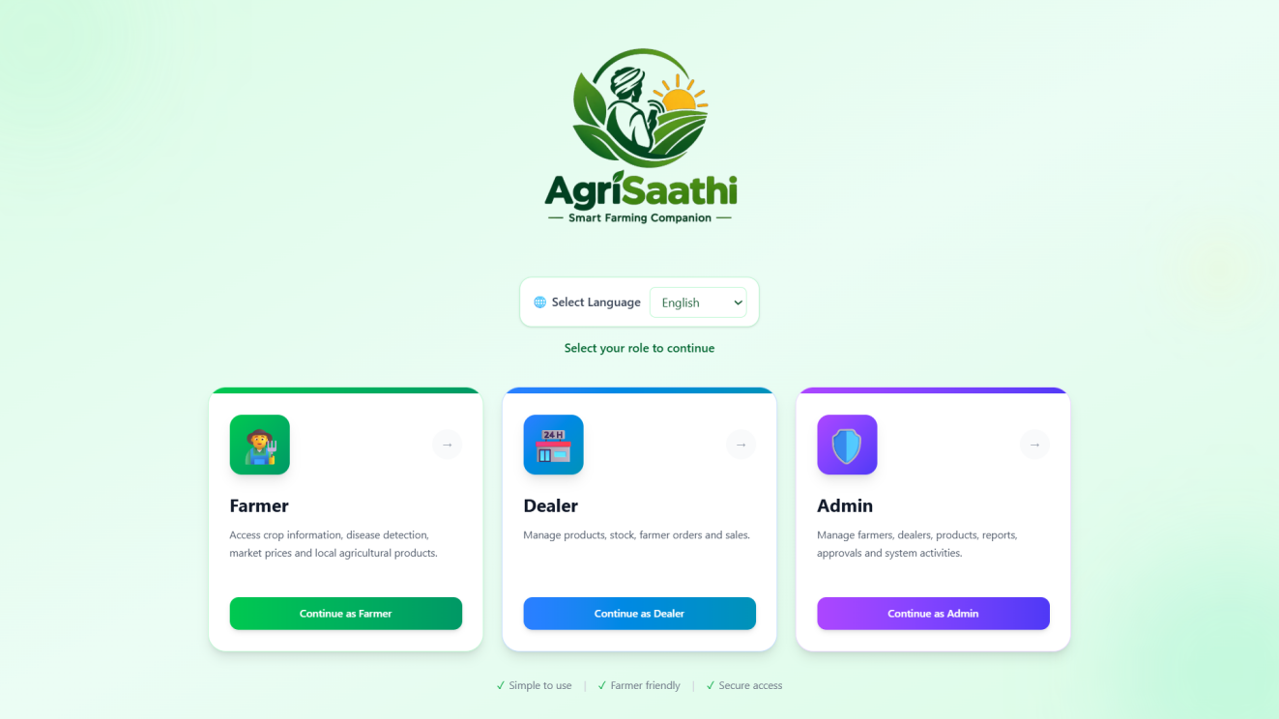
Fig:8.1 Homepage
8.2 Login Page

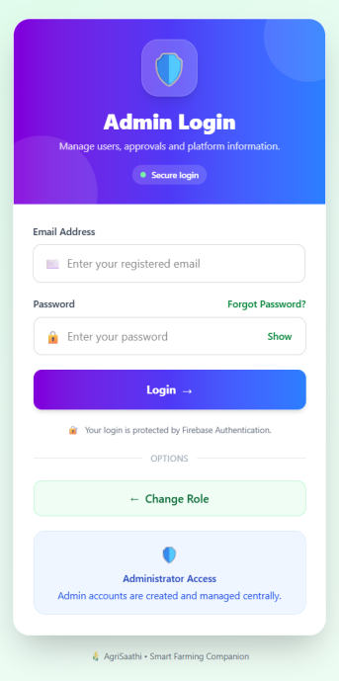
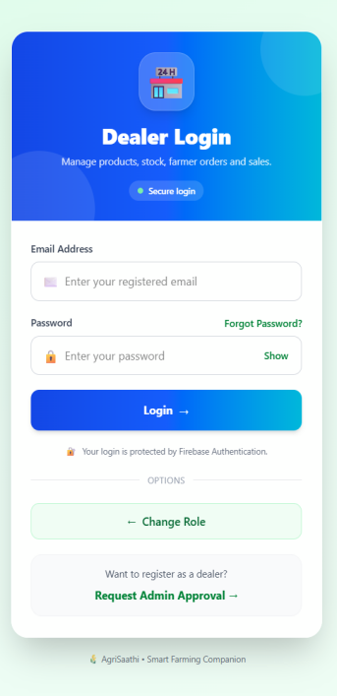
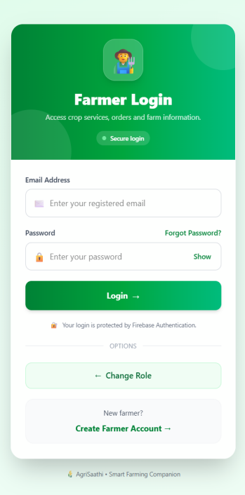
Fig:8. Login pages

8.3 Farmer Dashboard

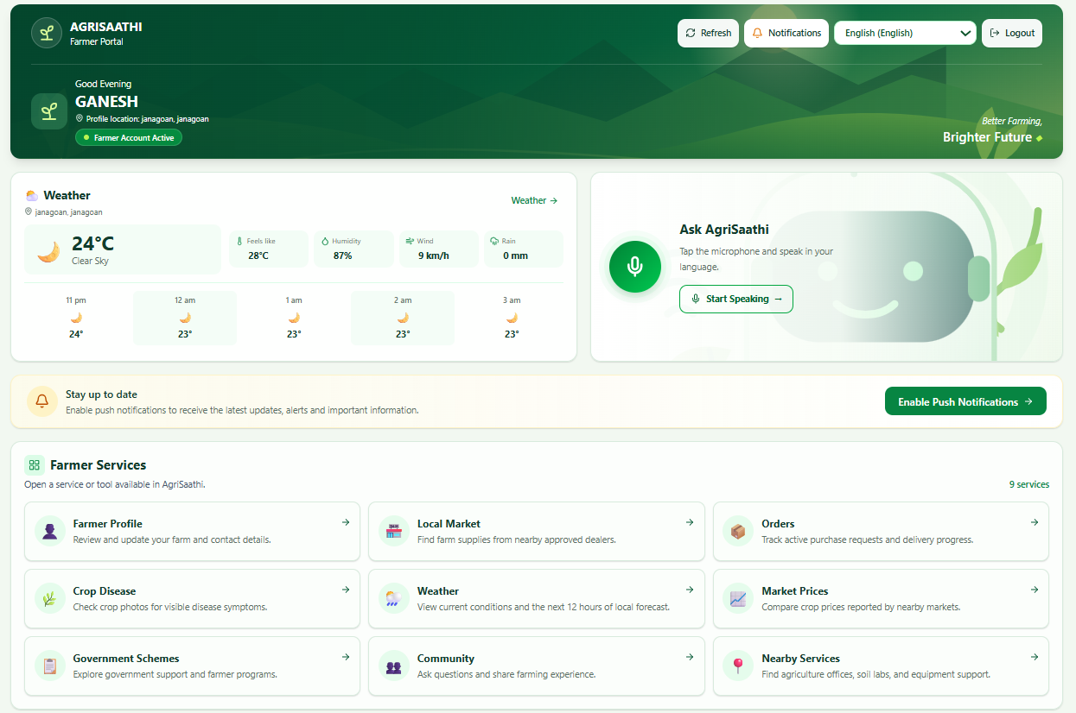
Fig:8.3.Farmer Dashboard

8.3.1Dealer Dashboard

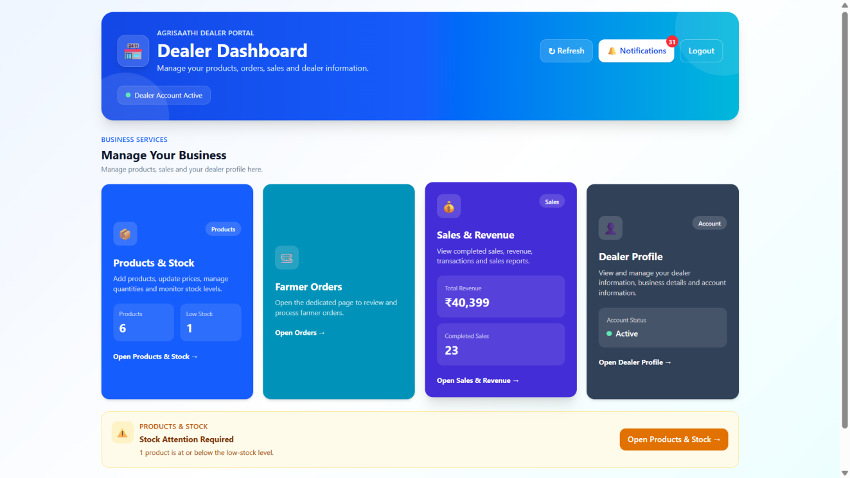
Fig:8.3.Dealer Dashboard

8.3 .2 Admin Dashboard

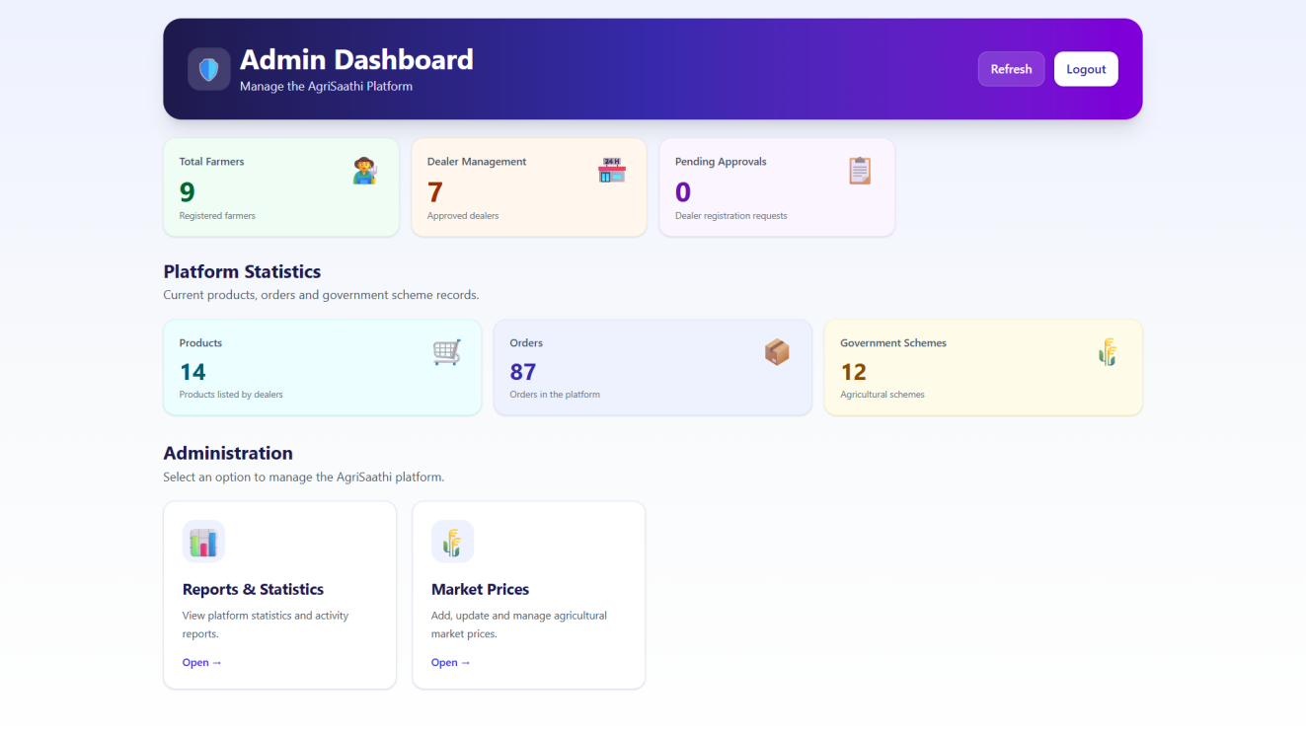
Fig:8.3.2 Admin Dashboard

8.4 Farmer Module Features
8.4.1 Farming Community

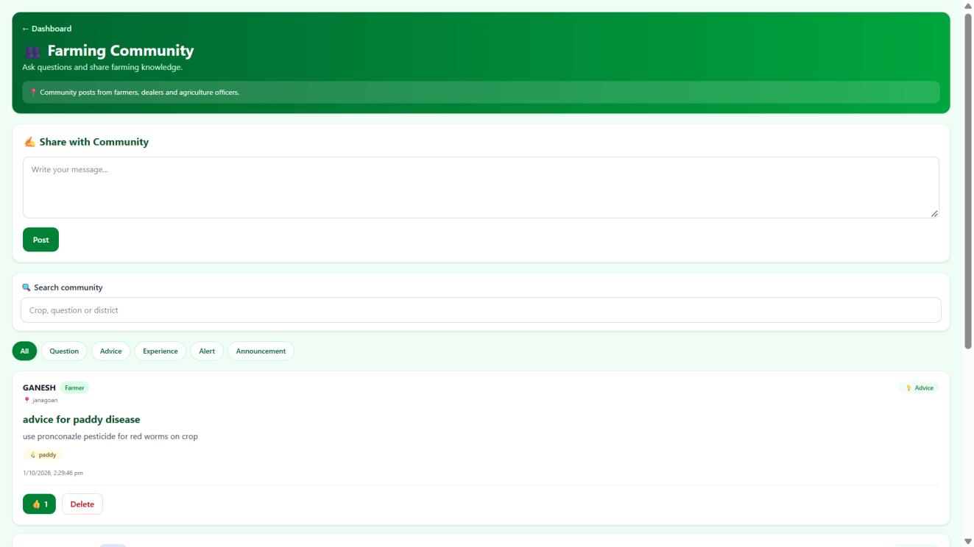

Fig:8.4.1.Farming Community

8.4.2 Local Crop Prices
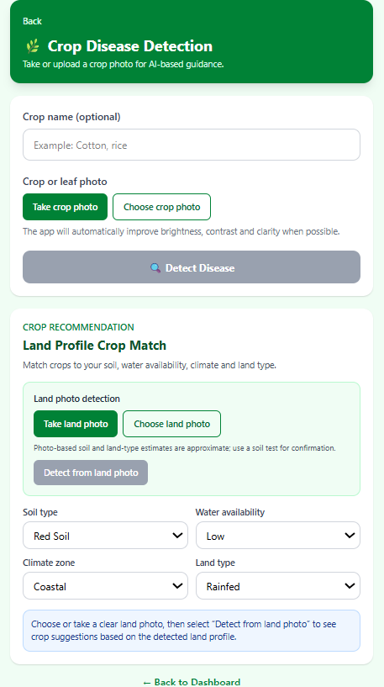
Fig. 8.4.2 Local Crop Prices
8.4.3 Crop Disease Detection
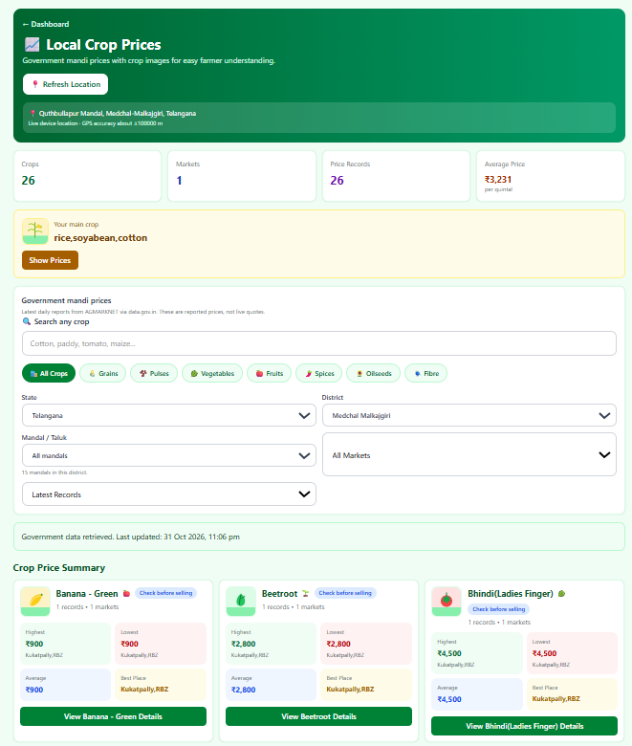
Fig. 8.4.3 Crop Disease Detection

8.4.4 Local Marketplace
8.4.5 Government Schemes
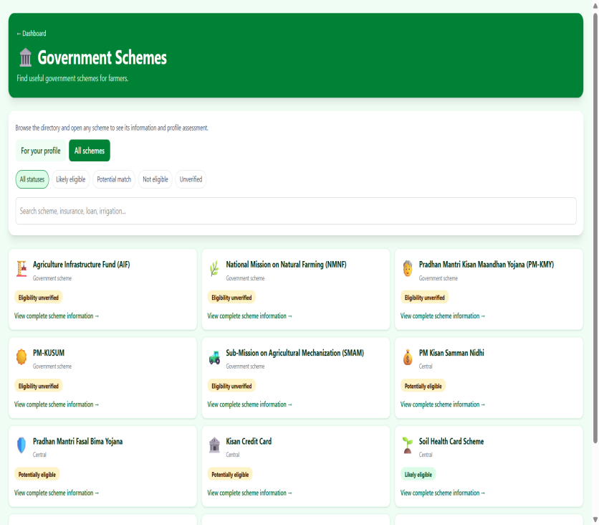
Fig. 8.4.5 Government Schemes
8.4.6 Weather Page
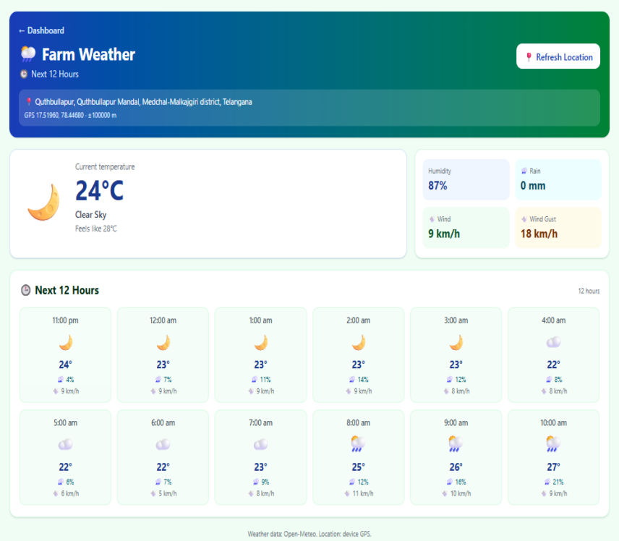
Fig. 8.4.6 Weather Page

8.4.7 My Orders

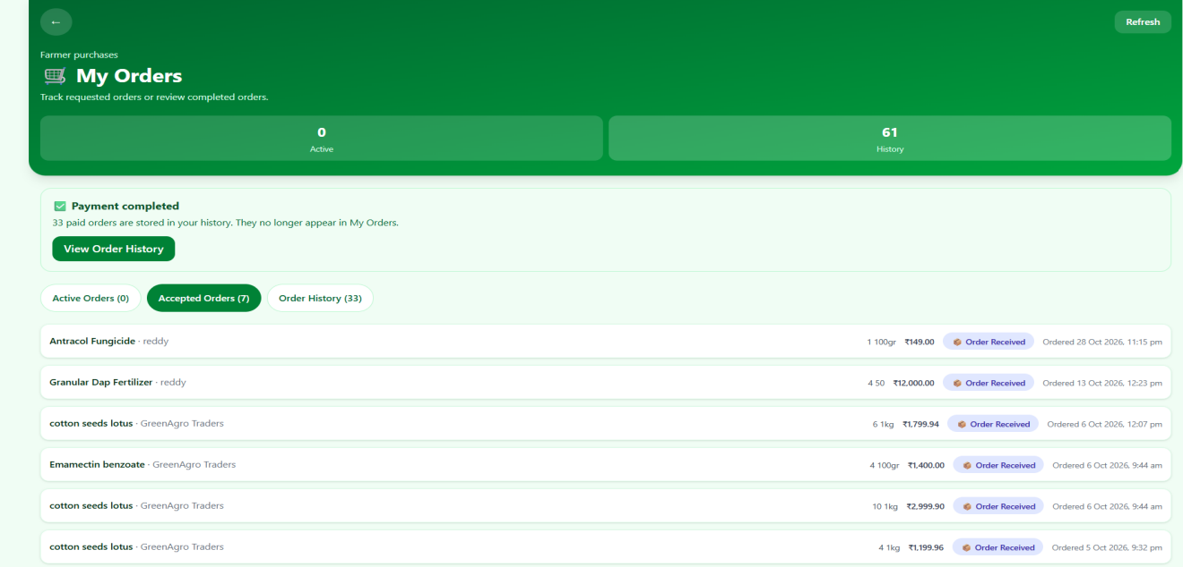

Fig. 8.4.7 My Orders

8.4.8 My Profile

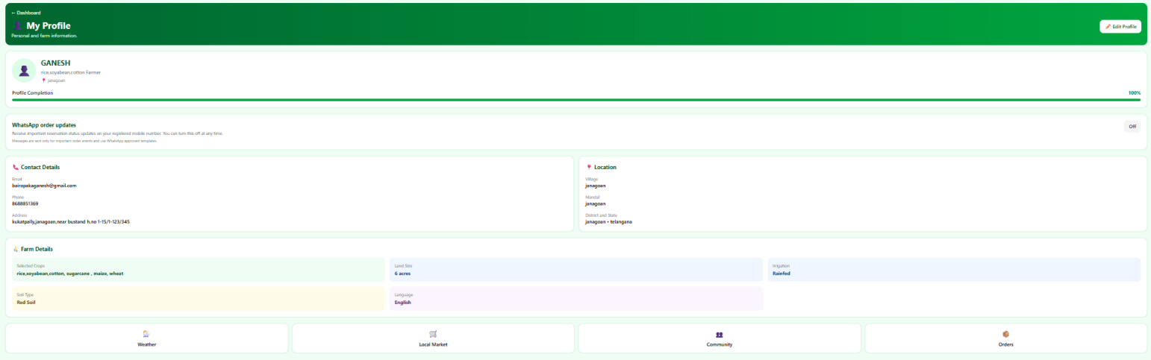

Fig. 8.4.8 My Profile

8.4.9 Notifications

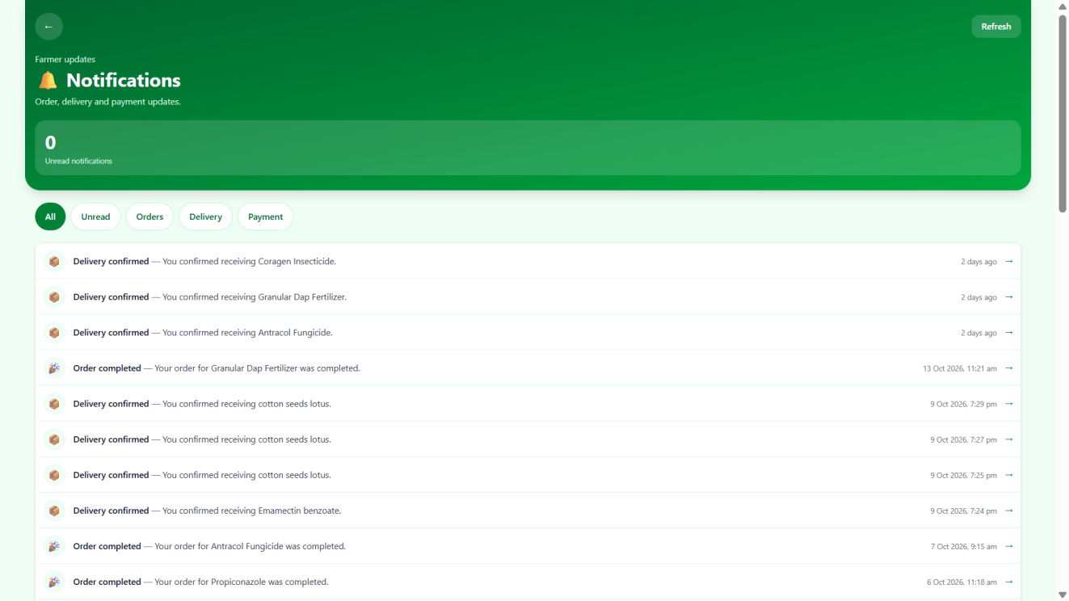
Fig. 8.4.9 Notifications

8.4.10 AgriSaathi Voice Assistant

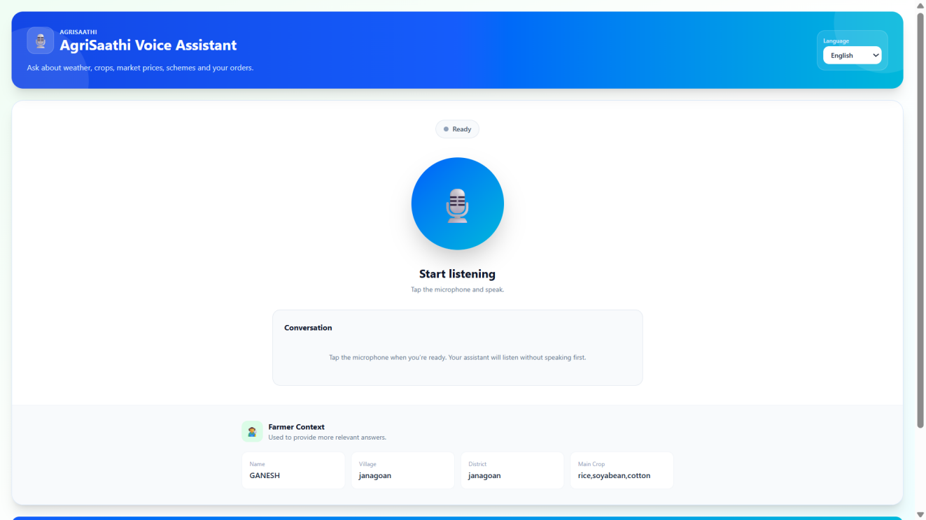

Fig. 8.4.10 AgriSaathi Voice Assistant

8.5Features of Dealer Module

8.5.1 Farmer Orders
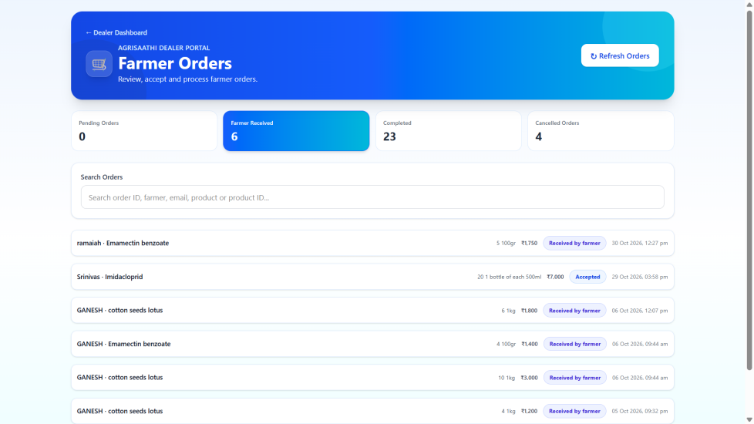
Fig. 8.5.1 Farmer Orders

8.5.2 Sales
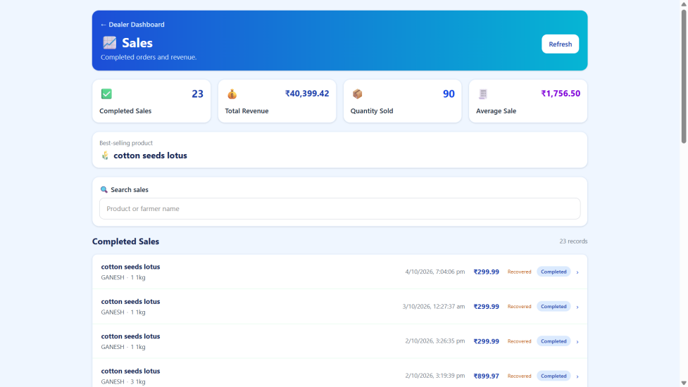
Fig. 8.5.2 Sales

8.5.3 Products&Stocks
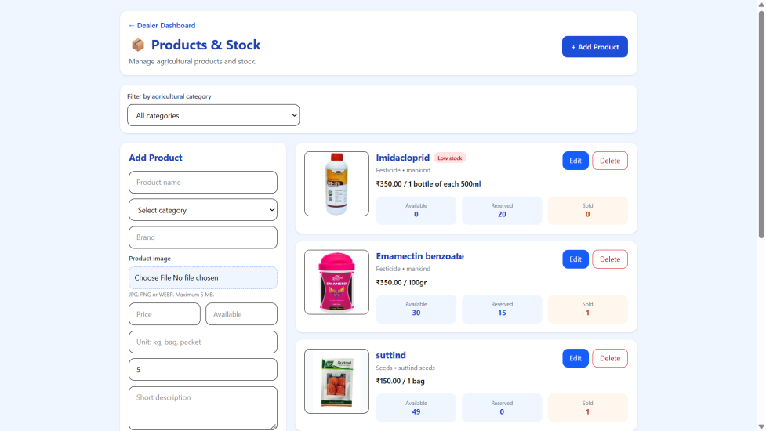
Fig. 8.5.3 Products and Stock

8.5.4 Dealer Profile
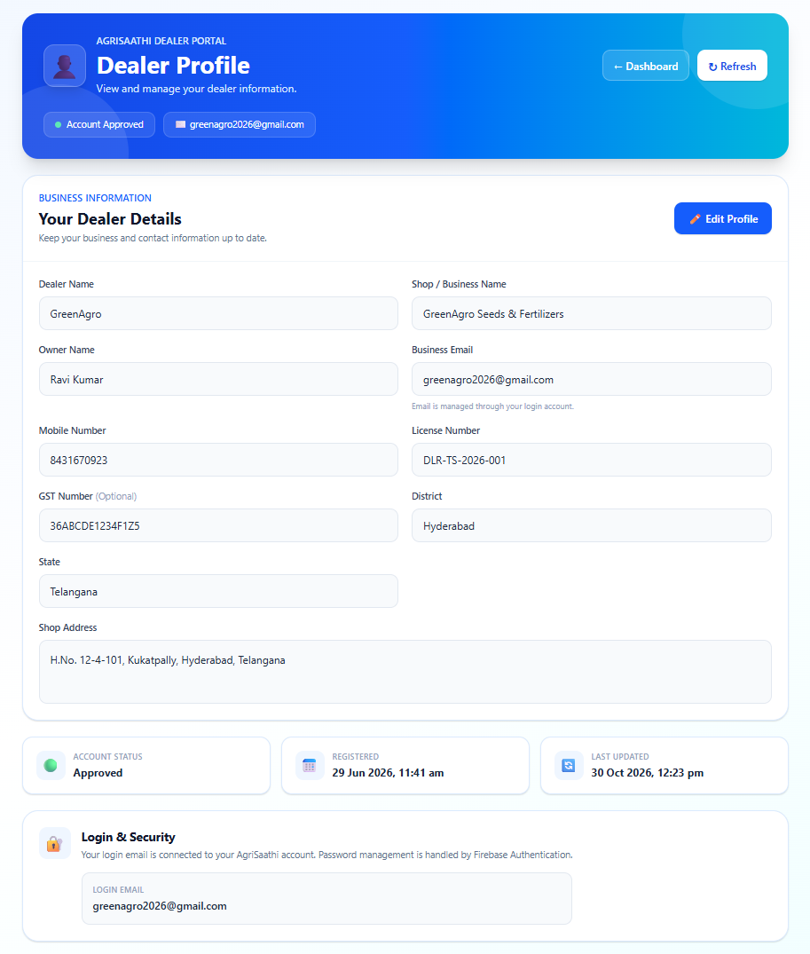
Fig. 8.5.4 Dealer Profile

8.5.5 Low Stock Items
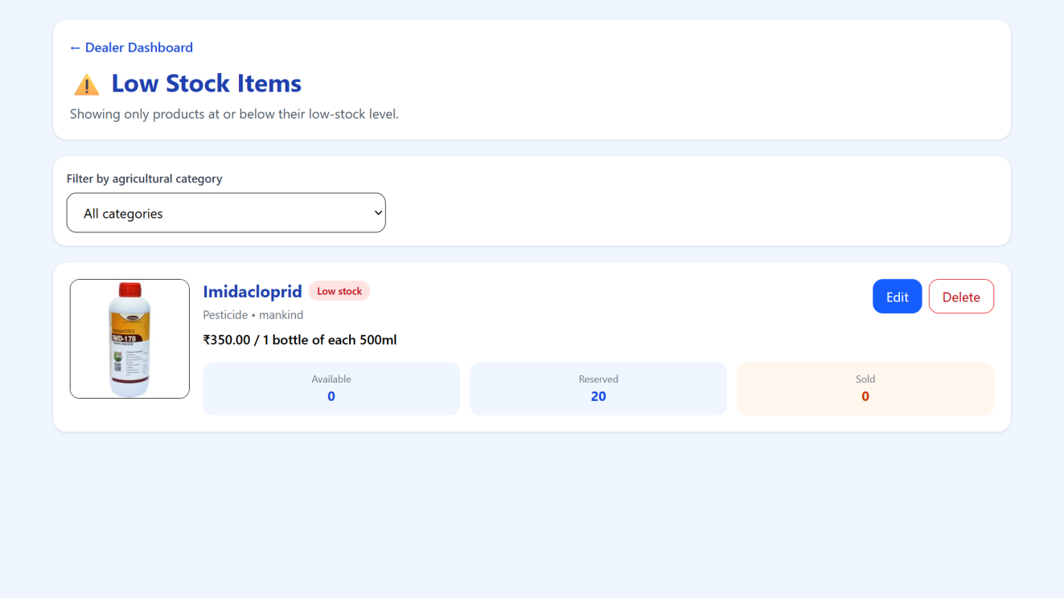
Fig. 8.5.5 Low Stock Items

8.6 Features of Admin Module

8.6.1 Order Management
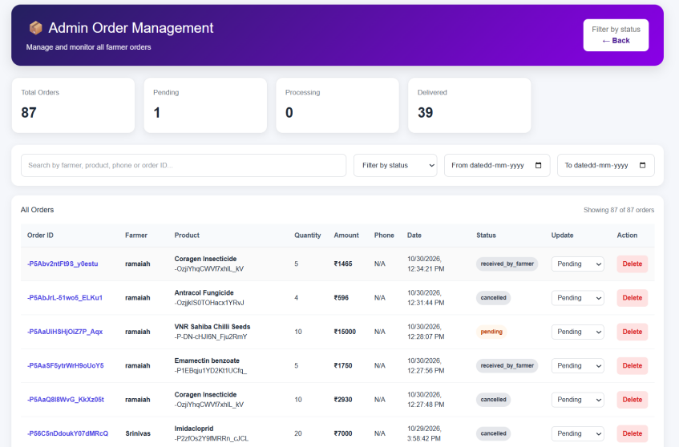
Fig. 8.6.1 Order Management
8.6.2 Product Management
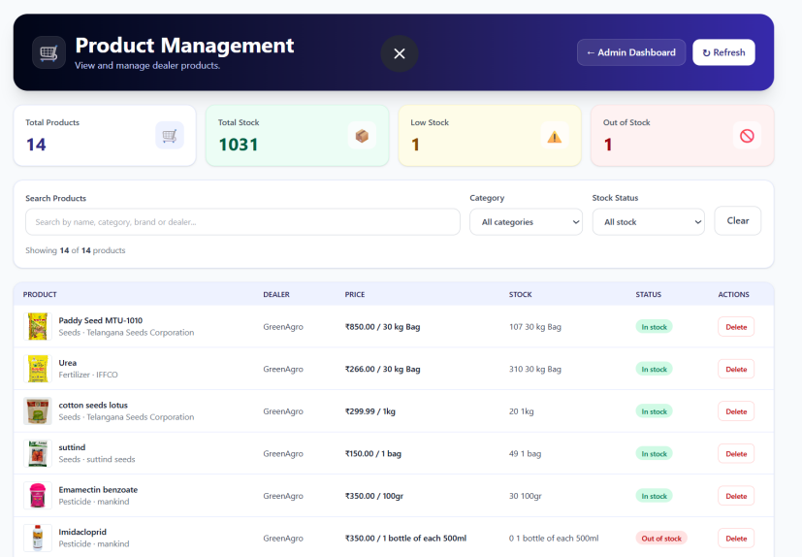
Fig. 8.6.2 Product Management

8.6.3 Dealer Management
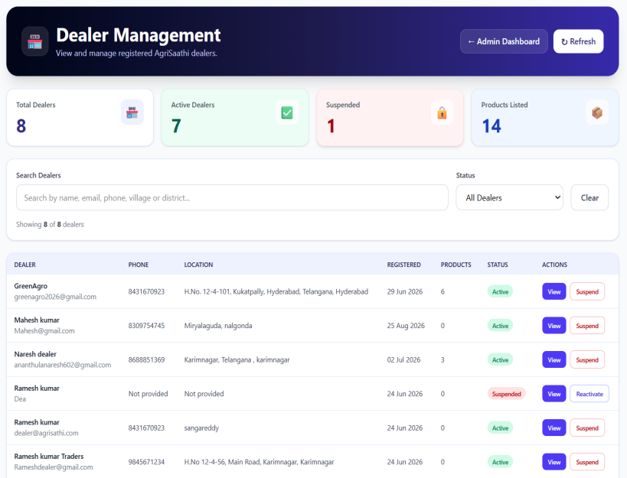
Fig. 8.6.3 Dealer Management
8.6.4 Government Schemes
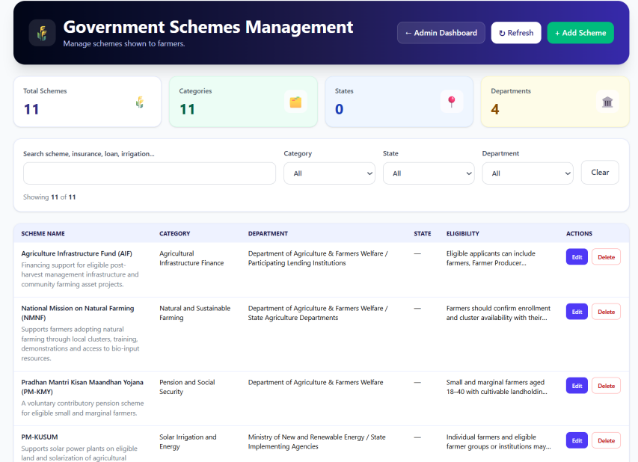
Fig. 8.6.4 Government Schemes

8.6.5 Dealer Requests
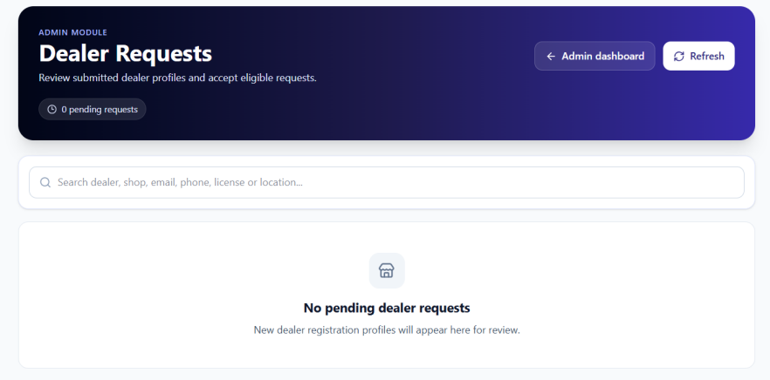
Fig. 8.6.5 Dealer Requests

8.6.6 Market Price
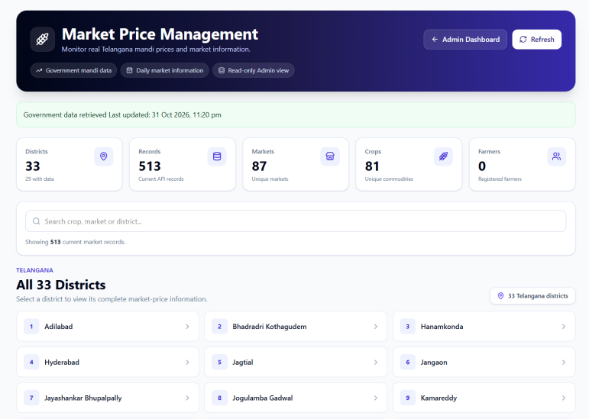
Fig. 8.6.6 Market Price

8.6.7 Reports and Statistics
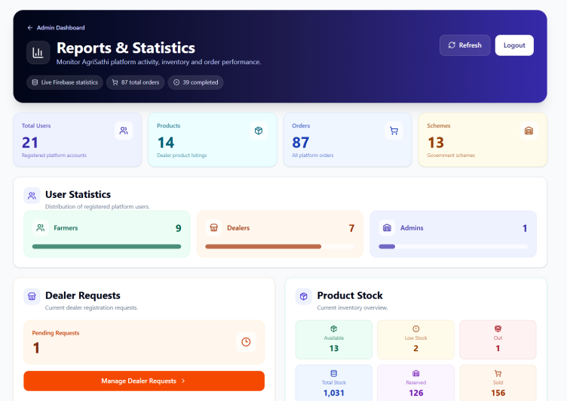
Fig. 8.6.7 Reports and Statistics

Fig:8.6.6 Reports&Satistics

IX.TESTING

\

CHAPTER 9 - TESTING

Software testing is an important phase of the Software Development Life Cycle (SDLC). It helps identify errors and verify that AgriSaathi functions according to its requirements.
Testing is performed on the farmer and dealer features, including account access, crop disease detection, market information, government schemes, product orders, and administration. It also checks whether information is transferred correctly between the connected modules.

9.1 Unit Testing
Unit testing involves testing individual modules of AgriSaathi separately to verify that each module performs its intended function.
Purpose of Unit Testing
To identify errors in individual modules.
To verify that each function works correctly.
To ensure that valid information is accepted and invalid information is handled appropriately.
Modules Tested
1. Login Validation
Checks whether users can log in with valid credentials and whether incorrect credentials are handled appropriately.
Fig. 9.1: Login Validation Testing
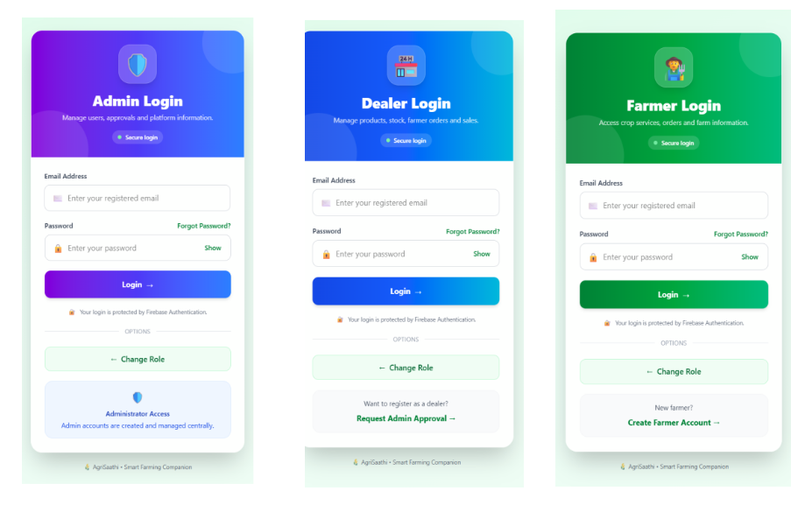

2. Crop Disease Detection
Checks whether the crop disease module accepts an image and displays the analysis result.

Fig. 9.2: Crop Disease Detection Testing
3. Marketplace Product Selection
Checks whether the selected product’s details, price, and available quantity are displayed correctly.
Fig. 9.3: Marketplace Product Testing
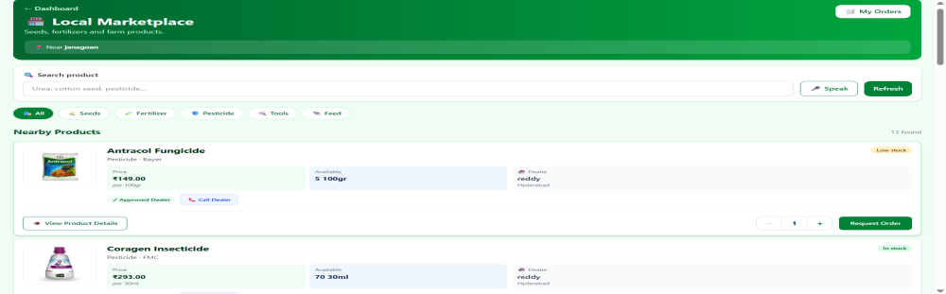

Expected Outcomes
Valid login credentials allow access to the application, while invalid credentials are handled appropriately.
The crop disease module displays an analysis result for the submitted image.
The marketplace displays the selected product’s information and available quantity.
Unit testing helps verify that individual modules work correctly before they are used together.
9.2 Integration Testing
Integration testing verifies that connected AgriSaathi modules work together correctly and exchange information as expected.
Modules Integrated and Tested
1. Dealer Products and Farmer Marketplace
Checks whether products managed by a dealer appear in the farmer marketplace with the correct product details.

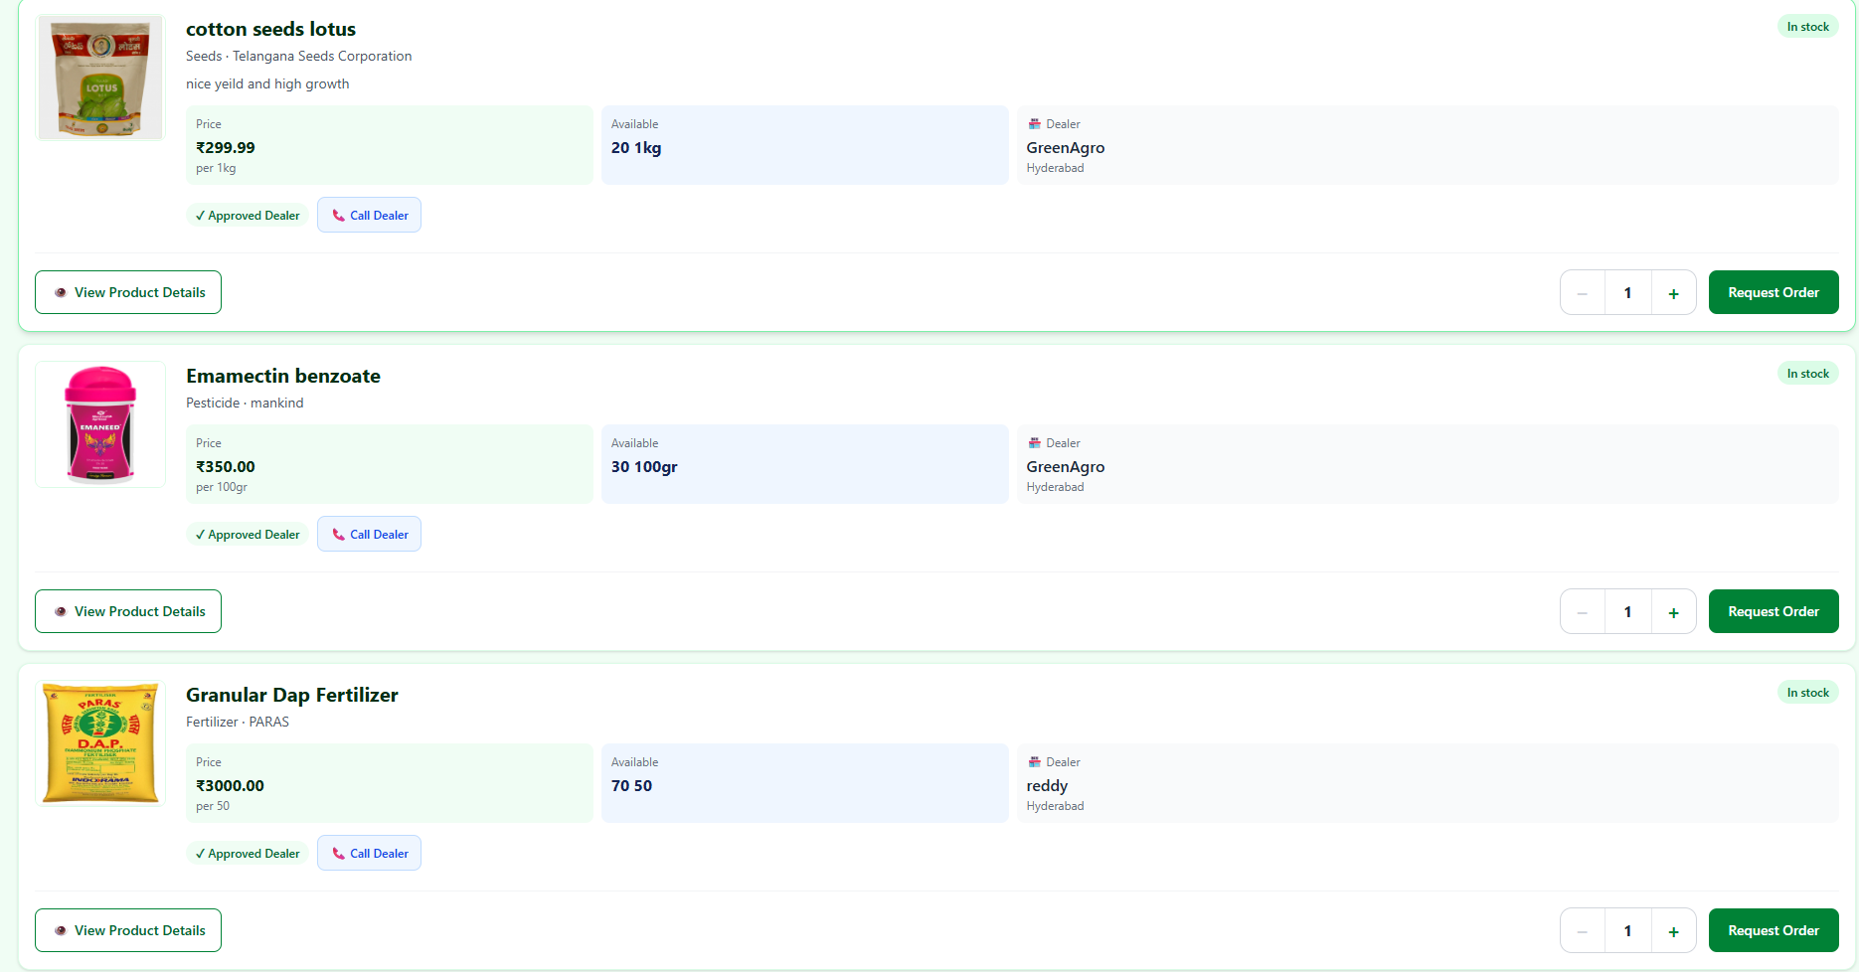
Fig. 9.4: Dealer Products and Farmer Marketplace Integration Testing
2. Farmer Orders and Dealer Orders
Checks whether an order placed by a farmer appears in the dealer’s order management section with the relevant order details.

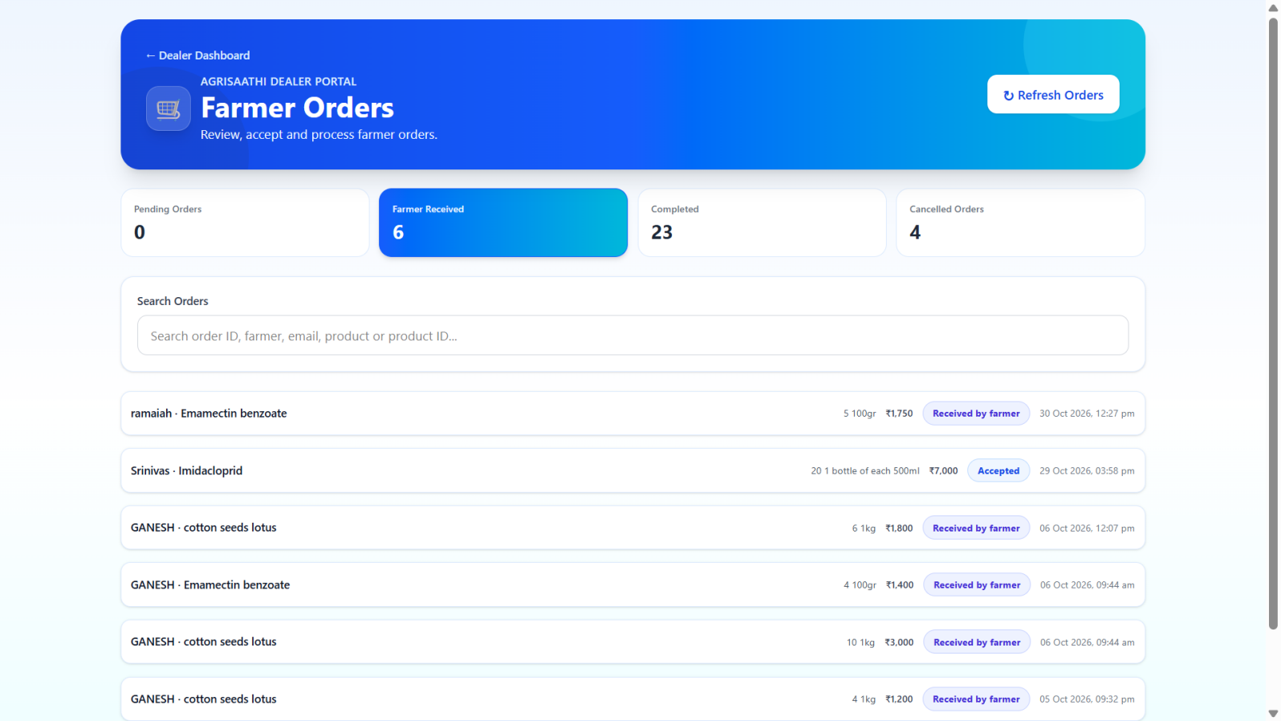
Fig. 9.5: Farmer and Dealer Order Integration Testing
3. Farmer Profile and Government Schemes
Checks whether the government schemes section uses the farmer’s available information to display relevant scheme details.

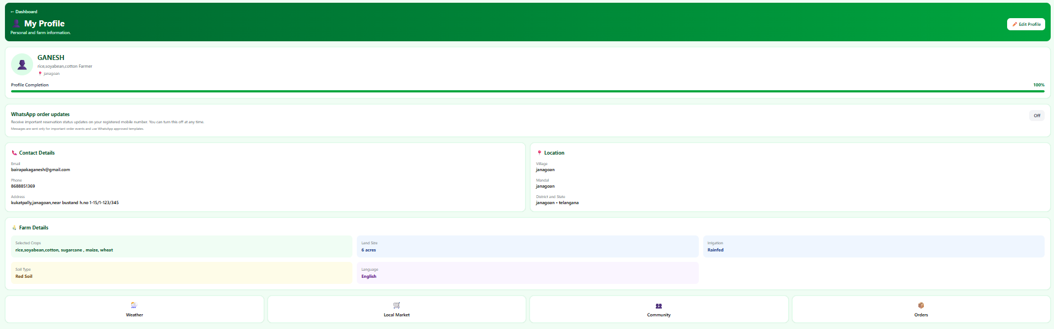

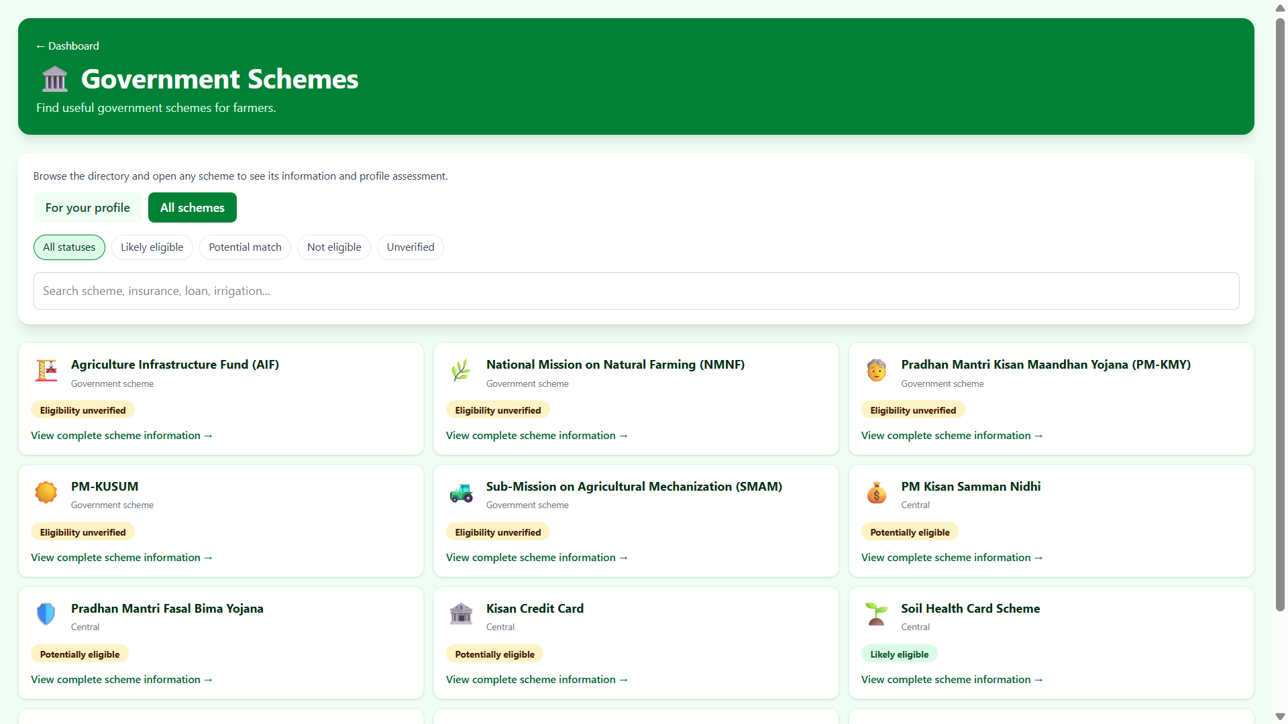
Fig. 9.6: Farmer Profile and Government Schemes Integration Testing
Expected Outcomes
Dealer products are displayed in the farmer marketplace.
Farmer orders are available in the dealer’s order section.
Relevant scheme information is displayed using the farmer’s available details.
Integration testing helps verify information flow between connected modules.
9.3 System Testing
System testing evaluates AgriSaathi as a complete application. It checks the main workflow and verifies that its features work together as expected.
System Testing Process
1. User Access
The registration and login process is checked using valid and invalid user details.

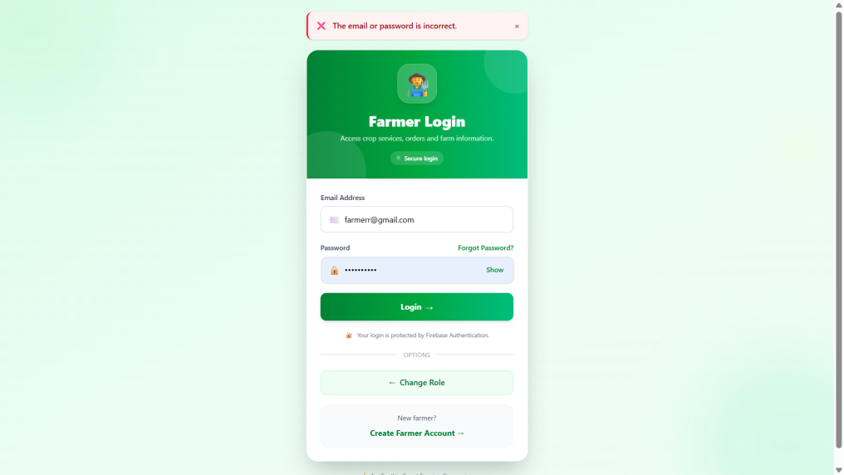

Fig. 9.7: User Access System Testing
2. Farming Information
Weather, market prices, crop disease detection, and government scheme sections are checked to ensure that their information is displayed appropriately.
Fig. 9.8: Farming Information System Testing
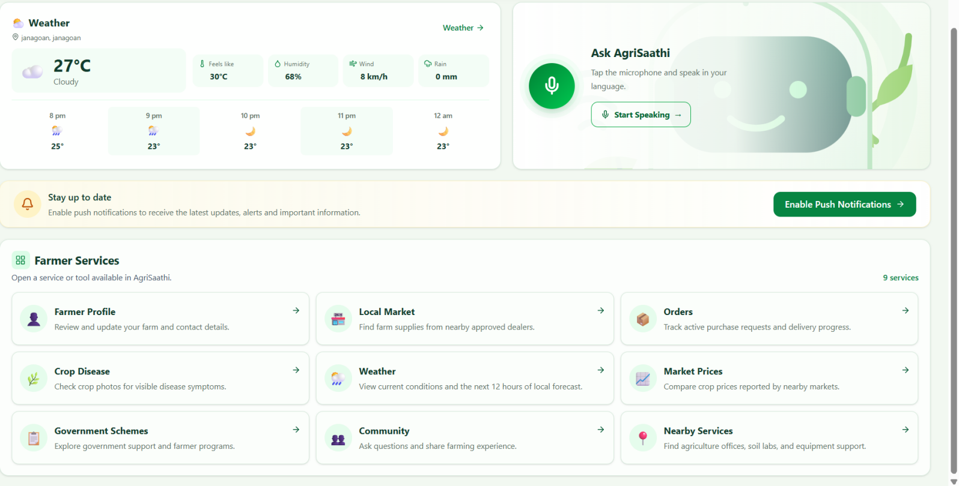
4. Administration
Administrative features are checked to verify that relevant product, user, and order information is displayed in the management sections.

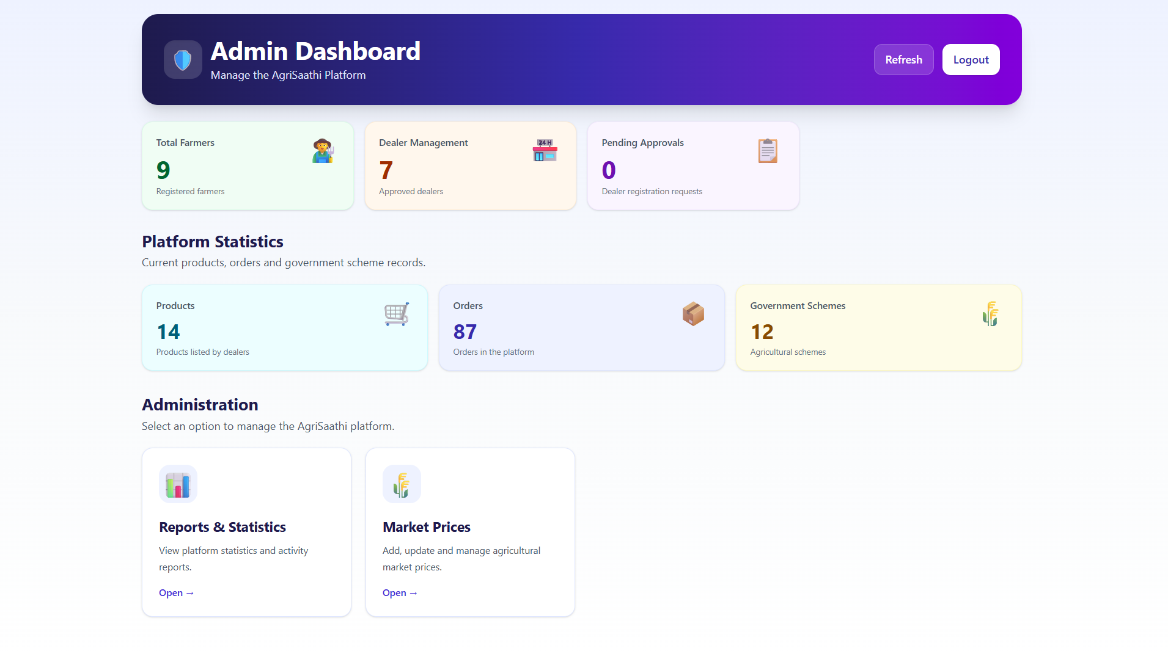
Fig. 9.10: Administration System Testing
Expected Results
Users can access the application using valid account details.
The farming information sections display the relevant information.
Product and order information is available to the appropriate users.
Administrative information is displayed in the relevant management sections.
System Testing Results
The actual results should be recorded after performing these tests on the running application.
9.4 Conclusion
Testing helps verify that AgriSaathi’s modules work individually and together. Unit testing checks individual features, integration testing checks information flow between connected modules, and system testing checks the application’s overall workflow. The actual test results should be recorded after testing the running application.

X.CONCLUSION

CHAPTER 10 - CONCLUSION
CHAPTER 10 - CONCLUSION
10.1 Conclusion
AgriSaathi is a web-based application with Android support that brings important agricultural information and services together in one role-based platform. It is designed to make these services easier for farmers to find and use, while also supporting the daily work of dealers and administrators.
Farmers can maintain their profile and access location-based weather information and reported market prices. The application also provides crop and land support, image-based crop disease analysis, government scheme information, nearby agricultural services, a farming community, a multilingual voice assistant, and a marketplace for agricultural products. Together, these features help farmers access relevant information and connect with services and products through one application.
The dealer module supports product listings, stock and sales management, and the handling of farmer orders. The administrator module provides tools for managing users, dealer requests, products, orders, schemes, market information, and reports. Linking these role-based workflows helps organize interactions between farmers, dealers, and administrators.
AgriSaathi uses React and Vite for the application interface, Firebase for authentication and data services, Capacitor for Android support, and a Python service for image processing, alongside configured external information services. Its usefulness depends on internet access, location permissions, accurate profile information, and correct service configuration. Overall, the project demonstrates a practical digital foundation for bringing farming information and farm-related workflows into one place, with room to improve through farmer feedback and broader regional coverage.
10.2 Future Scope
AgriSaathi can be improved further to provide more useful and localized services to farmers.
Possible Improvements
1. Improved Crop Disease Analysis
The crop disease feature can be enhanced with additional crop images and disease information to support more accurate analysis.
2. Localized Farming Information
Weather, market prices, and agricultural information can be expanded for more regions and local languages.
3. Offline Access
Selected farming information can be made available offline for users with limited or unreliable internet access.
4. Smart Agriculture Integration
Future versions can connect with agricultural sensors to provide information about soil moisture, temperature, and other field conditions.
5. Advanced Reports
Additional reports can help administrators and dealers review product activity, orders, and marketplace information.
Long-Term Vision
In the future, AgriSaathi can develop into a broader digital farming platform that provides localized agricultural information, improved crop analysis, and tools to support farm management and connections between farmers and agricultural service providers.

REFERENCES

REFERENCES
- Pressman, R. S., Software Engineering: A Practitioner’s Approach, McGraw Hill Education.
- Sommerville, I., Software Engineering, Pearson Education.
- React, React Documentation. Available at: https://react.dev/learn
- Vite, Vite Documentation. Available at: https://vite.dev/guide/
- Firebase, Firebase Documentation. Available at: https://firebase.google.com/docs
- Capacitor, Capacitor Documentation. Available at: https://capacitorjs.com/docs
- Tailwind CSS, Tailwind CSS Documentation. Available at: https://tailwindcss.com/docs
- MDN Web Docs, JavaScript Guide. Available at: https://developer.mozilla.org/en-US/docs/Web/JavaScript/Guide
- Lucide, Lucide for React Documentation. Available at: https://lucide.dev/guide/react/
- OpenAI, ChatGPT, used as an assistance tool for project documentation and language refinement. Available at: https://chatgpt.com

