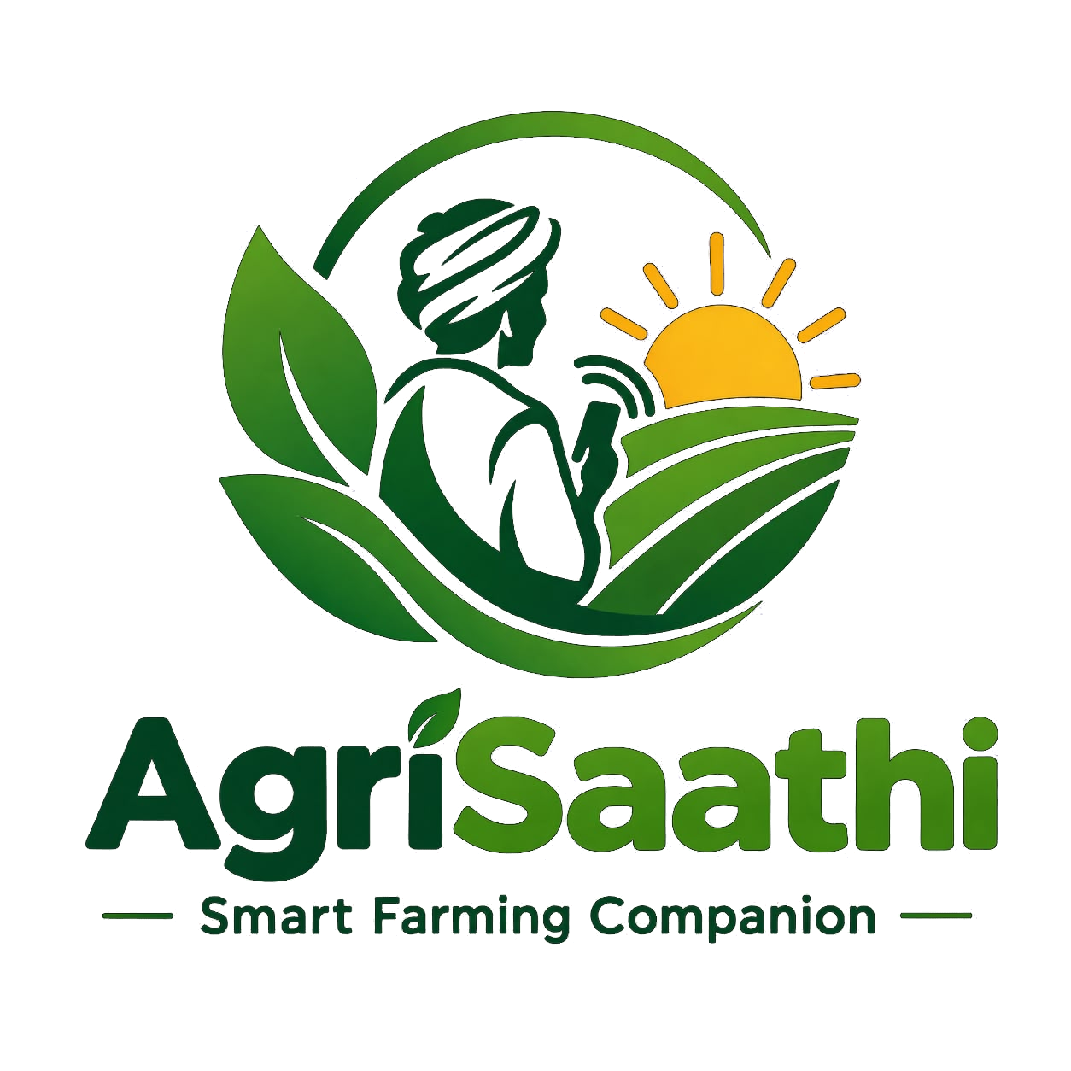

AGRISAATHI SMART FARMING COMPANION
PROJECT REPORT
A multilingual digital platform for farm information, crop support, markets and agricultural services

Submitted in partial fulfillment of the requirements for
[DEGREE / DIPLOMA / COURSE NAME]

PROJECT DETAILS | INFORMATION
Submitted by | [Student name(s) and roll number(s)]
Project guide | [Guide name and designation]
Department | [Department name]
Institution | [College / institution name]
Academic year | [Academic year]

[INSTITUTION NAME]

CERTIFICATE
This is to certify that the project report entitled “AgriSaathi Smart Farming Companion” is a record of project work carried out by [student name(s) and roll number(s)] under the guidance of [guide name] in the Department of [department], [institution], during [academic year].
The report describes the application implementation reviewed for this project and is submitted in partial fulfillment of the requirements for [degree / diploma / course].

PROJECT GUIDE | HEAD OF DEPARTMENT | PRINCIPAL
Signature: ______________ | Signature: ______________ | Signature: ______________
Name: [Guide name] | Name: [HOD name] | Name: [Principal name]

External Examiner: ______________________________ Date: __________________

DECLARATION
We declare that this report describes the AgriSaathi project developed by our project team. Implementation details are based on the source code and configuration reviewed for the project. Student, institutional, date, screenshot, and test-record details must be completed and verified by the project team before final submission.

Student signature(s): ______________________________________________

ACKNOWLEDGEMENT
We express our sincere gratitude to [principal name], [head of department name], and our project guide [guide name] for their support and guidance during the development of AgriSaathi. We thank the faculty and staff of [department / institution] for providing resources and feedback. We also thank our families and colleagues for their encouragement. External platform services used by the application are acknowledged in the references section.

ABSTRACT
AgriSaathi Smart Farming Companion is a role-based web and Android application intended to make selected agricultural information and services easier to reach. It supports farmer, dealer, and administrator workflows. Farmer-facing features include profile onboarding, weather forecasts, reported market prices, crop and land guidance, crop-image analysis, government-scheme information, a community area, nearby agricultural services, a multilingual voice assistant, and access to dealer products and orders. Dealers can manage product listings, stock, reservations, sales, and notifications. Administrative screens support user, dealer, product, order, scheme, market-data, and reporting tasks.
The client is built with React and Vite and uses Firebase Authentication, Realtime Database, Storage, Cloud Functions, Firestore, and Firebase Cloud Messaging. Capacitor packages the web client for Android. Weather information is requested from Open-Meteo; reported market-price data is fetched from AGMARKNET through data.gov.in. Gemini services support voice responses and image-based land or crop analysis. A separate FastAPI service provides image enhancement using OpenCV.
The source also contains incomplete areas. The irrigation screen and Python model modules are empty, so they are not described as implemented features. The report records the current structure, workflows, data organization, feasibility, and a verification plan without asserting test outcomes that have not been recorded.
Keywords: digital agriculture, farmer services, React, Firebase, market information, multilingual interface, Android

CONTENTS
1. Introduction
2. Software and Hardware Requirements
3. Technologies and Service Architecture
4. System Overview and Features
5. System Design
6. Feasibility Study
7. Implementation and Code Overview
8. Interface and Screen Inventory
9. Testing Plan
10. Conclusion and Future Scope
Appendix A. Selected Code Excerpts
Appendix B. Logical Data Map
References

LIST OF FIGURES
- 5.1 Three-layer application and service architecture
- 5.2 Role-based user workflow
- 5.3 Logical Firebase data map

LIST OF TABLES
- 2.1 Software environment
- 2.2 Development resources
- 4.1 User roles
- 5.1 Logical data objects
- 7.1 Project structure
- 8.1 Screen inventory
- 9.1 Verification scenarios

CHAPTER 1

INTRODUCTION

1.1 Background
Farmers often need to consult several sources for weather conditions, reported market prices, crop-health guidance, government-program information, input suppliers, and nearby agricultural services. AgriSaathi brings selected information and transaction workflows into one digital companion, with language selection and voice interaction intended to improve access for users who prefer local-language support.

1.2 Problem Statement
Agricultural information and services can be spread across websites, dealers, and local contacts. Farmers may switch channels to check weather, compare mandi reports, identify crop symptoms, find suppliers, and follow an order. Dealers and administrators also need separate workflows for products, reservations, farmer records, and scheme information. AgriSaathi addresses this coordination problem through one role-based application and shared data services.

1.3 Existing Approach
A fragmented approach relies on individual information sources and manual communication. It can slow information retrieval and leave farm details, order status, and service discovery disconnected. The application does not replace official agricultural advice or government portals; it provides access and navigation support around selected services.

1.4 Proposed System
AgriSaathi provides farmer, dealer, and administrator roles. Firebase manages identity and application data. External integrations provide forecast, market, geolocation, geocoding, AI-assisted responses, and optional WhatsApp updates. Capacitor packages the web client for Android. Feature availability depends on configured credentials, Firebase rules and deployment, network access, device permissions, and external service availability.

1.5 Objectives
- Provide a unified digital entry point for selected farmer information and services.
- Offer profile-aware weather, crop, scheme, and market workflows.
- Support voice interaction and interface text in multiple Indian languages.
- Connect farmers and dealers through product listings and order workflows.
- Provide administrators with user, dealer, product, order, scheme, and reporting tools.
- Package the client for Android while retaining browser use.
- Document implemented features separately from empty or planned modules.

1.6 Scope and Limitations
The reviewed code includes web and Android workflows and initializes Firebase Authentication, Realtime Database, Storage, and Functions. Some AI features call Gemini from the client using an environment key; image enhancement is a separate FastAPI service. The source tree does not include Firebase security rules, a populated database export, deployment records, or test evidence. The irrigation page and standalone Python model files are empty.

CHAPTER 2

SOFTWARE AND HARDWARE REQUIREMENTS

2.1 Software Environment
Component | Observed technology | Purpose
Frontend | React 19, React DOM, React Router 7 | Interface and client-side routes
Build | Vite 8, JavaScript ES modules | Development server and production bundling
Styling | Tailwind CSS 4 and project CSS | Responsive layout and visual styling
Icons | Lucide React | Interface icon components
Firebase | Firebase JS SDK 12 | Auth, Realtime Database, Storage, Functions, Messaging
Android | Capacitor 8 and Android Gradle project | Native Android application wrapper
Cloud functions | Node.js 20, Firebase Admin and Functions SDK | Market API and order status triggers
Image service | Python, FastAPI, NumPy, OpenCV | Optional image-enhancement endpoint

2.2 Development Resources
The project does not specify an official minimum computer specification. Development requires a computer able to run Node.js/npm and the source project. Android builds require Android Studio and Android SDK; README.md names SDK Platform 36. Running image enhancement requires the Python packages listed in agrisathi-python/requirements.txt. A modern Android device with precise-location support is needed to verify native GPS behavior. Internet access is required for Firebase and external services.

2.3 Configuration Requirements
- Firebase project configuration is initialized in src/firebase.js.
- Market prices require DATA_GOV_API_KEY as a Firebase Functions secret for Android and VITE_DATA_GOV_API_KEY for the web proxy, as documented in README.md.
- Voice and image-analysis features use the Gemini environment key referenced by client code.
- WhatsApp updates require an approved template, sender configuration, Graph API version, database URL, and WHATSAPP_ACCESS_TOKEN secret.
- Android location requires native permission; the app requests a high-accuracy device fix and does not substitute IP-based location.
- Push notification registration requires HTTPS, supported browser messaging, a service worker, and user permission.

CHAPTER 3

TECHNOLOGIES AND SERVICE ARCHITECTURE

3.1 Client and Service Model
React renders the interface and routes. Firebase provides identity, database, media, and callable services. Selected external providers are called by the client or by Cloud Functions. Image enhancement is a separately run FastAPI application. Capacitor supplies the native Android bridge used for high-accuracy geolocation.

3.2 Frontend Technologies
React components organize the interface by role and feature. React Router maps URL paths to pages; most screens load lazily with React.lazy and Suspense. Tailwind utility classes and local CSS define responsive styling. The language module stores the preferred language and supplies translated interface strings.

3.3 Backend and Data Technologies
The Firebase JavaScript SDK connects the client to Authentication, Realtime Database, Storage, Cloud Functions, and Cloud Messaging. Storage is initialized in src/firebase.js; no upload call was found in the inspected client source. Cloud Functions use Node.js 20 and Firebase Admin. Application records are organized as Realtime Database paths rather than a relational SQL schema. Firestore stores WhatsApp delivery event claims and statuses.

3.4 External Services
Service | Role | Integration
Open-Meteo | Current and hourly forecast | Client request with coordinates
AGMARKNET / data.gov.in | Reported daily market records | Callable function on Android; Vite proxy on web
Google Gemini | Voice responses, land-photo and crop-photo analysis | Client request; environment key required
OpenStreetMap Overpass | Nearby agriculture-related places | Client query around location
BigDataCloud and Nominatim | Reverse geocoding | Client-side location lookup
WhatsApp Business Cloud API | Opt-in order status messages | Realtime Database triggers call server function

3.5 Android Packaging
Capacitor identifies the application as com.agrisathi.app, names it Agrisathi, and uses the Vite dist directory. README.md describes npm run android:sync and npm run android:open. Native device location uses @capacitor/geolocation.

CHAPTER 4

SYSTEM OVERVIEW AND FEATURES

4.1 User Roles
Role | Main capabilities observed
Farmer | Profile onboarding; weather; market prices; voice; crop/land tools; schemes; community; nearby services; dealer products; orders; notifications
Dealer | Registration request; profile; product catalogue; stock; incoming orders; sales; notifications
Administrator | Farmer and dealer management; dealer requests; products; orders; schemes; market-price data; reports and statistics

4.2 Farmer Features
- Onboarding records contact and location, crops, land size and unit, soil distribution, irrigation type, cultivation status, and preferred language.
- Weather uses device coordinates and presents current conditions and an hourly view; the dashboard shows a summary.
- Market prices present AGMARKNET reports with state and district selection, pagination, caching, and missing-service messaging. The code labels these reported prices, not live quotes.
- Crop and land tools provide profile-based crop suggestions and visual land-photo assessment; crop photos can be analyzed for likely disease and general next steps.
- Nearby Services searches OpenStreetMap data for agricultural services within a 25 km radius.
- Government schemes combine a local directory with Firebase-managed data and profile-based potential-eligibility explanations.
- Community posts are read from Realtime Database and can be filtered by category and search text.
- Farmers can browse dealer products, reserve quantities, follow orders, and receive in-app notifications. Opt-in WhatsApp updates depend on server setup.
- The voice assistant combines browser speech recognition, local commands, speech output, conversational context, and a Gemini-backed response path.

4.3 Dealer and Administrator Features
Dealer pages cover product listings and stock, order acceptance and status updates, sales information, profile settings, and notifications. Farmer reservations are written under dealerOrders. Administrative screens manage farmer status, dealer requests, dealer details, products, orders, government schemes, market-price data, and summary reports.

4.4 Benefits
- Centralizes several farmer workflows in one interface.
- Provides language selection and voice interaction options.
- Supports location-aware weather and service searches.
- Connects farmers with dealer stock and reservation workflows.
- Gives administrators tools for multiple operational modules.
- Uses server functions for selected third-party operations that require server-held credentials.

4.5 Feature Boundaries
src/modules/irrigation/IrrigationPage.jsx and Python files under agrisathi-python/models are empty in the reviewed copy. They are not described as functional irrigation or machine-learning features. Crop suggestions are rule-based profile matching; photo-based land and disease analysis uses Gemini. The FastAPI endpoint improves image quality but does not identify disease.

CHAPTER 5

SYSTEM DESIGN

5.1 Application Architecture
The React interface is separated from Firebase and external services. The client reads and writes application records using the Firebase SDK. Market-price retrieval on native Android and WhatsApp status messaging use server functions so these operations can use server-held credentials.
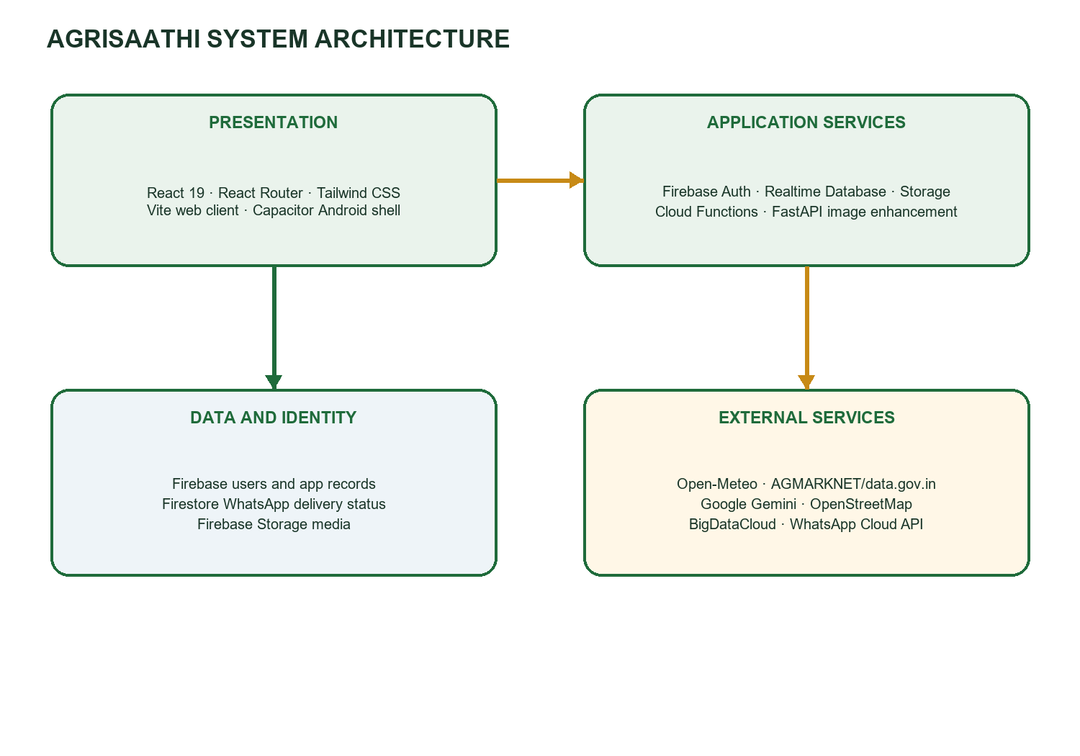
Figure 5.1 Three-layer application and service architecture

5.2 Role-Based Workflow
A user selects a language and role, then signs in or follows the relevant registration workflow. The selected role opens a farmer, dealer, or administrator area. Farmer screens combine personal context with information, crop-support, local-service, and marketplace tasks. Dealer and administrator pages share Firebase data and server functions where configured.
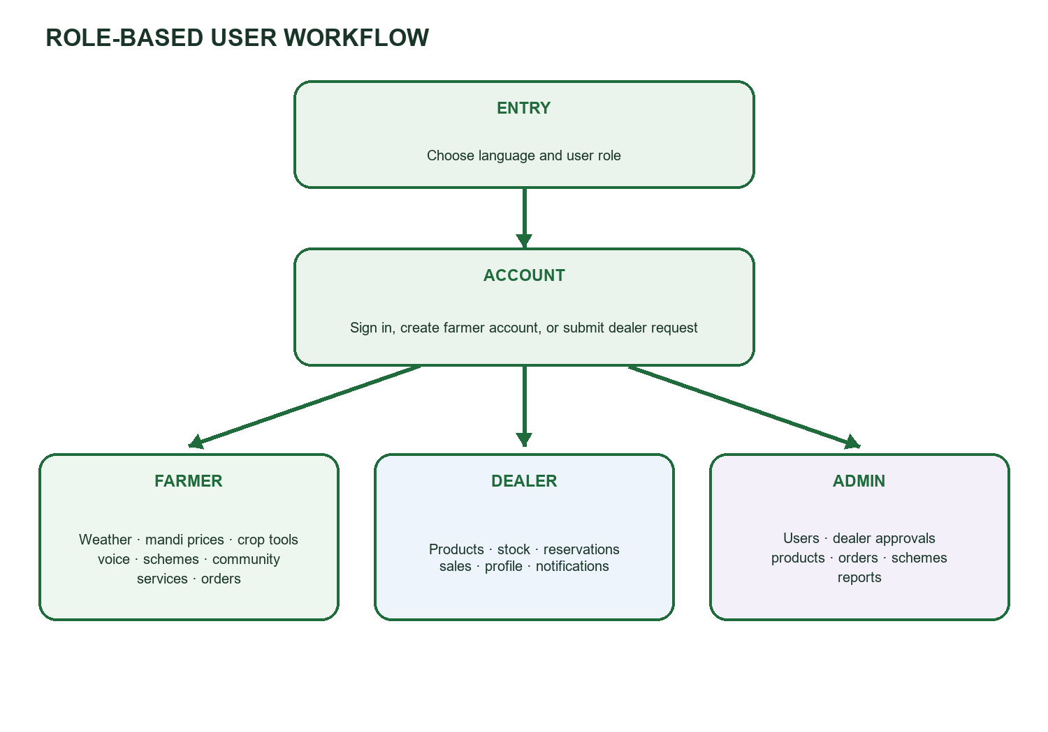
Figure 5.2 Role-based user workflow

5.3 Logical Data Organization
The implementation stores related records under named Realtime Database paths. It also uses Firebase Authentication for identity, Firebase Storage for media, and Firestore for WhatsApp delivery status. The following is a logical map inferred from source references; it is not a database export or a substitute for deployed security rules.
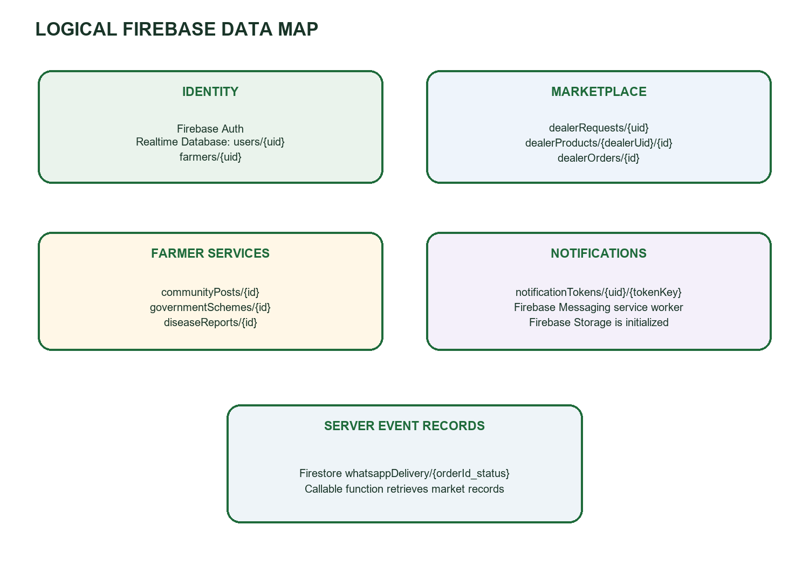
Figure 5.3 Logical Firebase data map

5.4 Major Data Objects
Path or service | Purpose inferred from source
users/{uid} | Shared account/profile and role-related information
farmers/{uid} | Farmer profile read by weather, schemes, and profile features
dealerRequests/{uid} | Dealer registration and review workflow
dealerProducts/{dealerUid}/{productId} | Dealer product listings and stock
dealerOrders/{orderId} | Reservations and order status shared by farmers and dealers
communityPosts/{postId} | Community entries
governmentSchemes/{schemeId} and legacy schemes | Scheme directory and migration compatibility
diseaseReports/{reportId} | Saved crop-analysis summary metadata
notificationTokens/{uid}/{tokenKey} | Registered Firebase Messaging tokens
Firestore whatsappDelivery/{orderId_status} | WhatsApp event claim and delivery outcome

5.5 Security and Data Flow
Firebase Authentication supplies user identity. Client pages check authentication before protected workflows; dealer pages use DealerAccessGuard. The reviewed source tree does not include database or storage rules, so access authorization cannot be verified here. The Cloud Function validates the market query and requires authentication. WhatsApp messaging checks farmer opt-in and stores the access token as a Functions secret according to README.md.

CHAPTER 6

FEASIBILITY STUDY

6.1 Operational Feasibility
The system is organized around three user roles and the workflows each role needs. Profile-based screens reduce repeated entry of farm context, while shared order records help farmers and dealers follow reservations. The application depends on connectivity for Firebase and external services, and users need guidance for permissions, language selection, and account setup.

6.2 Technical Feasibility
The source uses established web and mobile frameworks and service SDKs. Vite provides the web build, Capacitor wraps the client for Android, Firebase provides managed backend services, and FastAPI/OpenCV implement image enhancement. Deployment depends on Firebase configuration and secrets, provider availability, Android SDK setup, and a reachable Python service when image enhancement is enabled.

6.3 Economic Feasibility
The project uses open-source development frameworks and managed cloud services. No project budget, usage plan, API quota, or hosting cost is present in the source materials, so total operating cost cannot be calculated here. Actual costs depend on Firebase usage, Cloud Functions volume, third-party API terms, Android build infrastructure, and support needs.

6.4 Conclusion
AgriSaathi is technically feasible as a role-based web and Android application using the available source and service architecture. Operational deployment requires configuration and verification of Firebase access rules, secrets, external API availability, notification permissions, and location behavior. Empty modules remain outside the implemented feature set until they are completed and verified.

CHAPTER 7

IMPLEMENTATION AND CODE OVERVIEW

7.1 Project Structure
Directory or file | Responsibility
src/App.jsx | Browser routes and lazy-loaded role pages
src/modules/auth/ | Role selection, login, registration, password recovery
src/modules/dashboard/ | Farmer dashboard and feature navigation
src/modules/farmer/ and dealer/ | Marketplace, orders, profiles, stock, sales, notifications
src/modules/admin/ | Administrative management screens
src/modules/weather/, market/, cropDisease/, schemes/, community/ | Farmer information and service features
src/utils/ and src/services/ | Language, voice, location, notification, provider integrations
functions/index.js | Cloud Functions for market prices and WhatsApp updates
agrisathi-python/main.py | FastAPI image-enhancement service
android/ and capacitor.config.json | Native Android wrapper and configuration

7.2 Startup and Navigation
src/main.jsx initializes language preferences and mounts the application. App.jsx defines authentication, farmer, dealer, and administrator routes and lazy-loads most modules. Unknown routes return to the splash page. The language utility stores the selected language and broadcasts changes to screens.
initializeLanguage();
createRoot(document.getElementById("root")).render(
<StrictMode><App /></StrictMode>
);

7.3 Authentication and Registration
Login uses Firebase Email/Password authentication and reads the user profile to determine the next role workflow. Farmer registration creates an account, sends email verification, and writes user and farmer profile data to Realtime Database. The profile captures crop and farm context. Dealer registration creates a request for administrator review; role selection and dealer access checks are also present.

7.4 Weather and Location
The location service uses Capacitor Geolocation on native Android and browser Geolocation on web. It waits for improving fixes, tracks accuracy, maps permission and timeout errors, and can reverse-geocode coordinates using BigDataCloud and OpenStreetMap Nominatim. The weather service validates coordinates and requests current and hourly data from Open-Meteo, then selects the next twelve hours.

7.5 Market Prices
The market-price service fetches AGMARKNET records through the data.gov.in resource endpoint. It validates selected state and pagination values, retries transient failures, and caches records in memory and local storage. On native Android it calls fetchMarketPricePage in Firebase Functions. During web development and preview, the Vite proxy attaches the configured API key. The UI identifies results as reported records rather than real-time trading prices.

7.6 Crop, Land, and Image Assistance
The crop page includes a local rule-based crop recommendation table matched against soil, water, climate, and land profile values. Land photos are compressed and sent to Gemini for a cautious visual estimate of soil type and landform. Crop photos may first be enhanced by FastAPI and then sent to Gemini for structured disease analysis. Results are validated, show confidence and general safety guidance, can surface matching dealer products, and save a summary under diseaseReports.
The FastAPI endpoint accepts JPG, JPEG, PNG, or WEBP uploads up to 10 MB. It resizes large images, improves brightness and contrast using CLAHE, reduces color noise, sharpens the image, and returns a JPEG data URL with image metrics. It does not itself identify crop disease.

7.7 Voice and Language Support
The voice assistant uses browser speech-recognition APIs where supported, local command detection, and a Gemini-backed response service. Speech output uses browser speech synthesis and includes a Gemini text-to-speech path. Voice mappings include English, Telugu, Hindi, Tamil, Kannada, Malayalam, Marathi, Bengali, Gujarati, Punjabi, Urdu, and Odia. The app language selector uses the language list in src/utils/language.js.

7.8 Marketplace, Orders, and Notifications
Farmer pages read dealer products and dealer details, allow product and quantity selection, and write reservations under dealerOrders. Dealer order screens subscribe to relevant records and update order states. In-app notifications are generated by client workflows. Firebase Cloud Messaging registration stores device tokens after permission and service-worker checks. Cloud Functions can send opt-in WhatsApp template messages when orders are created or their status changes; a Firestore claim record limits duplicate event delivery.

7.9 Administrator Workflows
Administrative screens provide farmer status management, dealer request review, dealer management, product and order administration, scheme editing, market-price management, and reports. Government scheme records can use the current path or fall back to a legacy path. Eligibility explanations use profile information and identify criteria that need official confirmation.

7.10 Incomplete Components
Component | State in reviewed source | Treatment in report
src/modules/irrigation/IrrigationPage.jsx | Empty file | Not counted as implemented irrigation guidance
agrisathi-python/models/*.py | Model files are empty | No ML model is claimed as operational
Firebase rules/deployment | Not in inspected source tree | Authorization and deployment state not asserted
Runtime test evidence | No recorded results in shared project folder | Chapter 9 provides scenarios only

CHAPTER 8

INTERFACE AND SCREEN INVENTORY
The routed pages below are identified in src/App.jsx. This chapter inventories screens by function so the project team can add screenshots from its configured running application.
Area | Route examples | Purpose
Entry and account | / · /role-selection · /login · /register · /forgot-password | Splash, language and role selection, authentication, recovery
Farmer home | /dashboard · /profile · /farmer/notifications | Farm overview, profile, notifications
Farmer information | /weather · /market-prices · /crop-disease · /govt-schemes | Forecast, reported prices, crop/land support, schemes
Farmer services | /community · /farmer/nearby-services · /farmer/voice | Community, nearby services, voice assistant
Farmer marketplace | /farmer/dealer-products · /farmer/product/:dealerUid/:productId · /farmer/orders | Catalogue, product details, reservations and order history
Dealer workspace | /dealer · /dealer/products · /dealer/stock · /dealer/orders · /dealer/sales | Dashboard, catalogue, inventory, orders, sales
Administrator | /admin · /admin/farmers · /admin/dealer-requests · /admin/products · /admin/orders · /admin/schemes · /admin/reports | Review, management and reporting

8.1 Interface Principles
Screens use responsive layouts and role-specific navigation. The source uses green-forward branding, farmer profile context, loading and error states, and localization utilities. The Android package reuses the built web interface. Final submission should include screenshots captured from the configured application for entry and representative farmer, dealer, and administrator workflows.

CHAPTER 9

TESTING PLAN
Testing is required to verify module behavior, data access, integrations, and role boundaries. The scenarios below are a proposed verification plan based on the source. No execution results are recorded in this report.
ID | Scenario | Expected result | Result
T01 | Register farmer with valid profile | Account is created, verification is sent, profile is saved | Pending
T02 | Login with invalid credentials | Login is rejected with a clear error | Pending
T03 | Submit dealer request | Request is saved and visible for admin review | Pending
T04 | Open protected dealer page without access | Guard blocks or redirects the user | Pending
T05 | Load weather with valid location | Current conditions and hourly forecast display | Pending
T06 | Deny location or provide inaccurate fix | Explanation and retry/manual path appear where supported | Pending
T07 | Load market records with valid key | Reported AGMARKNET records display with filters | Pending
T08 | Load prices without required key | Missing-key message appears; no sample prices substituted | Pending
T09 | Submit crop photo with service configured | Structured analysis or clear error; summary associated with farmer | Pending
T10 | Reserve dealer product | Dealer sees reservation with correct product and farmer | Pending
T11 | Change order with WhatsApp opt-in | In-app state updates; function records delivery attempt/outcome | Pending
T12 | Browse schemes with incomplete profile | Missing criteria shown; no confirmed approval implied | Pending
T13 | Change interface language | Translated strings update and preference persists | Pending
T14 | Build Android package and grant location | App launches and native location obtains a device fix | Pending

9.1 Unit Testing
Test utility functions separately: coordinate validation, forecast-hour selection, market query validation and caching, voice-command detection, language storage, image resizing and enhancement, and order-status normalization.

9.2 Integration Testing
Verify Firebase Authentication with profile creation; farmer reservation with dealer order processing; Cloud Functions with data.gov.in; order changes with WhatsApp messaging; crop-image enhancement with Gemini analysis; and location acquisition with weather and reverse-geocoding providers.

9.3 System Testing
Run complete role-based flows in a configured Firebase project and on an Android device or emulator. Record test date, build identifier, role, device/browser, provider configuration, actual result, and defect reference. Use test accounts and test data.

CHAPTER 10

CONCLUSION AND FUTURE SCOPE

10.1 Conclusion
AgriSaathi combines farmer information and service workflows with dealer commerce and administrator management in one React application. Firebase supplies identity and shared data services, while cloud functions and external APIs support market retrieval and messaging. Capacitor extends the client to Android, and FastAPI supports image enhancement. The source shows a broad implemented feature set, but irrigation and Python model files are empty. This report documents the code as it exists and separates implemented features from incomplete or configuration-dependent work.

10.2 Future Scope
- Complete and validate the irrigation guidance module, including its route and data inputs.
- Implement and evaluate the empty Python model modules before presenting them as AI features.
- Add a region-aware crop calendar with planting, watering, treatment, harvest, and market reminders.
- Explore market trends using validated historical data and clear uncertainty.
- Add farmer milestone tracking from sowing through harvest and revenue review.
- Expand voice-first guidance and audio alerts across additional language workflows.
- Document Firebase security rules and review authorization boundaries.
- Add end-to-end verification evidence and screenshots from a configured demo environment.

CHAPTER A

SELECTED CODE EXCERPTS
The shortened examples below illustrate the implementation and service boundaries; they are not complete source files.

A.1 Client Routes
<BrowserRouter>
<Suspense fallback={<LoadingPage />}>
<Routes>
<Route path="/dashboard" element={<DashboardPage />} />
<Route path="/weather" element={<WeatherPage />} />
<Route path="/market-prices" element={<MarketPricesPage />} />
</Routes>
</Suspense>
</BrowserRouter>
Source: src/App.jsx.

A.2 Firebase Initialization
const app = initializeApp(firebaseConfig);
export const auth = initializeAuth(app, {
persistence: browserSessionPersistence,
});
export const database = getDatabase(app);
export const storage = getStorage(app);
export const functions = getFunctions(app, "asia-southeast1");
Source: src/firebase.js. Project identifiers and credentials are omitted.

A.3 Weather Request
const params = new URLSearchParams({
latitude: String(lat),
longitude: String(lon),
current: CURRENT_FIELDS.join(","),
hourly: HOURLY_FIELDS.join(","),
timezone: "auto",
forecast_days: "2",
});
const response = await fetch(FORECAST_URL + "?" + params);
Source: src/services/weatherService.js.

A.4 Callable Market Function
export const fetchMarketPricePage = onCall({
region: "asia-southeast1",
secrets: [dataGovApiKey],
}, async (request) => {
if (!request.auth) {
throw new HttpsError("unauthenticated", "Sign in to load market prices.");
}
// Validate allowed parameters before calling data.gov.in.
});
Source: functions/index.js. The server secret is omitted.

A.5 Image Enhancement Pipeline
resized_image = resize_image(original_image)
enhanced_image = improve_brightness_and_contrast(resized_image)
enhanced_image = reduce_noise(enhanced_image)
enhanced_image = sharpen_image(enhanced_image)
Source: agrisathi-python/main.py.

CHAPTER B

LOGICAL DATA MAP
This appendix summarizes paths observed in the client and server references. Actual field-level schemas and authorization requirements must be confirmed against the deployed Firebase project.
Service | Observed data groups | Use
Firebase Authentication | User identities | Sign-in and identity
Realtime Database | users, farmers, dealerRequests, dealerProducts, dealerOrders | Profiles, dealer workflow, marketplace and orders
Realtime Database | communityPosts, governmentSchemes, diseaseReports | Community, scheme directory and crop-analysis summaries
Realtime Database | notificationTokens | Registered push devices
Cloud Firestore | whatsappDelivery | WhatsApp event idempotency and delivery state
Firebase Storage | Media objects | Application media storage service is initialized

REFERENCES
1. AgriSaathi source project: README.md, package.json, src/App.jsx, src/firebase.js, src/services/, src/modules/, functions/index.js, agrisathi-python/main.py, capacitor.config.json.
2. React documentation. https://react.dev/
3. Vite documentation. https://vite.dev/
4. Firebase documentation. https://firebase.google.com/docs
5. Capacitor documentation. https://capacitorjs.com/docs
6. Tailwind CSS documentation. https://tailwindcss.com/docs
7. FastAPI documentation. https://fastapi.tiangolo.com/
8. OpenCV documentation. https://docs.opencv.org/
9. Open-Meteo API documentation. https://open-meteo.com/en/docs
10. data.gov.in portal and AGMARKNET integration. https://data.gov.in/
11. OpenStreetMap Nominatim API documentation. https://nominatim.org/release-docs/latest/api/Reverse/
12. Google Gemini API documentation. https://ai.google.dev/gemini-api/docs
13. Meta WhatsApp Cloud API documentation. https://developers.facebook.com/docs/whatsapp/cloud-api/
14. Project feature notes: agrisathi new ideas.txt.

