BUSINESS INTELLIGENCE

No.2

**Assignment 2.**

Learner’s name: Pham Le Hai Son

Assessor name: Nguyen Xuan Sam.

Class: GCS0804B

Learner’s ID: GCS190828

Subject’s ID: 1941

Assignment due: November 8, 2021.

Assignment submitted: November 8, 2021.

|  |  |  |  |
| --- | --- | --- | --- |
| COMP1640 (2022/23) | **Enterprise Web Software Development** | **Faculty Header ID:** | **Contribution: 100% of course** |
| **Course Leader: Mr Matthew Prichard** | **Individual coursework** |  | **Deadline Date: 11/4/2023** |
| This coursework should take an average student who is up-to-date with tutorial work approximately 50 hours   Feedback and grades are normally made available within 15 working days of the coursework deadline | | | |
| **Learning Outcomes:** All | | | |

|  |
| --- |
| **Plagiarism is presenting somebody else's work as your own. It includes: copying information directly from the Web or books without referencing the material; submitting joint coursework as an individual effort; copying another student's coursework; stealing coursework from another student and submitting it as your own work.  Suspected plagiarism will be investigated and if found to have occurred will be dealt with according to the procedures set down by the University. Please see your student handbook for further details of what is / isn't plagiarism.** All material copied or amended from any source (e.g. internet, books) must be referenced correctly according to the reference style you are using.   Your work will be submitted for plagiarism checking.  Any attempt to bypass our plagiarism detection systems will be treated as a severe Assessment Offence. |

Table of Contents

Table of table 4

1 Introduction 5

2 Functionality 5

2.1 Product Backlogs 5

2.2 ERD (Entity relationship diagram) 5

2.3 Sitemap 6

2.4 Activity Diagram 8

2.5 Wireframe 11

2.6 Testing 18

3 Agile method 20

4 Product 20

4.1 Group evaluation 20

4.2 Product screenshot 20

5 Conclusion 27

6 References 29

Appendix 30

Table of figure

Figure 1: Business intelligence 7

Figure 2 : BI tools 9

Figure 3: Tableau 10

Figure 4: Power BI 13

Figure 5: Data preprocessing 16

Figure 6: Steps in Data Preprocessing 17

Figure 7 : Data form ANSHUL-DISHORIYA (https://www.kaggle.com/anshuldishoriya/preprocessing-and-selling-price-prediction/log) 18

Figure 8: Connect data 19

Figure 9: Connect data success 19

Figure 10: Add data to columns and rows 20

Figure 11: Change type of chart 20

Figure 12: Add Trending line step 1 21

Figure 13: Add trending line step 2 21

Figure 14: Measure Values 22

Figure 15: Put data in column 22

Figure 16: Result second data 22

Figure 17 : Total amount of transactions from 1991 to 2020 by year 23

Figure 18 : Mileage used for each vehicle type 24

Figure 19 : Sales of vehicles across ownership periods 25

Figure 20 : Dashboard 26

Figure 21 : Security and the BI framework 27

# Table of table

Table 1 : how business intelligence tools can contribute to effective decision making. 27

# Introduction

# Functionality

## Product Backlogs

Một. Sản phẩm tồn đọng:

Chúng tôi có 3 loại tài khoản chính trong hệ thống này: Quản trị viên, Nhân viên, Điều phối viên

* Quản trị viên:
* Tạo tài khoản cho nhân viên.
* Quản lý User, Role, Topic, Department, Category
* Quản lý View Topic, View Submission, View Statics
* Chỉnh sửa các vai trò của tài khoản
* Add Role, Topic, Department, Category,
* Duy trì dữ liệu hệ thống
* Nhân viên:
* Nhân viên có thể gửi một hoặc nhiều bài đóng góp dưới dạng File
* Nhân viên có thể gửi một hoặc nhiều đóng góp của mình
* Nhân viên phải đồng ý các điều khoản dịch vụ trước khi gửi
* Nhân viên có thể xem được tất cả các ý tưởng đã gửi và có thể nhận xét về bất kỳ ý tưởng nào
* Sẽ không thể thêm đóng góp mới và chỉnh sửa đóng góp khi quá hạn.
* Ý tưởng và nhận xét có thể được đăng dưới dạng ẩn danh
* Điều phối viên:
* View Submission, View Topic, View Statics
* Quản lý, Department, Category
* Có thể tải được file đóng góp của nhân viên dưới dạn Zip và Excel File
* Sẽ được thông báo qua Email khi đóng góp được gửi đến hệ thống.
* Khả năng tương tác với nhân viên để chỉnh sửa và sắp xếp các đóng góp.

## ERD (Entity relationship diagram)

description

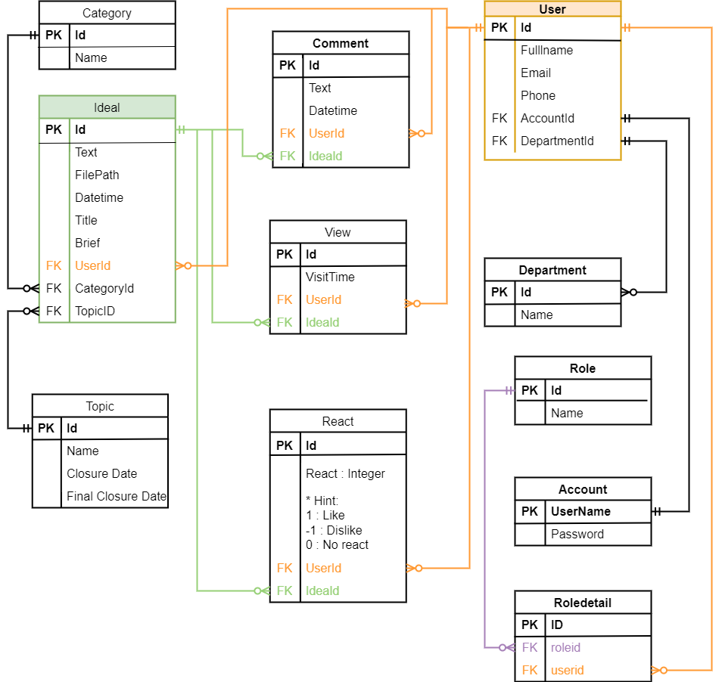

## Sitemap

### Home Sitemap

description

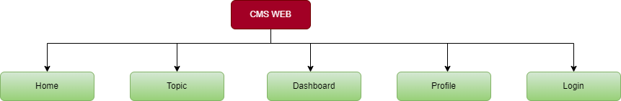

### Dashboard Sitemap

description

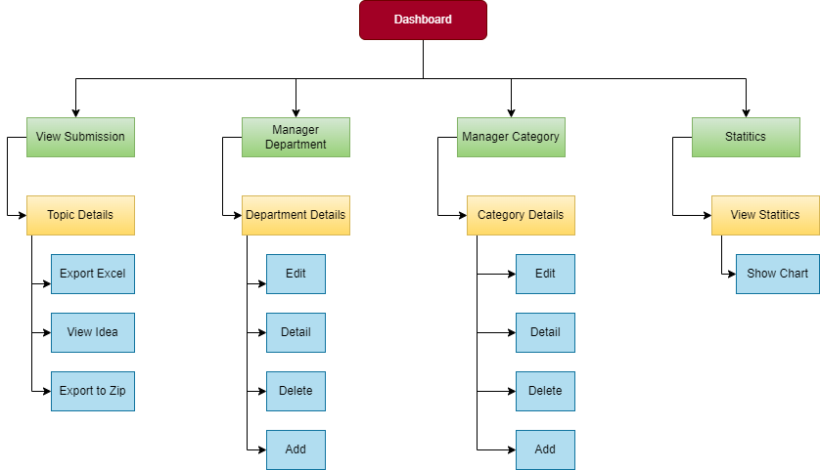

### Admin Sitemap

description

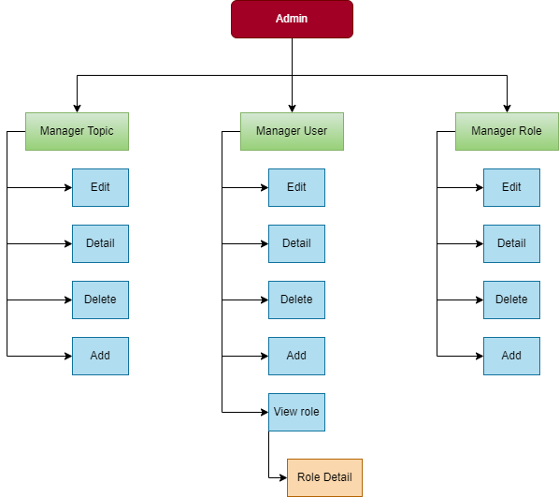

### Profile Sitemap

Description

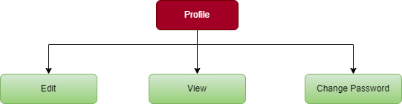

### Topic Sitemap

description

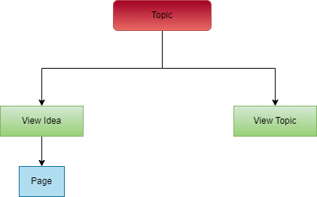

## Activity Diagram

### Main

Description

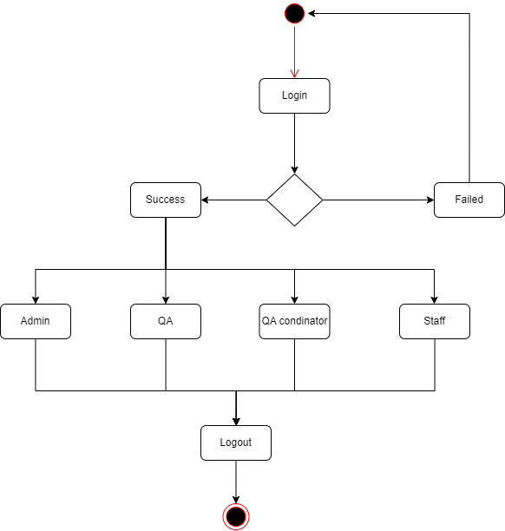

### Add topic

description

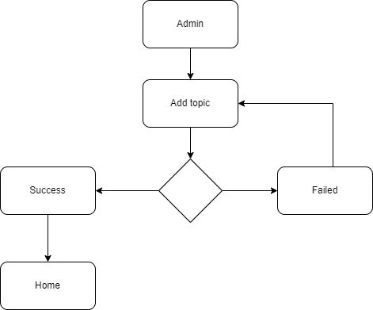

### Edit topic

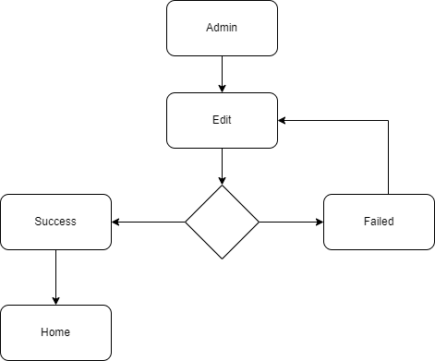

### Delete topic

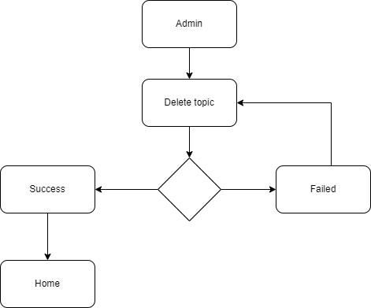

### Role Manager

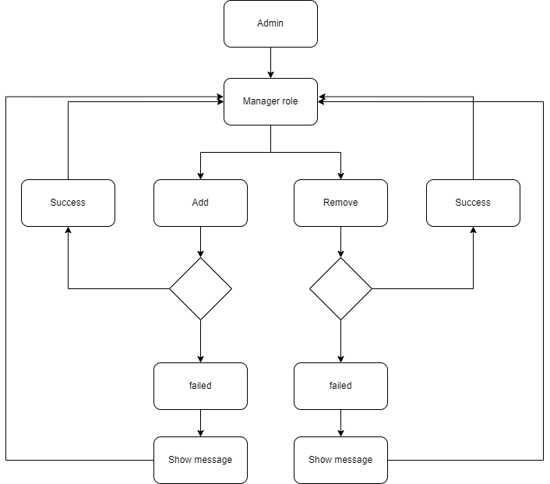

## Wireframe

### Home

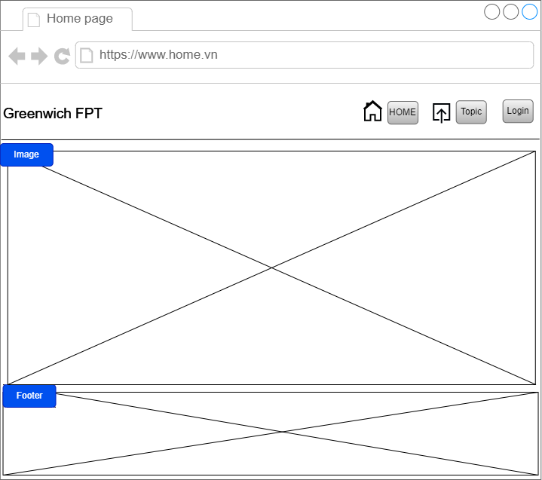

### Login

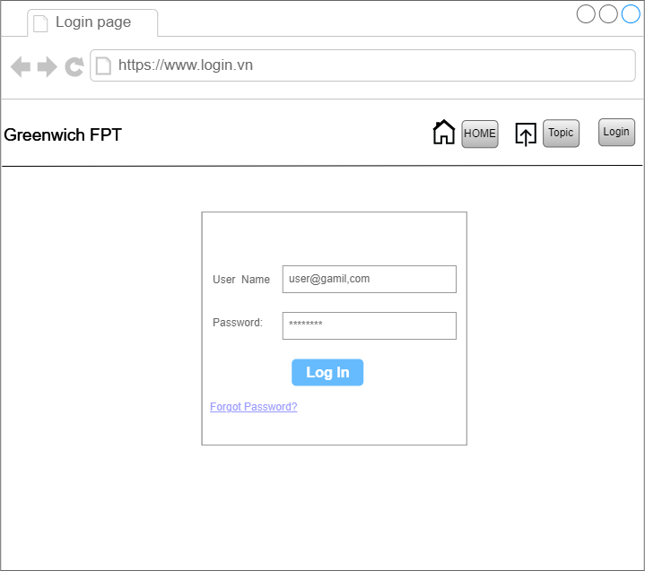

### Topic

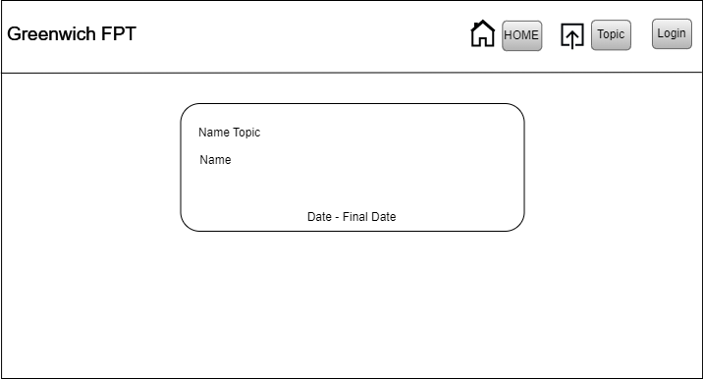

### Idea

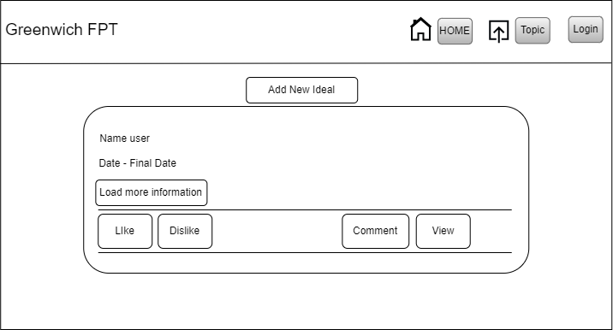

### Form Add topic

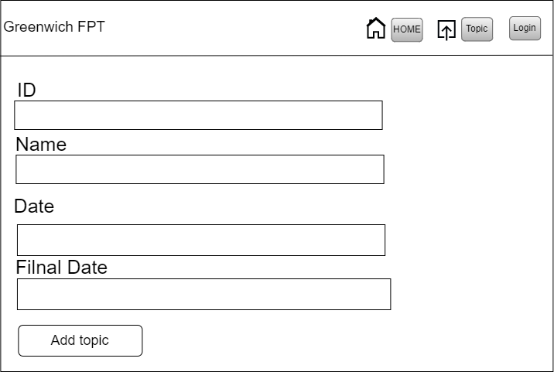

### Form Add Idea

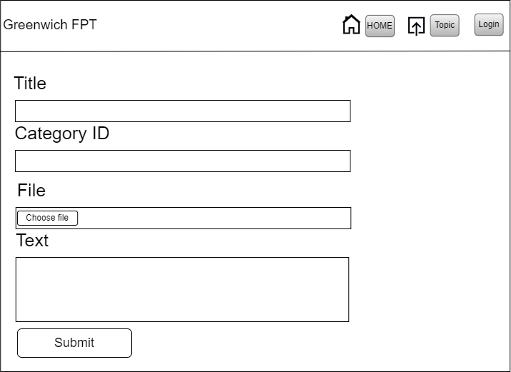

### Comment

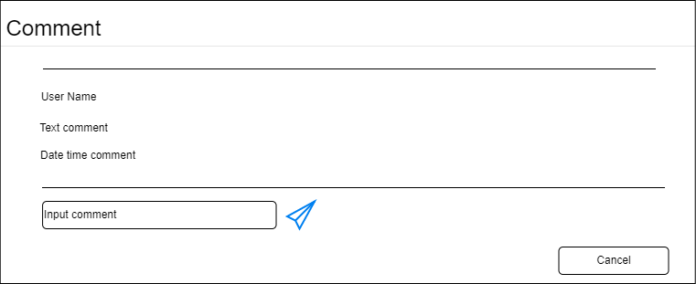

### View

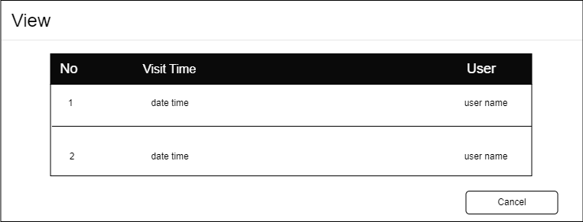

### Manager Submission

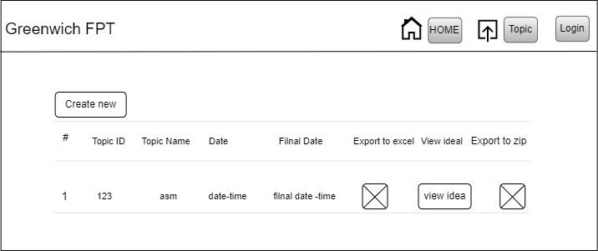

### Dashboard

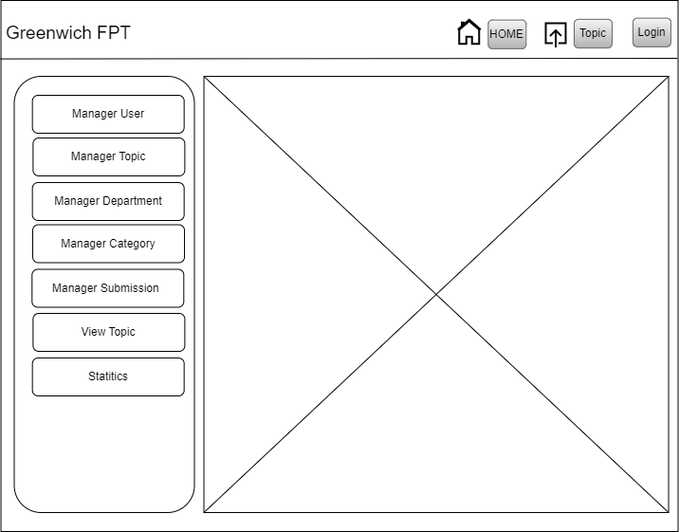

## Use Case Specification

* Create acount

|  |  |  |  |
| --- | --- | --- | --- |
| Use case: Create an account for a user | | ID: UC01 | Priority: Must Have |
| Description: This use case will help create an account for the user | | | |
| Trigger: To be able to log into the system, users need an account to do it. | | | |
| Actor: Admin | Type: Internal | | |
| Pre-conditions   * The administrator will log in as an administrator to create a new account for the user * Since this account is provided by admin, it can be deleted at any time. * Before creating an account, make sure that the newly created account is not in the database | | | |
| Post-conditions   * When the administrator creates the account successfully, it will be imported into the database * Only the administrator account created by the user can log in to the system. | | | |
| Basic flow   1. Administrator will log in to the system 2. Then admin will click “create new” button 3. Administrator has full rights to control user's account including email, password, date of birth and account type. 4. Then check if the previous account has been created or not. 5. Finally, go to the database to check if the newly created account is already in the database or not | | | |
| Alternative flow: None | | | |
| Exception flow: None | | | |
| Includes: Login | | | |
| Business rules: Requires administrator rights to enter user information such as email, password, name, etc. of the new user account. | | | |

* Login

|  |  |  |  |
| --- | --- | --- | --- |
| Use case: Login | | ID: UC02 | Priority: Must Have |
| Description: This function is used to let users log in to the CMS system | | | |
| Trigger: Users will be provided with a cms account to be able to log into the system | | | |
| Actor: all | Type: Internal | | |
| Pre-conditions   * The user's account must be created in the database by the administrator * User accounts must be valid for predefined syntax * In order for the user to be able to log into the cms system, the user must be connected to the network. | | | |
| Post-conditions   * When the user has entered the correct account, the test will successfully enter the CMS homepage * The system will be assigned specific permissions depending on the role of the logged in user | | | |
| Basic flow   * User logs into the system as administrator * In the user account management page, the administrator will be able to edit the information about the user's account * When the administrator edits the user's account information, the system will display the user account information that needs to be edited * The administrator has the right to change the email and password for the user's account | | | |
| Alternative flow: None | | | |
| Exception flow   * When the user enters the wrong account data, the system will ask the user to re-enter it. * The system will not be able to login if the user enters the wrong account. | | | |
| Includes: None | | | |
| Business rules: None | | | |

* Edit account

|  |  |  |  |
| --- | --- | --- | --- |
| Use case: Edit account | | ID: UC03 | Priority: Must Have |
| Description: This function allows administrators to edit information about user accounts. | | | |
| Trigger: This function only administrators can access and edit information. | | | |
| Actor: Admin | Type: Internal | | |
| Pre-conditions   * In the admin page, the user will log in as an administrator to make edits to the account information. * After the account is edited, the edited information will be stored in the database. | | | |
| Post-conditions   * Edited information must conform to the predefined structure in the system. * The database will be changed based on the newly edited village | | | |
| Basic flow   * This system user will login as administrator * The administrator after logging in will go to the user account management page to edit information * The system will then display the information that the administrator needs to edit * The administrator has the right to change the email and password information about the user's account * After editing, the database will save the changed information. * If an error is detected, the system will notify the administrator to correct the information | | | |
| Alternative flow: None | | | |
| Exception flow: None | | | |
| Includes: Login | | | |
| Business rules:   * For editing information about user accounts, the administrator is required to enter full email information, password and user type. * After successful editing, the data must be synchronized on the system. | | | |

* Delete account

|  |  |  |  |
| --- | --- | --- | --- |
| Use case: Delete account | | **ID:** UC04 | **Priority:** Must Have |
| Description: For this position will show how the administrator can delete the account | | | |
| Trigger: Only the administrator has the right to enable the delete user account function | | | |
| Actor: Admin | Type: Internal | | |
| Pre-conditions   * This system will be logged in by the user as an administrator * Admin can delete any account in the account management page | | | |
| Post-conditions   * The system will directly delete the user account on the web * Then check the database, the deleted account must be successfully deleted in the database | | | |
| Basic flow   * User must be logged in as an administrator to be able to access the account management page * The admin user will click the delete button in the account management page * The system will then display the information that the administrator wants to delete * The account in the database will be deleted successfully. * People will not be able to login after the administrator has deleted the account | | | |
| Alternative flow: None | | | |
| Exception flow: None | | | |
| None Includes: Login | | | |
| Business rules: Users must accept the risks after the account is locked | | | |

* Comment

|  |  |  |  |
| --- | --- | --- | --- |
| Use case: Comment | | **ID:** UC05 | **Priority:** Must Have |
| Description: User comments will be displayed in this case | | | |
| Trigger: A comment or a post that needs fixing | | | |
| Actor: All Staff | Type: Internal | | |
| Pre-conditions   * User must use the account of the grant system to log in * Student contributions must be submitted so that users can comment on student contributions | | | |
| Post-conditions   * User contributions will show up as student contributions * New comment information will be saved to the database by the system | | | |
| Basic flow   * The person needs to log into the system using the account provided by the administrator * User clicks “comment” * After clicking on the comment, the system will display the comment input box * The user fills in the comment information in the comment box and clicks the "send" icon * After submitting a comment, the system will save the user's comments in the database | | | |
| Alternative flow: None | | | |
| Exception flow: None | | | |
| Includes: Login | | | |
| Business rules: User is required to enter comment information in the input box | | | |

* Email notification

|  |  |  |  |
| --- | --- | --- | --- |
| Use case: Email notifications | | ID: UC06 | Priority: Should have |
| Description: This case will explain how email notifications are sent to the management coordinator | | | |
| Trigger: The moderator manager wants to receive notifications of users commenting or posting a certain post | | | |
| Actor: Coordinator manager | Type: Internal | | |
| Pre-conditions   * The administrator will decide the role of the coordinator manager * When a post is posted will be notified by email | | | |
| Post-conditions   * New donations will be received by them via email * New comments will be received by them via email | | | |
| Basic flow   * The account of the coordinator manager will receive the provisioning rights from the administrator. * When users comment and contribute, they will receive email notifications. * Go to google mail to check the accuracy. | | | |
| Alternative flow: None | | | |
| Exception flow: None | | | |
| Includes: Login | | | |
| Business rules: None | | | |

* Submit ideal

|  |  |  |  |
| --- | --- | --- | --- |
| Use case: Submit ideal | | ID: UC07 | Priority: Must Have |
| Description: use case này sẽ giúp người dùng nộp ideal lên hệ thống | | | |
| Trigger: Staff wants to submit ideas on their system | | | |
| Actor: Staff | Type: Internal | | |
| Pre-conditions   * Staff must prepare ideas to submit to the system. * The user uses a managed account to log in to the system. | | | |
| Post-conditions   * Contributions will be recorded into the system when staff submit ideas. * All ideas submitted will be recorded in the database * All ideas will be displayed in the given order,... | | | |
| Basic flow   * Staff logs into the system as a user. * Next, go to the idea submission page to submit your ideas. * Click the "submit ideal" button to submit your idea. * Contribution data will be automatically saved to the database. | | | |
| Alternative flow: None | | | |
| Exception flow:   * Do not submit ideas * Edit information without pressing the "submit ideal" button * Submit unlimited file ideas | | | |
| Includes: Submit ideal | | | |
| Business rules:  The data must be in sync with the original data | | | |

## Testing

Test Plan:

|  |  |  |  |  |
| --- | --- | --- | --- | --- |
| No | Test | Input | Test data | Result |
| 1 | Đăng nhập đến trang Admin | Nhập thông tin dữ liệu vào trang đăng nhập | Username: [bun123@gmail.com](mailto:bun123@gmail.com)  Password: 123 | Go to the Admin Page |
| 2 | Đăng nhập đến trang QA | Nhập thông tin dữ liệu vào trang đăng nhập | Username: [gokuhieu20@gmail.com](mailto:gokuhieu20@gmail.com)  Password: 123 | Go to the QA Page |
| 3 | Đăng nhập đến trang User | Nhập thông tin dữ liệu vào trang đăng nhập | Username: [bun456@gmail.com](mailto:bun456@gmail.com)  Password: 456 | Go to the Student Page |
| 4 | Add new topic | Nhập dữ liệu vào form topic được hiển thị trong trang topic | Test topic | Dữ liệu vừa nhập đã được thêm vào database và hiển thị thông báo thành công |
| 5 | Add new category | Nhập dữ liệu vào form topic được hiển thị trong trang category | Test category | Dữ liệu vừa nhập đã được thêm vào database và hiển thị thông báo thành công |
| 6 | Add department | Nhập dữ liệu vào form topic được hiển thị trong trang department | Test department | Dữ liệu vừa nhập đã được thêm vào database và hiển thị thông báo thành công |
| 7 | Add idea | Nhập dữ liệu vào form topic được hiển thị trong trang idea | Test idea | Dữ liệu vừa nhập đã được thêm vào database và hiển thị thông báo thành công |
| 8 | Add role | Nhập dữ liệu vào form topic được hiển thị trong trang role | Test role | Dữ liệu vừa nhập đã được thêm vào database và hiển thị thông báo thành công |
| 9 | View Statics | Click “Statics” trong trang Dashoboard | Test view statics | Hiển thị các thông tin statics ra màn hình thành công |
| 10 | Dowload file | Click và nút “ Export to excel và Export to Zip trong trang “ View Submit “ | Test Dowload file | Tải về thành công và xem được các thông tin trong cả hai file |

Test Log

|  |  |  |  |  |  |  |  |
| --- | --- | --- | --- | --- | --- | --- | --- |
| No | Action | Input | Expected output | Actual output | Date | Test result | Comment |
| 1 | Add new topic | ID : “topic1”  Name:”Idea for cms web” | Toast show message Add succesfully | Toast show message Add failed | April 16, 2023 | failed | Error same ID |
| 2 | Add new Idea | Title:”add dashboard”  Brief:”made by bun”  Category: select options image  File imge1.jpg  Text:”below is description” | Toast show message Add succesfully | Toast show message Add succesfully | April 16, 2023 | success |  |
| 3 | View topic | Click on button topic | See all topic | See all topic | April 16, 2023 | success |  |
| 4 | Add new topic | ID : “”  Name:”Idea for cms web” | Toast show message Add failed message required ID | Toast show message Add failed message required ID | April 16, 2023 | success |  |
| 5 | Login | Username:bun123@gmail.com  Password:”123” | Toast show login successfully and login succesfully | Toast show login failed and login failed | April 16, 2023 | Failed | Wrong query to database |
| 6 | Login User | Username:bun1234@gmail.com  Password:”123” | Toast show login failed and login failed with message username or password not match | Toast show login successfully and login succesfully | April 16, 2023 | Failed | Wrong query to database |
| 7 | Login QA | Username:gokuhieu20@gmail.com  Password:”123” | Toast show login successfully and login succesfully | Toast show login successfully and login succesfully | April 16, 2023 | Success |  |
| 7 | Add Comment | Text:”123” | Comment will show last comment | Comment show last comment | April 16, 2023 | success |  |
| 8 | Add view | User click on button detail in Idea | View will count 1 and in view Component will load my view | View count 1 and in view Component loaded my view | April 16, 2023 | success |  |
| 9 | Add react | Click on button like, dislike | Total like and dislike will plus 1 then I add new react | Total like and dislike plus 1 then I add new react | April 16, 2023 | success |  |
| 10 | Delete topic | Click on button delete and confirm delete button | It will show message delete successfully | It show message delete successfully | April 16, 2023 | success |  |

# Agile method

Applying Agile Method for Our Web Project

Agile is an iterative approach to project management and software development that helps teams deliver value to their customers faster and with fewer headaches.

The online system we developed is intended to support large-scale education and training projects, similar to those carried out by institutions in general. We have applied the Agile methodology to this project in a very thorough manner from the beginning, and the team members can support one another to produce the greatest results. In particular, we now possess the essential understanding of agile methodology's guiding concepts and software development statements.

Here is a presentation of the system used by this website:

Agile Methodologies Overview

The Agile Software Development Manifesto recommend progressive considering turning in fee and taking part with clients while it turned into created in 2001. In addition, the developers emphasized the support of twelve concepts on the back of the Agile Manifesto builders with the guidelines in the movement and follow agile strategies in the exercise. The concepts are as follows:

Delivering high-quality software on time and consistently is our top focus in order to satisfy the customer. We have a plan to ensure the project is completed on time and can improve the quality of the project afterwards. Ensuring customers will be satisfied with the product is our top priority.

Accept adjusting requirements, even late in the development process. For the sake of the customer's competitive edge, agile processes harness change. We meet with customers once a week to discuss product requirements. We will then improve the product week by week. The goal is to increase product quality to satisfy customers.

Provide workable software regularly, from a couple of weeks to a couple of months, with a preference to the shorter duration. We will meet with clients every 2 weeks to show users demos of the project to ensure that customers can keep track of the product's development.

The project requires daily collaboration between business professionals and developers. We have invited professional business analysts to analyze the requirements. And there are meetings every time the user has a new request to discuss the requirements.

Build initiatives around motivated people. Give them the environment and support they need, and trust them to get the job done. Group members are highly connected. We usually work Applying Agile Method for Our Web Project

Agile is an iterative approach to project management and software development that helps teams deliver value to their customers faster and with fewer headaches. Instead of betting everything on a "big bang" launch, an agile team delivers work in small, but consumable, increments. Requirements, plans, and results are evaluated continuously so teams have a natural mechanism for responding to change quickly.

The online system we developed is intended to support large-scale education and training projects, similar to those carried out by institutions in general. We have applied the Agile methodology to this project in a very thorough manner from the beginning, and the team members can support one another to produce the greatest results. In particular, we now possess the essential understanding of agile methodology's guiding concepts and software development statements.

Here is a presentation of the system used by this website:

Agile Methodologies Overview

The Agile Software Development Manifesto recommend progressive considering turning in fee and taking part with clients while it turned into created in 2001. In addition, the developers emphasized the support of twelve concepts on the back of the Agile Manifesto builders with the guidelines in the movement and follow agile strategies in the exercise. The concepts are as follows:

1. Delivering high-quality software on time and consistently is our top focus in order to satisfy the customer.

We have a plan to ensure the project is completed on time and can improve the quality of the project afterwards. Ensuring customers will be satisfied with the product is our top priority.

1. Accept adjusting requirements, even late in the development process. For the sake of the customer's competitive edge, agile processes harness change.

We meet with customers once a week to discuss product requirements. We will then improve the product week by week. The goal is to increase product quality to satisfy customers.

1. Provide workable software regularly, from a couple of weeks to a couple of months, with a preference to the shorter duration.

We will meet with clients every 2 weeks to show users demos of the project to ensure that customers can keep track of the product's development.

1. The project requires daily collaboration between business professionals and developers.

We have invited professional business analysts to analyze the requirements. And there are meetings every time the user has a new request to discuss the requirements.

1. Build initiatives around motivated people. Give them the environment and support they need, and trust them to get the job done. Group members are highly connected.

We usually work overtime. The team leader is responsible for dividing work and motivating team members during product development to make sure the job is completed on time.

1. Face-to-face conversation is the most effective and efficient way to communicate with and within a development team.

We often meet at the cafe to work and discuss products. In addition to face-to-face meetings, we also meet online on the Google Meet platform.

1. Good working software program is the primary degree of progress.

After completing a function, we quickly check and fix the error. Make sure the functions do not have many errors. Next, we will plan the next features.

1. Agile processes promote sustainable development. It should be possible for the sponsors, developers, and users to continue at the same pace indefinitely.

We also have help from other developers with similar work and platforms on popular platforms like GitHub, Stack Overflow, and learning on YouTube through videos shared by experienced programmers step by step to learn more about programming.

1. Constantly interested by appropriate strategies and designs to boom flexibility.

We regularly plan to improve programming skills, refer to similar products so that the design of the product is more flexible and beautiful.

1. Simplicity - the artwork of maximizing unfinished paintings - is fundamental.

We offer simple algorithms and designs so that team members can understand and complete unfinishedProduct

1. The first-rate architecture, the first-rate requirements, and the first-rate layout may be made through self-organizing teams.

We learn about the architecture, the requirements of the education industry to be able to get a product suitable for the field of education.

1. The manufacturing crew will frequently consider a way to emerge as greater efficient. They will then regulate and alternate their conduct accordingly.

After a period of taking the job, each member will report their progress as well as share their difficulties so that other members have timely remedies that do not affect the progress of the work as well as share their good skills with other members to better fit into the project.

**Burndown Chart:**

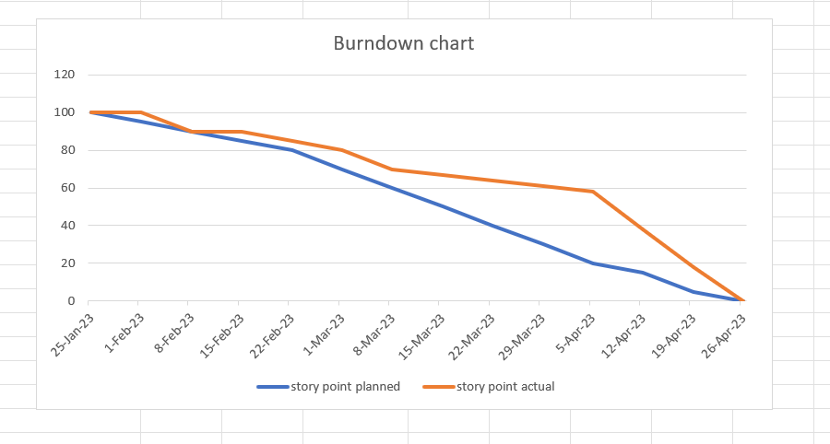

## Group evaluation

### Team member Introduction

Our team is composed of members who are all classmates in the same university. While each of us has our own set of strengths and weaknesses, we are working together on a project for the first time. To ensure that each person can contribute to the project to the best of their abilities, the team leader will assign tasks that align with their individual strengths. We believe that by working collaboratively, we will be able to overcome any weaknesses that may arise. The members of our team are Pham Le Hai Son, Nguyen Hoang Minh Trong, Vo Thanh Nam Phuong, Phan Huu Tien and Nguyen Tan Cuong

|  |  |  |  |
| --- | --- | --- | --- |
| Name | ID | Role | No |
| Pham Le Hai Son |  | Back-end  Support Font-end |  |
| Phan Huu Tien |  | Support Back-end, Font-end, Design, word |  |
| Vo Thanh Nam Phuong |  | Main Font-end , support Write Report |  |
| Nguyen Hoang Minh Trong |  | Support font-end, database, Design |  |
| Nguyen Tan Cuong |  | Design, support font-end, write report |  |

### Evaluate the work of the member

## Product screenshot

### Login

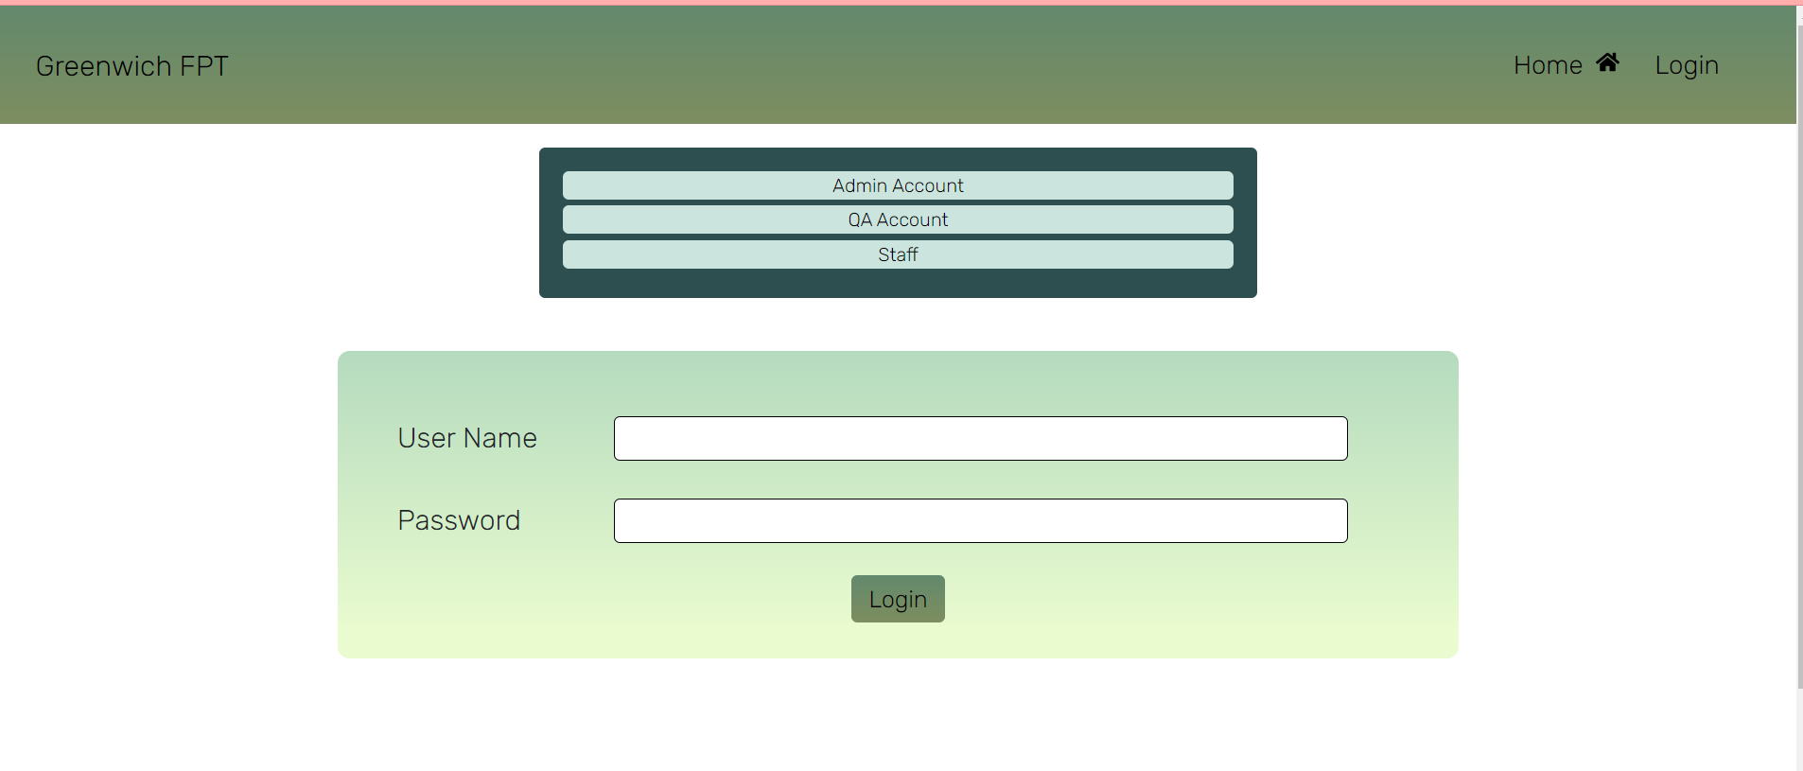

### Home

description

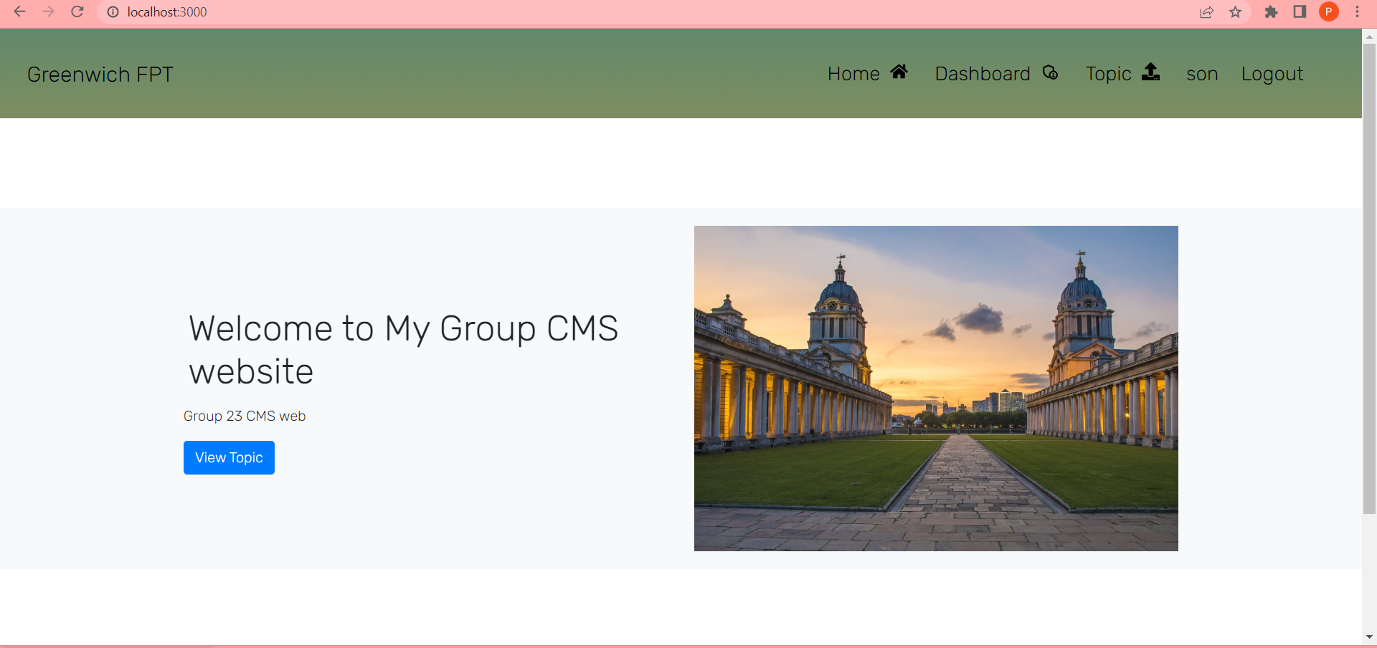

### Topic

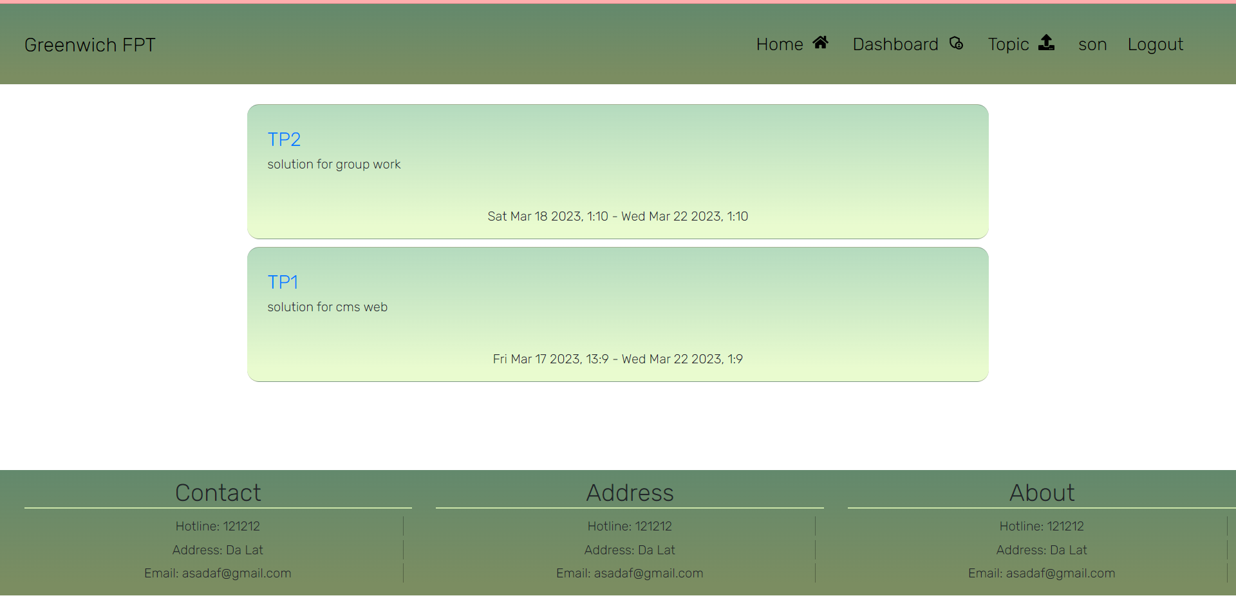

### Add Idea

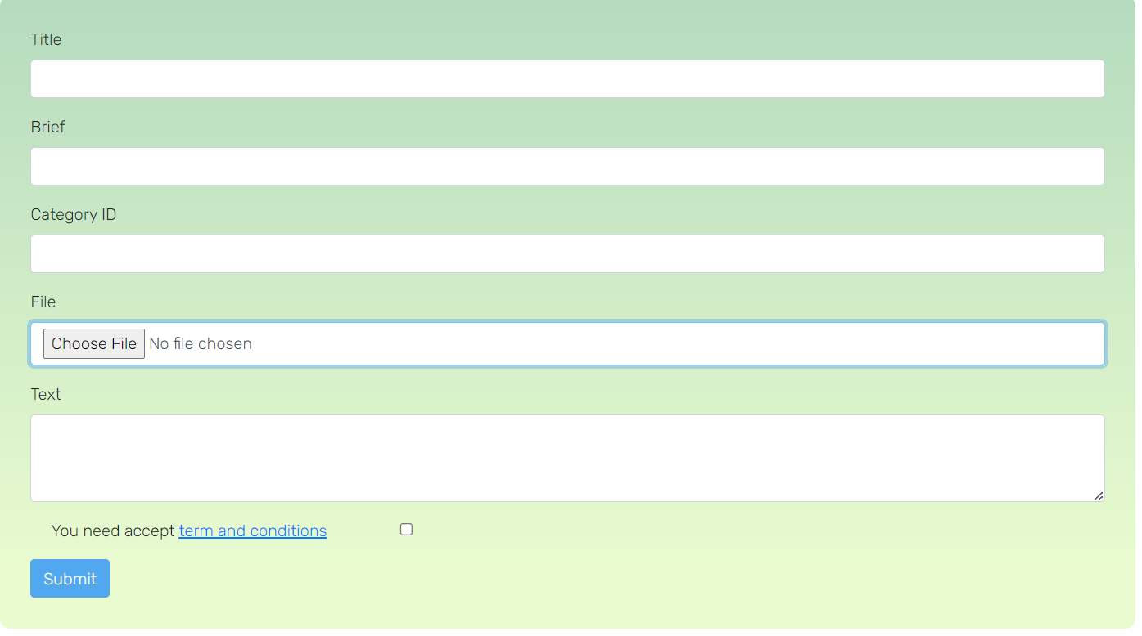

### Idea

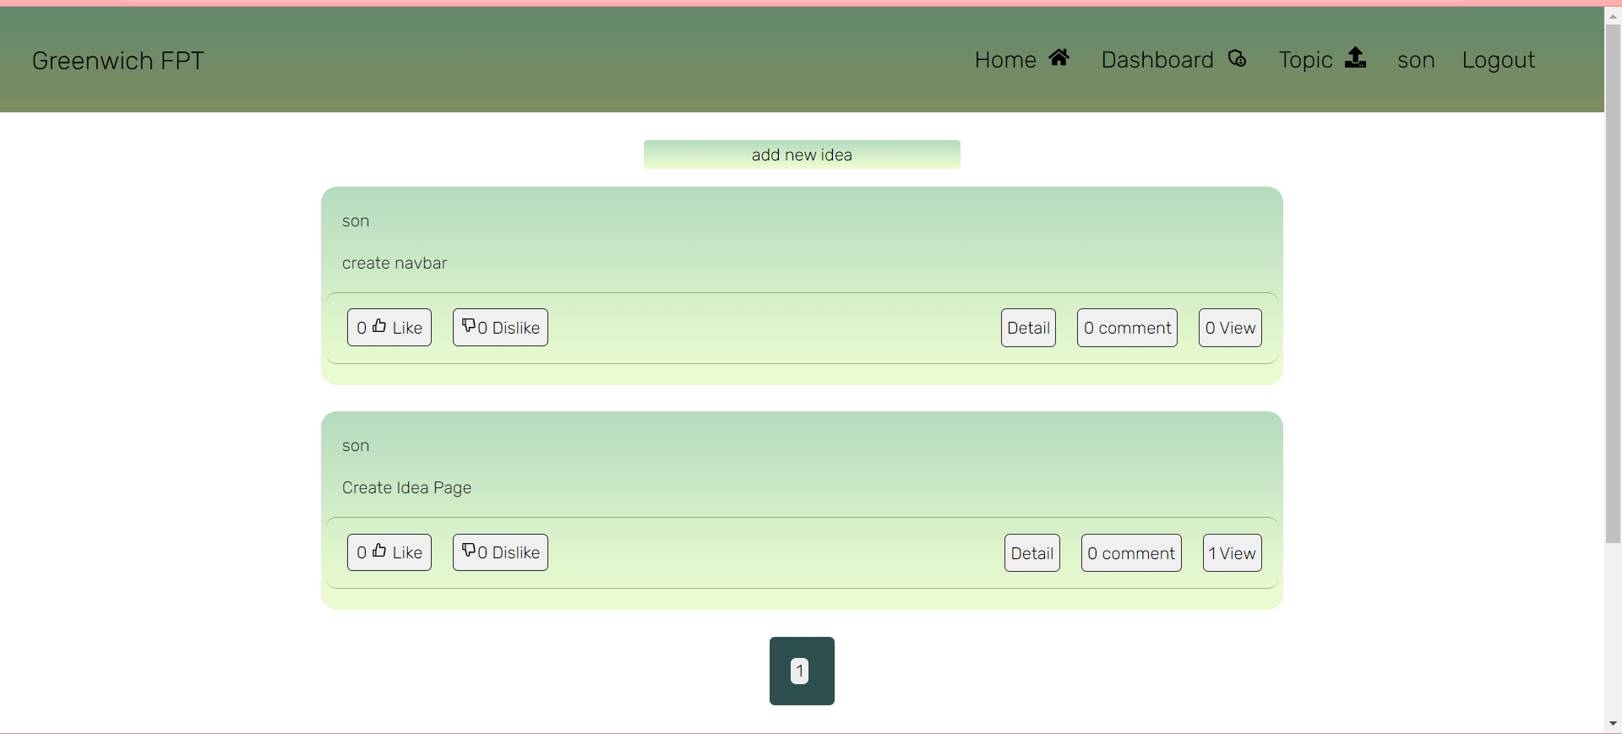

### Dashboard

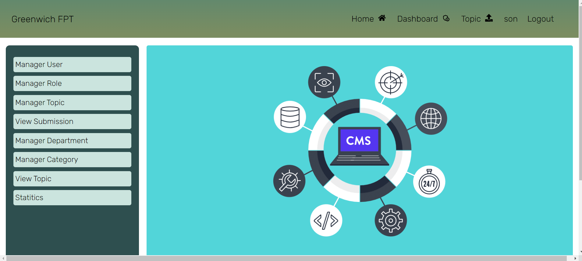

### Manager topic

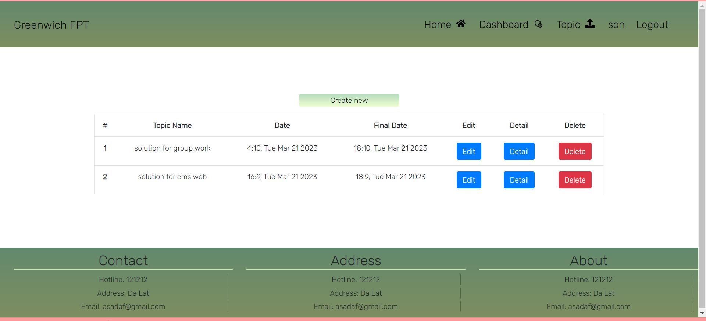

### Delete confirm

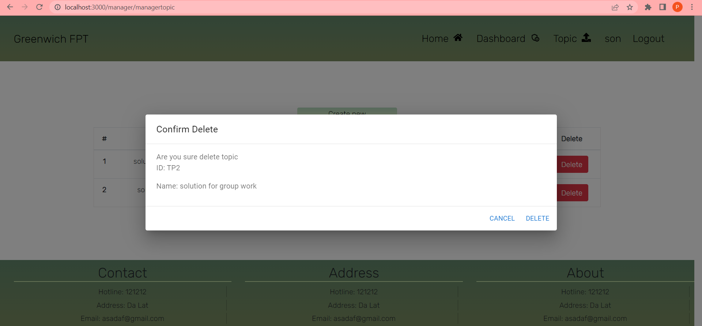

### Edit

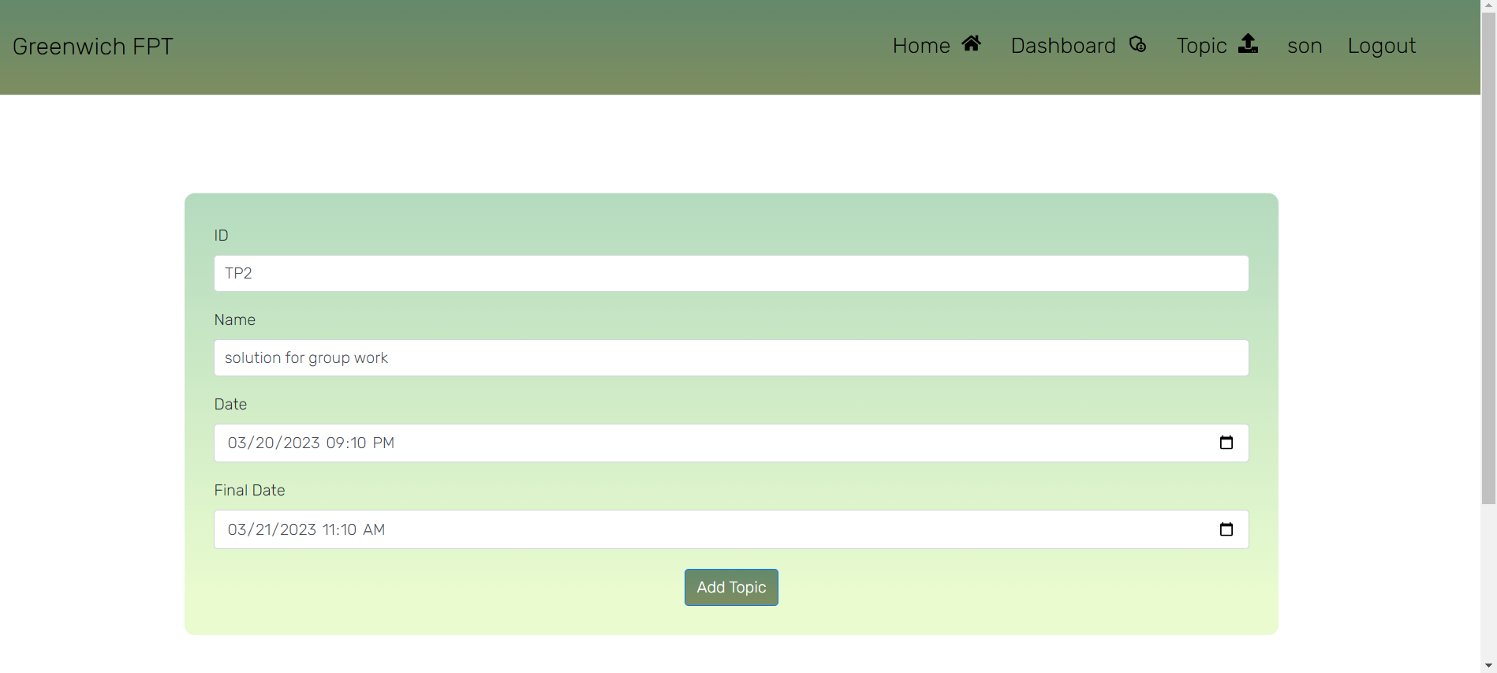

### Detail

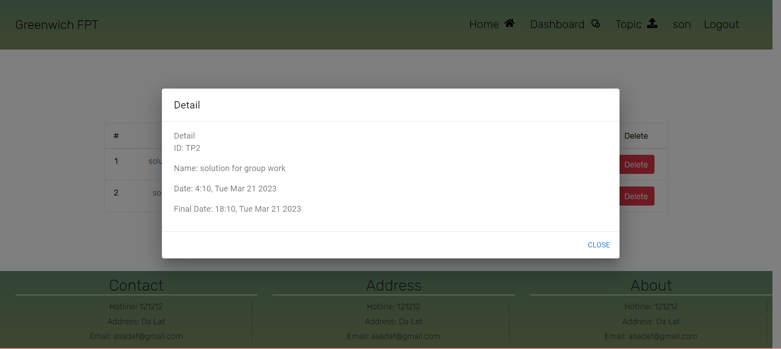

### Toast message

#### Success

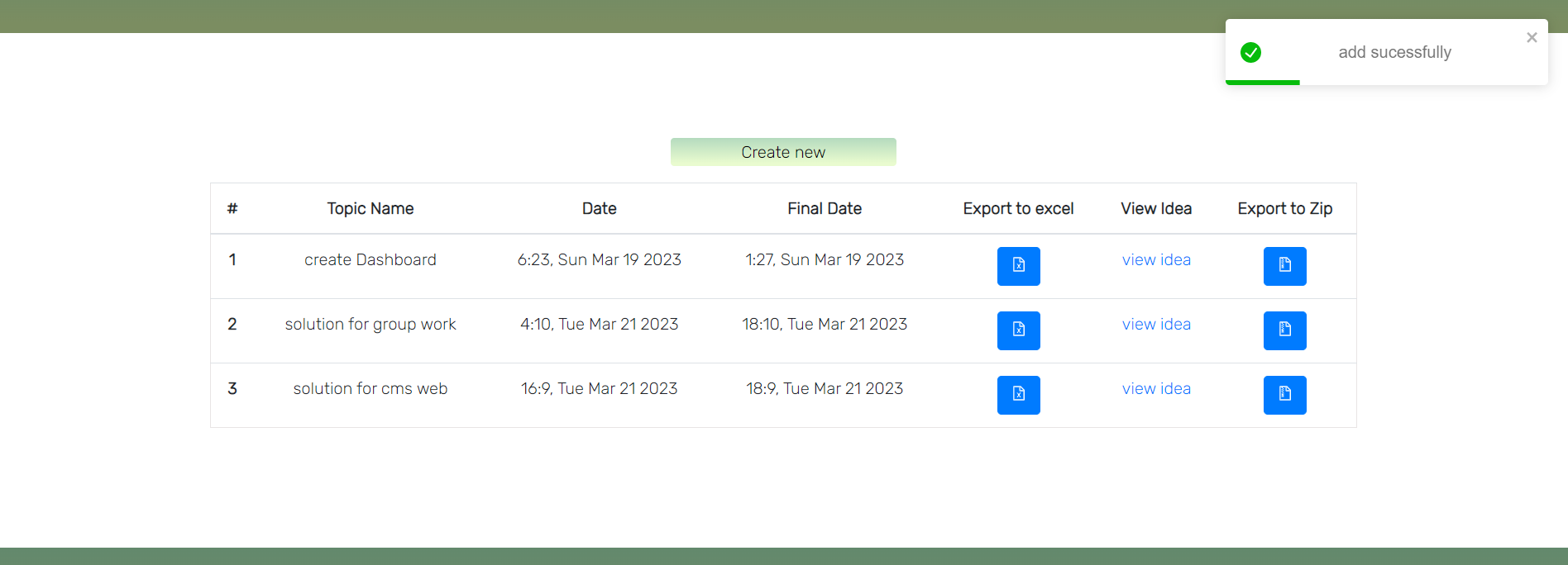

#### Failed

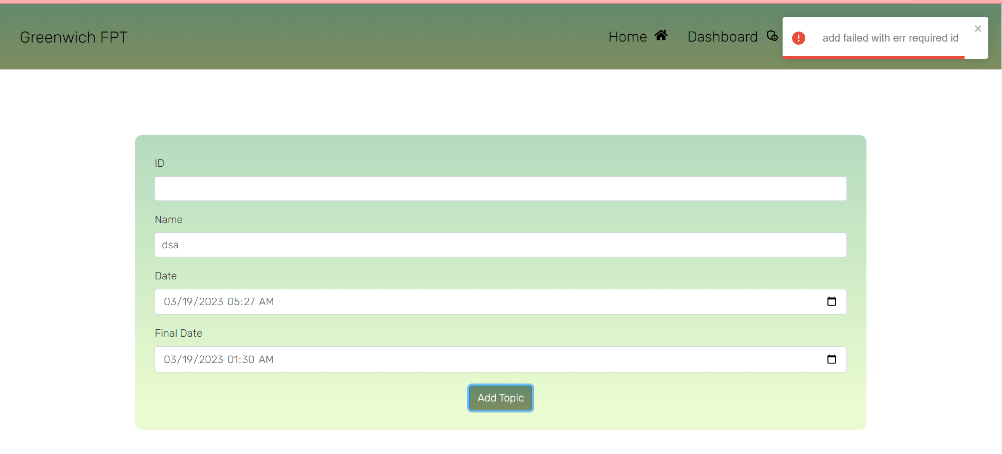

### Manager user with role

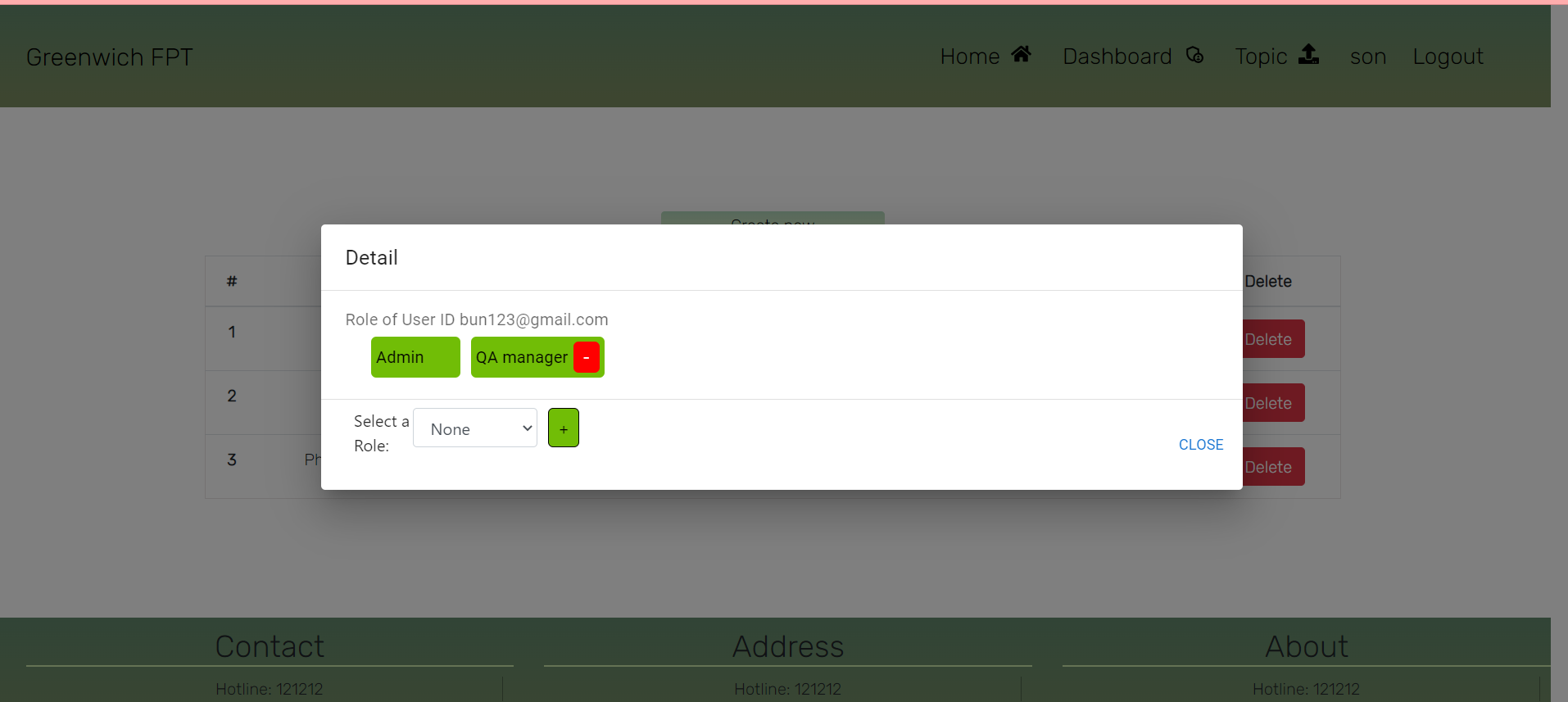

### Chart

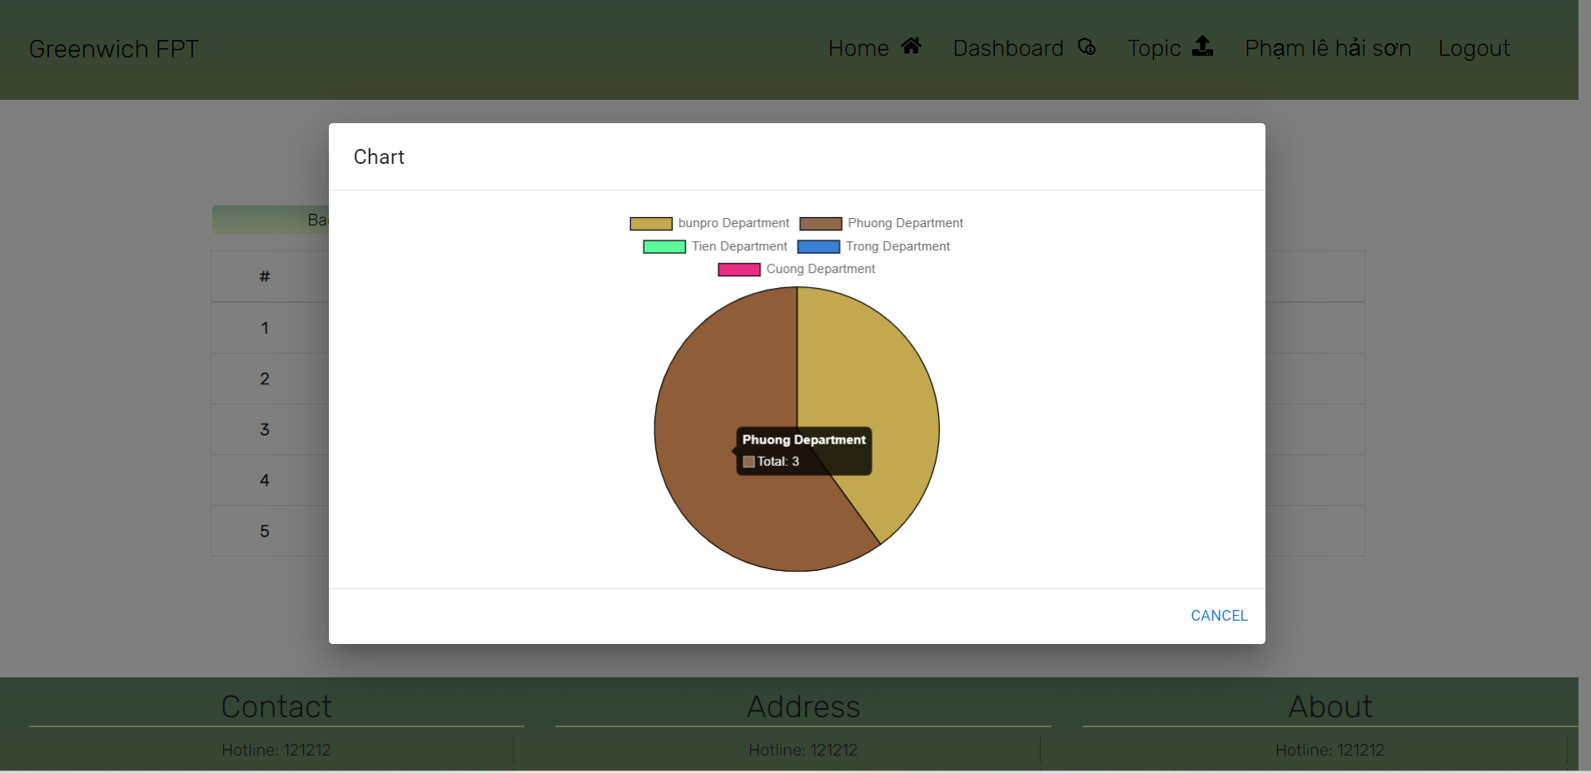

# Conclusion

# References

Fruhlinger, M., 2021. What is business intelligence? Turning data into business insights. [online] CIO. Available at: <https://www.cio.com/article/2439504/business-intelligence-definition-and-solutions.html> [Accessed 8 November 2021].

Bi4b.blogspot.com. 2021. What is BI. [online] Available at: <http://bi4b.blogspot.com/2017/12/what-is-bi.html> [Accessed 8 November 2021].

Callminer.com. 2021. What is Business Intelligence? Definition & Techniques. [online] Available at: <https://callminer.com/blog/what-is-business-intelligence-definition-techniques-tools-and-tips-from-experts> [Accessed 8 November 2021].

Selecthub.com. 2021. Best BI Tools 2021 | Top Business Intelligence Software. [online] Available at: <https://www.selecthub.com/business-intelligence-tools/> [Accessed 8 November 2021].

Powerbi.microsoft.com. 2021. What is Power BI | Microsoft Power BI. [online] Available at: <https://powerbi.microsoft.com/en-us/what-is-power-bi/> [Accessed 8 November 2021].

Tableau. 2021. What is Tableau?. [online] Available at: <https://www.tableau.com/why-tableau/what-is-tableau> [Accessed 8 November 2021].

Jacksonville. 2021. 10 Advantages of Tableau for Data Visualization. [online] Available at: <https://www.newhorizons-jax.com/blog/10-advantages-of-tableau-for-data-visualization> [Accessed 8 November 2021].

2021. [online] Available at: <https://data-flair.training/blogs/power-bi-advantages-and-disadvantages/> [Accessed 8 November 2021].

SaM Solutions. 2021. Pros and Cons of Tableau Software for Data Visualization [Review] | SaM Solutions. [online] Available at: <https://www.sam-solutions.com/blog/tableau-software-review-pros-and-cons-of-a-bi-solution-for-data-visualization/> [Accessed 8 November 2021].

Medium. 2021. *Basics of Data Preprocessing*. [online] Available at: <https://medium.com/easyread/basics-of-data-preprocessing-71c314bc7188> [Accessed 8 November 2021].

Kaggle.com. 2021. *Preprocessing and Selling Price Prediction*. [online] Available at: <https://www.kaggle.com/anshuldishoriya/preprocessing-and-selling-price-prediction/data> [Accessed 8 November 2021].

2021. [online] Available at: <https://www.forbes.com/sites/benkerschberg/2011/04/26/business-intelligence-and- legal-matter-management/#354b1e582d3c> [Accessed 8 November 2021].

Oppmann, A., 2021. *Security and legal issues are the biggest barriers to cloud BI for large & mid-size companies*. [online] BI Survey. Available at: <https://bi-survey.com/cloud-challenges-by-size> [Accessed 8 November 2021].

# Appendix

Link to github

<https://github.com/gokuhieu/cms_web_group23>