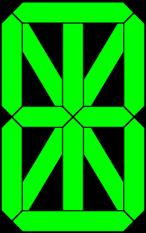

0

1

2

3

4

5

6

13

8

9

10

11

12

7



CellWidth

CellHeight

LedThickness

Gap



LedThickness

LedThickness

Sqrt(2)

