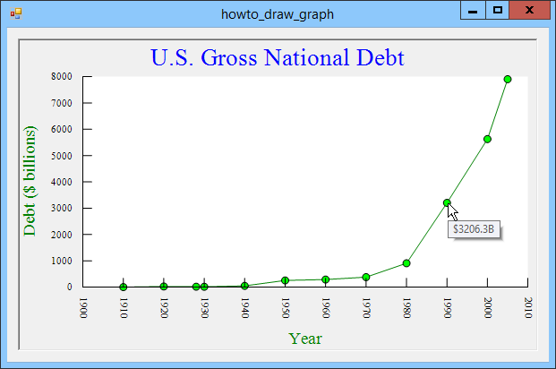

Graph Title

Tooltip

Y Axis Tic Marks

X Axis Tic Marks

X Axis Value Labels

X Axis Label

Y Axis Value Labels

Y Axis Label