my_vcs_16：
在TabControl的PWM頁製作PWM功能，需要新增通信格式。板子韌體使用CS8963_Sample_Codeg_vcs3。程式啟動時，直接跳到PWM頁。

 | Parameters | Command | 說明
PC端發送至MCU端 | AA 20 00 00 00 00 00 00 00 CS | Send_Reset_Cmd() | PC發送重置板子命令
PC端發送至MCU端 | AA 20 01 00 00 00 00 00 00 CS | Send_Initial_ADC_Cmd() | PC發送初始化ADC命令
PC端發送至MCU端 | AA 20 01 01 00 00 00 00 00 CS | Send_Disable_ADC_Cmd() | PC發送關閉ADC命令
PC端發送至MCU端 | AA 20 01 02 00 00 00 00 00 CS | Send_Read_ADC_Cmd() | PC發送讀取ADC命令
PC端發送至MCU端 | AA 20 01 03 00 00 00 00 00 CS | Send_Disable_Read_ADC_Cmd() | PC發送停止讀取ADC命令
PC端發送至MCU端 | AA 20 02 00 pin 00 00 00 00 CS | Send_Initial_DAC_Cmd(pin) | PC發送初始化DAC命令
PC端發送至MCU端 | AA 20 02 01 pin 00 00 00 00 CS | Send_Disable_DAC_Cmd(pin) | PC發送關閉DAC命令
PC端發送至MCU端 | AA 20 02 02 pin DACH DACL 00 00 CS | Send_DAC_Data_Cmd(pin, H, L) | PC發送設定DAC資料命令
PC端發送至MCU端 | AA 20 02 03 pin mVH mVL 00 00 CS | Send_DAC_Voltage_Cmd(pin, VH, VL) | PC發送設定DAC電壓命令
PC端發送至MCU端 | AA 20 02 04 on_off 00 00 00 00 CS | Send_DAC_Demo_Mode_Cmd(on_off) | PC發送DAC展示模式命令
PC端發送至MCU端 | AA 20 03 00 00 00 00 00 00 CS | Send_Initial_PWM_Cmd() | PC發送初始化PWM命令
PC端發送至MCU端 | AA 20 03 01 00 00 00 00 00 CS | Send_Disable_PWM_Cmd() | PC發送關閉PWM命令
PC端發送至MCU端 | AA 20 03 02 PRDH PRDL duty DT POL CS | Send_PWM_Parameter_Cmd(  PRDH, PRDL, duty, deadtime, polarity) | PC發送設定PWM參數命令
PC端發送至MCU端 | AA 20 03 03 port_on 00 00 00 00 CS | Send_PWM_ON_OFF_Cmd(port_on) | PC發送設定PWM開關命令
PC端發送至MCU端 | AA 20 03 04 on_off 00 00 00 00 CS | Send_PWM_Demo_Mode_Cmd(on_off) | PC發送PWM展示模式命令
 | MCU發送至PC端
 | 55 20 01 ADCH ADCL 00 00 00 00 CS | Send_ADC_Result_Cmd() | MCU發送讀取ADC結果
PWM ON/OFF，1:ON、0：OFF
Port_on：AP：0010_0000、AN：0001_0000、BP：0000_1000、BN：0000_0100、CP：0000_0010、CN：0000_0001
PWM Polarity，
NPOL:PPOL=00 PN皆不反相 NPOL:PPOL=01 P反相、N不反相
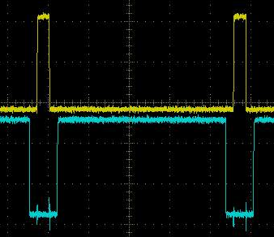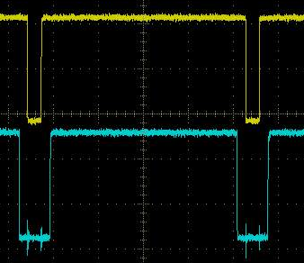
AP

AN
NPOL:PPOL=10 N反相、P不反相 NPOL:PPOL=11 PN皆反相
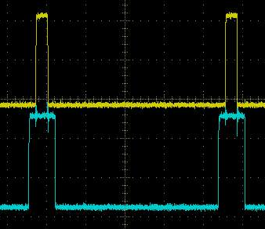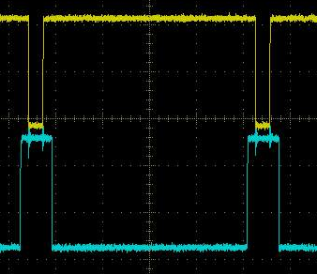
my_vcs_17：
接續my_vcs_16。在TabControl的CMP頁製作CMP功能，需要新增通信格式。板子韌體使用CS8963_Sample_Codeg_vcs3。程式啟動時，直接跳到CMP頁。

 | Parameters | Command | 說明
PC端發送至MCU端 | AA 20 00 00 00 00 00 00 00 CS | Send_Reset_Cmd() | PC發送重置板子命令
PC端發送至MCU端 | AA 20 01 00 00 00 00 00 00 CS | Send_Initial_ADC_Cmd() | PC發送初始化ADC命令
PC端發送至MCU端 | AA 20 01 01 00 00 00 00 00 CS | Send_Disable_ADC_Cmd() | PC發送關閉ADC命令
PC端發送至MCU端 | AA 20 01 02 00 00 00 00 00 CS | Send_Read_ADC_Cmd() | PC發送讀取ADC命令
PC端發送至MCU端 | AA 20 01 03 00 00 00 00 00 CS | Send_Disable_Read_ADC_Cmd() | PC發送停止讀取ADC命令
PC端發送至MCU端 | AA 20 02 00 pin 00 00 00 00 CS | Send_Initial_DAC_Cmd(pin) | PC發送初始化DAC命令
PC端發送至MCU端 | AA 20 02 01 pin 00 00 00 00 CS | Send_Disable_DAC_Cmd(pin) | PC發送關閉DAC命令
PC端發送至MCU端 | AA 20 02 02 pin DACH DACL 00 00 CS | Send_DAC_Data_Cmd(pin, H, L) | PC發送設定DAC資料命令
PC端發送至MCU端 | AA 20 02 03 pin mVH mVL 00 00 CS | Send_DAC_Voltage_Cmd(pin, VH, VL) | PC發送設定DAC電壓命令
PC端發送至MCU端 | AA 20 02 04 on_off 00 00 00 00 CS | Send_DAC_Demo_Mode_Cmd(on_off) | PC發送DAC展示模式命令
PC端發送至MCU端 | AA 20 03 00 00 00 00 00 00 CS | Send_Initial_PWM_Cmd() | PC發送初始化PWM命令
PC端發送至MCU端 | AA 20 03 01 00 00 00 00 00 CS | Send_Disable_PWM_Cmd() | PC發送關閉PWM命令
PC端發送至MCU端 | AA 20 03 02 PRDH PRDL duty DT POL CS | Send_PWM_Parameter_Cmd(  PRDH, PRDL, duty, deadtime, polarity) | PC發送設定PWM參數命令
PC端發送至MCU端 | AA 20 03 03 port_on 00 00 00 00 CS | Send_PWM_ON_OFF_Cmd(port_on) | PC發送設定PWM開關命令
PC端發送至MCU端 | AA 20 04 00 pin VTH 00 00 00 CS | Send_Initial_CMP_Cmd(pin, VTH) | PC發送初始化CMP命令
PC端發送至MCU端 | AA 20 04 01 00 00 00 00 00 CS | Send_Disable_CMP_Cmd() | PC發送關閉CMP命令
 | MCU發送至PC端
 | 55 20 01 ADCH ADCL 00 00 00 00 CS | Send_ADC_Result_Cmd() | MCU發送讀取ADC結果
 | 55 20 04 CMP 00 00 00 00 00 CS | Send_CMP_Result_Cmd() | MCU發送讀取CMP結果

my_vcs_18：
跑馬燈範例。

my_vcs_19：
TabControl範例，讓TabPage顯示或隱藏。

-----施工中---------------------------------------------------------------------------------------------------------
my_vcs_17：
接續my_vcs_17。在TabControl的Timer頁製作Timer功能，需要新增通信格式。板子韌體使用CS8963_Sample_Codeg_vcs3。

 | Parameters | Command | 說明
PC端發送至MCU端 | AA 20 00 00 00 00 00 00 00 CS | Send_Reset_Cmd() | PC發送重置板子命令
PC端發送至MCU端 | AA 20 01 00 00 00 00 00 00 CS | Send_Initial_ADC_Cmd() | PC發送初始化ADC命令
PC端發送至MCU端 | AA 20 01 01 00 00 00 00 00 CS | Send_Disable_ADC_Cmd() | PC發送關閉ADC命令
PC端發送至MCU端 | AA 20 01 02 00 00 00 00 00 CS | Send_Read_ADC_Cmd() | PC發送讀取ADC命令
PC端發送至MCU端 | AA 20 01 03 00 00 00 00 00 CS | Send_Disable_Read_ADC_Cmd() | PC發送停止讀取ADC命令
PC端發送至MCU端 | AA 20 02 00 pin 00 00 00 00 CS | Send_Initial_DAC_Cmd(pin) | PC發送初始化DAC命令
PC端發送至MCU端 | AA 20 02 01 pin 00 00 00 00 CS | Send_Disable_DAC_Cmd(pin) | PC發送關閉DAC命令
PC端發送至MCU端 | AA 20 02 02 pin DACH DACL 00 00 CS | Send_DAC_Data_Cmd(pin, H, L) | PC發送設定DAC資料命令
PC端發送至MCU端 | AA 20 02 03 pin mVH mVL 00 00 CS | Send_DAC_Voltage_Cmd(pin, VH, VL) | PC發送設定DAC電壓命令
PC端發送至MCU端 | AA 20 02 04 on_off 00 00 00 00 CS | Send_DAC_Demo_Mode_Cmd(on_off) | PC發送DAC展示模式命令
PC端發送至MCU端 | AA 20 03 00 00 00 00 00 00 CS | Send_Initial_PWM_Cmd() | PC發送初始化PWM命令
PC端發送至MCU端 | AA 20 03 01 00 00 00 00 00 CS | Send_Disable_PWM_Cmd() | PC發送關閉PWM命令
PC端發送至MCU端 | AA 20 03 02 PRDH PRDL duty DT POL CS | Send_PWM_Parameter_Cmd(  PRDH, PRDL, duty, deadtime, polarity) | PC發送設定PWM參數命令
PC端發送至MCU端 | AA 20 03 03 port_on 00 00 00 00 CS | Send_PWM_ON_OFF_Cmd(port_on) | PC發送設定PWM開關命令
PC端發送至MCU端 | AA 20 04 00 pin mode VTH mVH mVL CS | Send_Initial_CMP_Cmd1(  pin, mode, VTH, mVH, mVL) | PC發送初始化CMP命令  mode=0, 設定Vth,  mode=1, 設定 mV。
PC端發送至MCU端 | AA 20 04 01 00 00 00 00 00 CS | Send_Disable_CMP_Cmd() | PC發送關閉CMP命令
PC端發送至MCU端 | AA 20 05 00 timer on_off TT TH TL CS | Send_Timer_Setup_Cmd(timer, on_off, TT, TH, TL) | PC發送設定Timer命令
 | MCU發送至PC端
 | 55 20 01 ADCH ADCL 00 00 00 00 CS | Send_ADC_Result_Cmd() | MCU發送讀取ADC結果
 | 55 20 04 CMP 00 00 00 00 00 CS | Send_CMP_Result_Cmd() | MCU發送讀取CMP結果

timer：0：Timer0、1：Timer1、2：Timer2、3：Timer3、4：Timer4、5：Timer5
on_off：1：ON、0：OFF

GPIO控制按鍵、控制LED燈號
Flash Read/Write
IFB
UART測試與校正
PWM緊急中止
讀Hall Sensor結果

