Marco Buiani
Daniele Verì
Present Wrapping Problem

Z3 SAT model

Problem representation
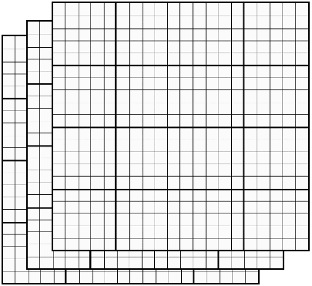
We use an NxWxH numpy tensor of boolean decision variables corresponding to the available position for each present, each occupying one of the N layers.

pos = np.empty((n, paper_shape[0], paper_shape[1]), dtype=object)

for i in range(paper_shape[0]):
for j in range(paper_shape[1]):
for k in range(n):
pos[k,i,j] = Bool('p'+str(k)+str(i)+str(j))

Core constraints

non-overlapping: for each position, at most one layer must hold, i.e. at most one present occupies that position.

for i in range(paper_shape[0]):
for j in range(paper_shape[1]):
notoverlap = Not(Or(*[And(pos[k1,i,j], pos[k2,i,j])
for k1 in range(n) for k2 in range(k1)]))
s.add(notoverlap)

shape compactness: for each layer (present) exactly one set of variables representing the rectangular shape must hold. All the sets of a layer are found by sliding a window in the plane, much like a 2D convolution.

for k in range(n):
conj = []
for i in range(paper_shape[0]-present_shape[k][0]+1):
for j in range(paper_shape[1]-present_shape[k][1]+1):
occupations = []
for x in range(paper_shape[0]):
for y in range(paper_shape[1]):
if (i <= x < i+present_shape[k][0] and
j<= y < j+present_shape[k][1]):
occupations.append(pos[k,x,y])
else:
occupations.append(Not(pos[k,x,y]))

conj.append(And(*occupations))

# at least
s.add(Or(*conj))

# at most
conj_pairs = [And(conj[i],conj[j])
for i in range(len(conj))
for j in range(i) if i != j]
s.add((Not(Or(*conj_pairs))))

Implied constraint

total area occupation: for each position, exactly one layer must hold.
We insert this constraint conditionally at model compilation time.

for i in range(paper_shape[0]):
for j in range(paper_shape[1]):
if present_area == paper_area:
o = Or([pos[k,i,j] for k in range(n)])
s.add(o)

