Marco Buiani
Daniele Verì
Present Wrapping Problem

Z3 SMT model

Problem representation

The problem uses decision variables pairs for the left-bottom corner of each present, added by the following python loop:

present_pos = []

for i in range(n):
present_pos.append((Int('x'+str(i)), Int('y'+str(i))))

Core constraints

The available roll paper shape constrains the position of present rectangles to be inside the bounding box

for i in range(n):
for j in range(2):
s.add(0 <= present_pos[i][j], present_pos[i][j] <= paper_shape[j] - present_shape[i][j])

The non-overlapping constraint is implemented for each pair of distinct presents.
Moreover, the pairs repetition is avoided by iterating “j” index over ”i” only.

for i in range(n):
for j in range(i):
s.add(Or(present_pos[i][0] + present_shape[i][0] <= present_pos[j][0],
present_pos[i][0] >= present_pos[j][0] + present_shape[j][0],
present_pos[i][1] + present_shape[i][1] <= present_pos[j][1],
present_pos[i][1] >= present_pos[j][1] + present_shape[j][1]))

Implied constraint

We add the suggested partial sums implied constraint for each row and column.
The partial sums are computed with an SMT if-then-else boolean operator, this checks if a present occupies the current column/row.

for k in (0,1):
for j in range(paper_shape[k]):
partial_sum = []
for i in range(n):
inc = If(And(present_pos[i][k] <= j, present_pos[i][k] + present_shape[i][k] > j), present_shape[i][1-k], 0)
partial_sum.append(inc)

s.add(sum(partial_sum) <= paper_shape[k])

Results

The solving time for each proposed instance is plotted.

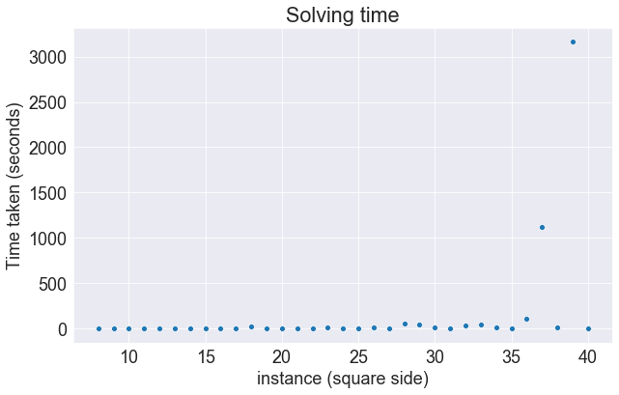

Other than time, the Microsoft Z3 Solver object offers the statistics() method, it returns a python dictionary with details about DPLL and T solver resolutions.

DPLL solver statistics (instance 39x39)

conflicts 5436
decisions 30083
propagations 5086590
binary propagations 4181210
restarts 42
added eqs 1179373
mk clause 89930
del clause 31448
minimized lits 15835

ILP solver statistics (instance 39x39)

arith conflicts 1637
arith row summations 345817
arith num rows 890
arith pivots 10620
arith tableau max rows 890
arith tableau max columns 3227

