LAB03-REPORT
Name: Nguyễn Ngọc Linh
ID: 20235520

- Source Code
- Method overloading

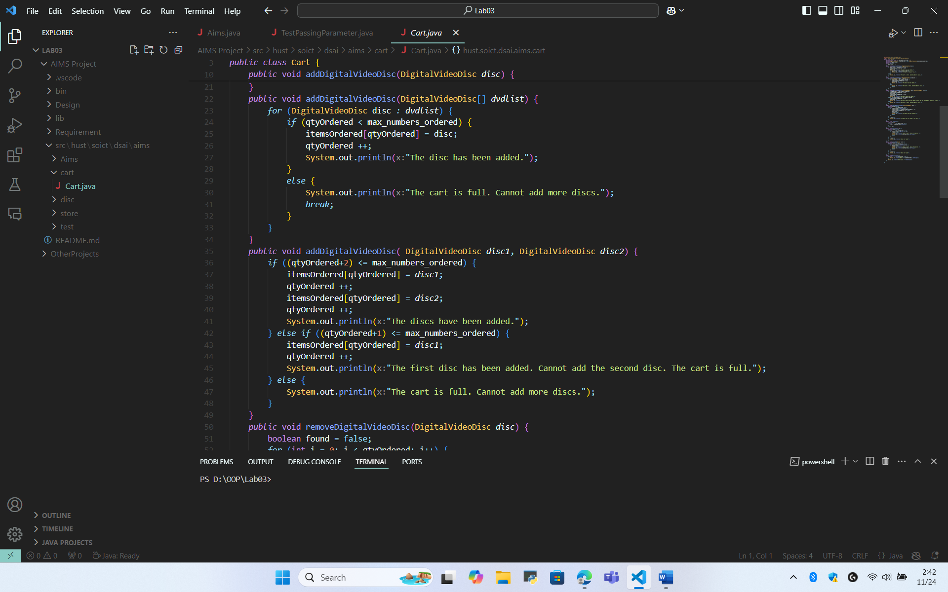

- Passing parameter

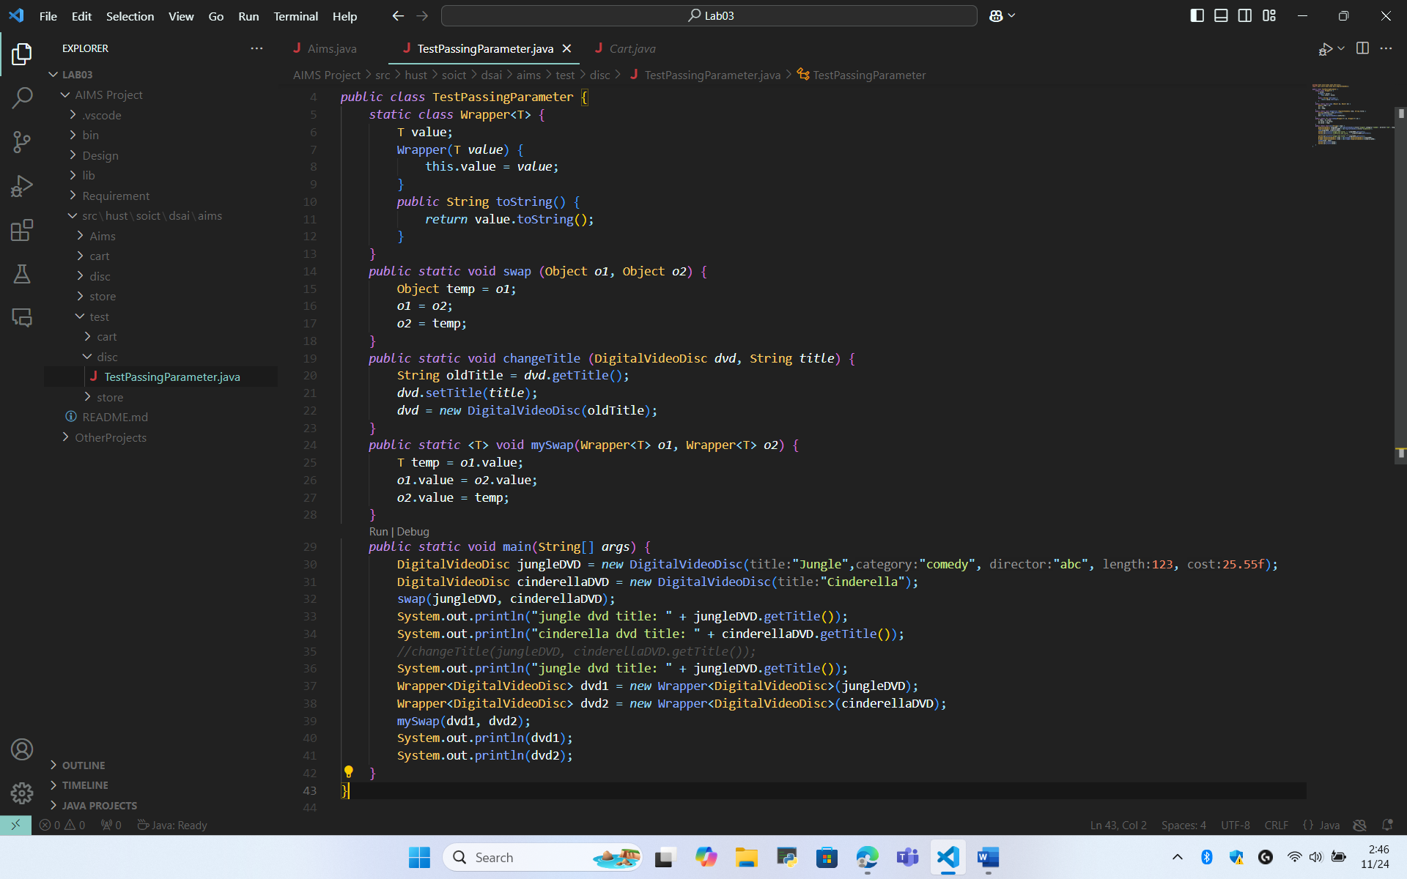

- Use Debug Run
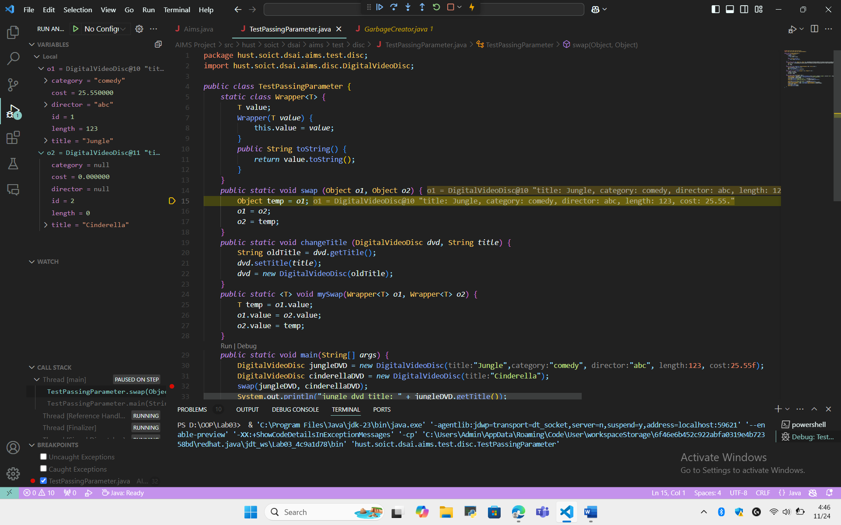
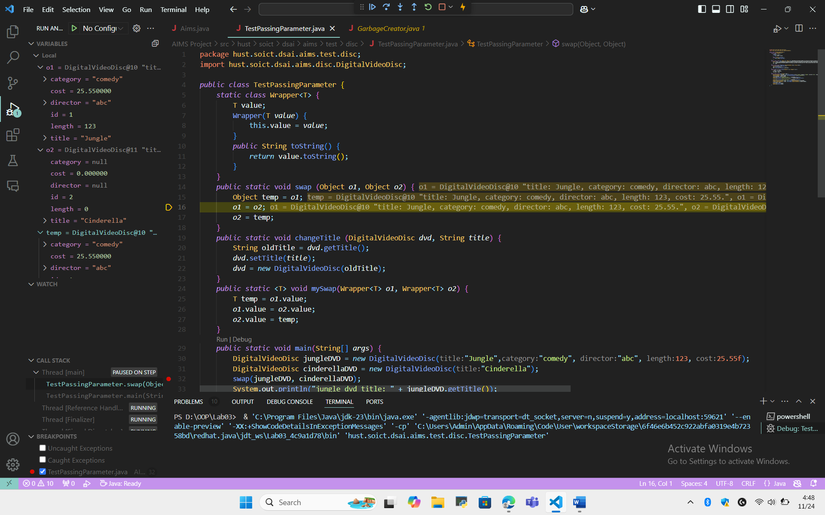
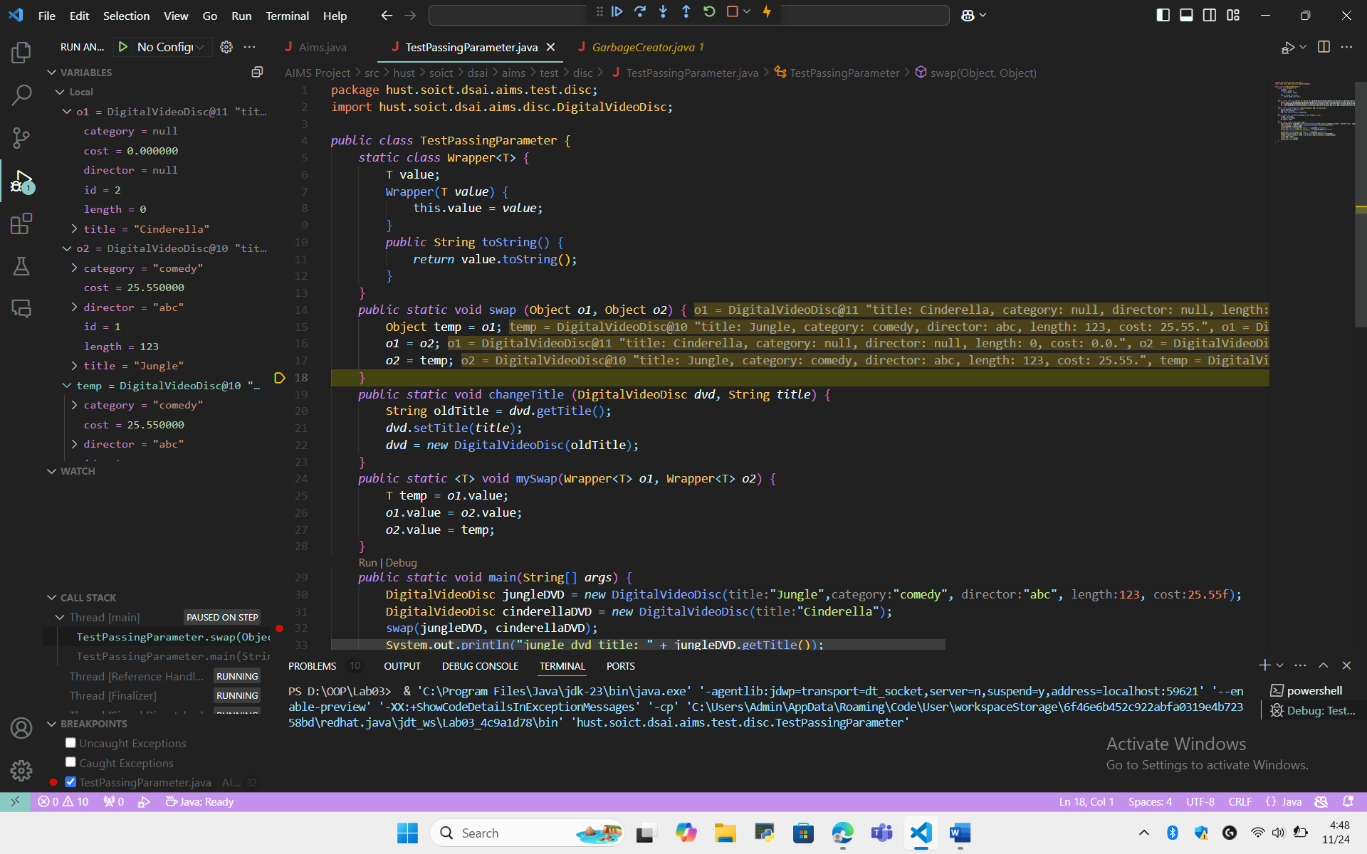
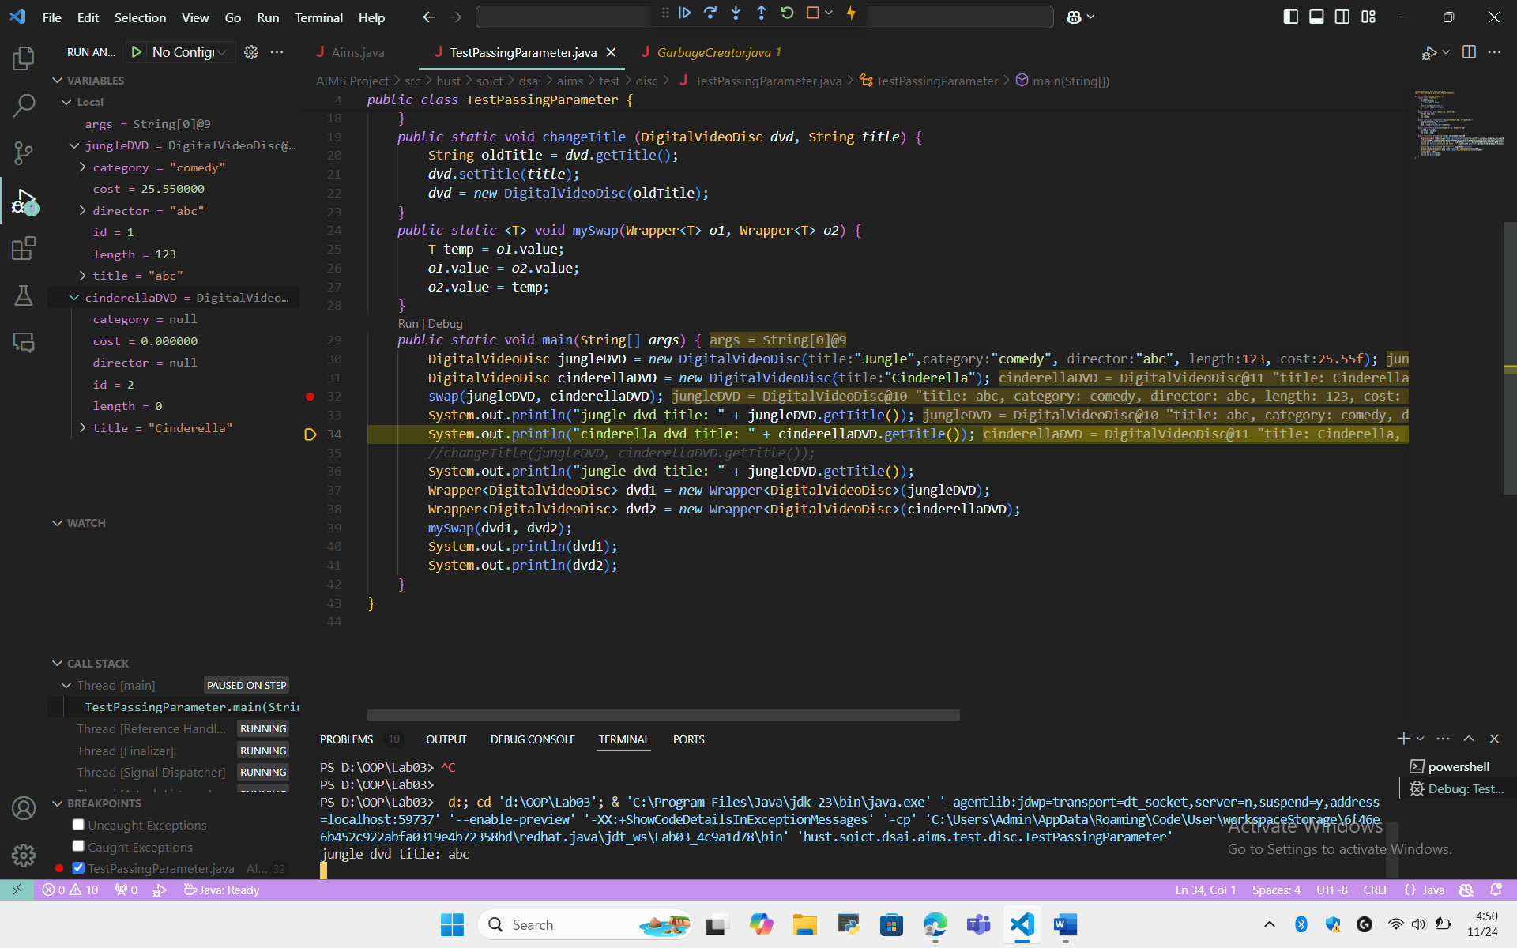

- Classifier Member and Instance Member

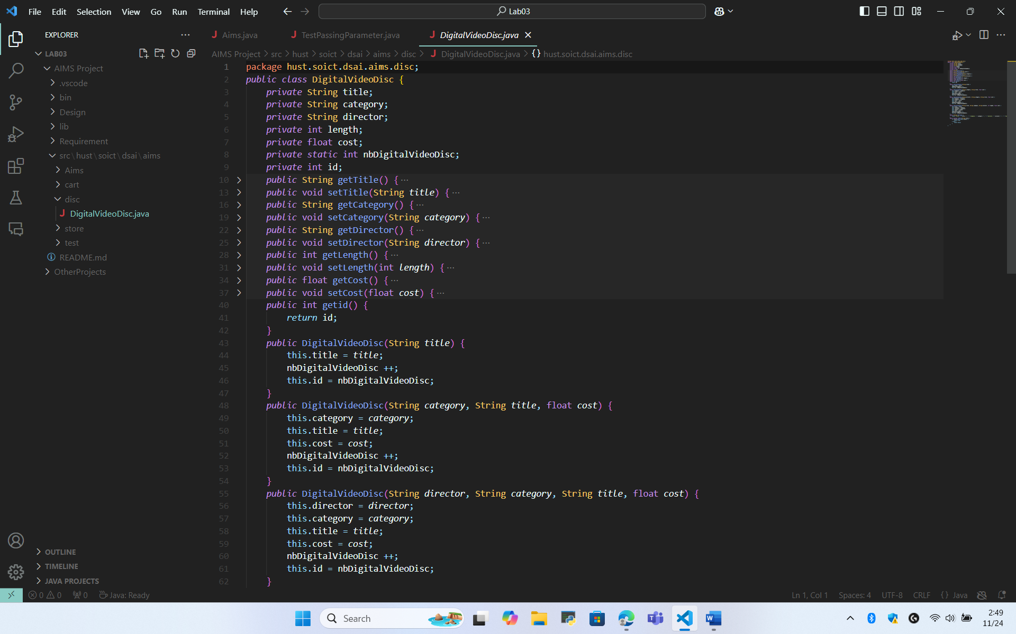

- Cart class
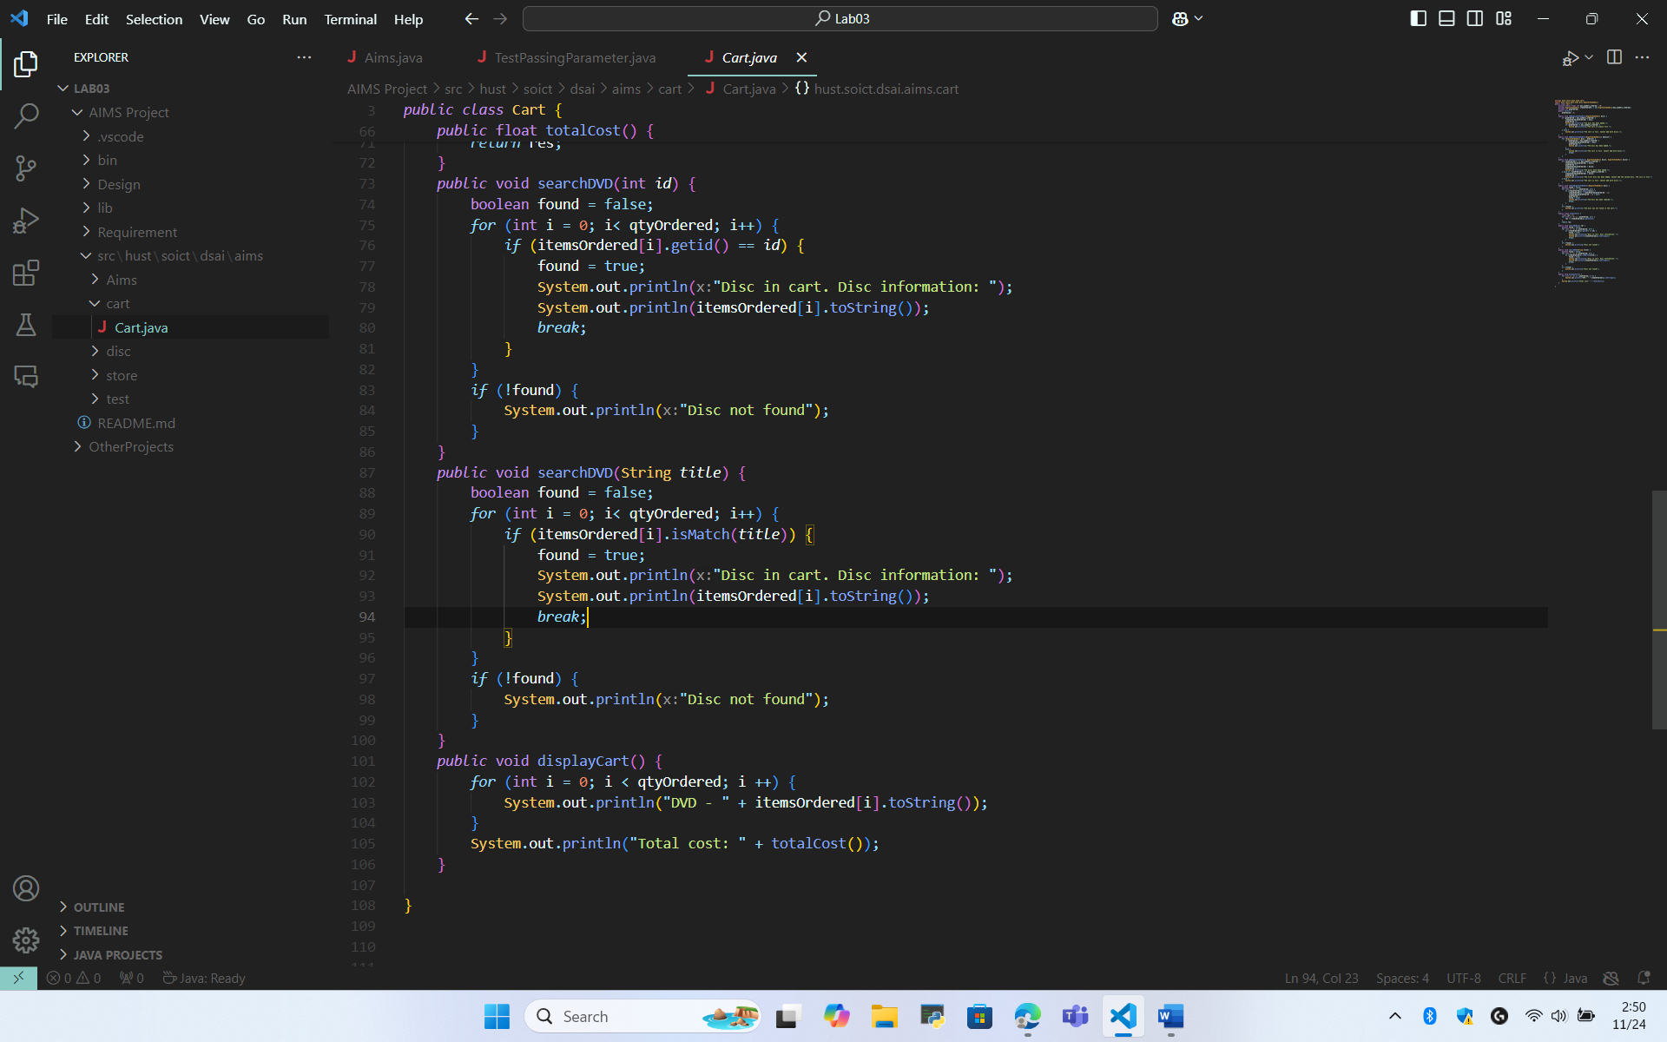
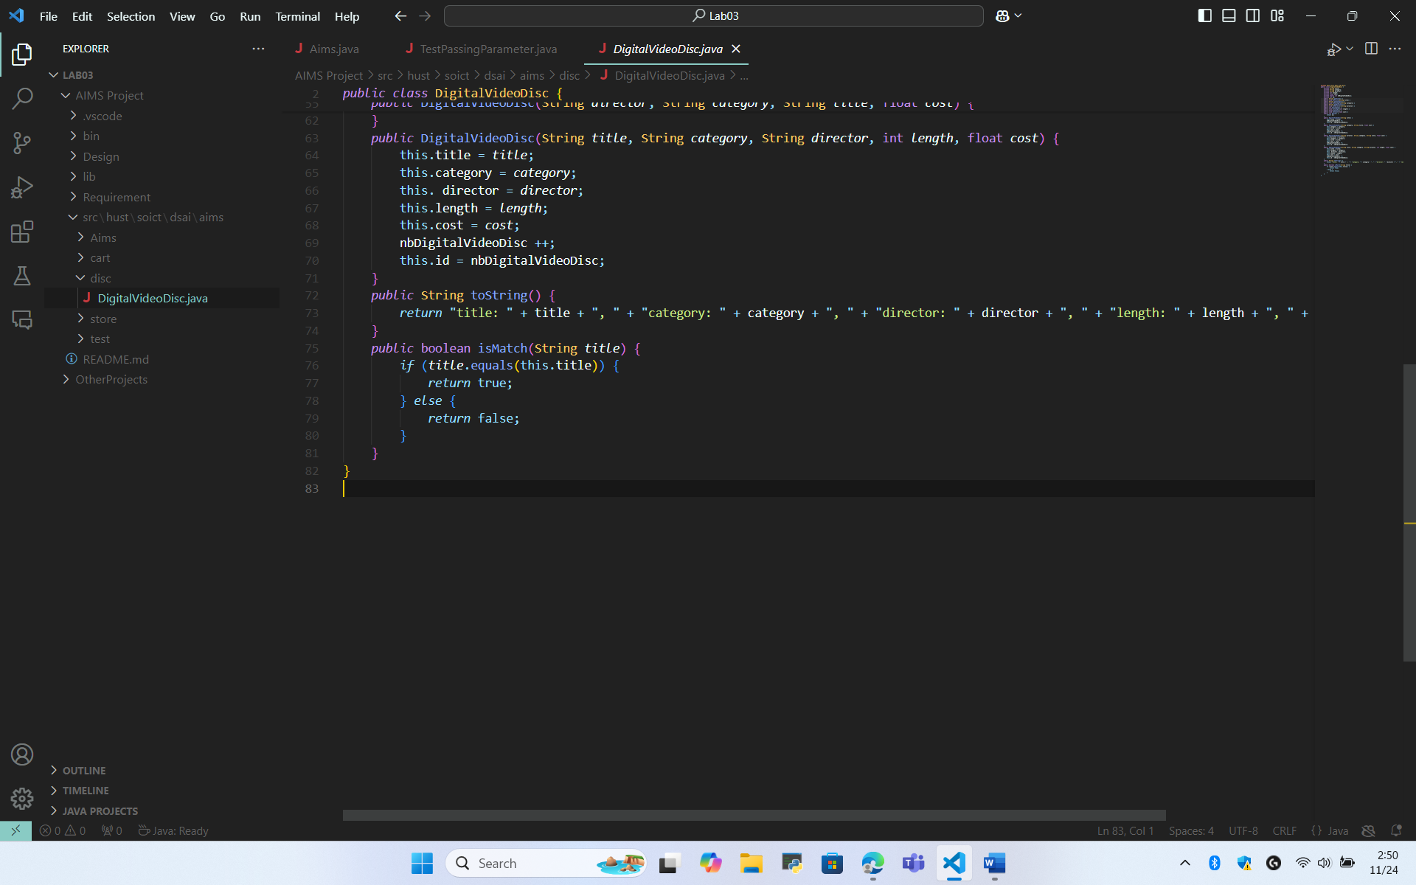

- Store Class

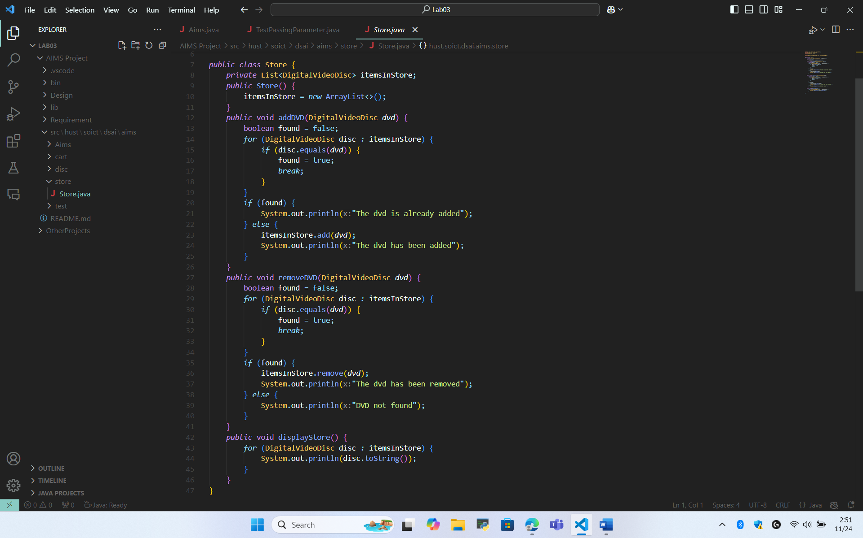

- StringBuilder, StringBuffer

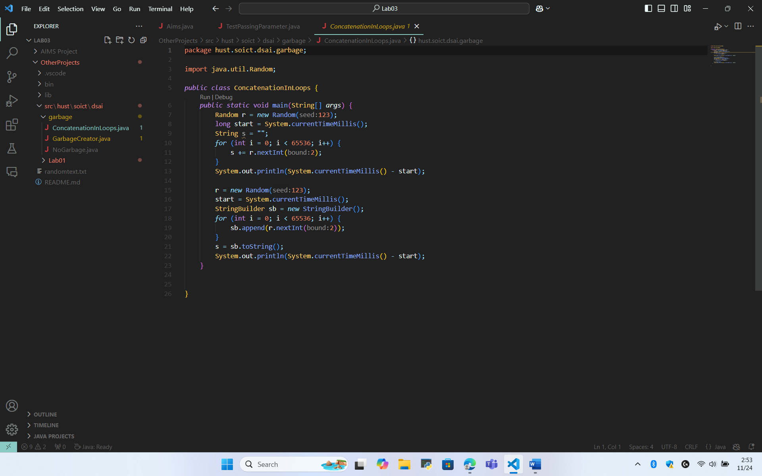
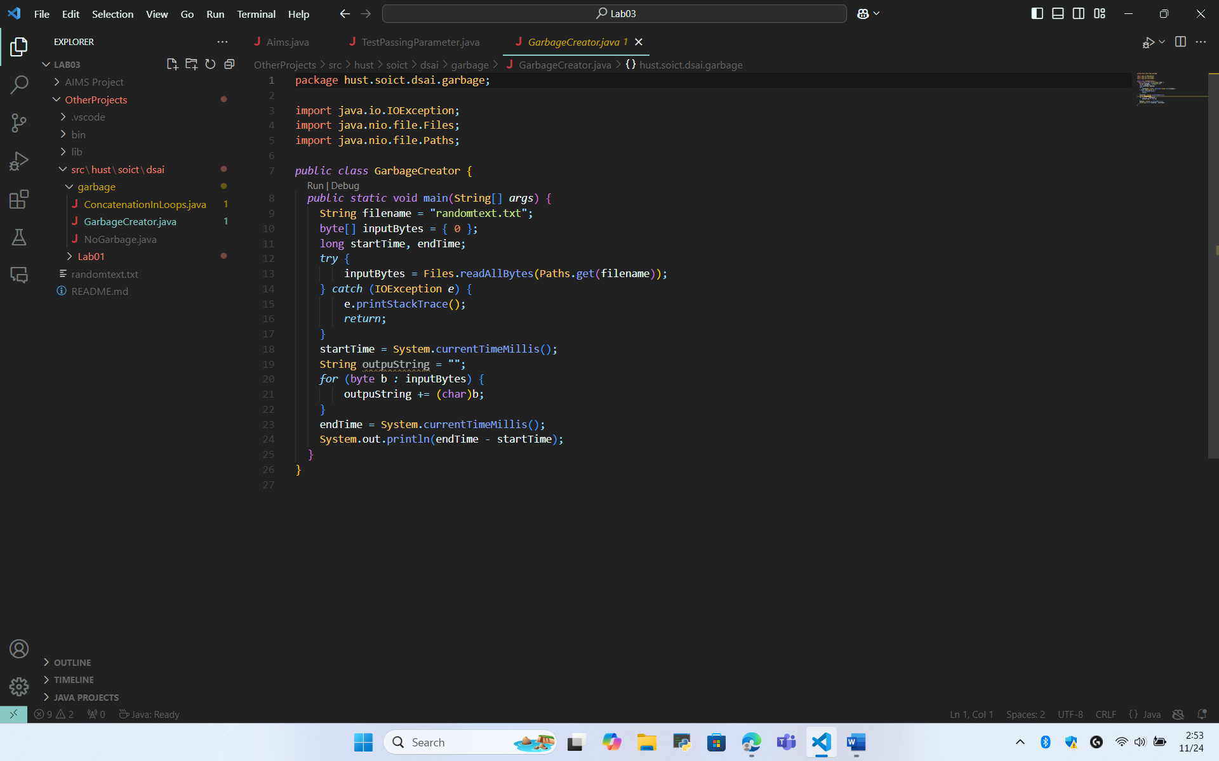
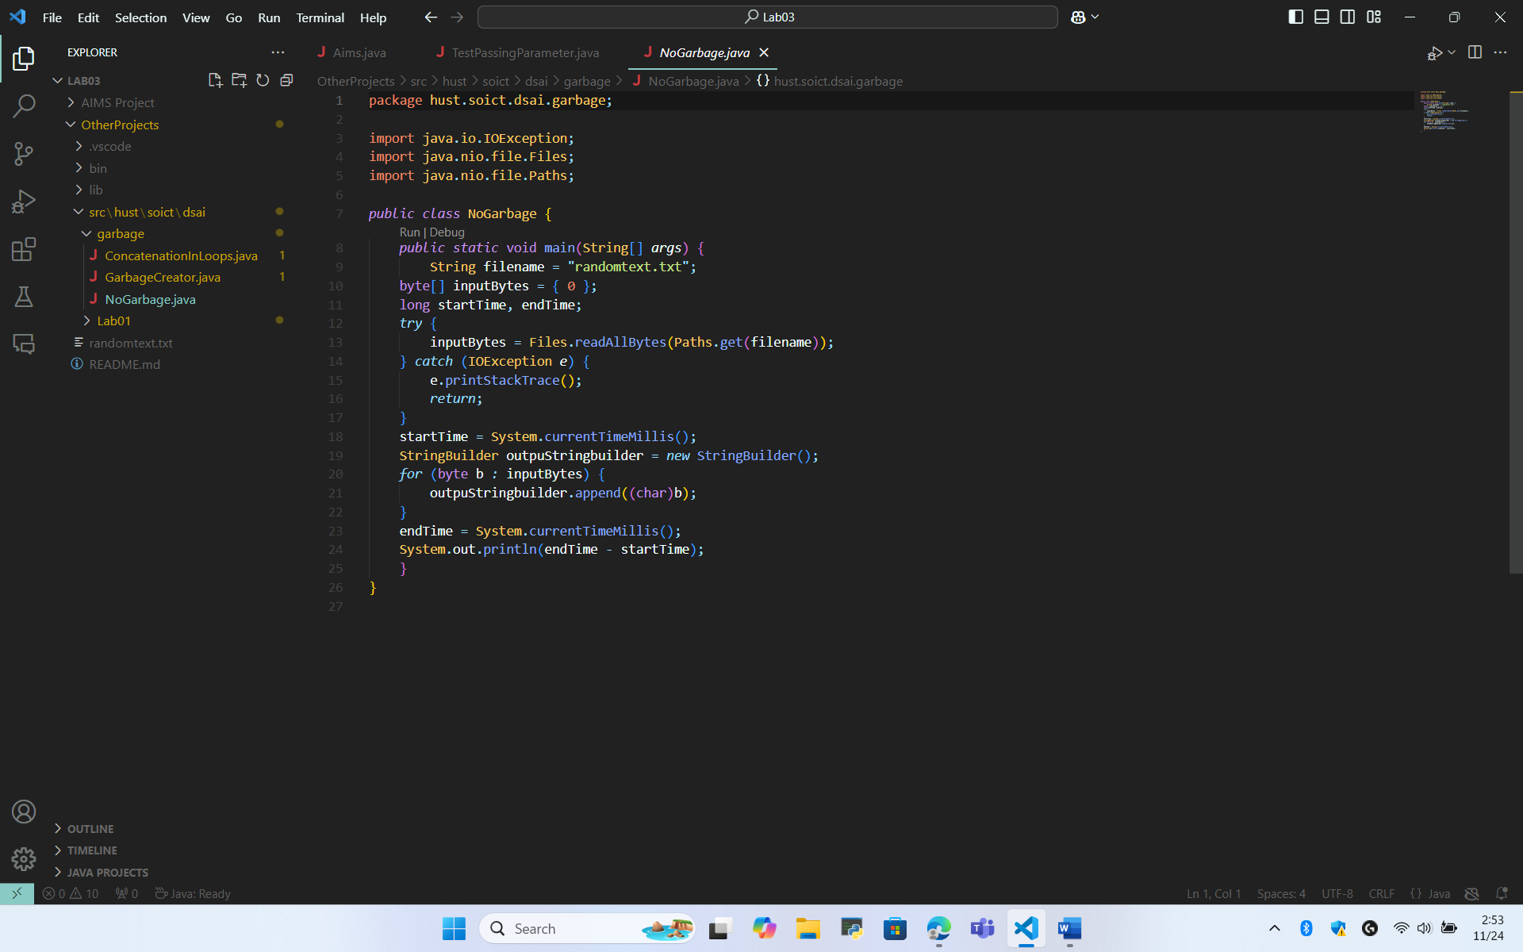

- Updated diagram
- Use case

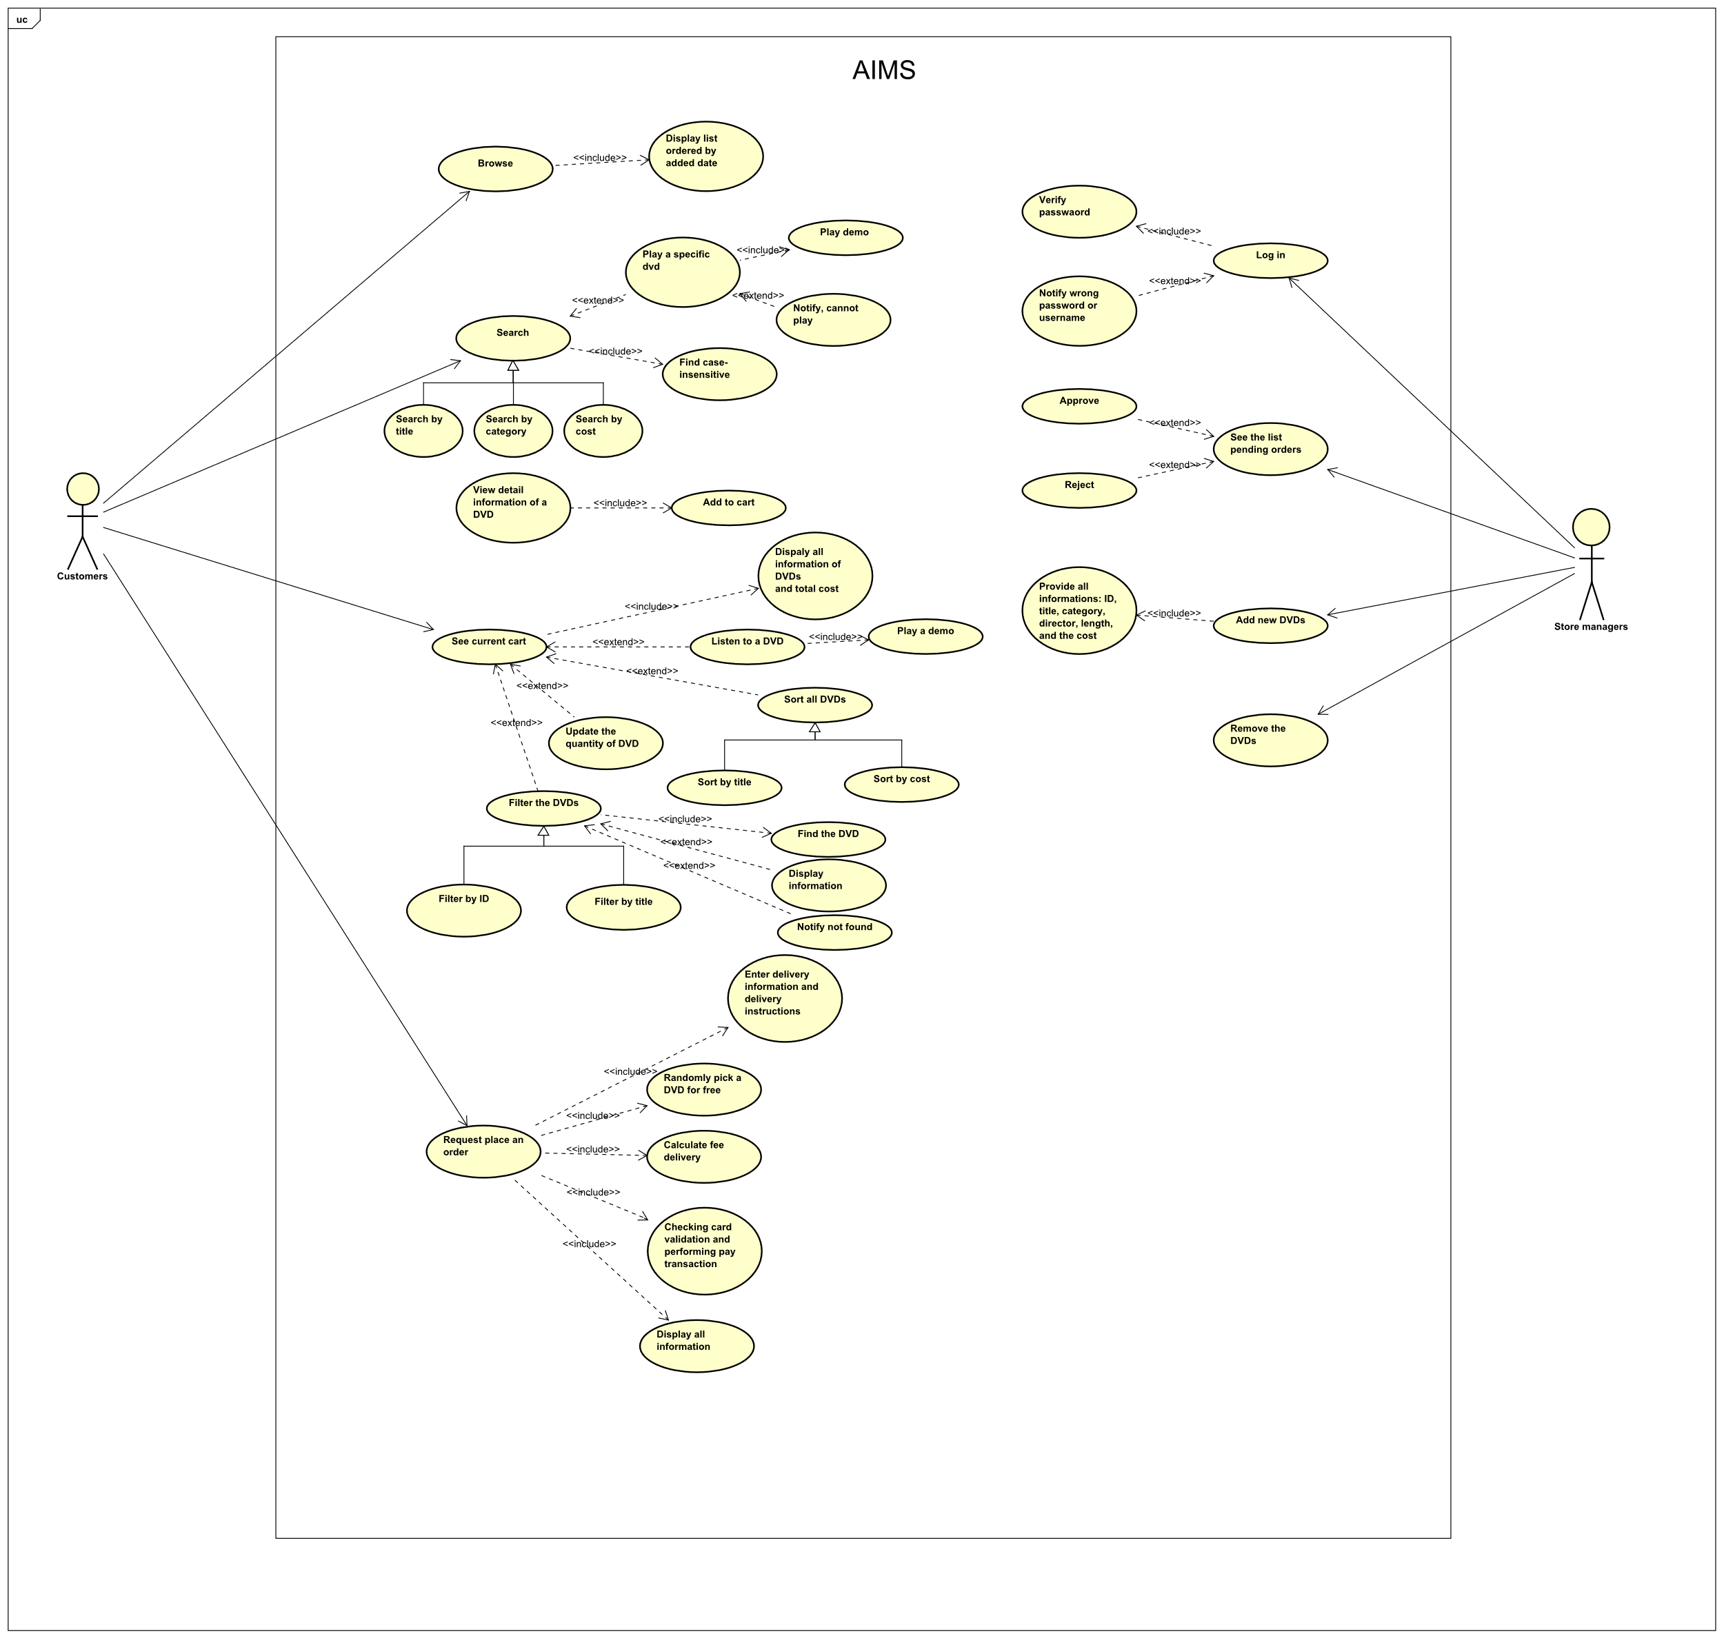

- Class
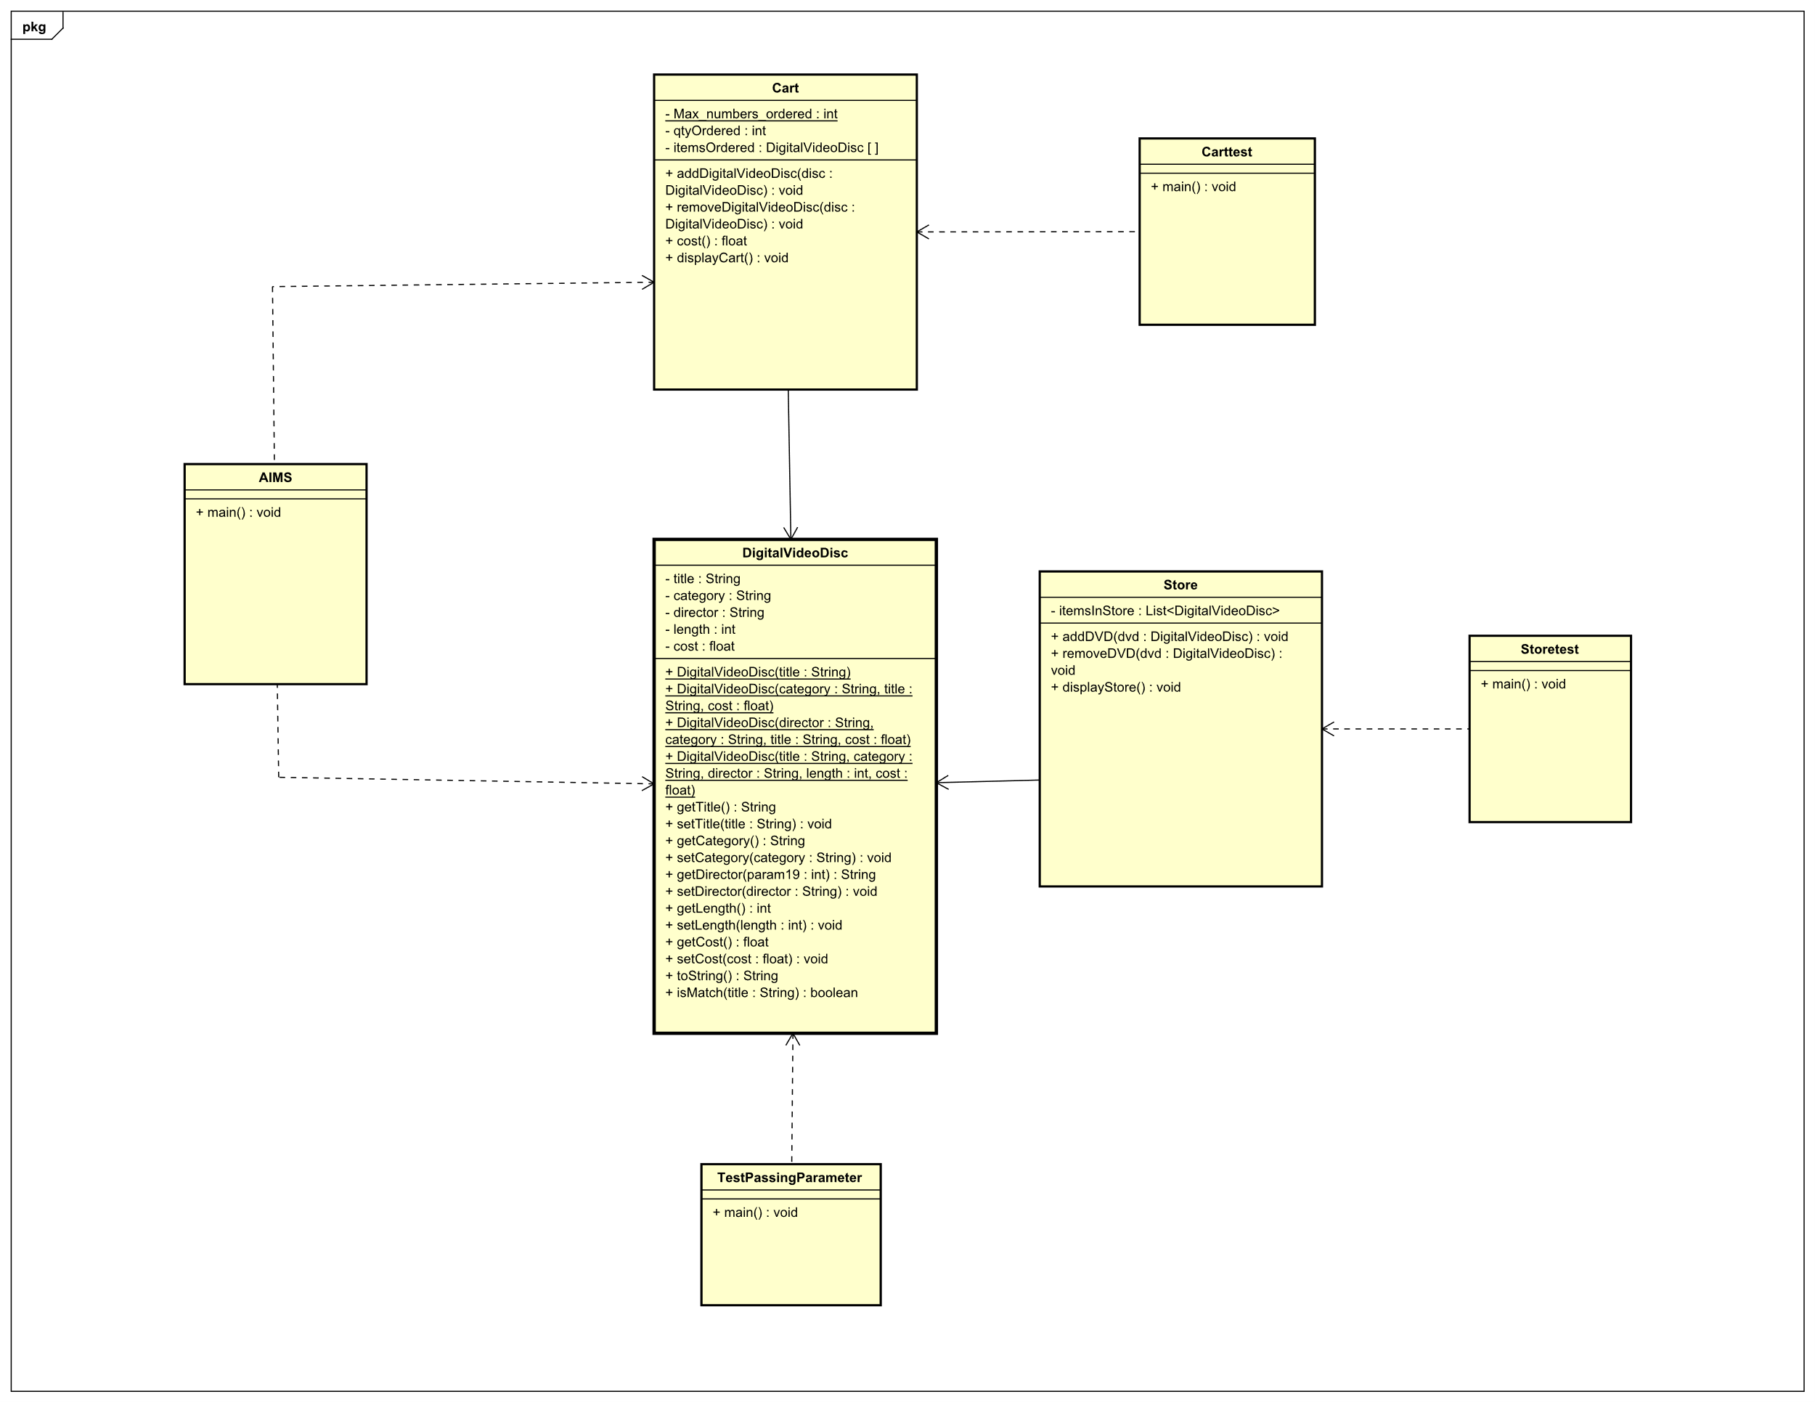
- Answer questions
- After the call of swap(jungleDVD, cinderellaDVD) why does the title of these two objects still remain?
- After the call of changeTitle(jungleDVD, cinderellaDVD.getTitle()) why is the title of the JungleDVD changed?
- Is JAVA a Pass by Value or a Pass by Reference programming language?
Java is a pass by value programming language, so after the call of swap(jungleDVD, cinderellaDVD), this method only swaps the copies of the references, not the actual references, hence these two objects still remain. In the second method, the dvd parameter is a reference to the same DigitalVideoDisc object as jungle DVD, hence when you use method setTitle, it change the title of that actual object.
Conclusion, Java is a pass by value programming language.

