

**UNIVERSITY OF GREENWICH**

**BSC COMPUTING**

**COMP 1645**

**001044341**

Table of Contents

INTRODUCTION …………………………………………………………………………..3

A1. NSSG RICH PICTURE…………………………………………………………………………………………..4

A2. ELO RICH PICTURE……………………………………………………………………………………………..5

A3 DISCUSSION OF OVERALL ENVIRONMENT……………………………………...6

A3.2 KEY ISSUES OF CONFLICT………………………………………………..6

A3.3 ORGANIZATIONAL CULTURES AND SUB-CULTURES……………..…7

A3.4 ORGANIZATIONAL REQUIREMENTS……………………………………………..7

PART B REQUIREMENTS ANALYSIS WITH USE CASE MODELLING…………….8

B2 DOCUMENTATION OF USE CASE DIAGRAM……………………………..9

B2.2 SECONDARY SCENARIO………………………………………………….11

B3 DISCUSSION OF USE CASE MODELLING PROCESS …………………………12

B3.1 ACTORS AND PROCESES…………………………………………………12

B3.2 CLARIFY UNDERSTANDING OF SYSTEM / UNDERSTANDING SECONDARY SCENARIOS ………………………………………………………12

B3.4 ASPECTS OF THE SYSTEM THAT NEED FURTHER INVESTIGATION…12

B3.4 ASSUMPTIONS MADE ABOUT THE SYSTEM………………………………12

C1. CRITIQUE OF USE CASES AND RICH PICTURES……………………………………………....13

**INTRODUCTION**

New Skill Set Gateway is a skills training center and is used by many commercial employers to train their staff in various fields, from basics in MS Excel to more advanced skills like Microsoft Certified Professional and ACCA just to mention a few, it currently has 20 centers which are used to conduct their training. The new manager, Felicia who promises to increase profits and efficiency has since placed a bid on a government program meant for Adult literacy and numeracy known as “The Looking Forward” she believes that this will increase funding in the company.

This report highlights the processes that it undertakes and shows its delivery of a new numeracy and literacy program “The Looking Forward” which is subsequently delivered with the help of its partners.

**A1. NSSG RICH PICTURE**

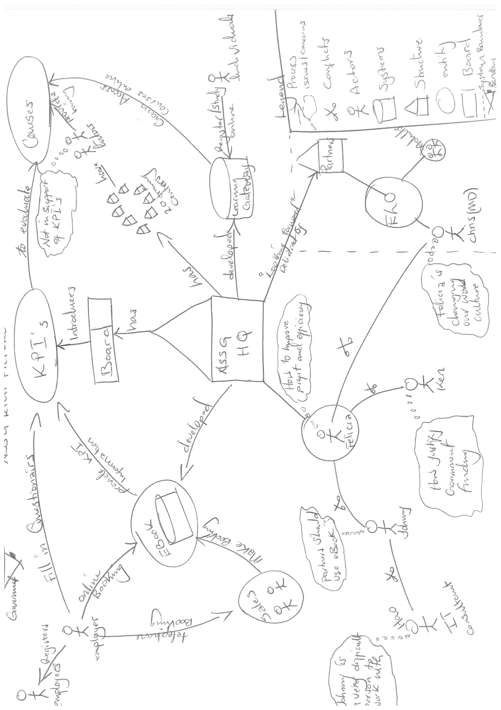

**A2. ELO RICH PICTURE**

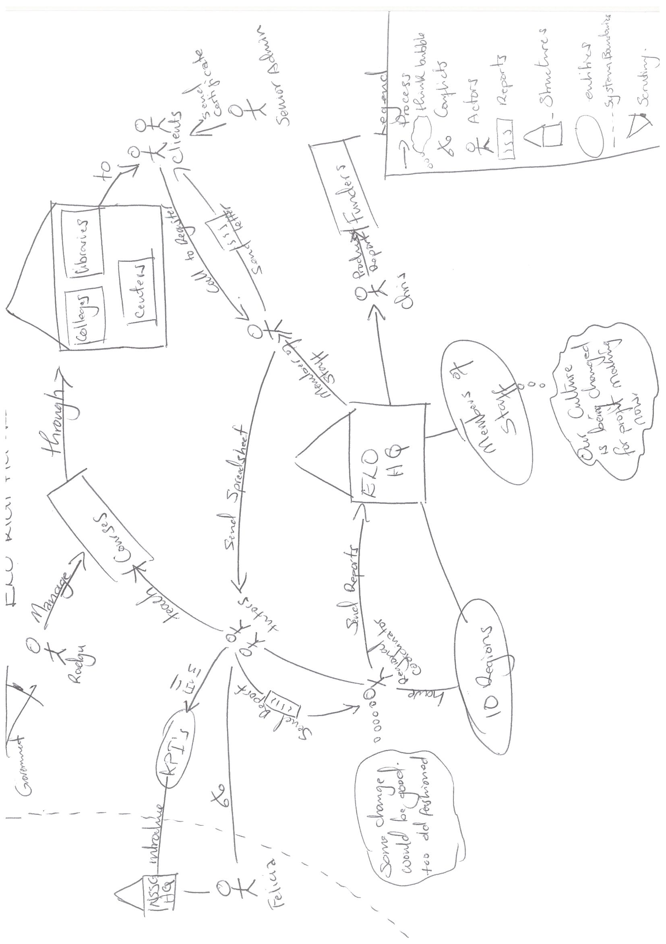

**A3 DISCUSSION OF OVERALL ENVIRONMENT**

A3.1 Key Actors

|  |  |
| --- | --- |
| Key Actor | Impact on the Environment |
| Managing Director (Felicia) | She is the driving force of the company, makes important decisions and is responsible for increasing profits and improving efficiency. |
| IT Manager (Johnny) | Responsible for all the IT systems in the company, driving force behind the development of systems like eBook. |
| Finance Director (Ken Wong) | In charge of all Accounts and Finance related issues f the company. Has to justify all the government funding which will be given. |
| IT Consultant  (Hao Pun) | Has been Hired to evaluate current partner IT systems and give recommendation of best way to roll out IT program. |
| Clients | Receive training from the various centers after making a booking. |
| Employer | These book for their employees to be trained. |
| NSSG (Board) | Responsible for overseeing the implantation of KPI’s |
| Funders (Government) | Oversea the “Looking Forward” program and provides funding. |
| Sales | Takes in calls and makes bookings for client’s who wish to book via the telephone. |
| Tutors | Deliver training to clients through the training centers. |

**A3.2 KEY ISSUES OF CONFLICT**

* Both the IT Manager and It Consultant think that the IT systems being run by their partners are inadequate. However, The IT Manager thinks that it will be best to roll out eBooks to its partners and they will eventually learn how to use it, whereas the IT Consultant hired by Felicia suggests that a simpler system be developed for the partners that will feed information to eBooks, this has created conflict with John as he thinks this will just be a waste of money while Hao seems to think Johnny is a difficult person to work with.
* Ken Wong does not agree with the MD’s decision to bid for the “Looking Forward” contract which is begin offered by the government and hence is in the public sector, he thinks that they should stay in the private sector and continue with their normal ways of operation, he doesn’t think they will even make profit as a result of the number of things that need to be done to ensure success of the project as he will have to create another financial system that will be able to capture all the KPI’s, as he has to justify the government funding.
* Felicia is in conflict with the general staff for introducing new ways of increasing profits and efficiencies, staff don’t agree with the way she is running things at the company, they feel she is only concerned about profits and doesn’t understand issues concerning training. The staff feel some sort of entitlement having worked at the company for a long time and have gotten accustomed to certain ways of doing their work and the new MD threatens normal work flow.
* Tutors are not happy with the introductions of KPI’s in regulating the courses as they feel that this will just add to their work load, they think management has added work which they did not initially sign up for.
* Felicia is in conflict with her new partners, Chris has complained on behalf of his staff about how their identity and culture is being completely changed, contrary to what he was told by Felicia in the initial meeting.

**A3.3 ORGANIZATIONAL CULTURES AND SUB-CULTURES.**

NSSG has a work culture that has been perpetuated by members of staff that have been with the company for long period of time they are against any change proposed by the MD, Felicia wants to drive the company to be more profitable and efficient, they are against such changes and want to continue to work in the same way. A good example would be Johnny IT Manager who has been working for the company since 1990 and is used to having things go his way when it comes to implementing IT systems, is now this is being challenged by the IT Consultant Hao who has been hired by the MD. He is threatened by the IT Consultant as he thinks he wants to take over his job.

The board has introduced KPi’s that will be used to evaluate course performance, this has not been received well with the tutors who do not like to fill in these KPI’s, they fill its too much work and not part of their job description.

The old staff resent Felicia because of her fresh new ideas that have come to shake up things, they have an ingrained culture of how they like to work which has been built over the years.

With the introduction of the partners into their company, this means that each company will have an already existing work culture, coupled with the introduction of new systems being introduced to its partners, it will have to deal with the already IT illiterate staff at its partner companies.

This is a huge deal and Felicia doesn’t realize that merging that culture with the subcultures of the partner companies is going to be especially difficult.

**A3.4 ORGANIZATIONAL REQUIREMENTS**

As an analyst, the main focus of this system will be to offer more efficient processes to be undertaken that will allow the increase in bookings and manage the courses in a better way. As recommended by the IT consultant it is imperative to introduce the much simpler secondary system that will collect information from partners and feed them into the eBook system. This is because most partners are IT Illiterate and imposing a complex Information system on them would have a negative impact on them as the system risks to be abandoned. When implementing systems, it is important to take into consideration the end users and their needs. The system must also ease the process of collecting KPI’s from NSSG and its partners. In addition to implementing these new systems facilitated workshops should be undertaken that will provide training to staff so that they can be able to appreciate the system more and use it effectively.

Lastly, an introduction of a special IT department that will deal with pertaining issues of the IT Systems as it is not explicitly mentioned that a department exists.

**PART B REQUIREMENTS ANALYSIS WITH USE CASE MODELLING**

B1 Use case diagram for ELO.

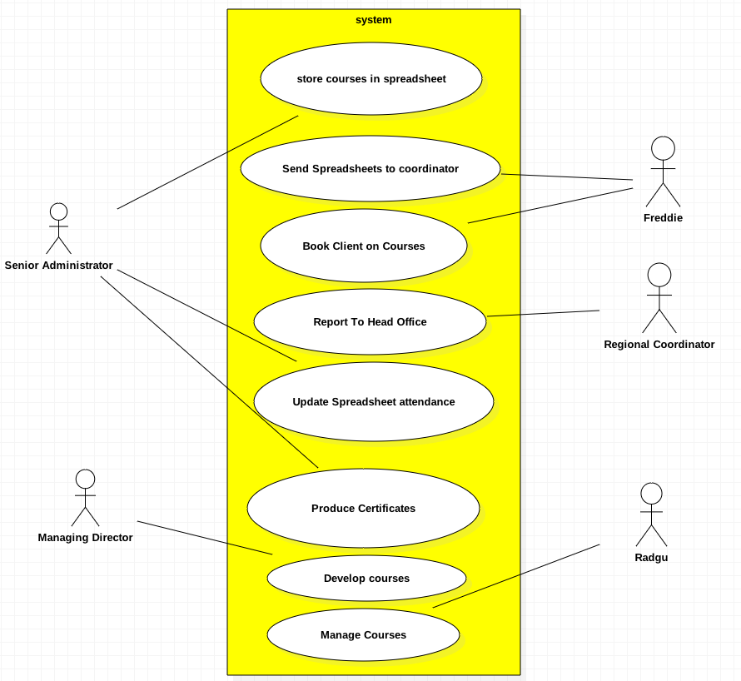

**B2 DOCUMENTATION OF USE CASE DIAGRAM**

B2.1 Primary Scenarios

Use Case: Store Courses in spreadsheet

Actor: **Alison Marshall (Senior Administrator – Head Office ELO)**

Preconditions: Has to be registered for a course

Flow of Events:

* Client finds out about the courses.
* Phone head office to make booking.
* Freddie makes booking
* Spreadsheet sent to made and sent to regional coordinator.

Post Conditions: Successfully Stored course in register

Use Case: Book Clients on Course, Send spreadsheet to Coordinator

Type: Essential

Actor: Freddie

Preconditions: Call Head Office for booking

Flow of Events:

* Interested client calls Freddie at the head office.
* Freddie takes details
* Checks start date of course
* Send spread sheet to regional coordinator
* If course is starting in 3 months, books them on a spreadsheet.
* If course has already started, calls or emails regional coordinator with client details.
* Books client on course
* Tutor receives spreadsheet and location.

Post Conditions: Successfully Booked for Course

Use Case: Produce Certificates

Type: Essential

Actor: Alison

Preconditions: Report of course completion must be sent to be reviewed

Flow of Events:

* Tutors send course end reports to coordinators
* Reports should show grades and whether they can be enrolled in next step
* Reports for end of course sent to head office.
* Updates spreadsheet and produce certificate if completed course successfully.
* Freddie phones to book the clients that have passed onto next available course.

Post Conditions: Certificates successfully produced after client has passed and end report has been reviewed.

­­­­­­­­­­­

Use Case: Manage Spreadsheets

Type: Essential

Actor: Regional Coordinator

Preconditions: A spreadsheet list must be received, that is used as a registrar and assignment if tutor.

Flow of Events:

* Receives spreadsheet form Head Office(ELO).
* Regional coordinator notes current courses running in region through spreadsheet
* Regional Coordinator assigns tutor after receiving spreadsheet.
* Spreadsheet is updated a copy sent to tutor (for clients that join after start date)
* The tutors use the spreadsheets as registers
* Sends report to Head office

Post Conditions: The spreadsheet is successfully updated, it is used as a register, shows course location and the tutors assigned to it.

Use Case: Develop Courses

Actor: Chris Paxton

Preconditions: Develop course content.

Flow of Events:

* Chris developed all the courses being used.
* Tutors review courses and upgrade its content
* Provide numeracy and literacy skills for free
* Tutors get feedback on courses they teach.
* New course content developed.

Post Conditions: Courses are successfully developed and updated.

Use Case: Manage Courses

Actor: Radgu

Preconditions: Manage course.

Flow of Events:

* Chris developed all the courses being used.
* Manage and maintain course

Post Conditions: Able to manage course successfully

**B2.2 SECONDARY SCENARIO**

Use Case: **Develop Courses**

Secondary scenario:

1. Lack of funding from local Government, charity trusts cause some course to be dropped, unable to develop content.

Use Case: **Generate Certificates**

Secondary scenario:

1. Alison not being able to receive course reports, hence unable to update spreadsheet and print certificates for clients who have completed

Use case: **Manage Spreadsheet**

Secondary scenario:

1. Coordinators unable to assign tutors to courses and venues as a result of the spreadsheets not being received from the HQ.

Use case: **Book course**

Secondary scenario:

1. Freddie registers clients on courses but does not send information to the regional coordinator.

Use case: **Manage Courses**

Secondary scenario:

1. Radgu not being able to mange to courses that being offered.

**B3 DISCUSSION OF USE CASE MODELLING PROCESS**

**B3.1 ACTORS AND PROCESES**

The Use Case denoted above helped a great deal in understanding the processes and identifying the actors involved in the ELO environment it gave perspective on the course management system currently being used by the organization. It shows the various actors and processes involved within the system being derived, these include Alison, who is the Senior Administrator. Drawing the use case showed that she is in charge of creating the unique names for the courses and then later storing them in a spreadsheet, with the aid of a Use Case, the process of updating the spreadsheet for clients is shown and subsequently after the client has successfully finished they are then issued with a certificate. Freddie, who is a member of staff at ELO has two processes denoted in the Use Case that show that he is in charge of booking clients when the call as well as sending the spreadsheet as soon as the client is booked on a course, Radgu manages the courses, these courses are ideally developed by Chris who is the (MD) and updated by the tutors. It’s not all the actors that are listed, only those that have key interaction with the system and this can be seen with the MD who is said to be the one who developed the Course Management system. Finally, the regional coordinator was added was added, these are responsible for mainly receiving monthly reports form the various tutors in their region and sending subsequent reports to the head office.

**B3.2 CLARIFY UNDERSTANDING OF SYSTEM / UNDERSTANDING SECONDARY SCENARIOS**

In order to come up with a suitable Use Cases, a proper step by step process of abstraction is required to be undertaken to identify only the relevant actors and possesses though all possible actors where listed some were eliminated by means of identifying whether they perform similar tasks. This enabled me to abstract the use case at a high level, including all processes involved in the use-case. The primary scenarios show the sequence of events that occur when all data required is provided, while on the other hand the secondary scenarios is there a way for the system to handle exceptions. Within the environment, the system is used to store, book update and generate certificates once clients successfully finish the course.

**B3.3 ASPECTS OF THE SYSTEM THAT NEED FURTHER INVESTIGATION**

How the integration of the online Looking forward program is going to be introduced, needs to be further analyzed and probably implemented in phases.

**B3.4 ASSUMPTIONS MADE ABOUT THE SYSTEM**

When modelling the Use Case, some assumptions had to be made about some of the processes that are being included

The current course management system at ELO does not include bookings via online means, this means that bookings are primarily made by phone and then later recorded on a spreadsheet. Suggestions are made to include a more robust system which will include things like online bookings and also enable the company to attract more clients in addition to this it will reduce incidents of storage of wrong information gathered from clients.

**C1. CRITIQUE OF USE CASES AND RICH PICTURES**

Drawing a rich picture in the requirements analysis process was particularly important and helpful as this gave an in-depth analysis of the whole environment that’s being dealt with, it is a soft systems methodology and as such does not dwell much on the technical aspects of the systems. This is a pictorial view that shows the various structures processes and issues/ concerns of an organization and gives the much-needed abstraction to understand all the processes in a much easier way.

It helps in the identification of various actors in the organization and is used to show conflicts, issues or concerns. This can be brought about due to various factors, as earlier discussed, the rich picture was able to show where the cultures and sub-cultures are, which play a role in the implementation of a system. Identifying this allows the analysist to only focus on dealing with potential problems that might arise when finally dispersing the system.

In order for this rich picture to be drawn an understanding of current environment had to be established, this was through conducting interviews with the various staff at the company they gave perspective on people’s internal conflicts/ issues, able to identify the people involved by denoting them as actors in the rich picture as well as the showing the scrutiny who is in charge of making sure that service is delivered.

Strengths of a rich picture

Rich pictures are diagrams that are used to represent an environment and as such they are very subjective, they can be drawn in many different ways but they always try to focus on main issues, since it’s a SSM and it’s a more flexible approach, the analysis has a better chance of understating the needs of the organization.

Since they can easily be read and understood by non- technical people, one does not necessary need a technical skill set to interpret processes in an environment.

The inclusion of the staff members in the gathering of requirements shows that the analyst is taking into consideration the views and opinions of the user.

Weaknesses

There is little technical involvement as this SSM processes focuses mainly on the people. Drawing cartoon like characters can be time consuming and sometime demining and example would be the representation of the MD as a stick figure in the diagram.

Because rich pictures are subjective, the overall conclusion of the diagram is going to be based on the discretion of the analysist as they are abstracting relevant information they might miss out on important elements of the environment.

Use Cases

These two processes have a lot in common as they both show actors involved and the processes involved within a system, as with the use case it is not based on pictorial view but rather its main focus is the interaction with the system and more technical details. It shows some detailed interactions that would otherwise not be depicted in a rich picture to avoid it being too clustered with a lot of information. The analysist uses this technic to acquire instances of user interactions with the system better known as use cases which are organized to show the system boundaries, actors and the processes involved.

Strengths

A comprehensive summary of the system can be analyzed from the use-cases

It uses short textual use-case notes that makes it extremely easy for a user to interpret even non- technical personnel can easily read the use case and feedback is made much easier.

Exception handling was taking into consideration by the introduction of secondary scenarios which were documented this will ideally preempt circumstances that were not initially considered.

Weaknesses

In order to draw a use-case some level of technical skill needs to be acquired in order to be able to make the correct formats and draw it based on norm and laid down conventions for its design

Usually the use cases depict non-functional requirements.

Common thing between rich picture and use-case

These two technics can to especially challenging or complex to develop and get a complete view of the system

Mostly the two processes will take a lot of time to gather requirements needed and subsequently to develop it.

Respective of their distinct focuses each can be used effectively to address respective views of the system.

Conclusion

Rich pictures as well as Use-cases are both used to view environments and their systems, and work out the best way in implanting solutions. With the rich picture displaying various challenges faced, use-cases are used to various functionalities of the system which are later documented.