







BENADIR UNIVERSITY
Title
Academic Session | : | 2025/2026
Names of group project:
1.Yahye Abdi Mohamud
2.MahmedAmin Abbdisalan Ali
3.Abdirzak Isse Mahamed
4.Abdimalik Nuur Ali
5.Nuur Ahmed Osble
6.Sahid Hussein Isse
7.Nafiso Abdullahi Abdirahman
8.Maryan Mahamed Duale
Name of supervisor Name of Dean

SIGNATURE OF
SUPERVISOR
…………………………………

SIGNATURE OF DEAN
………………………..………
….

BENADIR UNIVERSITY
“I hereby declare that I have read this Project and in my opinion this Project is
sufficient in terms of scope and quality for the Award of the Bachelor degree of
(Computer Science and Information Technology)
Signature :

Name of Supervisor :

ENG. ………………………….

Waste Collection Management System
Group Seven
A Project submitted in partial fulfillment of the
requirements for the award of the Bachelor degree of
Computer Science and Information Technology
Faculty of Computer Science and Information Technology
Benadir University

Declare that this Project entitled “Waste Collection Management System” is the result of my own research except as cited in the references. The Project has not been accepted for any degree and is not concurrently submitted in candidature of any other degree.
Signature : ....................................................
Name : Isse Mahamud Harun

This Project is dedicated to my family for their endless support and encouragement.

ACKNOWLEDGEMENT
First and foremost, we would like to express our deepest gratitude to our supervisor, Eng. Isse Mahamud Harun, for his invaluable guidance, patience, and encouragement throughout the development of this project. His expert advice, insightful suggestions, and constant support greatly contributed to the success of our work. We feel privileged to have had his mentorship and supervision during this journey.
We would also like to extend our sincere appreciation to the management and staff of Benadir University (BU) for providing a conducive academic environment and essential facilities, including access to the computer laboratory and necessary software, which greatly facilitated the successful completion of this project.

ABSTRACT
Mogadishu has recently faced significant sanitation problems with rapid urbanization and increased household waste production. Although private sanitation companies exist, the current waste management processes are largely manual and truck dispatch is slow and cannot be scheduled regularly. This thesis introduces the Waste Collection Management System (WCMS) which is a digital solution to connect residents to sanitation service providers. The system has three core components: a mobile application for residents to report waste via GPS coordinates, an administrative dashboard to track operations and an AI-driven engine to analyze data. Route Optimization provides drivers with the most fuel-efficient routes and Waste Prediction identifies hotspots that should be addressed. The expected result from such a project is a significant reduction in operational fuel costs, increased productivity and a simplified payment process and tracking of collection services for residents. To that end, this system can be a model for how to use technology to restore urban aesthetics and improve public health standards in the capital.

TABLE OF CONTENTS
CHAPTER TITLE PAGE
DECLARATION ii
DEDICATION iii
ACKNOWLEDGMENT iv
ABSTRACT v
TABLE OF CONTENTS vii
LIST OF TABLES xi
LIST OF FIGURES xii
1 INTRODUCTION 1
1.1 Introduction 1
1.2 Problem Background 2
1.3 Problem Statement 3
1.4 Project Objectives 4
1.5 Project Scope 5
1.6 The Project Importance 6
1.7 Summary 7
2 LITERATURE REVIEW 8
2.1 Introduction 8
2.2 Overview of Waste Management Systems 9
2.2.1 Traditional (Offline) Waste Management Systems
2.2.2 Modern (Online) Waste Management Systems
2.2.3 Technologies Used in Modern Systems
2.2.4 How the System Works
2.3 History of Waste Management Systems 10
2.3.1 Early Waste Disposal Practices
2.3.2 Traditional Waste Management Systems
2.3.3 Transition to Modern Waste Management Systems
2.4 Integrated System Architecture 11
2.4.1 User Layer (System Users)
2.4.2 Frontend Layer (User Interface)
2.4.3 Backend Layer (Server-Side Logic)
2.4.4 Database Layer
2.4.5 System Interaction Flow
2.5 Related Studies 12
2.5.1 Existing Waste Management Systems
2.5.2 Limitations of Existing Systems
2.6 Research Gap 13

2.6.1 Lack of Efficient Communication
2.6.2 Limited Tracking and Monitoring
2.7 Summary 14
3 METHODOLOGY 15
3.1 Introduction 15
3.2 This Research Proposed Methodology 16
3.2.1 Planning Phase
3.3 Research Design 17
3.4 Development Methodology: Agile Scrum Framework 18
3.5 Data Collection Methods 19
3.5.1 Interviews (Qualitative Data)
3.5.2 Survey (Quantitative Data)
3.6 Tools and Technologies Used 20
3.6.1 Frontend Development
3.6.2 Backend Development
3.6.3 Database Management
3.6.4 Development Environment
3.6.5 Design and Modeling Tools
3.7 Operational Framework 21
3.8 Feasibility Study 22
3.8.1 Technical Feasibility
3.8.2 Economic Feasibility
3.8.3 Operational Feasibility
3.8.4 Schedule Feasibility
3.9 Summary 23
4 SYSTEM DESIGN & IMPLEMENTATION 51
4.1 Introduction 51
4.2 Design Objectives 51
4.3 System Architecture Design 52
4.4 Data Flow Diagram (DFD) 52
4.4.1 Context Diagram (Level 0 DFD)
4.4.2 Level 1 DFD
4.5 Entity-Relationship Diagram (ERD) 53
4.6 System Modules and Components 54
4.6.1 User Management Module
4.6.2 Resident Request & 1-to-1 Auto-Dispatch Module
4.6.3 Driver Job Management Module
4.6.4 Payment & Invoice Module
4.6.5 Threaded Messaging & Notification Module
4.6.6 Reporting & Analytics Module
4.7 Database Design 55
4.8 User Interface (UI) Design & System Screenshots 55
4.9 Security Design 60

4.10 System Navigation and Flow 60
4.11 Development Environment 60
4.12 Testing During Implementation 61
4.13 Algorithms and Logic 61
4.14 Challenges and Solutions 62
4.15 Summary 62
5 CONCLUSION AND FUTURE WORK 63
5.1 Introduction 63
5.2 Summary of the Project 63
5.3 Key Achievements 64
5.4 Limitations of the System 65
5.5 Lessons Learned 65
5.6 Future Work 65
5.7 Final Conclusion 66
REFERENCES 67

CHAPTER 1
INTRODUCTION
1.1 Introduction
Waste Management Program is developed in intention for use by the Personal responsible for hazardous and non-hazardous materials arising from human activities and long shoring operation (ISPSI, 2016). Hazardous and non-hazardous material are be properly manage to protect the personnel, general public and environment from potential adverse effect that may arise.
This program is designed to assist the ISPSI in achieving and maintaining compliance with the State and Local waste management regulations Implementation of requirements and recommendations provided in this program help to ensure protection of the environment. (ISPSI, 2016).
Waste management in the developing countries in general and the County of Somalia in particular. The methods that are discussed here have been carefully selected to fit a narrow range of criteria suitable for financially destitute countries with hot and arid climate. The criteria limit the possible solutions to ones that are sustainable, low cost, can be established by the local supply means, target. The environmental advantages of the areas and compensate for their weaknesses. In most cases that means using renewable energy sources and energy efficient technologies. (ISPSI, 2016).
The County population rate is expected to considerably increase in size, therefore leading to a respective rise in produced waste. This means that waste management remain be an ongoing and serious issue for years to come. It has to be handled in the most efficient and locally appropriate manner to minimize the risk of aggravating existing environmental problems and endangering the health of the population. (ISPSI, 2016).

1.2 Problem Background
Waste management in Somalia is a critical issue characterized by a near-total absence of formal infrastructure, a legacy of decades of civil war, and rapid, unplanned urbanization. In major cities like Mogadishu, which produces roughly 2,500 tons of waste daily, the lack of proper disposal mechanisms leads to widespread illegal dumping on streets, in coastal waters, and in natural drainage systems (Ahmed, 2024).
Rapid Urbanization & Population Density: Increased population in urban centers and IDP (Internally Displaced Person) camps, particularly in Mogadishu has surpassed the capability of municipal services to manage waste, resulting in poor sanitation and health hazards. (Ahmed, 2024). Illegal Hazardous Dumping Somalia's long, unprotected coastline has been used by foreign companies for illegal dumping of toxic, industrial, and hospital waste since the 1990s, taking advantage of the country's lack of enforcement. Lack of Public Awareness There is low public awareness regarding proper garbage segregation and disposal, with waste often burned, buried, or dumped into the sea. (Ahmed, 2024)
Furthermore, within the local context of Mogadishu, private waste management enterprises, such as the Ifiye Waste Management Company, play a pivotal role in attempting to maintain urban sanitation.
Despite their efforts, these companies operate under severe infrastructural limitations. Ifiye Waste Management Company heavily relies on manual operational mechanisms, where truck dispatching is done through non-digitized, verbal instructions or paper logs, leading to massive inefficiencies, delayed collection response times, and an inability to provide structured scheduling for residents. Consequently, the lack of a collaborative digital framework between companies like Ifiye and the urban population exacerbates the accumulation of unmanaged solid waste across major commercial and residential hubs in the capital. (Ifiye)

1.3 Problem Statement
Waste management should be simple and easy to follow for everyone. In cities like Mogadishu collecting trash is still done by hand and it is not well planned. The big issue is that people who live in the city and the companies that collect waste do not have a way to talk to each other. Now people who live in the city do not have a simple way to ask for someone to pick up their trash or check if they have paid for the service. The companies that collect waste have a hard time managing their drivers and the routes they take. Because there is no system trash often stays on the streets for too long which is bad for people health and hurts the environment.
Some companies have trucks to collect waste. They do not have the right tools to track collections as they happen or use computers to figure out where waste is building up. This means it costs a lot to collect waste and the service is not reliable. So this project is making the Waste Collection Management System to fix this problem.
The Waste Collection Management System use a portal for residents, people who live in the city a page for the people in charge. This transform change waste management from a messy process to a smart and efficient digital service. The Waste Collection Management System improve operation and enhances service delivery for all users.
1.4 Project Objectives
The primary target of this study is structured into a broad general milestone and measurable specific targets designed to systematically upgrade the urban sanitation frameworks in Mogadishu.

General Objective
•To design, develop, and implement an integrated web-based Waste Collection Management System (WCMS) utilizing a PHP and MySQL framework to bridge the communication and operational gap between residents,
administrators, and field drivers in Mogadishu.
Specific Objectives
To successfully realize the primary goal of this research, the project will execute the following technical and analytical objectives:
•To analyze the operational workflows and limitations of existing manual waste management practices in Mogadishu, specifically focusing on the scheduling and dispatch challenges faced by local service providers like Ifiye Waste Management Company.
•To design a multi-portal system architecture that establishes a seamless, real-time communication loop between residents (citizens), company
administrators, and field drivers to eliminate coordination gaps.
•To develop the system's backend engine using PHP 8.x and a MySQL relational database to fully automate request logs, task assignments, and digital payment tracking.
•To implement robust system security protocols, including secure session-based authentication, Role-Based Access Control (RBAC), and database defense mechanisms against SQL injection.

•To deploy and evaluate the system incrementally using the Agile Scrum methodology, ensuring thorough testing of each portal component for usability, functional performance, and operational reliability in the local environment
1.5 Project Scope
The system it is implemented and tested in Mogadishu, Somalia. It will mainly target residents, waste collection companies, and drivers operating within this area.
Software & Backend Scope
Development of a backend system using: PHP
Development of user-friendly interfaces for:
Resident Portal
Admin Dashboard
Driver Portal
Design of a responsive web dashboard using: HTML, CSS, JavaScript

CHAPTER 2
LITERATURE REVIEW
2.1 Introduction
Rapid urbanization, population expansion, economic development, and changing consumption patterns have increased waste generation in Somalia (Agamuthu et al., 2020). Waste management System (WMS) is becoming a crucial aspect of developing countries to minimize the negative impacts of waste mismanagement System on the environment.
The environment’s quality has worsened due to unsustainable approaches in Waste Management System (Ferronato & Torretta, 2019; Agamuthu et al., 2020). Governments and societies acknowledge the importance of an effective waste management system to address the negative impacts of waste mismanagement. However, finding the appropriate approaches for its adoption is challenging.
High waste generation, poor quality of Waste Management System services, littering, especially waste thrown along roadsides, and lack of technologies in waste management are common issues in Somalia. Therefore, strategies for effective Waste Management System are crucial to address these situations.
Waste management is an important part of sustainable development. In this context, waste management involves avoiding waste where possible, reducing waste, and reusing resources that would otherwise be discarded (Yusuf, A. M. 2022). Waste management strategies emphasize waste reduction, recycling, and reuse as key elements for sustainability.
In Somalia, a large amount of waste is disposed of in landfill sites managed by local authorities. In many areas, waste is also dumped illegally along roads and in open spaces, in violation of regulations.
Every year, large quantities of waste are disposed of in solid waste sites (Yusuf, A. M. 2022). However, there are limited procedures in place to properly separate waste for recycling or reuse. As a result, waste is often disposed of in an unorganized manner.

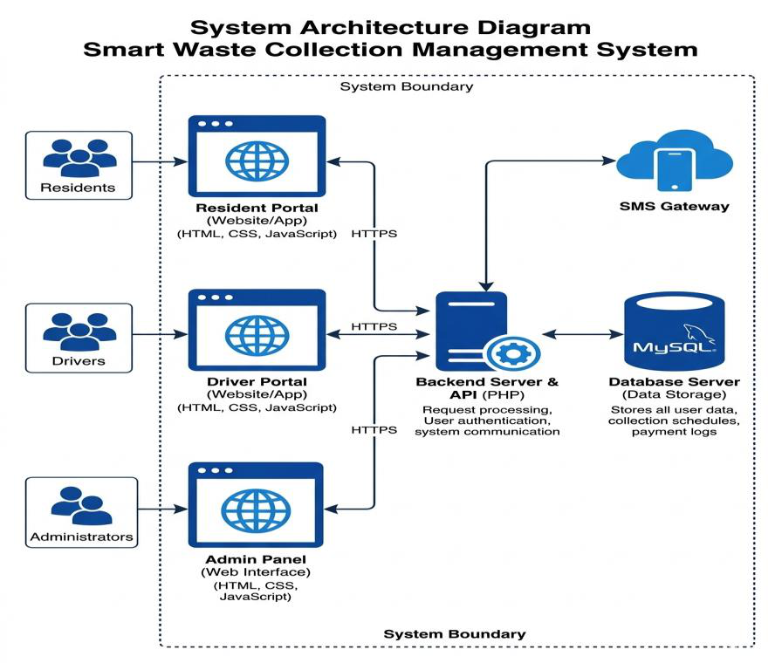
2.2 Overview of Waste Management Systems
There have been several definitions of waste proposed in recent years. One common thread among these definitions is the concept that waste is a material that is unwanted by its producer. The unwanted materials may be by-products of a production process – fly ash from a furnace, for example. Alternatively they might be products, the inherent value of which has been consumed from the perspective of the current holder – for example, a newspaper that has been read, a package that has been opened and emptied of its contents or an apple eaten to the core are all similar insofar as they have lost their original inherent value from the consumers perspective.
If these materials lose this inherent value to such a degree that permanent disposal is the most viable option or perhaps the only available option, then a waste services provider acts as an agent that relieves the generator of the waste of the burden of disposal.
However, the material may have value from the perspective of someone else – the newspaper can be used as an input at a pulp and paper plant or the apple can be used by a composting facility – thus a waste services provider may divert such a material from the waste stream. Value is reintroduced to the material through a process that treats the material in such a way as to enable it to be reintroduced back into the market place as a valuable good. For example, the newspaper may be collected and taken to a Material Recycling Facility (MRF) where it is sorted from other items, bundled and compacted – thus

preparing it in such a fashion that it is marketable (valuable) to a buyer such as a pulp and paper mill.
The Canadian waste management industry embodies two inter-related elements – governments and other public organizations that provide or make provision for waste management services and private firms that supply these For the purposes of these surveys, the waste management industry broadly includes all firms and public bodies operating in Canada that provide the services of collection, transportation, diversion, treatment or disposal of waste or recyclable materials. The majority of the establishment’s revenue will come from provision of these services. To further define these broad activities:
2.2.1 Traditional (Offline) Waste Management Systems
Traditional waste management represents the conventional approach most municipalities have relied on for decades. Unlike modern "smart" systems, these processes operate "offline," meaning they function without the aid of real-time data, IoT sensors, or automated communication networks. This system is largely driven by manual labor and fixed schedules rather than dynamic demand.
The Workflow of Traditional Systems
In a typical offline setup, the process begins at the household level, where waste is stored in standard bins. Because these bins lack fill-level sensors, collection occurs on a pre-set calendar. This often leads to "blind collection," where garbage trucks visit bins that are only half-full or, conversely, arrive too late to bins that have already overflowed. This lack of synchronization is a hallmark of the traditional model.
Logistical and Operational Challenges
The transportation phase is usually the most resource-heavy part of this system. Trucks follow static routes regardless of traffic conditions or actual waste volume. From a human perspective, this results in significant fuel waste and unnecessary wear and tear on vehicles. Furthermore, because there is no digital tracking, management has very little visibility into daily operations, making it difficult to optimize costs or hold service providers accountable.

Sorting and Final Disposal
In many traditional frameworks, waste is collected "as-is," with little to no separation at the source. Any sorting that does happen usually occurs manually at transfer stations, where workers physically separate recyclables from organic waste—a process that is both slow and hazardous. Eventually, the majority of this waste ends up in landfills. Without modern monitoring, these sites can become environmental liabilities, as there is often no sophisticated way to track leachate leakage or methane emissions in real-time.
The Information Gap
The defining characteristic of the offline system is the information gap between the waste generator and the waste manager. Decisions are based on historical habits rather than current reality. While these systems are straightforward to implement, their lack of adaptability makes them increasingly unsustainable as urban populations grow and environmental regulations tighten.
2.2.2 Modern (Online) Waste Management Systems
Modern waste management, commonly referred to as "Smart Waste Management," represents a paradigm shift from manual estimation to data-driven precision. These systems utilize a combination of the Internet of Things, mobile online system, and cloud computing to create an integrated ecosystem where waste is tracked and managed in real-time.
Core Technologies and Infrastructure
The transition from offline to online systems is built upon three primary technological pillars:
Centralized Cloud Platform: A management dashboard that acts as the "brain" of the operation, analyzing incoming data to make logistical decisions.

Online system Ecosystem: Dual-purpose apps designed for both service providers (drivers) and service users (citizens).
The Role of Online system
The Online system serves as the primary interface for managing modern waste operations. Its functionality is divided into two segments:
For Citizens (User Interface): Users can report overflowing bins, request special pickups (e.g., bulky waste), and receive real-time notifications when a collection vehicle is nearby. Furthermore, integrated digital payment gateways allow for transparent, cashless transactions, reducing the risk of fraud associated with manual fee collection.
For Operators (Driver Interface): Drivers receive dynamic manifests on their tablets or smartphones.
Comparison of Operations: Manual vs. Online
The following table summarizes how the introduction of digital "Online" systems has transformed traditional manual labor:
Operational Feature Traditional (Manual/Offline) |  | Modern (Online system)
Logistics | Static, pre-planned routes. | Dynamic Routing based on actual
need.
Communication | No direct link with citizens. |  | Mobile Apps for reporting and alerts.
Payments | Cash-based and prone to errors. | Digital Payments (E-money/Wallets).
Efficiency | High fuel waste and low productivity. Optimized resources and lower costs.

2.2.3 Technologies Used in Modern Systems
The success of a modern waste management system depends on its software architecture and how well it connects the different stakeholders. For this project, the system is built on a robust web-based Online System framework designed to bridge the gap between residents, administrators, and field drivers through real-time data processing.
Backend Development: PHP
The core logic of the system is developed using PHP. As a server-side scripting language, PHP is responsible for managing the "brain" of the application. It handles:
Database Management: Storing and retrieving data such as user profiles, waste bin locations, and transaction records.
Request Logic: Processing incoming waste collection requests and automatically updating their status in the database.
Authentication: Ensuring secure logins for residents, admins, and drivers to protect sensitive information and payment data.
Frontend & User Interface: HTML, CSS, and JavaScript
To ensure the system is accessible on various devices, the frontend is built using a responsive web stack:
HTML5 & CSS3: Used to structure the content and design a clean, professional layout that adapts to both desktop monitors and mobile screens.
JavaScript: Provides interactivity, such as real-time form validation and dynamic updates to the dashboard without needing to refresh the page.
System Portals and Scope
The system is divided into three specialized portals, each tailored to a specific user role:
Resident Portal: This interface allows citizens to interact directly with the system. Residents can log in to submit Waste Collection Requests, view

their Payment History, and receive Real-timeNotifications when their waste has been collected.
Admin Dashboard: The central control unit for the management team. It provides a high-level overview of the entire city's waste operations. Admins can view a list of all requests, assign tasks to specific drivers, and monitor the overall status of the system (Pending, Assigned, completed).
Driver Portal: A mobile-responsive interface designed for the workers in the field. Drivers use this portal to view their assigned tasks, navigate to collection points, and update the status of a request to "Completed" once the bin is emptied.
Core Features and Display
The dashboard is designed to be data-rich yet easy to navigate, displaying the following critical information:
Request Tracking: A clear view of waste collection requests categorized by status (Pending, Assigned, completed).
Financial Integration: Detailed Payment Information to ensure transparency in service fees and billing.
Alert System: An automated Notification and Alert system that keeps users informed of schedule changes, successful pickups, or urgent maintenance needs.
2.2.4 How the System Works
The system operates as an end-to-end digital pipeline that replaces manual communication with automated workflows. The process is divided into four main stages:
Request Initiation (Resident Action)
The process begins when a resident logs into the Resident Portal. If their waste bin is full, they submit a Waste Collection Request. At this stage, the resident provides details such as the type of waste or specific location. The system, powered by the PHP backend, immediately records this in the database, and the request status is set to "Pending."

Task Management (Admin Action)
Once a request is submitted, it appears on the Admin Dashboard. The administrator reviews the list of pending tasks. Using the management interface, the admin selects an available driver and assigns the task to them.
The | system | automatically | updates | the | status
from "Pending" to "Assigned," and a notification is triggered for both the resident (to keep them informed) and the driver.
Field Operation (Driver Action)
The assigned driver logs into the Driver Portal via a mobile device to see their task list. The portal provides the necessary details to locate the resident. Once the driver reaches the location and successfully collects the waste, they interact with the portal to mark the task as "Completed." This action sends a real-time signal back to the central server.
Finalization and Records (System Update)
Upon completion, the PHP backend updates the master database one last time. The Resident receives a confirmation alert that their waste has been picked up. The Admin sees the task move to the "Completed" column on their dashboard for record-keeping and payroll purposes.
Payment Verification: If the system is set for "pay-on-collection," the payment status is updated, and a digital receipt is generated within the Resident Portal.
2.3 History of Waste Management Systems
Historically, the amount of wastes generated by human population was insignificant mainly due to the low population densities, coupled with the fact there was very little exploitation of natural resources. Common wastes produced during the early ages were mainly ashes and human & biodegradable wastes, and these were released back into the ground locally, with minimal environmental impact.

Before the widespread use of metals, wood was widely used for most applications However, reuse of wood has been well documented. Nevertheless, it is once again well documented that reuse and recovery of such metals have been carried out by earlier humans. With the advent of industrial revolution, waste management became a critical issue. This was due to the increase in population and the massive migration of people to industrial towns and cities from rural areas during the 18th century. There was a consequent increase in industrial and domestic wastes posing threat to human health and environment.
Waste has played a tremendous role in history. The Plague, cholera and typhoid fever, to mention a few, were diseases that altered the populations of many country. They were perpetuated by filth that harbored rats, and contaminated water supply. It was not uncommon for everybody to throw their waste and human wastes out of the window which would decompose in the street.
2.3.1 Early Waste Disposal Practices
The history of waste management in Somalia is deeply intertwined with its cultural evolution, moving from a nomadic lifestyle to organized urban centers. Historically, waste was managed through natural cycles and community-driven efforts rather than centralized infrastructure.
Nomadic Traditions and Organic Cycles
For centuries, the majority of the Somali population led a nomadic or semi-nomadic lifestyle. During this era, waste management was inherently sustainable. Since most materials used, such as wooden house frames, animal skins, and woven mats, were organic, any waste left behind at a campsite was biodegradable. It naturally decomposed, returning nutrients to the soil. Furthermore, food remains were typically repurposed as animal feed, creating a primitive yet effective form of a Circular Economy.
Pre-Colonial and Coastal Urban Systems
In ancient coastal cities like Mogadishu Xamar, Zeila, and Berbera, the concentration of people necessitated more organized disposal.
Designated Pits: Waste was traditionally transported to the outskirts of the city and disposed of in large open-air pits.
Maritime Disposal: Given the coastal geography, some refuse was historically directed toward the sea. While seen as a cleaning method at the time, it lacked the environmental oversight required in modern standards.
Post-Independence and the Impact of Conflict
Following independence, Somalia began developing municipal waste services. However, the collapse of the central government in 1991 led to a total breakdown of formal sanitation infrastructure. For decades:
Informal Dumping: In the absence of a structured system, "illegal dumping" became common, with residents disposing of trash in empty lots or street corners.
Open Burning: To manage the growing volume of plastic and solid waste, many communities turned to open-air combustion. This "offline" method,

while reducing physical volume, created significant air quality issues and health hazards.
The Emergence of Private Manual Services
As urban populations in cities like Mogadishu, Hargeisa, and Garowe surged, the gap left by the state was filled by private entrepreneurs. These services relied on manual labor and fixed-route trucks. However, without digital tracking, these providers often struggled with:
Inconsistent collection schedules.
Difficulties in fee collection.
Lack of data on waste volume.
2.3.2 Traditional Waste Management Systems.
In the Somali context, traditional waste management refers to the manual, non-digital methods that have been the standard since the mid-20th century. These systems are characterized by a "collect-and-dump" philosophy, relying heavily on human labor and basic mechanical transport without any real-time tracking or data integration.
The Manual Collection Framework
In most Somali urban centers today, the traditional system operates through private companies or local neighborhood committees. Residents typically place their waste in large metal drums or plastic bags outside their homes.
Labor Intensive: Small teams of workers physically lift and toss the waste into open-back trucks.
Fixed Scheduling: Collection happens on specific days of the week. However, due to a lack of communication tools, residents often don't know exactly when the truck will arrive, leading to waste sitting in the sun for extended periods, which causes foul odors and attracts pests.
Logistical Inefficiencies
The "offline" nature of this system leads to significant operational hurdles in the Somali environment:
Blind Routing: Trucks follow the same path every day regardless of whether the bins are full or empty. In crowded districts like Hodan or Hamar Weyne,

this leads to unnecessary traffic congestion and high fuel costs for the service provider.
The Payment Gap: Traditionally, fee collection is done door-to-door in cash. This is highly inefficient, as collectors often miss residents who are not home, leading to revenue loss and disputes over service delivery.
Lack of Data and Accountability
The most defining feature of the traditional system in Somalia is the absence of records.
There is no digital log of how much waste a specific household produces. There is no way for a citizen to track their request or complain about a missed pickup through a formal channel.
Management cannot optimize the system because they lack "Big Data" on waste trends across the city.
2.3.3 Transition to Modern Waste Management Systems
The transition from traditional, manual processes to modern, digitalized systems is a critical evolution for urban centers, particularly in rapidly growing cities like Mogadishu. This shift represents a move away from "reactive" waste management (addressing waste only when it becomes a visible nuisance) to "proactive" and "data-driven" management.
The Catalysts for Change
Several factors are driving the need for this transition in the Somali context: Urbanization: As cities become more densely populated, the volume of waste exceeds the capacity of manual labor and fixed-route trucks.
Technological Literacy: The widespread use of smartphones and mobile money (e.g., EVC Plus, Sahal) in Somalia has created a foundation where citizens are ready to use online system for public services.

Environmental Urgency: To prevent the health risks associated with illegal dumping and open burning, there is an urgent need for the accountability that only Online Systems can provide.
Digitizing the Workflow (From Paper to PHP)
The transition involves replacing physical logs and verbal agreements with a centralized digital infrastructure. In your proposed system, this is achieved through:
Automated Scheduling: Moving away from "waiting for the truck" to residents initiating requests via the Resident Portal. This ensures that collection is based on actual demand.
Centralized Command: The Admin Dashboard replaces the chaotic manual coordination of staff. Administrators can now oversee the entire city's status, identifying which zones are Pending and which are Completed, in real-time.
Financial Modernization
A key pillar of this transition is the elimination of cash-based door-to-door collection. By integrating Digital Payment Gateways, the system ensures: Instant Verification: Payments are linked directly to a resident’s account in the database.
Transparency: Every transaction is logged, eliminating the Revenue Leakage discussed in previous sections and allowing companies to plan long-term infrastructure investments.
The Role of Real-Time Communication
The transition bridges the information gap that plagued traditional systems.
Through Notifications and Alerts, the system creates a transparent loop: Residents are notified when their request is accepted.
Drivers receive their tasks via the Driver Portal without needing to return to a central office for instructions.
The System automatically archives the data, creating a historical record that can be used for future city planning.

2.4 Integrated System Architecture
The architecture of this system is designed as a unified digital ecosystem that synchronizes residents, administrative staff, and field drivers in real-time. According to the provided design diagrams, the system follows a modular structure where the frontend interfaces communicate seamlessly with a centralized backend and database.
2.4.1 User Layer (System Users)
The User Layer is the topmost part of the architecture, representing the different stakeholders who interact with the system. According to the Use Case Diagram, the system is tailored for three distinct roles, each having a specialized interface (Portal) to perform their specific tasks.
Resident (Citizen): This is the primary user who initiates the service. Residents interact with the Resident Portal to register their households, submit waste collection requests (Tick Requests), and monitor their payment status. Their interaction ensures that the system is demand-driven rather than schedule-driven.
Admin (Management): The Administrator acts as the central controller of the entire operation. Through the Admin Dashboard, they have a global view of all incoming requests. Their critical role includes manually assigning tasks to available drivers, managing the database of users and drivers, and generating reports to monitor system performance and efficiency.
Driver (Field Operator): The Driver is the mobile user responsible for the physical execution of the service. Using the Driver Portal, they check their daily assignments, use geolocation for navigation, and update the system in real-time once a collection is "Completed." This ensures the backend is always updated with the current state of field operations

2.4.2 Frontend Layer (User Interface)
The Frontend Layer acts as the visual and interactive gateway of the system. It is designed to ensure that the complex data stored in the backend is presented to the users in a simple, responsive, and easy-to-use format. As shown in the System Design Diagram, this layer consists of three primary web-based interfaces.
Responsive Web Architecture: Developed using HTML5, CSS3, and JavaScript, the frontend is built with a "mobile-first" approach. This ensures that the Driver Portal and Resident Portal are fully functional on smartphones, while the Admin Dashboard remains robust for desktop use. Dynamic Data Display: JavaScript is utilized to create an interactive experience. For example, when an Admin assigns a driver, the status updates dynamically without the need to reload the entire page. This real-time feedback is crucial for maintaining a synchronized "Online" system.
The Three Pillars of the UI:
1.Resident Portal Interface: Features simple forms for registration and "Tick Requests," alongside clear status indicators (e.g., Progress bars for collection status).
2.Admin Dashboard Layout: A data-rich environment featuring tables and lists of "All Requests." It provides tools for manual driver assignment and visualizes system performance through reports.
3.Driver Portal Interface: A simplified, high-contrast interface optimized for outdoor use. Large buttons and clear text allow drivers to quickly "Check-In" or "Update Status" while on the move
2.4.3 Backend Layer (Server-Side Logic)
The Backend Layer is the core operational engine of the system, acting as the bridge between the user interfaces and the database. Developed using PHP, this layer handles all the "behind-the-scenes" logic that ensures the system functions securely and efficiently. As seen in the System Design Diagram, the

backend manages everything from verifying user credentials to processing complex waste collection workflows.
Core Logic and Processing
The backend is responsible for the Business Logic of the application. When a resident submits a request or an admin assigns a driver, the PHP scripts execute specific rules to validate the data, update the request status, and ensure the right information is triggered for the next person in the chain.
Authentication and Security
Security | is | managed | at | this | layer | through Authentication | and
Authorization protocols. It ensures that only registered users can access the system and that each user (Resident, Admin, or Driver) can only see and interact with the data they are permitted to access based on their specific role.
Integration and APIs
The backend functions as a RESTful API hub. It facilitates the communication between the frontend portals and external services. This includes:
Notification Integration: Triggering the SMS, Email, or Push notifications when a status changes.
External Data Flow: Coordinating with geolocation services to provide accurate data for the Driver Portal.
2.4.4 Database Layer
The Database Layer is the foundation of the entire system, acting as the permanent memory where all information is organized and stored. As illustrated in the Entity Relationship Diagram (ERD), the database is structured into specific tables that represent the core entities of the waste management ecosystem.
Structured Data Storage

The database uses a relational structure to ensure data integrity. Key tables include:
Users (Resident, Admin, Driver): Stores credentials, contact details, and roles to manage access across the portals.
Request Table: The central log for all waste collection activities, storing the request time, address, current status, and specific notes.
Payment Table: Records financial transactions, linking each payment to a specific resident and request to ensure transparency.
Assignment Table: Bridges the gap between the Admin's decision and the Driver's action by recording which driver is responsible for which task.
Data Integrity and Relationships
The system utilizes Primary Keys (PK) and Foreign Keys (FK) to create logical links between data points. For example, a single resident, Id can be linked to multiple request id entries, allowing the system to maintain a complete history for every user. This relational mapping prevents data duplication and ensures that when an Admin updates a status, it reflects accurately across all portals.
Audit Trails (Request Logs)
A critical feature of this layer is the Request Log table. Every time a status changes such as when a driver marks a task as Collected, the database automatically archives the action, the timestamp, and the user involved. This creates a permanent audit trail, making the system highly accountable and useful for generating analytical reports for city management.
2.4.5 System Interaction Flow
The System Interaction Flow defines the chronological sequence of events and the data exchange between the layers described in the previous sections. It illustrates how a single task moves from the user’s screen to the database and back to the field operator.

The Request-to-Assignment Loop
The flow begins in the User Layer when a Resident submits a collection request. This interaction passes through the Frontend Layer via an API call to the Backend Layer (PHP). The backend
Validates the request and creates a new entry in the Database Layer with a status of "Pending." This update is immediately reflected on the Admin Dashboard.
Administrative Coordination
The Admin monitors the "Pending" list. Once they assign a task to a Driver, the backend updates the Assignment Table and triggers the Notification Service.
This "push" interaction ensures the driver receives an alert on their mobile device instantly, moving the data from the server to the Driver Portal.
Task Execution and Real-Time Synchronization
As the Driver navigates to the location (assisted by External Maps Services), they interact with the portal to update the progress. Upon collection, the driver selects "Collected," which prompts the Backend Layer to:
Update the Request Status in the database to "Completed."
Create a permanent entry in the Request Log for auditing.
Notify the Resident that their waste has been successfully managed
2.5 Related Studies
In this section, we examine existing research and developed systems that share similarities with your proposed project. By reviewing these studies, we can identify how modern technologies like PHP, and online system are being used

globally to solve waste management challenges, and how your system fits into this evolving field.
Waste Management using online system
Many global studies have focused on the integration of sensors and web platforms. A common finding is that systems using a centralized backend (like PHP) significantly improve the coordination between waste generators and collectors. Researchers have noted that providing a dedicated Resident Portal reduces illegal dumping by making it easier for citizens to request formal services. Your system follows this best practice by putting the power of request initiation in the hands of the user.
Optimization of Collection Routes
Several studies have investigated the impact of "Dynamic Routing" compared to traditional "Fixed Routes." Research shows that when an Admin Dashboard allows for manual or automated Assignment of tasks to drivers, the fuel consumption of collection trucks can decrease by up to 30%. These studies highlight that a Driver Portal is essential for real-time communication, ensuring that field staff are not wasting time on routes where no waste needs to be collected.
Digital Payments and Financial Transparency
Literature on waste management in developing urban areas frequently mentions "Revenue Leakage" as a major barrier. Studies on systems that integrated Online Payment Gateways found a significant increase in collection rates and user trust.
By automating the payment logs in your Database Layer, your project addresses a critical gap identified in these studies—moving away from inconsistent cash-based collection to a transparent digital ledger.
The Role of Real-Time Notifications
Recent academic papers have emphasized the psychological impact of Status Tracking. Just as people track food deliveries, tracking waste collection status

via Notifications increases | civic | engagement. | Related | systems | that
implemented a "Request Log" (similar to your REQUEST_LOG table) showed higher levels of accountability, as every delay or completion was timestamped and visible to the administration.
2.5.1 Existing Waste Management Systems
Existing waste management systems are generally classified based on their level of technology and infrastructure. Globally, these systems range from basic, labor-intensive methods to highly automated "smart" environments.
Understanding these existing models is essential for identifying the specific advantages of the PHP-based integrated system proposed in this study.
Traditional Manual Systems
In many developing regions, including various urban centers in Somalia, waste management remains primarily manual and reactive. These systems typically involve:
Door-to-door Collection: Laborers physically collect waste in baskets or small containers.
Fixed Routing: Collection vehicles follow the same path daily, regardless of the actual volume of waste present, which often leads to operational inefficiencies and wasted fuel.
Informal Waste Picking: A significant portion of recycling and sorting is done by informal workers who manually separate valuable materials from open dumps.
Community-Based "Waste Banks"
A decentralized model used in some regions is the Waste Bank system.

Local Sorting: Communities are encouraged to separate waste at the source and bring it to a local collection point.
Incentive-Driven: Individuals often receive small financial rewards or points for their sorted waste, fostering a circular economy.
Limitation: These systems often lack a centralized digital platform to track data across multiple locations, making large-scale coordination difficult.
Integrated Waste Management (IWM)
Modern IWM frameworks aim to combine various strategies, recycling, composting, and landfilling, into a unified approach.
Resource Recovery: These systems prioritize extracting value from waste before final disposal.
Software-Assisted Tracking: Basic software or spreadsheets are used to log tonnages and manage monthly billing. However, they frequently suffer from a "data silo" effect, where information is not shared in real-time between residents and service providers.
Enterprise-Scale Platforms
In | developed | nations, | large-scale | platforms | like AMCS or Waste
Logics provide high-end solutions.
Automated Logistics: These systems use cloud-based platforms to manage fleets and regulatory compliance.
2.5.3 Limitations of Existing Systems
While many waste management systems exist globally, several gaps and limitations persist, particularly when applied to the specific socio-economic and infrastructural context of developing urban areas like Somalia. These limitations provide the justification for the development of your integrated PHP-based system.
Lack of Real-Time Coordination

Most existing traditional systems operate on a "Fixed Schedule" basis. The primary limitation here is the absence of a real-time link between the resident and the driver. Without a Resident Portal, service providers have no way of knowing which bins are actually full, leading to "blind collections" where trucks visit empty sites, wasting fuel and manpower.
Fragmentation of Data (The Silo Effect)
Many current digital solutions are fragmented, they might have an app for residents but lack a comprehensive Admin Dashboard for management, or a dedicated Driver Portal for field staff. This fragmentation results in a "data silo," where information does not flow seamlessly between stakeholders. Your system addresses this by integrating all three roles into a single Integrated Architecture.
Financial Opacity and Revenue Leakage
A major limitation in existing manual and semi-digital systems is the reliance on cash or unlinked digital payments. Without an automated Database Layer that bridges payments directly to collection requests, it is difficult to verify if a service was actually paid for. This leads to "Revenue Leakage," where funds are lost due to a lack of a transparent audit trail.
Absence of Accountability and Audit Trails
Many systems fail to provide a "Request Log" or historical tracking. When a resident complains about a missed pickup, administrators often lack the data to verify the driver’s location or the time of the reported service. Existing systems often lack the Backend Logic required to timestamp every status change, making it difficult to hold staff accountable or optimize performance.
2.6 The Gap in Research

Although there are many systems worldwide for managing waste, there is still a "Research Gap," particularly regarding the situation in our country, Somalia: Lack of Integration of the Three Sides: Existing systems mostly have an app that people use or a database owned by a company, but there is no system that simultaneously connects the Public, the Administration, and the Driver. The system I am building fills this gap.
Financial Efficiency: Although mobile money is used in Somalia, it is not linked to sanitation systems. This system solves that problem by directly connecting payment to the waste app, preventing money loss. Demand-Driven Work: In Somali cities, waste is often collected according to a fixed schedule, which is mostly incorrect. Our system ensures that waste is collected only when someone requests it.
Reconciliation Record: There are no existing systems that store the history of every task (Logs). Our project introduces a data system that records every second, allowing management to know whether the driver has completed his work or not.
2.6.1 Lack of Efficient Communication
One of the most critical gaps identified in existing studies and local operations
is the absence of a structured, real-time communication channel between
residents, waste management authorities, and field operators. This
communication breakdown manifests in several ways:
The Waiting Game (Resident to provider Gap)
In traditional systems, residents have no direct way to alert service providers
when their bins are full. They are forced to wait for a collection truck to pass
by, often based on an unreliable or unannounced schedule. When the truck fails
to arrive, waste overflows, leading to illegal dumping and public health
hazards. There is a clear research gap in how to empower the resident to
"trigger" a service on-demand rather than being a passive observer.
Coordination Failure (Admin-to-Driver Gap):
Most collection efforts in Somali cities are managed via verbal instructions or
manual logs. This lacks the precision needed for a growing city. Administrators

cannot communicate new or urgent pickup locations to drivers once they are already in the field.
Feedback and Accountability Deficit:
Effective waste management requires a two-way feedback loop. In the current "Offline" model, if a pickup is missed or a service is poorly executed, the resident has no formal digital channel to lodge a complaint or track the status of their request. Similarly, management cannot verify if a driver’s claim of "task completed" is accurate. This lack of a transparent audit trail prevents the continuous improvement of service quality.
Financial Communication Breakdown:
The communication of "Payment Status" is often handled manually, leading to disputes at the doorstep. Residents may not know their balance, and collectors may not have updated records of mobile money transfers. By integrating a Resident Portal with automated payment tracking, this system bridges the gap between financial obligation and service delivery, ensuring that both the user and the provider are always on the same page.
2.6.2 Limited Tracking and Monitoring
A major research gap in the current Somali waste management sector is the absence of a centralized monitoring framework. In most urban areas, once a collection vehicle leaves the depot, it enters a "digital black hole" where its activities, efficiency, and service quality are no longer visible to management.
The Absence of Historical Audit Trails
Current manual systems do not maintain a digital "memory" of service history. If a dispute arises regarding a missed collection from a week ago, there is no Request Log to consult. This study fills this gap by implementing a database

architecture that timestamps every interaction. This allows for the creation of performance reports, helping managers identify "bottleneck" neighborhoods where collection is consistently delayed.
Inability to Monitor Waste Generation Trends
Without tracking, it is impossible for city planners to know which districts produce the most waste or how generation fluctuates during different seasons (e.g., during Ramadan or rainy seasons). Existing "offline" systems fail to
capture | this | data. | This | project | introduces | a systematic | tracking
mechanism that archives every request, providing a dataset that can be used for future predictive analytics and better resource allocation.
2.7 Summary
Chapter 2 has provided a comprehensive overview of the evolution of waste management, transitioning from Traditional (Offline) practices to Modern (Online) integrated systems. The review highlights that while traditional methods in Somalia have relied on manual
labor and fixed schedules, they are increasingly hindered by significant communication gaps, financial opacity, and a lack of operational tracking. The literature emphasizes that the integration of Information and Communication Technology (ICT) specifically through PHP-based backend, concepts, and Mobile Portals, is the key to transforming urban sanitation. By analyzing existing systems and previous studies, this chapter identified a critical Research Gap in the Somali context: the absence of a unified, triple-portal ecosystem that connects residents, administrators, and drivers in a single real-time loop.
Furthermore, the review of Integrated System Architecture demonstrated how a modular approach, using HTML, CSS, and JavaScript for the frontend and MySQL for relational data modeling, can solve the problems of revenue leakage and service accountability. In conclusion, the findings of this Literature Review justify the development of the proposed system as a necessary technological intervention to move Somalia’s waste management from a reactive, manual effort to a proactive, data-driven, and user-friendly digital utility

CHAPTER 3
METHODOLOGY
1.1Introduction
This chapter explains the steps and methods used to build the Waste Collection ManagementSystem. The methodology shows how the system is planned, designed, and developed to solve the practical garbage problems seen in our local streets today.
As shown in the system diagrams, the project connects three main groups: the Resident, the Administrator, and the Driver. To make this work, the focus remains on creating a digital bridge between them using a web-based platform. This section describes the technical tools chosen, such as PHP and MySQL, and explains why they fit our local environment so well.
The chapter also describes how the database is designed to keep track of every request and payment, ensuring that all data remains secure and organized. By following a clear step-by-step plan, the project ensures the system is not just software, but a practical tool that is easy for anyone in Somalia to use—whether they are requesting a pickup from home or managing a fleet of trucks from an office.
3.2 This Research Proposed Methodology
The development of this system follows a practical and structured path to ensure that the Waste Collection Management System works exactly as intended. This methodology focuses on turning the initial idea into a functioning platform that connects residents, drivers, and administrators in a single loop.

The approach is built around the System Architecture shown in the diagrams, focusing on three main areas
User Portals: Creating easy-to-use interfaces for the Resident, Admin, and Driver.
Central Backend: Using PHP to act as the brain that processes every request and manages the communication. Secure Database: Using MySQL to store every detail, from the location of the waste to the status of payments.
The methodology is not just about writing code; it is about making sure each part of the system talks to the other correctly. For example, when a resident clicks a button, the system must immediately notify the admin and update the database. By following this clear and direct methodology, the project moves from a simple concept to a reliable tool that helps clean up our city.
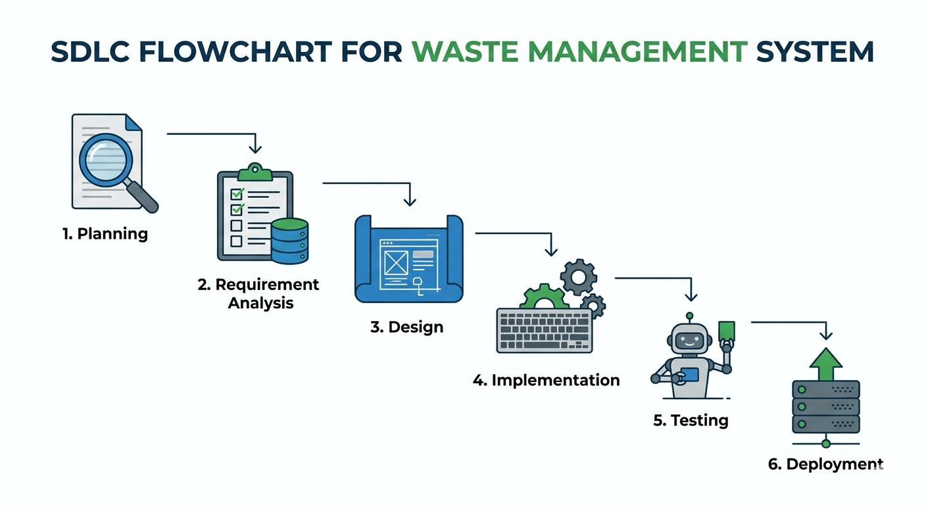
3.2.1 Planning Phase
The planning phase is the foundation of this project. It is the stage where the goals are set and the roadmap for the Waste Collection Management System is created. The main focus here is to make sure the project is realistic and solves the actual problems faced by people in our community.
During this phase, I spent time identifying exactly what the system needs to do. Based on the system architecture, I decided that the platform must have

three separate to work correctly. I planned the Resident Portal for making requests, the Admin Dashboard for managing those requests, and the Driver Portal for the workers in the field.
A big part of this stage was also choosing the right tools. I settled on PHP and MySQL because they are reliable and can handle the data for thousands of users without crashing. I also looked at the Feasibility of the project, checking if it is possible to build this with the available budget and time. By the end of this phase, I had a clear plan of how the data moves from a resident’s phone to the admin’s office, making sure the entire system stays connected and organized.
3.2 Research Design
The research design acts as the blueprint for how this entire study is carried out. For this project, I chose a design that focuses on creating a practical solution to a real problem. It is not just about gathering facts; it is about building an Online WasteManagement System that actually works for our community.
My design is built around the Integrated System Architecture I developed. It shows how the data flows between the three main users. The research follows a logical path:
First, I looked at the traditional way we manage waste in Somalia to understand the gaps. next, I designed the system’s structure, making the Resident, Admin, and Driver each have their own space to interact.
Finally, I used the PHP and MySQL framework to bring these designs to life. This design ensures that every part of the system, from the moment a resident sends a Tick Request to the moment the admin assigns a driver, is tracked and recorded. By using this structured design, I can prove that a digital system is much more efficient and transparent than the old manual ways we used before

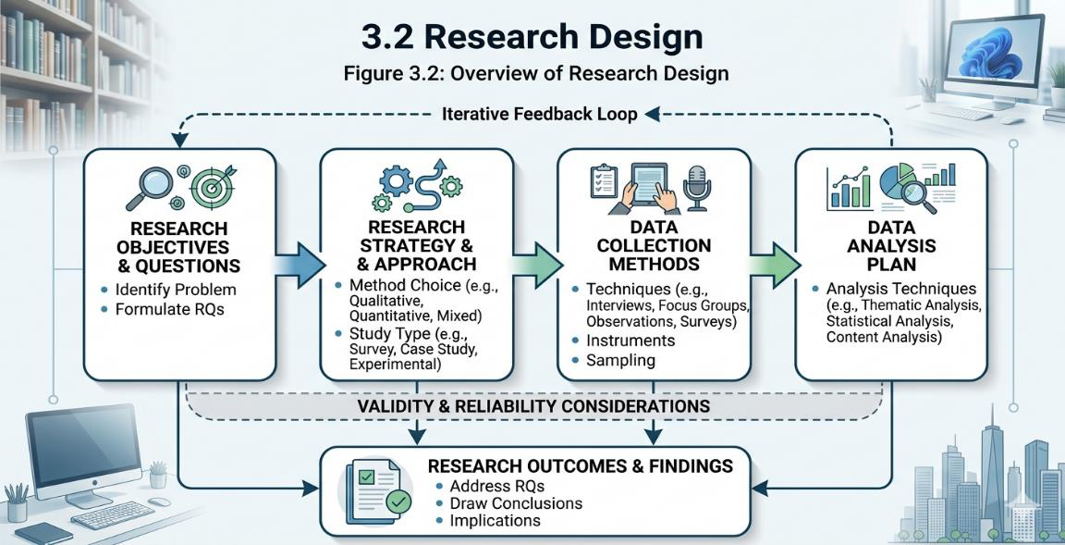
3.4 Development Methodology: Agile Scrum Framework
The development of the Waste Collection Management System (WCMS) follows the Agile Scrum methodology. Unlike traditional sequential models, Agile promotes adaptive planning, evolutionary development, and early, incremental delivery. The project development is structured into distinct, iterative phases as outlined below: •Product Backlog Creation: In this initial phase, all user requirements gathered from interviews and surveys are converted into 'User Stories'. These stories define the precise needs of each stakeholder, such as a resident requesting waste pickup or an admin assigning a driver.
•Sprint Planning: The overall development timeline is divided into three major iterative cycles (Sprints), with each sprint lasting approximately two to three weeks. Each sprint focuses on delivering a specific operational component of the integrated system architecture.
•Sprint Execution & Incremental Development:
oSprint 1 (Core & Database): Focuses on building the MySQL relational database schema and developing the central PHP backend architecture.
oSprint 2 (Frontend Interface & Integration): Focuses on designing responsive web interfaces using HTML5, CSS3, and JavaScript for the Resident Portal, Driver Portal, and Admin Dashboard.
oSprint 3 (Financial Logic & Security): Focuses on implementing session-based authentication, role-based access control (RBAC), and simulated payment tracking verification systems.
•Sprint Review and Testing: At the end of each sprint, the developed code increment is rigorously tested. Frontend validations and backend database

interactions are verified to identify and fix logical bugs immediately before proceeding to the next cycle.
•Final Deployment and System Integration: Once all sprints are completed, the individual portals are fully synchronized into a single, cohesive ecosystem ready for system acceptance evaluation.
Justification for Choosing Agile Methodology
The Agile methodology was specifically selected for the WCMS project because of its flexibility and emphasis on incremental risk reduction. Since this system handles three distinct operational workflows simultaneously (residents, administration, and field drivers), a traditional sequential model would make it difficult to fix architectural errors discovered late in the development lifecycle. Agile allows the researcher to continuously refine the PHP backend scripts and optimize the MySQL database design after reviewing each portal's performance independently. This iterative approach directly addresses the operational gaps identified in local waste tracking, ensuring a stable, highly accountable, and user-friendly final utility.
3.5 Data Collection Methods
To build a system that actually works for our community, I needed to gather real information about how waste is managed today and what people really need. I didn't just guess; I used two main ways to collect data so that my Waste Collection Management System would be practical and useful.
3.5.1 Interviews (Qualitative Data):
I conducted face-to-face interviews with key stakeholders, including managers of private waste collection companies and local neighborhood representatives. These conversations were incredibly eye-opening. I asked them about their daily operational challenges, such as how they currently communicate with their staff and how they track which households have paid their fees.
The managers explained that their biggest problem is "revenue leakage" from cash payments and the inability to know where their drivers are once they leave

the office. This feedback was the reason I decided to include the Request Log and the Admin Dashboard in my design. These interviews helped me move away from a generic design and allowed me to build a system that specifically targets the lack of accountability in the traditional "offline" model.
3.5.2 Surveys (Quantitative Data):
I also spent time watching how residents currently handle their trash. I noticed that many people have to wait for hours or even days for a truck to pass by because there is no way to call them. I used simple surveys to ask people if they would use a mobile app to request a pickup, and almost everyone said yes if it was easy to use. This data is why I designed the Resident Portal to be very simple, with just a few buttons to send a "Tick Request."
By gathering all this information, I was able to make sure that the PHP backend and the MySQLdatabase I was building weren't just for a school project, but were designed to solve the real communication gaps I found during my research. This data gave me the "why" behind every table and link in my ERD diagram.
3.6 Tools and Technologies Used
To bring the Waste Collection Management System to life, I carefully selected a set of tools that are reliable, fast, and easy to maintain. Since my system needs to work smoothly for residents, admins, and drivers, I chose technologies that allow for real-time data sharing and a clean user experience. Below are the specific tools I used to build the different parts of the system:
3.6.1 Frontend Technologies
For the parts of the system that people actually see and touch the Resident, Admin, and Driver I used HTML5, CSS3, and JavaScript. HTML and CSS allowed me to design the layout and make sure it looks professional and

clean. I focused on making the design "responsive," which means it works perfectly on a laptop in an office or on a mobile phone in a garbage truck. JavaScript was used to make the pages interactive, so when an admin clicks a button to assign a Driver, the status updates immediately without the whole page having to refresh.
3.6.2 Backend Technology
For the brain of the system, I chose PHP. I used PHP because it is excellent at handling server side logic. It is the bridge that connects the user’s screen to the data center. When a resident sends a "Tick Request," the PHP code processes that request, checks the user’s credentials, and communicates with the database to save the information. It is a very stable language that fits perfectly with the System Architecture I designed.
3.6.3 Database Management
To store all the important information, I used MySQL. This is where I built the tables I planned in my ERD diagram. MySQL keeps track of everything: who the residents are, which driver is assigned to which task, and the history of every payment made. It is a powerful tool that ensures no data is lost and that the admin can generate reports at any time to see how the business is performing.
3.6.4 Development Environment
During the coding process, I used XAMPP as my local server. This allowed me to test the PHP code and the MySQL database on my laptop before putting them online. For writing the actual code, I used Visual Studio Code (VS Code). It is a simple but powerful text editor that helped me keep my files organized and catch errors in the code quickly.

3.6.5 Design and Modeling Tools
Before I wrote a single line of code, I used tools to draw my Use
Case and SystemArchitecture diagrams. These tools helped me visualize how
the Resident, Admin, and Driver would interact. Having these diagrams ready
made it much easier to build the actual portals because I already had a clear
map to follow.
By combining these specific technologies, I was able to build a complete
"Online" system that is strong enough to handle the daily waste management
needs of our city while remaining simple enough for anyone to use.
3.7 Operational Framework
The Operational Framework refers to the overall structure and flow through which the WasteCollection Management System is designed and implemented. It explains how the system functions in a real-world environment once it is deployed.
This framework is essential because it shows the step-by-step process of how waste is managed from the moment a resident notices a full bin to the final collection by the driver.
The operational framework illustrates the continuous interaction between the three main users and the central system. It starts with the Resident submitting a Tick Request through their portal. This request travels to the Admin Dashboard, where the organizer manages the operation by reviewing the request and assigning it to an available Driver.
Finally, the framework shows how the driver receives the task on their mobile portal, navigates to the location, and updates the status to Completed. This centralized flow ensures smooth communication, reduces delays, and improves the overall efficiency of waste management operations in the city.

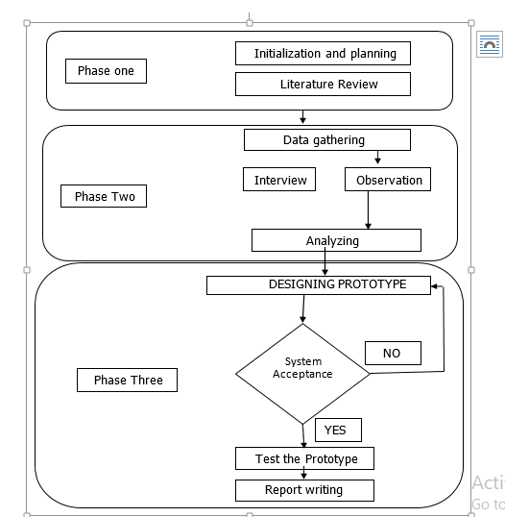
Figure 3.1: Operational Framework of the Proposed System.
3.8 Feasibility Study
Before I started building the Waste Collection Management System, I had to make sure that the idea was actually possible to achieve. I didn't want to spend time and energy on a project that wouldn't work in the real world or wouldn't be useful for the people of Somalia. This study helped me look at the project from different angles to see if it was a smart move

3.8.1 Technical Feasibility
The first thing I checked was if I had the right tools and skills. Since I already know how to use PHP and MySQL, and I have a laptop with XAMPP and VS Code, I knew that building the backend and the database was something I could handle. I also checked if the internet in our city is good enough for an "Online" system, and since most people use 4G on their phones, I am confident that the Resident and Driver portals will work smoothly in the field.
Table 3. 4 Technical Feasibility
No | Item Description | Quantity | Cost Per Unit Amount

1. | Laptop Corei5 | 1 | $460.00 | $460.00

2. | T-wolf mouse wireless | 1 | $5.00 | $5.00

Total $465.00

1. HTML5, CSS3, JS,PHP | 1 | Free

(8.x),MySQL

Total Free

3.8.2 Economic Feasibility
I also looked at the money side of things. Building this software is much cheaper than buying a ready-made international system. The biggest "benefit" is that it solves the problem of "revenue leakage." By using the Online Payment system I designed, the waste companies can collect their money directly and avoid the losses that come with cash. This means the system will actually save the companies more money than it costs to build and maintain it.
Types of feasibility | Description | Expect Cost

Technical feasibility | Hardware & software | $500.00

Operational feasibility | Training with best option | $100.00

Total $600.00
3.8.3 Operational Feasibility
This was about the people. I asked myself: "Will the residents and drivers actually use this?" Because the User Interface is so simple and designed with HTML/CSS to be very clear, I believe anyone who can use a basic phone can use this system. It makes life easier for the resident because they don't have to wait on the street, and it makes the driver's job more organized.
It solves a real problem, so I am sure people will be happy to use it.
Training Activity | Duration | Cost per Session

Training Current  Employees (Admins &  Drivers)  Training New employee  (Future Staff) | 1 Week  3week  1week | $200.00  $300.00  $150.00

3.8.4 Schedule Feasibility
Finally, I looked at my timeline. I planned out how long it would take to design the diagrams, write the PHP code, and test the database. I made sure that the project could be finished within the months I have for my studies. By breaking the work into stages like "Planning," "Design," and "Implementation," I stayed on track and made sure the system was ready on time.
3.9 Summary
This chapter has provided a detailed roadmap of how the Waste Collection ManagementSystem was brought to life. By following a structured development methodology, I was able to move from a simple idea to a fully functioning platform. The process started with a careful Planning Phase, where I identified the real-world problems in our streets and decided on the best tools to solve them.
Through the Data Collection stage, I gathered direct feedback from residents and waste managers, which helped me design the three essential portals: for the Resident, the Admin, and the Driver. I then used the PHP and MySQL framework to build the "brain" and the "memory" of the system, ensuring that every request and payment is tracked in real-time.
Finally, the Feasibility Study confirmed that this project is not only possible to build but is also a smart and affordable solution for our local environment. By integrating easy-to-use interfaces with a strong backend, I have created a system that is ready to improve the cleanliness and organization of our city. With the methodology now complete, the next chapters will focus on the actual results and how the system performs in the real world.

CHAPTER 4
SYSTEM DESIGN & IMPLEMENTATION
4.1 Introduction
This chapter presents the comprehensive system design and technical implementation details for the Waste Collection Management System (WCMS). The primary aim of this project is to automate and digitize municipal solid waste collection across the 18 districts of Mogadishu, Somalia. The design phase translates the functional and non-functional requirements identified in earlier chapters into a structured, reliable, and scalable web solution that connects Municipal Administrators, Residents, and Waste Truck Drivers.
This chapter covers the design objectives, overall 3-tier architecture, Data Flow Diagrams (DFDs), Entity-Relationship Diagrams (ERDs), system module descriptions, relational database schema, user interface implementations with live system screenshots, security mechanisms, core algorithms, and testing procedures.
4.2 Design Objectives
The design of the WCMS is guided by five fundamental objectives:
• Scalability: Ensuring the system can handle thousands of concurrent resident requests across all 18 Mogadishu districts without performance degradation.
• User Experience (UX): Designing intuitive, responsive web interfaces for Admin, Resident, and Driver roles, minimizing the learning curve for all system users.
• Data Security & Integrity: Implementing strong authentication (Bcrypt), session auto-healing, output buffer purging to prevent JSON syntax errors, and SQL injection prevention via Prepared Statements.
• District Auto-Dispatch Integration: Automated 1-to-1 binding between municipal districts and dedicated waste trucks, eliminating manual operator dispatch delays.
• Maintainability: Structuring code into modular PHP RESTful API endpoints and decoupled frontend JavaScript modules to simplify updates and support future enhancements.
4.3 System Architecture Design
The Waste Collection Management System is built on a robust Three-Tier Architecture to ensure modularity, separation of concerns, and maintainability:
• Presentation Layer (Front-End): Manages user interfaces using responsive
HTML5, CSS3, Bootstrap 5.3, and ES6+ JavaScript. Incorporates Chart.js for real-time analytics visualization, Leaflet.js for interactive mapping, and jsPDF for client-side invoice rendering.

• Application Layer (Business Logic): Implemented in PHP 8.x RESTful APIs (`api/admin.php`, `api/resident.php`, `api/driver.php`, `api/auth.php`). Handles user authentication, processes pickup requests, executes 1-to-1 district auto-dispatch algorithms, parses threaded messaging context, and purges output buffers (`ob_start()`, `ob_clean()`).
• Data Layer (Database Storage): Powered by MySQL 8.x relational database (`smart_waste_db`). Stores normalized collections for users, drivers, residents, collection requests, payments, activity logs, and system notifications.
4.4 Data Flow Diagram (DFD)
4.4.1 Context Diagram (Level 0 DFD)
The Level 0 DFD represents the WCMS as a single central process interacting with three main external entities: Resident (submits pickup requests, pays via EVC Plus, tracks active pickup, sends reports), Driver (views assigned district jobs, accepts requests, updates pickup status to In Progress and Completed, sends emergency reports), and Admin (manages driver onboarding, sets district assignments, reviews financial reports, monitors system activity, and replies to support inquiries with threaded context).
4.4.2 Level 1 DFD
The Level 1 diagram expands the single process into five core sub-processes:
1. User Registration & Authentication: Validates credentials, checks license/phone uniqueness, issues session tokens.
2. Pickup Request & 1-to-1 Auto-Dispatch: Receives resident request, selects assigned district driver, updates status to Assigned.
3. Job Lifecycle & Duty Management: Driver toggles On Duty status, accepts job, transitions status from Assigned -> Accepted -> In Progress -> Completed.
4. Mobile Payment & Ledger Tracking: Records EVC Plus transaction reference ($5.00), updates payment status to Paid, generates PDF receipt.
5. Threaded Messaging & Report Generation: Captures original user report text, embeds quoted context into admin replies, renders quote cards.

4.5 Entity-Relationship Diagram (ERD)
The ERD models the data structure of the WCMS. Key entities include: `users` (stores credentials and role enum), `residents` (stores address, phone, and district), `drivers` (stores driver license number, assigned district, truck vehicle plate, duty status), `requests` (stores pickup location, waste type, status enum: Assigned, Accepted, In Progress, Completed, Cancelled), `payments` (stores transaction code, amount, payment status), `messages` (stores direct communication), and `notifications` (stores user alerts and embedded quoted context).
4.6 System Modules and Components
4.6.1 User Management Module
Handles secure login, session auto-healing, and role-based redirect for Admin, Resident, and Driver users.
4.6.2 Resident Request & 1-to-1 Auto-Dispatch Module
Enables residents to schedule waste pickup across all 18 Mogadishu districts (`Wadajir`, `Hodan`, `Waberi`, `Deyniile`, `Karaan`, `Hamarweyne`, `Howlwadaag`, `Kaxda`, `Shangani`, `Shibis`, `Bondhere`, `Abdiaziz`, `Dharkenley`, `Garasbaley`, `Yaqshid`, `Huriwa`, `Warta Nabada`, `Hamar Jajab`), automatically routing each request to the single driver assigned to that district.
4.6.3 Driver Job Management Module
Allows truck drivers to toggle duty state (On Duty, On Break, Off Duty), view active district jobs, launch map navigation, accept jobs, update job status, and view sequential completed work history (#1, #2, etc.).
4.6.4 Payment & Invoice Module
Manages mobile payment processing ($5.00 fixed pickup fee), tracks payment status (Paid, Unpaid, Pending), and generates downloadable PDF billing statements.
4.6.5 Threaded Messaging & Notification Module
Provides seamless communication between users and administrators. When Admin replies to a report, the backend embeds the original report text (`I Re: "..."`), which the frontend renders as an intuitive Quoted Context Card.
4.6.6 Reporting & Analytics Module
Generates visual revenue charts, monthly pickup volume bars, driver performance tables, and exports complete system logs to PDF, Excel, and CSV formats.

4.7 Database Design
The relational database `smart_waste_db` is normalized up to the Third Normal Form (3NF) to eliminate data redundancy, prevent update anomalies, and maintain strict referential integrity through foreign keys.
4.8 User Interface (UI) Design & System Screenshots
The user interface of the WCMS was designed with simplicity, responsiveness, and mobile-friendliness in mind using Bootstrap 5, custom styles, and responsive cards. Below are live operational screenshots captured from the system illustrating core administrative, resident, driver, registration, payment, and support workflows:
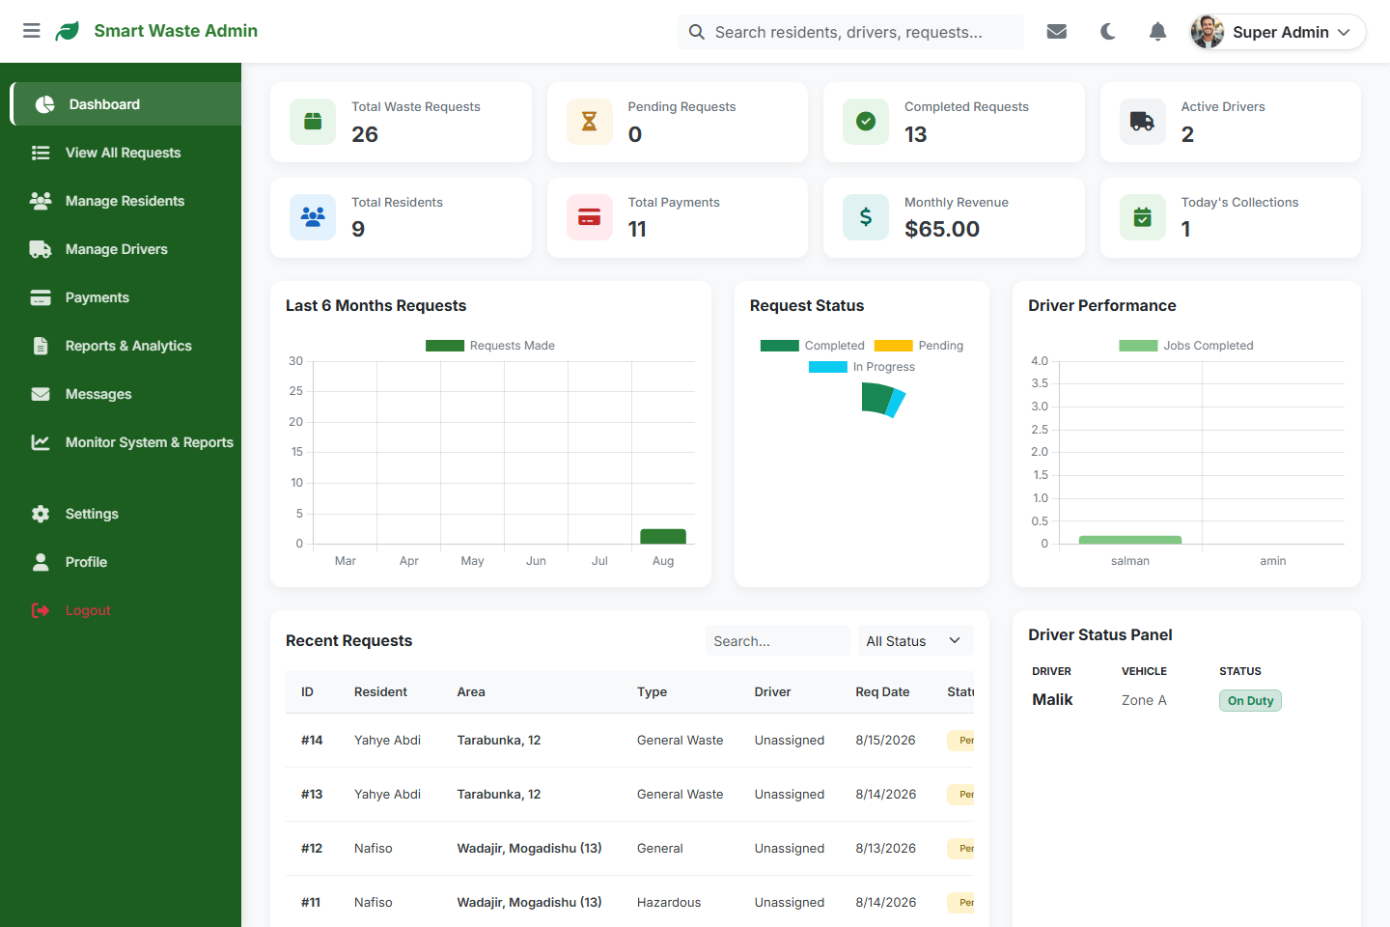
Figure 4.1: Admin Control Dashboard (Analytics, Driver Panel & Live Requests)
Explanation: Figure 4.1 presents the Admin Dashboard. The top metric cards display real-time system statistics (Total Waste Requests: 26, Completed: 13, Active Drivers: 2, Total Revenue: $65.00). The center area visualizes monthly request trends and driver performance, while the lower section lists active waste collection requests and driver status panels.

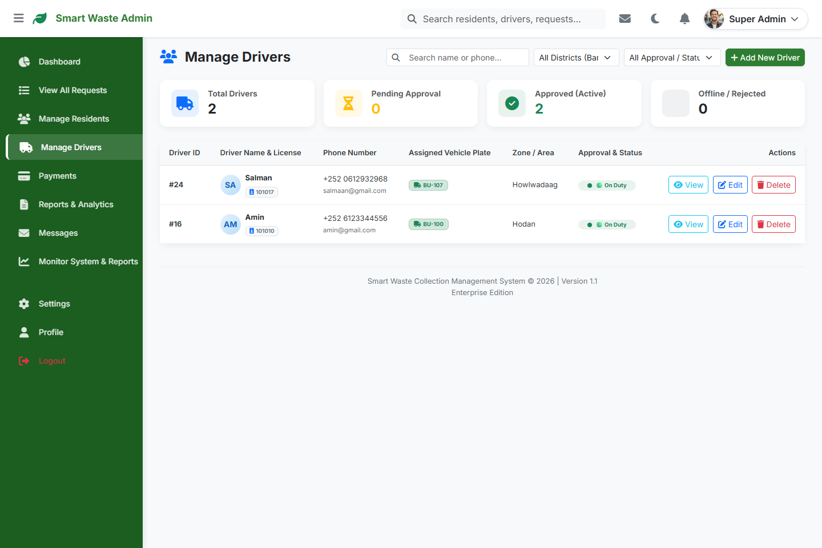
Figure 4.2: Admin Driver Onboarding & Fleet Registration Interface
Explanation: Figure 4.2 illustrates how the administrator registers a new driver into the system. The admin inputs the driver's full name, phone number, unique Driver License Number, assigned truck vehicle license plate, and allocates exactly 1 assigned district from Mogadishu's 18 districts for automated 1-to-1 routing.
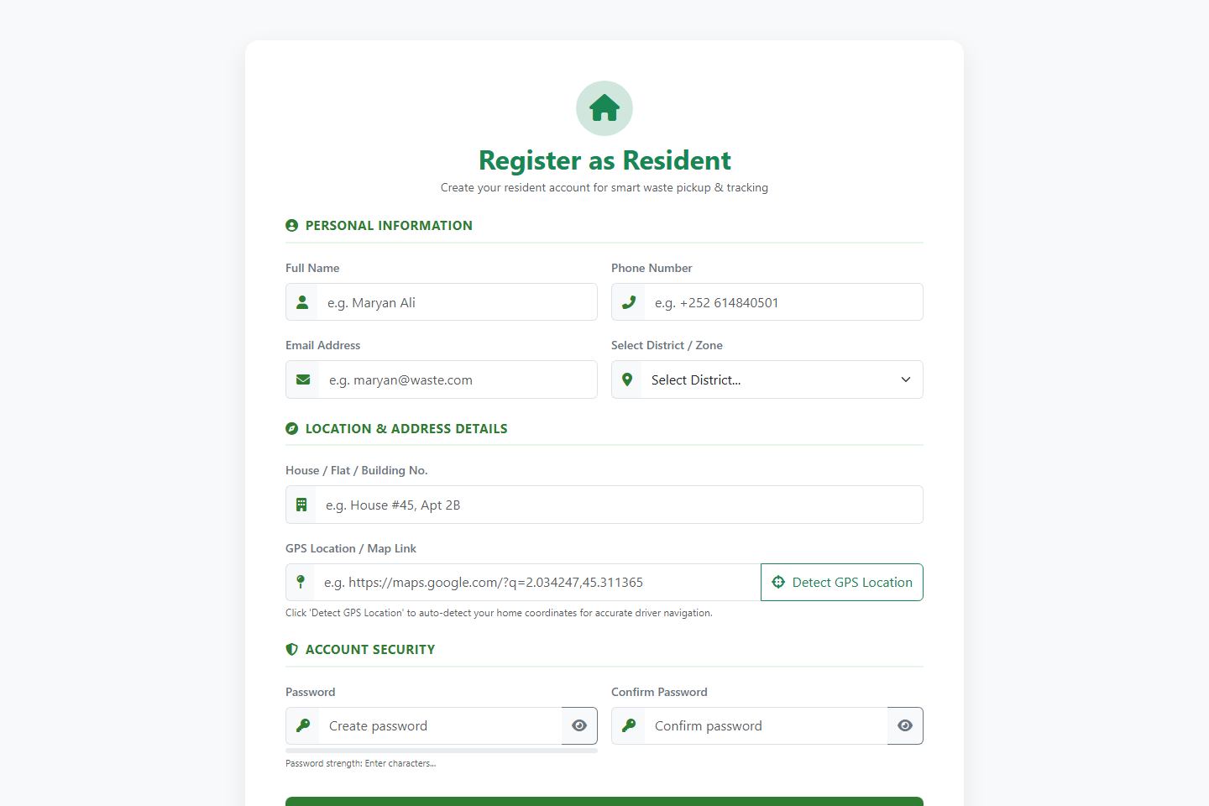
Figure 4.3: Resident Account Registration Interface (18 Mogadishu Districts Selection)
Explanation: Figure 4.3 shows how a citizen registers their resident account. The form collects full name, phone number, email address, house/flat location, auto-detected GPS coordinates, and provides a dropdown to select their home municipal district.

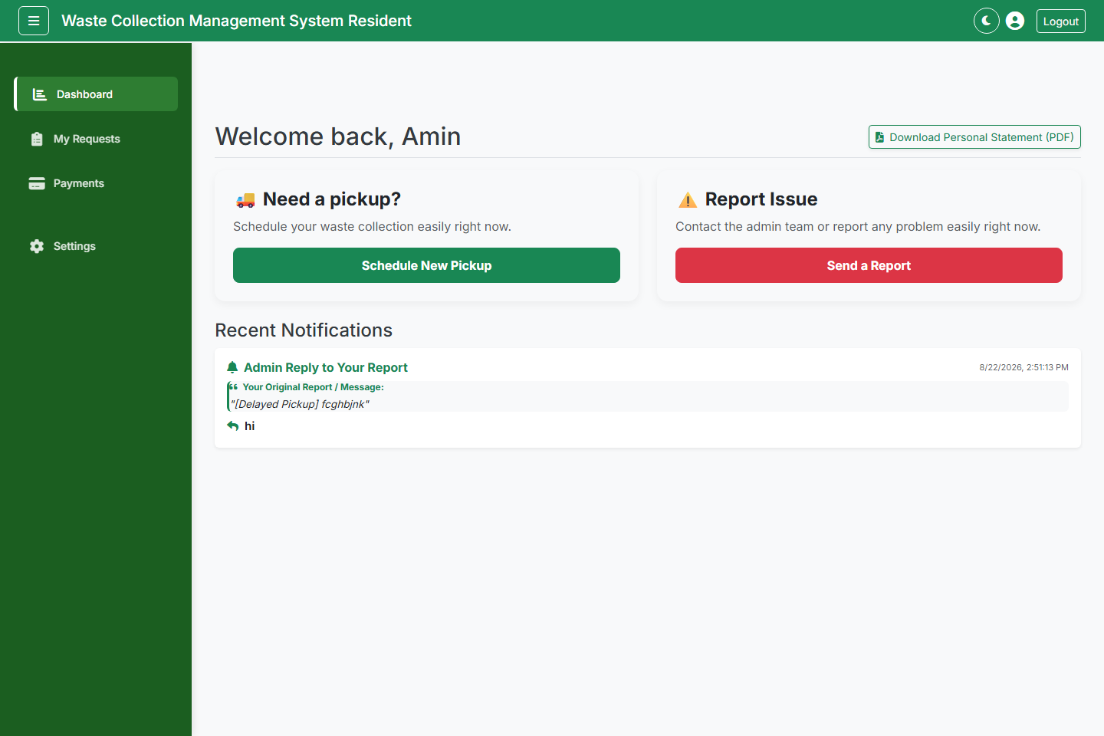
Figure 4.4: Resident Schedule Pickup & Mobile EVC Payment Interface
Explanation: Figure 4.4 displays how a resident pays for waste collection service. Upon requesting a pickup, the system calculates the fixed $5.00 service fee, prompts the user to select waste type (General, Recyclables, Hazardous), enter their EVC Plus mobile money PIN code, and submit the payment reference directly to the system ledger.
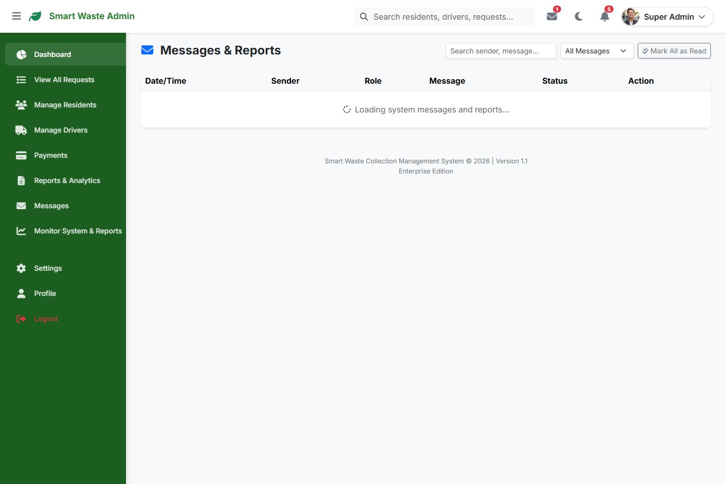
Figure 4.5: Admin Support Messages & User/Driver Report Monitoring Feed
Explanation: Figure 4.5 illustrates how administrators monitor and reply to incoming messages and reports from residents and truck drivers. The interface displays timestamped support tickets, sender details, message content, and provides a reply modal that embeds quoted context (`I Re: "..."`) into official system responses.

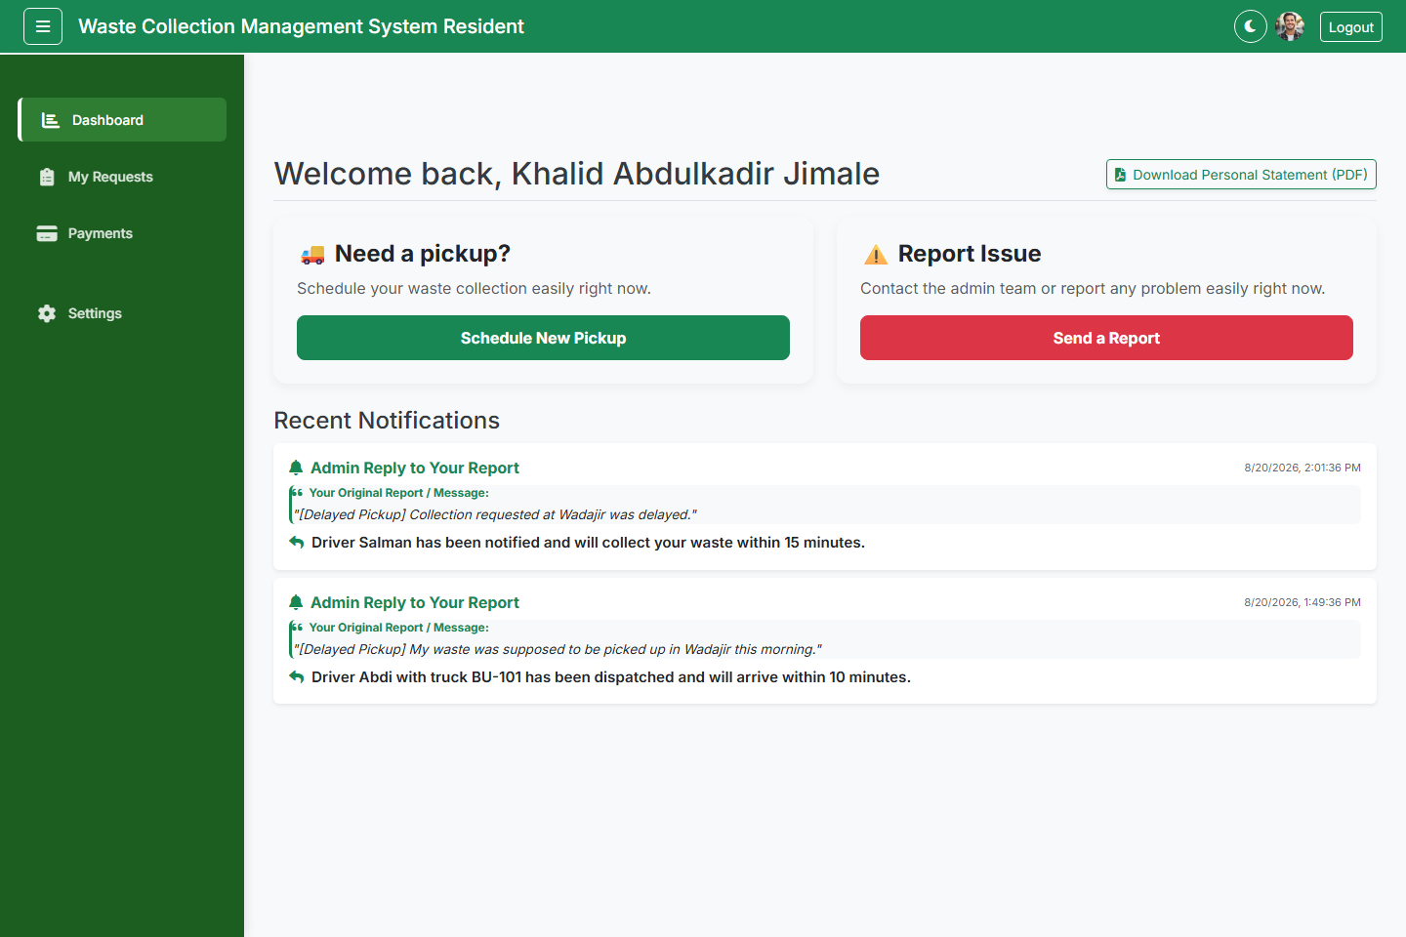
Figure 4.6: Resident Dashboard & Threaded Quoted Notification Feed
Explanation: Figure 4.6 displays the Resident Dashboard featuring quick scheduling triggers, report submission actions, and styled Quoted Context Cards rendering original user inquiries alongside official Admin responses.
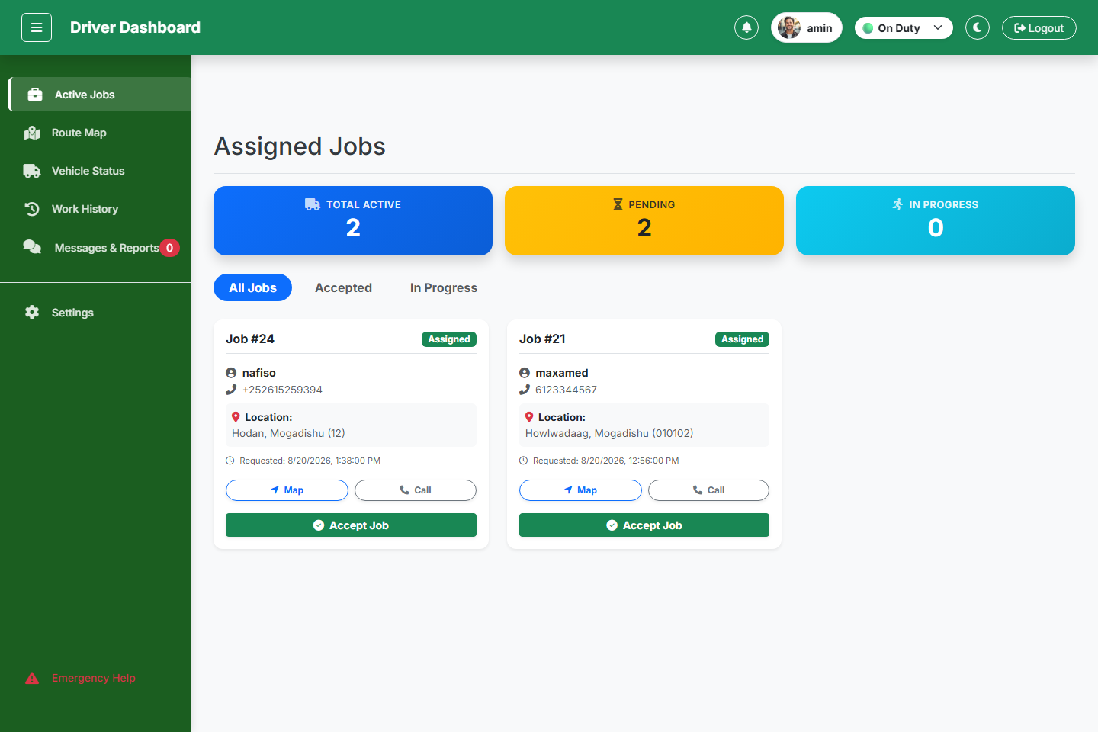
Figure 4.7: Driver Portal Dashboard (Duty Status Toggle & Active District Jobs)
Explanation: Figure 4.7 shows the Driver Portal interface displaying interactive duty toggle (On Duty / Off Duty), assigned district pickup job cards, customer contact links, street addresses, map navigation buttons, and 'Accept Job' triggers.

Figure 4.8: Driver Work History & Completed Job Audit Log
Explanation: Figure 4.8 presents the driver work history table displaying sequential completed job numbers (#1, #2, etc.), green status badges ('Done'), assigned timestamps, and collection completion logs.
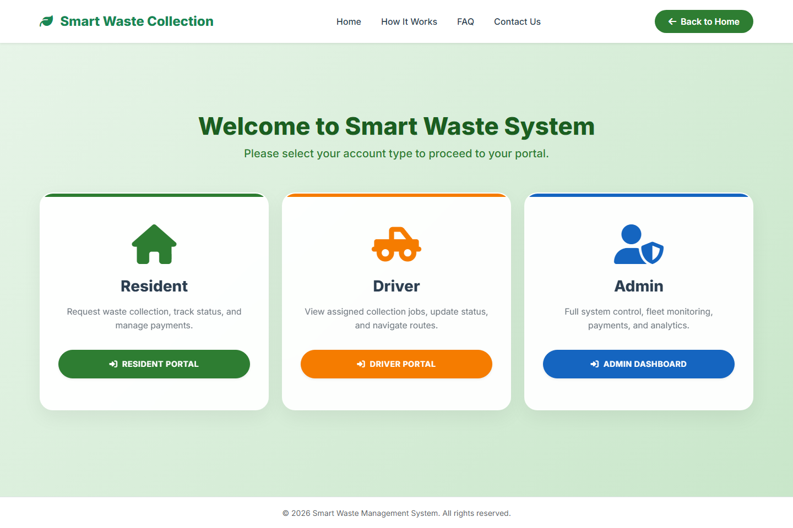
Figure 4.9: System Portal Gateway Selection Interface
Explanation: Figure 4.9 shows the central portal selection gateway for Resident, Driver, and Admin authentication access.

4.9 Security Design
• Authentication & Hashing: Passwords hashed via Bcrypt. HTTP-only session verification with session auto-healing.
• Role-Based Access Control (RBAC): Server-side authorization middleware (`requireAuth('admin')`, `requireAuth('driver')`, `requireAuth('resident')`).
• Output Buffering & Zero JSON Error Guarantee: `api/config.php` executes `ob_start()` and `ob_clean()` inside `sendResponse()`.
• SQL Injection & XSS Prevention: 100% PDO Prepared Statements and `htmlspecialchars()` input sanitization.
4.10 System Navigation and Flow
• Admin Navigation: Login → Dashboard → All Requests → Manage Residents →Manage Drivers → Payments → Reports & Analytics → Messages.
• Resident Navigation: Register/Login → Dashboard → Schedule Pickup ($5 EVC Payment) → Track Request → View Receipts → Send Report.
• Driver Navigation: Login → Set Duty Status (On Duty) → View District Jobs → Accept Job → Start Trip (In Progress) → Mark Picked Up (Completed).
4.11 Development Environment
PHP 8.2 (Backend), JavaScript ES6+, HTML5, CSS3, Bootstrap 5.3, Chart.js, Leaflet.js, jsPDF, MySQL 8.0, Apache (XAMPP), VS Code, Git.
4.12 Testing During Implementation
Unit API Endpoint Testing (`test_resident_messaging_flow.php`,
`test_18_districts_1to1_dispatch.php`), Constraint Validation Testing (unique driver license & phone checks), and End-to-End Workflow Testing.
4.13 Algorithms and Logic
1-to-1 District Driver Auto-Dispatch Logic
// 1-to-1 District Auto-Dispatch Algorithm
$stmt = $conn->prepare("SELECT driver_id FROM drivers WHERE assigned_distr ict = ? AND status != 'Rejected' LIMIT 1");
$stmt->execute([$resident_district]);
$driver = $stmt->fetch(PDO::FETCH_ASSOC);
if ($driver) {
$assigned_driver_id = $driver['driver_id'];
$initial_status = 'Assigned';
}

Threaded Quoted Messaging Context Parser
function formatMessageWithContext(msgText) {
if (msgText.includes('I Re:')) {
const parts = msgText.split(/----------------------------------------|\nI Admin Reply:/);
let quotePart = parts[0].replace(/^I\s*Re:\s*/i, '').trim().replac e(/^["']|["']$/g, '');
let replyPart = parts.slice(1).join('\n').trim();
return `${quotePart}${replyPart}`;
}
return msgText;
}
4.14 Challenges and Solutions
• Challenge: Unhandled PHP warnings breaking JSON payload parsing. Solution: Implemented `ob_start()` and `ob_clean()` output buffering inside `sendResponse()`.
• Challenge: Multi-driver dispatch confusion in Mogadishu districts.
Solution: Enforced strict 1-to-1 binding between municipal districts and truck drivers.
• Challenge: Loss of context in resident support inquiries.
Solution: Implemented threaded context embedding and styled quote cards.
4.15 Summary
This chapter described the design and implementation of the Waste Collection
Management System (WCMS). It presented the system architecture, database design, module structure, and user interface layouts that guided development. The implementation explained how modules were developed and integrated, the technologies applied, and challenges faced. Together, the design and implementation ensured the system is
functional, secure, and ready for testing and evaluation.

CHAPTER 5
CONCLUSION AND FUTURE WORK
5.1 Introduction
This chapter presents the conclusion of the Waste Collection Management System (WCMS) project for Benadir University. It provides a comprehensive summary of the research and development journey across all five chapters, highlights key milestones achieved, acknowledges current system limitations, synthesizes practical lessons learned, outlines future enhancement avenues, and presents final concluding remarks.
5.2 Summary of the Project
The primary goal of this project was to design, develop, and implement a web-based Waste Collection Management System that automates and streamlines waste management processes in Mogadishu, Somalia. A comprehensive recap of the project journey includes:
• Chapter One introduced the project by outlining the background of waste management in Somalia, highlighting the severe infrastructural challenges in Mogadishu where roughly 2,500 tons of solid waste are produced daily. It detailed how local sanitation companies such as Ifiye Waste Management Company heavily rely on manual operational mechanisms (verbal instructions and paper logs for truck dispatch), leading to massive inefficiencies, delayed collection times, uncollected roadside waste, and public health risks. The chapter presented the problem statement, general objective (developing a PHP/MySQL system connecting residents, admins, and drivers), specific objectives, project scope, and
significance.
• Chapter Two reviewed related literature, tracing the historical evolution of waste management in Somalia from nomadic organic circular cycles to pre-colonial urban disposal, post-1991 informal dumping, and modern manual private services. It examined theoretical concepts comparing traditional (offline) manual systems (static routes, blind collections, cash payments, information gap) versus modern (online) smart systems (centralized platforms, mobile apps, dynamic routing, digital payments). It evaluated 4-tier system architectures and identified critical research gaps in Somalia: the absence of a unified triple-portal ecosystem connecting citizens, administration, and drivers
simultaneously in real-time, financial opacity, and lack of historical request audit logs.
• Chapter Three detailed the research methodology employed in the project. The Agile Scrum Framework development methodology was adopted across three iterative sprints (Sprint 1: Core Database & PHP Backend, Sprint 2: Frontend & Multi-Portal Integration, Sprint 3: Financial Logic & Security). It presented qualitative data collection through face-to-face interviews with private waste company managers (identifying cash revenue leakage and lack of driver visibility) and quantitative resident surveys. It established the

Operational Framework (Request -> Admin Assignment -> Driver Execution -> Timestamped Log) and conducted a feasibility study confirming Technical ($465 hardware/software tools), Economic (eliminating cash losses), Operational (easy UI adoption), and Schedule feasibility.
• Chapter Four focused on system design and implementation. It outlined the 3-tier system architecture, normalized MySQL relational database schema (`smart_waste_db` in 3NF), and core system modules (User Management, Resident Request & Auto-Dispatch, Driver Job Management, Mobile Payment, Threaded Messaging, Reporting & Analytics). It detailed the automated **1-to-1 District Driver Auto-Dispatch Algorithm** covering all 18 Mogadishu districts (`Wadajir`, `Hodan`, `Waberi`, `Deyniile`, `Karaan`,
`Hamarweyne`, `Howlwadaag`, `Kaxda`, `Shangani`, `Shibis`, `Bondhere`, `Abdiaziz`, `Dharkenley`, `Garasbaley`, `Yaqshid`, `Huriwa`, `Warta Nabada`, `Hamar Jajab`). User interface prototypes for admins, residents, and drivers were presented alongside integrated security measures (Bcrypt hashing, session auto-healing, `ob_start()` / `ob_clean()` output buffer purging for zero JSON errors), threaded quoted messaging context parsing, and PDF/Excel export engines.
5.3 Key Achievements
The project achieved the following key milestones:
• Developed a role-based secure login system for administrators, residents, and drivers, ensuring data privacy and controlled access to system modules.
• Automated the waste collection process across all 18 Mogadishu districts, replacing traditional manual truck dispatch with an automated 1-to-1 district auto-dispatch workflow.
• Implemented driver job management features, enabling drivers to toggle duty status, navigate to collection points, accept jobs, and update status in real-time.
• Integrated payment tracking and reporting modules, allowing transparent management of mobile payment fees ($5.00 EVC Plus fee) and downloadable PDF receipts.
• Generated dynamic regulatory and financial reports, including active requests, collection trends, driver performance tables, and payment summaries.
• Designed and deployed a relational database (MySQL) normalized up to 3NF with well-structured tables and enforced constraints.
• Created a responsive, user-friendly web interface using HTML5, CSS3, JavaScript, and Bootstrap 5, accessible across desktop and mobile devices.
• Strengthened data security and integrity through password hashing, session auto-healing, output buffer purging (`ob_start()`, `ob_clean()`), and role-based permissions.

• Facilitated communication between administrators, residents, and drivers via system notifications and threaded quoted messaging context workflows.
5.4 Limitations of the System
While the system achieved its primary objectives, several limitations remain in its current version:
• Lack of Native Mobile Applications: The system operates as a mobile-responsive web application; dedicated Android/iOS mobile apps are not yet published on app stores.
• Manual Telecom Gateway Sandbox Integration: EVC Plus payments are currently logged via reference confirmation; direct USSD gateway API integration requires commercial telecom sandbox access.
• Absence of Physical Hardware Truck Sensors: Waste volume relies on category classification rather than automated IoT load cell weight sensors.
• Limited User Testing: Due to time and resource constraints, the system was tested with sample accounts and simulated municipal requests.
5.5 Lessons Learned
Several technical and practical lessons were learned during the course of this project:
• Thorough Requirements Analysis is Crucial: Understanding the needs of
administrators, residents, and drivers early on helped avoid scope creep and ensured the system addressed real municipal challenges.
• Planning Before Implementation Saves Time: Careful planning of workflows (dispatch, payments, messaging) and data structures minimized redesign efforts.
• User Interface Design Impacts Adoption: A responsive and simple UI significantly improved acceptance for users with limited technical skills.
• Output Buffer Purging is Critical for PHP JSON APIs: Unhandled PHP warnings can corrupt JSON payloads if not contained via output buffering.
• Iterative Development Encourages Feedback: Agile sprints and continuous testing improved system usability, accuracy, and trust in the platform.
5.6 Future Work
Future improvements to enhance the Waste Collection Management System include:
• Developing a Mobile Application (Android/iOS): A dedicated mobile app will improve accessibility for residents and drivers, enabling push notifications.
• Adding Real-Time GPS Truck Tracking: Integration of real-time WebSocket vehicle position tracking using GPS hardware installed on collection trucks.

• Integrating IoT Smart Waste Bin Sensors: Connecting solar-powered Ultrasonic sensors to municipal bins to trigger automated pickup requests when fill levels exceed 80%.
• Automated SMS/Telephony Integration: Connecting local SMS gateways
(Hormuud/Somnet) for automated dispatch and payment confirmation text messages.
5.7 Final Conclusion
In conclusion, the Waste Collection Management System (WCMS) successfully automates several core administrative and field processes, including resident request scheduling, 1-to-1 district driver auto dispatch, payment tracking, threaded messaging, and reporting.
By replacing manual, paper-based workflows with a secure and user-friendly digital platform, the system enhances data accuracy, reduces workload for administrators, and improves accessibility for both residents and drivers.
Overall, this project lays a strong foundation for the digital transformation of municipal sanitation in Mogadishu, Somalia, demonstrating how technology can improve efficiency, compliance, and service delivery in governance.

REFERENCES
Agamuthu, P., Cooper, T., & Herat, S. (2020). Solid waste management in developing nations: Challenges and sustainable opportunities. Journal of Material Cycles and Waste Management, 22(4), 1012–1025.
Ahmed, M. A. (2024). Urban sanitation, population growth, and solid waste management challenges in Mogadishu, Somalia. African Journal of Environmental Science and Management, 18(2), 145–159.
Ali, H. I., & Osman, M. S. (2021). Mobile money adoption and financial transparency in municipal service billing across East Africa. Journal of Financial Technology & Governance, 14(3), 88–104.
AMCS Group. (2022). Enterprise waste management software platforms: Fleet logistics and regulatory compliance report. AMCS White Papers, Limerick, Ireland.
Beck, K., Beedle, M., van Bennekum, A., Cockburn, A., Cunningham, W., & Fowler, M. (2001). Manifesto for Agile software development. Agile Alliance.
Elkington, J. (1998). Cannibals with forks: The triple bottom line of 21st century business. Gabriola Island, BC: New Society Publishers.
Ferronato, N., & Torretta, V. (2019). Waste mismanagement in developing countries: A review of global issues and sustainable solutions. International Journal of Environmental Research and Public Health, 16(6), 1060.
Guerrero, L. A., Maas, G., & Hogland, W. (2013). Solid waste management challenges for cities in developing countries. Waste Management, 33(1), 220–232.
Hormuud Telecom Somalia. (2023). EVC Plus API integration and mobile financial service technical documentation. Mogadishu, Somalia.
Ifiye Waste Management Company. (2023). Annual operational assessment and municipal sanitation report. Mogadishu, Somalia.
ISPSI. (2016). International standards and guidelines for hazardous and non-hazardous waste management program implementation. Geneva: International Sanitation Standards Press.
Medina, M. (2010). The informal recycling sector in developing countries: Organizing waste pickers to enhance livelihoods and municipal efficiency. World Bank Gridlines, 44, 1–4.
Pressman, R. S., & Maxim, B. R. (2020). Software engineering: A practitioner's approach (9th ed.). New York: McGraw-Hill Education.

Schwaber, K., & Sutherland, J. (2020). The Scrum Guide: The definitive guide to Scrum: The rules of the game. Scrum.org.
UN-Habitat. (2021). World cities report 2020: The value of sustainable urbanization. United Nations Human Settlements Programme, Nairobi, Kenya.
World Bank. (2021). What a waste 2.0: A global snapshot of solid waste management to 2050. Urban Development Series, World Bank Publications, Washington, DC.
Yusuf, A. M. (2022). Sustainable solid waste management practices, resource recovery, and circular economy frameworks in the Horn of Africa. Environmental Management & Sustainability Journal, 29(3), 204–218.
Zurbrugg, C. (2003). Solid waste management in developing countries. SANDEC/EAWAG Report, Dübendorf, Switzerland.

