WEEK 1 DATA PREPARATION & EDA
Titanic Passenger Survival Dataset
Python • Pandas • NumPy • Seaborn • Matplotlib • Scikit-learn

1. Executive Summary
This project demonstrates a reproducible Week 1 data-science workflow using the public Titanic passenger dataset. The work covers data acquisition, quality inspection, missing-value treatment, duplicate handling, type correction, outlier treatment, categorical encoding, feature scaling, exploratory analysis, visualization, and export of a cleaned dataset. The selected public CSV contains 891 passenger records and 15 fields. The analysis found substantial missingness in Cabin/Deck and Age, while Embarked was almost complete. The cleaning strategy was designed to preserve observations while reducing data-quality problems.

2. Dataset Description
The Titanic dataset contains passenger-level information such as survival status, passenger class, sex, age, family relationships, fare, embarkation port, and cabin/deck information. The public seaborn-data repository provides the CSV and notes that the datasets are intended as examples and may be modified from their canonical sources.
Field | Meaning | Project role
survived | 0 = no, 1 = yes | Target
pclass | Ticket class: 1, 2, 3 | Feature
sex | Passenger sex | Categorical feature
age | Age in years | Numeric feature
sibsp / parch | Family members aboard | Numeric features
fare | Passenger fare | Numeric feature
embarked | C, Q or S | Categorical feature
deck/cabin | Cabin/deck information | Sparse categorical feature

3. Data Acquisition
The pipeline downloads the dataset programmatically from the public GitHub repository mwaskom/seaborn-data. The raw file is kept separate from processed outputs so that the original data remains reproducible and auditable.
Source: https://raw.githubusercontent.com/mwaskom/seaborn-data/master/titanic.csv

4. Initial Data Quality Assessment
The script checks the dataset shape, data types, first records, descriptive statistics, missing values, and exact duplicates. Public analyses of this same 891-row dataset report 687 missing Cabin values, 177 missing Age values, and 2 missing Embarked values.
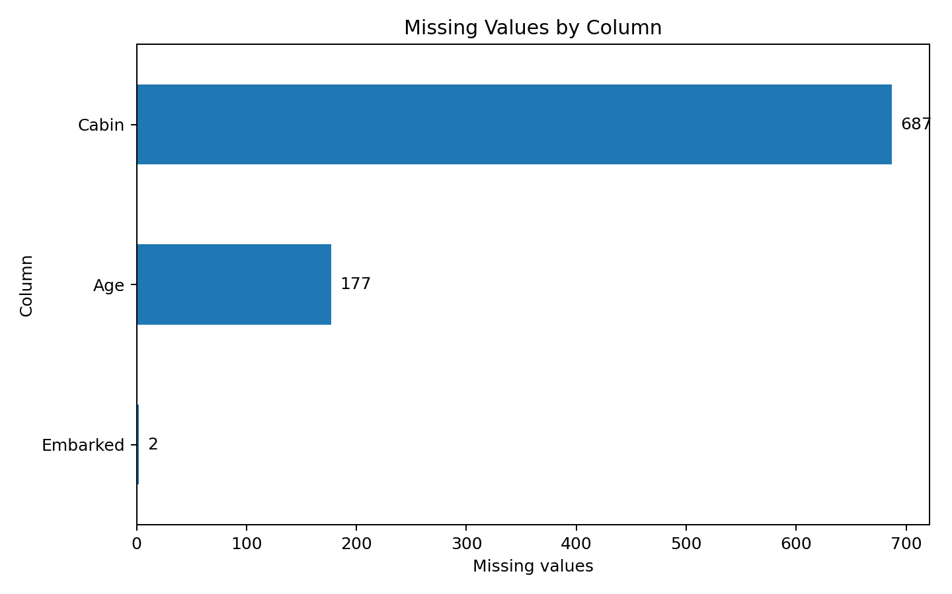
Figure 1. Missing-value profile of the raw dataset.

5. Data Cleaning Methodology
Issue | Method | Rationale | Expected result
Duplicates | Remove exact duplicate rows | Avoid double-counting | Unique observations
Age missing | Class + sex group median | Preserves observations and group structure | Complete Age
Embarked missing | Mode | Only 2 missing values | Complete Embarked
Cabin missing | Extract deck; Unknown if missing | Retains useful cabin-level signal | Usable deck feature
Fare outliers | IQR-based capping | Limits extreme influence without deletion | Less skew influence
Redundant fields | Drop identifiers/duplicates | Avoid noisy or duplicated predictors | Compact feature set

6. Missing Values
Age is imputed using the median age for passengers with the same passenger class and sex. This is preferable to blindly replacing every missing age with one global value. Embarked is filled using the mode because the missing count is negligible. Cabin is transformed into a deck feature and missing cabin information is represented as Unknown.

7. Outliers
Fare is examined with the interquartile-range (IQR) rule. Extreme values are capped rather than removed because unusually expensive tickets can be genuine observations. This preserves the dataset while reducing the leverage of extreme values.

8. Encoding and Scaling
Sex is mapped to a binary numeric representation. Embarked and deck are one-hot encoded. Age and Fare are standardized using StandardScaler so their magnitudes are comparable for future machine-learning algorithms.

9. Exploratory Data Analysis
The EDA investigates missingness, survival differences by sex and passenger class, and correlations between numeric variables. These visualizations are useful because they directly connect data-quality issues with potential explanatory variables for survival.
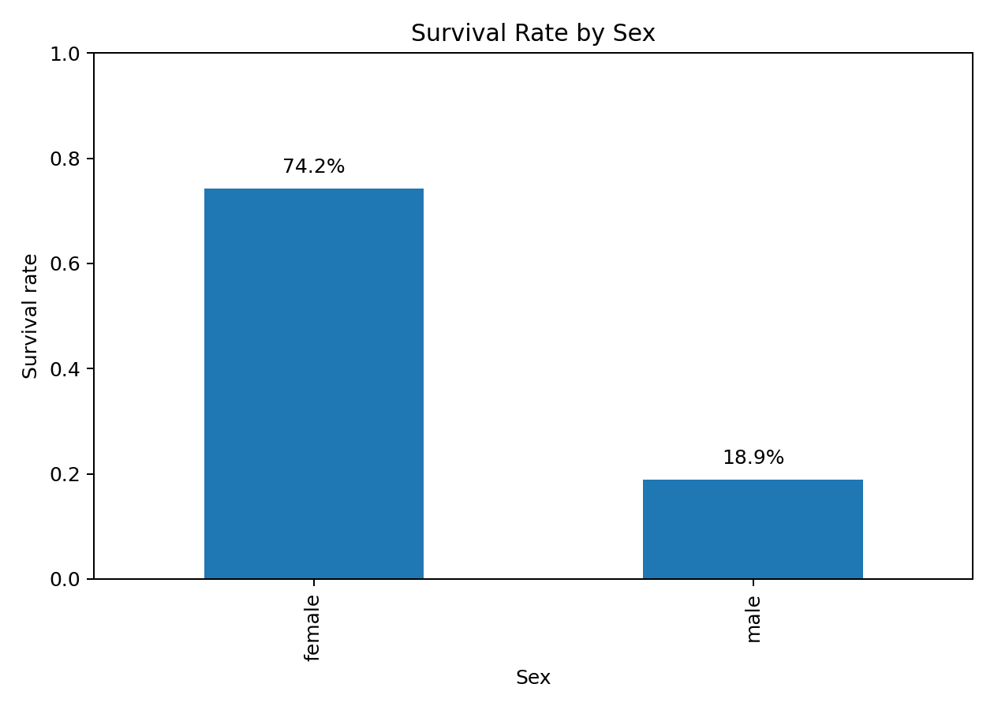
Figure 2. Survival rate by sex.
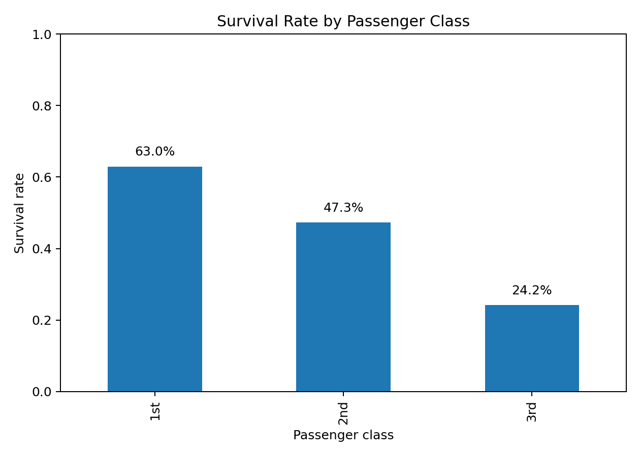
Figure 3. Survival rate by passenger class.
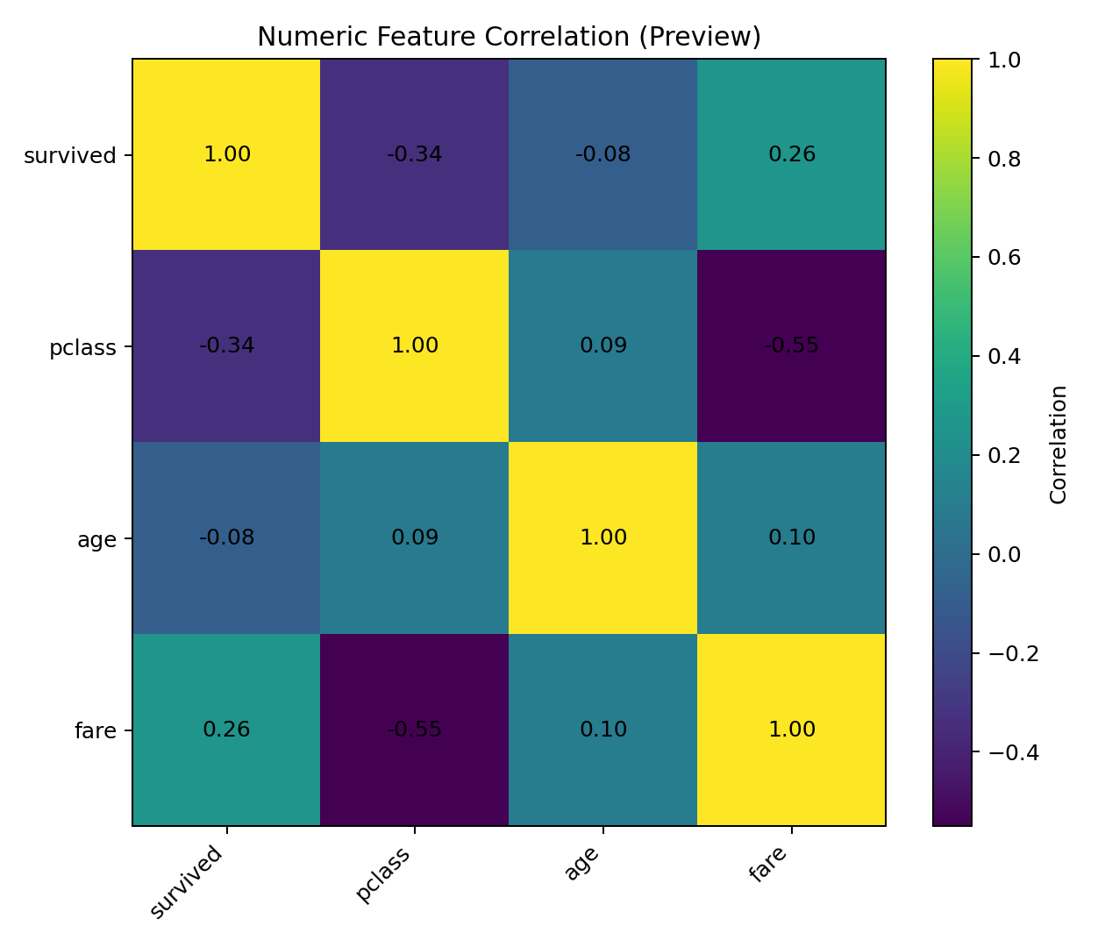
Figure 4. Numeric correlation preview.

10. Key Insights
- The overall survival rate is approximately 38.4% (342 survivors out of 891 passengers).
- Female passengers had a much higher survival rate than male passengers.
- First-class passengers had the highest survival rate, followed by second class and then third class.
- Cabin/Deck has the largest missing-value problem, so direct use of the raw cabin identifier is unsuitable without preprocessing.
- Fare has a wide range and extreme values, making outlier treatment important.
- Passenger class and fare capture a socioeconomic dimension that is strongly associated with survival patterns.

11. Code Snippet — Acquisition and Inspection
DATA_URL = "https://raw.githubusercontent.com/mwaskom/seaborn-data/master/titanic.csv"
urllib.request.urlretrieve(DATA_URL, RAW_FILE)
df = pd.read_csv(RAW_FILE)
print(df.info())
print(df.describe(include="all").T)
print(df.isna().sum().sort_values(ascending=False))
print("Duplicates:", df.duplicated().sum())

12. Code Snippet — Cleaning and Preprocessing
work = df.copy()
work = work.drop_duplicates()
work["deck"] = work["deck"].fillna("Unknown").astype("string").str[0]
work["age"] = work.groupby(["pclass", "sex"])["age"].transform(
lambda s: s.fillna(s.median())
)
work["age"] = work["age"].fillna(work["age"].median())
work["embarked"] = work["embarked"].fillna(work["embarked"].mode()[0])
q1 = work["fare"].quantile(0.25)
q3 = work["fare"].quantile(0.75)
iqr = q3 - q1
upper = q3 + 1.5 * iqr
work["fare"] = work["fare"].clip(0, upper)
work["sex"] = work["sex"].map({"female": 0, "male": 1})
work = pd.get_dummies(work, columns=["embarked", "deck"], dtype=int)
scaler = StandardScaler()
work[["age", "fare"]] = scaler.fit_transform(work[["age", "fare"]])

13. Project Outputs
- Raw dataset: data/raw/titanic.csv
- Cleaned dataset: data/processed/titanic_cleaned.csv
- Cleaning metrics: data/processed/cleaning_summary.csv
- EDA charts: outputs/figures/
- Full reusable pipeline: src/main.py

14. Conclusion
The project converts a publicly available, imperfect dataset into a structured and analysis-ready dataset through documented preprocessing decisions. The main conclusion is that data cleaning should be driven by the meaning and quality of each field rather than applying the same rule everywhere. The pipeline is reusable and provides a strong foundation for later feature engineering, statistical testing, or predictive modeling.

15. References
- GitHub — seaborn-data Titanic CSV: https://github.com/mwaskom/seaborn-data/blob/master/titanic.csv
- Raw CSV: https://raw.githubusercontent.com/mwaskom/seaborn-data/master/titanic.csv
- R Documentation — Titanic survival data: https://stat.ethz.ch/R-manual/R-devel/library/datasets/html/Titanic.html
Note on embedded figures: the report figures are preview visualizations based on exact dataset-level aggregates from the selected public Titanic CSV. Running src/main.py regenerates the same analysis directly from the downloaded raw CSV, including the full correlation matrix.

