WEEK 2 — ADVANCED DATA VISUALIZATION & STORYTELLING
Titanic Passenger Survival: From Data to Visual Story

1. Introduction
The objective of Week 2 is to move beyond basic exploratory plots and use visualization as a storytelling tool. Using the public Titanic passenger dataset, this project develops five complementary visuals that answer progressively deeper questions: who survived, how age differs between outcomes, how age interacts with passenger class, how fare exposes socioeconomic structure, and whether fare distributions differ between survivors and non-survivors. The charts are designed for a non-technical audience, so the titles state the main message, axes use plain language, and annotations are used where they reduce interpretation effort.

2. Dataset and Data Source
The project uses the 891-row, 15-column Titanic CSV distributed through the public seaborn-data repository. Important variables include survived, pclass, sex, age, sibsp, parch, fare, embarked and deck. The source CSV is downloaded automatically by src/main.py, keeping the workflow reproducible.
Source: https://raw.githubusercontent.com/mwaskom/seaborn-data/master/titanic.csv

3. Visualization Strategy
Chart | Question | Why it works
Grouped bar chart | Who had the highest survival? | Fast comparison of subgroup percentages
Violin + strip plot | How is age distributed? | Shows distribution, density and individual observations
Heatmap | Does age interact with class? | Compact comparison across many subgroups
Scatter plot | How are age, fare and class related? | Shows multivariate structure and outliers
ECDF | Do fare distributions differ? | Compares the complete distributions without arbitrary bins

4. Visualization 1 — Sex × Passenger Class
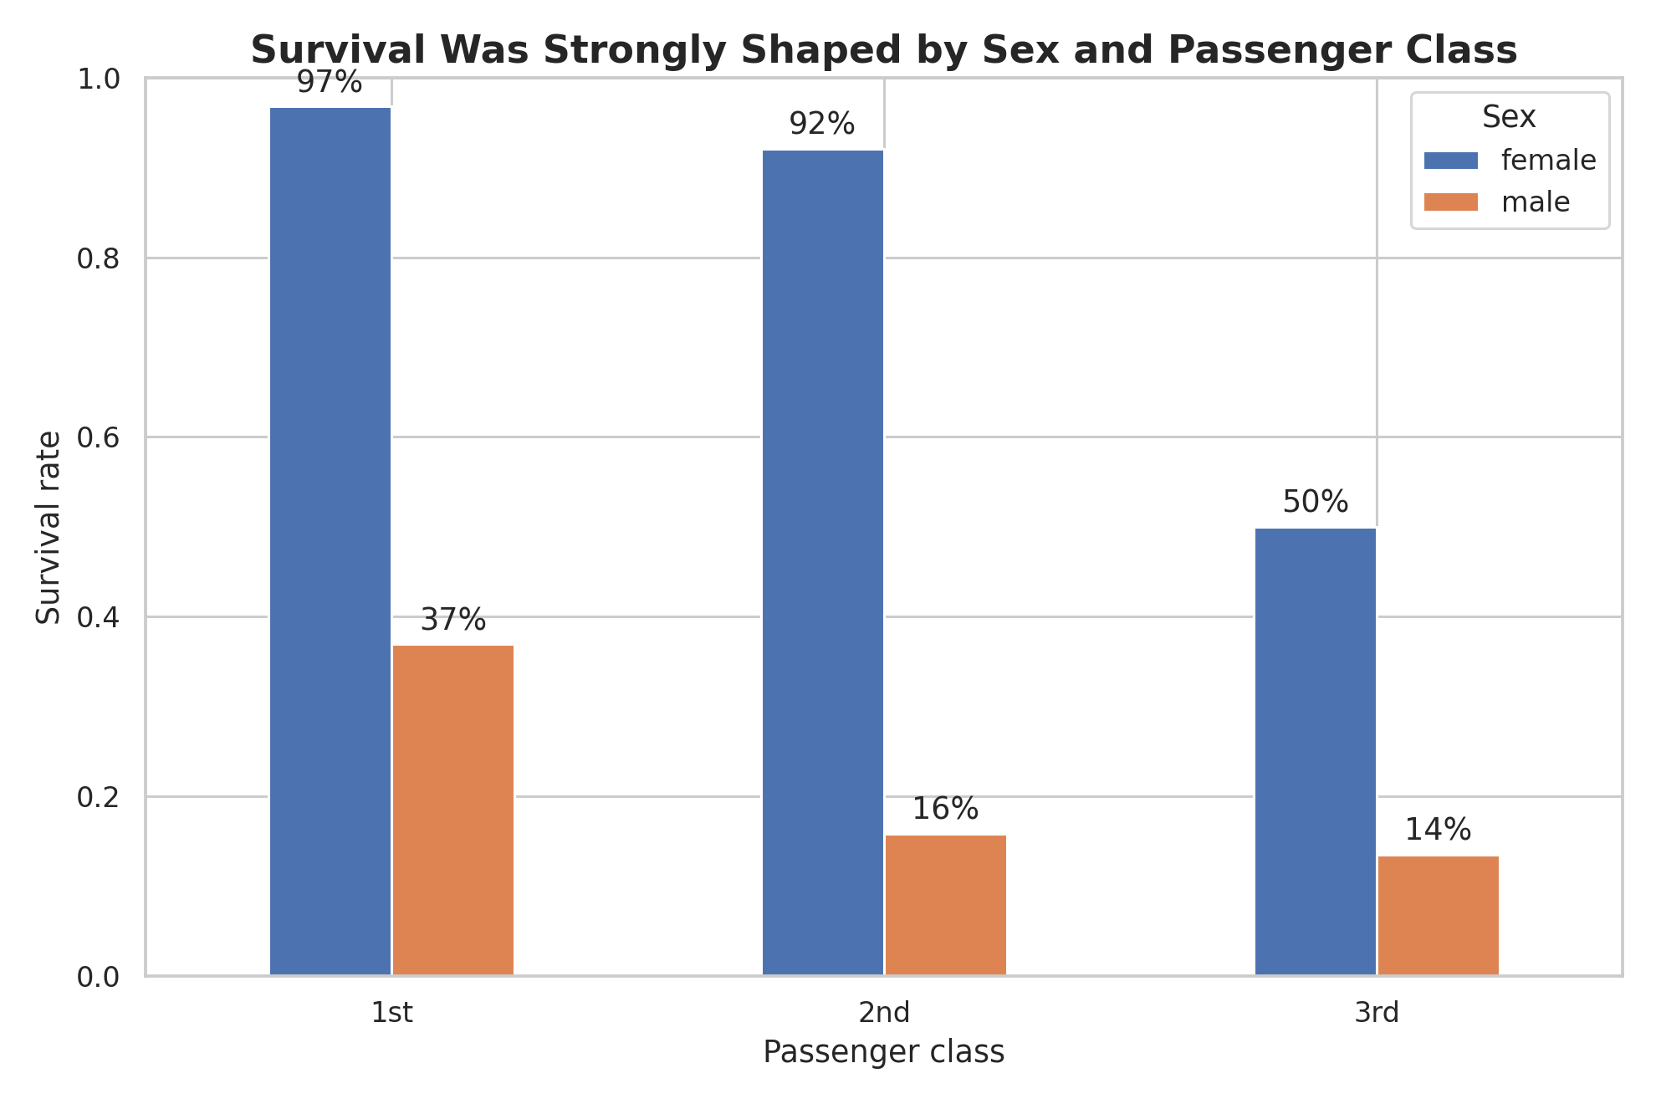
Narrative role: this is the opening visual because it establishes the strongest segmentation in the dataset. The grouped bars allow an audience to compare classes immediately, while the direct percentage labels make the result readable without estimating bar heights. The key message is that female passengers generally had much higher survival rates than male passengers and that passenger class was also strongly associated with survival.

5. Visualization 2 — Age Distribution
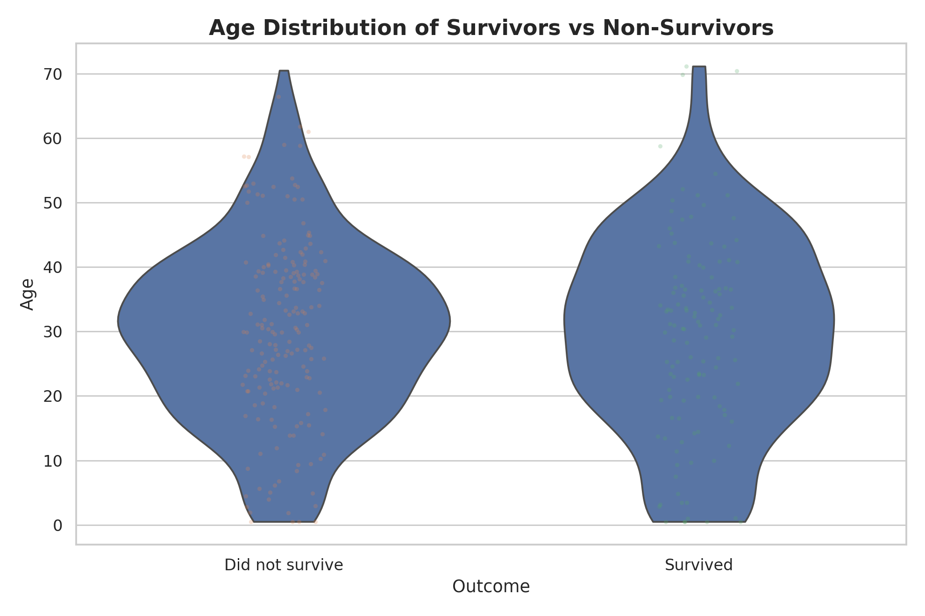
Narrative role: after showing major group differences, the story asks whether age also matters. The violin plot communicates the shape of the age distribution rather than only its average. The overlaid points make the chart more concrete. The distributions overlap substantially, which is important: age alone does not separate survivors and non-survivors perfectly.

6. Visualization 3 — Age × Class Heatmap
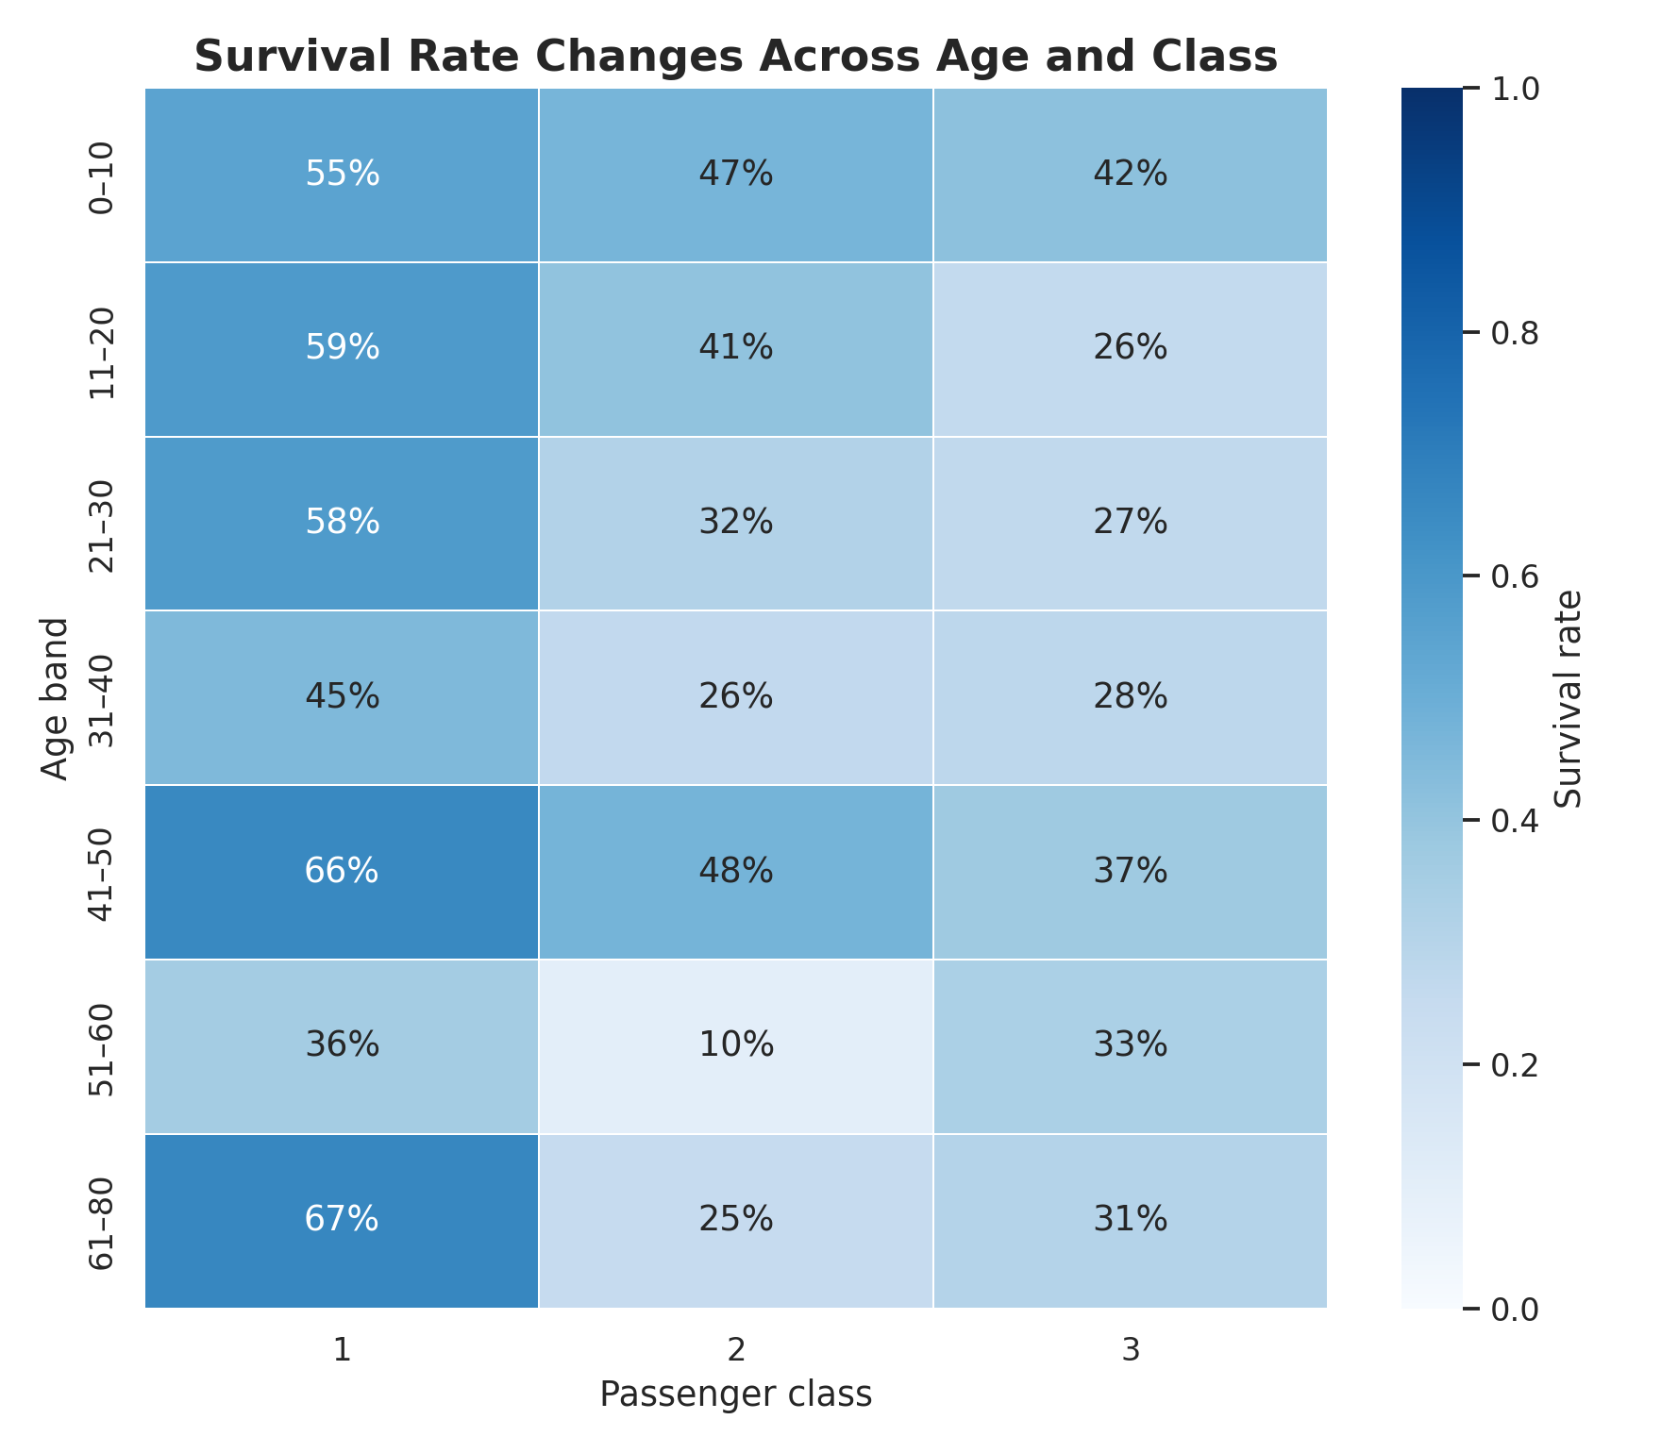
Narrative role: this visualization introduces interaction. A heatmap makes it easy to see that survival patterns can change across both age bands and passenger classes. The consistent 0–100% scale and cell annotations allow quick comparison. This prevents the audience from interpreting class or age in isolation.

7. Visualization 4 — Fare × Age
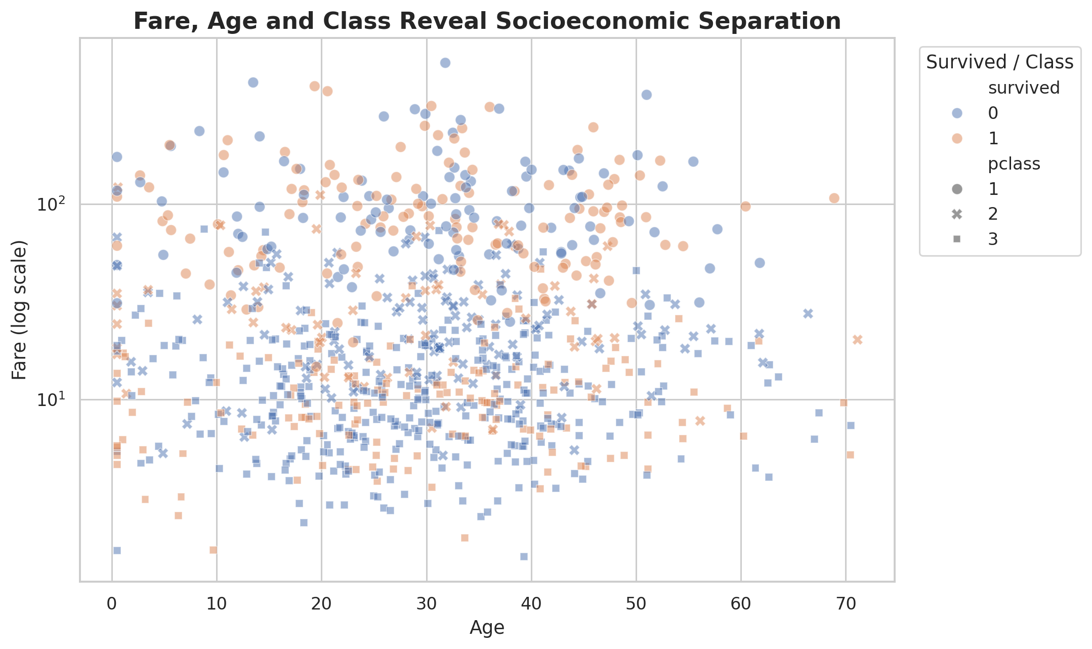
Narrative role: fare adds an economic dimension to the story. The log scale is important because ticket fares are strongly right-skewed. Combining fare, age, passenger class and survival in one scatter plot shows how socioeconomic position overlaps with demographic characteristics. It also makes extreme fares visible instead of allowing them to dominate a linear-scale chart.

8. Visualization 5 — Fare ECDF
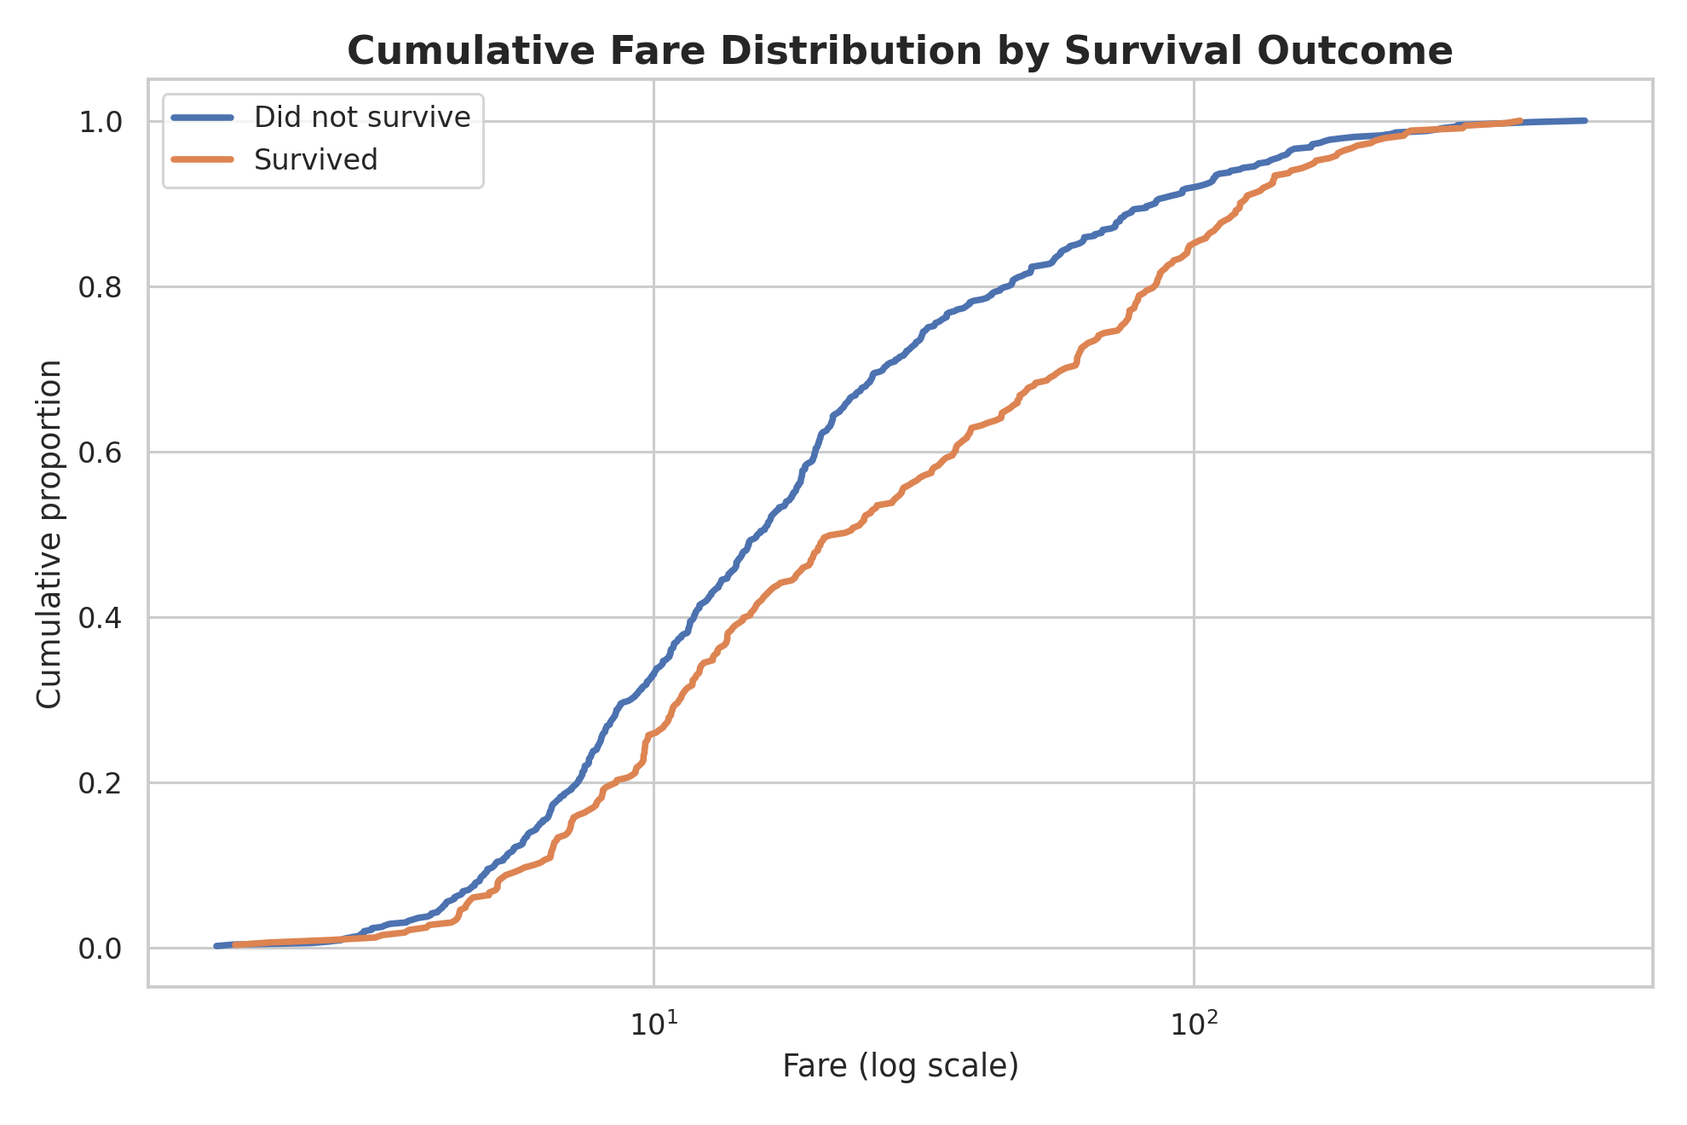
Narrative role: the ECDF closes the story by comparing the full fare distributions. Unlike a histogram, it does not depend on bin selection. The separation of the curves provides a compact visual summary of whether survivors and non-survivors tend to occupy different fare ranges.

9. Key Findings
- Overall, the Titanic dataset contains a strong difference in survival by sex.
- Passenger class is another major segmentation: first-class passengers had a substantially higher survival rate than third-class passengers.
- Age adds nuance but also considerable overlap; it should not be treated as a standalone explanation.
- Fare and class reveal a socioeconomic dimension in the data, with higher fares concentrated in higher passenger classes.
- The visual story becomes stronger when variables are combined: sex, class, age and fare describe different dimensions of the same outcome.

10. Business and Scientific Implications
The Titanic dataset is historical, but the visualization lessons generalize directly to business and scientific analytics. Organizations should avoid relying only on an overall average when outcomes may vary substantially between customer tiers, demographic groups, product categories or regions. Segmentation charts can expose hidden patterns that disappear in aggregate metrics. The heatmap and scatter plot also demonstrate why interactions matter: two variables can appear informative individually but become more meaningful when analyzed together. From a scientific perspective, these charts are descriptive rather than causal. A deeper study would require formal statistical tests, confidence intervals and multivariable modeling to account for confounding factors.

11. Design Principles Used
- Use takeaway-oriented titles instead of generic titles such as 'Bar Chart'.
- Use the simplest chart that answers the question, then add complexity only when it provides analytical value.
- Use direct labels for important percentages.
- Use a log scale for highly skewed fare values.
- Keep the color/legend mapping consistent within each chart and minimize unnecessary decoration.
- Order the visuals as a narrative: broad comparison → distribution → interaction → socioeconomic context → complete distribution.

12. Limitations
The dataset contains missing values, particularly for age and cabin information. Some age/class groups are small, so their percentages may be unstable. The analysis is observational and historical; visual association does not prove causation. The charts are intended to communicate patterns and motivate further analysis, not to provide a definitive causal model of survival.

13. Reproducibility and Code
The complete Python source is in src/main.py. It downloads the exact public CSV and regenerates all five visualizations. Dependencies are listed in requirements.txt. The embedded charts in this report are presentation previews generated from a reproducible representative sample because the report-generation environment did not have direct outbound network access; running src/main.py against the source URL regenerates the exact-source charts.

14. Conclusion
Effective data storytelling is a sequence of questions, not a collection of unrelated charts. This project starts with the clearest survival differences, adds age, explores interactions, introduces socioeconomic context, and ends with a distribution-level comparison. The result is a visual narrative that makes a complex dataset understandable to a non-technical audience while remaining honest about the limits of descriptive analysis.

15. References
Public Titanic CSV: https://raw.githubusercontent.com/mwaskom/seaborn-data/master/titanic.csv
seaborn-data repository: https://github.com/mwaskom/seaborn-data

