WEEK 3 — STATISTICAL ANALYSIS & HYPOTHESIS TESTING
Is Titanic Survival Independent of Passenger Sex?

1. Introduction
Statistical hypothesis testing provides a formal way to determine whether an observed pattern is strong enough to be considered evidence of an underlying association rather than random sampling variation. This project uses the public Titanic passenger dataset to investigate whether survival was independent of passenger sex. The question is relevant because the descriptive analysis from Weeks 1 and 2 showed a large difference in survival rates between females and males. Week 3 tests that observation statistically.

2. Research Question and Hypotheses
Research question: Is passenger survival independent of sex?
- Null hypothesis (H₀): Passenger sex and survival outcome are independent.
- Alternative hypothesis (H₁): Passenger sex and survival outcome are associated.
Significance level: α = 0.05. The null hypothesis will be rejected when the p-value is below 0.05.

3. Dataset
The analysis uses the canonical 891-row Titanic passenger dataset distributed through the public seaborn-data repository. For the hypothesis test, only sex and survived are required. The observed 2×2 table contains 233 female survivors, 81 female non-survivors, 109 male survivors and 468 male non-survivors.
Sex | Survived | Did not survive
Female | 233 | 81
Male | 109 | 468

4. Statistical Methodology
Method | Purpose
Pearson Chi-square test | Tests whether two categorical variables are independent.
Fisher's exact test | Exact test used as a robustness check for the 2×2 table.
Two-proportion z-test | Tests whether the two sex-specific survival proportions differ.
95% confidence intervals | Quantify uncertainty around survival proportions and their difference.
Phi coefficient | Measures the strength of association for a 2×2 contingency table.

5. Assumptions and Test Choice
Both variables are categorical. The Pearson chi-square test is appropriate because the table has four cells and all expected counts are comfortably above the common minimum threshold of 5. Fisher's exact test is additionally reported because it does not depend on the large-sample approximation. The observations represent individual passengers, although the historical dataset is observational rather than a randomized experiment.

6. Visualization 1 — Survival Rates with Confidence Intervals
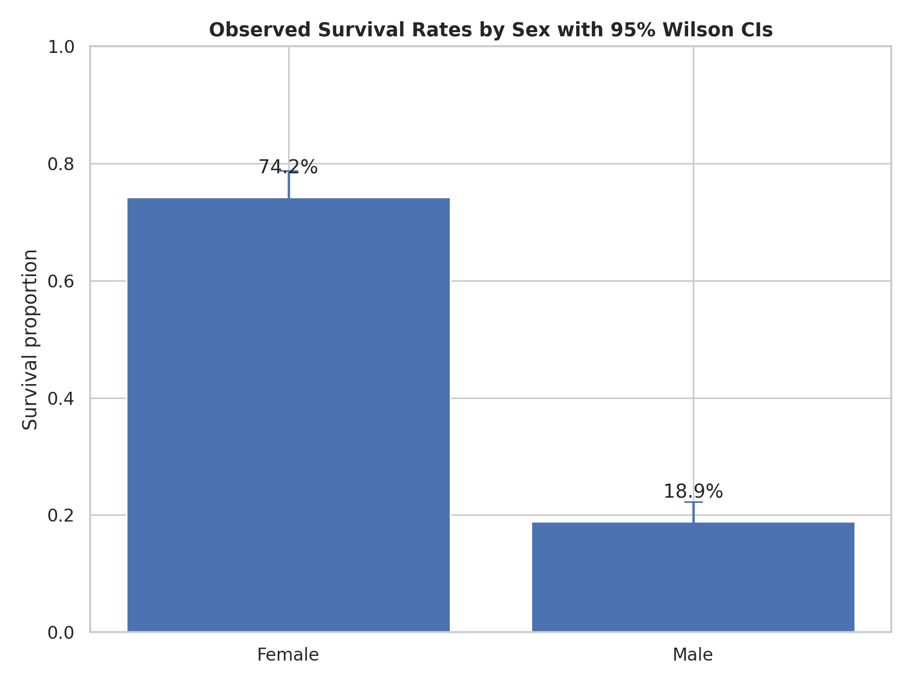
The female survival proportion is about 74.2%, while the male survival proportion is about 18.9%. The confidence intervals are far apart, visually supporting the hypothesis that the observed difference is not a small random fluctuation.

7. Visualization 2 — Outcome Composition
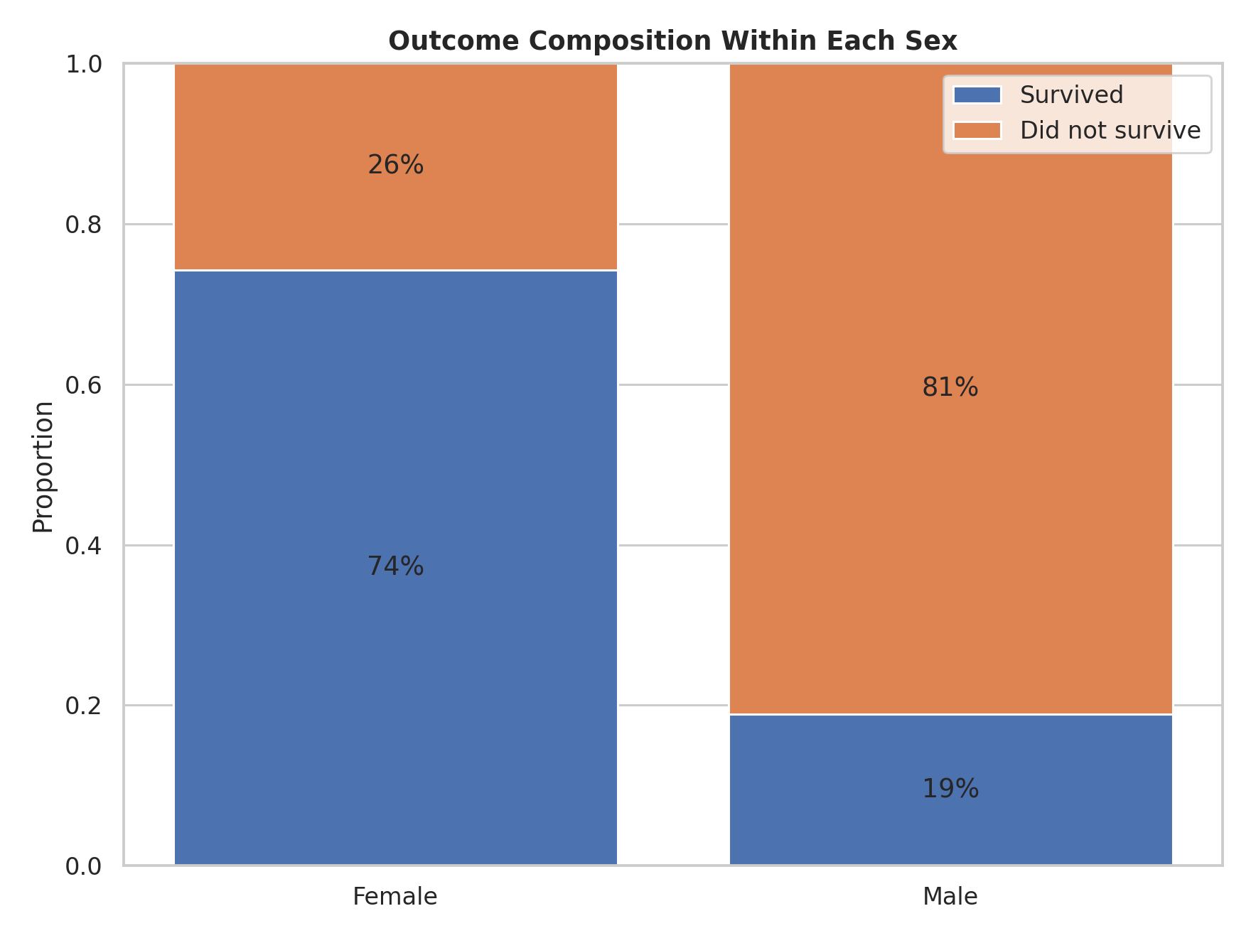
The stacked bars show the composition of outcomes within each sex. The visual makes the magnitude of the difference accessible to a non-technical reader before the formal p-value is introduced.

8. Visualization 3 — Observed vs Expected Counts
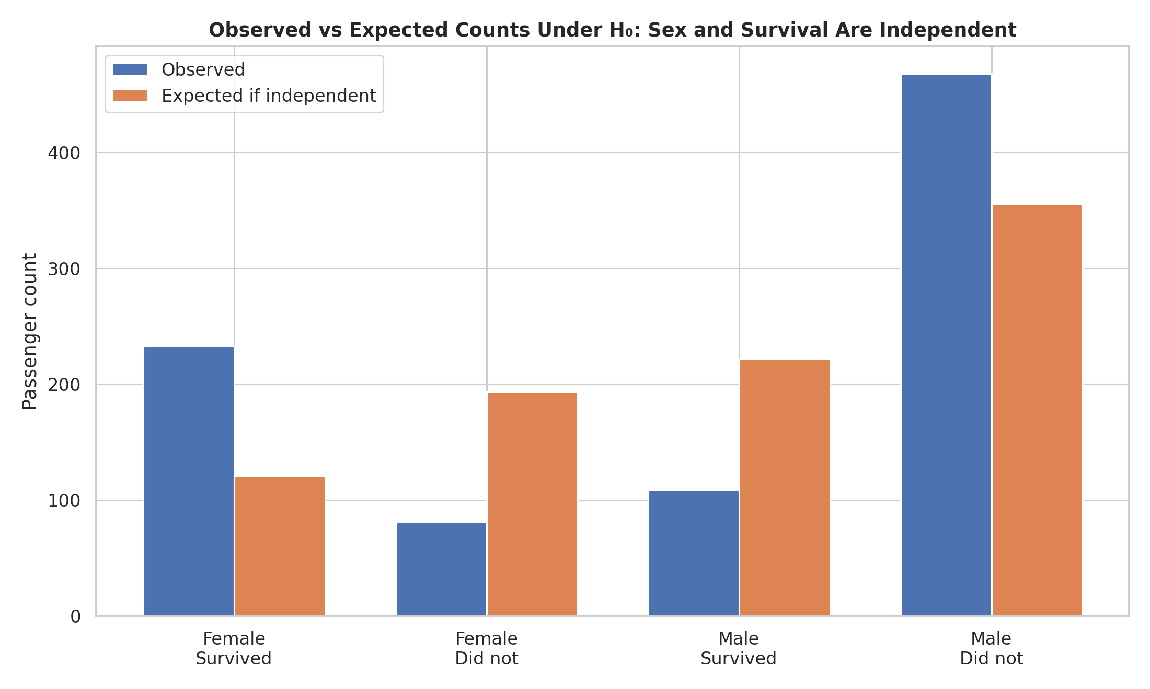
Under the null hypothesis of independence, the expected counts would be much more balanced across sex and outcome than the observed counts. The large gaps between observed and expected counts drive the chi-square statistic.

9. Visualization 4 — Difference in Survival Proportions
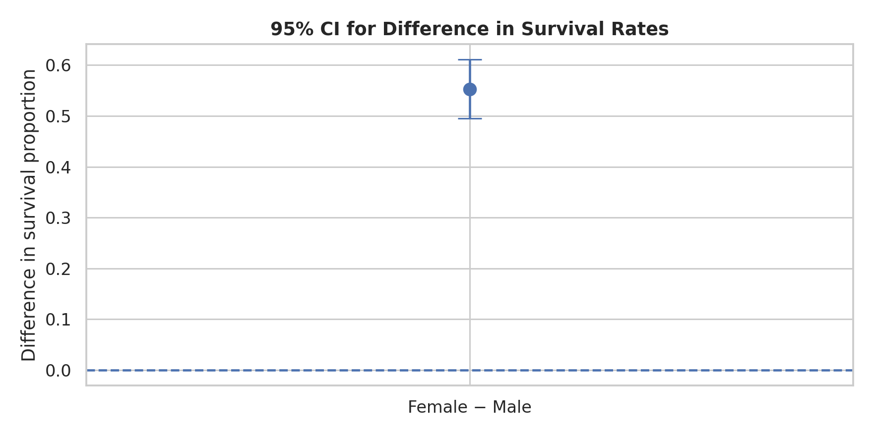
The observed female-minus-male survival difference is 0.553, or about 55.3% percentage points. The approximate 95% confidence interval is [0.495, 0.611], which does not cross zero.

10. Visualization 5 — Effect Size
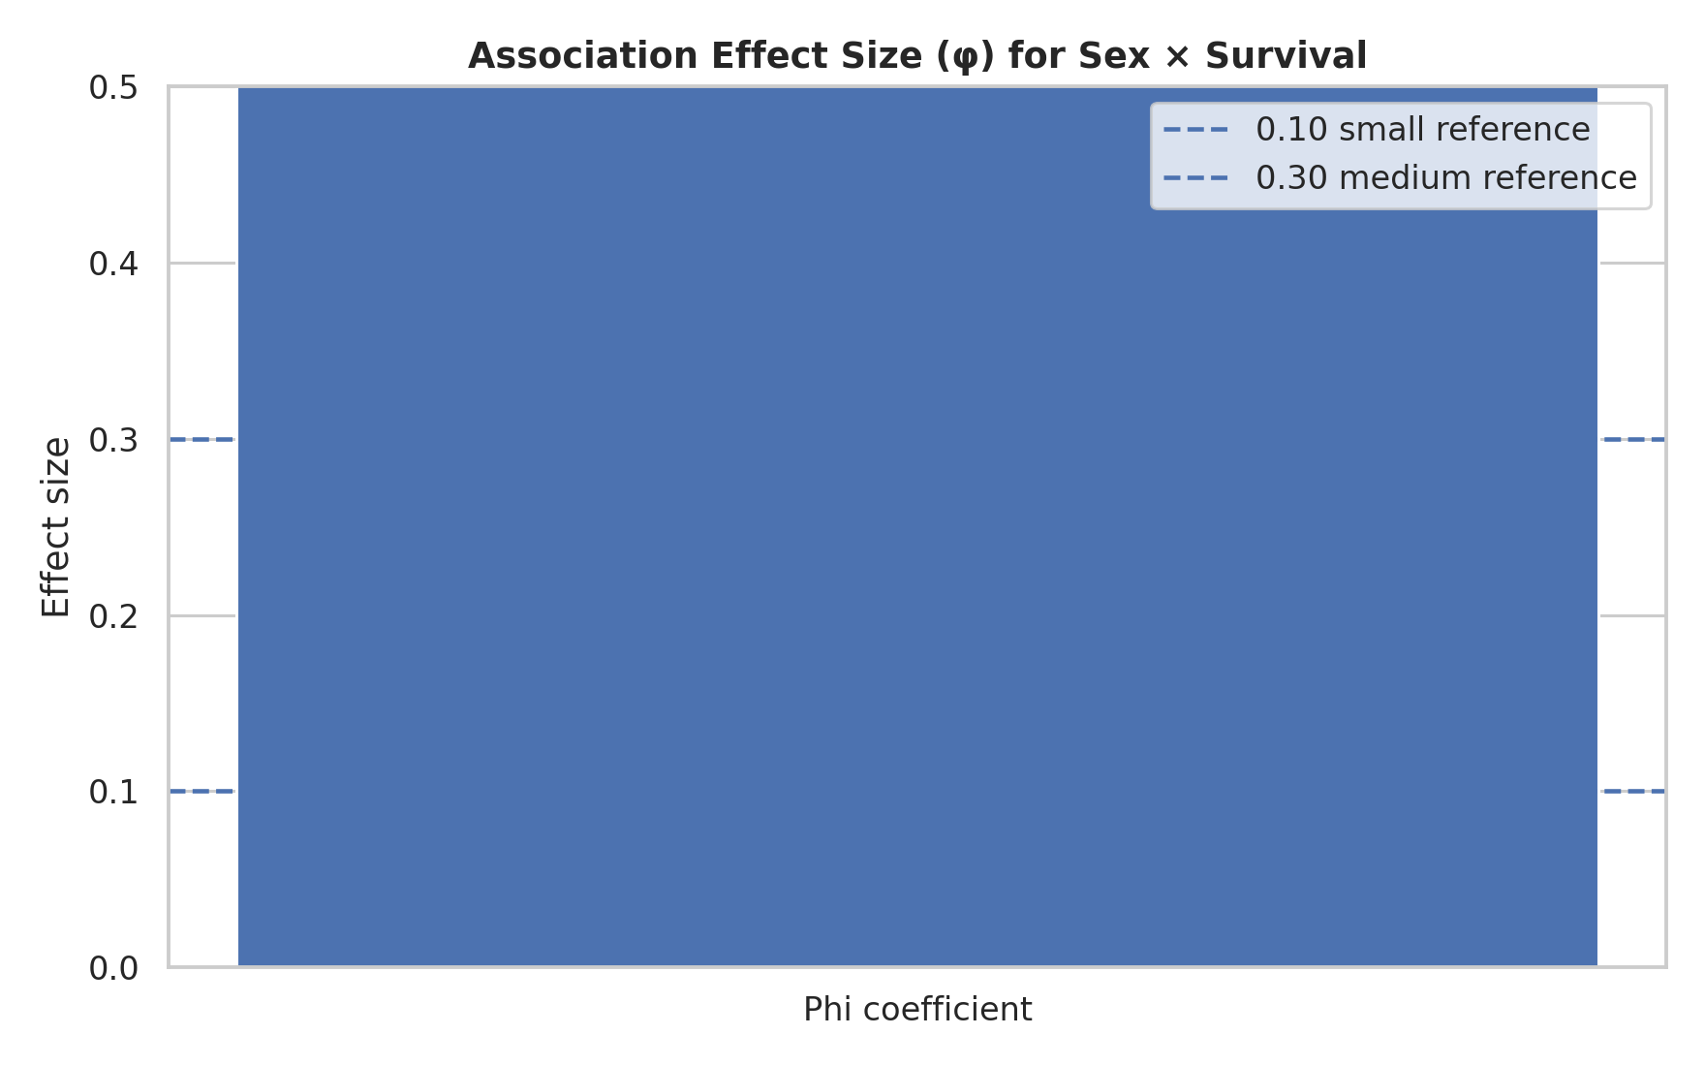
The phi coefficient is approximately 0.543. This indicates a strong association in this dataset, not merely a statistically detectable difference. Effect-size reporting is important because a very large dataset can produce a small p-value even for a practically weak effect.

11. Statistical Results
Test | Statistic | p-value
Pearson chi-square | χ² = 263.05 | < 0.000001
Fisher's exact | Odds ratio = 12.35 | < 0.000001
Two-proportion z-test | z = 16.22 | < 0.000001
The Pearson chi-square test gives χ² = 263.05 with 1 degree of freedom and a p-value far below 0.05. Fisher's exact test and the two-proportion z-test lead to the same decision. Therefore, the null hypothesis of independence is rejected at the 5% significance level.

12. Confidence Intervals
Female survival: 74.2% (95% Wilson CI: 69.1%–78.7%). Male survival: 18.9% (95% Wilson CI: 15.9%–22.3%). The female-minus-male difference is 55.3% with an approximate 95% CI of 49.5%–61.1%.

13. Interpretation
The evidence strongly contradicts the null hypothesis that sex and survival were independent in this dataset. Female passengers had a substantially higher observed survival rate than male passengers. The very small p-values indicate that the difference would be extremely unlikely if sex and survival were truly independent in the population represented by this dataset. The effect size is also substantial, so the result is statistically and practically notable.

14. Important Statistical Caution
Rejecting H₀ does not mean that sex alone caused the difference in survival. Passenger class, age, family structure, location on the ship, evacuation access, and other factors are related to survival and may also be related to sex. This is an observational dataset, so causal claims require a more sophisticated multivariable analysis. The correct conclusion is that sex and survival are statistically associated.

15. Python Code
table = pd.crosstab(df["sex"], df["survived"])
chi2, p, dof, expected = stats.chi2_contingency(
table, correction=False
)
odds_ratio, fisher_p = stats.fisher_exact(table)
counts = np.array([
table.loc["female", 1],
table.loc["male", 1]
])
totals = np.array([
table.loc["female"].sum(),
table.loc["male"].sum()
])
z, z_p = proportions_ztest(counts, totals)
print(chi2, p, odds_ratio, fisher_p, z, z_p)

16. Conclusion
The hypothesis test provides strong evidence of an association between passenger sex and Titanic survival. The result is supported consistently by the Pearson chi-square test, Fisher's exact test, and two-proportion z-test, while the confidence interval and phi coefficient show that the difference is large in practical terms. The appropriate scientific conclusion is therefore to reject the independence hypothesis while avoiding a causal interpretation. A logical next step would be logistic regression or a stratified analysis controlling for passenger class and age.

17. References
Public Titanic CSV: https://raw.githubusercontent.com/mwaskom/seaborn-data/master/titanic.csv
SciPy statistical functions documentation: https://docs.scipy.org/doc/scipy/reference/stats.html
Statsmodels proportion tests: https://www.statsmodels.org/stable/stats.html

