WEEK 4 — MACHINE LEARNING MODEL DEVELOPMENT & EVALUATION
Breast Cancer Classification using Logistic Regression

1. Introduction
Week 4 moves from statistical analysis into predictive modeling. The objective is to build a supervised machine-learning classifier, train it on historical observations, evaluate its predictions on unseen data, and critically discuss errors and limitations. The selected problem is binary classification of breast tumor measurements as malignant or benign. This is a scientifically meaningful classification task because a model should distinguish the two outcomes while minimizing clinically important errors. The project uses Logistic Regression because it is interpretable, computationally efficient, and well suited to a binary target.

2. Dataset
The Breast Cancer Wisconsin (Diagnostic) dataset is distributed through scikit-learn and originates from the UCI Machine Learning Repository. It contains 569 observations, 30 numeric predictors and a binary target. The features are computed from digitized images of fine-needle aspirate samples and describe characteristics such as radius, texture, perimeter, area, smoothness, compactness, concavity and symmetry.
Item | Value
Observations | 569
Predictor variables | 30
Target | Malignant / Benign
Train set | 455 (80%)
Test set | 114 (20%)
Split | Stratified, random_state=42

3. Problem Definition
Given the 30 measured characteristics of a tumor image, predict whether the observation belongs to the malignant or benign class. The model output is a class prediction and a probability estimate for the positive class. The evaluation focuses on generalization to a held-out test set rather than performance on training data.

4. Data Preparation
- Features and target are separated before model training.
- The dataset is divided into 80% training and 20% testing data using stratification so that the class distribution is preserved.
- StandardScaler is applied because the predictors have very different numerical ranges.
- Scaling is placed inside a scikit-learn Pipeline, so the scaler is fitted only on the training data. This prevents test-set information from leaking into model training.
- No synthetic observations or manual labels are introduced.

5. Model Selection
Logistic Regression was selected as the primary model. It is a strong baseline for binary classification and provides coefficients that can be inspected to understand which standardized features contribute positively or negatively to the predicted class. More complex algorithms could potentially improve performance, but starting with an interpretable baseline makes it easier to establish whether additional complexity is justified.

6. Training Pipeline
Pipeline:
1. StandardScaler
2. LogisticRegression(max_iter=5000)
Training:
model.fit(X_train, y_train)
Prediction:
pred = model.predict(X_test)
prob = model.predict_proba(X_test)[:, 1]

7. Evaluation Metrics
Accuracy measures the fraction of all test predictions that are correct. Precision measures how many predicted positive cases are actually positive. Recall measures how many actual positive cases are detected. F1-score balances precision and recall. ROC-AUC measures ranking performance across classification thresholds. The confusion matrix provides the most direct view of true positives, true negatives, false positives and false negatives.

8. Visualization 1 — Confusion Matrix
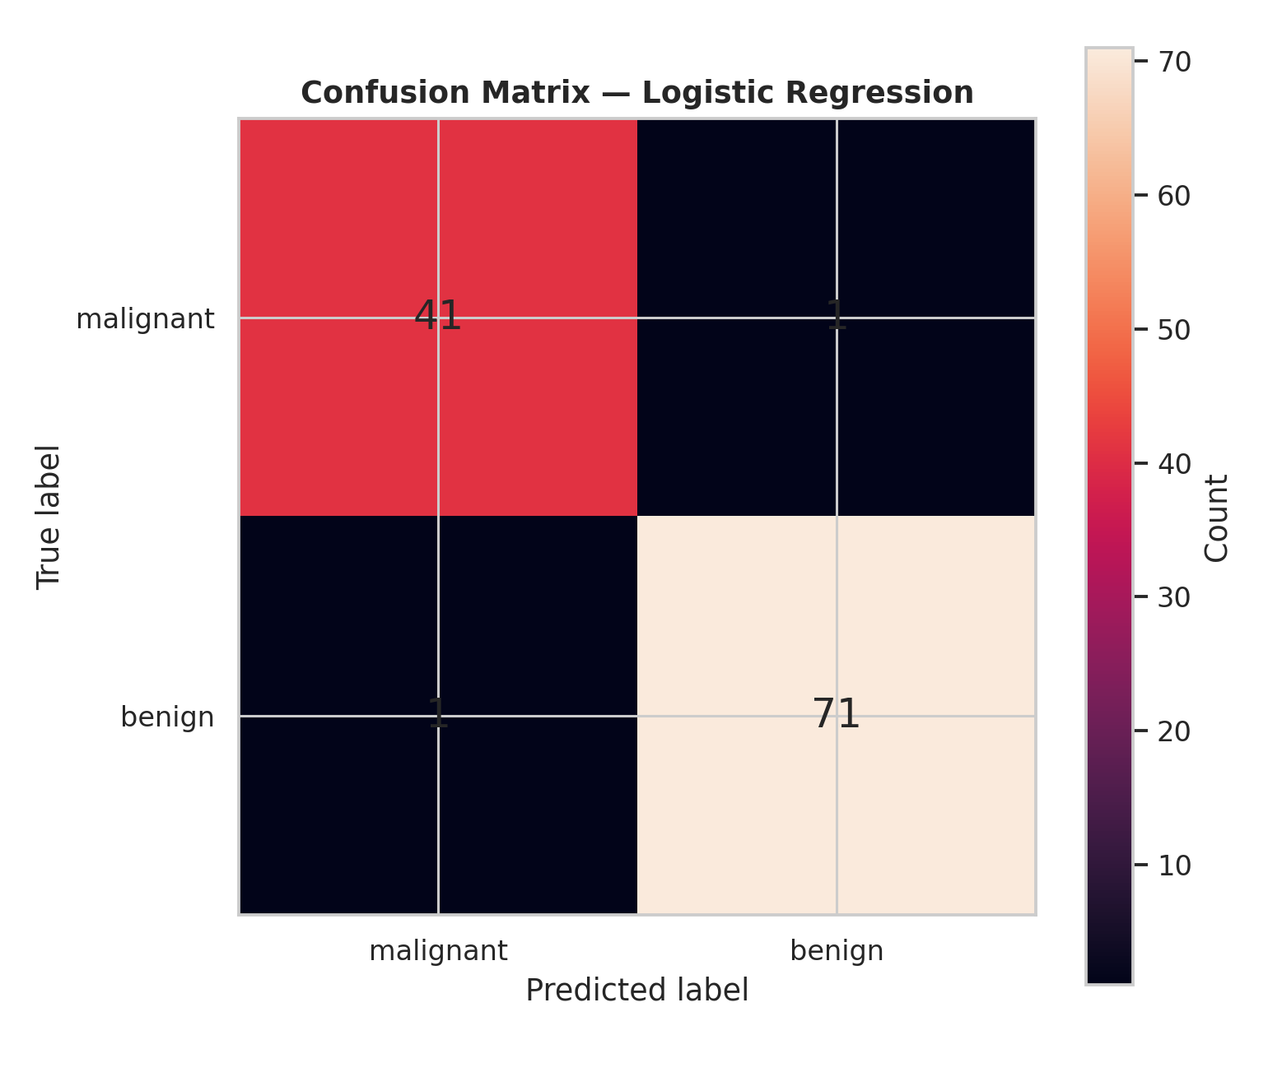
The test confusion matrix contains 41 malignant observations correctly classified as malignant, 1 malignant observation incorrectly classified as benign, 1 benign observation incorrectly classified as malignant, and 71 benign observations correctly classified as benign. The matrix is useful because it exposes the exact error types instead of hiding them behind a single accuracy value.

9. Visualization 2 — ROC Curve
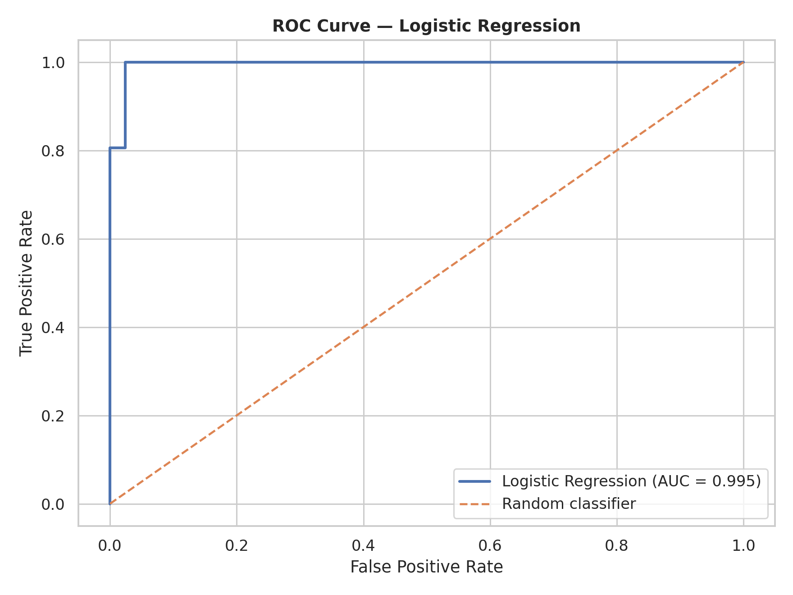
The ROC curve is close to the upper-left corner, with an AUC of 0.995. This indicates excellent discrimination on the held-out test set. The diagonal line represents random classification and provides a baseline for comparison.

10. Visualization 3 — Metric Comparison
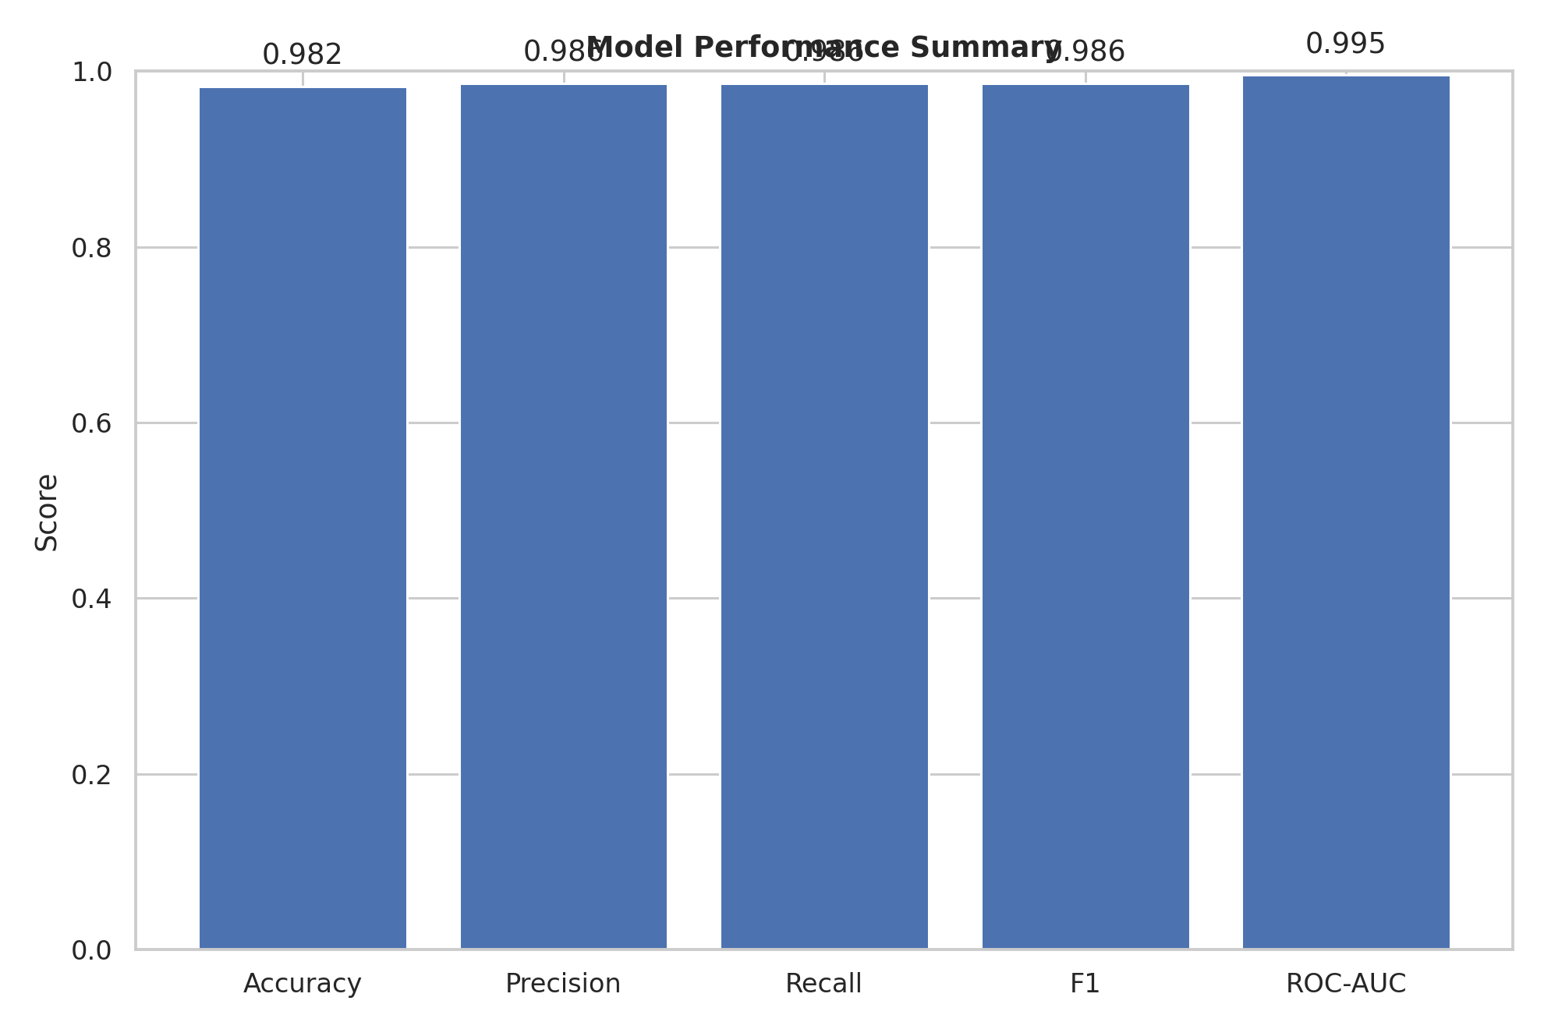
The metric chart compares accuracy, precision, recall, F1 and ROC-AUC on the same 0–1 scale. Using several metrics avoids judging the model solely by accuracy and makes the balance between different types of performance visible.

11. Visualization 4 — Feature Coefficients
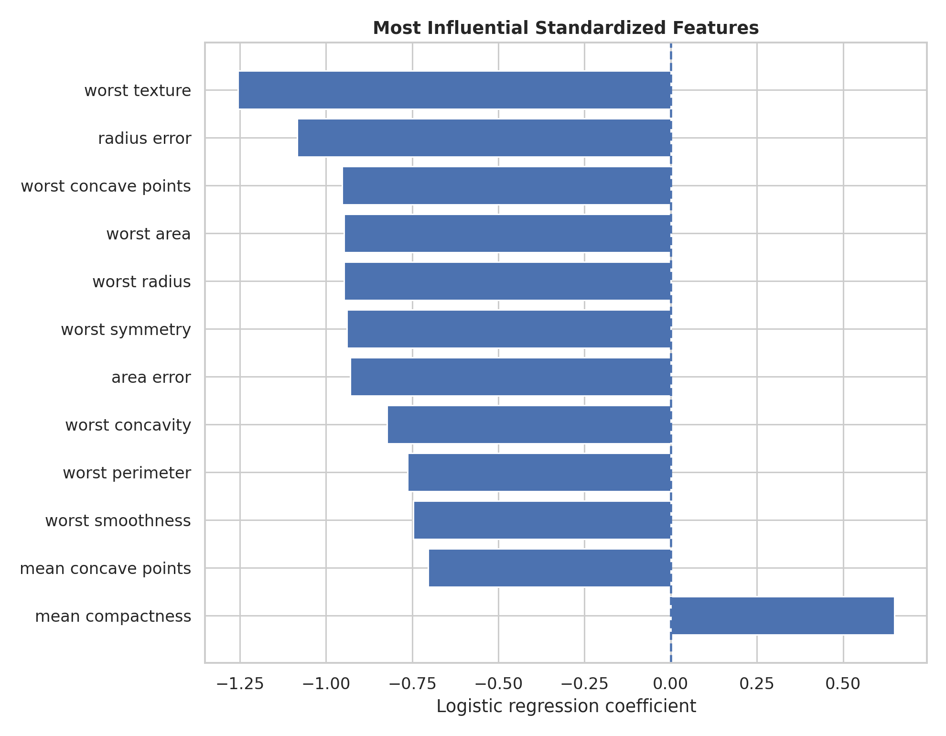
The coefficient chart identifies the standardized features with the largest absolute logistic-regression coefficients. Because the features are standardized, coefficient magnitudes are more comparable. Coefficients should be interpreted as model associations rather than causal scientific effects.

12. Results
Metric | Test score
Accuracy | 0.982
Precision | 0.986
Recall | 0.986
F1-score | 0.986
ROC-AUC | 0.995
On the held-out test set, the model achieved 98.2% accuracy, 98.6% precision, 98.6% recall, 98.6% F1-score and a ROC-AUC of 0.995. The confusion matrix shows only two misclassified observations in this particular split. These results indicate strong predictive performance, although a single train/test split should not be treated as proof that the same performance will occur on every future dataset.

13. Error Analysis
The model made one false negative and one false positive on the test set. A false negative is particularly important in a medical screening context because a malignant case predicted as benign could delay further investigation. A false positive can lead to additional testing or anxiety. Therefore, the preferred operating threshold should depend on the real-world cost of each error rather than automatically using the default 0.50 threshold.

14. Overfitting and Underfitting
The model's high test performance suggests that the linear baseline captures a substantial amount of structure in the data. However, high performance on one split does not eliminate the possibility of overfitting to that split. A stronger evaluation would use stratified k-fold cross-validation and report the mean and standard deviation of each metric. Underfitting could be investigated by comparing the logistic model with nonlinear models such as decision trees, random forests or gradient boosting.

15. Model Improvement Plan
- Use stratified k-fold cross-validation rather than relying on one train/test split.
- Tune the Logistic Regression regularization parameter C using cross-validation.
- Compare Logistic Regression with tree-based models and support vector machines.
- Perform feature selection or dimensionality reduction where justified.
- Evaluate probability calibration if predicted probabilities will support decisions.
- Choose a decision threshold based on the relative cost of false negatives and false positives.
- Use an independent external test set before making any real-world claims.

16. Critical Limitations
- The dataset is relatively small by modern machine-learning standards.
- The test result depends on the selected random split.
- The data comes from a specific historical diagnostic setting and may not generalize to different populations or imaging protocols.
- High predictive performance does not establish causal relationships between features and malignancy.
- This project is educational and must not be used as a clinical diagnostic system.

17. Complete Python Code
"""
Week 4 — Machine Learning Model Development and Evaluation
Dataset: Breast Cancer Wisconsin (Diagnostic), bundled with scikit-learn.
Target:
0 = malignant
1 = benign
Model:
StandardScaler + LogisticRegression
The pipeline includes:
1. Dataset loading
2. Stratified train/test split
3. Feature scaling
4. Model training
5. Classification metrics
6. Confusion matrix
7. ROC curve and AUC
8. Feature coefficient inspection
"""
from pathlib import Path
import pandas as pd
import matplotlib.pyplot as plt
from sklearn.datasets import load_breast_cancer
from sklearn.model_selection import train_test_split
from sklearn.pipeline import Pipeline
from sklearn.preprocessing import StandardScaler
from sklearn.linear_model import LogisticRegression
from sklearn.metrics import (
accuracy_score, precision_score, recall_score, f1_score,
confusion_matrix, roc_curve, roc_auc_score
)
BASE=Path(__file__).resolve().parents[1]
FIG=BASE/"outputs/figures"
OUT=BASE/"data/processed"
FIG.mkdir(parents=True,exist_ok=True)
OUT.mkdir(parents=True,exist_ok=True)
# Load public dataset
data=load_breast_cancer()
X=pd.DataFrame(data.data,columns=data.feature_names)
y=pd.Series(data.target,name="target")
# Stratified split preserves class proportions
X_train,X_test,y_train,y_test=train_test_split(
X,y,test_size=0.20,stratify=y,random_state=42
)
# Scale inside a pipeline to prevent data leakage
model=Pipeline([
("scaler",StandardScaler()),
("classifier",LogisticRegression(max_iter=5000,random_state=42))
])
model.fit(X_train,y_train)
pred=model.predict(X_test)
prob=model.predict_proba(X_test)[:,1]
# Metrics
accuracy=accuracy_score(y_test,pred)
precision=precision_score(y_test,pred)
recall=recall_score(y_test,pred)
f1=f1_score(y_test,pred)
auc=roc_auc_score(y_test,prob)
cm=confusion_matrix(y_test,pred)
print("Accuracy:",accuracy)
print("Precision:",precision)
print("Recall:",recall)
print("F1:",f1)
print("ROC-AUC:",auc)
print("Confusion matrix:\n",cm)
# Confusion matrix
fig,ax=plt.subplots(figsize=(7,6))
im=ax.imshow(cm)
ax.set_xticks([0,1],data.target_names)
ax.set_yticks([0,1],data.target_names)
ax.set_xlabel("Predicted label")
ax.set_ylabel("True label")
ax.set_title("Confusion Matrix — Logistic Regression")
for i in range(2):
for j in range(2):
ax.text(j,i,str(cm[i,j]),ha="center",va="center",fontsize=16)
plt.colorbar(im,label="Count")
plt.tight_layout()
plt.savefig(FIG/"01_confusion_matrix.png",dpi=220)
plt.close()
# ROC curve
fpr,tpr,_=roc_curve(y_test,prob)
fig,ax=plt.subplots(figsize=(8,6))
ax.plot(fpr,tpr,linewidth=2,label=f"Logistic Regression (AUC={auc:.3f})")
ax.plot([0,1],[0,1],linestyle="--",label="Random classifier")
ax.set_xlabel("False Positive Rate")
ax.set_ylabel("True Positive Rate")
ax.set_title("ROC Curve — Logistic Regression")
ax.legend()
plt.tight_layout()
plt.savefig(FIG/"02_roc_curve.png",dpi=220)
plt.close()
# Metrics
metric_dict={"Accuracy":accuracy,"Precision":precision,"Recall":recall,
"F1":f1,"ROC-AUC":auc}
fig,ax=plt.subplots(figsize=(9,6))
bars=ax.bar(metric_dict.keys(),metric_dict.values())
ax.set_ylim(0,1)
ax.set_ylabel("Score")
ax.set_title("Model Performance Summary")
for b,v in zip(bars,metric_dict.values()):
ax.text(b.get_x()+b.get_width()/2,v+.025,f"{v:.3f}",ha="center")
plt.tight_layout()
plt.savefig(FIG/"03_metric_comparison.png",dpi=220)
plt.close()
# Feature coefficients
coef=pd.Series(model.named_steps["classifier"].coef_[0],index=X.columns)
top=coef.abs().sort_values(ascending=False).head(12).sort_values()
fig,ax=plt.subplots(figsize=(9,7))
ax.barh(top.index,coef[top.index])
ax.axvline(0,linestyle="--")
ax.set_xlabel("Standardized coefficient")
ax.set_title("Most Influential Standardized Features")
plt.tight_layout()
plt.savefig(FIG/"04_feature_coefficients.png",dpi=220)
plt.close()
pd.DataFrame({
"actual":y_test.values,
"predicted":pred,
"probability_class_1":prob
}).to_csv(OUT/"test_predictions.csv",index=False)
pd.DataFrame({
"metric":list(metric_dict),
"score":list(metric_dict.values())
}).to_csv(OUT/"model_metrics.csv",index=False)
print("Training and evaluation completed.")

18. Conclusion
The Week 4 project successfully implements an end-to-end supervised machine-learning workflow. Logistic Regression was trained through a leakage-safe preprocessing pipeline and evaluated on unseen data using multiple complementary metrics. The model achieved strong test performance, with high accuracy, precision, recall, F1-score and ROC-AUC. The confusion matrix demonstrates that both false positives and false negatives were rare in this test split. Nevertheless, responsible model evaluation requires more than a high score: cross-validation, threshold analysis, external validation and comparison with alternative models would be appropriate before any real-world deployment.

19. References
Scikit-learn Breast Cancer Wisconsin dataset: https://scikit-learn.org/stable/modules/generated/sklearn.datasets.load_breast_cancer.html
Scikit-learn Logistic Regression: https://scikit-learn.org/stable/modules/generated/sklearn.linear_model.LogisticRegression.html
Scikit-learn model evaluation: https://scikit-learn.org/stable/modules/model_evaluation.html

