Screenshots or program listings must be copied into appropriate cells in the following table.
Save this evidence document as evidence_ followed by your centre number_ candidate number, for example, evidence_ zz999_9999 and insert your name, candidate number and centre number into the header above.
Examiners must be able to read the contents including any screenshots without the use of a magnifying glass. Answers that are not readable or are missing will not be awarded any marks.
Save this evidence document at regular intervals, for example every 10 minutes.
Question 1
Part 1(a)(i)
def IterativeVowels(Value):
Total = 0
LengthString = len(Value)
for x in range(LengthString):
FirstCharacter = Value[0]
if FirstCharacter == 'a' or FirstCharacter == 'e' or FirstCharacter == 'i' or FirstCharacter == 'o' or FirstCharacter == 'u':
Total = Total + 1
Value = Value[1][len(Value)]
return Total

Part 1(a)(ii)
temp = IterativeVowels("house")
print(temp)

Part 1(a)(iii)
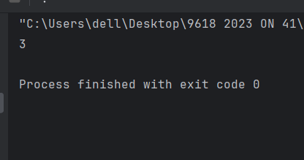

Part 1(b)(i)
def RecursivVowels(value):
LengthString = len(value)
if LengthString == 0:
return 0
else:
FirstCharacter = value[0]
if FirstCharacter == 'a' or FirstCharacter == 'e' or FirstCharacter == 'i' or FirstCharacter == 'o' or FirstCharacter == 'u':
value = value[1:len(value)]
return RecursivVowels(value) + 1
else:
value = value[1:len(value)]
return RecursivVowels(value)

Part 1(b)(ii)
temp = RecursivVowels("imagine")
print(temp)

Part 1(b)(iii)
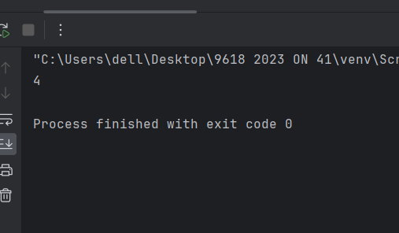

Question 2
Part 2(a)(i)
# DECLARE Queue : ARRAY [1:50] OF STRING
global Queue
global HeadPointer
global TailPointer
Queue = [""]* 50
HeadPointer =-1
TailPointer = 0

Part 2(a)(ii)
def Enqueue(valueinput):
global TailPointer
global Queue
if TailPointer >50:
print("the Queue is already full")
else:
Queue[TailPointer] = valueinput
if TailPointer ==0:
HeadPointer = 0
TailPointer = TailPointer +1

Part 2(a)(iii)
def DeQueue():
global HeadPointer
global Queue
global TailPointer
if HeadPointer == -1 :
print("the Queue is empty")
return "Empty"
else:
returnvalue= Queue[HeadPointer]
HeadPointer = HeadPointer + 1
if HeadPointer == TailPointer:
HeadPointer= -1
TailPointer = 0
return returnvalue

Part 2(b)
def ReadData():
try:
file = open("QueueData.txt","r")
for line in file:
temp = line.strip()
temp2 =Enqueue(temp)
if temp2 == "":
break
file.close()
except IOError:
print("file was not found ")

Part 2(c)(i)
class RecordData():
# PUBLIC ID: string
# PUBLIC Total : INTEGER
def __init__(self,IDP,TOTalP):
self.ID = IDP
self.Total = TOTalP

Part 2(c)(ii)
# DECLARE Records : ARRAY [1:50] OF RecordData
global Records
global NumberRecords
NumberRecords = 0
Records = []

Part 2(c)(iii)
def TotalData():
global NumberRecords
global Records
# DECLARE DataAccessed : STRING
# DECLARE Flag : BOOLEAN
DataAccessed = DeQueue()
Flag = False
if NumberRecords == 0 :
Records[NumberRecords].ID = DataAccessed
Records[NumberRecords].Total = 1
Flag = True
NumberRecords = NumberRecords + 1
else:
for x in range(0,NumberRecords):
if Records[x].ID == DataAccessed:
Records[x].Total = Records[x].Total + 1
Flag = True
if Flag == False:
Records[NumberRecords].ID = DataAccessed
Records[NumberRecords].Total = 1
NumberRecords = NumberRecords + 1

Part 2(d)
def OutputRecords():
global Records
for x in range(50):
IDtemp = Records[x].ID
totaltemp = Records[x].Total
print("ID"+" "+ str(IDtemp)+ " " + "Total" + " " + str(totaltemp))

Part 2(e)(i)

Part 2(e)(ii)
{Copy and paste screenshot for Question 2(e)(ii) here}

Question 3
Part 3(a)(i)
class Character():
# PRIVATE Name : STRING
# PRIVATE XPosition : INTEGER
# PRIVATE YPosition : INTEGER
def __init__(self,Namep,Xpositionp,Ypositionp):
self.__Name = Namep
self.__XPosition = Xpositionp
self.__YPosition = Ypositionp

Part 3(a)(ii)
def GetXPosition(self):
return self.__XPosition
def GetYPosition(self):
return self.__YPosition

Part 3(a)(iii)
def SetXPosition(self,Xchange):
temp = self.__XPosition + Xchange
if temp > 10000:
self.__XPosition = 10000
elif temp <0:
self.__XPosition = 0
else:
self.__XPosition = temp
def SetYPosition(self, Ychange):
temp = self.__YPosition + Ychange
if temp > 10000:
self.__YPosition = 10000
elif temp < 0:
self.__YPosition = 0
else:
self.__YPosition = temp

Part 3(a)(iv)
def Move(self,direction):
if direction == "up":
self.__YPosition = self.__YPosition + 10
elif direction == "down":
self.__YPosition = self.__YPosition - 10
elif direction == "left":
self.__XPosition = self.__XPosition - 10
elif direction == "right":
self.__XPosition = self.__XPosition + 10

Part 3(b)
Jack = Character("Jack",50,50)

Part 3(c)(i)
class BikeCharacter(Character):
# PRIVATE Name : STRING
# PRIVATE XPosition : INTEGER
# PRIVATE YPosition : INTEGER
def __init__(self,name,xposition,yposition):
super().__init__(name,xposition,yposition)

Part 3(c)(ii)
def Move(self,direction):
yposition = super().GetYPosition()
xposition = super().GetXPosition()
if direction == "up":
yposition = yposition + 20
elif direction == "down":
yposition = yposition - 20
elif direction == "left":
xposition = xposition - 20
elif direction == "right":
xposition = xposition + 20

Part 3(d)
Karla = BikeCharacter("Karla",100,50)

Part 3(e)(i)
charactermove = input("please enter the name of character to be moved:")
directionmove = input("input direction to move.left right down up:")
if charactermove.lower() == "karla":
Karla.Move(directionmove)
xmovement = Karla.GetXPosition()
ymovement = Karla.GetYPosition()
print("Karla's new position is X =" + " " +str(xmovement) + " " + "Y="+" "+ str(ymovement))
elif charactermove.lower() == "jack":
Jack.Move(directionmove)
xmovement = Jack.GetXPosition()
ymovement = Jack.GetYPosition()
print("Jack's new position is X =" + " " + str(xmovement) + " " + "Y=" + " " + str(ymovement))

Part 3(e)(ii)
