Screenshots or program listings must be copied into appropriate cells in the following table.
Save this evidence document as evidence_ followed by your centre number_ candidate number, for example, evidence_ zz999_9999 and insert your name, candidate number and centre number into the header above.
Examiners must be able to read the contents including any screenshots without the use of a magnifying glass. Answers that are not readable or are missing will not be awarded any marks.
Save this evidence document at regular intervals, for example every 10 minutes.
Question 1
Part 1(a)(i)
# DECLARE StackVowel : ARRAY [0:99] OF STRING
# DECLARE StackConstant : ARRAY [0:99] OF STRING
global StackVowel
global StackConstant
StackVowel = [""]*100
StackConstant = [""]*100

Part 1(a)(ii)
global VowelTop
global ConsonantTop
VowelTop = 0
ConsonantTop = 0

Part 1(b)(i)
def PushData(letter):
global StackVowel
global StackConsonant
global VowelTop
global ConsonantTop
if letter == 'a' or letter == 'e' or letter == 'i' or letter == 'o' or letter == 'u':
if VowelTop >= 100:
print("the stack vowel is full")
else:
StackVowel[VowelTop] = letter
VowelTop = VowelTop + 1
else:
if ConsonantTop >= 100:
print("the stack consonant is full")
else:
StackConsonant[ConsonantTop] = letter
ConsonantTop = ConsonantTop + 1

Part 1(b)(ii)
def ReadData():
try:
file= open("StackData.txt","r")
for x in range(100):
check = file.readline().strip()
PushData(check)
file.close()
except IOError:
print("file not found")

Part 1(c)
def PopVowel():
global StackVowel
global VowelTop
if VowelTop <= 0:
return "No Data"
return StackVowel[VowelTop]
VowelTop = VowelTop - 1
def PopConsonat():
global StackConsonant
global ConsonantTop
if ConsonantTop <= 0:
return "No Data"
return StackConsonant[ConsonantTop]
ConsonantTop = ConsonantTop - 1

Part 1(d)(i)
{Copy and paste program code listing for Question 1(d)(i) here}

Part 1(d)(ii)
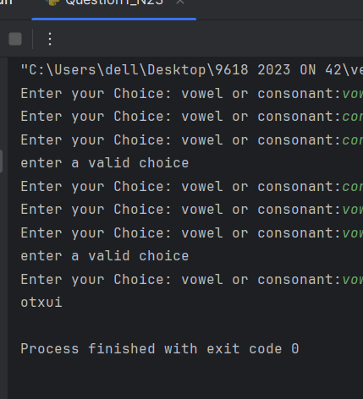

Question 2
Part 2(a)(i)
def IterativeCalculate(Number):
# DECLARE Total : INTEGER
# DEACLARE ToFind : INTEGER
ToFind = Number
Total = 0
while Number != 0:
if ToFind % Number ==0:
Total = Total + Number
Number = Number - 1
return Total

Part 2(a)(ii)
print(IterativeCalculate(10))

Part 2(a)(iii)
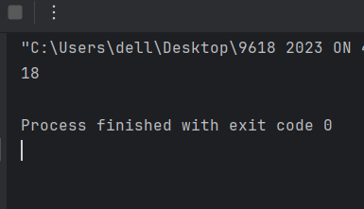

Part 2(b)(i)
def RecusriveValue(Number,ToFind):
if Number == 0:
return 0
elif ToFind % Number == 0:
return Number + RecusriveValue(Number-1,ToFind)
else:
return RecusriveValue(Number-1,ToFind)

Part 2(b)(ii)
temp = RecusriveValue(50,50)
print("the recursive value is :",temp)

Part 2(b)(iii)
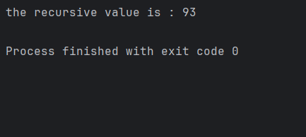

Question 3
Part 3(a)(i)
class Character():
# PRIVATE CharacterName : STRING
# PRIVATE DateOfBirth : DATE
# PRIVATE Intelligence : REAL
# PRIVATE Speed : INTEGER
def __init__(self,CharacterNamep,DateOfBirthp,Intelligencep):
self.__CharacterName = CharacterNamep
self.__DateOfBirth = DateOfBirthp
self.__Intelligence = Intelligencep

Part 3(a)(ii)
def GetIntelligence(self):
return self.__Intelligence
def GetName(self):
return self.__CharacterName

Part 3(a)(iii)
def SetIntelligence(self,newIntelligence):
self.__Intelligence = newIntelligence

Part 3(a)(iv)
def Learn(self):
self.__Intelligence = self.__Intelligence + (0.1*self.__Intelligence)

Part 3(a)(v)
def ReturnAge(self):
yearborn = self.__DateOfBirth.year
age = 2023 - yearborn
return age

Part 3(b)(i)
datebirth = datetime.datetime(2019,1,1)
FirstCharacter = Character("Royal",datebirth,70,30)

Part 3(b)(ii)
FirstCharacter.Learn()
print("the name is :",FirstCharacter.GetName())
print("the age is :",FirstCharacter.ReturnAge())
print("the intelligencec is:",FirstCharacter.GetIntelligence())

Part 3(b)(iii)
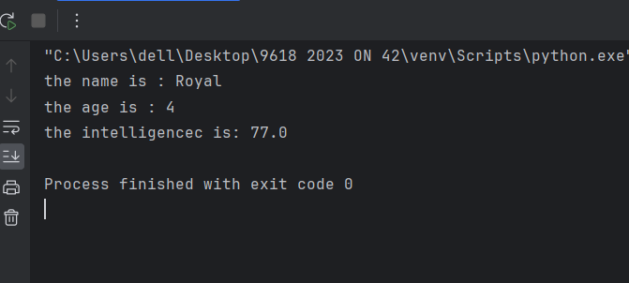

Part 3(c)(i)
class MagicCharacter(Character):
# PRIVATE Element : STRING
def __init__(self,Elementp,CharacterNamep,DateOFbrithp,Intelligencep,speedp):
super().__init__(CharacterNamep,DateOFbrithp,Intelligencep,speedp)
self.__Element = Elementp

Part 3(c)(ii)
def Learn(self):
if self.__Element == "fire" or self.__Element == "water":
int = super().GetIntelligence()
int = int + (int* 0.2)
super().SetIntelligence(int)
elif self.__Element == "earth":
int = super().GetIntelligence()
int = int + (int * 0.3)
super().SetIntelligence(int)
else:
super().Learn()

Part 3(d)(i)
DOB = datetime.datetime(2018,3,3)
FirstMagic = MagicCharacter("fire","Light",DOB,75,22)

Part 3(d)(ii)
FirstMagic.Learn()
print("the name is :",FirstMagic.GetName())
print("the age is :",FirstMagic.ReturnAge())
print("the intelligencec is:",FirstMagic.GetIntelligence())

Part 3(d)(iii)
