Game Design Document

GAME’s Name: World Tree’s Guardian

Student Name(s): Aydın Burak Kuyumcu, Canberk Balcı, Mehmet Ayaz

Introduction

For the purpose of Game Development (CENG447), we designed and implemented a game called "Word Tree's Guardian". Word Tree's Guardian is an action-RPG game. Our aim in this game is to protect the World Tree, which has an important place in Turkish Mythology, against enemies. Our general motivation in making this game is to introduce Turkish mythology to the world and to do it in an entertaining way.

Problem

The goal of our game was to teach players about Turkish mythology in an entertaining way. Especially the small number of Turkish games in the gaming industry and the almost non-existence of games about Turkish mythology pushed us to solve this problem. The main purpose of this game is to both inform players about this mythology and provide them with an entertaining RPG experience

Analysis
The resources in our game are the player's health points, rage points, health potions, equipment and items. Players develop and manage their characters using these resources. The limits in our game are that the player attacks the opponent with a click. If the player wants to attack the enemies, they must click again. Players can talk to NPCs and learn about the environment. This helps players to understand the situation around story. The game ends when all the enemies around the World Tree are cleared. The main conflict in our game is provided by not allowing the enemies to defeat us, and by us defeating them and protecting the tree. Thanks to this conflict, the player puts himself in the shoes of that warrior and enters the story.

Design
The game designs are shown below:

Initial Design Idea
Word Three's Guardian is an action RPG game where players manage limited resources to protect the world tree while overcoming environmental hazards and developing their own character. The game is played with one player. The main challenge is resource management combined with strategic character development. This challenge was chosen because it allows the game to engage the player more, fits the theme of the game, and encourages the player through problem solving. The game takes place in a Turkish village located around the world tree. Players must clear and protect the tree from enemies to win. The main gameplay flow is briefly that the player will clear certain enemies and win the game. The shaman of the tribe has entrusted the player with an urgent quest: fearsome giants have appeared near the tribe's settlement, posing a significant threat. To defeat these giants, the player must obtain a mystical ring forged by Ülgen, the god of the skies. However, this powerful ring is guarded by formidable itbaraks (werewolves). The challenge lies in defeating the itbaraks, securing the ring, and using its power to enhance the player's abilities before confronting the giants. The journey is perilous, requiring players to strategize, survive fierce battles, and overcome all obstacles to protect the tribe and complete their mission. Players explore the village, collect various equipment and health potions by clicking on objects, and change their character's stats through the equipment menu. The game is an isometric action game, and players look down on the game world and attack enemies by clicking on them.

Final Design Idea

Players can talk to NPCs, fight enemies, or collect items around. There is a character development system where players combine the stats on their equipment with their own stats to make their characters stronger, and a skill system that players can use every other cooldown. Players have limited health and can only equip one piece of equipment. If the health bar reaches zero, the player loses. Players start the game without any items. They explore the village and collect items throughout the game. The game ends when players kill all the enemies and save the village.

Implementation

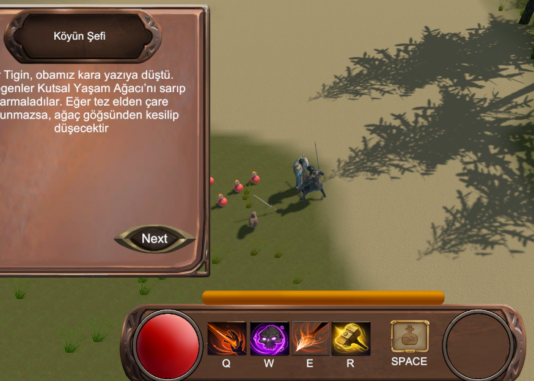

Picture-1 Player Talking to An Npc

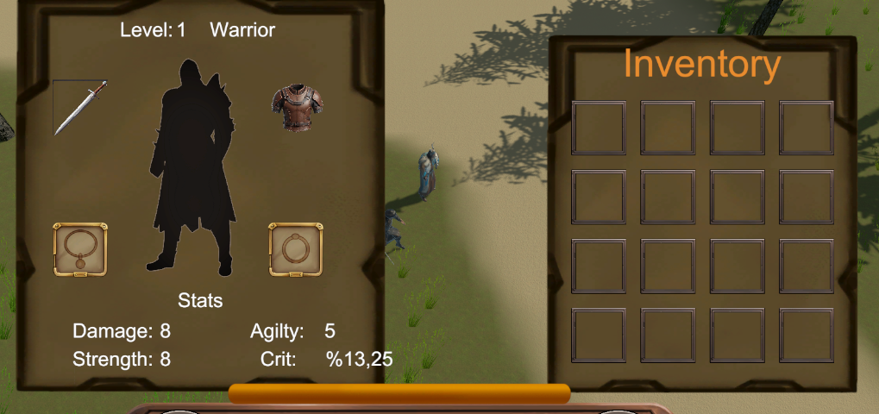
Picture 2 Inventory and Equipment

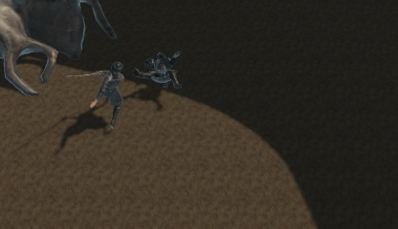
Picture-3 Fight Sequance

Flow in this game is very effective and fun people have to discover everywhere in order to win the game.

Evaluation

We tested our game with different groups. First, we asked them to play as a player/customer, and then we asked them to play as a game designer or game engineer. The purpose of doing this was to see what our game was like from both a player's and a game designer's perspective. After receiving feedback from both sides, we had the game run in debug mode by users, and with that feedback, we got all the ideas and suggestions we wanted. These suggestions and ideas helped shape the game.

Results of Your Play Testing Session
As a result of the tests of our game, we realized our shortcomings in many aspects. Although we had very successful results in some subjects, we had deficiencies and problems in some basic parts. We underlined these problems and started to think about how to solve them. Thanks to the important feedback, we found which problems we should prioritize.

Recommendations & Conclusions
If we need to address the general problems of our game, we can say that the game time should be increased, the game mechanics should be improved, the story should be expanded and improved, and finally a boss system should be added. Thanks to these improvements, the game mechanics can be made more effective and fun. As a result, thanks to this game, we learned the concept of RPG and how to make an RPG game. We also learned the general concepts of Turkish mythology and researched the stories in mythology. We had trouble with assets and resources throughout the project. We had difficulty making some mechanics, but in the end, we all gained important information about RPG and game making.

Github: https://github.com/burak-kuyumcu/WorldTreesGuardian

Trailer Video: https://www.youtube.com/watch?v=rEwKDedHqOc

