**COMP421X Homework 02**

**Prepared By: Burak Özbek**

**Student Id: 0073811**

**COMP421X Homework 02 Discrimination by Regression**

**Question 1:** Read Section 10.8 from the textbook.

**Answer:** Ok.

**Question 2:** Load the iris data set executing the following lines:

**Answer:**

data("iris")

X_iris_data <- as.matrix(iris[,1:4])

y_iris_vector <- as.numeric(iris[,5])

**Question 3:** Divide the data set into two parts by assigning the first 25 samples from each class to the training set and the remaining 25 samples to the test set. You will have 75 data points in your training data set and 75 data points in your test data set.

**Answer:**

X <- rbind(X_iris_data[1:25,],X_iris_data[51:75,],X_iris_data[101:125,])

y_train <- c(y_iris_vector[1:25],y_iris_vector[51:75],y_iris_vector[101:125])

y_test <- c(y_iris_vector[26:50],y_iris_vector[76:100],y_iris_vector[126:150])

**Question 4:** Learn a discrimination by regression algorithm using the sigmoid function for this multiclass classification problem. You can use the following learning parameters.

**Answer:** My sigmoid function is:

sigmoid <- function(X,W, w0){

return(sapply(X=1:ncol(W), function(c) (matrix(1/ (1+ exp(-cbind(X,1)%*% rbind(W,w0) [,c])), nrow=nrow(X)/K, ncol=ncol(W), byrow=FALSE))))

}

**Question 5:** Draw the objective function values throughout the iterations. Your figure should be similar to the following figure.

**Answer:** I found following results in 3036 iterations with train data set 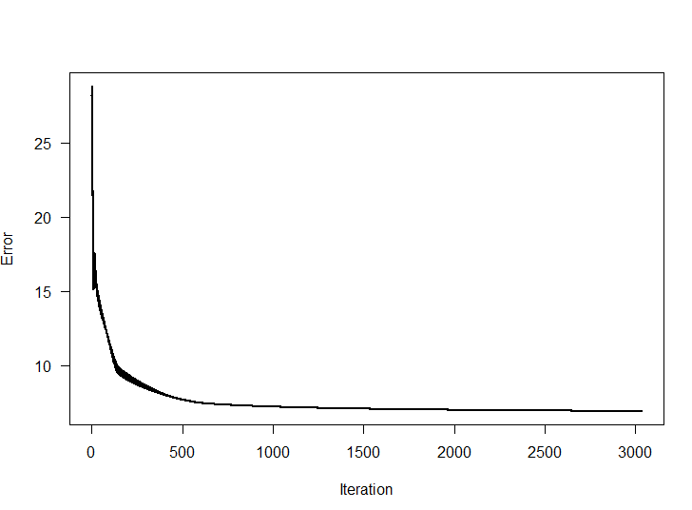

Also found belowing result in 4454 iterations with test data set 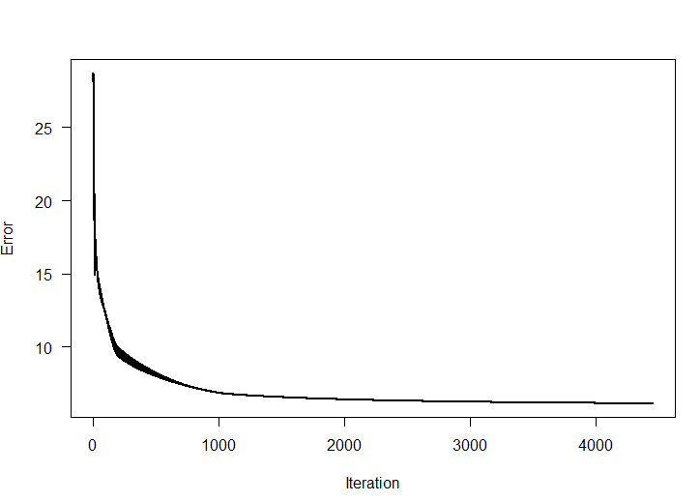

**Question 6:** Calculate the confusion matrix for the data points in your training set using the discrimination rule you will develop using the learned parameters. Your confusion matrix should be similar to the following matrix.

**Answer :**

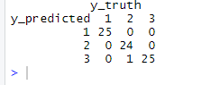

**Question 7:** Calculate the confusion matrix for the data points in your test set using the discrimination rule you will develop using the learned parameters from the previous step. Your confusion matrix should be similar to the following matrix.

**Answer :**

