**COMP421X Homework 03**

**Prepared By: Burak Özbek**

**Student Id: 0073811**

**HW03: Multilayer Perceptron for Multiclass Discrimination**

**Question 1:** Read Section 11.7 from the textbook

**Answer:** Ok.

**Question 3:** Divide the data set into two parts by assigning the first 80 samples from each class to the training set and the remaining 20 samples to the test set. You will have 800 data points in your training data set and 200 data points in your test data set:

**Answer:**

# read data into memory

X_data <- read.csv("hw03_digits.csv")

y_data <- read.csv("hw03_labels.csv")

#parse the data as train and test

X <- rbind(X_data[1:80,],X_data[101:180,],X_data[201:280,],X_data[301:380,],X_data[401:480,],X_data[501:580,]

,X_data[601:680,],X_data[701:780,],X_data[801:880,],X_data[901:980,])

Xtest <- rbind(X_data[81:100,],X_data[181:200,],X_data[281:300,],X_data[381:400,],X_data[481:500,],X_data[581:600,]

, X_data[681:700,],X_data[781:800,],X_data[881:900,],X_data[981:1000,])

y_truth <- c(y_data[1:80,],y_data[101:180,],y_data[201:280,],y_data[301:380,],y_data[401:480,],y_data[501:580,]

,y_data[601:680,],y_data[701:780,],y_data[801:880,],y_data[901:980,])

y_test <- c(y_data[81:100,],y_data[181:200,],y_data[281:300,],y_data[381:400,],y_data[481:500,],y_data[581:600,]

, y_data[681:700,],y_data[781:800,],y_data[881:900,],y_data[981:1000,])

**Question 4:** Train a multilayer perceptron for multiclass discrimination using the sigmoid activation function for twenty nodes in the hidden layer (𝐻 = 20) and using the softmax activation function for ten nodes in the output layer. You should develop a backpropagation algorithm under batch learning scenario with the following learning parameters.

eta <- 0.0005

epsilon <- 1e-3

H <- 20

max_iteration <- 500

set.seed(421)

You should initialize weight parameters W and V using the following initialization procedure.

W <- matrix(runif((D + 1) * H, min = -0.01, max = 0.01), D + 1, H)

V <- matrix(runif((H + 1) * K, min = -0.01, max = 0.01), H + 1, K)

**Answer:**

Ok.

**Question 5:** Draw the objective function values throughout the iterations.

**Answer:** The calculated graph of objective_values is:

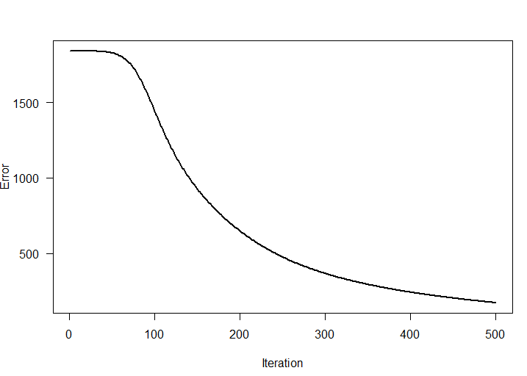

**Question 6:** Calculate the confusion matrix for the data points in your training set using the discrimination rule you will develop using the trained multilayer perceptron.

**Answer:** Calculated confusion matrix for the train data points is shown as below:

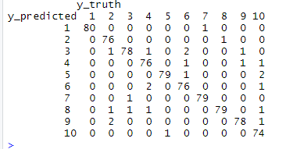

**Question 7:** Calculate the confusion matrix for the data points in your test set using the discrimination rule you will develop using the trained multilayer perceptron.

**Answer** : Calculated confusion matrix for the test data points using trained multilayer perceptron values is shown as below

