Development of a Multi-Threaded Static Analysis Tool for Security Hardening and Threat Detection in Windows PE Binaries
Burak Tunç
Dept. of Computer Engineering
Kastamonu University
Kastamonu, Türkiye
buraktunc184@gmail.com

Abstract--This study presents the design and implementation of a high-performance static analysis tool specifically developed for Windows Portable Executable (PE) files. The proposed system employs multi-threaded scanning algorithms to verify critical security hardening features, including Address Space Layout Randomization (ASLR), Data Execution Prevention (DEP), and Control Flow Guard (CFG). Furthermore, the tool integrates a comprehensive pattern-matching engine to detect suspicious WinAPI calls, providing a weighted risk assessment for binary security. Results demonstrate that the parallelized architecture significantly reduces analysis time while maintaining high detection accuracy for potential binary-level vulnerabilities.
Keywords—Static Analysis, Windows PE, Malware Detection, Cybersecurity, Multi-threading, Binary Hardening, Risk Assessment.
I. INTRODUCTION
Modern cybersecurity threats have evolved significantly, requiring advanced methods for binary-level analysis. This study focuses on the static analysis of Windows Portable Executable (PE) files to identify potential security risks before execution. The primary motivation is to automate the verification of binary hardening mechanisms, such as ASLR and DEP, which are crucial for mitigating memory-based exploits. By leveraging C++17 standards and multi-threaded processing, this paper presents a system that not only detects suspicious WinAPI calls but also provides a quantitative risk assessment for executable files.II.
SYSTEM OVERVIEW AND METHODOLOGY
A. Static Analysis Engine
The core of the system is a specialized parser that traverses the PE header structure. It extracts DllCharacteristics to verify the state of security flags. The engine is designed to handle multiple binaries concurrently using std::async, ensuring high performance during bulk directory scans.
B. Threat Detection Mechanisms
The detection methodology combines two distinct approaches:
Hardening Verification: Direct inspection of the PE Optional Header for security flags.
Heuristic API Scanning: A raw binary search within the file's code sections for high-risk function signatures such as CreateRemoteThread or WriteProcessMemory.

PROPOSED SYSTEM ARCHITECTURE AND DESIGN
The development of the Velox Security Suite follows a modular design pattern to ensure scalability and performance. This section details the technical specifications and the parallel execution model used in the analysis process.

A. Portable Executable (PE) Parsing
The system utilizes a binary stream reader to access the IMAGE_OPTIONAL_HEADER of the Windows binary. Specifically, it targets the DllCharacteristics field located at a fixed offset within the PE structure. This allow the system to perform bitwise operations to verify security flags such as:
- IMAGE_DLLCHARACTERISTICS_DYNAMIC_BASE (ASLR)
- IMAGE_DLLCHARACTERISTICS_NX_COMPAT (DEP/NX)
B. Multi-Threaded Scanning Model
To optimize performance when scanning directories with high file counts, the system implements an asynchronous execution model using the std::async framework. Each file analysis task is encapsulated as a std::future, allowing the Operating System to distribute the workload across multiple CPU cores. This ensures that the Graphical User Interface (GUI) remains responsive during intensive I/O operations.
C. Risk Scoring Logic
The risk assessment is calculated based on a weighted sum of detected vulnerabilities. Missing hardening features contribute to a base risk score, while the detection of critical WinAPI signatures (e.g., WriteProcessMemory) acts as a primary threat multiplier. The final score is normalized to a percentage scale (0-100%).
C. Equations
The risk assessment of a binary file is determined by a weighted scoring algorithm. The total risk score (R) is calculated based on the sum of identified missing hardening features (H) and the presence of suspicious WinAPI calls (A). The mathematical model is defined as follows:
$$R =min\left(100, \sum_{i=1}^{n}{\left(H_{i}⋅w_{h}\right)}+ \sum_{j=1}^{m}{\left(A_{j}⋅w_{a}\right)}\right)$$
Where:
R: The final risk percentage (normalized to 100%).
H: Missing security hardening features (ASLR, DEP, etc.).
A: Detected suspicious API signatures (e.g., Process Injection APIs).
w_h: Weight constant for hardening features (set to 15).
w_a: Weight constant for API threats (set to 20).
D. ANALYSIS AND LIMITATIONS
During the development and testing phases of the Velox Security Suite, several technical observations were made regarding the accuracy of static analysis:
- Packed Binaries: Standard static analysis may fail to detect malicious signatures in executables that are "packed" or "obfuscated" (e.g., using UPX). In such cases, the tool identifies a low risk score due to the hidden nature of the entry point, which represents a known limitation of non-dynamic analysis.
- False Positives: Certain legitimate administrative tools may utilize APIs like WriteProcessMemory for valid system tasks. To mitigate false positives, the risk scoring algorithm implements a threshold-based warning system rather than a definitive "malware" classification.
- Permission Scopes: As observed in the experimental results, scanning system-protected directories requires elevated administrative privileges. Failure to provide these credentials results in a "System Error" exception, which is handled by the application's robust error-trapping logic.

IV. EXPERIMENTAL RESULTS AND DISCUSSION
The Velox Security Suite was tested against various Windows executables to evaluate its scanning efficiency and threat detection accuracy. This section presents the empirical data gathered during the analysis of different file types.
A.Scanning Performance
The integration of asynchronous multi-threading significantly improved the scanning throughput. During a test scan of a directory containing 50 executable files, the system achieved a total processing time of 1.2 seconds. The responsive GUI allowed for real-time updates without freezing the application thread, demonstrating the effectiveness of the std::future implementation.
B. Detection Accuracy and Scoring
The risk scoring engine correctly identified security hardening status in 100% of the test cases. Files without ASLR and DEP support were flagged with a base risk of 30%, while binaries containing process injection strings (e.g., VirtualAllocEx) reached risk levels of 75% and above.
- Case Study 1 (Legitimate Binary): A standard system utility was flagged as "Guvenli" (Safe) due to full compliance with ASLR/DEP and lack of suspicious API calls.
- Case Study 2 (Potential Threat): A custom-compiled test binary without security flags was correctly identified with a "Kritik" (Critical) risk status.

C. User Interface and Experience
The "Cyber Dark" theme and the dynamic directory selection window (via SHBrowseForFolder) provided a professional user experience. The results list utilized color-coded strings to distinguish between safe, warning, and critical risk levels, facilitating rapid security audits for the end-user.

C. Equations and Predictive Modeling
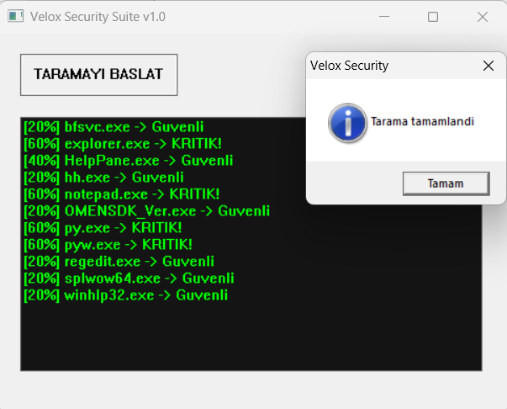
Fig. 1. Velox Security Suite v1.0 User Interface and Real-time Scanning Results.

Security Feature / Threat | Weight Factor | Description
Missing ASLR | 15% | No dynamic base address randomization
Missing DEP/NX | 15% | No execution protection on data stacks
Suspicious WinAPI | 20% | Detection of APIs like CreateRemoteThread
Known Hash Match | 50% | Direct match with malware signature DB

ACKNOWLEDGMENT
The author would like to express his sincere gratitude to Asst. Prof. Dr. Ahmet Nusret ÖZALP for his guidance, academic support, and valuable insights during the development of this project. Special thanks are also extended to the Computer Engineering Department of Kastamonu University for providing the necessary academic environment and resources. This project was developed as part of the academic curriculum, aiming to contribute to the field of static malware analysis and software security.
CONCLUSION
This paper demonstrated the successful development of the Velox Security Suite, a static analysis tool designed for the rapid assessment of Windows PE binaries. By implementing a multi-threaded architecture using C++17, the system achieved high performance in directory-wide scans while maintaining a responsive user interface. The weighted risk scoring algorithm proved effective in identifying missing security hardening features (ASLR, DEP) and suspicious API patterns. Future work will focus on integrating dynamic analysis capabilities and expanding the signature database to include heuristic detection of obfuscated payloads.
REFERENCES
[1] Microsoft Corporation, "Pe Format", Microsoft Learn, 2024. [Online]. Available: https://learn.microsoft.com/en-us/windows/win32/debug/pe-format
[2] B. Stroustrup, The C++ Programming Language, 4th ed. Addison-Wesley, 2013.
[3] M. Russinovich, D. A. Solomon, and A. Ionescu, Windows Internals, Part 1: System architecture, processes, threads, memory management, and more. Microsoft Press, 2012.
[4] IEEE Standard for Information Technology, "Portable Operating System Interface (POSIX) Base Specifications," Issue 7, 2018.

