3. SOFTWARE REQUIREMENTS SPECIFICATIONS

3.1 Introduction

In this SRS part, all the technical details will be explained about Earthquake simulation in detail like user requirements and system requirements.

3.1.1 Purpose

This instructive and virtual reality simulation purposes to teach people the importance of earthquake in human life as understanding clearly. Simularthquake: Simulated Virtual Reality for Earthquake is a virtual reality simulation Project that has the purpose of how to act during the Earthquake in real life. The project occurs two main parts: lifeguard and survival mode.

3.1.2 Intendant Audience and Reading Suggestions

This document can be used by readers of Simularthquake owners who hope or expect to see this project as a real life simulation by reading the general scope of the simulation, which will be explained in detail in the remainder. Developers interested in the game engine (unity) will refer to the general idea and flow of the architectural design of the project.

3.1.3 Product Scope

The aim of the project as mentioned above, we aim to teach and give experience of how to act during a real earthquake. All people who can play this virtual earthquake simulation will be experienced how to save some other person and how to be survive perfectly as earthquake happening.

3.1.4 References

Some of the utilities we use to develop the application are presented below.

3.1.4.1 What is Unity?

Unity is a visual studio based game engine with its own library. Thanks to its unique library, we can shape objects or move objects by giving them real-world physics. The game engine, which provides convenience to the other program languages in the coding part with the c # language used, also provides us a lot of convenience when assigning these codes to the objects. The Unity game engine provides a great convenience to the users in the transformation of the games or projects completed in itself into different platforms. If we are making mobile games, we can upgrade our game to Android or IOS platform. However, since we made a PC based game, we preferred the pc platform part of the Unity game engine. Also, since our Unity game is VR based, it is integrated with Steam VR, so we can easily make our game VR and it helps us a lot. It is a solution to our VR system with only a small plugin. Thanks to the simple interface it uses, there is a system that plans to minimize the optimization problems of the games we make and do. In addition, Unity offers users 2D and 3D game options. Users whose system requirements for Unity are not enough for 3D games can turn to 2D gaming. Since it is a free game engine, people who are interested in the whole game can use the Unity game engine.[3]

3.1.4.2 What is Blender?

This section provides information about blender game and modeling.Thanks to its own library, Blender 3D provides 3D modeling and animation.If we give an example in use. Blender is a platform where interior designers provide designs inside the building, exterior architects provide designs located outside the building, or people playing 3D games will play better. In our project, we used the blender to create buildings, create roads, people and car animations. We also added the ability to collapse into each column so that the buildings can be demolished. On the other hand, we also designed the character that we will save in a stage of the game from this platform.[4]

3.1.4.3 What is Autodesk 3DS MAX?

3DS Max program, which is generally preferred by architects, has been of great importance for game makers recently. So much so that it is now a crucial point for game makers. Nowadays, games are more prominent with the atmosphere they provide their users rather than their mechanics. So much so Open World games are becoming more and more popular today. Here, game designer people have a lot of work with 3DS Max. Since Open World games have a very large map, it is necessary to add different architectures or designs to each region. In addition, 3DS Max user assists in operations such as lighting or sizing. Thanks to the many resources we can find over the internet, we have developed many houses for our game in terms of design. In addition, with 3DS Max, we are able to develop every building, every floor, every apartment as we want due to its improved writing success. Thanks to the wide range of configuration opportunities it offers, it is easier for us to reach the structures you want. The printout of our project according to the game engine you use is just one of the advantages of this program. Thanks to this, we can easily integrate the output we get without using any tool in our game as drag and drop.[5]

3.2 The Overall Description

This section is going to provide background for external systems that related to Simularthquake simulation.

3.2.1 External Interface Requirements

3.2.1.1 User Interfaces

The user interface will be worked on Windows.

3.2.1.2 Hardware Interfaces

The simulation requires HTC Vive. HTC Vive requires drivers installed within the operating system. Also, it requires 1 USB and HDMI port on the PC.

3.2.1.3 Software Interfaces

There are no external software interface requirements.

3.2.1.4 Communications Interfaces

There are no external communications interface requirements.

**3.3 User Characteristics**

Players get the benefit of the simulation at any time that they can reach the HTC vive or similar virtual reality glasses. Players can move around the map at survival mode and also exeminethe materials that they can use or investigate in the sumilation as they wish.

**3.4 Functional Requirements**

In this section, we will show the functional systems we use.

3.4.1 Starting Menu Use Case

Menu diagram (Figure 1) explains the basic operations which is related to starting the game and how to exit it.User can access the two modes of the game as choosing the start button and also quit the game when choose the exit button.

**Initial Step by Step Description;**

1. User/Player can start to choose mode of them simulation.
2. User/Player can exit from the simulation.

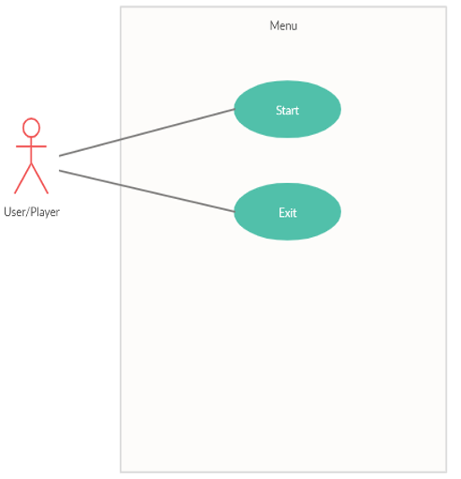

Figure 1 Simulation Starting Menu Use Case

3.4.2 Options Menu Use Case for Settings

Use case:

* Pause
* Continue
* Volume Settings
* Display Instructions
* Exit

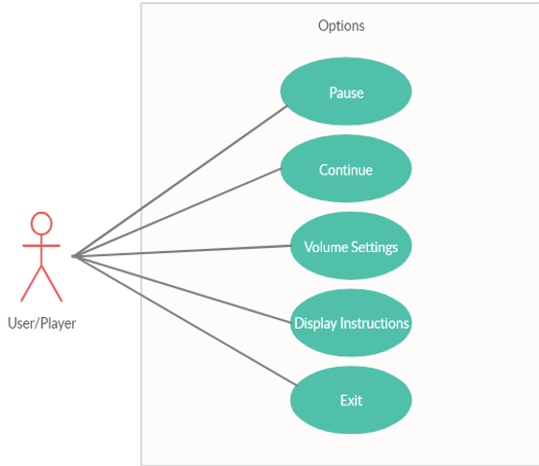

Figure 2 Simulation Options Menu Use Case for Settings

**Brief Description :**

Figure 2 shows simulation option menu use case diagram. When user/player started to lifeguard or survival mode within the system, he/she can display the options menu. Player can execute functions of Pause, Continue, Volume Settings, Display Instructions and Exit in options menu.

**Initial Step-By-Step Description :**

1- If player selects Pause button, the simulation stops.

2- If player selects Continue button, the simulation continues from where it is left.

3- If player selects Volume Settings button, a panel is displayed on the screen.

3.1 Player can increase volume of the simulation by selecting “+” button.

3.2 Player can decrease volume of the simulation by selecting “-“ button.

3.5 Constraints

Sufficient technology is required to enter the game. Enough technology is intentional virtual glasses. HTC Vive VR technology is required for virtual world-based realism technology. A computer with a Windows operating system is required to enter the game. Then the Steam VR application must be installed on the Windows operating computer.

3.6 Assumption and Dependencies

There are many restrictions affecting SRS in Earthquake VR game. Both in terms of hardware and accessibility.

Firstly, it is necessary to have a sufficient system. For this, a computer equipped with strong hardware is necessary for the efficiency of the game to be sufficient. As our game is memory based like every game, enough RAM amount must be available on the computer. Since we use an innovative technology, the computer hardware, RAM, must have sufficient capacity. Another hardware, the graphics card, should be a new generation in order to provide the necessary power graphically. It must have a powerful processor to deliver high FPS values. Since the VR technology we use gives a 3D perspective, it contains many pixels that need to be processed graphically. Therefore, processing power of powerful graphics cards will help for the smoothness of the game.

Connection cables, another part, is one of the important parts for the VR system. If any malfunction in the connection cable is connected to the game, it will cause no image. Therefore, there may be disruption in the parts we write in SRS. Likewise, SRS titles may differ in system capability.

3.7 Apportioning of Requirements

Our game may include features that can be added in future releases.

3.7.1 Primary

The geography used will vary with future updates. This is because each community has a city or village structure that has been shaped according to its own. Since the cities generally have multi-story and hard structures, they show different earthquake responses compared to the villages. In addition, different types of materials used by different geographies may differ in the effect on building construction due to increasing or decreasing the effects of the earthquake. Since the village life style differs according to the cities, earthquake effects can be felt more because village houses are more durable than the city houses.

3.8 Specific Requirements

This requirements section has split into two main parts: user requirements and system

Requirement.

3.8.1 Functions

Thanks to VR technology, the user can walk around as if he were in real life and look at the desired point. The difference from the normal game point of view is that the technology used gives a feeling of real life.

There are many earthquake magnitudes for the user. Rather than this user, there is a function of increasing and decreasing the intensity of the earthquake, added to the features of the game.

The menu for entering the game helps the user to access the sections.

At first, when the game is entered, the user will be sent to the game tutorial and will be informed about the use of VR and the game.

3.8.2 Performance Requirements

Due to the new technology used, it is not only a multiplayer system, but is played only by a single user. Therefore, large servers are not needed. Therefore, high internet speeds are not required for the user.

There are factors such as video card, ram and VR technology among the factors that will hardware affect performance. A smoother game will be achieved thanks to the processing power with a powerful graphics card. Thanks to its high ram capacity, our map will be easier to process and help the user to offer a smooth game. What we mean by VR technology is that there are many distributors. Our healthiest advice is HTC Vive.

4. SYSTEM DESIGN SPECIFICATION

4.1 Introduction

In this section, character movement and look, the items required for the operation of the VR system are mentioned.There are no visible characters in VR Games. In fact, using VR, the user moves a virtual character. Also, in order for the VR system to work, we need to connect it to the computer. The user enables the imaginary character to change their perspective with glasses and move with the control arms.

4.2 System Architecture

This section describes which environmental elements are used, where these environmental elements are accessed, and the elements required for the operation of the system.

Necessary tools for this system to work:

1-Personal Computer

2-VR System

3-The user to direct the character in the game is required. In addition, the addition of environmental elements of the game (Trees, lawns, roads, buildings, cars, etc.) was provided by the unity.

4.2.1 System Software Architecture

In this section, it is talked about how to move the character software and how the building was destroyed during an earthquake.

First of all, an animation of demolition was added to demolish the building. Later, motion script code was added for the user to move during the game.

4.3 Database Design

Since there are only 2 stages in this game, that is, there is no score system, no database design was used because, game is always start from first level.

4.4 Human-Machine Interface

Buildings, cars, roads, trees, lawns are used in the environmental design of this game. The reason for the placement of the buildings is to ensure that these buildings are demolished and the user get rid of the wreckage when the earthquake occurs or the game character under the wreckage is saved by the user.

Other items (cars, roads, lawns) have been added to increase the environmental quality of the game, to increase the game's playability, and to increase the playing time of the user.

There are 2 types of scenes in the game. The first stage is that the user who plays the game rescues the character who is under the wreckage. The second scene is The user who remains under the wreckage is moving and getting rid of the wreckage. [Figure 3 , Figure 4]

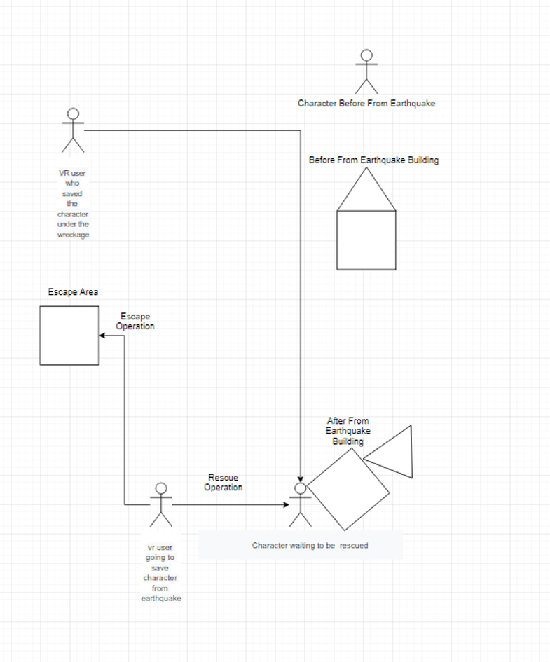

Figure 3 First Scene Flow

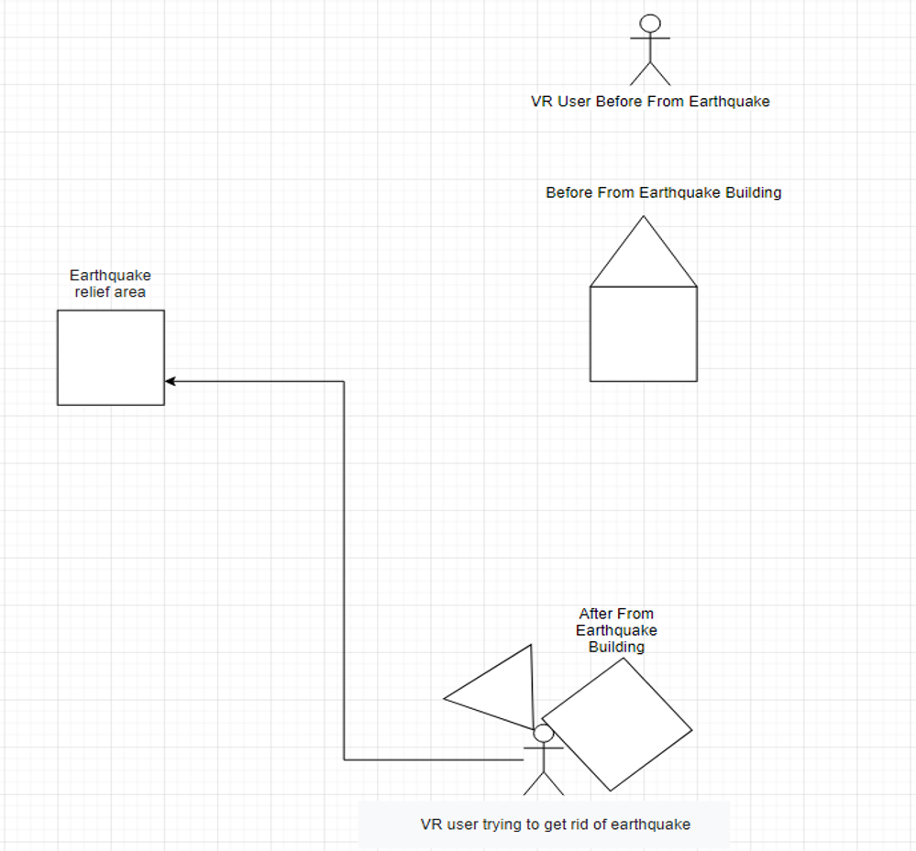

Figure 4 Second Scene Flow

4.4.1 Input

In this section, the inputs used in our VR game are mentioned.

As you know, computers have two types of inputs.

1-Software Input

2-Hardware Input

Software Input are devices that enable the connected device to work.

As an example, devices such as usb ports, ram, graphics cards.

Hardware Input, on the other hand, is the devices that enable a running program to run.

As an example, keyboard, mouse, cd rom, dvd drive, microphone such devices are examples in hardware input.

Software inputs used in our game:

1-Graphics Card

2- Ram

3-Ssd

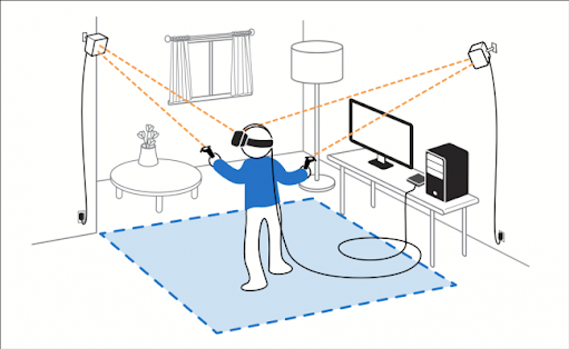

Figure 5 How Htc Vive Works

**REFERENCES**

**[1.] IRIS** , **03.04.2020**

<https://www.iris.edu/>

**[2.] Earthquake Similator VR , 03.04.2020**

[**https://store.steampowered.com/app/607590/Earthquake_Simulator_VR/**](https://store.steampowered.com/app/607590/Earthquake_Simulator_VR/)

**[3.] Unity Game Engine , 03.04.2020**

[**https://unity.com/**](https://unity.com/)

**[4.] Blender , 03.04.2020**

[**https://www.blender.org/**](https://www.blender.org/)

**[5.] 3DS MAX , 03.04.2020**

[**https://www.autodesk.com.tr/products/3ds-max/overview**](https://www.autodesk.com.tr/products/3ds-max/overview)