BAKIRDEF: The Defense Compliance Engine for SMEs

MIS Project Report
November 2025

Project Members

Yusuf Yaşbula
211005020

Kaan Parıltı
211005028

Umut Önal
201005045

Burak Alp Yahşi
211005046

Supervisor
Asst. Prof. Dr. Hunaıda Avvad

Department of Management Information Systems, İzmir Bakırçay University
Corresponding project member e-mail: 211005020@bakircay.edu.tr

Contents
Market Size And Key Players 4
Global SME Market Landscape 5
Finding 5
Need Analysis 6
Competition Analysis(Global & Local) 7
The Bakirdef Advantage 7
CONCLUSION: BAKIRDEF’S MARKET POSITIONING 10

Market Size And Key Players

In Türkiye, defense and aerospace SMEs are primarily concentrated in industrial clusters that serve as hubs for collaboration, resource sharing, and supplier networks. SAHA İstanbul is the country’s largest cluster, encompassing over a thousand companies involved in aerospace, defense, and space technologies. OSTİM Defense and Aerospace Cluster (OSSA) in Ankara specializes in precision machining, mechatronics, cable manufacturing, and other industrial subcomponents. Technopark İstanbul’s Defense Industry Cluster (TSSK) hosts high-tech startups and system suppliers, focusing on innovation and advanced technology development. Eskişehir Aviation Cluster (ESAC) is another specialized ecosystem, emphasizing aircraft engines and aviation-related components. Each cluster maintains publicly available member directories, which allow researchers to identify SMEs by sector, capability, and certifications such as AS9100.

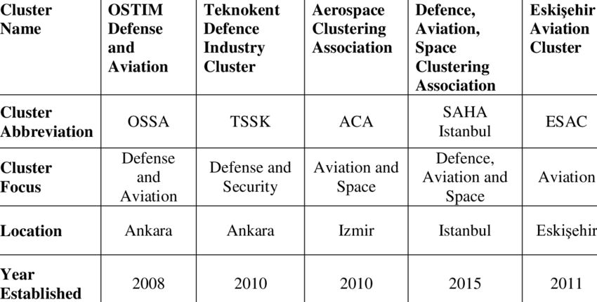
Large Turkish defense contractors, including ASELSAN, TAI (TUSAŞ), ROKETSAN, HAVELSAN, BMC, and FNSS, maintain approved supplier lists or strategic partner announcements, which are rich sources of SMEs. These suppliers typically specialize in precision machining, composite parts, cable harness production, electronic subsystems, and defense software. From a technology perspective, many of these SMEs rely on enterprise resource planning (ERP) systems to manage production, inventory, and procurement processes. SAP ERP solutions are among the most common, particularly SAP S/4HANA, SAP Business One, and SAP Business ByDesign, as they offer robust modules for manufacturing, compliance, and supply chain management. Competing ERP platforms include Oracle NetSuite, Microsoft Dynamics 365, IFS Applications, and Infor CloudSuite Industrial, which are also widely used in mid-sized defense manufacturers to streamline operations, ensure quality control, and maintain regulatory compliance. Understanding which platforms are deployed by target SMEs can help position complementary software, analytics tools, or cloud solutions effectively.

Global SME Market Landscape
Globally, defense and aerospace SMEs are similarly clustered in networks and supported by industry associations. France’s Aerospace Valley hosts hundreds of SMEs engaged with major manufacturers such as Airbus and Dassault, while Germany and the UK maintain extensive SME supply chains focusing on machining, electronics, and system integration. The European Defence Agency provides databases of SMEs active in defense projects, facilitating cross-border collaboration. Globally, SAP ERP competes with Oracle NetSuite, Microsoft Dynamics, IFS Applications, and Infor CloudSuite Industrial, with adoption often reflecting company size, complexity of production, and integration needs across defense programs.

Finding
Information we gathered provides clear evidence of stractured and active market. From our point of view there is a huge potential in SME’s who are lacking consultation and ERP adoptation due to the lack competition in the local market which causes SME’s to be skeptical to new practices due to high cost.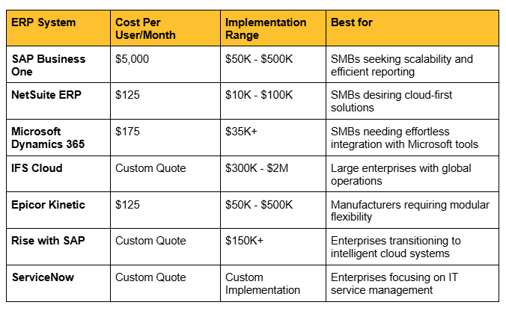

Need Analysis
The first step involves reviewing the websites of the SMEs identified earlier, particularly the sections labeled “About Us,” “Quality,” or “Certifications.” Companies that hold AS9100 certification, which is the international standard for quality management in aerospace and defense, indicate a high level of process maturity. Understanding the requirements of AS9100 is critical, as it imposes strict obligations on traceability, configuration management, and quality record-keeping.
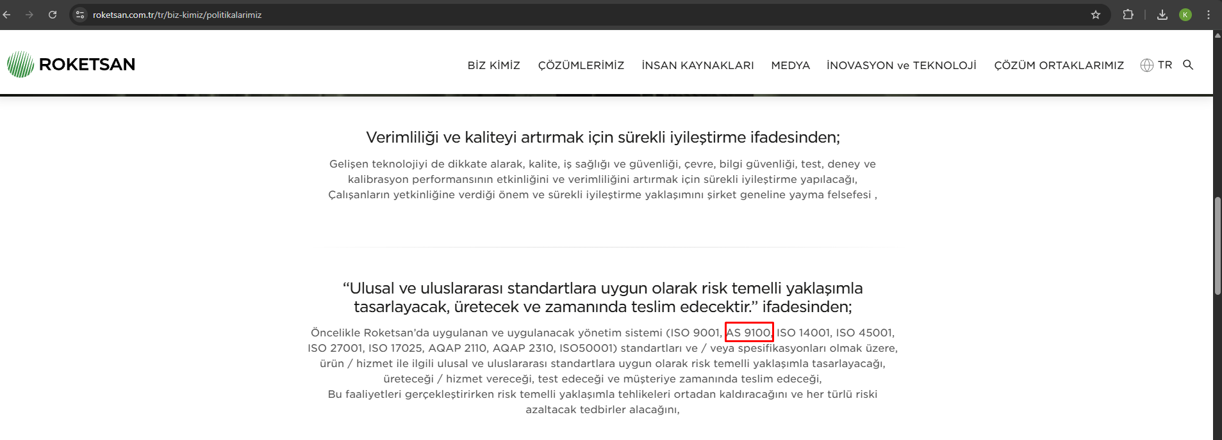
Traceability ensures that every raw material can be tracked through the production chain, including which machine processed it, which operator handled it, and the exact date of processing. Configuration management requires that any design change is documented and traceable, showing exactly which product batches are affected. Quality records, such as Non-Conformance Reports (NCRs) and Corrective/Preventive Actions (CAPA), are essential to meet compliance standards.
SMEs typically present their capabilities in a section often titled “Our Capabilities” or “Capabilities.” These sections provide insight into the technical competencies of the company. For example, machining-focused SMEs often list capabilities such as 5-axis CNC machining, precision metalworking, and surface treatments. Electronics SMEs often highlight printed circuit board (PCB) design, cable harness assembly, and automated testing capabilities.
By examining processes, machining SMEs typically follow a workflow that begins with raw material acceptance, followed by cutting, CNC processing, coating, heat treatment, quality control through coordinate measuring machines (CMM), and final shipment. Electronics SMEs usually handle component acceptance, surface-mount technology (SMT) assembly, automated testing (ATE), and shipment. These processes are highly structured and regulated, reflecting the rigorous standards required by aerospace and defense clients.

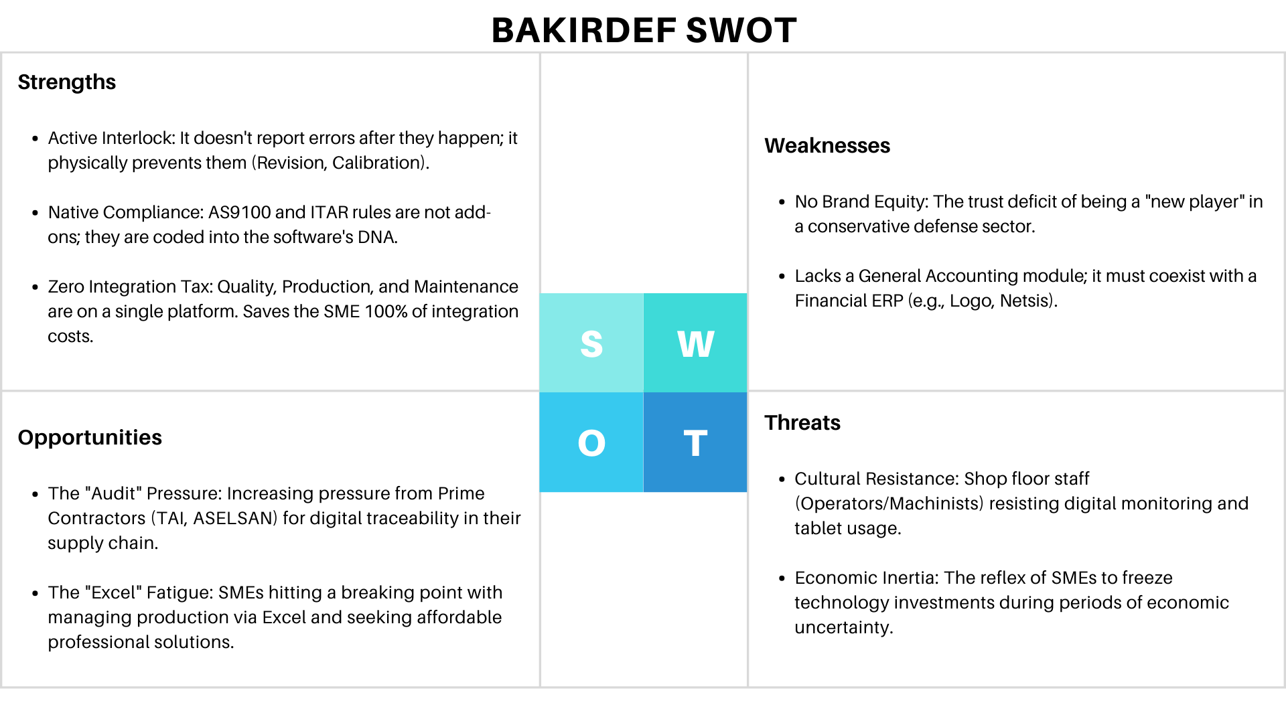

Competition Analysis(Global & Local)

A. Global Giants (SAP, Oracle, IFS): "Unattainable Excellence"
At the top of the market, global Tier-1 providers dominate, with IFS being particularly strong in the defense sector, alongside SAP and Oracle.
- Strengths: These platforms are designed to fully meet rigorous AS9100 and AQAP standards. They offer flawless capabilities in Traceability, Configuration Management (CM), and PLM integration. They are robust solutions built for complex, large-scale operations.
- The Barrier for SMEs: The primary disadvantage is cost. Licensing, implementation, and consulting fees often reach millions of dollars. For a typical SME, these systems are technically desirable but financially inaccessible.

B. Local Solutions (Logo, Netsis, Canias): "Insufficient Fit"
On the other end of the spectrum are domestic ERP solutions like Logo, Netsis, Uyumsoft, and Canias, which hold approximately 90% of the Turkish SME market.
- Strengths: These systems are excellent for general Accounting, Finance, and basic Inventory management. They are highly affordable, widely supported, and fully compliant with local tax regulations.
- The Barrier for SMEs: Designed for "general commerce," they lack "Engineering Depth." Critical defense requirements such as Serial Number-Based Genealogy, Engineering Change Management (Rev A/B), and Project-Based Costing are either entirely absent or severely limited.

C. The "De Facto" Competitor: Excel & Paper (The Hidden Risk)
Caught between local ERPs (which lack capability) and global ERPs (which are too expensive), most SMEs resort to managing their critical defense processes using Microsoft Excel and paper forms. This creates "data islands," breaks data integrity, and poses a massive risk during quality audits.

D. BAKIRDEF vs. Niche Module and MES Solutions: Why SMEs Should Choose BAKIRDEF
Niche solutions (e.g., software only for Calibration or NCR) address only a fraction of AS9100 requirements. BAKIRDEF, however, surpasses AS9100 by offering operational interlocking mechanisms all within a single platform.

1. Interlocking Mechanism: Active Control Over Passive Recording
Feature | Niche MES/QMS Modules | BAKIRDEF (Single Platform) | SME Advantage
Revision Control | Records the revision, sends alerts (Passive). | Interlocks the Work Order and physically prevents continuation with the old drawing (Active). | 100% Scrap Prevention (Eliminates the risk of multi-million dollar material loss).
Competency Control | Emails HR when a certificate expires (Passive). | Forbids the machine from starting with an expired certificate upon operator badge scan (Active Interlock). | Legal Validity Guarantee (Zeroes out the risk of audit rejection).
Calibration Lock | Flags the instrument on a list when calibration expires (Passive). | Blocks data entry from the measuring tool if its calibration is overdue. | Prevents Flawed Data (Maintains the legal validity of the entire measurement chain).

2. Defense-Specific Financial and Legal Management
Feature | Niche MES/QMS Modules | BAKIRDEF (Single Platform) | SME Advantage
GFE Management | Typically lacks this function; inventory tracking remains in the ERP. | Creates a Shadow Inventory; completely isolates customer property from the financial balance sheet. | Financial and Tax Compliance (Prevents balance sheet inflation and tax issues).
Export Control | Typically lacks this function; it's a legal domain. | Shipment Blockage System; automatically prevents shipment of restricted parts to unauthorized addresses. | Protection Against Penalties (Eliminates the risk of international embargo violations).
3. Integration and Total Cost of Ownership (TCO)
Feature | Niche MES/QMS Modules | BAKIRDEF (Single Platform) | SME Advantage
Integration | Requires high-cost API integration for every single module. | Single Platform; Zero Integration Cost (All features work natively together). | Lower TCO (Total cost of License + Integration is significantly lower).
Data Integrity | Data transfer errors and delays occur between disparate systems. | All data is collected in a single Defense Database, ensuring it is instant, consistent, and genealogy-compliant. | Reliable Digital Genealogy (Guarantees the consistency of data queried during audits).

...Why SMEs Must Choose BAKIRDEF
By choosing niche solutions, SMEs often face the hassle of integrating 3–4 different software packages, which is often more expensive than ERP integration itself.
BAKIRDEF offers the following instead:
- Highest Security in a Single Solution: It actively manages the sector's most critical legal risks (GFE, Export, Calibration) within one single interface.
- Cost-Effectiveness: Instead of paying the cumulative integration cost of multiple niche solutions, they acquire all interlocking mechanisms under a single license.
- Guaranteed Business Continuity: BAKIRDEF takes the work order from the ERP, performs interlocking and verification functions, and then sends the completed, verified information back to the ERP. This is an integrated system that protects the production flow, a feature niche competitors cannot offer.

The Bakirdef Difference
BAKIRDEF is not merely a passive database; it is an active Operational Management System designed to physically control production processes and prevent "Leakage, Errors, and Risks" in the Defense Industry environment.
While our competitors (Standard Local ERPs) "record" the process history, BAKIRDEF "governs and interlocks" the process in real-time. The following 8 critical scenarios demonstrate this fundamental difference:

1. Scenario: Dynamic Engineering Revision Lock
- The Critical Issue: A Prime contractor (e.g., TAI) updates a technical drawing (Rev A is cancelled, Rev B is released). However, the old work order remains open in the standard ERP. The operator continues manufacturing based on the old drawing, resulting in thousands of dollars in scrap.
- The BAKIRDEF Solution: The moment an Engineering Change Order (ECO) is entered, BAKIRDEF locks all shop-floor tablets. The operator cannot start the machine until they acknowledge the prompt: "New Revision B Released."
- Value: Error-Proofing (Poka-Yoke) Software Architecture.

2. Scenario: Raw Material Traceability & Digital Genealogy
- The Critical Issue: An aircraft part fails during testing. The client asks: "Which steel batch was this produced from?" In the current system, the quality manager hunts through physical archives for hours. If the document is lost, the supplier is blacklisted.
- The BAKIRDEF Solution: At the machine level, the operator must scan the raw material barcode before loading. The system validates: "Is this steel certified?" If yes, it records the link. During an audit, we generate the Digital Genealogy with one click: "This part was machined by Operator Ahmet on 12.05.2024 using Steel Batch #8493 from Ereğli Steel."
- Value: 100% Full Traceability and Audit-Readiness.

3. Scenario: First Article Inspection (FAI) Interlock
- The Critical Issue: An operator sets up the CNC and starts mass production without quality approval. If the setup is wrong, 100 parts become scrap.
- The BAKIRDEF Solution: "Process Interlock." When the operator produces the 1st part, the system physically stops the workflow. The operator must enter measurement values into the tablet. The system will not allow the 2nd part (or barcode generation) until the Quality Department gives digital approval.
- Value: Scrap Prevention via Digital FAI Management.

4. Scenario: Government Furnished Equipment (GFE) Management
- The Critical Issue: Contractors (like ASELSAN) often ship raw materials to the SME for processing ("Take this titanium, machine it, send it back"). This material is not an asset of the SME; it is "Consignment/Trust." Standard ERPs treat this as "Inventory Asset," inflating the financial balance sheet and creating tax issues.
- The BAKIRDEF Solution: "Shadow Inventory." The system tags these materials as "Customer Property." It tracks usage and scrap rates in production but completely isolates them from the company's financial ledger.
- Value: Financial & Legal Compliance for GFE.

5. Scenario: Operator Competency Control (Skill Matrix)
- The Critical Issue: A critical aerospace weld is performed by personnel whose certification expired 3 days ago. Even if the part is perfect, it is marked as "Non-Conformance" (NCR) during an audit because the cert was invalid.
- The BAKIRDEF Solution: When an operator scans their ID card to start a job, the system runs a background check on the "Skill Matrix." It triggers an alert: "Warning! Welder Certificate Expired" and prevents the job from starting.
- Value: Dynamic Skill Management and Risk Mitigation.

6. Scenario: Tool Life Management
- The Critical Issue: An operator continues machining with a worn-out (dull) cutting tool, degrading the surface quality of expensive titanium parts.
- The BAKIRDEF Solution: The system tracks the actual cutting time of every CNC insert. It sends a "Prepare Replacement" alert to the warehouse when tool life hits 95% and locks the process at 100% life.
- Value: Cost Reduction in Cutting Tools and Quality Assurance.

7. Scenario: Calibration Lock
- The Critical Issue: A part is measured using a caliper with an expired calibration date. The measurement is legally invalid.
- The BAKIRDEF Solution: The operator must scan the measurement tool before data entry. If the system does not return a "Calibration Valid" status, it blocks data entry from that specific tool.
- Value: Audit-Readiness and Zero-Defect Culture.

8. Scenario: Export Control (ITAR / Compliance)
- The Critical Issue: A restricted defense component (e.g., NATO Secret) is accidentally shipped to an unauthorized receiver or country.
- The BAKIRDEF Solution: "Export Shield." If the product card has an "Export Restriction" flag and the shipping address conflicts with the authorized list, the system automatically blocks the generation of the delivery note.
- Value: International Legal Compliance and Embargo Protection.

9. Scenario: Real-Time Production Monitoring via IIoT Architecture
- The Critical Issue: Quality managers rely on manual, post-production reporting (Excel sheets) to confirm that critical processes (like heat treatment or CNC run times) remained within acceptable parameters, leading to delays and potential late detection of non-conformity.
- The BAKIRDEF Solution: IIoT Integration & Process Interlock. BAKIRDEF utilizes MTConnect/OPC UA and PLC integration to collect real-time data (e.g., machine cycle time, furnace temperature profiles $T \pm \delta$) directly from the shop floor. This data is instantly verified against tolerance limits.
- Value: Continuous Process Validation and Digital Genealogy. Critical process parameters are automatically hard-coded into the part's genealogy record, ensuring immediate deviation alerts and providing a complete, audit-ready digital history in seconds.

Visionary Feature: AI-Based Smart Bidding
- The BAKIRDEF Difference: By analyzing historical data (actual machining times vs. planned times, scrap rates, and tool usage), the system provides a "Data-Driven Cost Prediction" for new tenders. This prevents the SME from underbidding (losing money) or overbidding (losing the contract).

CONCLUSION: BAKIRDEF’S MARKET POSITIONING
Our competitors (Standard Local ERPs) are designed to manage a company's "Wallet" (Accounting & Finance).
BAKIRDEF, however, is a specialized system designed to manage the "Engineering Brain" and "Production Muscles" of a Defense SME, with AS9100 and AQAP standards hard-coded into its DNA.
We offer SMEs a unique proposition: "Acquire million-dollar defense capabilities without abandoning your existing ERP infrastructure."

