The Market Reality: A Digital Gap

BAKIRDEF(Will be Changed): Quality Management Module Targeting Sme’s Who are operating under obsolute systems
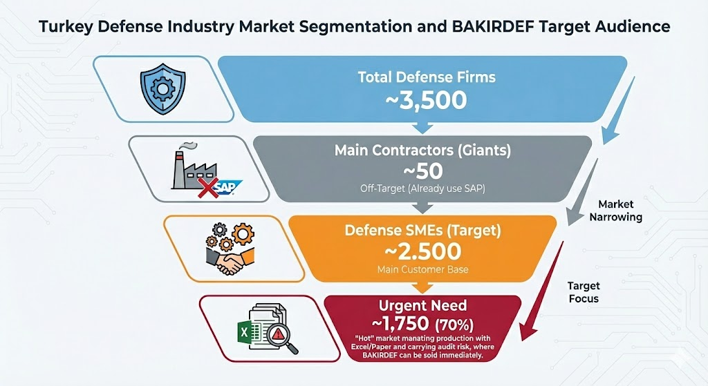
Small and medium-sized enterprises (SMEs) operating in the aerospace and defence supply chain face increasing pressure to comply with high-level quality and traceability requirements imposed by prime contractors and international standards. However, many of these organizations continue to rely on obsolete systems such as paper-based documentation, disconnected Excel files, or outdated ERP modules that do not fully support AS9100 Rev D requirements. This situation results in inefficiencies, inconsistent documentation practices, and increased risk of nonconformities. The proposed Quality Management Module, tentatively named BAKIRDEF, aims to address these challenges by providing a modern, digital, and risk-based quality management platform designed specifically for defence-focused SMEs.
The module’s primary goal is to enforce high quality and compliance standards in line with AS9100 Rev D, ISO 9001:2015, and NATO AQAP. It uses a risk-based approach focused on preventing nonconformities through continuous monitoring, structured NCR/CAPA/ECO workflows, and real-time revision control. This supports certification readiness while reducing scrap, rework, and schedule disruptions—key issues in defence manufacturing.
The system supports multiple user roles, each with tailored access. Operators use simplified interfaces to view work instructions or report nonconformities, while quality engineers access advanced tools such as audit planners, root-cause analysis templates, and supplier quality records. This role-based structure enhances data integrity and aligns with controlled documentation requirements.
Core features include document and revision control, nonconformance management, CAPA tracking, audit management, training and competency tracking, and optional supplier quality management. A notable innovation is the real-time engineering revision lock, Dashboards with trend analysis, risk heatmaps, and defect Pareto charts further enable data-driven decisions and continuous improvement.
The "Zero-Error" Mechanism
- Stops the Machine, Saves the Batch: If an operator tries to use an old drawing (Rev A) after a new one (Rev B) is released, the system actively locks the interface.
- Instant Digital Genealogy: Provides the full DNA of a part—raw material batch, specific operator, and machine time—in a single click.
- Quality Interlock: Blocks mass production until the First Article Inspection (FAI) is digitally approved. No approval, no movement.
- Skill Enforcement: Prevents uncertified or expired personnel from operating critical machinery.
- Shadow Inventory (GFE): Isolates customer-owned material (e.g., from ASELSAN) from company assets, preventing tax liabilities and balance sheet inflation.
- Calibration & Export Shield: Rejects data from expired tools and auto-blocks shipments to unauthorized countries.
From a technological standpoint, the module uses a scalable cloud-based architecture that enables fast deployment and seamless API integration with existing ERP systems while functioning as an independent QMS. Its subscription-based pricing model makes it accessible to SMEs that cannot invest in large enterprise platforms like SAP or IFS.
In summary, the proposed Quality Management Module offers a focused digital transformation solution for defence industry SMEs aiming to improve quality performance, sustain compliance, and stay competitive. By incorporating risk-based thinking, modular design, and defence-specific requirements, it closes key gaps in SME quality practices and provides a cost-effective route to AS9100 certification and operational excellence.
Example Databases that are used:
https://www.kaggle.com/datasets/behrad3d/nasa-cmaps
https://www.kaggle.com/datasets/stephanmatzka/predictive-maintenance-dataset-ai4i-2020
https://www.kaggle.com/datasets/shashwatwork/dataco-smart-supply-chain-for-big-data-analysis
https://www.kaggle.com/c/severstal-steel-defect-detection/data
https://www.kaggle.com/datasets/fantacher/neu-metal-surface-defects-data

