BURAK AYBİ

20712

ASSIGNMENT 4

DOMAIN: CAR MANUFACTUARING FOR COLOR, TECHNOLOGY AND MANUFACTURED CAR.

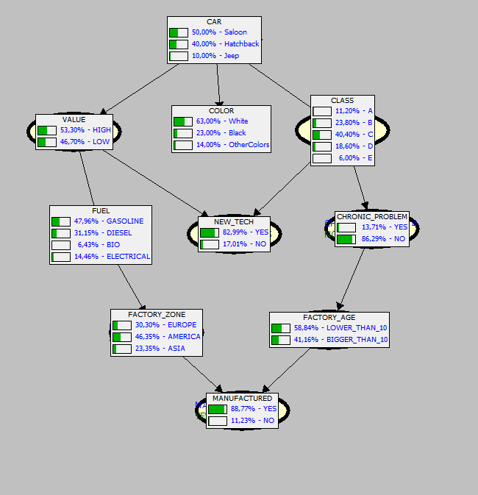

NETWORK: This network shows that Bayes relationship between variables that are Car’s features for manufacturing in which way and specialty.



CASE 1: If value is high for manufacturing, it has more probability to be manufactured because company does not want to waste it easly.

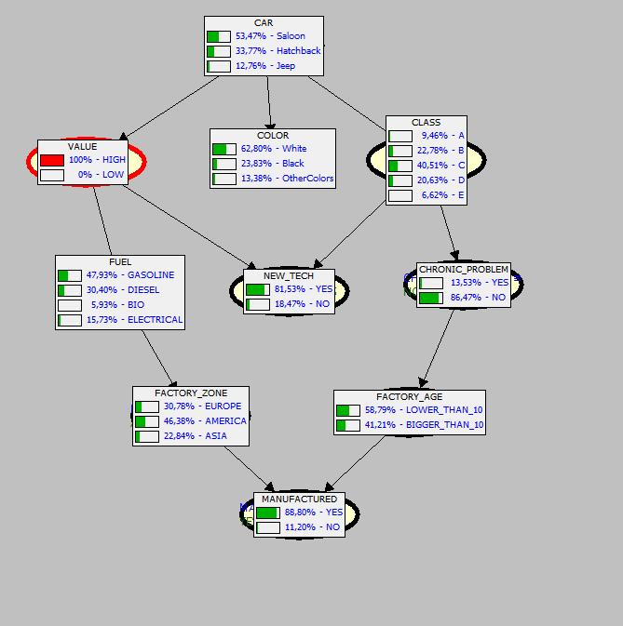

CASE2: If car is a jeep and fuel is a bio it has less probability because jeep uses a lot of fuel and bio could not afford that usage and power.

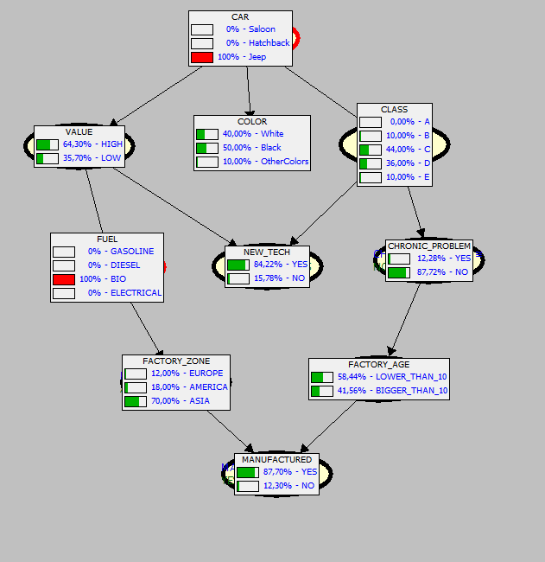

CASE 3: If car factory is in America and it is less than 10 years old. It has more probability to manufacture car because factory is in great economy and new technologies.

