MEE 428 REAL TIME CONTROL

FINAL PROJECT

**MY PROPOSED SYSTEM :**

As a project, my design a system that can be switched on and off depending on rain.

Materials : 1 rain sensor(FC-37), 1 potentiometer, 1 DC motor, L295-H motor driver, Arduino uno, 12V 1a Adapter.

The aim of my project is to save water in greenhouses. With the rain sensor on the greenhouse, the roof opens when it rains.Thus, rainwater feeds the plants. Then the greenhouse is covered when there is no rain. In this way, I reduce the cost by saving in water use. I will be able to learn how many degrees the roof will open and how long it will remain open with the potentiometer.

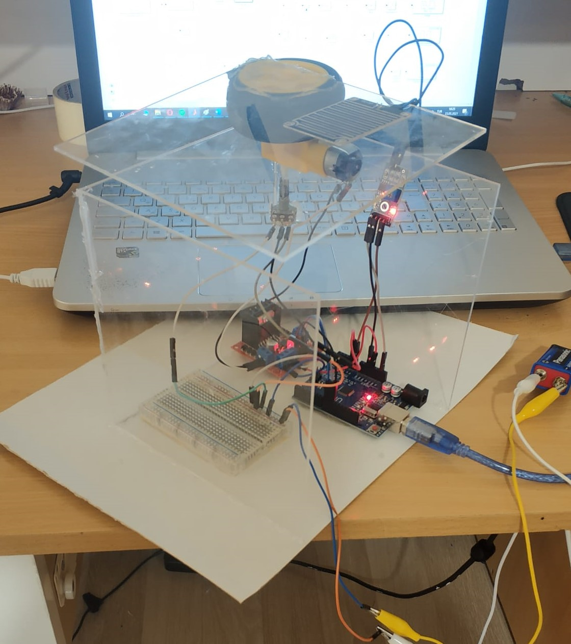

**EXPLANATION OF SIMULINK MODEL**

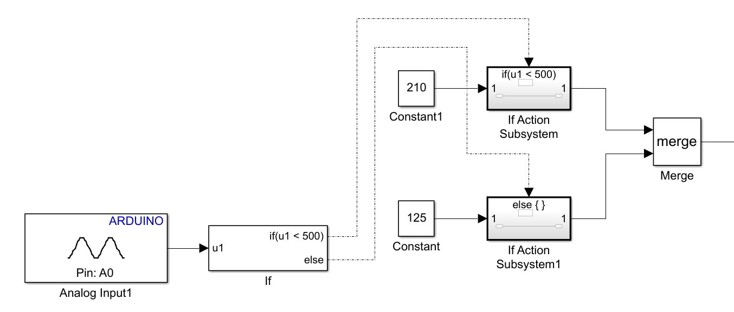

I am getting the analog data I measured from the sensor from the A0 pin. The values I measured from the sensor are between 0 and 1023. I converted these analog data to digital signals with the if else command, 0 if greater than 500, and 1 if less than 500. I combined this data with the merge block. I also added constant blocks for the rotation angle of the motor. With the potentiometer, I can find out the rotation angle of the DC motor and how long the roof is open and closed. When the potentiometer shows 210 °, the roof is open and the roof is closed when it points 125°.

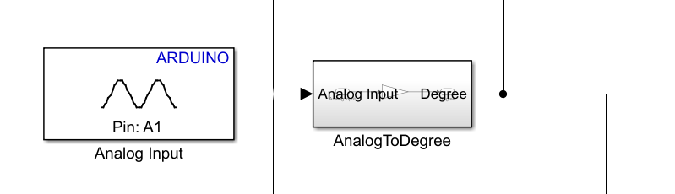

I'm getting the analog data on the potentiometer from pin A1. I converted these analog to degrees. I extracted the data from the sensor from the data from the potentiometer with the sum block.

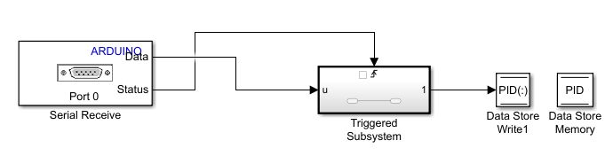

I made data length 3 in this part because I have 3 values (P, I, d) .When I give an input value, it gives status 1, then it enters the triggered subsystem, and then my values come out. Values from Data Store Write are being read and written in Data Store Memory.

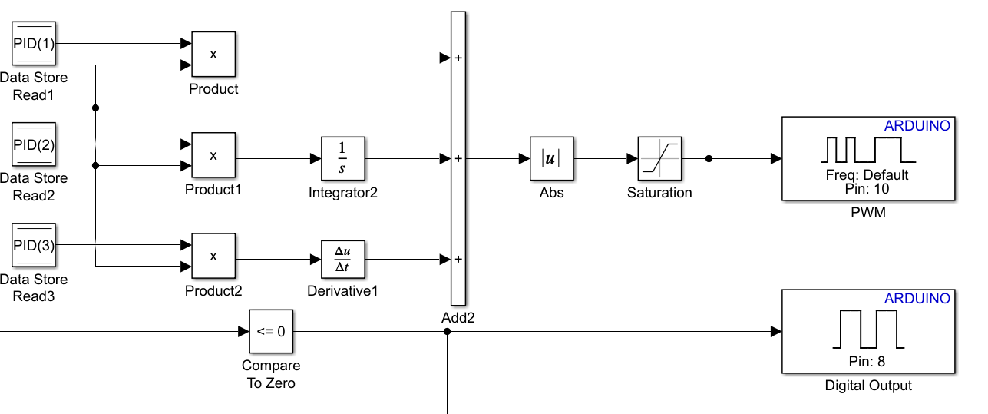I'm reading the data in the datastore here by Data Store Read. There are 3 Data Store Read because I'm inputting 3 values. Then the values here are multiplied by the gain and the reference. Then i used absolute block. I used saturation block and limited the operation of the DC motor(0-65). I used logic so I can control the direction of the DC motor.

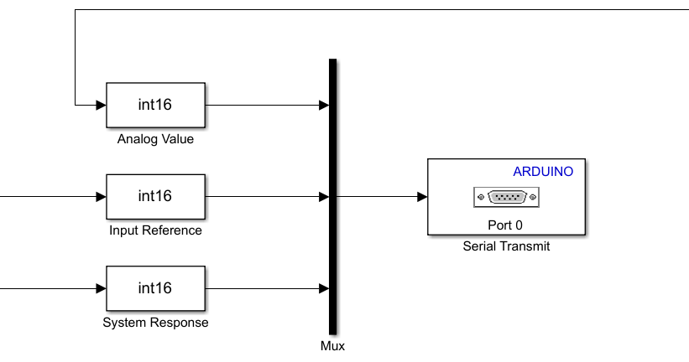

In this part, I print the data I get from my system in the GUI where necessary.

**GUI EXPLANATION**

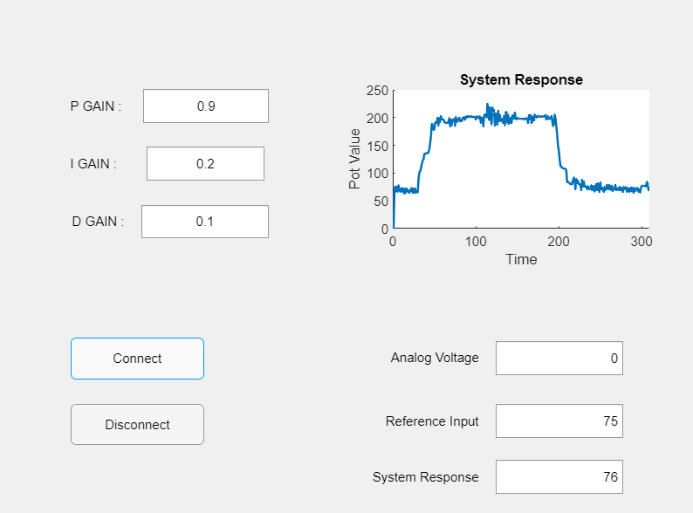

I used App designer instead of GUI because it is simpler to use than GUI. I start the system with the connect button and stop the system with disconnect.I can control my system by entering PIDV and reference input values. By entering the pid values, I make the system work more smoothly. You can see the values necessary for my system to work well. At these values, the error varies between 1-2 in the input and output of my system.

**When the roof of the system is closed**

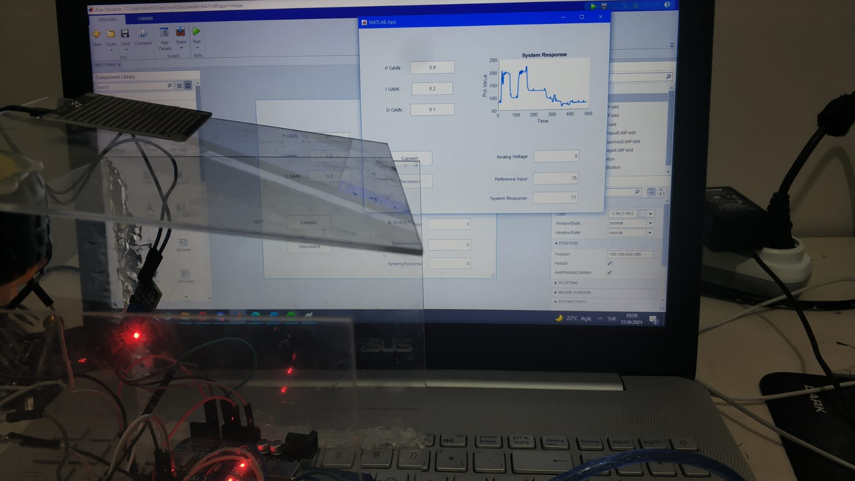

**When the roof of the system is opened**



**BLOCK DIAGRAM**

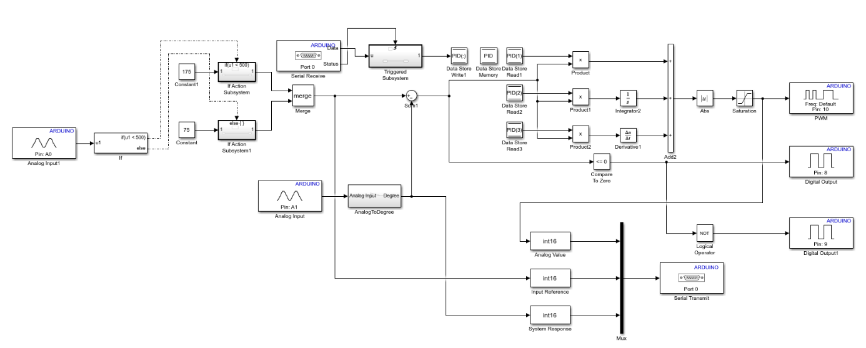

**SYSTEM DEMONSTRATION**

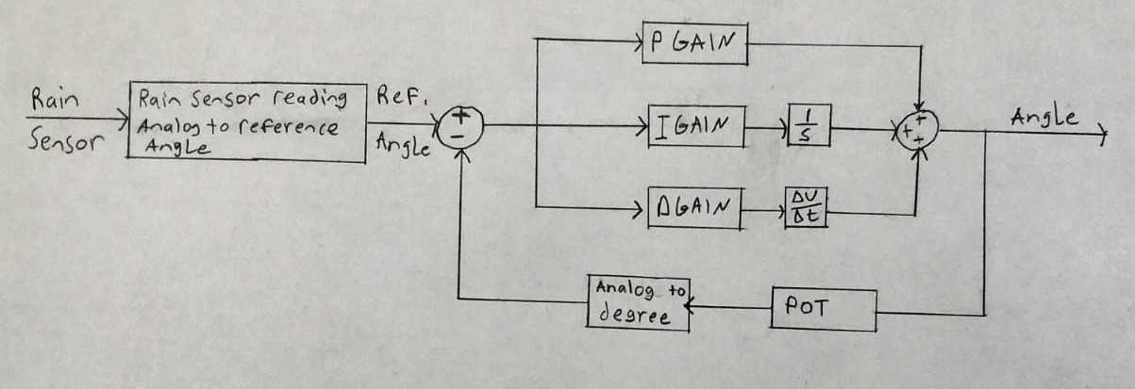

0-1023 analog value coming from rain sensor, reference input is determined with if-else command. Then compared with the reference angle and degree analog values from the feedback. It sends a command to the dc motor according to the error. Trying to reduce the error with pid values.

**UNDER DAMPED SYSTEM**

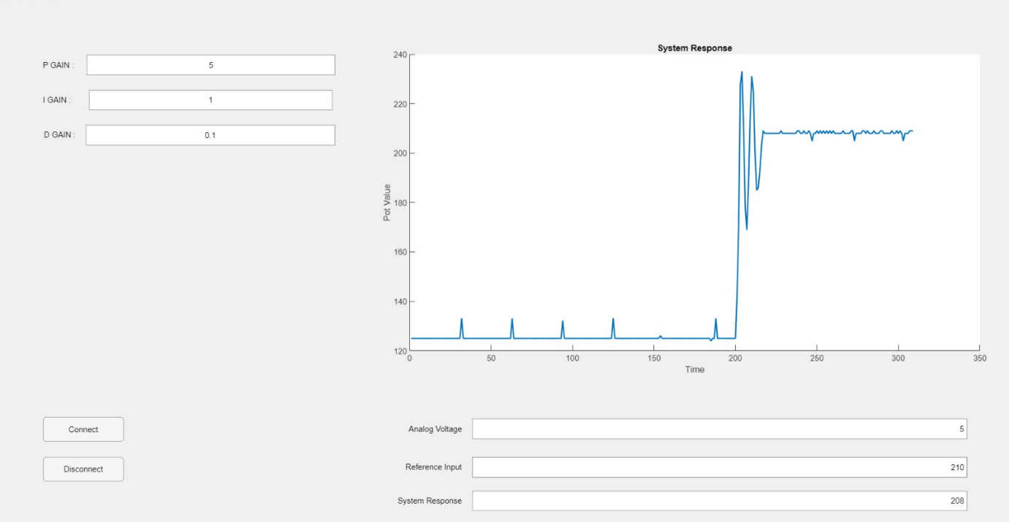

**OVER DAMPED SYSTEM**

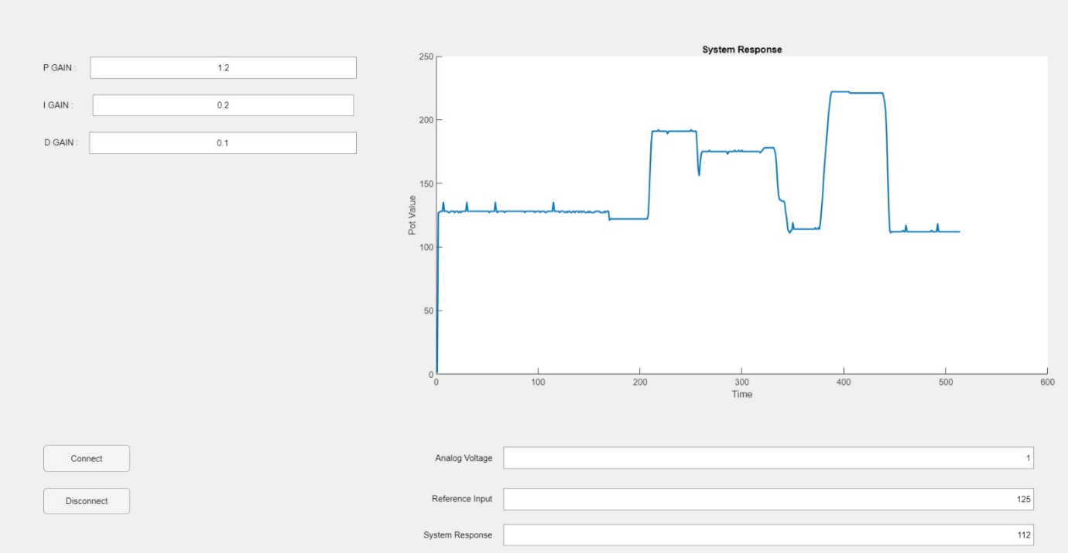

**CONCLUSION AND RESULT**

In this project, I saw how we would encounter the theoretical knowledge I learned in the lessons in real life. I made a computer simulation of the system I had planned with block diagrams. The system extracts the reference value by analyzing the data from the sensor. With this value, the value measured from the potentiometer is Sum. then it enters the PID blocks and gives direction to the motor. We must choose PID values for the system to work well. I observed that when I increased the PID values of the system, the system constantly went back and forth. As a result of my observations, the best reference value for my system is P= 1.2 I=0.2 D=0.1 . Also, by changing the PID values, I obtained the over-damping and under-damping graphs in the system response. You can see these values in the video and in the report.

I could not draw the critical damping graph as an error in my system. I think the reason for this is mechanical problems in my system.Also, one of the other errors in my system is that when I enter the reference input value, the system responds very quickly to this answer and goes back to the old reference value.

In general, my system was working fine. This project was very useful for me to improve my MATLAB skills.

**APP DESIGNER (GUI) CODE**

classdef app1 < matlab.apps.AppBase

% Properties that correspond to app components

properties (Access = public)

UIFigure matlab.ui.Figure

PGAINEditField matlab.ui.control.NumericEditField

PGAINEditFieldLabel matlab.ui.control.Label

DGAINEditField matlab.ui.control.NumericEditField

DGAINLabel matlab.ui.control.Label

IGAINEditField matlab.ui.control.NumericEditField

IGAINLabel matlab.ui.control.Label

ReferenceInputEditField matlab.ui.control.NumericEditField

ReferenceInputEditFieldLabel matlab.ui.control.Label

SystemResponseEditField matlab.ui.control.NumericEditField

SystemResponseEditFieldLabel matlab.ui.control.Label

AnalogVoltageEditField matlab.ui.control.NumericEditField

AnalogVoltageEditFieldLabel matlab.ui.control.Label

ConnectButton matlab.ui.control.Button

DisconnectButton matlab.ui.control.Button

UIAxes matlab.ui.control.UIAxes

end

properties (Access = private)

Response % variable y for the system's response

s % Serial

ctr % Counter to store the elements in arrays for plot

end

methods (Access = private)

function ReadInputDataOverSerial(app, hObject, eventdata, handles)

%Read

Values=fread(app.s,[1,app.s.BytesAvailable],'char')

if(~isempty(Values))

Analog_Voltage = Values(1);

Reference_Input = Values(3);

System_Response = Values(5);

%Display in GUI

app.SystemResponseEditField.Value = System_Response;

app.AnalogVoltageEditField.Value = Analog_Voltage;

app.ReferenceInputEditField.Value = Reference_Input;

%Store

app.Response{app.ctr} = System_Response;

app.ctr = app.ctr + 1;

end

%Plot for system response

x = 1:size(app.Response,2);

y = zeros(1,size(app.Response,2));

for i=1:size(y,2)

y(i) = app.Response{i};

end

if (mod(app.ctr,5)==0)

plot(app.UIAxes,x,y,'LineWidth',1.5);

end

end

end

% Callbacks that handle component events

methods (Access = private)

% Code that executes after component creation

function startupFcn(app)

app.Response = cell(1,1); %Initialize the variable

app.ctr = 1; %Set the counter to 1

end

% Value changed function: PGAINEditField

function PGAINEditFieldValueChanged(app, event)

value = app.PGAINEditField.Value;

fwrite(app.s,value) % input to be able to enter a value.

End

% Value changed function: IGAINEditField

function IGAINEditFieldValueChanged(app, event)

value = app.IGAINEditField.Value;

fwrite(app.s,value) % input to be able to enter a value.

End

% Value changed function: DGAINEditField

function DGAINEditFieldValueChanged(app, event)

value = app.DGAINEditField.Value;

fwrite(app.s,value) % input to be able to enter a value.

End

% Button pushed function: ConnectButton

function ConnectButtonPushed(app, event)

app.s=serial('COM3','BaudRate',9600);

app.s.BytesAvailableFcn={@app.ReadInputDataOverSerial};

app.s.BytesAvailableFcnCount = 8;

app.s.BytesAvailableFcnMode='byte';

fopen(app.s); % Open The Gui

end

% Button pushed function: DisconnectButton

function DisconnectButtonPushed(app, event)

fclose(app.s); % stop the Gui

end

% Value changed function: ReferenceInputEditField

function ReferenceInputEditFieldValueChanged(app, event)

value = app.ReferenceInputEditField.Value;

fwrite(app.s,value) % input to be able to enter a value.

end

end

% Component initialization

methods (Access = private)

% Create UIFigure and components

function createComponents(app)

% Create UIFigure and hide until all components are created

app.UIFigure = uifigure('Visible', 'off');

app.UIFigure.Position = [100 100 640 480];

app.UIFigure.Name = 'MATLAB App';

% Create UIAxes

app.UIAxes = uiaxes(app.UIFigure);

title(app.UIAxes, 'System Response')

xlabel(app.UIAxes, 'Time')

ylabel(app.UIAxes, 'Pot Value')

zlabel(app.UIAxes, 'Z')

app.UIAxes.Position = [319 233 284 183];

% Create DisconnectButton

app.DisconnectButton = uibutton(app.UIFigure, 'push');

app.DisconnectButton.ButtonPushedFcn = createCallbackFcn(app, @DisconnectButtonPushed, true);

app.DisconnectButton.Position = [67 71 123 37];

app.DisconnectButton.Text = 'Disconnect';

% Create ConnectButton

app.ConnectButton = uibutton(app.UIFigure, 'push');

app.ConnectButton.ButtonPushedFcn = createCallbackFcn(app, @ConnectButtonPushed, true);

app.ConnectButton.Position = [67 131 123 38];

app.ConnectButton.Text = 'Connect';

% Create AnalogVoltageEditFieldLabel

app.AnalogVoltageEditFieldLabel = uilabel(app.UIFigure);

app.AnalogVoltageEditFieldLabel.HorizontalAlignment = 'right';

app.AnalogVoltageEditFieldLabel.Position = [356 140 86 22];

app.AnalogVoltageEditFieldLabel.Text = 'Analog Voltage';

% Create AnalogVoltageEditField

app.AnalogVoltageEditField = uieditfield(app.UIFigure, 'numeric');

app.AnalogVoltageEditField.Position = [457 135 117 31];

% Create SystemResponseEditFieldLabel

app.SystemResponseEditFieldLabel = uilabel(app.UIFigure);

app.SystemResponseEditFieldLabel.HorizontalAlignment = 'right';

app.SystemResponseEditFieldLabel.Position = [339 31 103 22];

app.SystemResponseEditFieldLabel.Text = 'System Response';

% Create SystemResponseEditField

app.SystemResponseEditField = uieditfield(app.UIFigure, 'numeric');

app.SystemResponseEditField.Position = [457 26 117 31];

% Create ReferenceInputEditFieldLabel

app.ReferenceInputEditFieldLabel = uilabel(app.UIFigure);

app.ReferenceInputEditFieldLabel.HorizontalAlignment = 'right';

app.ReferenceInputEditFieldLabel.Position = [351 82 91 22];

app.ReferenceInputEditFieldLabel.Text = 'Reference Input';

% Create ReferenceInputEditField

app.ReferenceInputEditField = uieditfield(app.UIFigure, 'numeric');

app.ReferenceInputEditField.ValueChangedFcn = createCallbackFcn(app, @ReferenceInputEditFieldValueChanged, true);

app.ReferenceInputEditField.Position = [457 77 117 31];

% Create IGAINLabel

app.IGAINLabel = uilabel(app.UIFigure);

app.IGAINLabel.Position = [67 318 61 22];

app.IGAINLabel.Text = 'I GAIN :';

% Create IGAINEditField

app.IGAINEditField = uieditfield(app.UIFigure, 'numeric');

app.IGAINEditField.ValueChangedFcn = createCallbackFcn(app, @IGAINEditFieldValueChanged, true);

app.IGAINEditField.HorizontalAlignment = 'center';

app.IGAINEditField.Position = [137 313 108 31];

app.IGAINEditField.Value = 0.2;

% Create DGAINLabel

app.DGAINLabel = uilabel(app.UIFigure);

app.DGAINLabel.HorizontalAlignment = 'right';

app.DGAINLabel.Position = [63 265 54 22];

app.DGAINLabel.Text = 'D GAIN :';

% Create DGAINEditField

app.DGAINEditField = uieditfield(app.UIFigure, 'numeric');

app.DGAINEditField.ValueChangedFcn = createCallbackFcn(app, @DGAINEditFieldValueChanged, true);

app.DGAINEditField.HorizontalAlignment = 'center';

app.DGAINEditField.Position = [132 260 117 31];

app.DGAINEditField.Value = 0.1;

% Create PGAINEditFieldLabel

app.PGAINEditFieldLabel = uilabel(app.UIFigure);

app.PGAINEditFieldLabel.Position = [67 371 52 22];

app.PGAINEditFieldLabel.Text = 'P GAIN :';

% Create PGAINEditField

app.PGAINEditField = uieditfield(app.UIFigure, 'numeric');

app.PGAINEditField.ValueChangedFcn = createCallbackFcn(app, @PGAINEditFieldValueChanged, true);

app.PGAINEditField.HorizontalAlignment = 'center';

app.PGAINEditField.Position = [134 366 115 31];

app.PGAINEditField.Value = 0.9;

% Show the figure after all components are created

app.UIFigure.Visible = 'on';

end

end

% App creation and deletion

methods (Access = public)

% Construct app

function app = app1

% Create UIFigure and components

createComponents(app)

% Register the app with App Designer

registerApp(app, app.UIFigure)

% Execute the startup function

runStartupFcn(app, @startupFcn)

if nargout == 0

clear app

end

end

% Code that executes before app deletion

function delete(app)

% Delete UIFigure when app is deleted

delete(app.UIFigure)

end

end

end