Member Name | Member Roll # | Primary Responsibility
Shehryar Munir | 20L-1302
Fatima Siddiqui | 20L-1213
Irtaza Zulfiqar | 20L-1290
Muhammad Abdullah | 20L-1261
Samreen Abbas | 20L-1292
Rabia Shakil | 20L-1319
E-Heal
Phase # 3
Team # 4

Table of Contents

1. Architectural Style Diagram………………………………………………………………......1
2. Architectural Context Diagram………………………………………………………………..2
3. Rationale…………………………………………………………………………………………3

Architectural Style diagram
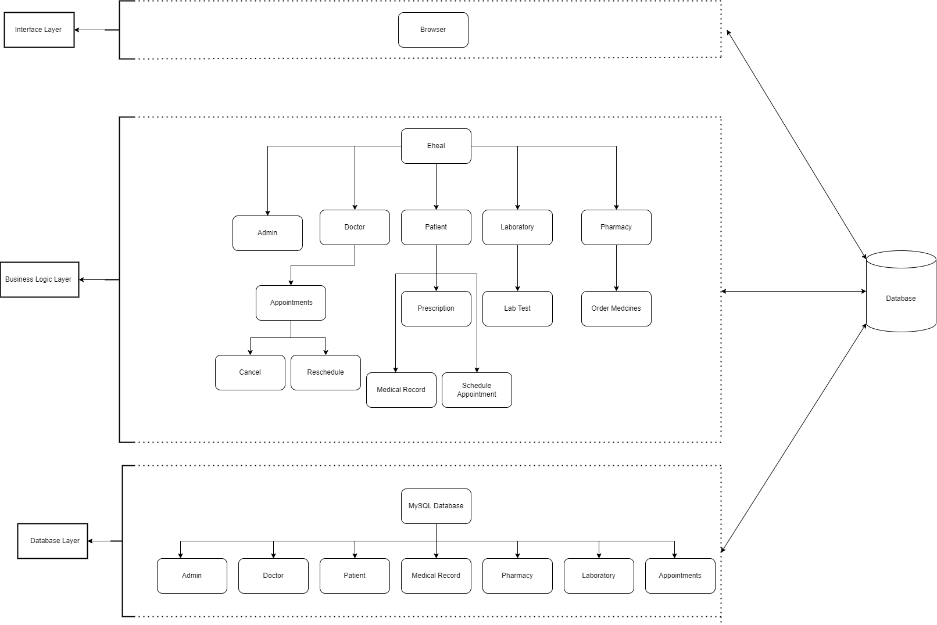

2. Architectural Context diagram
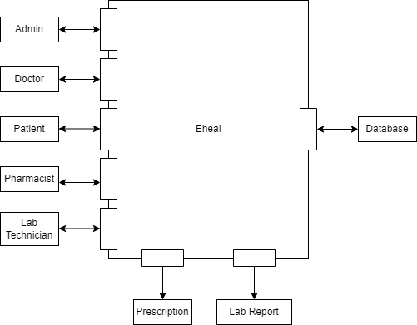

3. Rationale

The project E-Heal follows multiple Software Architectural styles:

- Data Centered

This architectural style is followed because we are dealing with a database, and only that database enables interaction. Without that database, there is no interaction between the components. The stored data is continuously updated, added, deleted and modified by the components. Further in data centered, the style is active. That is because whenever a change occurs, components are informed about it.

- Layered

This style is followed because the components are organized into horizontal layers, and each layer performs a specific role within the program. The outer layer is the presentation layer, which deals with handling all the user interface as well as communicational logic. The middle layer consists of a business logic layer that processes requests from the presentation layer and acts as a medium for interaction between the outer (presentation) and inner (database) layer. The most inner layer is the database layer upon which a set of operations is applied. The outer layers can access the inner layer, but not vice versa.

- Object oriented architecture

That is because the components of the system encapsulate data as well as the operations that must be applied to manipulate the data.

Component Name | Component Description | Reference
Admin | This is the actor that deals with enrolling other actors in the database.  Follows object oriented architectural style and is part of the business layer in layered architectural style. Furthermore it uses a database to store data, hence following data centered architecture style.. | UC-24,UC-25
Doctor | This is an actor that the patient schedules an appointment with. Every doctor has an area of specialization.  Follows object oriented architectural style and is part of the business layer in layered architectural style. Furthermore it uses a database to store data, hence following data centered architecture style.. | UC-1,UC-2,UC-3,UC-15,UC-16,UC-17,UC-18,UC-19
Patient | This actor schedules the appointments with the doctor. A patient has a medical record.  Follows object oriented architectural style and is part of the business layer in layered architectural style. Furthermore it uses a database to store data, hence following data centered architecture style.. | UC-1,UC-2,UC-3,UC-4,UC-5,UC-6,UC-7,UC-8,UC-9,UC-10,UC-11,UC-12,UC-13,UC-14
Pharmacist | The pharmacist can send prescribed medicines to the patient upon request. Follows object oriented architectural style and is part of the business layer in layered architectural style. Furthermore it uses a database to store data, hence following data centered architecture style. | UC-1,UC-2,UC-3,UC-21,UC22
Lab technician | Lab technician conducts lab tests and publishes a report.  Follows object oriented architectural style and is part of the business layer in layered architectural style. Furthermore it uses a database to store data, hence following data centered architecture style.. | UC-1,UC-2,UC-3,UC-22,UC-23
Medical Record | Every patient has a medical record associated with it. It is updated upon an appointment.  Follows object oriented architectural style and is part of the business layer in layered architectural style. Furthermore it uses a database to store data, hence following data centered architecture style. | UC-6
Appointments | An appointment involving a doctor and a patient is scheduled, and every appointment has a prescription.  Follows object oriented architectural style and is part of the business layer in layered architectural style. Furthermore it uses a database to store data, hence following data centered architecture style. | UC-11,UC-14,UC-19,UC-22,UC-15
Prescription | It is a document that is updated by the doctor after an appointment.  Follows object oriented architectural style and is part of the business layer in layered architectural style. Furthermore it uses a database to store data, hence following data centered architecture style. | UC-7,UC-17
Lab Test | If a lab test is prescribed by the doctor, a lab test is conducted by the lab technician and a report is made.  Follows object oriented architectural style and is part of the business layer in layered architectural style. Furthermore it uses a database to store data, hence following data centered architecture style. | UC-9,UC-23
Order Medicines | A patient can order the medicines prescribed by the doctor.  Follows object oriented architectural style and is part of the business layer in layered architectural style. Furthermore it uses a database to store data, hence following data centered architecture style. | UC-7,UC-13,UC-20,UC-21
Cancel Appointment | A doctor or a patient can cancel an appointment.  Follows object oriented architectural style and is part of the business layer in layered architectural style. Furthermore it uses a database to store data, hence following data centered architecture style. | UC-5,UC-18
Reschedule Appointment | A doctor or a patient can reschedule an appointment.  Follows object oriented architectural style and is part of the business layer in layered architectural style. Furthermore it uses a database to store data, hence following data centered architecture style. | UC-14
Schedule Appointment | A patient can schedule an appointment with the doctor.  Follows object oriented architectural style and is part of the business layer in layered architectural style. Furthermore it uses a database to store data, hence following data centered architecture style. | UC-4,UC-8

