**ITU Computer and Informatics Faculty**

**BLG 354E Signals and Systems for Computer Engineering – 2020 Spring**

**Homework-1 Report**

**1-**a)

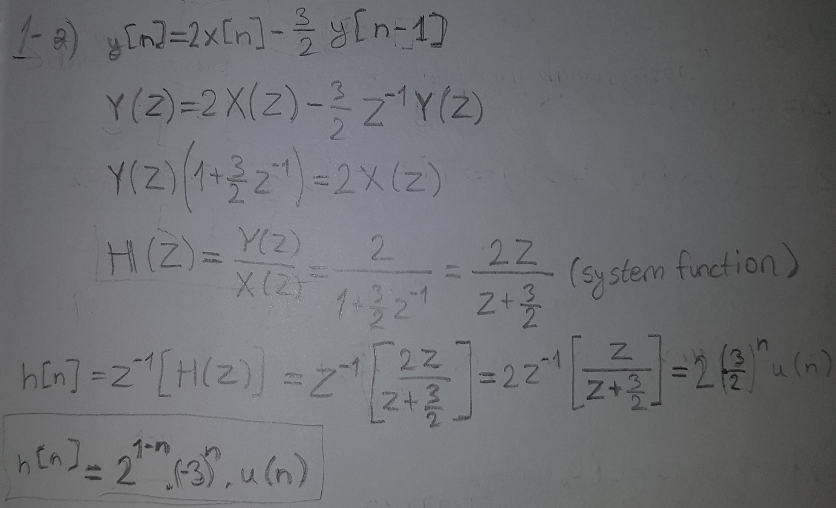

b)

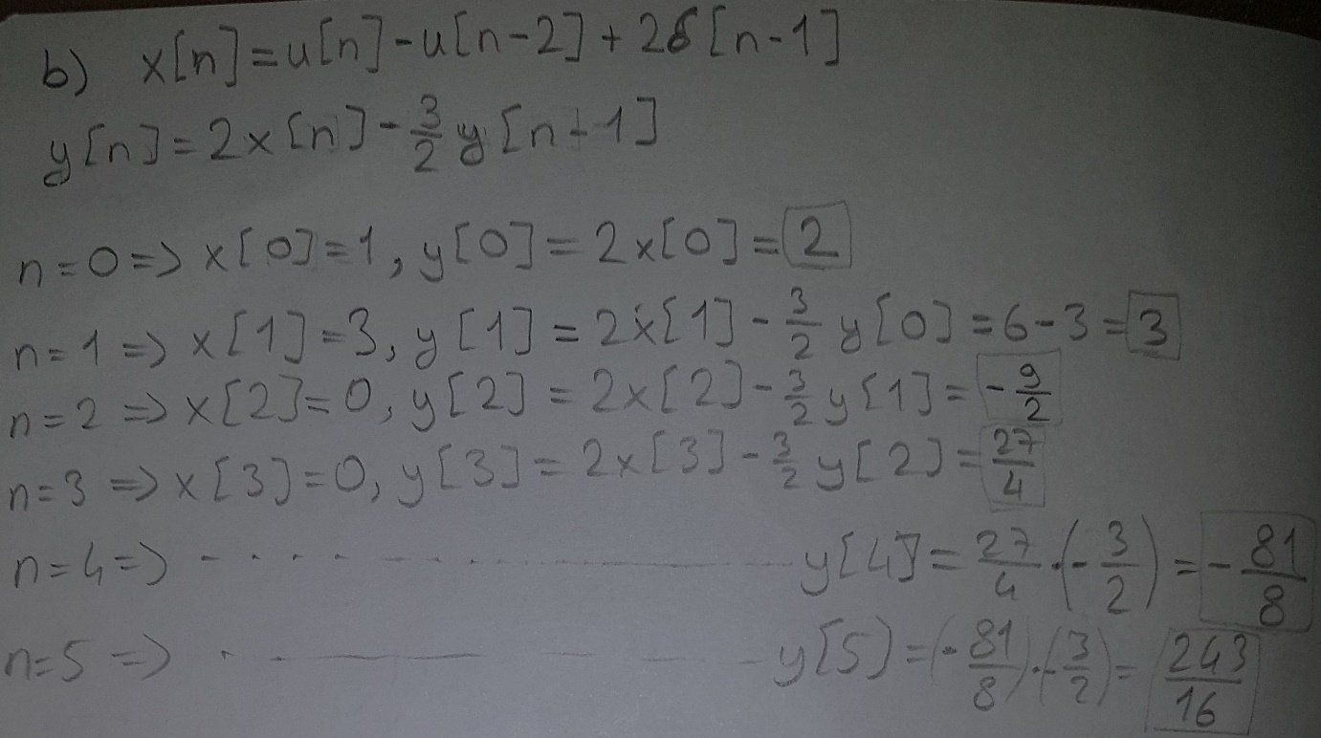

**2-**a)

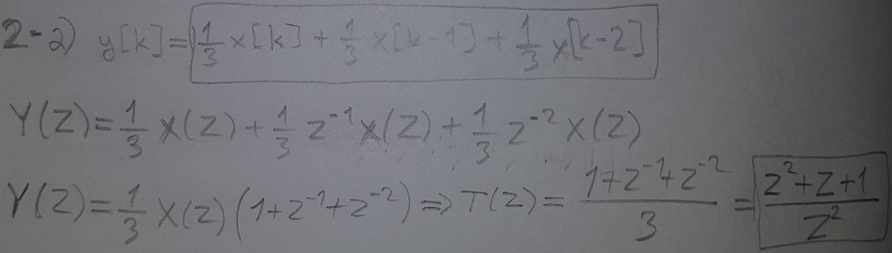

b)

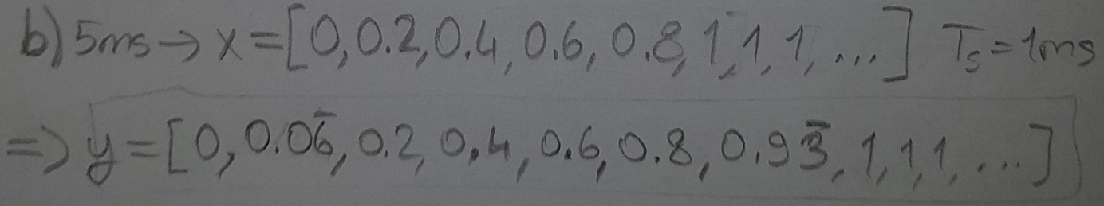

c)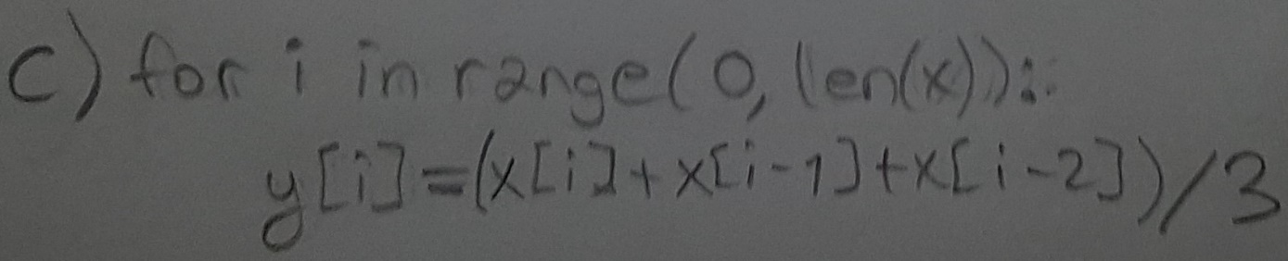

**3-**

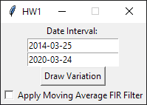

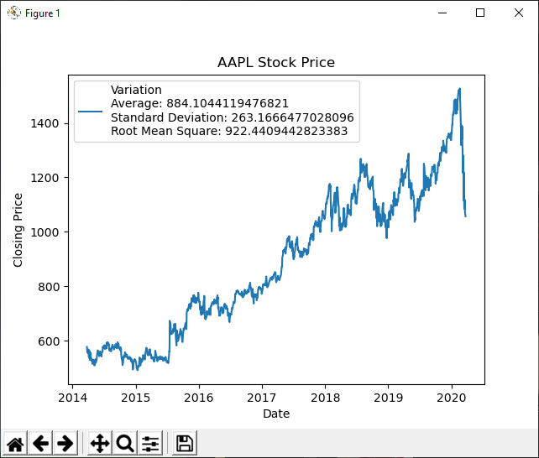

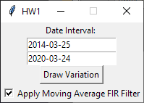

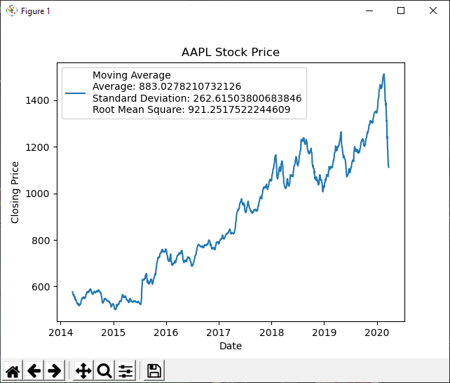

To do combined plotting; draw the variation without filter, then redraw the variation with filter but do not close the previous plot.

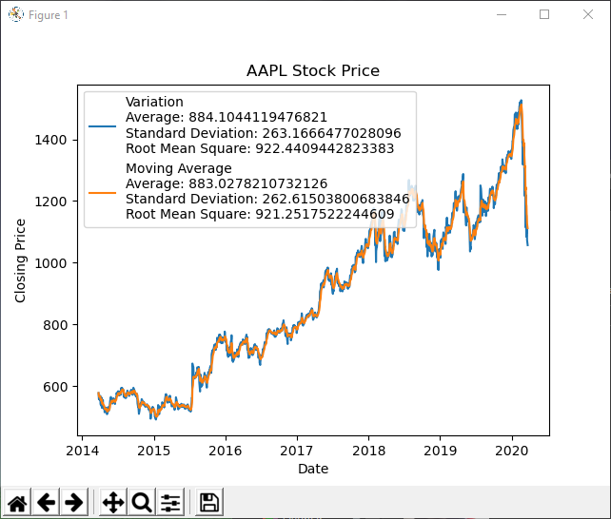

If the date is entered wrong, the program will not create any plot nor any error messages. If you cannot see any plot while trying to draw the variation, it means that the input does not match with any record in csv file.

**Note:** Please read README.txt before using the program.