**ITU Computer and Informatics Faculty**

**BLG 354E Signals and Systems for Computer Engineering - 2020 Spring**

**Homework-2 Report**

**1-** The code simply takes first 5 numbers of the given input. Fills the remaining unentered numbers with zero according to the largest array (x or h). Using *scipy.signal.convolve*, the output is printed to the console.

**a)**

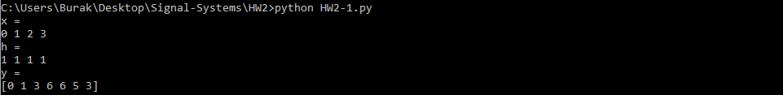

**b)**

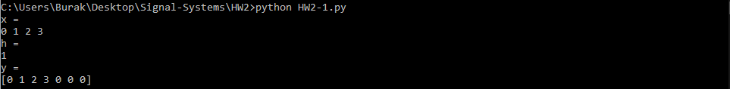

**c)**

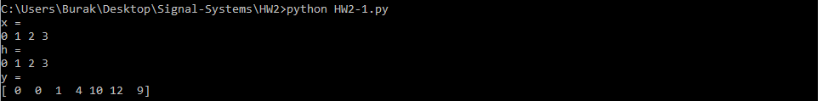

**d)**

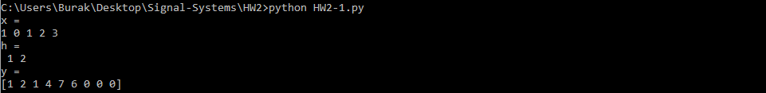

**2-** Date interval is locked to the last 400 data points. Using buttons given in the GUI, you can draw a graph using specific data types.

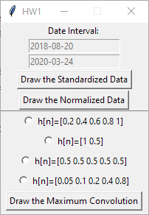

**a)**

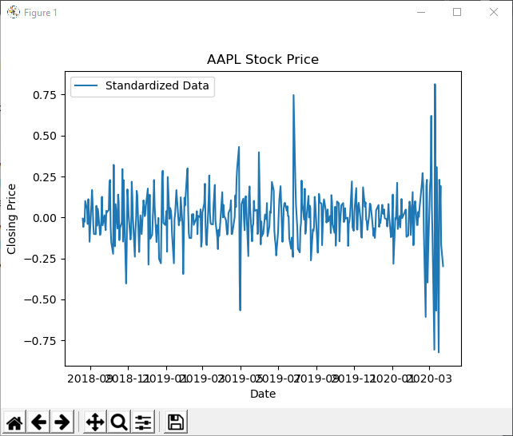

**b)**

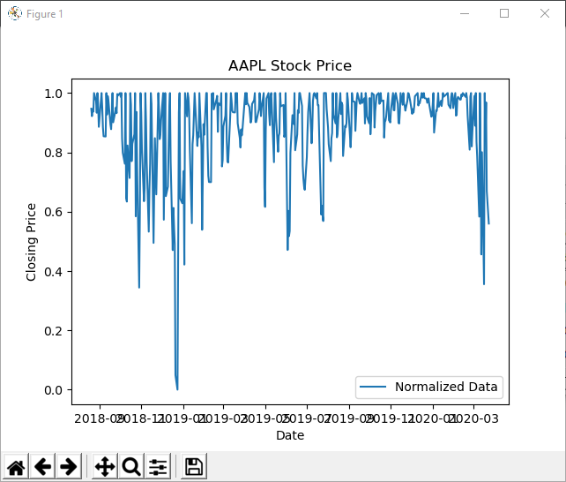

**c)**

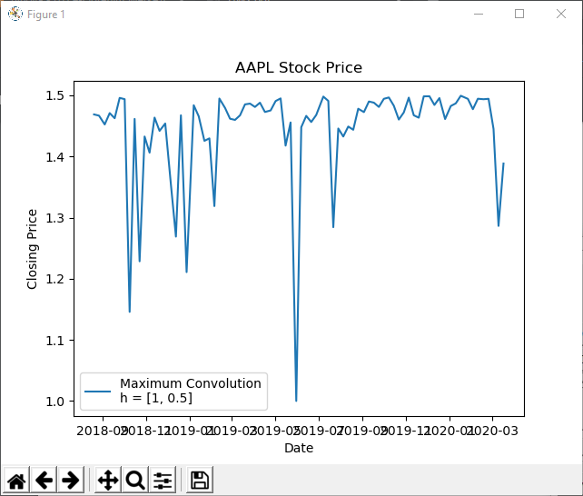

Note that you can choose any h arrays from the GUI using radio buttons.

**Note:** All Python codes are tested in Python 3.8.2, backwards compatibility is not guaranteed.

**Used packages:**

* *Matplotlib.pyplot*
* *Numpy*
* *Scipy*
* *Tkinter*