**BLG 354E Signals and Systems for Computer Engineering Homework-4 Report**

**Problem 1**

In this homework, I used one of the two 16-bit sampled (@44100Hz) mono audio records (music) that were provided for homework 3.

I wrote a Python implementation of Radix-2 Decimation in Frequency (DIF) type Fast Fourier Transform.

Then, I run 256-point Radix 2 DIF-FFT code on one of the audio records. I visualized spectrograms using logarithmic scale for frequency and the amplitude axes.

An example run of the program is as follows:

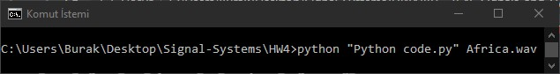

The output:

