LAB ASSIGNMENT 1 — UNDERSTANDING LINEAR AND LOGISTIC REGRESSION
  - Experimental report | Biomedical System Design Capsule-S1
Burak Bekir Çakırer | Student ID: 2211011008
20 October 2026

Abstract
This lab studies two supervised machine-learning tasks on real biomedical datasets. Linear regression predicts a continuous one-year diabetes disease-progression score from body mass index (BMI) and average blood pressure (442 observations). Logistic regression distinguishes malignant from benign breast-tumor samples using worst radius and worst concave points (569 observations). Both datasets were split into 80% training and 20% held-out testing data with a fixed random seed of 42. The linear model obtained a test MAE of 50.04 and R² of 0.294. The two-feature logistic model obtained 95.61% accuracy and 0.938 F1 at threshold 0.5. Additional controlled experiments examine standardization, learning-rate convergence, decision thresholds, and feature inclusion. The goal is to interpret model behavior, rather than to claim clinical readiness.
Keywords: linear regression; logistic regression; feature scaling; gradient descent; decision threshold; biomedical data.

1. Study Design and Reproducibility
The experiments follow the assignment's Parts A–D. Exactly two real biomedical datasets are used, with two prespecified features from each for interpretable models and plots. The datasets are distributed with scikit-learn and are loaded locally; no external download or invented records are needed. Their origin, class conventions, and feature definitions are documented by the original publications and repository records [1–5].
Setting | Linear regression | Logistic regression
Dataset | Diabetes (442 samples) | Wisconsin Diagnostic Breast Cancer (569 samples)
Features | BMI, average blood pressure | Worst radius, worst concave points
Label | Continuous progression score | Malignant = 1; benign = 0
Train / test | 353 / 89 | 455 / 114
Partition | 80/20, random seed 42 | 80/20, seed 42, stratified
Baseline estimator | Ordinary least squares (OLS) | L2-regularized logistic regression
Preprocessing | Unscaled raw features for B1; train-only z-scaling for B2–B3 | Train-only z-scaling
Software and configuration. Python 3.13.5; NumPy 2.3.5; pandas 2.2.3; scikit-learn 1.8.0; Matplotlib 3.10.8 [6]. The logistic estimator uses the lbfgs solver, C = 1, and at most 2000 iterations. All model parameters are learned from the training split only. In B3, batch gradient descent runs 150 iterations for each rate. Test records are excluded from scaler fitting, coefficient learning, and gradient-descent settings.
Reproducibility note: the project ZIP contains the analysis program, dependency specification, saved train/test assignments, figures, and machine-readable result tables. No implementation code is included in this report. For a different environment, numerical differences may occur from library versions.

2. Part A — Dataset Selection and Exploration

2.1 Dataset 1: Diabetes progression (linear regression)
Problem. Predict a continuous disease-progression score one year after baseline from two patient measurements. This 442-observation Diabetes dataset is documented in the original research by Efron and colleagues and in the official scikit-learn description [1, 2]. The target is a continuous progression measure, not a diabetes diagnosis or glucose measurement.
Inputs and suitability. BMI represents body mass index and BP average blood pressure; they are the selected two of ten available predictors. Their original (not scikit-learn standardized) feature values are used for the baseline model, making coefficients interpretable in original units. No missing-value imputation is needed. The continuous target makes ordinary linear regression suitable.
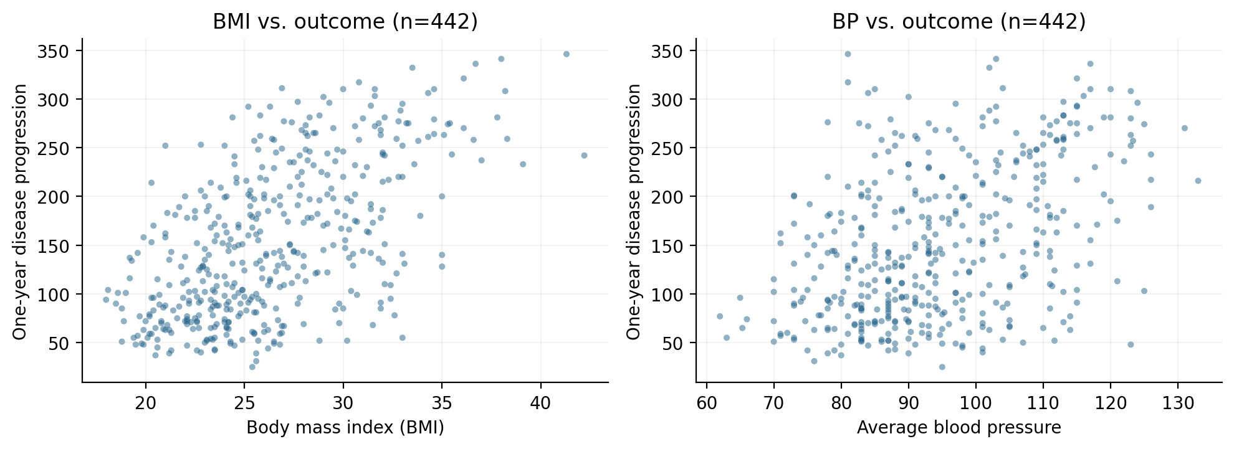
Figure 1. Exploratory relationships of BMI and average blood pressure with the continuous disease-progression target. Wide scatter indicates that two predictors cannot explain all variation.
Observation. Higher BMI and higher blood pressure tend to accompany higher progression scores, but both scatter plots show substantial spread. This is an early indication that the two-feature linear fit may have limited predictive accuracy.

2.2 Dataset 2: Breast cancer diagnostic features (logistic regression)
Problem. Classify malignant versus benign breast-mass measurements using the Wisconsin Diagnostic Breast Cancer dataset (569 records: 212 malignant and 357 benign). The dataset is documented by UCI [3], the original feature-extraction research [4], and the scikit-learn user guide [5]. Two of 30 predictors are retained: worst radius and worst concave points. Features were extracted from digitized fine-needle aspirate images; this experiment uses the numerical features, not raw images.
Inputs and preprocessing. The binary outcome is encoded 1 = malignant, 0 = benign. This reverses the dataset’s original numeric label mapping to make sensitivity to malignancy explicit. The split is stratified to preserve relative class proportions. StandardScaler means and standard deviations are estimated on training samples only. This dataset is suitable for logistic regression because the outcome is binary and both selected predictors are numerical.
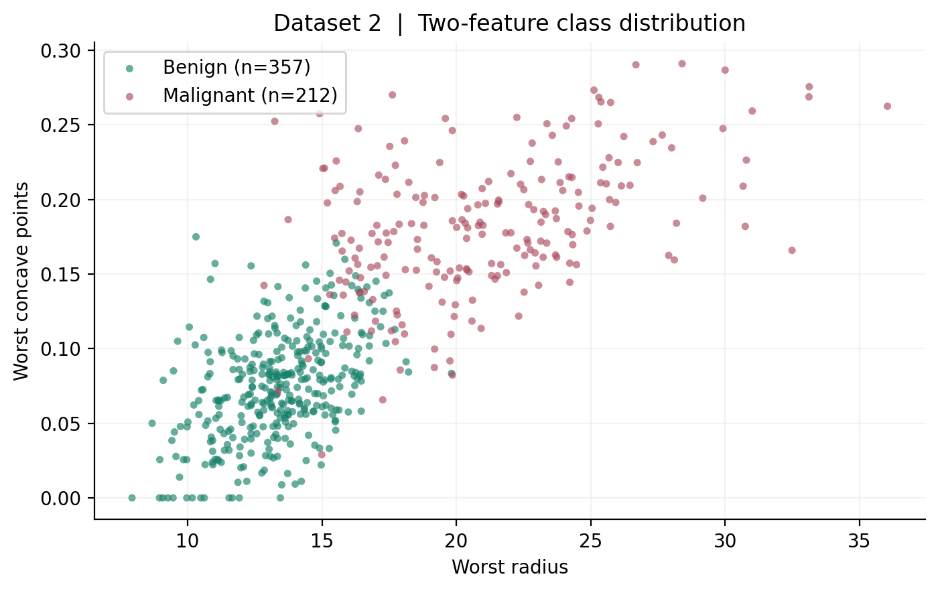
Figure 2. Distribution of the 569 diagnostic records across the two input features. The partially overlapping regions motivate probabilistic classification.
Observation. Malignant observations tend to have larger values of both features. The classes overlap, implying that no simple boundary can eliminate every mistake without changing the balance between false positives and false negatives.

3. Part B — Linear Regression Experiments

B1. Model parameters and predictions
Ordinary least squares was fitted on the raw BMI and blood-pressure values. The resulting linear model is an intercept plus one coefficient for each input.
Fitted parameter | Estimate | Meaning with other feature fixed
Intercept | -215.053 | Prediction when BMI and BP are both zero (outside the observed population)
BMI coefficient | +9.048 | +9.05 progression points per BMI unit
Blood pressure coefficient | +1.355 | +1.35 points per BP unit

Held-out test metric | Result
Mean absolute error (MAE) | 50.044
Mean squared error (MSE) | 3740.507
Root mean squared error (RMSE; additional context) | 61.160
Coefficient of determination (R²) | 0.294
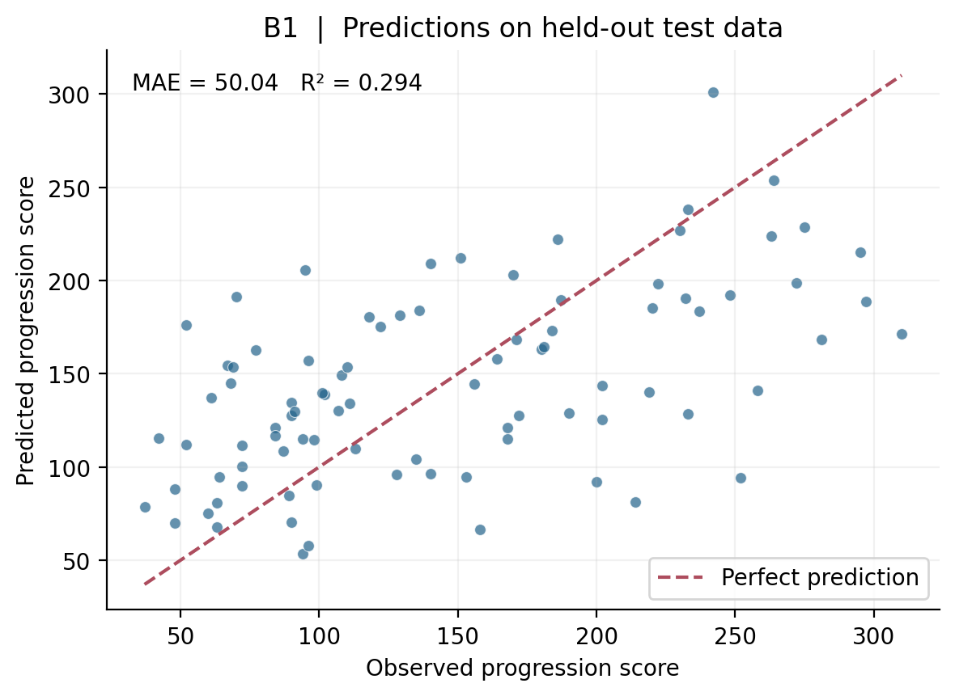
Figure 3. Actual versus predicted progression scores on the 89 held-out diabetes observations. The dashed diagonal denotes perfect predictions.
Interpretation. Holding blood pressure constant, one higher BMI unit is associated with about 9.05 higher predicted progression points, whereas one higher BP unit is associated with about 1.35 higher points, all else equal in this simple model. Because the feature units differ, coefficient magnitudes should not be interpreted as direct rankings of importance. The negative intercept is an extrapolation, not a physically meaningful patient’s score. Test MAE approximately 50.0 progression points and R² approximately 0.294 show moderate-to-weak explanatory ability; predictions cluster toward the mean and miss extreme cases. Association does not establish causation.

B2. Feature scaling
A second OLS model was trained after fitting StandardScaler only to the training set. It subtracts training means and divides by training standard deviations. For unregularized OLS with an intercept, this affine transformation changes the numerical coefficients, but not the set of fitted predictions.
Comparison | Raw features | Standardized features
BMI coefficient | 9.048 | 39.632
Blood pressure coefficient | 1.355 | 19.043
Intercept | -215.053 | 153.737
Test MAE | 50.044 | 50.044
Test R² | 0.294 | 0.294
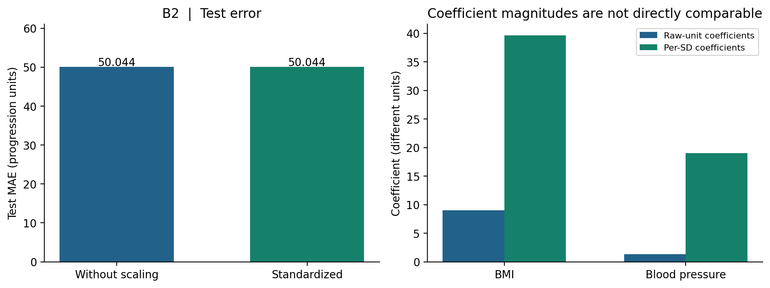
Figure 4. Baseline versus standardized OLS: identical test MAE, despite changed coefficient scales. Coefficient groups use different units and must not be compared directly.
Interpretation. The largest absolute difference between the two models’ test predictions was only 5.68e-14, attributable to floating-point precision. After standardization, the BMI coefficient represents one training-set standard deviation of BMI rather than one BMI unit; the intercept becomes the predicted score at the training feature means. Standardization matters especially to gradient-based optimization, distance-based methods, and regularized models, even though it leaves this OLS model’s predictive accuracy unchanged.

B3. Learning rate and convergence
To make learning behavior observable, batch gradient descent minimized half the training mean squared error using the same standardized diabetes features and centered training target. All runs started with zero coefficients, used 150 iterations, and differed only in learning rate (η). The exact OLS minimum of this same objective was 1773.929 training-loss units. “Within 1%” means the first iteration at which the loss is no greater than 1.01 times that minimum.
Learning rate (η) | Loss at iteration 10 | Loss at iteration 150 | First within 1% of optimum
0.01 | 2737.0 | 1802.1 | Not reached
0.10 | 1851.9 | 1773.9 | 17
0.80 | 1773.9 | 1773.9 | 2
1.50 | 8682.6 | 3.03e+14 | Diverges
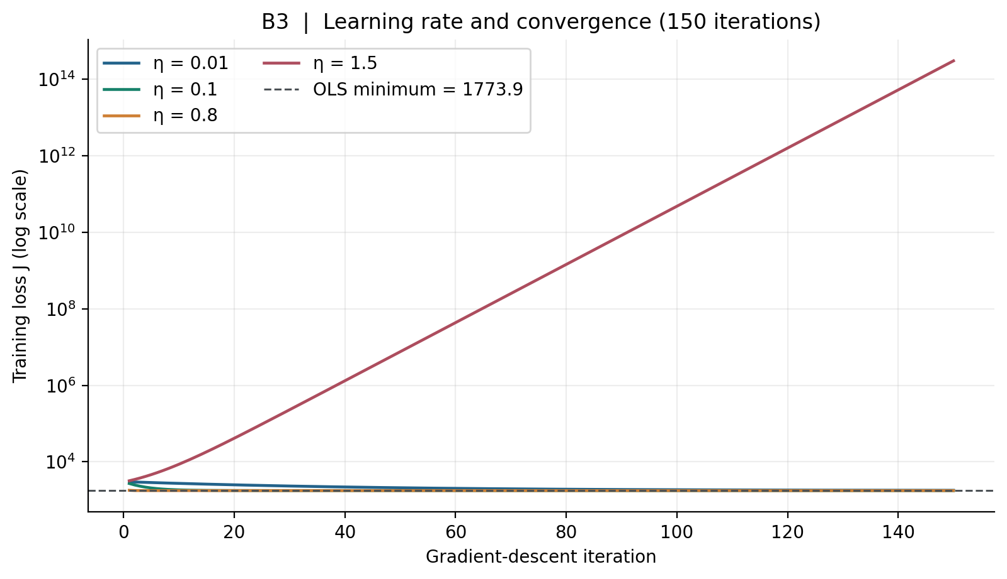
Figure 5. Training loss versus iteration for four learning rates, shown on a log scale. η = 0.80 converges rapidly; η = 1.50 diverges.
Interpretation. Among tested values, η = 0.80 was the fastest stable choice, reaching the 1% band after 2 iterations. η = 0.10 needed 17 iterations, whereas η = 0.01 remained outside the band after 150 iterations. At η = 1.50, the step size overshot repeatedly and training loss grew to about 3.03e+14. More iterations can help a stable small step, but cannot fix a divergent step. These findings apply to this standardized two-feature quadratic objective, not to every dataset.

4. Part C — Logistic Regression Experiments

C1. Model parameters and binary classification
The classifier uses a linear function of the two standardized inputs, transformed by a sigmoid function into a probability of malignancy. At threshold 0.5, probabilities at least 0.5 are labeled malignant. An L2 penalty is applied by scikit-learn with C = 1.
Parameter (standardized model) | Coefficient | Interpretation
Worst radius | +3.269 | Higher standardized radius increases predicted malignant log-odds
Worst concave points | +2.311 | Higher standardized concavity increases predicted malignant log-odds
Intercept | -0.835 | Baseline log-odds at training mean feature values

Test metric at threshold 0.5 | Result
Accuracy | 0.956 (95.61%)
Precision (malignant positive) | 0.974
Recall / sensitivity | 0.905
F1-score | 0.938
True negative / false positive | 71 / 1
False negative / true positive | 4 / 38
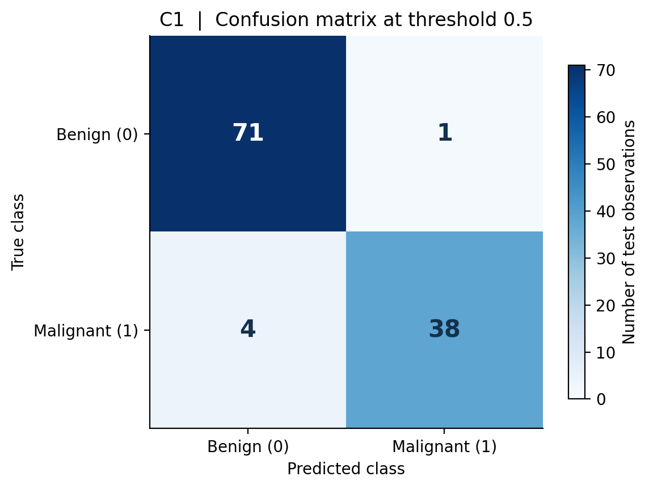
Figure 6. Confusion matrix on the 114 held-out diagnostic observations at threshold 0.5. Rows indicate actual diagnoses and columns indicate predicted classes.
Interpretation. The raw linear score is a log-odds value; the sigmoid produces a probability between 0 and 1 before thresholding. A one-training-standard-deviation increase in worst radius, with the other feature fixed, multiplies modeled odds by approximately 26.27; the analogous factor for worst concave points is 10.09. These are model associations, not causal effects. The confusion matrix shows 1 false positive (benign labeled malignant) and 4 false negatives (malignant labeled benign). Missing malignant cases is consequential in a hypothetical screening workflow, though this dataset and model must not be interpreted as a validated clinical tool.

C2. Decision-threshold experiment
The logistic model was trained once. Exactly the same held-out predicted probabilities were converted to labels using thresholds 0.3, 0.5, and 0.7; no refitting or new probability estimates were performed.
Threshold | Accuracy | Precision | Recall | F1 | FP | FN
0.3 | 0.974 | 0.933 | 1.000 | 0.966 | 3 | 0
0.5 | 0.956 | 0.974 | 0.905 | 0.938 | 1 | 4
0.7 | 0.930 | 1.000 | 0.810 | 0.895 | 0 | 8
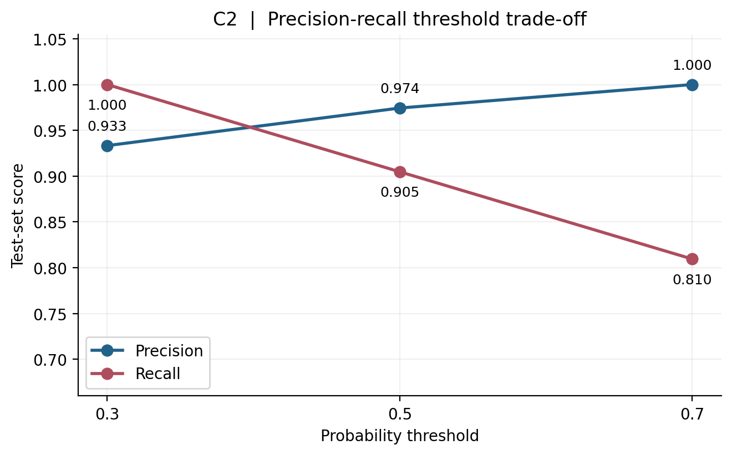
Figure 7. Precision and recall evaluated on identical test probabilities for three thresholds. A lower threshold emphasizes sensitivity; a higher threshold emphasizes precision.
Interpretation. Lowering the threshold to 0.3 classified all 42 test malignant cases correctly (zero observed false negatives), at the cost of 3 false positives. Raising it to 0.7 eliminated false positives but increased false negatives to 8. For an illustrative high-sensitivity triage setting, 0.3 is the preferred illustrative threshold among these options, because missing a positive is treated as more costly than triggering follow-up review. This is not a clinically validated choice and must not be selected for deployment from test-set results: any genuine operating threshold should be fixed on a separate validation set using explicit error costs, calibration, and prospective evaluation.

C3. One input feature versus two input features
Two logistic models used the same training/test indices and threshold 0.5: one used worst radius alone; the other included worst radius and worst concave points. A fresh train-only scaler was fitted within each model pipeline.
Test metric | One feature | Two features
Accuracy | 0.904 | 0.956
Precision | 0.943 | 0.974
Recall | 0.786 | 0.905
F1-score | 0.857 | 0.938
False negatives | 9 | 4
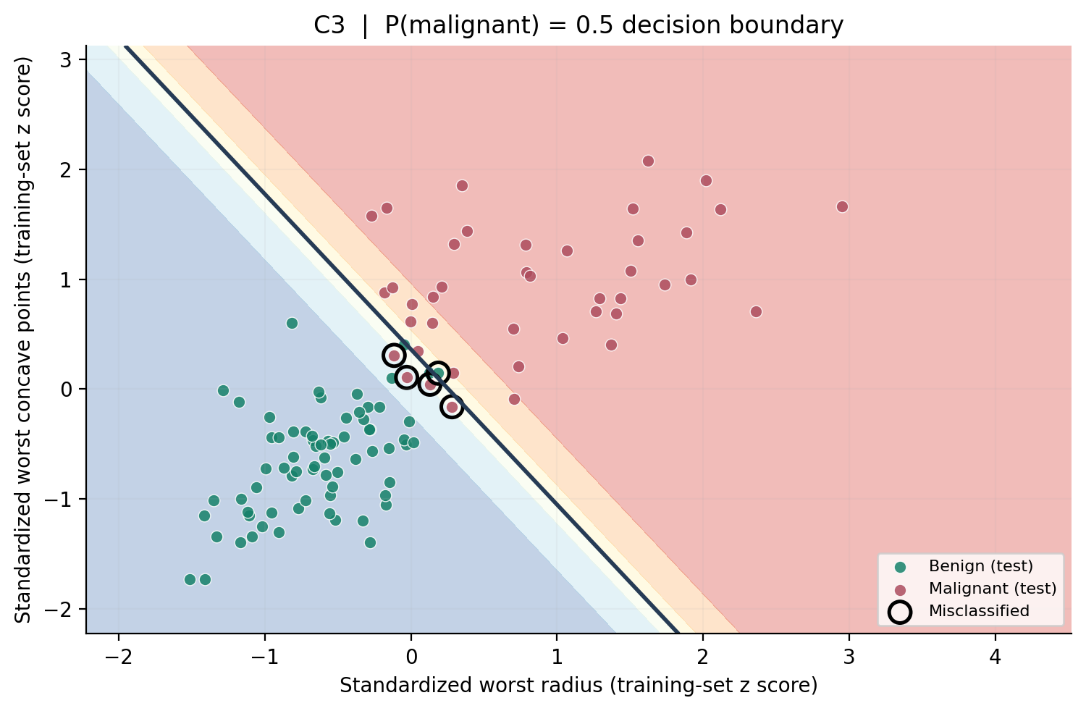
Figure 8. Two-feature logistic decision boundary (dark line at predicted probability 0.5) and held-out records in training-standardized coordinates. Black rings mark test misclassifications.
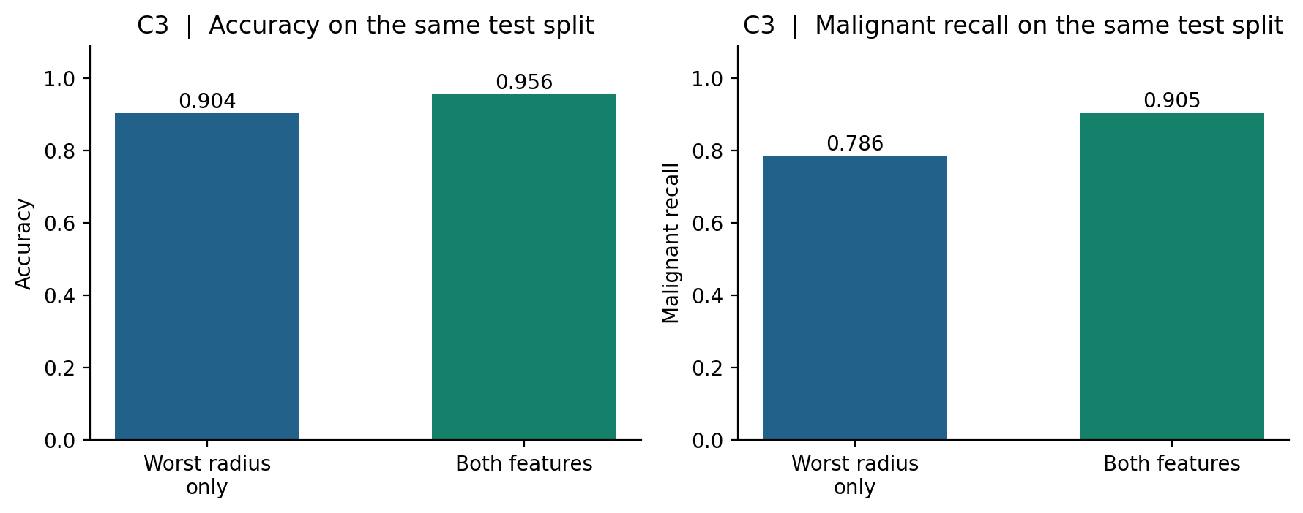
Figure 9. Classification accuracy and malignant recall using one feature versus both features on the identical held-out partition.
Interpretation. The second feature increased accuracy from 90.35% to 95.61%, while malignant recall increased from 0.786 to 0.905; false negatives decreased from 9 to 4. The decision boundary is the set of feature combinations for which the model predicts 0.5 malignant probability. In these standardized two-dimensional coordinates it is a straight line. Observations near the line and in overlapping regions are difficult to classify because small changes in measured features can flip the predicted label. Confident mistakes are also possible when the two features omit useful information.

5. Part D — Reflection and Comparison
1. What differs between the two model outputs? Linear regression generates an unrestricted continuous prediction for a numerical progression score. Logistic regression generates an estimated probability of class 1 using a sigmoid; a chosen cutoff then converts that probability to a benign/malignant decision. This difference explains why B1 reports an MAE of 50.04 progression points while C1 reports recall of 0.905 for malignant examples.
2. What is a parameter versus a hyperparameter? Parameters are learned from training data: the BMI coefficient 9.048, the unscaled regression intercept -215.053, and the standardized logistic coefficient 3.269 are examples. Hyperparameters are settings specified before fitting, such as logistic C = 1, gradient-descent learning rate η, the iteration count (150 in B3), and the classification cutoff. The cutoff changes decisions, but not the fitted logistic coefficients.
3. How does learning rate affect fitting? A low rate moves slowly (η = 0.01 did not reach the 1% training-loss band in 150 iterations), η = 0.80 reached it in two, and η = 1.50 diverged. Iteration count and rate jointly control convergence; the largest step is not always fastest in a stable sense.
4. Why use different metrics? Regression errors have a magnitude in target units, so MAE, MSE, and R² communicate numeric performance. Classification errors are discrete and often have unequal consequences. Accuracy alone hides the direction of errors; precision, recall, F1, and the confusion matrix identify the trade-off. For example, moving from threshold 0.5 to 0.7 raises malignant precision from 0.974 to 1.000 but lowers recall from 0.905 to 0.810.
5. What was unexpected? Standardizing the OLS inputs dramatically altered the numerical coefficients, while changing held-out predictions by only 5.68e-14. This is explained by OLS being invariant to invertible affine rescaling when an intercept is fitted. A second informative result is that threshold 0.3 achieved zero false negatives on this particular test partition; that result is not proof of perfect sensitivity in unseen populations.

6. Limitations and Conclusion
Limitations. The diabetes fit uses only two of ten available predictors, yielding a modest R²; omitted predictors, nonlinearity, and measurement noise may account for residual errors. The cancer comparison also uses just two of 30 features, evaluated on one stratified holdout split (114 cases). A single split provides uncertain performance estimates and the class frequencies may not reflect screening populations. The threshold comparison is explanatory, not a valid procedure for optimizing an operational cutoff on the test set. Neither exercise performs patient-level external validation, fairness assessment, probability calibration, or clinical risk analysis. No medical decision should be based on these models.
Conclusion. The experiments demonstrate that model output determines the appropriate learning objective and evaluation metrics. OLS input standardization changes parameter units but not predictions, whereas gradient descent shows strong sensitivity to step size. Logistic classifications depend on both the learned probability surface and the operating threshold. Adding a second diagnostic feature improved held-out malignant recall in this study, yet careful validation is more important than a single attractive test score.

References
[1] Efron, B., Hastie, T., Johnstone, I., & Tibshirani, R. (2004). “Least Angle Regression.” The Annals of Statistics, 32(2), 407–499. https://doi.org/10.1214/009053604000000067
[2] scikit-learn developers. (2026). “Diabetes dataset — load_diabetes.” Official documentation. https://scikit-learn.org/stable/modules/generated/sklearn.datasets.load_diabetes.html (accessed 21 October 2026).
[3] Wolberg, W., Mangasarian, O., Street, N., & Street, W. (1993). Breast Cancer Wisconsin (Diagnostic) [Data set]. UCI Machine Learning Repository. https://doi.org/10.24432/C5DW2B
[4] Street, W. N., Wolberg, W. H., & Mangasarian, O. L. (1993). “Nuclear feature extraction for breast tumor diagnosis.” Biomedical Image Processing and Biomedical Visualization, SPIE Vol. 1905, 861–870. https://doi.org/10.1117/12.148698
[5] scikit-learn developers. (2026). “Breast cancer Wisconsin dataset — load_breast_cancer.” Official documentation. https://scikit-learn.org/stable/modules/generated/sklearn.datasets.load_breast_cancer.html (accessed 21 October 2026).
[6] Pedregosa, F., et al. (2011). “Scikit-learn: Machine Learning in Python.” Journal of Machine Learning Research, 12, 2825–2830. https://jmlr.org/papers/v12/pedregosa11a.html

