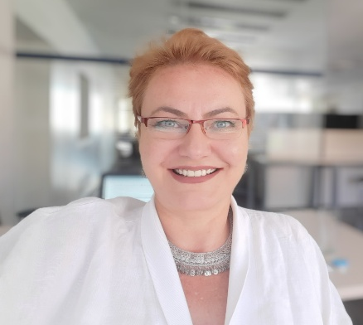

Gülçatay Can Özbayrak

Гюлчатай Местанова Назифова-Йозбайрак

Baba Nedelya NO:8 SOFIA - BULGARIA

Phone + 359 89 442 30 84

e-mail: gulcatay.mimar@gmail.com

EDUCATIONAL BACKGROUND

## 2003 - Mimar Sinan University Faculty of Architecture Sound B,C,D Master Degree

## 1999 - Mimar Sinan University Faculty of Architecture Bachelor Degree

* 1990 - Ankara Mimar Kemal Construction Technical High School

Primary Education

WORK EXPERIENCE and APPLICATIONS

Project Manager, Worksite Chief Experience

* Nokta Yatırım Holding .İstanbul

İnvestment Development And Construction Department Coordinator Work time :12.2018-02.2020

Reference:Suat SURMEN Chairman of the board

* Ağaoğlu Maslak 1453,

1 870 000m2, 3880 Residences, 1000 Offices, University, Shopping Mall, Hotel, 10 Cinema Halls, 3 Congress Halls, 32 Blocks between 11 and 51 variable floors

Project Manager, AB section

Construction Date: 10.2014 - 10.2018

Reference: Abdullah Murad ACAR General Coordinator,

Head of Construction Group

* Ağaoğlu My Home Ayazağa

260000m2, 800 Residences, 100 Offices, Markets, 3 Blocks with 41 floors

Deputy Project Manager, Decoration Works Manager

Construction Date: 05.2013 - 10.2014

Reference: Adem Yıldırım Project Manager

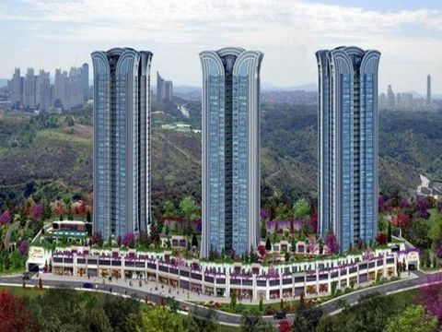

* Dünya Göz Hospital Istanbul Pendik

2500m2 Construction Zone

Project Manager

Construction Date: 04.2012 - 05.2013

Reference: Enver Küçükali (Serpent Architecture)

* Dünya Göz Hospital Samsun

2500m2 Construciton Zone

Project Manager

Construciton Date: 02.2011 - 06.2011

Referans: Enver Küçükali (Serpent Architecture)

* WOW Congress Center Istanbul

15000m2 Construction Zone

Site Chief

Construction Date: 06.2011 - 04.2012

Reference: Muzaffer Kupe

* Çebitaş Business Center

19000m2 Construction Zone

Project Manager

Construction Date: 10.2009 - 02.2011

Reference: Enver Küçükali (Serpent Architecture)

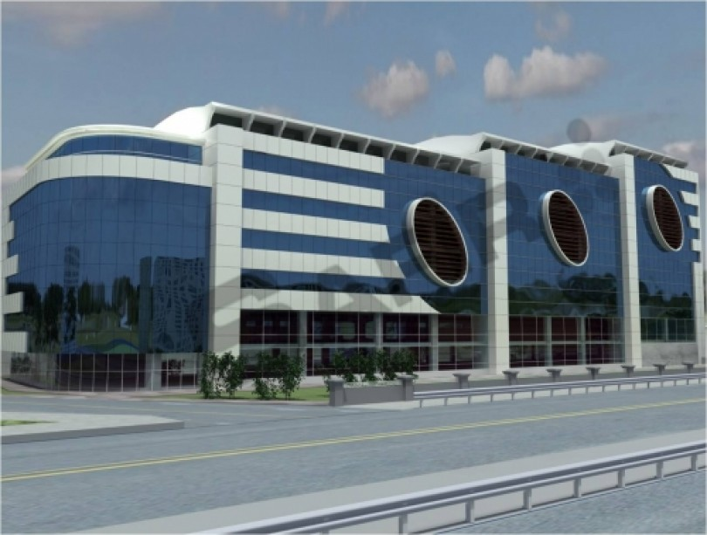

* Arıkan Structure Park City Residence

385 Houses 100 000m2

Deputy Project Manager, Decoration Works Manager

Construction Date: 05.2007 - 11.2009

Reference: Osman Arıkan (Arıkan Structure)

Levent Kaya (General Coordinator)

* HAVAŞ Antalya Mechanical Workshop Building Application

Site Chief

Construction Date: 01.2007 - 05.2007

Reference: Muzaffer Kupe (General Coordinator)

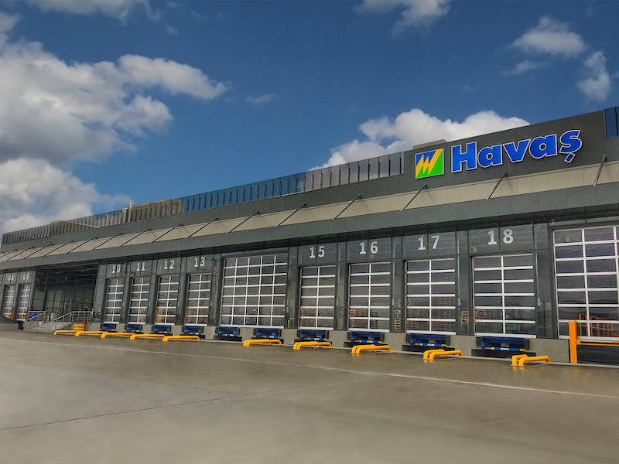

* Önka Textile Factory Construction

20000m2 Construction Zone

Site Chief

Construction Date: 06.2004 - 08.2005

Reference: Abdul Kerim Önecek (Önka Textile)

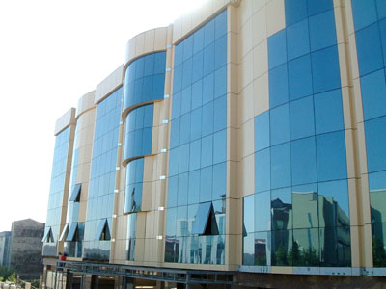

* Ar-El Educational Institutions 35000 m2

Site Chief

Construction Date: 03.2002 - 04.2004

Reference: Kemal Gözükara(Ar-El Educational Institutions)

Decoration and Renovation Works – Employer

Between the years 2005-2007, Applications made from Pim Architecture

Reference: Murat Onur Company Partner - 0549 726 21 17

* Halk Bank Esenyurt and Çatalca Branch Offices
* Faruk Eczacıbaşı Galata Office Acoustic Project and application
* Faruk Eczacıbaşı Canyon Office Acoustic Project and application
* Fazıl Özen’s Summer House Celaliye
* Beyoğlu DIESEL
* Meis bar Beyoğlu
* Fatih Center of Culture finishing works 15000m2
* Yaşar Küçükali’s House Fenerbahçe
* Fatih Çebi’s House Ataşehir
* Dental Hospital – Bursa

Sound Acoustic Projects - Consultansy Design

* Bağcılar Sports Center Ambient Sound Control application
* Bağcılar Sports Center Generator Sound Loss of Transition application
* Channel 7 Studios Ambient Sound Control application
* City Theaters Muhsin Ertuğrul’s Sound Recording Studio
* AFM Cinemas Ambient Sound Control application and Sound Acoustic Arrangement
* Balmumcu Assan Generator Sound Loss of Transition application
* West Collage Conference Hall Acoustic Arrangement
* Do RE Mi Factory – Office part Sound Loss of Transition application
* Tuzla Center of Culture Theater and Cinema
* Fatih Center of Culture finishing works 15000m2
* Channel Türk Studios Acoustic Arrangement
* Erzurum Cinema TV Sound Loss of Transition application

SEMINARS and COURSES

* 2006 - 2007 Sto Term Germany

-Acouistic and Heat Isolation course

* 2000 - Izocam Isolation and Education Center IYEM

- Sound B : Noice Control Manager: Prof.Dr. H. Nevzat Özgüven

- Sound C : Archtitectural Acoustic Manager: Prof.Dr. Mehmet Çalışkan

- Sound D : Applied Sound Isolation Manager: Korhan Işıkel

* 1999 - Istanbul Architectures Room - ACAD course

Languages

* **English [x] [x] [x] [ ] [ ]**
* **Russian [x] [x] [x] [x] [ ]**
* **Bulgarian [x] [x] [x] [x] [x]**

Personal

* MS Office Programs and ACAD user
* Birth Date: 22.02.1972 Bulgaria
* Driving Licence: B class