EX-1
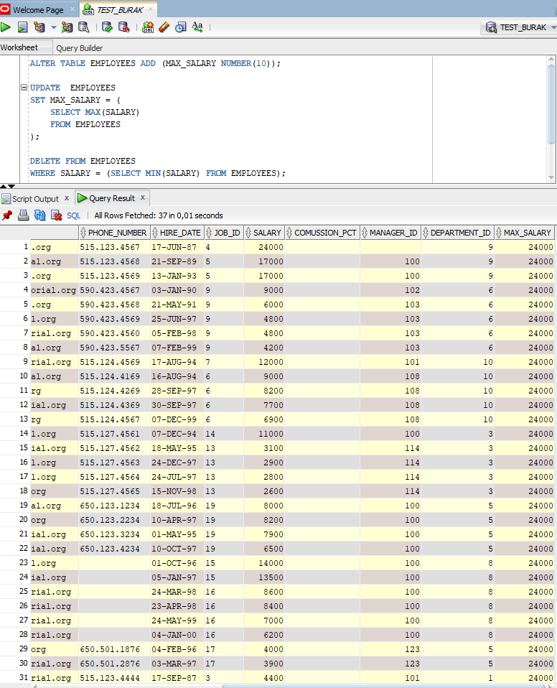
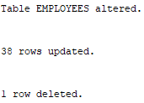

EX-2
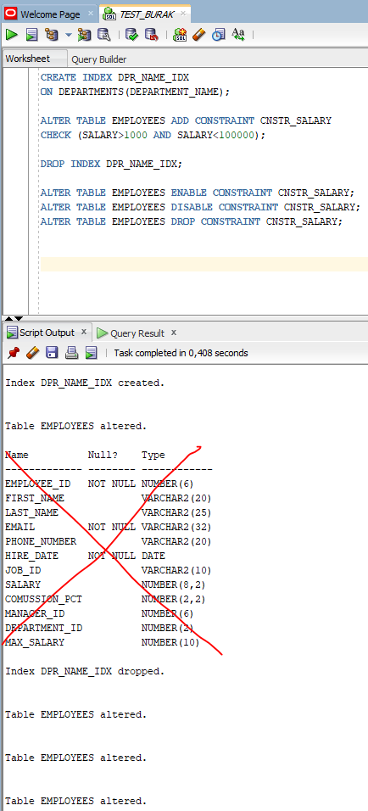

EX-3
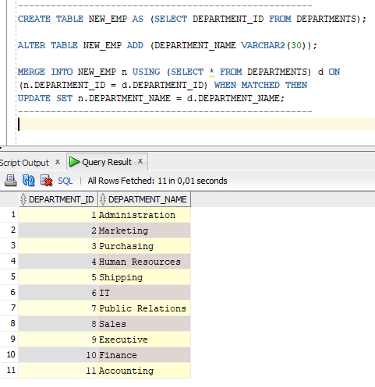

EX-4
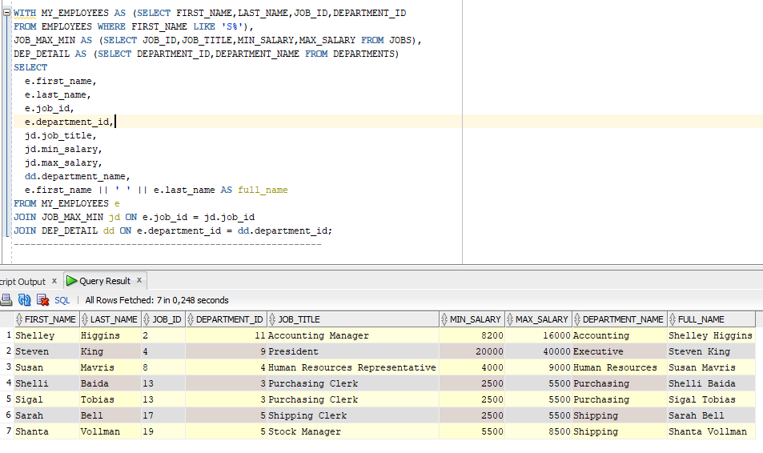

EX-5
COMMIT
It irreversibly deletes the deleted data from the database. Permanently writes updated data to the database.
ROLLBACK
Invalidates deletion and update operations.
NOT: DDL KOMUTLARI DML KOMUTLARINI OTOMATİK COMMIT EDER.

