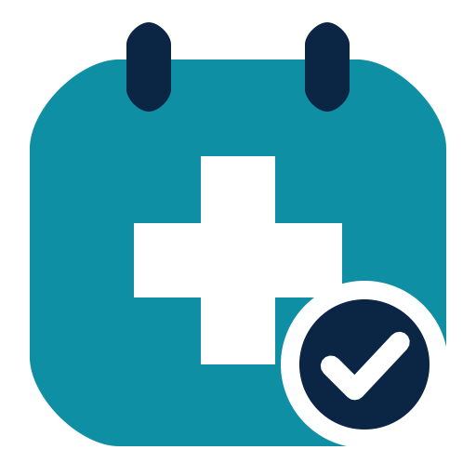
HALİÇ UNIVERSITY
Faculty of Engineering
Department of Software Engineering

SEN4100 – Software Project Management
Team Project: Clinic Appointment System (CAS)

2.4 Risk Register
Milestone 2 (Week 7)

Name | Student No | Role
Burak Demir | 20091000008 | Project Manager, Backend
Davut Ayfer | 20091000054 | Database, Doctor module
Enes Küçükkaya | 22091000275 | UI, Patient module, Dashboard
Alper Keskin | 24352525053 | Testing, Documentation

Instructor: Asst. Prof. M. Fatih Mintaş
Version / Date: 1.0 / 13 November 2026

Contents
1. Purpose
2. Risk categories (taxonomy)
3. How we score risks
4. Response strategies
5. Probability-Impact matrix
6. Risk Register
Summary
7. Risk vs issue
8. Monitoring

1. Purpose
Our schedule (documents 2.2 and 2.3) is only a plan. Many things can go wrong. Risk management means we find these possible problems early and decide what to do about them before they happen.
A risk is an uncertain future event. If it happens, it has an effect on the project (time, cost, scope or quality).

2. Risk categories (taxonomy)
A risk taxonomy is a list of risk groups. It helps us look for risks in every area. We use the four groups from the lecture:
Category | Meaning | Example in CAS
Technical | Problems with technology, code, tools or quality | Double booking bug, LocalDB setup fails
Project Management | Problems with estimates, schedule, scope or resources | Effort is underestimated, scope creep
Organizational | Problems inside the team or organization | A member is not available, poor communication
External | Problems from outside the project (laws, vendors) | Health data privacy law (KVKK)

3. How we score risks
For every risk we give two numbers:
- P (Probability): how likely the risk is to happen, from 0.1 (very unlikely) to 0.9 (very likely).
- I (Impact): how bad the effect is if it happens, from 1 (very small) to 5 (very large).
Then we calculate the Risk Exposure:
RE = P x I
Example: R1 has P = 0.7 and I = 3, so RE = 0.7 x 3 = 2.1.
We put each risk into a zone:
Zone | RE | What we do
Red | RE >= 2.0 | Critical. Immediate, strong action plan.
Yellow | 1.0 <= RE < 2.0 | Monitored. We set a trigger and watch it.
Green | RE < 1.0 | Accepted. Kept on a watch list with little active work.

4. Response strategies
For each risk we choose one strategy:
- Mitigate: act now to lower the probability or the impact.
- Avoid: change the plan so the risk cannot happen.
- Transfer: move the impact to a third party (for example insurance or an outside service).
- Accept: do nothing now, because action costs more than the impact. We keep a reserve (our 56 h management reserve) for it.
A trigger is an early warning sign that the risk is starting to happen. The risk owner is the team member who watches the trigger and starts the action.

5. Probability-Impact matrix
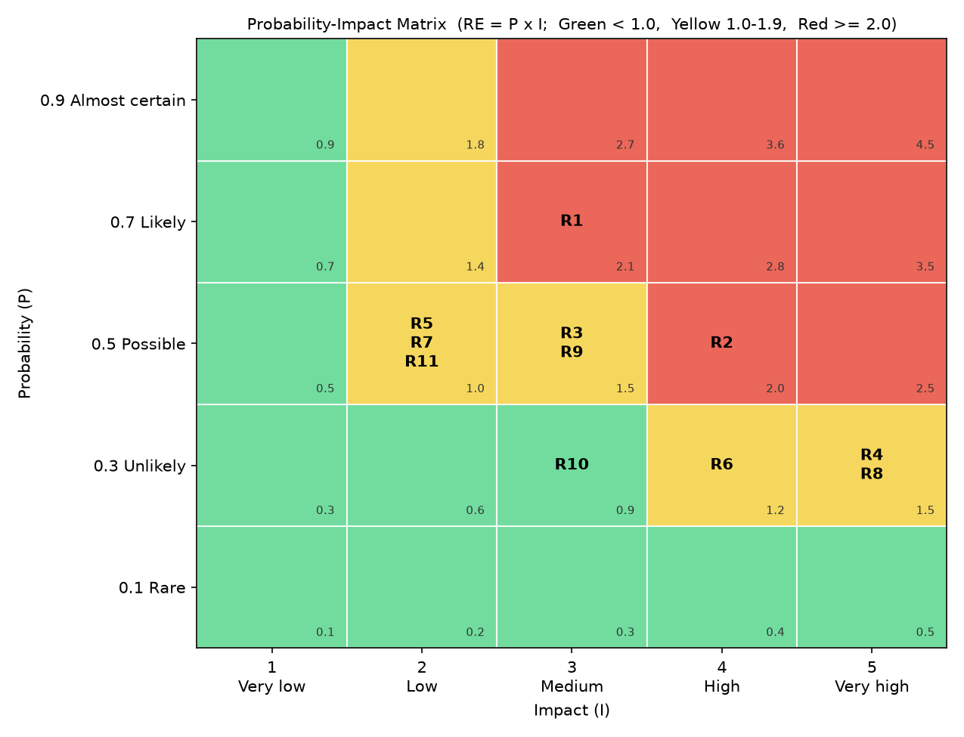
Risk matrix

6. Risk Register
The register is sorted by Risk Exposure (highest first). The description uses the form cause -> risk -> effect.
ID | Description (cause -> risk -> effect) | Category | P | I | RE | Zone | Strategy | Action | Trigger | Owner
R1 | Exams, illness or other courses -> a team member is not available for some days -> his work packages are late and the critical path moves. | Organizational | 0.7 | 3 | 2.1 | Red | Mitigate | Shared exam calendar; each module has a second person who knows it (pair reviews in pull requests); code and notes always pushed to GitHub. | A member reports less than 6 h of work in a week, or misses two meetings. | Burak Demir
R2 | The instructor or users ask for new or different features after the scope is approved -> requirements change late -> rework and delay of the booking module and tests. | Project Management | 0.5 | 4 | 2.0 | Red | Mitigate | Scope baseline from M1; every change goes through the Change Control Board with an impact check (hours, days); show demos early so feedback comes early. | A change request arrives after Week 7, or a demo gets major comments. | Burak Demir
R3 | We are students with little estimation experience -> effort is underestimated -> work takes more hours than the 560 h plan and we pass the deadline. | Project Management | 0.5 | 3 | 1.5 | Yellow | Mitigate | Three estimation methods compared (WBS, FP + COCOMO, LOC); 10% management reserve (56 h); weekly tracking of actual hours; EVM in Milestone 3. | Actual hours of an activity are more than 10% above its plan, or SPI < 0.95. | Burak Demir
R4 | Complex booking rules and two users booking at the same time -> a double booking bug in scheduling -> two patients get the same doctor slot; trust in the system is lost. | Technical | 0.3 | 5 | 1.5 | Yellow | Mitigate | Check in the code AND filtered UNIQUE indexes in SQL Server; unit tests for every booking rule; separate bugfix/double-booking-index branch. | A test or a user shows two BOOKED appointments for the same doctor or patient at the same time. | Burak Demir
R8 | The system stores names and TC Kimlik No of patients -> a personal health data privacy (KVKK) issue -> legal problem and loss of grade or trust. | External | 0.3 | 5 | 1.5 | Yellow | Avoid | Use only fake test data (seed.sql), never real patient data; database stays on local machines (LocalDB); no data in GitHub except test data. | Someone wants to load real patient data, or real personal data is found in the repo. | Davut Ayfer
R9 | Team members like to add "nice" extras -> scope creep (extra features) -> hours are used for things not in the WBS and core work is late. | Project Management | 0.5 | 3 | 1.5 | Yellow | Avoid | Only WBS work is done; new ideas go to a "future work" list; no feature branch without a WBS code. | A pull request contains a feature that is not in the WBS or SRS. | Burak Demir
R6 | No regular backup of the local database -> data loss (no database backup) -> test data and work are lost and must be rebuilt. | Technical | 0.3 | 4 | 1.2 | Yellow | Mitigate | The whole database can be rebuilt from create_database.sql, schema.sql and seed.sql in Git; tests use a separate database ClinicAppointmentDB_Test. | A script change is not committed, or a laptop or disk problem is reported. | Davut Ayfer
R5 | Most of the team has not used Flask and pyodbc before -> low experience with Flask / pyodbc -> slow progress in the first modules. | Technical | 0.5 | 2 | 1.0 | Yellow | Mitigate | Short learning spike in Week 4-5 (small sample app); shared code examples for routes and database access; pair programming on the first module. | A member is blocked on a framework problem for more than one day. | Enes Küçükkaya
R7 | Four people change the same files at the same time -> merge conflicts in Git -> lost time and broken code in develop. | Technical | 0.5 | 2 | 1.0 | Yellow | Mitigate | GitFlow-light: one feature branch per module, small pull requests, pull develop often, --no-ff merges with review. | A merge conflict takes more than one hour, or develop does not run after a merge. | Alper Keskin
R11 | Different Windows versions and drivers on student laptops -> SQL Server LocalDB setup fails on a laptop -> that member cannot run or test the app. | Technical | 0.5 | 2 | 1.0 | Yellow | Mitigate | Written setup guide (LocalDB + ODBC driver); one setup session for all members; a member can use a teammate's machine while it is fixed. | The app cannot connect to (localdb)\MSSQLLocalDB on a member's laptop. | Davut Ayfer
R10 | Busy schedules and only online contact -> poor communication in team -> duplicate work or missed tasks. | Organizational | 0.3 | 3 | 0.9 | Green | Accept | Keep normal practice: weekly meeting, group chat, task list on GitHub. No extra action needed. | A task is done twice, or nobody knows who owns a task. | Burak Demir

Summary
Zone | Risks | Count
Red | R1, R2 | 2
Yellow | R3, R4, R8, R9, R6, R5, R7, R11 | 8
Green | R10 | 1
Total |  | 11

- The two red risks (R1, R2) are about people and scope, not technology. The PM reviews them every week.
- R4 and R8 have the highest impact (5). Even if they are not likely, they would hurt the project badly, so they have strong actions.
- Why no Transfer? In a student project there is no insurance or outside company that can take over the impact. The closest thing is that GitHub keeps a copy of our code and scripts, but the risk itself stays with us. So we use Mitigate, Avoid and Accept.

7. Risk vs issue
A risk has not happened yet. It has a probability, and we plan for it. An issue is a problem that has already happened. It needs action now, not probability analysis.
Example: "A team member may be ill during exam week" is a risk (R1). "Enes is ill today and cannot work this week" is an issue. When a risk trigger fires and the event happens, the owner moves it to the issue log, and the PM solves it at once (for example, by moving work to the backup person or using reserve hours).

8. Monitoring
- The register is reviewed in the weekly team meeting.
- Each owner checks his triggers and reports changes in P or I.
- New risks are added; closed risks are marked as closed (not deleted).
- In Milestone 3 we will report which risks happened and how well our responses worked.

