Before you starting you must know the basic of JAVA. I am making this App by using Swing Component.

Open NerBeans IDE => Create new Project.

If you use another IDE, do not worry the program logic will be the same. So here is creating it.

File=>New Project=>categories(java) & Projects(Java Application) => Click next => Project Name(calculator_ap)=>Click finish

Now we will create new jFrame from for using Swing Components. It will help to create GUI(Graphical User Interface) Apps.

Under the Source code you will right click to calculator_app => new =>jFrame Forms =>Class Name(calculator) and we will delete first java file(calculator_ap) because we will not need it.

If swing components window does not come automatically then search “palette” right side of the top and select “Properties(window)”. Before you start just click run to make sure if you have it. Lets begin.

From “properties” give a “title” as “Calculator”. From “other properties” change “type” as “UTILITY”. Its sizing for for now and to uncheck resize the Project go to “properties” again and delete the tic from “resizable”. Now we will set “locatıon” as X = 500 & Y = 250.

Now we select ”Text Field” from the “Swing Controls” and move to the calculator and arrange it “245x45”. From “properties” click to “font” => font style (Bold) & size(23). After that click on “horizontal alignment” => “RIGHT” and “editable” mark off. click to “text” delete “jTextField1”.

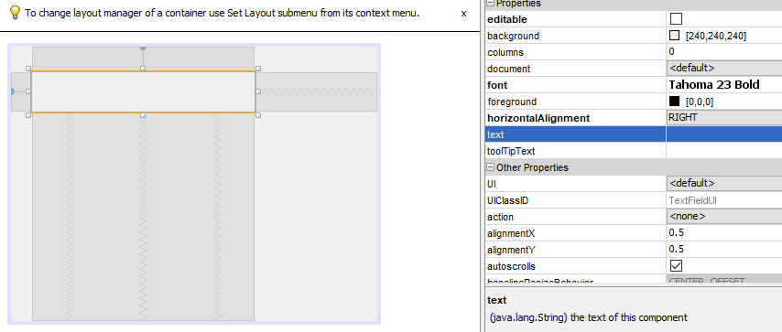

This should be your screen so far.

Now we select “Radio Button” from “Swing Controls” two times right under the Text Field. From “properties” click text(ON) and click “font” => font style (Bold) & size(11) for “jRadioButton1” and for “jRadio button2” again from “properties” click text(OFF) and click “font” => font style (Bold) & size(11) . Select “Button” from “Swing Controls” and move it next to the “ON” button the size it “60x30”. From the “properties” “text” it as “<-- ” and “font” => font style (Bold) & size(14). Again select “Button” from “Swing Controls” to move it next to the “<--” the size it “55x30”. From the “properties” “text” it as “C ” for clear and “font” => font style (Bold) & size(20). Now copy the last one for 16 times and style will be the. First one will be “+” next to the “C” other 15 buttons should be ordered as;

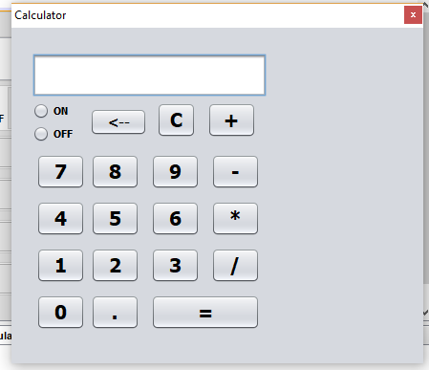

If you click “ON” and “OFF” buttons, these are both checks but we need either “ON” or “OFF”. Select “Button Group” from “Swing Controls” and put anywhere on the calculator. Now click “ON” and select “button Group” from “properties” from “none” to “buttonGroup1”. Do the same thing for “OFF”.

