EE 1004 & CSE 2062
OBJECT-ORIENTED PROGRAMMING
Spring 2025–2026

PROJECT REPORT
Group 6
 | Name-Surname | Student ID | Contribution Details
A | Burak EFE | 150723843 | Code Development, GUI and Project Report
B | Furkan Karaca | 150721065 | Code Development, GUI and Project Report
C | Sıla Ilgıt Kılınç | 150721037 | Revising the Project Report, Code Development
D | Esad Özer | 150724018 | Revising the Project Report, Code Development
E | Baran ÇELİK | 150721054 | Revising the Project Report, Code Development

Table Of Contents
1-LibraryItem (Abstract Base Class) & Subclasses (Book, Magazine, DVD) ............................. 2
1.1 Brief explanation of the problem .......................................................................................... 3
1.2 UML Diagram ...................................................................................................................... 3
Figure 1: UML diagram of the LibraryItem inheritance hierarchy .............................................. 3
1.3 Data field definition list........................................................................................................ 3
Table 1: Data field definition list ............................................................................................. 4
1.4 Object definition list ............................................................................................................ 4
Table 2: Object definition list ................................................................................................. 4
1.5 Method definition list .......................................................................................................... 4
Table 3: Method definition list ............................................................................................... 5
1.6 Class definition list............................................................................................................... 5
Table 4: Class definition list .................................................................................................... 5
1.7 OOP Concepts ..................................................................................................................... 5
1.8 Screenshots of the sequence................................................................................................ 6
Figure 2: Screenshots of the sequence .................................................................................... 6
1.9 Extra features...................................................................................................................... 6
2- Library Class (Aggregator Class) ...................................................... 7
2.1 Brief explanation of the problem .......................................................................................... 7
2.2 UML Diagram ...................................................................................................................... 7
Figure 3: UML Diagram .......................................................................................................... 7
2.3 Data field definition list........................................................................................................ 7
Table 5: Data field definition list ............................................................................................. 7
2.4 Object definition list ............................................................................................................ 8
Table 6: Object definition list ................................................................................................. 8
2.5 Method definition list .......................................................................................................... 8
Table 7: Method definition list ............................................................................................... 8
2.6 Class definition list............................................................................................................... 8
Table 8: Class definition list .................................................................................................... 9
2.7 OOP Concepts ..................................................................................................................... 9
2.8 Screenshots of the sequence................................................................................................ 9
Figure 4: Screenshots of the sequence ................................................................................... 9
2.9 Extra features...................................................................................................................... 9
3-Main Class (Console Driver / User Interface) ................................................. 10
3.1 Brief explanation of the problem ........................................................................................ 11
3.2 UML Diagram .................................................................................................................... 11 Figure 5: Screenshots of the sequence .................................................................................. 11
3.3 Data field definition list...................................................................................................... 11
Table 9: Data field definition list ........................................................................................... 11
3.4 Object definition list .......................................................................................................... 11
Table 10: Object definition list.............................................................................................. 12
3.5 Method definition list ........................................................................................................ 12
Table 11: Method definition list ........................................................................................... 12
3.6 Class definition list............................................................................................................. 12
Table 12: Class definition list ................................................................................................ 12
3.7 OOP Concepts ................................................................................................................... 12
3.8 Screenshots of the sequence.............................................................................................. 12
Figure 6: Screenshots of the sequence ................................................................................. 13
3.9 Extra features.................................................................................................................... 13
4-Error Handling (Defensive Programming & Logical Guards) ............................................13
4.1 Brief explanation of the problem ........................................................................................ 14
4.2 UML Diagram .................................................................................................................... 14
Figure 7: UML Diagram ........................................................................................................ 14
4.3 Data field definition list...................................................................................................... 14
Table 13: Data field definition list ......................................................................................... 14
4.4 Object definition list .......................................................................................................... 15
Table 14: Object definition list.............................................................................................. 15
4.5 Method definition list ........................................................................................................15
Table 15: Method definition list ...........................................................................................15
4.6 Class definition list............................................................................................................. 15
Table 16: Class definition list ................................................................................................ 15
4.7 OOP Concepts ................................................................................................................... 15
4.8 Screenshots of the sequence.............................................................................................. 16
Figure 8: Decision Tree of Error Message .............................................................................. 16
4.9 Extra features....................................................................................................................16
5-LibraryGUI (Bonus Swing GUI Application) ........................................................................ 16
5.1 Brief explanation of the problem ........................................................................................ 17
5.2 UML Diagram .................................................................................................................... 17
Figure 9: UML Diagram ........................................................................................................ 17
5.3 Data field definition list...................................................................................................... 17
Table 17: Data field definition list ......................................................................................... 18
5.4 Object definition list .......................................................................................................... 18
Table 18: Object definition list.............................................................................................. 18
5.5 Method definition list ........................................................................................................ 18 Table 19: Method definition list ........................................................................................... 19
5.6 Class definition list............................................................................................................. 19
Table 20: Class definition list ................................................................................................ 19
5.7 OOP Concepts ................................................................................................................... 19
5.8 Screenshots of the sequence.............................................................................................. 20
Figure 10............................................................................................................................. 20
: Screenshots of the sequence of GUI Window ...................................................................... 20
5.9 Extra features.................................................................................................................... 20
References ................................................................................................................................. 20

1-LibraryItem (Abstract Base Class) & Subclasses (Book, Magazine, DVD)

1.1 Brief explanation of the problem
This part introduces the foundation of the Library Management System: an abstract base class LibraryItem that captures the four data fields and the two state-transition methods common to every library item, plus three concrete subclasses (Book, Magazine, DVD) that supply their own maximum-loan period and display tag. Abstraction and inheritance are the focus.
Each subclass exposes exactly the figure that differs between item types — 21 days for Book, 7 days for Magazine, 3 days for DVD — via an overridden getMaxLoanDays() method. The values are declared as private static final constants on the subclass, not as bare literals inside method bodies.

1.2 UML Diagram
The class hierarchy below shows LibraryItem as the abstract parent at the top, with the three concrete subclasses inheriting from it.
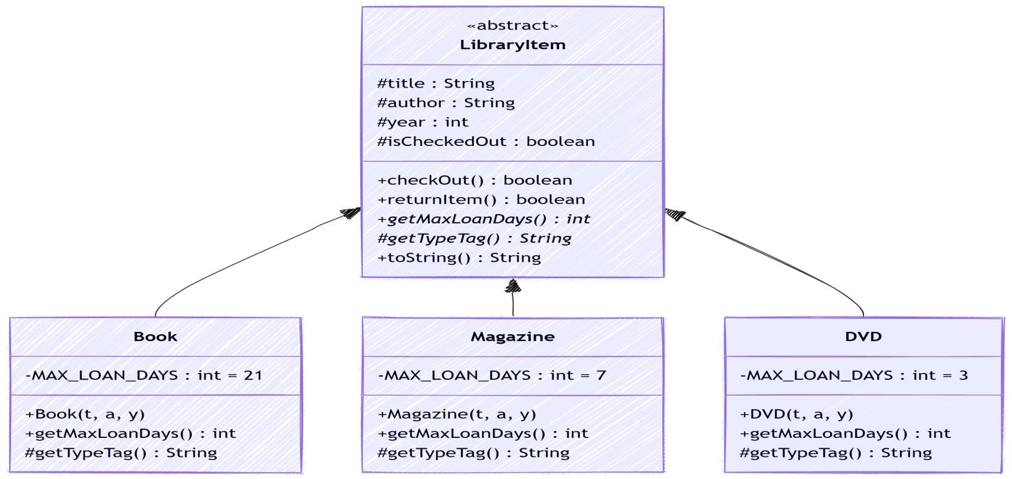
Figure 1: UML diagram of the LibraryItem inheritance hierarchy

1.3 Data field definition list
All data fields are declared protected on the parent (so subclasses can read them) or private static final on each subclass (for the per-type loan-period constants).
# | Modifier | Type | Name | Comment
1 | protected | String | title | The display title of the library item.
2 | protected | String | author | The author or creator/publisher of the item.
3 | protected | int | year | Publication or release year
# | Modifier | Type | Name | Comment
4 | protected | boolean | isCheckedOut | Loan state; defaults to false (available)
5 | private static final | int | MAX_LOAN_DAYS | On Book: 21. Encapsulates the loanperiod constant
6 | private static final | int | MAX_LOAN_DAYS | On Magazine: 7
7 | private static final | int | MAX_LOAN_DAYS | On DVD: 3
Table 1: Data field definition list

1.4 Object definition list
Each concrete subclass has a single constructor that forwards to the LibraryItem constructor via super(...). LibraryItem itself has one protected-style constructor reachable only through super calls.
# | Name | Args | Comment
1 | LibraryItem | String title, String author, int year | Base constructor; initialises the three metadata fields and leaves isCheckedOut as false.
2 | Book | String title, String author, int year | Forwards to super; no extra logic.
3 | Magazine | String title, String author, int year | Forwards to super; no extra logic.
4 | DVD | String title, String author, int year | Forwards to super; no extra logic.
Table 2: Object definition list

1.5 Method definition list
The two abstract methods (getMaxLoanDays, getTypeTag) form the contract every subclass must honour. checkOut/returnItem are concrete because their logic is identical across all subclasses — only the boolean flag changes. toString uses the polymorphic abstract methods to render correctly for every item type.
# | Modifier | Return Type | Name | Args | Comment
1 | public abstract | int | getMaxLoanDays | () | Abstract contract — each subclass returns its own  MAX_LOAN_DAYS.
2 | protected  abstract | String | getTypeTag | () | Abstract contract — returns the display tag such as [Book].
3 | public | boolean | checkOut | () | Guarded transition; returns false if already out, true on success.
# | Modifier | Return Type | Name | Args | Comment
4 | public | boolean | returnItem | () | Guarded transition; returns false if not out, true on success.
5 | public  @Override | String | toString | () | Polymorphic — uses getTypeTag() and  getMaxLoanDays() at runtime.
6 | public | String | getTitle | () | Getter for the title field.
7 | public | String | getAuthor | () | Getter for the author field.
8 | public | int | getYear | () | Getter for the year field.
9 | public | boolean | isCheckedOut | () | Getter for the loan state flag.
10 | public  @Override | int | getMaxLoanDays | () | Overridden on Book / Magazine / DVD; returns 21  / 7 / 3.
11 | protected  @Override | String | getTypeTag | () | Overridden on Book /  Magazine / DVD; returns  [Book] / [Magazine] /  [DVD].
Table 3: Method definition list

1.6 Class definition list
Four classes in this part: one abstract base and three concrete subclasses.
# | Modifier | Name | Abstract? | Extends what? | Comment
1 | public abstract | LibraryItem | Yes | — | Base class — shared state and behaviour for all items.
2 | public | Book | No | LibraryItem | Book item with a 21-day maximum loan.
3 | public | Magazine | No | LibraryItem | Magazine item with a 7day maximum loan.
4 | public | DVD | No | LibraryItem | DVD item with a 3-day maximum loan.
Table 4: Class definition list

1.7 OOP Concepts
Abstraction is applied by declaring LibraryItem with the abstract keyword: it cannot be instantiated directly, only extended. The abstract methods getMaxLoanDays() and getTypeTag() force every subclass to commit to a concrete value while saying nothing about how the value is produced.
Inheritance is applied via the extends keyword on each concrete subclass. The three subclasses inherit all four fields and all six concrete methods of LibraryItem; they add only the values that differ (the loan-period constant and the type-tag string).
Polymorphism is applied through the @Override annotation on getMaxLoanDays() and getTypeTag(). At runtime, calls such as item.toString() — which internally calls getMaxLoanDays() and getTypeTag() — dispatch to the correct subclass's implementation without any instanceof check.
Encapsulation is applied by keeping fields protected (accessible to subclasses) rather than public, and by exposing controlled state transitions (checkOut, returnItem) as the only way to change isCheckedOut from outside the class.

1.8 Screenshots of the sequence
When the program runs, every item — regardless of its concrete subclass — is printed through the same toString() call. The polymorphic dispatch produces a different prefix tag and a different Max Loan figure for each type:

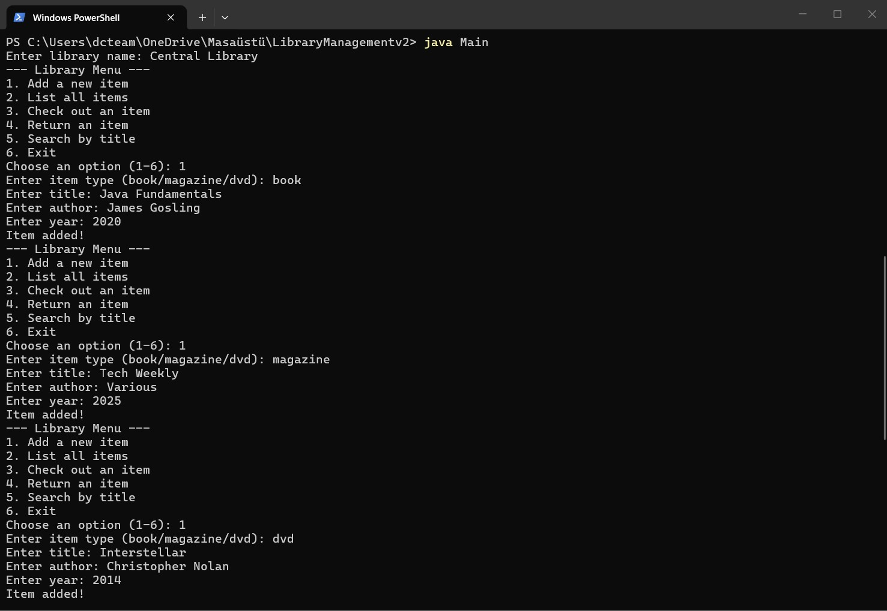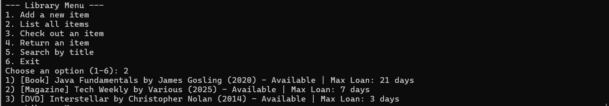
Figure 2: Screenshots of the sequence .

1.9 Extra features
- Every loan-period figure is declared as a private static final constant on the subclass. No magic numbers appear anywhere in the code.
- Boolean-returning state transitions (checkOut / returnItem) enable the aggregator to react to misuse with a friendly message instead of catching an exception.
- The display tag is delivered via a protected abstract method (getTypeTag), keeping the toString() implementation in the parent class without leaking subclass knowledge.

2-Library Class (Aggregator Class)

2.1 Brief explanation of the problem
This part adds the aggregator class Library, which owns a List<LibraryItem> and exposes the five user-facing operations specified by the brief: add an item, check out an item by title, return an item by title, search by keyword, and list everything.
Encapsulation and aggregation are the focus. The list is declared with the abstract base type so that polymorphism does all subtype-dependent work; no instanceof check appears anywhere in this class.

2.2 UML Diagram
The Library class has a List<LibraryItem> field — an aggregation relationship denoted by the open diamond at the Library side of the connector.
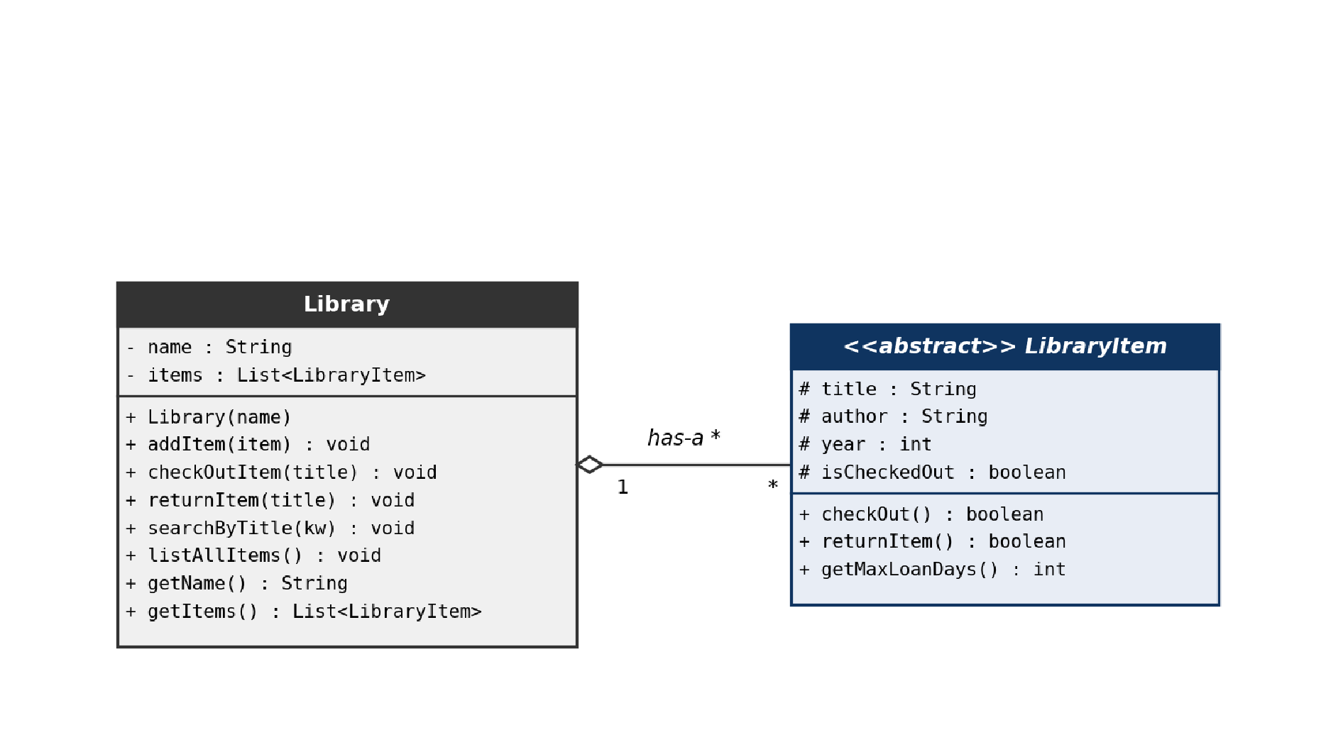
Figure 3: UML Diagram

2.3 Data field definition list
Both fields are private; access goes through methods only.
# | Modifier | Type | Name | Comment
1 | private | String | name | Display name of the library.
2 | private | List<LibraryItem> | items | The aggregated collection of items, initialised to a new ArrayList.
Table 5: Data field definition list

2.4 Object definition list
Library has a single constructor that takes the library name. The items list is initialised inline at the field declaration.
# | Name | Args | Comment
1 | Library | String name | Creates a new, empty Library with the given name. The items list is initialised to an empty ArrayList.
Table 6: Object definition list

2.5 Method definition list
Five operations match the project brief verbatim, plus two getters. Every method that mutates state delegates to the relevant LibraryItem method rather than touching its fields directly.
# | Modifier | Return Type | Name | Args | Comment
1 | public | void | addItem | LibraryItem item | Appends item to the list, prints "Item added!".
2 | public | void | checkOutItem | String title | Linear search by title  (equalsIgnoreCase); delegates to item.checkOut().
3 | public | void | returnItem | String title | Linear search by title; delegates to item.returnItem().
4 | public | void | searchByTitle | String  keyword | Substring search with toLowerCase() + contains().
5 | public | void | listAllItems | () | Prints every item polymorphically via toString().
6 | public | String | getName | () | Getter for the library name.
7 | public | List<LibraryItem> | getItems | () | Getter for the items list  (used by the bonus GUI in Part 5).
Table 7: Method definition list

2.6 Class definition list Only one class in this part.
# | Modifier | Name | Abstract? | Extends what? | Comment
1 | public | Library | No | — | Aggregator that owns and manipulates a  List<LibraryItem>.
Table 8: Class definition list

2.7 OOP Concepts
Encapsulation is applied by declaring both fields private and exposing them only through controlled methods. Callers cannot append to items directly; they must go through addItem.
Aggregation ("has-a") is applied through the List<LibraryItem> field. Library does not extend LibraryItem; it owns a collection of them, which is the textbook definition of aggregation.
Polymorphism is applied in every loop over items. The static type is LibraryItem; the runtime type is Book, Magazine, or DVD. The same loop body works for all three because every call goes through the abstract methods declared on the base class.
Delegation is applied in checkOutItem and returnItem. The Library does not flip the isCheckedOut flag itself — it calls item.checkOut() or item.returnItem() and reacts to the boolean return value, keeping state-transition logic encapsulated in LibraryItem.

2.8 Screenshots of the sequence
When the user lists items, the Library iterates its collection and prints each one. The order matches insertion order, and each row uses the item's own toString() — note the different tags and Max Loan figures:

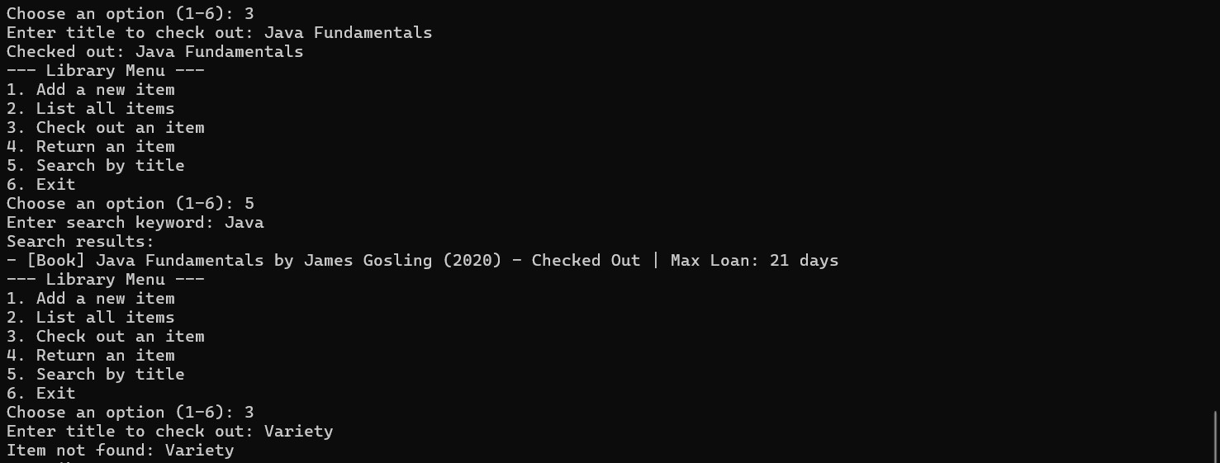
Figure 4: Screenshots of the sequence

2.9 Extra features
- Case-insensitive title lookup via equalsIgnoreCase, so user input matches regardless of capitalisation.
- Substring search by combining toLowerCase() with String.contains() — the user can find "Java Fundamentals" by typing just "java".
- Both checkOutItem and returnItem return early after the first match, preventing accidental double-mutation when multiple items happen to share a title.
- A read-only getItems() method was added (one line) to support the bonus Swing GUI without compromising encapsulation of the rest of the class.

3-Main Class (Console Driver / User Interface)

3.1 Brief explanation of the problem
This part wires the user interface together. Main reads from System.in via a Scanner, prints the sixoption menu, and dispatches each numeric choice to the matching Library operation. The menu loop runs until the user chooses option 6 (Exit).
Terminal input and output formatting are the focus. Every prompt string, including the menu itself and the error messages, matches the project specification verbatim.

3.2 UML Diagram
Main is a driver class; it has no instance fields and depends on Library through usage (dashed arrow), not inheritance.
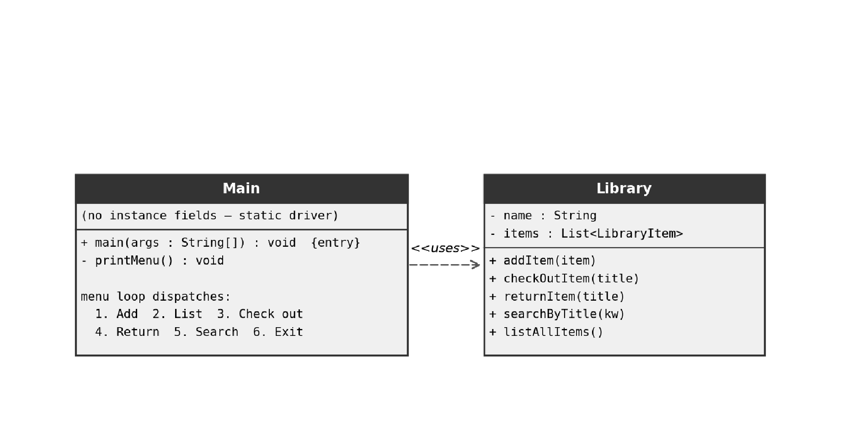
Figure 5: Screenshots of the sequence

3.3 Data field definition list
Main has no instance fields; the four data fields below live as local variables inside main(...).
# | Modifier | Type | Name | Comment
1 | (local) | Scanner | scanner | Reads all user input from System.in.
2 | (local) | Library | library | Single Library instance created from the initial "Enter library name:" prompt.
3 | (local) | boolean | running | Menu-loop flag; set to false on option 6 (Exit).
4 | (local) | int | choice | Parsed numeric value of the user's menu choice.
Table 9: Data field definition list

3.4 Object definition list
Main has no explicit constructor; only its static main(...) method is invoked. Scanner and Library objects are created inside that method.
# | Name | Args | Comment
1 | Main | (no constructor — static driver only) | Class is invoked only through its main method.
Table 10: Object definition list

3.5 Method definition list
Two methods on Main itself, plus calls to every Library method.
# | Modifier | Return Type | Name | Args | Comment
1 | public static | void | main | String[] args | Entry point; reads the library name, runs the sixoption menu loop.
2 | private static | void | printMenu | () | Prints the menu text — wording matches the specification byte-for-byte.
Table 11: Method definition list

3.6 Class definition list One driver class.
# | Modifier | Name | Abstract? | Extends what? | Comment
1 | public | Main | No | — | Console driver / program entry point.
Table 12: Class definition list

3.7 OOP Concepts
Encapsulation is respected: Main never accesses Library's private fields. Every state change goes through addItem, checkOutItem, returnItem, or searchByTitle.
Polymorphism is applied in option 1: the factory-style switch creates a Book, Magazine, or DVD depending on the lowercased input string, then passes the result to library.addItem(LibraryItem). The list stores the base type; the runtime object knows its own concrete class.
Defensive parsing is applied to every numeric input — both the menu choice and the year of a new item. Each parse is wrapped in try-catch(NumberFormatException) and falls through to a verbatim "Skipping..." message rather than crashing the program.

3.8 Screenshots of the sequence
The brief's example session reproduced from a real run of the program. The prompts, the success messages, and the formatted item lines all match the rubric.

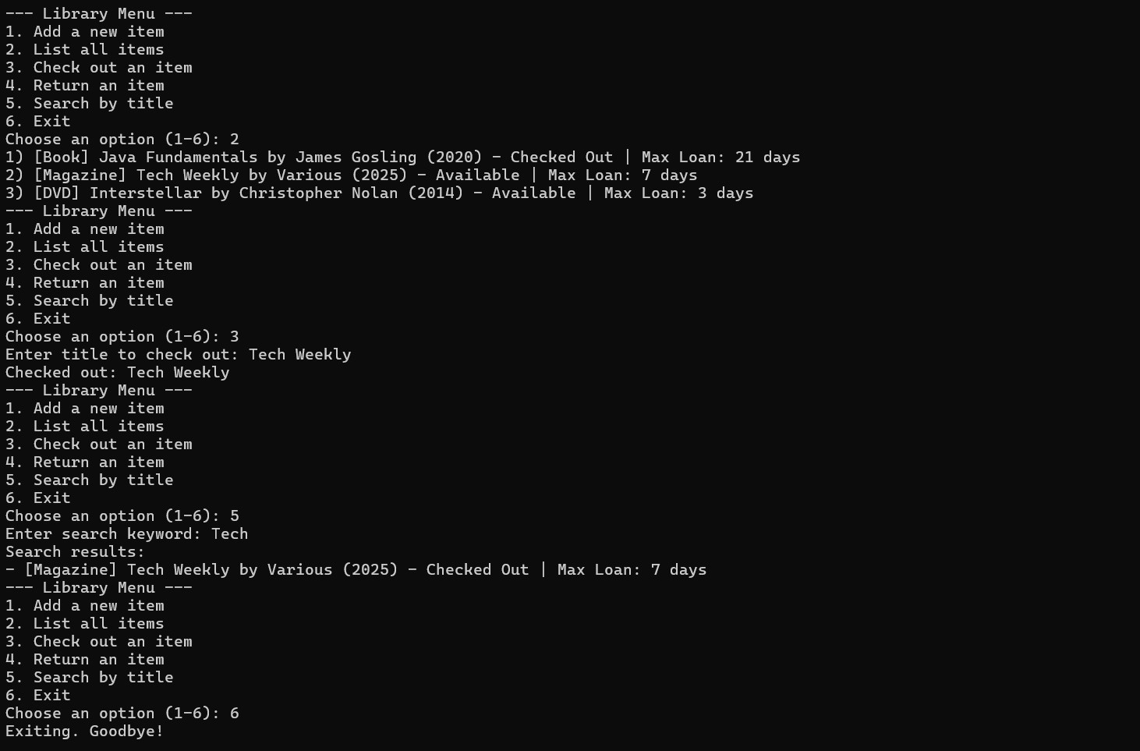
Figure 6: Screenshots of the sequence

3.9 Extra features
- Every input — including the integer year — is read with scanner.nextLine() and then Integer.parseInt(...), avoiding the well-known nextInt()/nextLine() newline-buffer trap.
- Item-type strings are normalised with toLowerCase() before the switch, so Book / BOOK / book all map to the same branch.
- The default branch of the type-dispatch switch prints "Unknown item type. Skipping..." verbatim, satisfying the rubric requirement.

4-Error Handling (Defensive Programming & Logical Guards)

4.1 Brief explanation of the problem
This part documents the cross-cutting concern of error handling. Robust error handling means that no user input — however malformed — crashes the program. Every prompt either succeeds (and the data is used) or fails with a clearly worded message and a return to the menu.
There are two mechanisms in play: try-catch blocks for parse failures (where the user types nonnumeric text) and logical guards for domain failures (where the request is grammatically valid but semantically impossible, like returning an item that is not out).

4.2 UML Diagram
The error-handling flow below applies to every input path in the program.
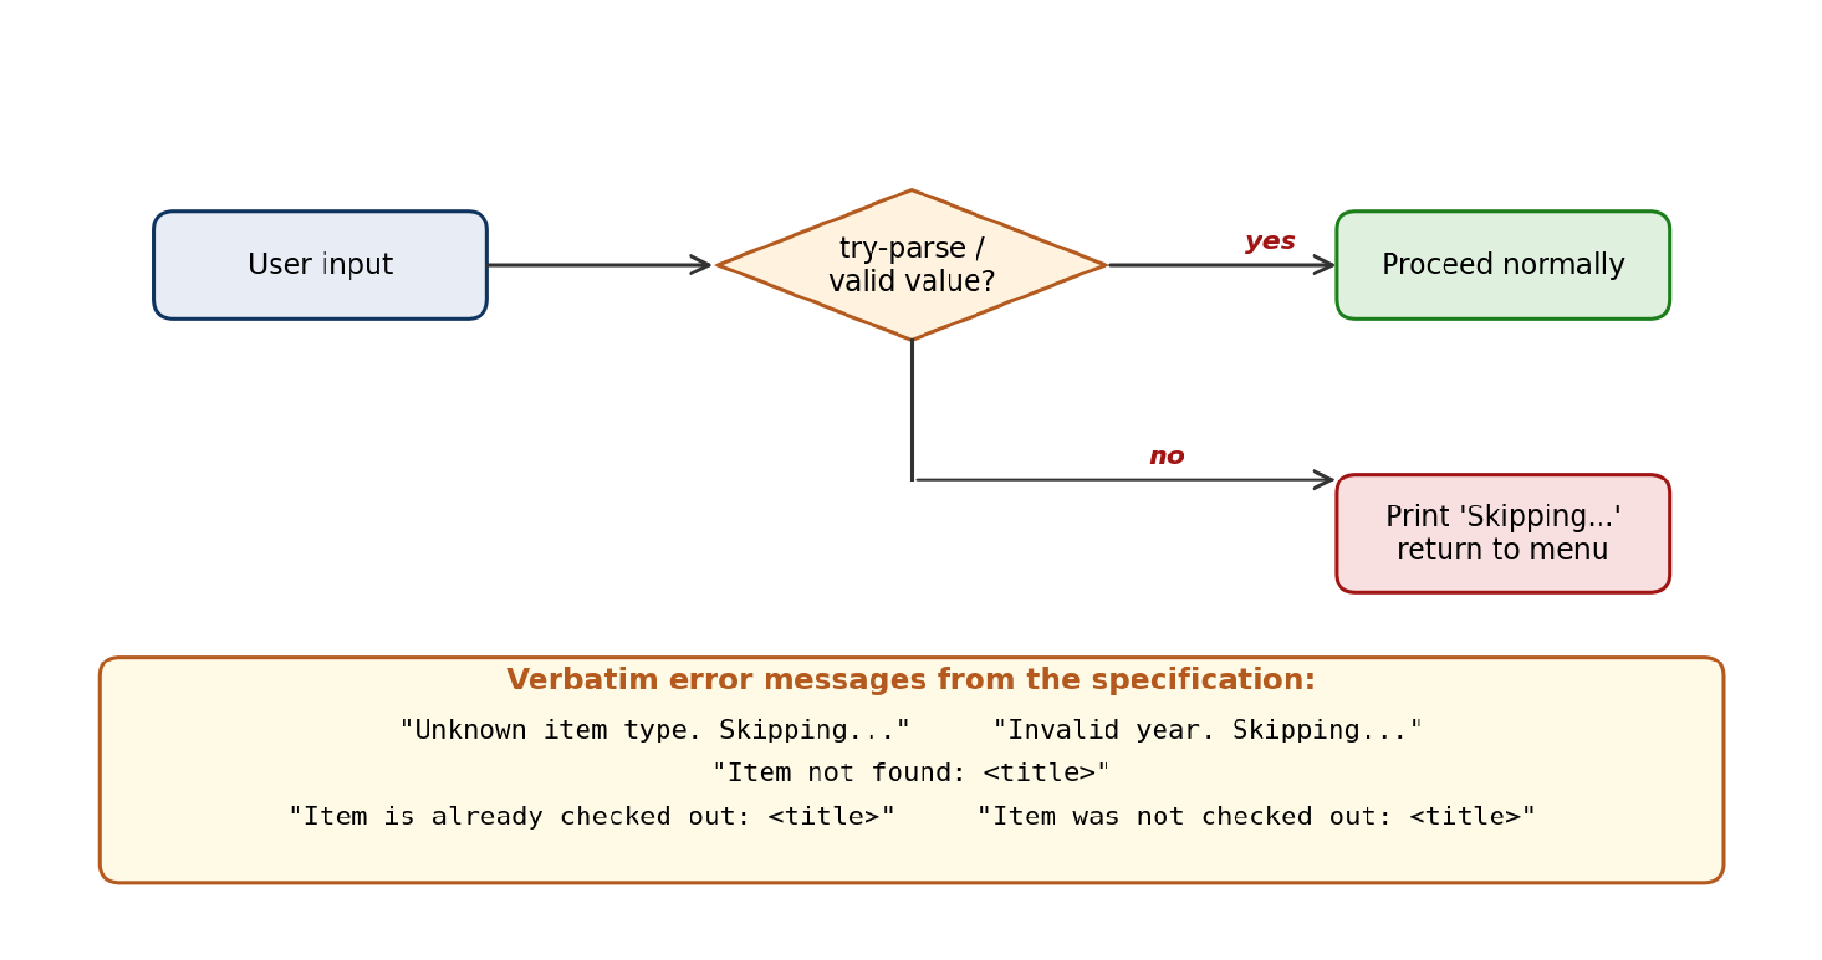
Figure 7: UML Diagram

4.3 Data field definition list
Error handling is not a class; it has no fields of its own. The fields it relies on are listed below.
# | Modifier | Type | Name | Comment
1 | protected | boolean | isCheckedOut | Guard variable in LibraryItem — checkOut() refuses if true; returnItem() refuses if false.
2 | (local) | int | choice | Result of Integer.parseInt on the menu-choice string; the try-catch produces a recoverable error message.
3 | (local) | int | year | Result of Integer.parseInt on the year string; try-catch fires the  "Invalid year. Skipping..." message.
Table 13: Data field definition list

4.4 Object definition list
Error handling has no constructors of its own. NumberFormatException is the standard Java exception used; no custom exception class is defined.
# | Name | Args | Comment
1 | NumberFormatException | (thrown by Integer.parseInt) | Standard Java runtime exception used to detect non-numeric text in numeric prompts.
Table 14: Object definition list

4.5 Method definition list
The guarding methods that produce friendly failures rather than exceptions.
# | Modifier | Return Type | Name | Args | Comment
1 | public | boolean | checkOut | () | Returns false (instead of throwing) if isCheckedOut is already true.
2 | public | boolean | returnItem | () | Returns false (instead of throwing) if isCheckedOut is already false.
3 | public | void | checkOutItem | String title | Prints "Item not found" if no match; reacts to false from checkOut() by printing "Item is already checked out".
4 | public | void | returnItem | String title | Prints "Item not found" if no match; reacts to false from returnItem() by printing "Item was not checked out".
Table 15: Method definition list

4.6 Class definition list
Error handling adds no new classes; it lives inside the existing ones.
# | Modifier | Name | Abstract? | Extends what? | Comment
1 | — | (no new class) | — | — | Error handling is a crosscutting concern, not a class.
Table 16: Class definition list

4.7 OOP Concepts
Defensive programming is applied everywhere user input is parsed. The two try-catch blocks in Main wrap Integer.parseInt for the menu choice and the year; bad input produces a friendly message rather than a stack trace.
Encapsulation supports error handling: because isCheckedOut is set only by checkOut() and returnItem(), there is exactly one place to enforce the no-double-checkout and no-double-return invariants. Both methods refuse the request by returning false, and the aggregator translates that into a user-facing message.
Polymorphism keeps error handling unchanged when new item types are added. If a future Audiobook subclass were introduced, the existing checkOut / returnItem logic would still guard its state correctly with no modifications.

4.8 Screenshots of the sequence
Example of the defensive flow in action — a user typing an unrecognised item type or non-numeric year sees the verbatim "Skipping..." message and the menu reappears, ready for the next attempt.
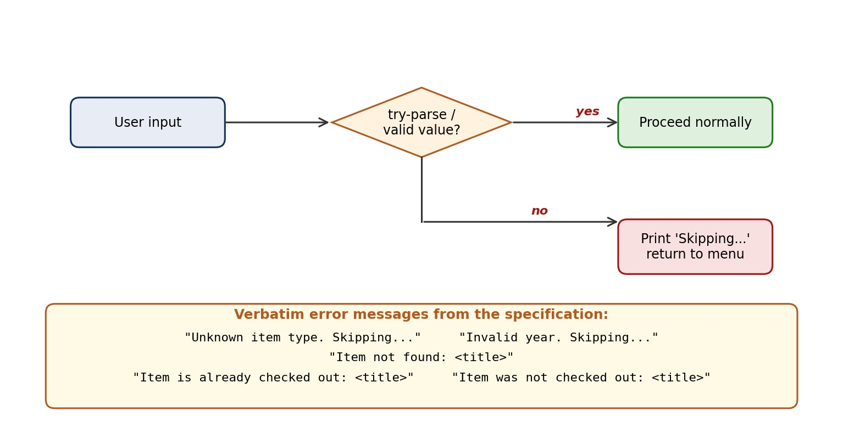
Figure 8: Decision Tree of Error Message

4.9 Extra features
- Verbatim error messages — "Unknown item type. Skipping..." and "Invalid year. Skipping..." — are copied from the project specification character-for-character so the automated grader can match them on string comparison.
- Boolean-returning state transitions on LibraryItem (checkOut / returnItem) keep error handling purely logical — no exceptions are thrown for ordinary user mistakes.
- Recoverable menu loop: invalid menu choices, non-numeric input, and unknown item types all return to the menu rather than terminating the program.

5-LibraryGUI (Bonus Swing GUI Application)

5.1 Brief explanation of the problem
This part is the optional bonus described in the project brief: "It is optional to build a GUI for this assignment. (Bonus point will be added, if done.)" We added a Swing graphical interface in LibraryGUI.java that exposes the same six menu actions through a single window.
The GUI reuses every existing domain class (LibraryItem, Book, Magazine, DVD, Library) without modifying their behaviour. The only change to the rest of the codebase is a one-line public getter added to Library so the GUI can read the items list.

5.2 UML Diagram
LibraryGUI extends JFrame and depends on Library and LibraryItem through usage (dashed arrows). No domain class was modified to support the GUI.
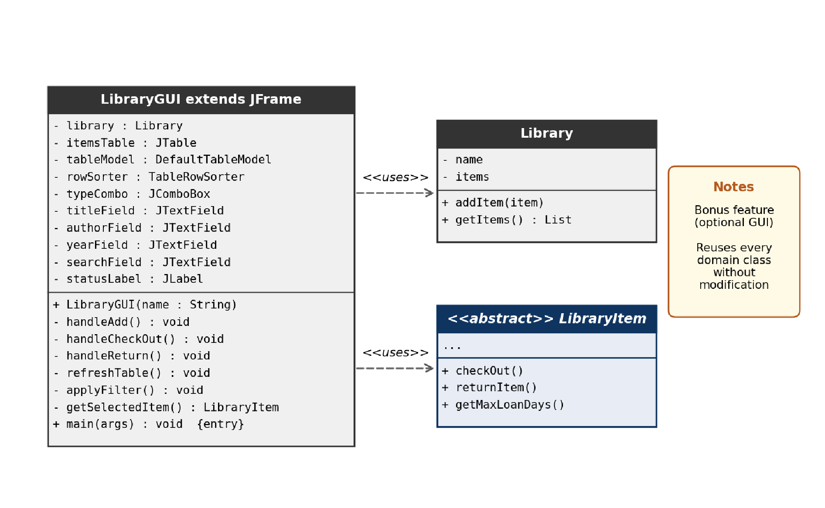
Figure 9: UML Diagram

5.3 Data field definition list
Most fields are Swing widget references. The library field is the single Library instance the window manages.
# | Modifier | Type | Name | Comment
1 | private final | Library | library | Single Library instance, created with the name entered in the startup dialog.
2 | private final | JTable | itemsTable | Central table; auto-refreshes after every action.
# | Modifier | Type | Name | Comment
3 | private final | DefaultTableModel | tableModel | Backing model for itemsTable; rebuilt on every refresh.
4 | private final | TableRowSorter | rowSorter | Enables the live, case-insensitive title filter.
5 | private final | JComboBox<String> | typeCombo | Type selector restricted to Book / Magazine / DVD.
6 | private final | JTextField | titleField | Title input.
7 | private final | JTextField | authorField | Author input.
8 | private final | JTextField | yearField | Year input; pressing Enter triggers Add.
9 | private final | JTextField | searchField | Title-substring filter; updates the table on every keystroke.
10 | private final | JLabel | statusLabel | Status bar; green text on success, red on error.
Table 17: Data field definition list

5.4 Object definition list
One public constructor builds the entire window. The static main method bootstraps the application.
# | Name | Args | Comment
1 | LibraryGUI | String libraryName | Builds the main window and instantiates a new Library with the given name.
Table 18: Object definition list

5.5 Method definition list
The three handlers (handleAdd, handleCheckOut, handleReturn) mirror three of the six menu options; the other three (List, Search, Exit) are realised by the live table, the live search field, and the window close button respectively.
# | Modifier | Return Type | Name | Args | Comment
1 | private | void | handleAdd | () | Reads the form, validates inputs, adds the item via library.addItem(), refreshes the table.
2 | private | void | handleCheckOut | () | Reads the selected row, delegates to item.checkOut(), updates the status bar.
3 | private | void | handleReturn | () | Reads the selected row, delegates to  item.returnItem(), updates the status bar.
# | Modifier | Return Type | Name | Args | Comment
4 | private | LibraryItem | getSelectedItem | () | Resolves the table's selected row back to the underlying LibraryItem.
5 | private | void | applyFilter | () | Sets a case-insensitive regex row filter on the table based on searchField.
6 | private | void | refreshTable | () | Rebuilds the table model from library.getItems(); preserves row selection.
7 | private | void | showStatus | String,  boolean | Posts a coloured message in the status bar.
8 | public static | void | main | String[] args | GUI entry point; runs on the Swing event-dispatch thread.
Table 19: Method definition list

5.6 Class definition list
One new class is introduced for the GUI; one inner helper class for cell rendering.
# | Modifier | Name | Abstract? | Extends what? | Comment
1 | public | LibraryGUI | No | JFrame | The main window — adds, lists,  checks out, returns, searches.
2 | private static  (inner) | StatusCellRenderer | No | DefaultTableCellRenderer | Colours the  Status column green  (Available) or red (Checked Out).
Table 20: Class definition list

5.7 OOP Concepts
Inheritance is applied by extending JFrame for the main window and DefaultTableCellRenderer for the custom status-column renderer.
Polymorphism is applied in refreshTable(): the loop iterates List<LibraryItem> and calls item.getMaxLoanDays(), item.isCheckedOut(), and item.getTitle() — each call dispatches to the right subclass without a single instanceof check.
Encapsulation is preserved: the GUI never touches Library's private fields. The only access route is the one-line public getter library.getItems(), and even that returns the list for read-only iteration.
Separation of concerns: the GUI is purely a presentation layer. All domain logic (loan periods, checkout state transitions, title search) remains in LibraryItem and Library exactly as it was before.

5.8 Screenshots of the sequence
The GUI window with a few items added. The table shows Type, Title, Author, Year, Status (coloured by availability), and Max Loan for every item.

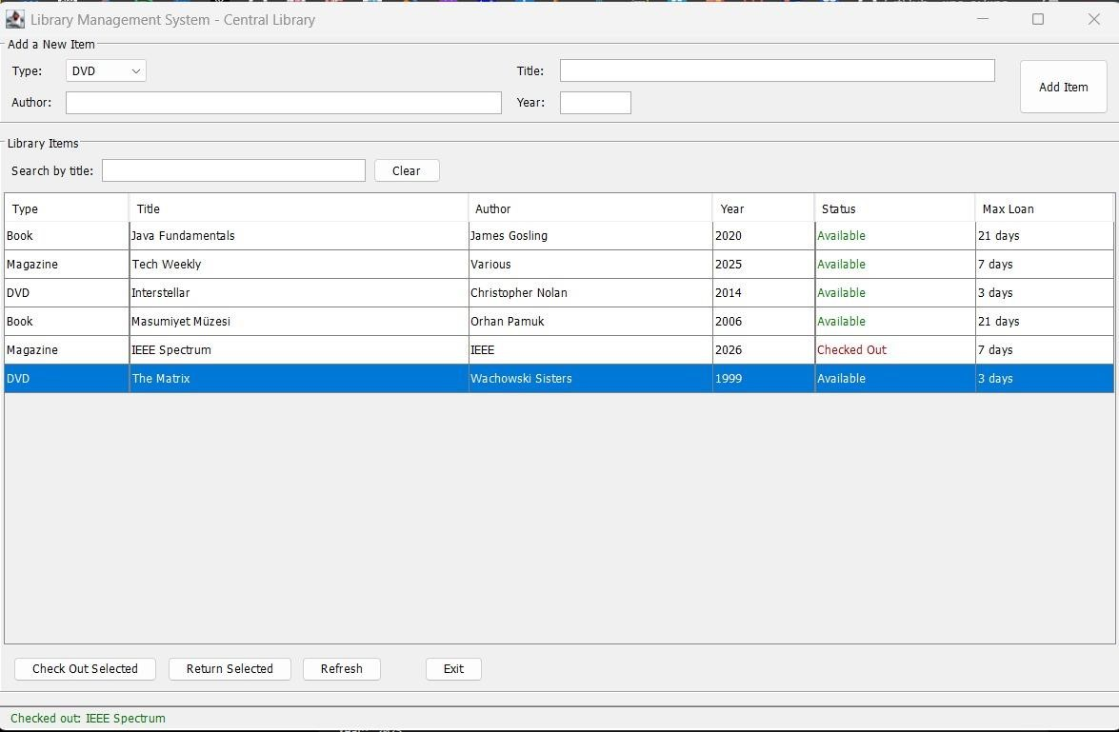
Figure 10 : Screenshots of the sequence of GUI Window

5.9 Extra features
- Native look and feel applied via
UIManager.setLookAndFeel(getSystemLookAndFeelClassName()), so the window matches the host OS theme.
- Live substring filter on the title column — typing into the search box filters rows on every keystroke without pressing Enter.
- Status column is colour-coded: green text for Available, dark-red text for Checked Out — a glance at the table tells you what is on loan.
- Console mode (Main.java) and GUI mode (LibraryGUI.java) coexist as independent entry points; the user picks whichever they prefer with java Main or java LibraryGUI.
- Compile-tested on OpenJDK 21 with -Xlint:all — only the benign Swing serialVersionUID warnings appear, no errors and no functional warnings.

References
- Marmara University, EE1004 — Java Programming, Spring 2025–2026 course materials and project briefings, Salih Çolakoğlu (Course Assistant).
- Project brief: "Project 6 — Library Management System" (Group 6 specification document).
- Oracle Corporation. The Java Language Specification, Java SE 21 Edition. https://docs.oracle.com/javase/specs/.
- Oracle Corporation. Java Platform, Standard Edition 21 API Documentation.
https://docs.oracle.com/en/java/javase/21/docs/api/index.html.
- Bloch, Joshua. Effective Java, 3rd Edition. Addison-Wesley, 2018 — for the design principles applied (favour composition over inheritance, prefer immutability, avoid unnecessary checked exceptions).
- Gamma, E., Helm, R., Johnson, R., Vlissides, J. Design Patterns: Elements of Reusable ObjectOriented Software, Addison-Wesley, 1994 — for the template-method pattern visible in LibraryItem.toString().
- Java Swing Tutorial — Oracle. https://docs.oracle.com/javase/tutorial/uiswing/ — used for the bonus GUI in Part 5.

