CS224
Section No: 5
Spring 2021
Lab No: 6
Full Name / Bilkent ID: Burak Öztürk / 21901841
A. Direct Mapped Caches

Row Major Averaging

Matrix Size: 50 x 50
 | Block Size (number of words)
Cache Size (bytes) | 16 | 32 | 64 | 128 | 256
2048 | Miss Rate: 6%  Miss #: 162 | Miss Rate: 3%  Miss #: 82 | Miss Rate: 2%  Miss #: 42 | Miss Rate: 1%  Miss #: 21 | Miss Rate: 0%  Miss #: 11
4096 | Miss Rate: 6%  Miss #: 162 | Miss Rate: 3%  Miss #: 82 | Miss Rate: 2%  Miss #: 42 | Miss Rate: 1%  Miss #: 21 | Miss Rate: 0%  Miss #: 11
8192 | Miss Rate: 6%  Miss #: 162 | Miss Rate: 3%  Miss #: 82 | Miss Rate: 2%  Miss #: 42 | Miss Rate: 1%  Miss #: 21 | Miss Rate: 0%  Miss #: 11
16384 | Miss Rate: 6%  Miss #: 162 | Miss Rate: 3%  Miss #: 82 | Miss Rate: 2%  Miss #: 42 | Miss Rate: 1%  Miss #: 21 | Miss Rate: 0%  Miss #: 11
32768 | Miss Rate: 6%  Miss #: 162 | Miss Rate: 3%  Miss #: 82 | Miss Rate: 2%  Miss #: 42 | Miss Rate: 1%  Miss #: 21 | Miss Rate: 0%  Miss #: 11

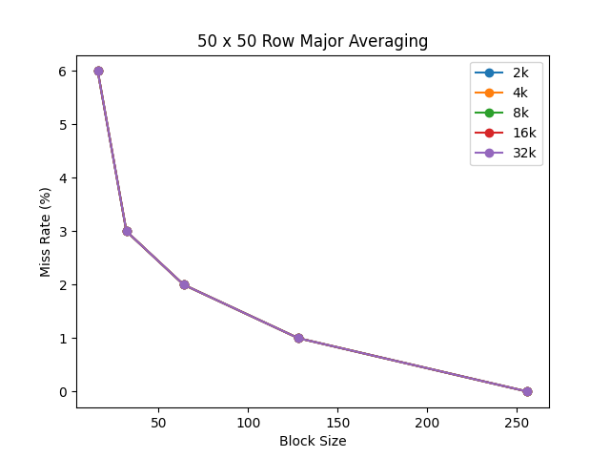
Graph:

Matrix Size: 100 x 100
 | Block Size (number of words)
Cache Size (bytes) | 16 | 32 | 64 | 128 | 256
2048 | Miss Rate: 6%  Miss #: 631 | Miss Rate: 3%  Miss #: 317 | Miss Rate: 2%  Miss #: 160 | Miss Rate: 1%  Miss #: 80 | Miss Rate: 0%  Miss #: 41
4096 | Miss Rate: 6%  Miss #: 631 | Miss Rate: 3%  Miss #: 317 | Miss Rate: 2%  Miss #: 160 | Miss Rate: 1%  Miss #: 80 | Miss Rate: 0%  Miss #: 41
8192 | Miss Rate: 6%  Miss #: 631 | Miss Rate: 3%  Miss #: 317 | Miss Rate: 2%  Miss #: 160 | Miss Rate: 1%  Miss #: 80 | Miss Rate: 0%  Miss #: 41
16384 | Miss Rate: 6%  Miss #: 631 | Miss Rate: 3%  Miss #: 317 | Miss Rate: 2%  Miss #: 160 | Miss Rate: 1%  Miss #: 80 | Miss Rate: 0%  Miss #: 41
32768 | Miss Rate: 6%  Miss #: 631 | Miss Rate: 3%  Miss #: 317 | Miss Rate: 2%  Miss #: 160 | Miss Rate: 1%  Miss #: 80 | Miss Rate: 0%  Miss #: 41

Graph:
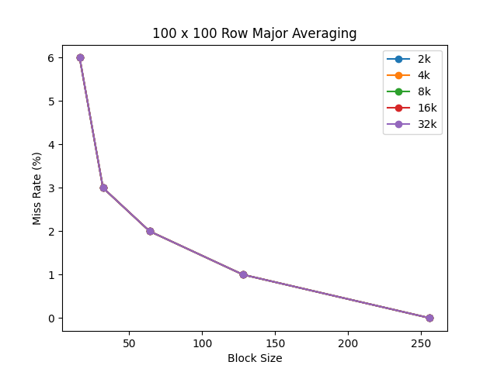

Column Major Averaging

Matrix Size: 50 x 50
 | Block Size (number of words)
Cache Size (bytes) | 16 | 32 | 64 | 128 | 256
2048 | Miss Rate: 60%  Miss #: 1619 | Miss Rate: 92%  Miss #: 2503 | Miss Rate: 73%  Miss #: 1966 | Miss Rate: 37%  Miss #: 1001 | Miss Rate: 20%  Miss #: 551
4096 | Miss Rate: 36%  Miss #: 977 | Miss Rate: 60%  Miss #: 1637 | Miss Rate: 73%  Miss #: 1966 | Miss Rate: 37%  Miss #: 1001 | Miss Rate: 20%  Miss #: 551
8192 | Miss Rate: 35%  Miss #: 950 | Miss Rate: 34%  Miss #: 926 | Miss Rate: 28%  Miss #: 754 | Miss Rate: 15%  Miss #: 413 | Miss Rate: 11%  Miss #: 306
16384 | Miss Rate: 6%  Miss #: 162 | Miss Rate: 3%  Miss #: 82 | Miss Rate: 2%  Miss #: 42 | Miss Rate: 1%  Miss #: 21 | Miss Rate: 0%  Miss #: 12
32768 | Miss Rate: 6%  Miss #: 162 | Miss Rate: 3%  Miss #: 82 | Miss Rate: 2%  Miss #: 42 | Miss Rate: 1%  Miss #: 21 | Miss Rate: 0%  Miss #: 12

Graph:
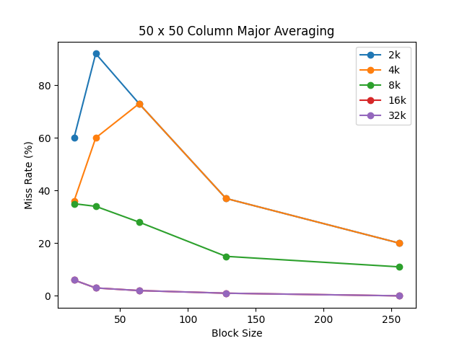

Matrix Size: 100 x 100
 | Block Size (number of words)
Cache Size (bytes) | 16 | 32 | 64 | 128 | 256
2048 | Miss Rate: 98%  Miss #: 10005 | Miss Rate: 98%  Miss #: 10003 | Miss Rate: 98%  Miss #: 10005 | Miss Rate: 77%  Miss #: 7817 | Miss Rate: 38%  Miss #: 3917
4096 | Miss Rate: 83%  Miss #: 8487 | Miss Rate: 98%  Miss #: 10003 | Miss Rate: 83%  Miss #: 8487 | Miss Rate: 77%  Miss #: 7817 | Miss Rate: 38%  Miss #: 3917
8192 | Miss Rate: 83%  Miss #: 8487 | Miss Rate: 91%  Miss #: 9245 | Miss Rate: 83%  Miss #: 8487 | Miss Rate: 77%  Miss #: 7817 | Miss Rate: 38%  Miss #: 3917
16384 | Miss Rate: 83%  Miss #: 8487 | Miss Rate: 91%  Miss #: 9245 | Miss Rate: 83%  Miss #: 8487 | Miss Rate: 77%  Miss #: 7817 | Miss Rate: 38%  Miss #: 3917
32768 | Miss Rate: 83%  Miss #: 8487 | Miss Rate: 91%  Miss #: 9245 | Miss Rate: 83%  Miss #: 8487 | Miss Rate: 28%  Miss #: 2882 | Miss Rate: 14%  Miss #: 1457

Graph:
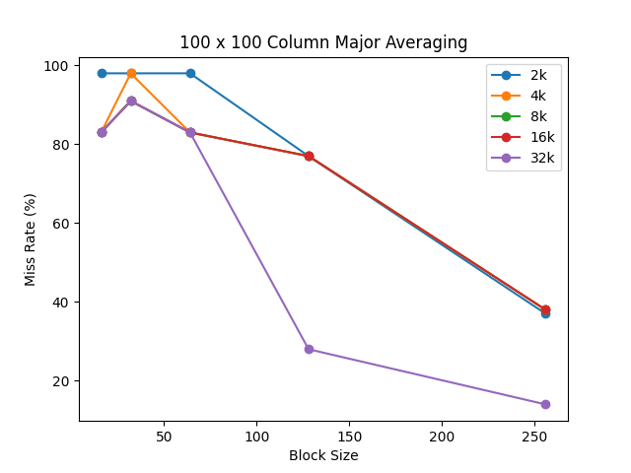
B. Fully Associative Caches
Column Major Averaging
Matrix Size: 50 x 50
 | Cache Type
Cache Size/Block Size | Direct Mapped | Fully Associative / LRU | Fully Associative / Random
16384 / 64  (Good) | 2% | 2% | 2%
4096 / 128  (Medium) | 37% | 37% | 33%
2048 / 32  (Poor) | 92% | 92% | 88%

Graph:
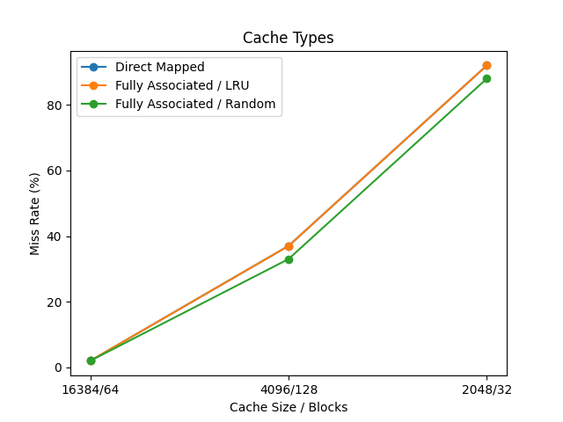
As seen in the graph, results are exactly same for all three caches (Fully associative / Random is a little better due to randomness.). Change from direct mapped to fully associative cache does not make a difference because while doing column by column reading neighboring integers are placed in cache too and cache is large enough to get same miss rate for every cache. That means for “good” cache, there is enough cache size in direct mapped therefore fully associative is not needed and for “medium” and “poor” caches, most of the misses are not conflict misses but capacity miss therefore fully associativity does not help.
Matrix Size: 100 x 100
 | Cache Type
Cache Size/Block Size | Direct Mapped | Fully Associative / LRU | Fully Associative / Random
32768 / 256  (Good) | 14% | 38% | 13%
2048 / 256  (Medium) | 38% | 38% | 38%
2048 / 16  (Poor) | 98% | 98% | 94%

Graph:
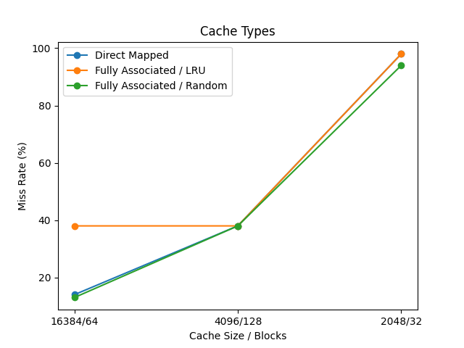
This graph’s conclusion is same as 50 x 50 matrix’s graph except for “good”. For “good” configuration, fully associative / LRU cache type is not same for miss rate as other but worse. This is because there wasn’t much conflict misses from the direct mapping and fully associativity brings capacity misses. Therefore it is not helping and making performance worse.
C. N-way Set Associative Caches

Column Major Averaging
Matrix Size: 50 x 50

Cache Size/Block Size: 4096 / 128 (Medium)
N-way Cache | 1 | 2 | 4 | 8
Hit Rate | 63 | 63 | 63 | 63
Miss Rate | 37 | 37 | 37 | 37
Miss Count | 1001 | 1001 | 1001 | 1001

Cache Size/Block Size: 16384 / 64 (Good)
N-way Cache | 4 | 8 | 16 | 32
Hit Rate | 98 | 98 | 98 | 98
Miss Rate | 2 | 2 | 2 | 2
Miss Count | 42 | 42 | 42 | 42

Cache Size/Block Size: 2048 / 32 (Poor)
N-way Cache | 2 | 4 | 8 | 16
Hit Rate | 8 | 8 | 8 | 8
Miss Rate | 92 | 92 | 92 | 92
Miss Count | 2503 | 2503 | 2503 | 2503

For all three cases, miss rate does not change as the N increases or decreases because as in Part B, misses are not conflict misses but capacity misses. Therefore making cache more divided by increasing N, does not do any good other than wasting resources.

