

**MUĞLA SITKI KOÇMAN UNIVERSITY**

**DEPARTMENT OF COMPUTER ENGINEERING**

**SENIOR DESIGN PROJECT REPORT**

**BYOM: BRING YOUR OWN MUSIC**

**PROJECT OWNER : BURAKHAN SEVİM**

**130709036**

**MENTOR : DR. CİHAT ÇETİNKAYA**

**1.INTRODUCTION**

**Spotify is the most widely used music application in the world. Users of this application offering music categorized according to the mood and energy of people can choose freely while using the application and can listen to the music they want anywhere, but in social areas (cafes, restaurants, etc.), music selection is done by playing the cafe-restaurant owner automatically from a pre-recorded playlist or via the Youtube app.This situation causes people to listen to music types they do not like and causes discontent.**

**There is always the situation of not going to the places visited because of their music.This situation causes enterprises to lose customers and thus financial losses.**

**Based on this problem, in this project, a system was designed which selects the song list according to the common music tastes of the people and selects the next song according to the spotify public playlists of the application users.**

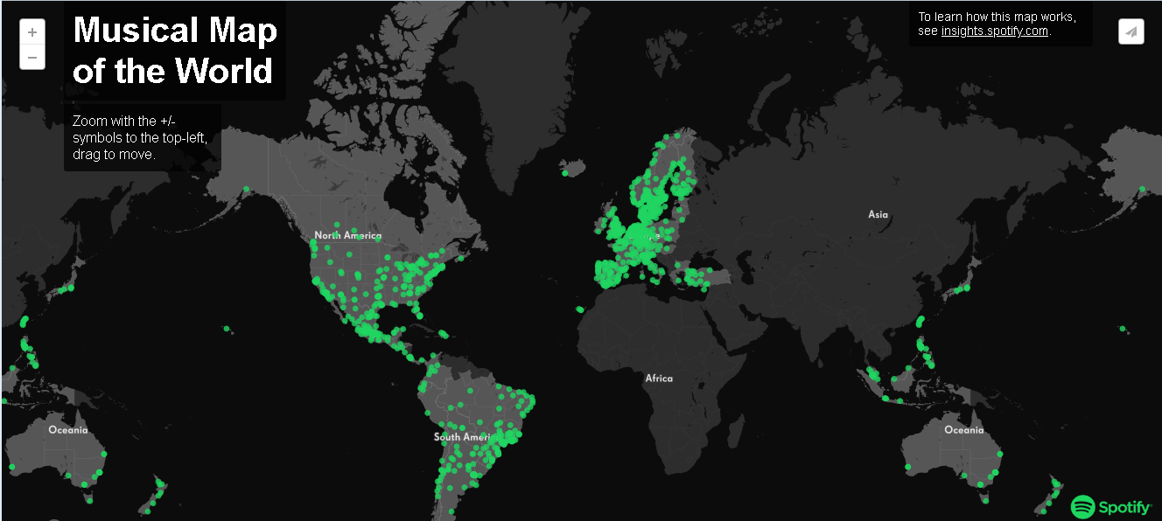

**2.MOTIVATION AND PURPOSE**

**In this project, the purpose is design a system that select and play the next song based on the spotify public playlists according to the common music tastes of people in social areas.**

**Also in this project,one of other purpose is make song selection according to the instant playlist of the people in social areas unlike similar applications that offer songs and present that application as an in-app plugin to the spotify application.**

**3.DESIGN AND ANALYSIS**

**metin, harita içeren bir resim

Açıklama otomatik olarak oluşturuldu**

**(1) In the project which works with client-server architecture, user names and location information of the client are received on the client side and transmitted to the application server.** **Users can enter their information through the login screen via the mobile app or through the wifi portal of their environment.**

**(2) The server then connects to the Spotify Web Api to provide users with access to public playlists. Spotify Web Api contains users' general information, songs and playlists.** **Users' private playlists and profiles are not accessible for data security reasons.At this stage, we access the Spotify Web Api datas with ‘spotipy’ python library.**

**(3) Then the most played song type in public playlists or the most frequently played song is determined by the server. In this stage, the selection method can be done automatically.** **The automatic selection method prevents the same song from being played 2 times in a row.** **In addition, the selection of songs in the server part of the project is done with python algorithm.**

**(4) At the last stage, the server sends the song that it determines to the application player and the song is played.**

**4.CONCLUSION**

**As a result, the fact that this project is a user-friendly application and responding to people's wishes with fast and accurate results enables the quality of social life to increase.With this application, people will be able to get better results in song selection in their social areas.**