  
  
  
  
CS 319 - Object-Oriented Software Engineering  
System Design Report  
  
  
Panzer 2017  
Group 2-C  
Ndriçim RRAPİ  
Burak SİBİRLİOĞLU  
Pınar BAYATA

Contents

1. Changes In the Implementation 3

2.Status of the Project 4

3.User’s Guide 5

3.1. System Requirements 5

3.2. Installation 5

3.3.Overview of the Game 9

3.4. Game Objects Management Subsystem 9

3.4.1.Objects 9

3.4.2. Controls 10

3.4.3. Game Screenshots & Menus 10

4.References 15

# Changes In the Implementation

1. **Speed(Additional Feature)**

In our design report, we thought that the speed will be constant during the game. However, we decided during the implementation that the speed will increase if playerTank reaches to a bonus such as the speed will increase if playerTank gets a speed bonus.

1. **Tank Class**

In the tank class, we said previously in our reports that there will be one move() method. However, fort he ease of implementation, we divided the method into four parts such as moveLeft(), moveRight(), moveDown() and move Up().

Apart from the methods, we changed the parameters of Tank class. We added ArrayList<Image> _icon in order to have different images of tanks. For example, if the tank goes left we will have a left looking tank image and it will be the sam efor other directions.

1. **Main Class**

We defined a new class which is called GamePanel initializing the Main Menu.

1. **Bonuses**

We changed our Bonus objects in order fort he functionality of the game. The ‘Explosion Time Freeze’ bonus that we mentioned in the analysis report, we removed it because we created a tank which shoots and freezes the Player Tank. We have ‘Fast Bullet’ object as we discussed in Analysis Report but the image of it is changed for a better view. Multiple Bullets Bonus is removed also. Lastly, the ‘Extra Life Bonus’ gives full life to tank, not an additional life.

1. **JavaFX**

We used JavaFX to replace swing as the standard GUI library for JavaSE.

1. **Setup**

Users will be eager to play the game by using the setup.exe file which enables the game to be a desktop icon. After downloading, users can reach to the game without Internet connection, anywhere, anytime.

1. **Settings**

In previous reports, we mentioned that there will be a shooting effect also in the settings part. However, we decided it is not a good choice so we removed that too.

1. **Extra Feauture**

We have very smart tanks. These tanks can follow you, shoot you, can go to your castle directly and shoot , and turn around and shoot.

# 2.Status of the Project

We finished the implementation of our Project successfully. We were consistent with our Design Report. Everyone can enjoy this game now.

# 3.User’s Guide

## 3.1. System Requirements

Panzer17 is a game which implemented in Java. We used JavaFX to replace swing as the standard GUI library for JavaSE[1]. The version Java JRE 8u150 is needed. Therefore, users should download JavaSE.

**Minimum System Requirements:**

* Windows XP or Mac OS X Snow Leopard
* Pentium2 233 MHz CPU or higher
* 256 MB of RAM or higher
* Screen resolution: 800x600

**Recommended System Requirements:**

* Windows 10 or macOS Sierra
* Intel i5 2 GHz CPU or higher
* 1 GB of RAM or higher
* Screen Resolution: 800 x 600

## 3.2. Installation

If the users know how to implement on Java, the game can be downloaded from our Github page which is <https://github.com/buraksibirlioglu/CS319_SEC2_2C>. NetBeans can be used as a Java program.

We added a setup.exe file in github, users can install and after some ‘license agreements’ they can play the game easily. After the download, users will folow these steps:

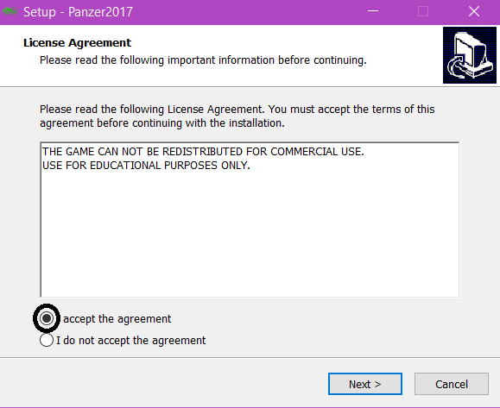1.

1. 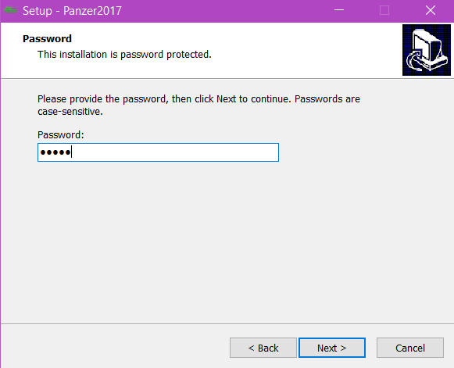Password is ‘cs319’.

3.

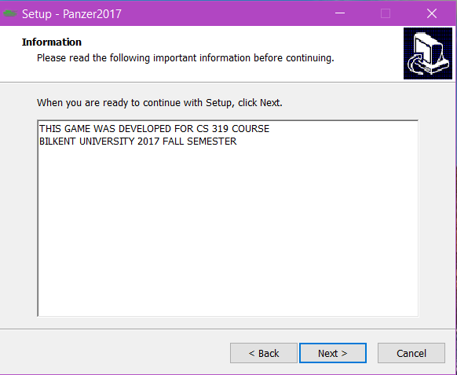

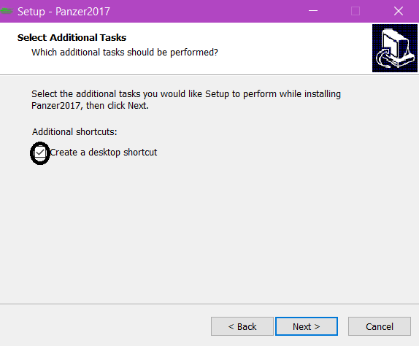4.

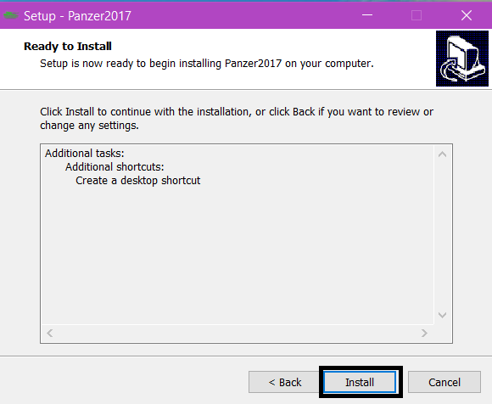

## 3.3.Overview of the Game

When the player presses play button , Panzer 2017 starts with the top view of a map and tanks. The map consists of various bricks such as one brick can be collapsed with one shoot while the other one should be shot three times. There are two castles, one for the enemies and one for the player. The castles are surrounded by the easily destroyable bricks. There will be 3 levels and in each level, map’s design is changed so that it will be hard for the player to move and catch an enemy. Enemies are classified in themselves. Like the bricks, some of them have to be shot more than the other ones. Heart counter starts to count from 3 and decreases the value whenever player is shot by an enemy. Apart from that, point counter will start from 0 and adds the points as the player shoots enemies. An enemy will not be able to shoot other enemy. An enemy’s tank will be different from the player’s. Enemy’s position will be generated randomly in every level. The goal is to play all the levels and reach the castle in every levels.

## 3.4. Game Objects Management Subsystem

### 3.4.1.Objects

**Player Tank:** Player tank is our main object which should avoid from enemies and should protect the castle.

**Bullet:** When player presses space button on keyboard, there will be a bullet.

**Enemy Tank:** In all levels, there will be enemies.

**Bricks:** Bricks divide into four brick types such as green brick, red brick, blue brick, white brick.

**Bonus:** There will be bonus objects that will appear randomly in the map.

**Castle:** There will be two castles, one for enemies an done for player.

### 3.4.2. Controls

**‘LEFT’ Button:** Go left

**‘DOWN’ Button:** Go down

**‘RIGHT’ Button:** Go right

**‘UP’ Button:** Go up

**Space:** Fire

### 3.4.3. Game Screenshots & Menus

The Game Screenshots shows the status of the project. Because the implementation is not over yet, there is no ‘High Scores’ part.

**Main Menu**: Opening screen is main menu and it contains 4 options: Play, Settings, Help, High Scores, Credits.

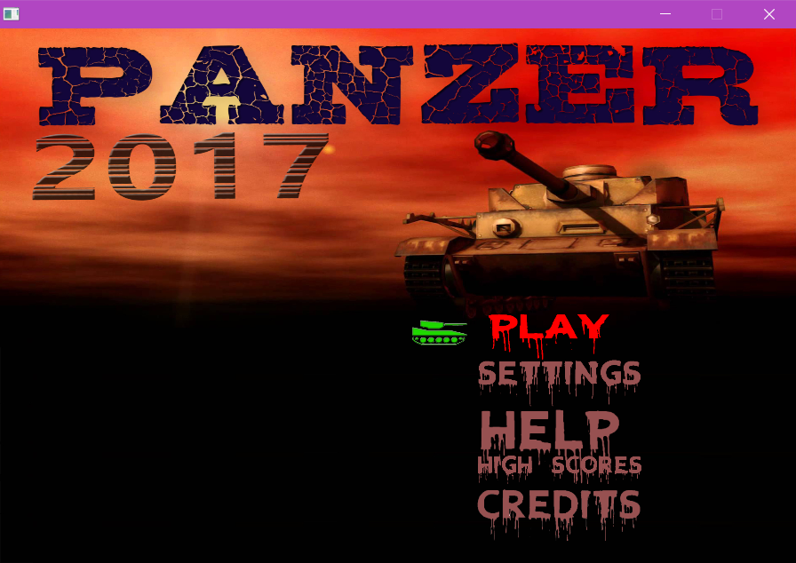

**Pause Menu:** It opens when the player presses ‘P’ button on the keyboard. The player can continue the game, can turn on/off the sound and exit.

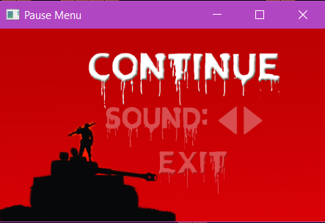

**Play:** If player chooses play button, ‘User Name Prompt’ window will appear and users can enter or if they wish they can skip this part by clicking ‘OK’ and then they can start the game.

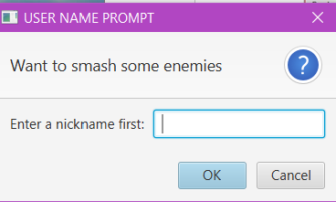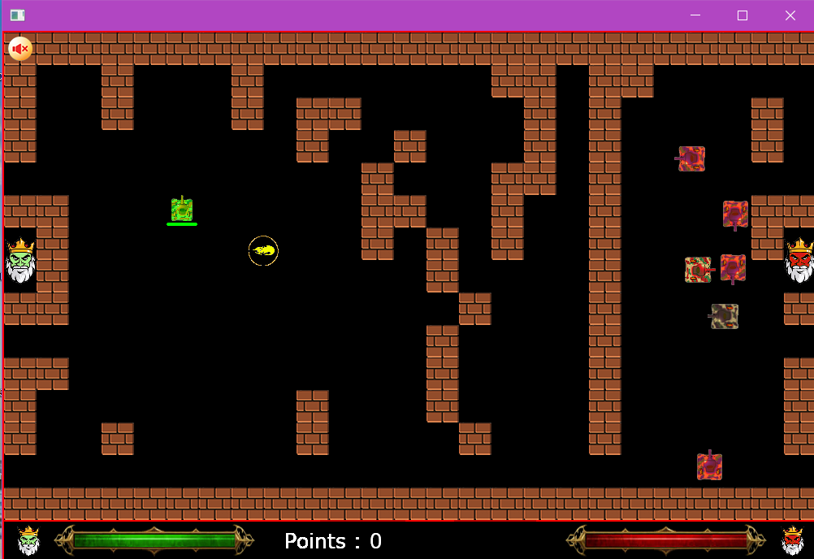

**High Scores:** This window appears when the player presses ‘High Scores’ in the Main Menu. The player can go back to the Main Menu by clicking ‘Back’.

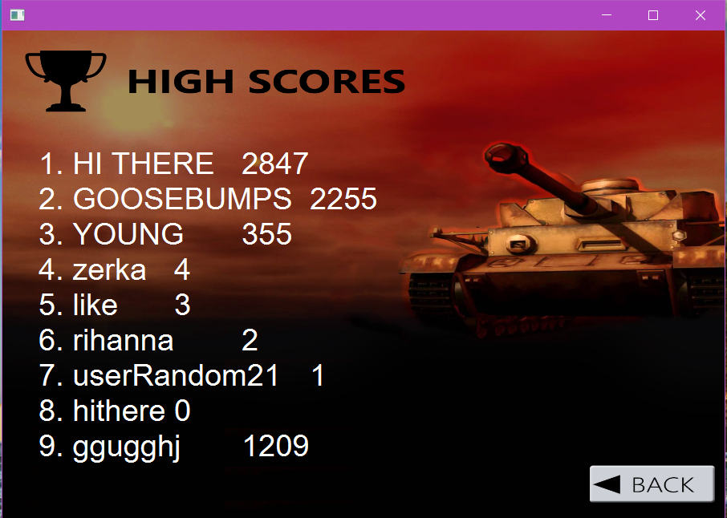

**Settings:** Player can choose Settings and the screen below shows up.

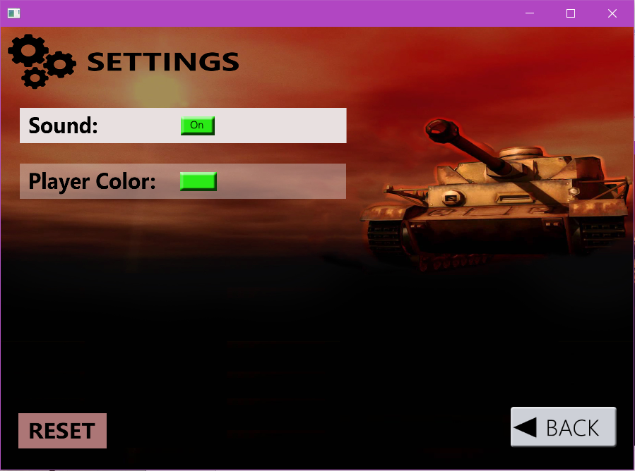

**Help:** If this option is selected, player can see the help instructions.

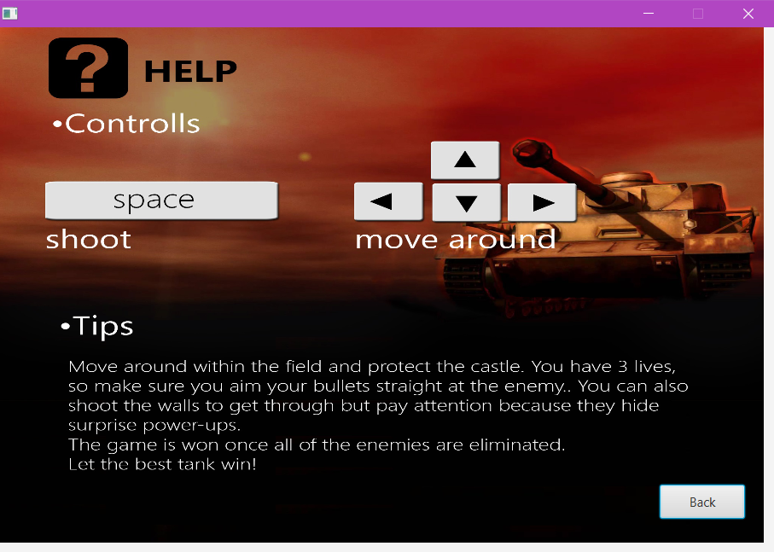

**Credits:** User can view the implementers by selecting ‘Credits’

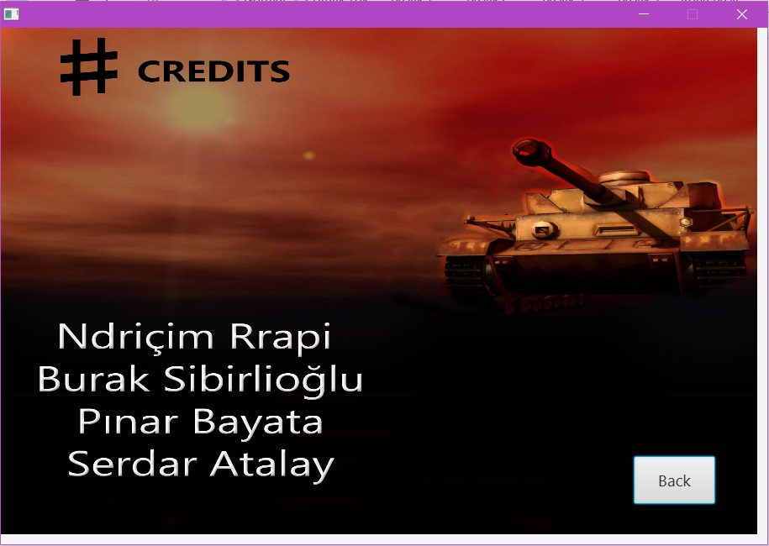

# 4.References

**[1]** https://docs.oracle.com/javafx/2/overview/jfxpub-overview.html