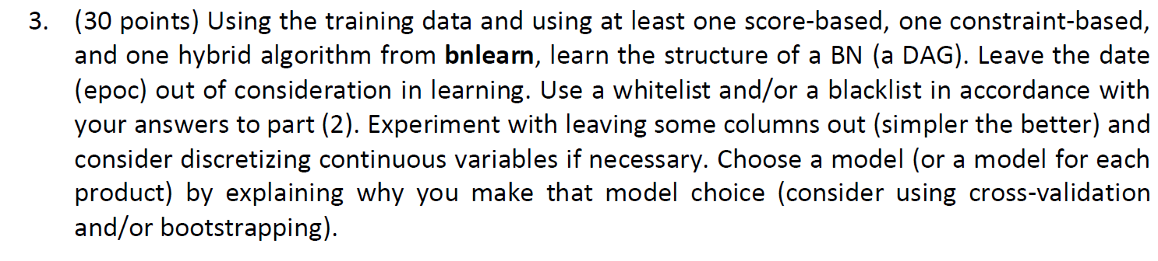

Three different methods (Hill Climbing, Grow Shrink and Max-Min Hill Climbing) which are scored-based, constraint-based and hybrid algorithms respectively, are used to learn structure of BN with a given train data.

"is_Amazon", "price_gap_ratio", "sid_pos_fb", "rank" and "bbox" parameters are used to learn DAG. "price_gap_ratio", and "sid_pos_fb" parameters does not discrete and it is known that continues nodes cannot be parent of discrete nodes. Therefore, our model tends to be misinterpreted. To prevent this problem these two parameters transformed to discrete by making intervals so that it can be treated as factor.

First DAG does not seem good model since we know some information between parameters. Therefore, whitelist and blacklist are used to force wanted arc and prevent unwanted arcs between parameters.

|  |  |  |  |
| --- | --- | --- | --- |
| Whitelist | | Blacklist | |
| from | to | from | to |
| price_gap_ratio | bbox | is_Amazon | price_gap_ratio |
| is_Amazon | bbox | price_gap_ratio | is_Amazon |
| rank | bbox | price_gap_ratio | sid_pos_fb |
| sid_pos_fb | bbox | sid_pos_fb | price_gap_ratio |
| is_Amazon | sid_pos_fb | rank | price_gap_ratio |
|  |  | rank | sid_pos_fb |
|  |  | sid_pos_fb | rank |
|  |  | rank | is_Amazon |

We are making whitelist and blacklist with the highest possible and logical information between nodes since learnt DAG is heuristic depends on whitelist and blacklist approval order. We start with whitelist since it is superior of blacklist.