- Project Name:
Multifunction Standalone Access Control
- Introduction:
The device is a single door multifunction standalone Access controller or a Wiegand output reader. It uses Xtensa® dual-core 32-bit LX6 microprocessor assuring high and stabe performance. The operation is very user-friendly.
- Features:
  - PIN Lenght: 4~6 digits
  - Communacation: Wiegand Input*1, Wiegand-Output*1
  - Control Output: Electric Lock*1
  - Control Input: Door Sensor*1, Exit Button*1
- Operation Modes:
The device has 3 different operating modes.
Standalone Mode(Default Mode): The device can work as Standalone Access Control for single door.
Bu modda Wiegand Input/Output haberleşmesi olmayacak.
Digital Inputlar bu modda çalışacak.
1.Dig_In : Exit Button : Direkt olarak kapıyı açabilir.
2.Dig_In : Door Contact: Kapının Açık/Kapalı konumu algılamak için kullanacağız. Bu giriş LOW olduğunda kapı açık konumda olduğunu anlayacağız.
Controller Mode: The device can work as Controller, connected with the external Wiegand Reader.
Bu modun Standalone modundan tek farkı Wiegand girişinden harici bir reader bağlanabilecek.
Yani dahili inputları olan RFID, PIN ve QR okuyucularının yanı sıra, harici bağlanan Reader da UID gönderebilecek.
Digital Inputlar bu modda çalışacak.
1.Dig_In : Exit Button : Direkt olarak kapıyı açabilir.
2.Dig_In : Door Contact: Kapının Açık/Kapalı konumu algılamak için kullanacağız. Bu giriş LOW olduğunda kapı açık konumda olduğunu anlayacağız.
Wiegand Reader Mode: The device can work as Standard Wiegand Reader, connected to the third party Controller.
Çünkü cihaz bu modda inputlarından okuduğu ID leri hiç bir işlem yapmadan Wiegand Outputundan gönderecek.
Digital Inputlar bu modda çalışmayacak.
- Authentication Type:
  - Card via 13.56Mhz (Mifare M1 Card)
  - Touch PIN
  - QR Code
  - External Card Reader with Wiegand- Input(26-34bit)
  - External Button (Digital Input)
- Verification Type:
  - Local Database (Offline)
  - Uzak Sunucu (Wi-Fi) (Online)
- Hardware Specs:
  - Power Supply : 12V DC
  - Components
    - MCU: ESP32-WROOM-32E-N4
    - RFID: MFRC522 IC
    - Touch: TSM12 IC
    - QR: XR1300 Module
    - Shift Register: SN74HC595
    - Buzzer: without Circuit, driver with PWM
    - Relay
    - Wiegand Interface: Input- Output
    - Digital Inputs: 2 inputs
  - MCU Pin Configuration:
    - RFID:
      - MOSI: GPIO 5
      - MISO: GPIO 36
      - CLK: GPIO 15
      - CS: GPIO 0
      - IRQ: GPIO 35
      - RST: 74HC595-2-QG
    - Touch PIN (TSM12):
      - SDA: GPIO 32
      - SCL: GPIO 33
      - INT: GPIO 14 (Interrupt output from TSM12)
      - OUT: GPIO 27
      - RST: 74HC595-1-QD
    - QR Code Reader (XR1300):
      - TX: GPIO 25 (Connect to QR Reader RX)
      - RX: GPIO 39 (Connect to QR Reader TX)
    - Shift Register Digital (SN74HC595):
      - CLK (SHCP): GPIO 4
      - DATA (DS): GPIO 16
      - LATCH 1 (STCP for First Block): GPIO 17
      - LATCH 2 (STCP for Second Block): GPIO 13
    - Wiegand Interface :
      - D0 (Data 0): GPIO 22 (Input/Output capable logic)
      - D1 (Data 1): GPIO 23 (Input/Output capable logic)
    - Digital Input (e.g., Door contact, Exit Request button):
      - Input-1: GPIO 19
      - Input-2: GPIO 21
    - Buzzer:
      - PWM Output: GPIO 2
    - Relay:
      - Relay-EN: 74HC595-2-QH
    - Addresable RGB Led(WS2812B):
      - Data IN: GPIO 12
    - Shift Register-Outputs (SN74HC595 x2):
      - SN74HC595-1
        - QA: LED_EN_9
        - QB: LED_EN_1
        - QC: LED_EN_4
        - QD: TSM_RST
        - QE: LED_EN_5
        - QF: LED_EN_6
        - QG: LED_EN_3
        - QH: LED_EN_2
      - SN74HC595-2
        - QA: LED_EN_8
        - QB: LED_EN_10
        - QC: LED_EN_7
        - QD: LED_EN_11
        - QE: LED_EN_12
        - QF: Wiegand Output Enable
        - QG: RFID_RST
        - QH: Relay-EN
- Sound and LED Indication
Operation Status | LED | Buzzer
Stand by | Red light bright
In the programming Mode | Orange light bright | One beep
Operation Error | Red light shines | Three beeps
Exit from the Programming Mode | Red light bright | One beep
Open Lock | Green light bright | One beep
Alarm | Red light Shines quickly | Beeps

- Reset
Menu 9 ile reset işlemi gerçekleştirilir. Reset işleminden sonra cihaz hafızasında bulunan Wi-Fi bilgileri, tüm UserID ve USERPIN kayıtları, Master Card kayıtları silinir. MasterCode Default değeri “123456” değerine döner.
Programming Step | Keystroke Combination
Enter Program Mode | ✶→ (Master Code) → #  (Factory default ise 123456)
Reset Fabrication Settings | 9 → 9 → #

- Basic Programming
  - Enter and Exit Program Mode
Programming Step | Keystroke Combination
Enter Program Mode | ✶→ (Master Code) → #  (Factory default ise 123456)
Exit Program Mode | *

  - Set Master Code
Programming Step | Keystroke Combination
1.Enter Program Mode | ✶→ (Master Code) → #  (Factory default ise 123456)
2.Update Master Code | 0 → (New Master Code) → # → (Repeat New Master Code) → #  (Master code is any 6 digits)
3.Exit Program Mode | *

  - Set the Working Mode
Notes: The device has 3 working modes:Standalone Mode, Controller Mode and Wiegand Reader Mode, choose the mode you use.
Programming Step | Keystroke Combination
1.Enter Program Mode | ✶→ (Master Code) → #
2.Standalone Mode  2.Controller Mode  2.Wiegand Reader Mode | 6 → 7 → #  6 → 8 → # (Factory Default for PIN+QR and PIN+RFID)  6 → 9 → # (Factory Default for RFID_Only)
3.Exit Program Mode | *

- OFFLINE OPERATION (Offline Mode)
  - Standalone Mode
The device can work as Standalone Access Control for single door.
67#
    - Connection Diagram Common Power Supply
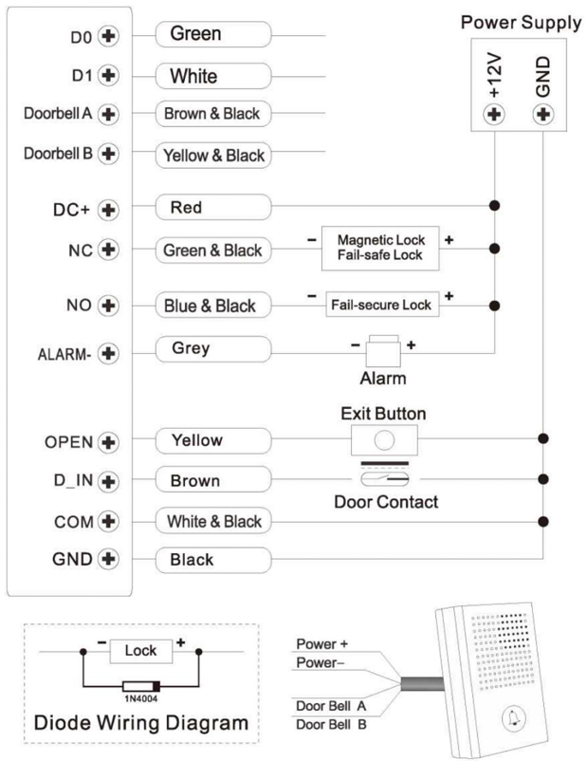
    - Programming
Programming will be vary depending on Access configuration. Follow the instructions according to your Access configuration.
Notes:
- UserID number: Assign a user ID to the Access card / PIN in order to track it.
- UserID number:
The Common Card/ PIN User ID: 1-9988
IMPORTANT: User IDs do not have to be proceeded with any leading zeros. Recording of User ID is critical. Modifications to the user require the User ID be available.
- Proximity Card: Mifare Card
- PIN: Can be any 4~6 digits.
- QR: Support

    - Add Master Card
(Card MasterID: 10000-10010)
Programming Step | Keystroke Combination
1.Enter Program Mode | ✶→ (Master Code) → #
Add Card Master
2.Using Master ID (Allows the device to assign Card to next available Master ID number) OR | 1 → Read Card → #  1 → Input 8/10/17 Digits Card Number → #  The cards can be added contionusly.
2.Using Specific ID (Allows Master to define a specific Master ID to associate the card to) OR | 1 → MasterID → # → Read Card → #  1 → MasterID → # → Input 8/10/17 Digits Card Number → #
3. Exit | *

    - Add Users
Programming Step | Keystroke Combination
1.Enter Program Mode | ✶→ (Master Code) → #
Add Card User
2.Using Auto ID (Allows the device to assign Card to next available User ID number) OR | 2 → Read Card → #  2 → Input 8/10/17 Digits Card Number → #  The cards can be added contionusly.
Add PIN User
2.Using Auto ID (Allows the device to assign Card to next available User ID number) | 2 → Input (4-6) Digits UserPIN → # → PIN Again → #  The pins can be added contionusly.
3. Exit | *
Note: Users are added via the mobile application for QR code access.
Tips for PIN Security (Only validfor 6digits PIN):
For higher security we allow you to hide your correct PIN with other numbers up to a max of 10 digits.
Example PIN: 123434
You could use **(123434) ** or ** (123434)
(“*”can be any numbers from 0~9)
    - Change PIN Users (PIN lenght: 4~6 digits)
Programming Step | Keystroke Combination
Note: Below is done outside programming model users can undertake this themselves
Change PIN | ✶ → UserID → # → OldPIN → # → NewPIN → # → Repeat NewPIN → #

    - Delete Users
Programming Step | Keystroke Combination
Entering the Programming Mode | ✶ → MasterCode → #
2. Delete User – by Read Card  OR  2. Delete User – by ID  OR  2. Delete User – by CardNumber  OR  2. Delete ALL Users | 3 → ReadCard → #  The users can be deleted continuously  3 → UserID → #  3 → Input 8/10/17 Digits Card Number → #  3 → Master Code → #  3 → Read Master Card → #
Exit | ✶

    - Set Open Door Detection
Programming Step | Keystroke Combination
Entering the Programming Mode | ✶ → MasterCode → #
2. Disable Door Open Detection  OR  2. Enable Door Open Detection Set Alarm Time | 7 → 3 → # (Factory Default)  7 → 4 → 0~3→ #  (Factory Default is 1 minutes)
Exit | ✶

    - Set Relay Configuration
Programming Step | Keystroke Combination
Entering the Programming Mode | ✶ → MasterCode → #
2. Pulse Mode  OR  2. Toggle Mode  OR  2. Led Always ON | 4 → 1~99 → # (Factory Default)  The relay time is 1-99 seconds.  Default is 5 seconds.  4 → 0 → #  Sets the relay to ON/OFF Toggle mode  8 → 2 → #  8 → 3 → # (Factory Default)

    - Set Audible and Visual Response
Programming Step | Keystroke Combination
Entering the Programming Mode | ✶ → MasterCode → #
2. Disable Sound  OR  2. Enable Sound  OR  2. Led Always OFF  OR  2. Led Always ON | 8 → 0 → #  8 → 1 → # (Factory Default)  8 → 2 → #  8 → 3 → # (Factory Default)
Exit | ✶

    - Master Card Usage
Using Master Card to ADD and DELETE user
Add Card / PIN Users | 1. Read the Master Card.  2. Read User Card or UserID → # → PIN → #  Repeat step 2 for additional users.  3. Read the Master Card again.
Delete Card / PIN Users | 1. Read the Master Card Twice within 5sec.  2. Read User Card or UserID → #  Repeat step 2 for additional users.  3. Read the Master Card again.

    - SpecificID Kullanıcı Ekleme ve Toplu Kullanıcı Ekleme
(PIN / Card / QR user ID: 1-9988; PIN lenght: 4~6 digits)
Programming Step | Keystroke Combination
1.Enter Program Mode | ✶→ (Master Code) → #
Add Card User
2.Using Specific ID (Allows Master to define a specific User ID to associate the card to) OR | 5 → UserID → # → Read Card → #  5 → UserID → # → Input 8/10/17 Digits Card Number → #
2. Add Card: Block Enrollment (Allow Master to add up to 200 cards to the Reader in a single step) Takes 2 minutes to program. | 5 → UserID → # → Card Quantity → # → The First Card 8/10/17 Digits Number → #  Card’s number must be consecutive;  Card quantity = number of cards to be enrolled.
Add PIN User
2.Select Specific ID (Allows manager to define a specific User ID to associate the PIN to) | 5 → UserID → # → PIN → #  UserPIN lenght: 4~6 digits).  The pins can be added contionusly.
3. Exit | *

    - Users Opearation & Reset to Factory Default
      - Open the door: Read Valid User Card or Input Valid UserPIN → #
      - Remove Alarm: Enter MasterCode → # or Read Master Card or Valid User Card or Enter UserPIN
  - CONTROLLER MODE
The device can work as Controller, connected with the external Wiegand reader.
- 67#
    - Connection Diagram
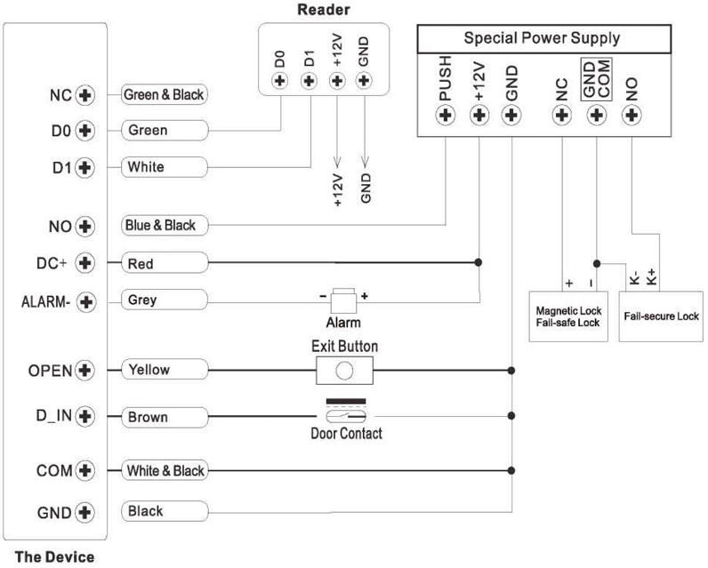
    - Set Wiegand Input Formats
Digital Input State :
If LOW = 26bit
If HIGH = 34bit
    - Programming
Basic Programming is the same as Standalone Mode

  - WIEGAND READER MODE
The device can work as Standard Wiegand Reader, connected to the third party Controller — 68#
    - Connection Diagram
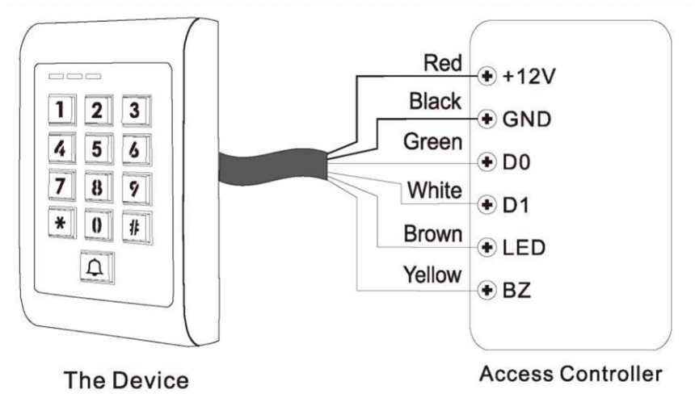
Notes:
- When set into Wiegand Reader Mode, nearly all settings in Controller Mode will become invalid, and Brown & Yellow wires will be redefined as below:
- - Brown wire: Green LED light control
- Yellow wire: Buzzer Control
If you need to connect Brown/Yellow wires:
When the input voltage for LED is low, the LED will turn into Green; and when the input voltage for Buzzer is low, it will sound.
    - Set Wiegand Output Formats
- Digital Input State :
If LOW = 26bit
If HIGH = 34bit
Simplified Instruction
Function Description | Operation
Enter the Programming Mode | * → Master Code → #  then you can do the programming.  (Factory default MasterCode is 123456)
Change the Master Code | 0 → New Code → # → Repeat the New Code → #  (code: 6 digits)
Add Card User | In programming mode  1 → Read Card → #  OR 1→ Input 8/10/17 Digits Card Number → #  (can add cards continuously)
Add PIN User | In programming mode  1 → UserID → PIN #  The PIN is any 4~digits
Add QR User | In programming mode  2 → QR Code → #  (can add QR continuously)
Delete User | In programming mode  2 → Read Card → #  2 → UserID → #  2 → QR Code → #
Exit from the Programming Mode | *
How to Release the Door
Card User | Read Card
PIN User | Input PIN → #
QR User | Read QR

