Akdeniz University
Department of Computer Engineering
Software Engineering Project
Group 25
Project short-name:TazelenmeApp,
Tazelenme University Student Management, RFID Attendance and Mini-LMS Platform

Software Requirements Specification & Analysis
Project Group 25, Project Group Member 1 - Burak Yalçın - 20220808069

Team Leader: Burak Yalçın
Product Owner: Akdeniz University

Instructor: Prof. Ümit Deniz ULUŞAR

Date: 24 April 2026
This report is submitted to the Department of Computer Engineering of Akdeniz University of the Software Engineering course CSE332.

Abbreviations
DB | Database
API | Application Programming Interface
JWT | JSON Web Token
LMS | Learning Management System
PWA | Progressive Web Application
RFID | Radio Frequency Identification
SRS | Software Requirements Specification
KVKK | Turkish Personal Data Protection Law
PIN | Personal Identification Number
Contents
1 Introduction 1
1.1 Purpose 1
1.2 Product Scope 1
1.3 References 1
2 Overall Description 2
2.1 Product Perspective 2
2.2 Product Functions 3
2.3 User Types and Characteristics 3
2.4 Operating Environment 3
2.5 Design and Implementation Constraints 3
2.6 User Documentation 4
2.7 Assumptions and Dependencies 4
3 External Interface Requirements 5
3.1 User Interfaces 5
3.2 Hardware Interfaces 6
3.3 Software Interfaces 6
3.4 Communications Interfaces 6
4 System Features 7
4.1 Authentication and Role-Based Access 7
4.2 Student, Health, and Enrollment Management 7
4.3 Attendance and RFID Card Management 8
4.4 Mini-LMS, Notifications, and Reports 9
5 Nonfunctional System Requirements 10
5.1 Performance Requirements 10
5.2 Safety Requirements 11
5.3 Security Requirements 11
5.4 Software Quality Attributes 12
5.5 Business Rules 12
6 Other Requirements 13
7 System Models 14
7.1 System Context 14
7.2 Interaction Models 14
7.2.1 Use-Case Models 15
7.2.1.1 RFID Attendance Scan 15
7.2.1.2 Manual Attendance 16
7.2.1.3 View Course Materials 16
7.2.2 Sequence Diagrams 17
7.2.2.1 Login 17
7.2.2.2 RFID Attendance Scan 18
7.2.2.3 Student Material Access 18
7.3 Structural Models 19
7.3.1 Object and Class Model 19
7.3.1.1 User Class 20
7.3.1.2 StudentProfile Class 20
7.3.1.3 RfidCard Class 20
7.3.1.4 Attendance Class 21
7.3.1.5 CourseMaterial Class 21
7.4 Behavioral Models 22
7.4.1 Data Driven (Activity Diagrams / Sequence Diagrams) 22
7.4.2 Data Driven (Sequence Diagrams) 23
7.4.3 Event Driven Models (State Diagrams) 23
7.5 User Interface 24
7.6 Test 25
8 References 26
9 Appendix A: Glossary 26

1 Introduction

1.1 Purpose
The purpose of this document is to define the software requirements and analysis models for TazelenmeApp. TazelenmeApp is a web-based and mobile-first platform for Tazelenme University, where 60+ age-group students attend courses. This HW2 version extends the initial SRS with UML use cases, sequence diagrams, a class model, behavioral diagrams, and user interface designs.

1.2 Product Scope
The system replaces paper-based attendance and fragmented course material sharing with a single platform. It supports coordinator workflows for student records, health notes, RFID card management, attendance, courses, materials, notifications, and reports. Students use a simplified PWA to view only their own courses, attendance status, and course materials.

1.3 References
- TazelenmeApp repository README.md, inspected on 26 April 2026.
- backend/prisma/schema.prisma database schema.
- backend/src/controllers/* implementation files for auth, attendance, cards, materials, reports, and student portal.
- frontend/src/app and frontend/src/components application screens and shared UI components.
- Software Requirement Report Template for HW2.docx provided by the course.

2 Overall Description

2.1 Product Perspective
TazelenmeApp is a new self-contained product with three operational surfaces: a coordinator admin panel, a student PWA, and an RFID reader integration API. The deployed application consists of a Next.js frontend, an Express/TypeScript backend, Prisma ORM, PostgreSQL, file upload storage, and scheduled background jobs.
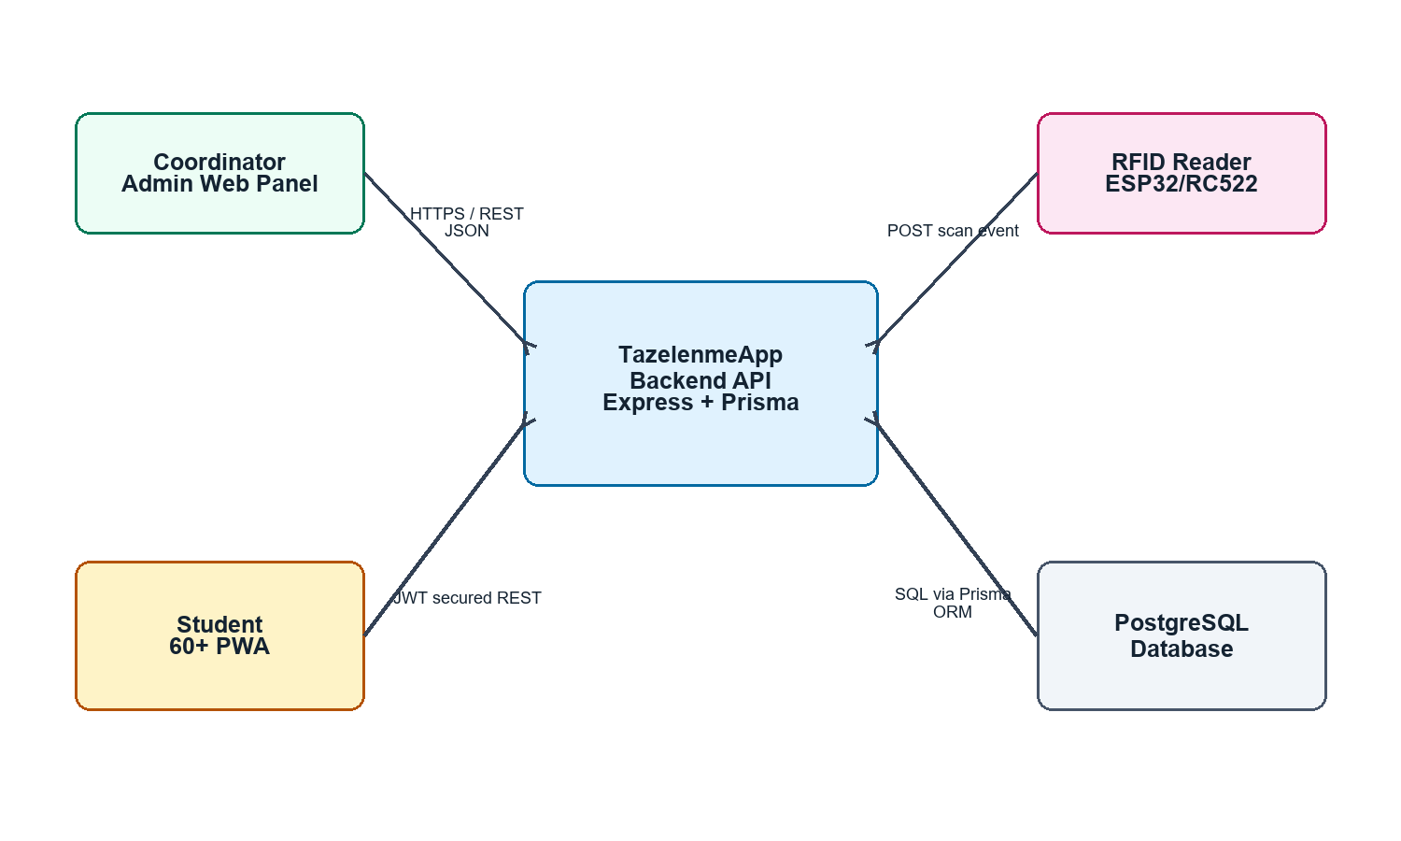
Figure 1. System context model.

2.2 Product Functions
- Authenticate coordinators and students with TC identity number plus PIN.
- Create, update, filter, import, export, and deactivate student records.
- Store emergency contact and health condition information with privacy controls.
- Assign RFID cards, mark cards as lost or revoked, and block invalid card scans.
- Record attendance through RFID scan events or coordinator manual fallback.
- Manage classrooms, courses, lesson sessions, enrollments, and course materials.
- Calculate pass/fail results based on a 70% attendance threshold.
- Detect social isolation risk after three weeks of non-attendance and notify coordinators.

2.3 User Types and Characteristics
User Type | Characteristics
Coordinator / Admin | High-frequency operational user. Uses desktop web panel to manage students, cards, courses, attendance, materials, reports, and risk notifications.
Student | 60+ age-group user. Uses a simplified PWA with large buttons, large text, and high contrast to view only personal course and attendance information.
RFID Reader | Hardware/system actor. Sends scan events containing card UID and classroom/location code to the backend API.

2.4 Operating Environment
Frontend runs on Next.js 16 and React 19. Backend runs on Node.js, Express 5, TypeScript, Prisma 7, and PostgreSQL. The standard local environment is Docker Compose with frontend, backend, and database services. Student devices access the PWA through a modern mobile browser.

2.5 Design and Implementation Constraints
- Student UI must be accessible for 60+ users: minimum 18px text, large touch targets, clear focus states, and simple navigation.
- TC identity numbers and health-related data must be protected according to KVKK expectations.
- RFID attendance must tolerate repeated scans without duplicate attendance records.
- The system must be deployable with Docker Compose and must not require manual database setup after migrations.
- The hardware reader communicates over HTTP/HTTPS using JSON and an API key.

2.6 User Documentation
The project shall be delivered with practical documentation for both installation and daily operation. The current README already explains Docker startup, local development, seed/demo credentials, validation commands, and a presentation flow. For the final delivery, the documentation set should also describe role-based use of the system and common troubleshooting steps.
- Coordinator/Admin Guide: login, dashboard overview, student creation and update, health information entry, RFID card assignment, card loss/revocation, course/session/material management, manual attendance, notification follow-up, CSV import/export, and pass/fail report generation.
- Student PWA Guide: TC No + PIN login, viewing enrolled courses, checking attendance status, opening or downloading course materials, and basic mobile/PWA installation steps.
- RFID Reader Setup Guide: device location code configuration, API endpoint information, API key usage, expected success/error responses, and LED/buzzer behavior for accepted, duplicate, unknown, lost, or revoked cards.
- System Administration Guide: docker compose startup/shutdown, environment variables, PostgreSQL backup/restore, Prisma migration/seed commands, upload storage location, and health-check endpoint usage.
- Privacy and Support Notes: coordinator responsibility for KVKK-sensitive data, student PIN handling, who may access health notes, and how to contact the project team when login or card problems occur.

2.7 Assumptions and Dependencies
- RFID readers have stable Wi-Fi connectivity during course entry periods.
- Lesson sessions are created with correct classroom, start time, and end time values.
- Coordinators are responsible for entering accurate student, health, course, and enrollment data.
- Students are given a random PIN and understand that it must not be shared.

3 External Interface Requirements

3.1 User Interfaces
The coordinator interface is a modern admin dashboard with sidebar navigation, KPI cards, data tables, forms, dialogs, and CSV import/export actions. The student interface is a mobile-first PWA with large navigation buttons, attendance status cards, course progress, and filtered material lists.
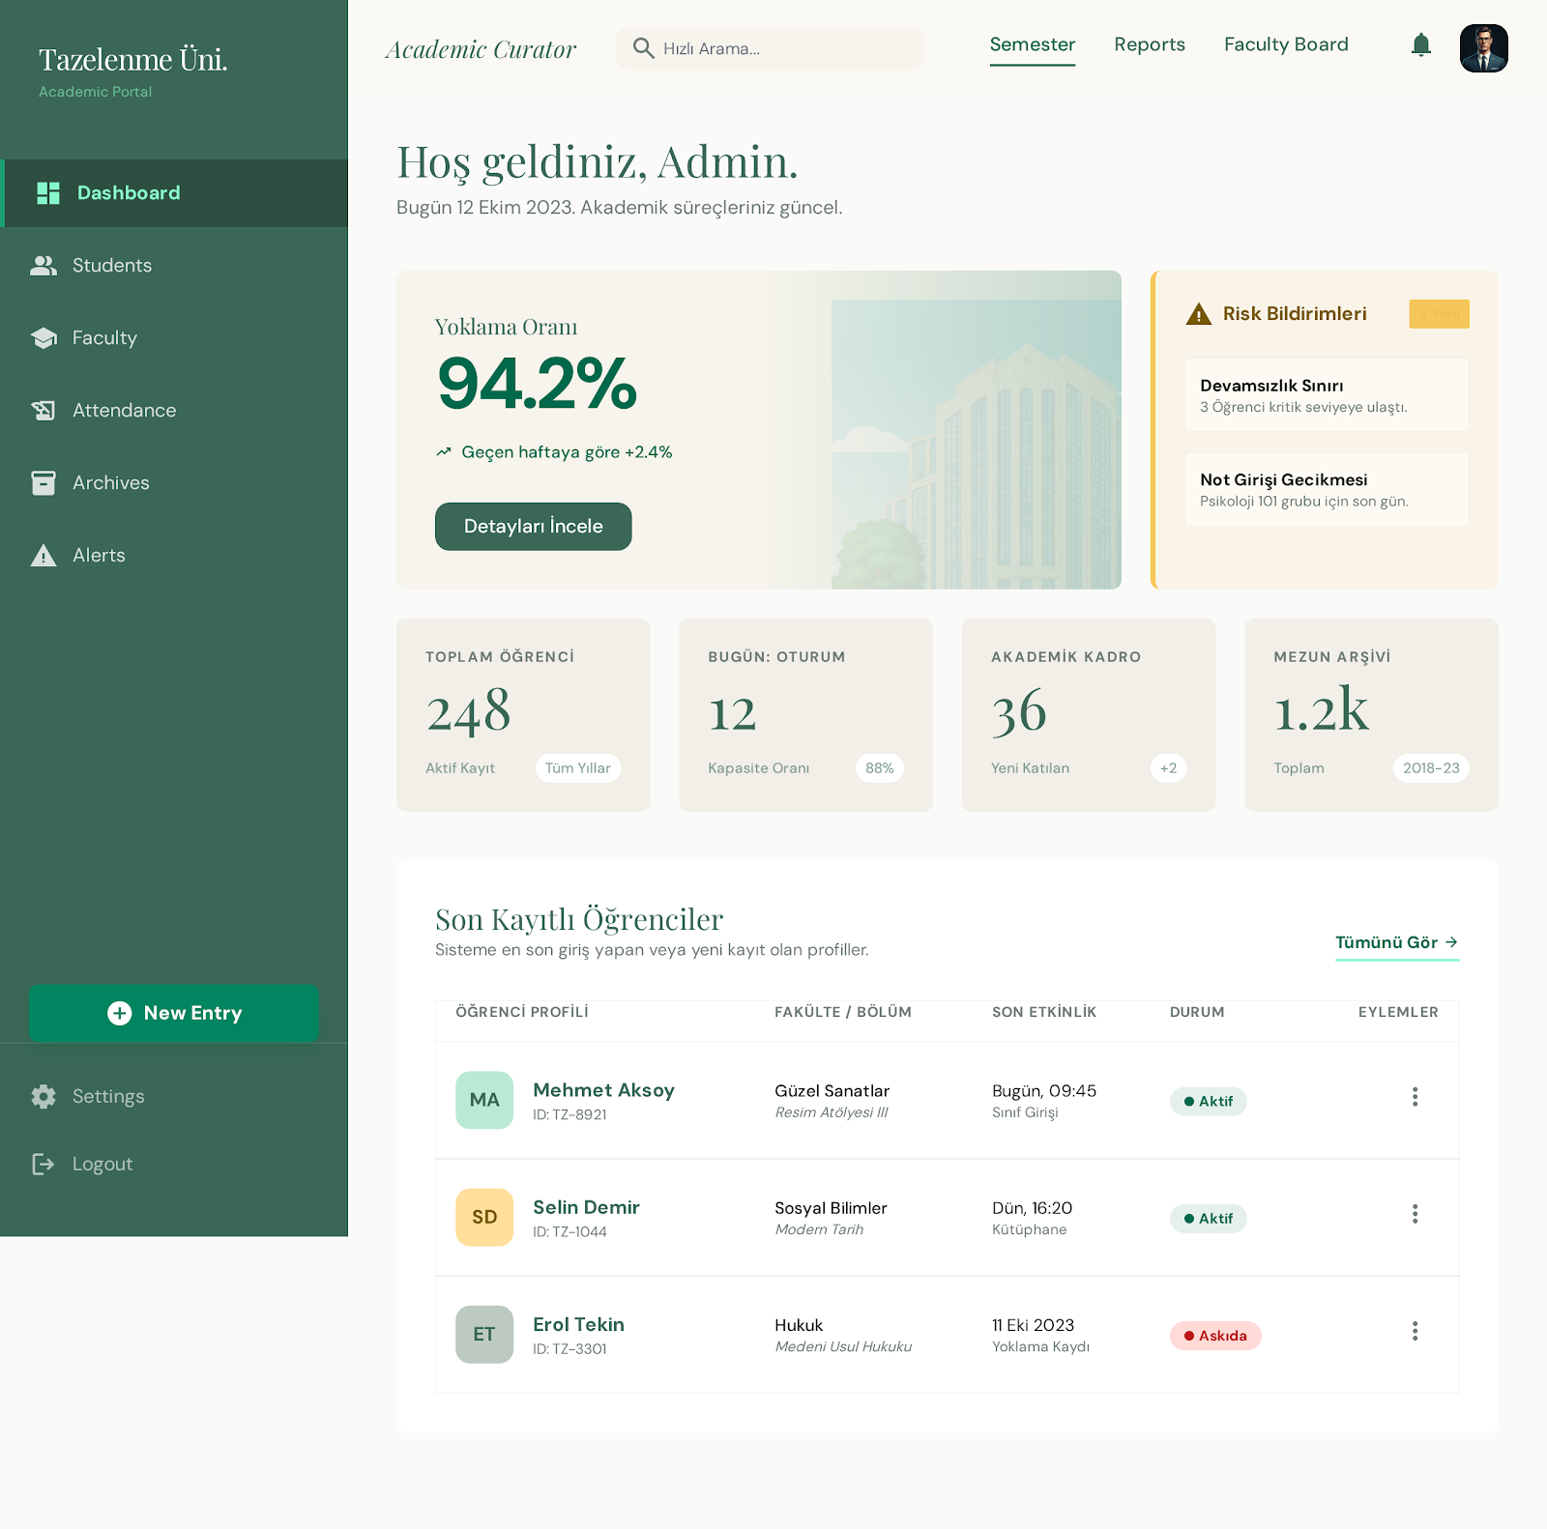
Figure 2. Coordinator admin dashboard UI design.
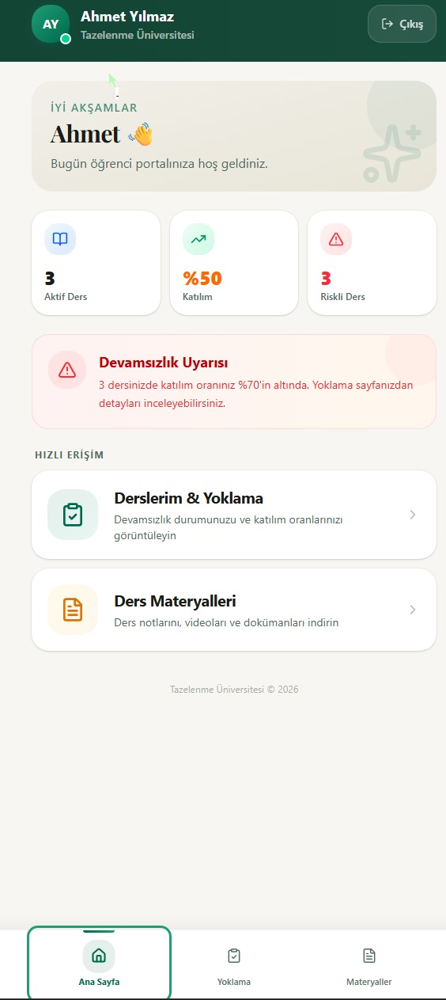
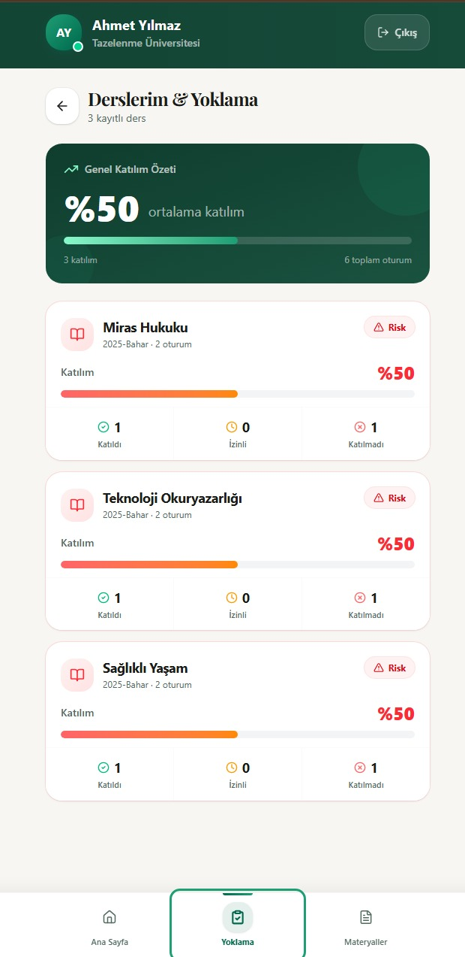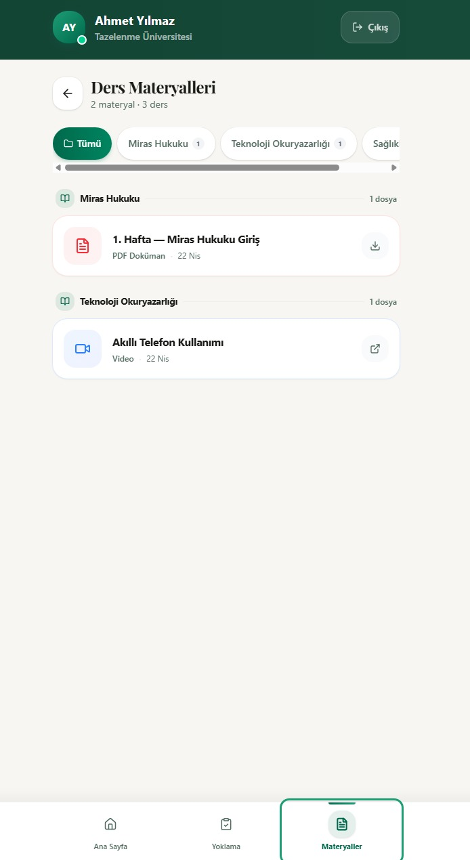
Figure 3. Student PWA home UI design.

3.2 Hardware Interfaces
The RFID reader is expected to be an ESP32/ESP8266-like microcontroller connected to an RC522-compatible RFID module. It reads the physical card UID and sends it to POST /api/v1/attendance/scan together with a deviceLocation/classroom code.

3.3 Software Interfaces
- Next.js frontend communicates with the backend through REST API calls.
- Express backend accesses PostgreSQL through Prisma ORM.
- JWT access and refresh tokens support authenticated sessions.
- Multer handles PDF material upload storage.
- node-cron runs isolation-risk checks every Friday at 18:00 Europe/Istanbul.

3.4 Communications Interfaces
All client-to-server and reader-to-server communication uses HTTP/HTTPS and JSON. Admin and student endpoints require JWT authorization. RFID scan endpoints require device authentication through x-api-key. CORS is limited to configured frontend origins.

4 System Features

4.1 Authentication and Role-Based Access
ID | Title | Description | Rationale | Dependencies
FR-1 | Login with TC No and PIN | The system shall authenticate users by TC identity number and PIN. | Protects private data while keeping login simple for 60+ users. | None
FR-2 | Role-based redirect | After login, admins shall be routed to the admin panel and students to the PWA. | Prevents students from accessing administrative functions. | FR-1
FR-3 | Token refresh | The system shall support refresh tokens for session continuity. | Reduces repeated login burden. | FR-1

4.2 Student, Health, and Enrollment Management
ID | Title | Description | Rationale | Dependencies
FR-4 | Manage student records | Admins shall create, update, list, import, export, and deactivate student records. | Maintains accurate university records. | FR-1
FR-5 | Store health notes | Admins shall store predefined health conditions and optional notes for a student. | Supports emergency awareness and social-care context. | FR-4
FR-6 | Manage enrollments | Admins shall enroll students into courses and prevent duplicate enrollments. | Links attendance and material visibility to course membership. | FR-4

4.3 Attendance and RFID Card Management
ID | Title | Description | Rationale | Dependencies
FR-7 | Assign RFID cards | Admins shall assign a unique card UID to a student. | Enables physical attendance capture. | FR-4
FR-8 | Block lost/revoked cards | The system shall reject LOST or REVOKED cards and create a notification. | Prevents misuse of lost cards. | FR-7
FR-9 | RFID attendance scan | The reader shall submit cardUid and deviceLocation; the system shall mark the student PRESENT for the active session. | Automates high-volume course entry. | FR-6, FR-7
FR-10 | Anti-passback | The system shall store at most one attendance record per student per session. | Prevents duplicate attendance caused by repeated scans. | FR-9
FR-11 | Manual attendance | Admins shall manually mark PRESENT, ABSENT, or EXCUSED for enrolled students. | Provides fallback when cards are forgotten or hardware is unavailable. | FR-6

4.4 Mini-LMS, Notifications, and Reports
ID | Title | Description | Rationale | Dependencies
FR-12 | Upload materials | Admins shall upload PDF files or create LINK/VIDEO materials for a course. | Centralizes learning resources. | FR-6
FR-13 | Student material access | Students shall view and download only materials for enrolled courses. | Protects course privacy and simplifies student experience. | FR-1, FR-6, FR-12
FR-14 | Isolation risk notification | The system shall flag students with no PRESENT or EXCUSED attendance in the last 21 days. | Supports early intervention against social isolation. | FR-9, FR-11
FR-15 | Pass/fail report | The system shall calculate pass/fail using a 70% attendance threshold. | Supports end-of-term administrative reporting. | FR-9, FR-11

5 Nonfunctional System Requirements
ID | Quality Attribute | Requirement
NFR-1 | RFID scan response time | Under normal load, attendance scan responses should complete within 2 seconds for 100% of measured test requests.
NFR-2 | Peak load | The backend should handle rapid consecutive scan events for approximately 200 students entering a classroom.
NFR-3 | Accessibility | Student PWA shall use large text, high contrast, visible focus, and at least 48px touch targets.
NFR-4 | Security and privacy | TC identity numbers shall be encrypted for storage and hashed for lookup; students shall not access other students' data.
NFR-5 | Portability | The system shall run with docker compose up using frontend, backend, and PostgreSQL containers.
NFR-6 | Auditability | Sensitive admin actions such as login, material upload, card status update, and manual attendance shall be logged.

5.1 Performance Requirements
- RFID scan requests should return a success, duplicate, or validation response within 2 seconds under normal classroom network conditions.
- The backend should support rapid consecutive scans for approximately 200 students at the beginning of a lesson without creating duplicate attendance rows.
- Admin dashboard list, filter, and report screens should load within 3 seconds for typical course and student volumes used by Tazelenme University.

5.2 Safety Requirements
- The system shall not treat a lost or revoked RFID card as valid attendance; it shall block the card and notify the coordinator.
- Emergency contact and health-condition information shall be available only to authorized coordinator users because it may be needed during student support or emergency follow-up.
- Manual attendance changes shall be auditable so accidental or incorrect status changes can be traced to an admin action.

5.3 Security Requirements
- Users shall authenticate with TC identity number and PIN; PIN values shall be stored only as hashes.
- TC identity numbers shall be encrypted for storage and hashed for lookup, reducing exposure of KVKK-sensitive data.
- Students shall access only their own course, attendance, and material data. Admin-only endpoints shall require JWT authentication and ADMIN authorization.
- RFID scan endpoints shall require device authentication through the x-api-key header, and API responses shall avoid exposing unnecessary private data.

5.4 Software Quality Attributes
- Usability: the student PWA shall use readable text, large touch targets, high contrast, simple navigation, and clear status indicators for 60+ users.
- Maintainability: backend logic is separated into controllers, routes, middleware, jobs, and utility modules; database structure is represented through Prisma schema and migrations.
- Portability: the application shall run through Docker Compose with frontend, backend, and PostgreSQL services.
- Reliability: attendance uniqueness is enforced at database level through the session-student unique constraint, protecting the system from repeated scans.
- Observability: important operations such as login, manual attendance, card status changes, and material upload shall be logged or auditable.

5.5 Business Rules
- Only admins may manage students, health data, cards, courses, sessions, materials, reports, and notification follow-up.
- A student may see only personal attendance summaries and materials for courses in which the student is enrolled.
- A course pass result requires at least 70% PRESENT or EXCUSED attendance.
- A card with LOST or REVOKED status must not create an attendance record.
- A student can have card history, but RFID card UIDs must remain globally unique.

6 Other Requirements
The database must maintain relational integrity for users, student profiles, RFID cards, courses, enrollments, sessions, attendance records, materials, notifications, and audit logs. Future work may include offline material caching, real-time dashboard updates through Server-Sent Events or WebSockets, and hardened IoT firmware.

7 System Models

7.1 System Context
The system context model defines the external actors and systems around TazelenmeApp: coordinator admin panel, student PWA, RFID reader hardware, backend API, and PostgreSQL database. The detailed context diagram is provided as Figure 1 in Section 2.1 and is used as the top-level boundary for the UML models below.

7.2 Interaction Models

7.2.1 Use-Case Models
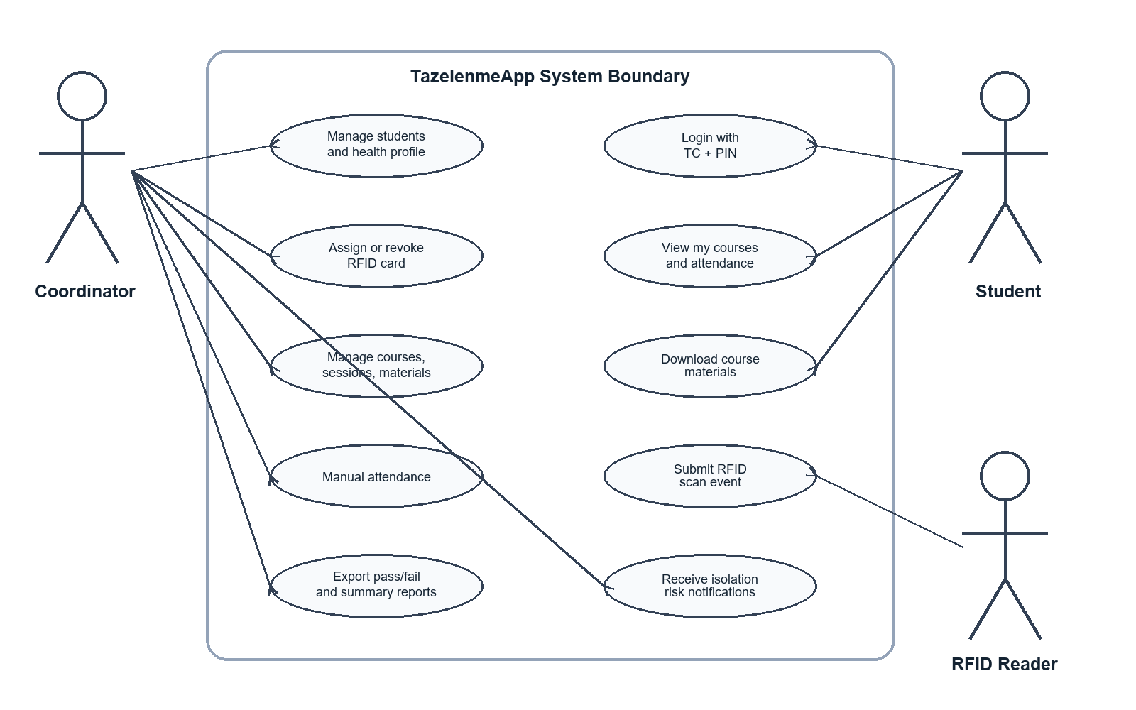
Figure 4. Use-case model for TazelenmeApp.

7.2.1.1 RFID Attendance Scan
Use Case | RFID Attendance Scan
Actors | RFID Reader, Student, Backend API
Description | A student scans an assigned RFID card at a classroom entrance. The reader sends cardUid and deviceLocation to the API, and the system records attendance for the active lesson session.
Data | cardUid, deviceLocation, active session, enrollment, card status, attendance status
Stimulus | RFID card is scanned by the classroom reader.
Response | The system returns success, duplicate scan, unknown card, lost/revoked card, inactive session, or non-enrolled student response.
Comments | Anti-passback is enforced by the unique sessionId-studentId attendance rule.

7.2.1.2 Manual Attendance
Use Case | Manual Attendance
Actors | Coordinator/Admin
Description | The coordinator opens a lesson session attendance list and manually marks students as PRESENT, ABSENT, or EXCUSED.
Data | sessionId, studentId, attendance status, admin user id, timestamp
Stimulus | Coordinator submits an attendance status change from the admin panel.
Response | The system validates enrollment and updates or creates the attendance record.
Comments | Manual changes are logged through audit records for accountability.

7.2.1.3 View Course Materials
Use Case | View Course Materials
Actors | Student
Description | A student logs in to the PWA and views PDF, link, or video materials only for enrolled courses.
Data | student profile id, enrollments, course materials, download URL
Stimulus | Student opens the Materials page in the PWA.
Response | The system returns enrolled courses and their materials; unauthorized course materials are not shown.
Comments | This use case supports privacy and simple access for 60+ users.

7.2.2 Sequence Diagrams
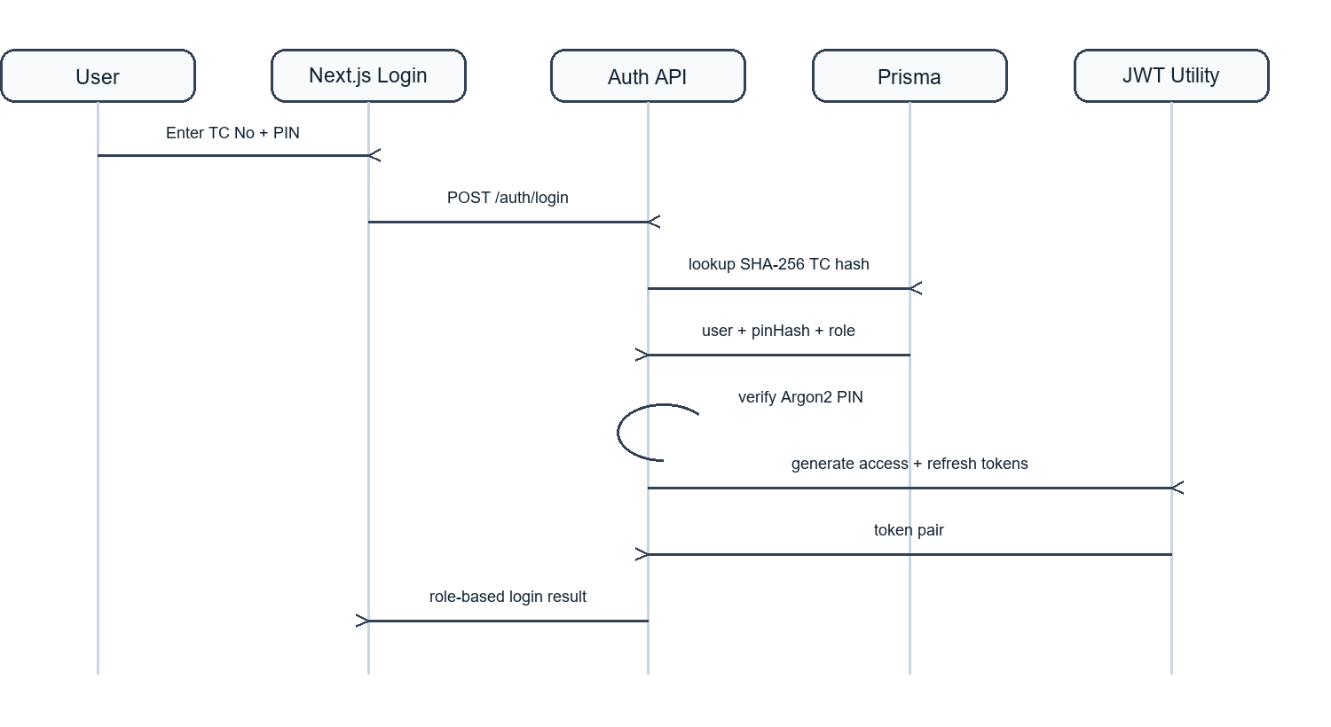
Figure 5. Login sequence diagram.
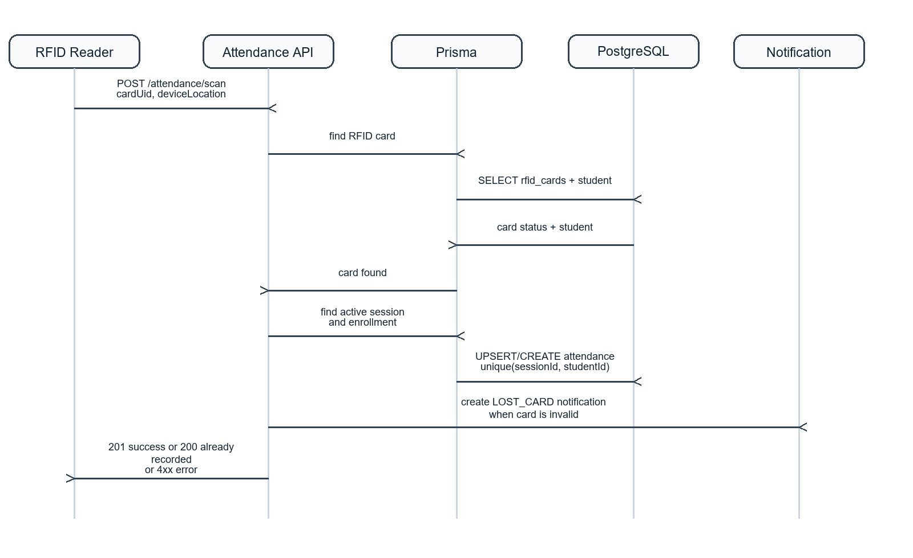
Figure 6. RFID attendance scan sequence diagram.
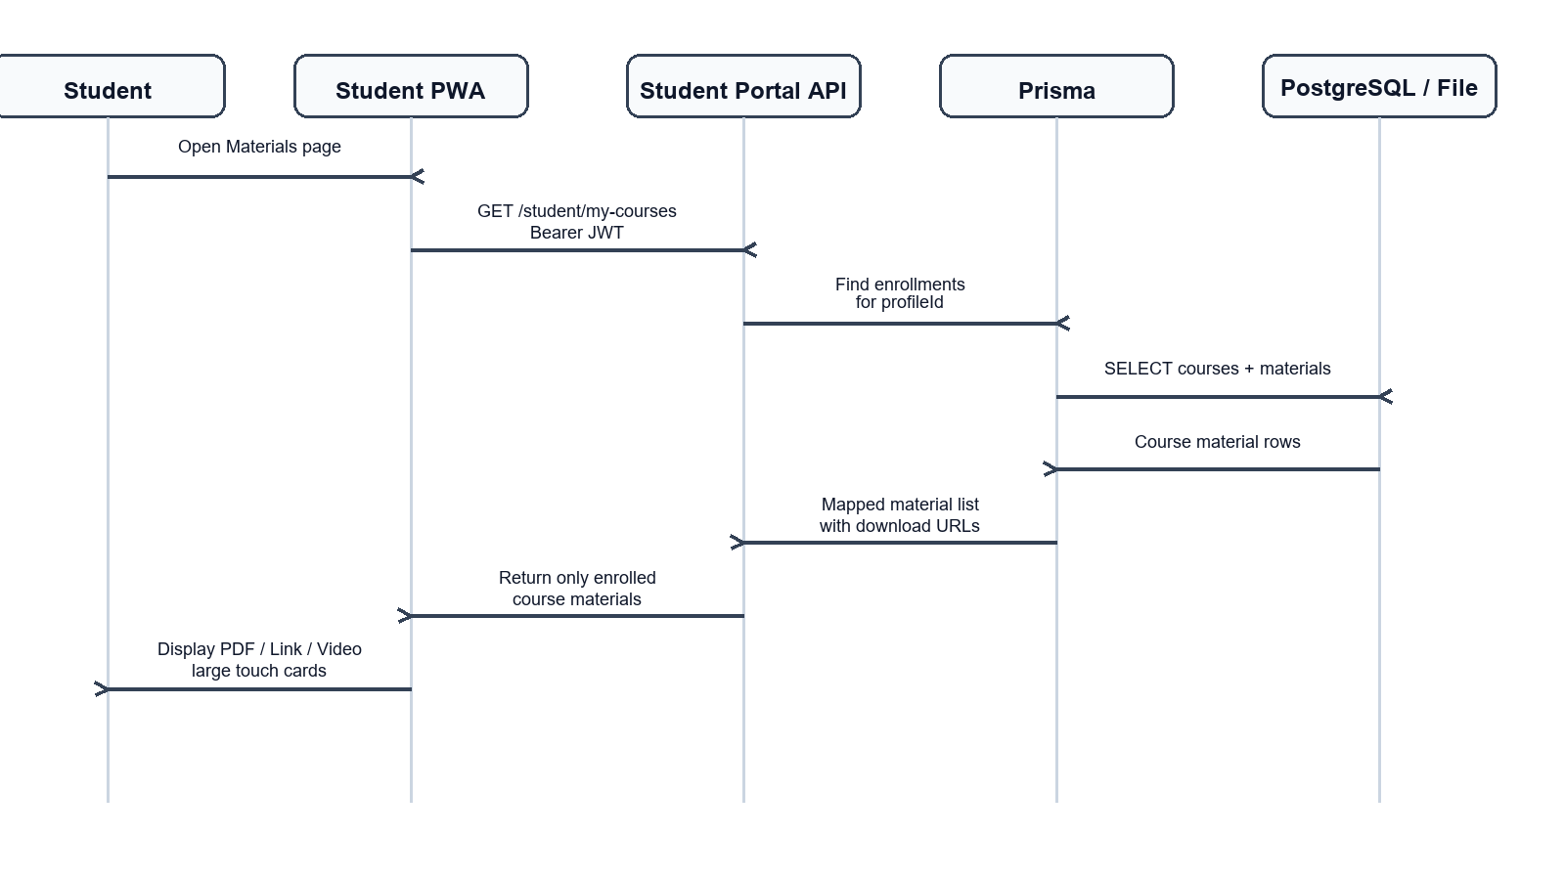
Figure 7. Student material access sequence diagram.

7.3 Structural Models

7.3.1 Object and Class Model
The object/class model is derived from the Prisma database schema and shows the main persistent entities, associations, and multiplicity rules used by the backend.
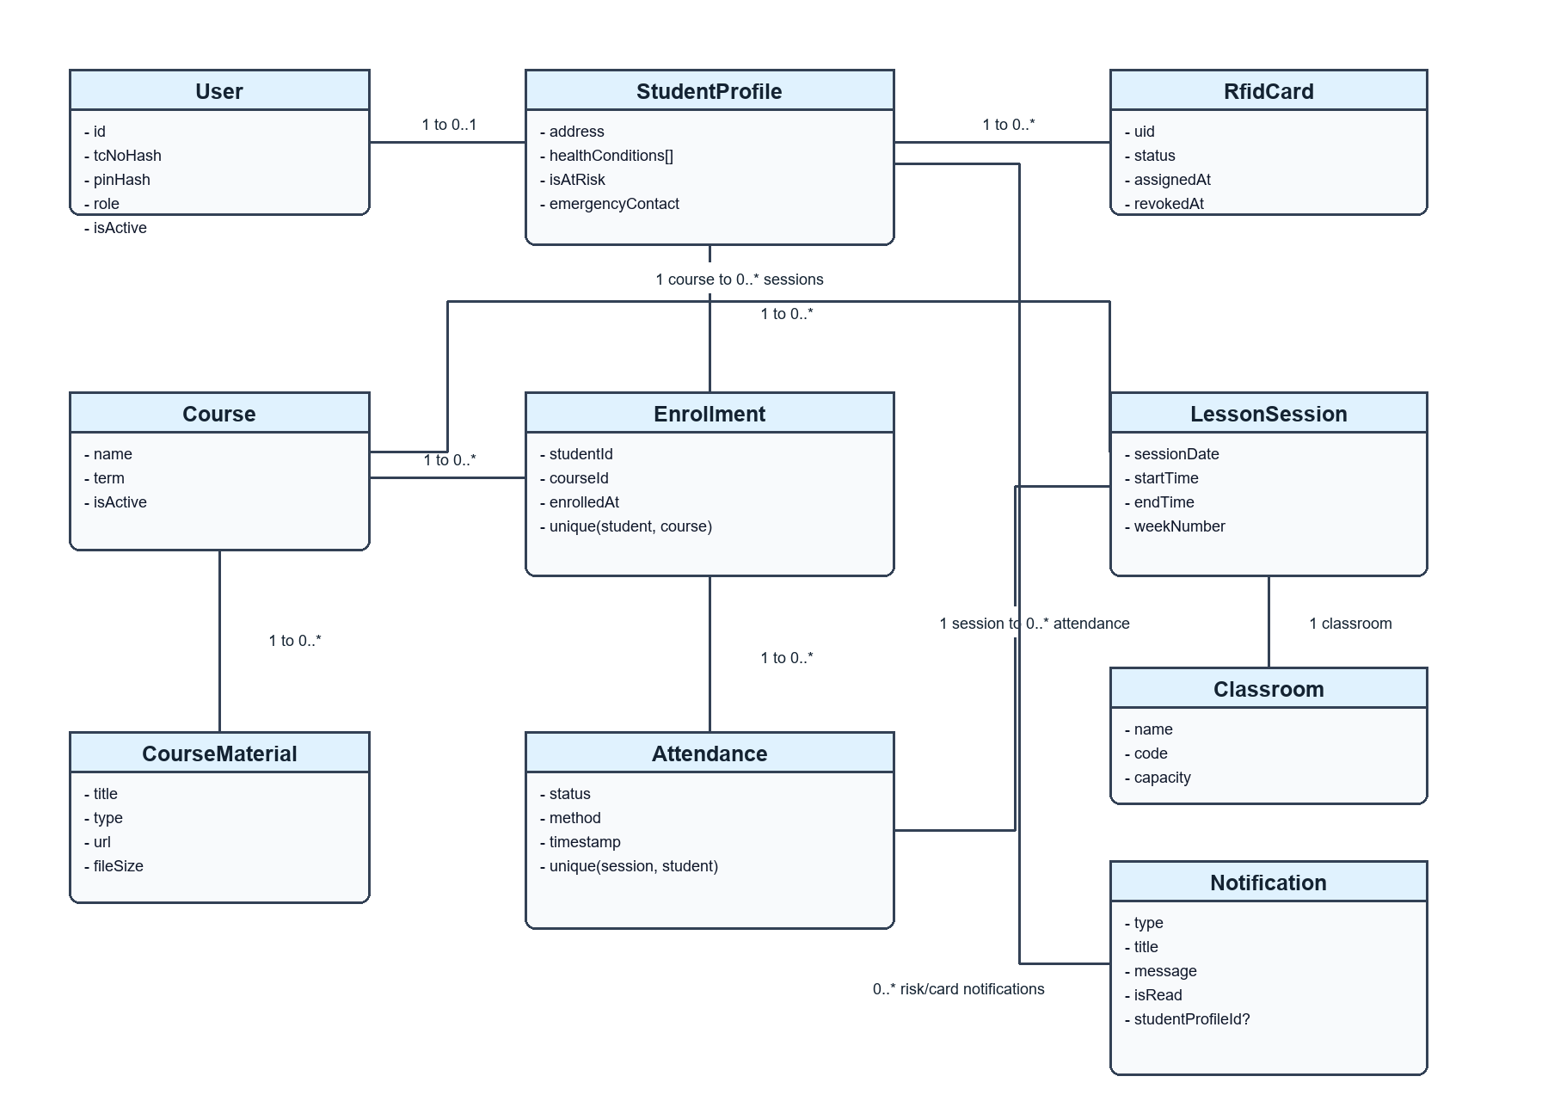
Figure 8. Core class and data model.

7.3.1.1 User Class
User represents a login-capable person in the system. It stores encrypted/hash-based identity lookup data, PIN hash, role, active status, and common personal fields. It is the authorization root for both admins and students.

7.3.1.2 StudentProfile Class
StudentProfile extends a STUDENT user with address, emergency contact, health condition list, other health notes, and isolation-risk flag. It connects the student to cards, enrollments, and attendance records.

7.3.1.3 RfidCard Class
RfidCard stores a physical card UID, assignment date, status, and optional revoked date. Its status controls whether a card can create attendance records or should produce a security notification.

7.3.1.4 Attendance Class
Attendance is the core record for each student-session pair. It stores PRESENT, ABSENT, or EXCUSED status, the recording method, and timestamp. A unique constraint prevents duplicate attendance for repeated scans.

7.3.1.5 CourseMaterial Class
CourseMaterial stores course-specific PDF, link, or video resources. Student access is filtered by enrollment so each student sees only materials for registered courses.

7.4 Behavioral Models

7.4.1 Data Driven (Activity Diagrams / Sequence Diagrams)
The social-isolation activity model describes the scheduled data-processing flow that scans attendance data and generates coordinator notifications.
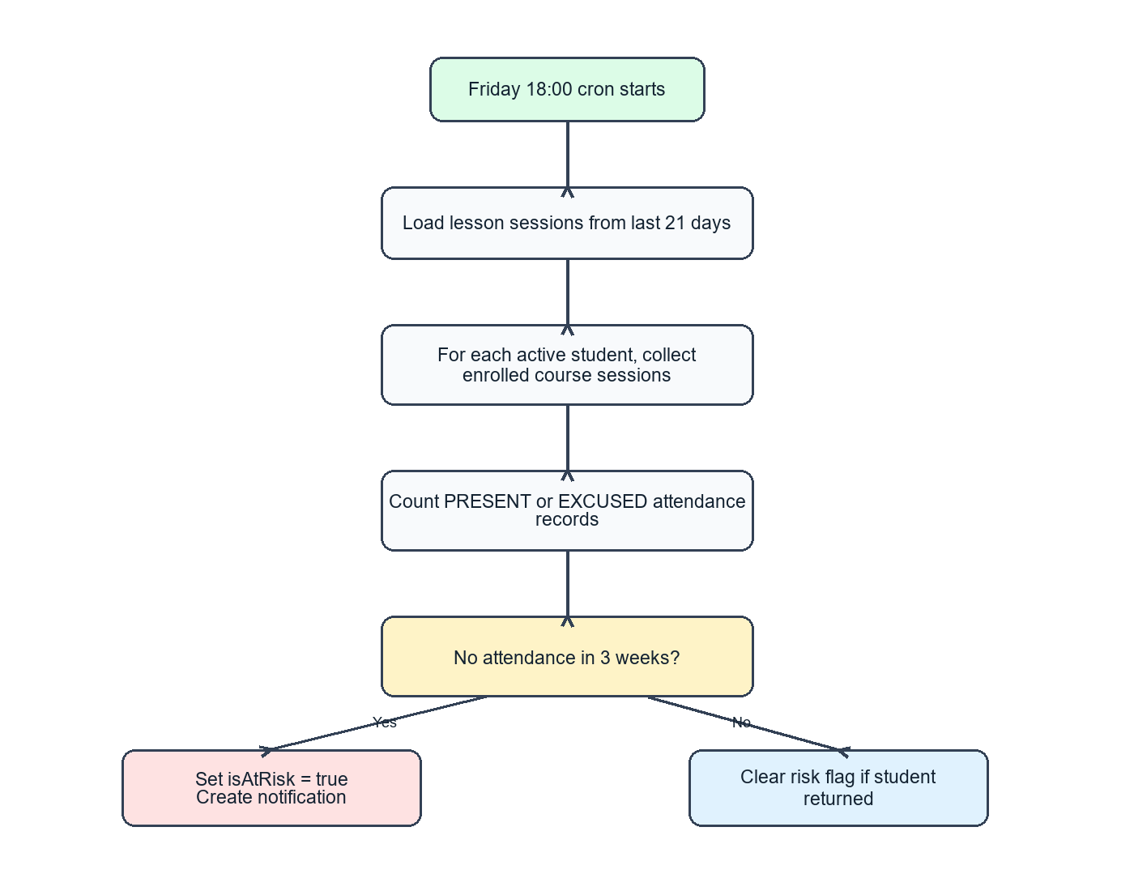
Figure 9. Social isolation risk activity model.

7.4.2 Data Driven (Sequence Diagrams)
The login, RFID attendance, and student material access sequence diagrams in Section 7.2.2 also represent data-driven processing because each request is validated, transformed into database queries, and returned as a structured response.

7.4.3 Event Driven Models (State Diagrams)
The RFID card state model shows how admin events move a physical card between unassigned, active, lost, and revoked states.
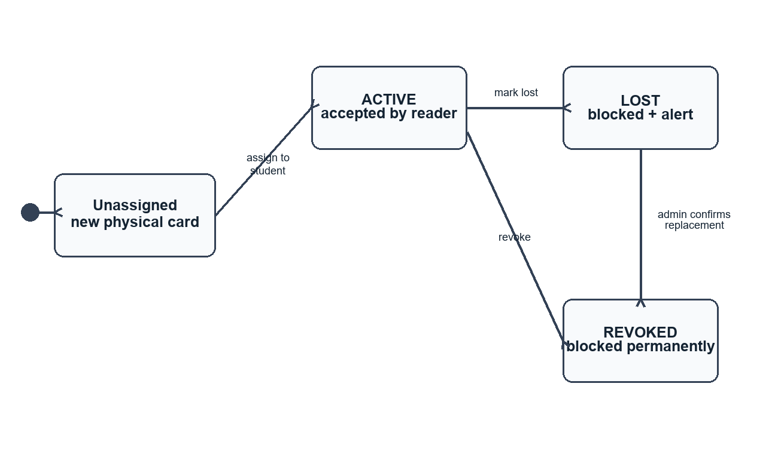
Figure 10. RFID card state diagram.

7.5 User Interface
The admin UI prioritizes dense operational control: searchable data tables, KPI summaries, report export actions, student detail pages, and status badges. The student UI prioritizes clarity: large buttons, attendance progress, minimal navigation, readable labels, and mobile-first layout.
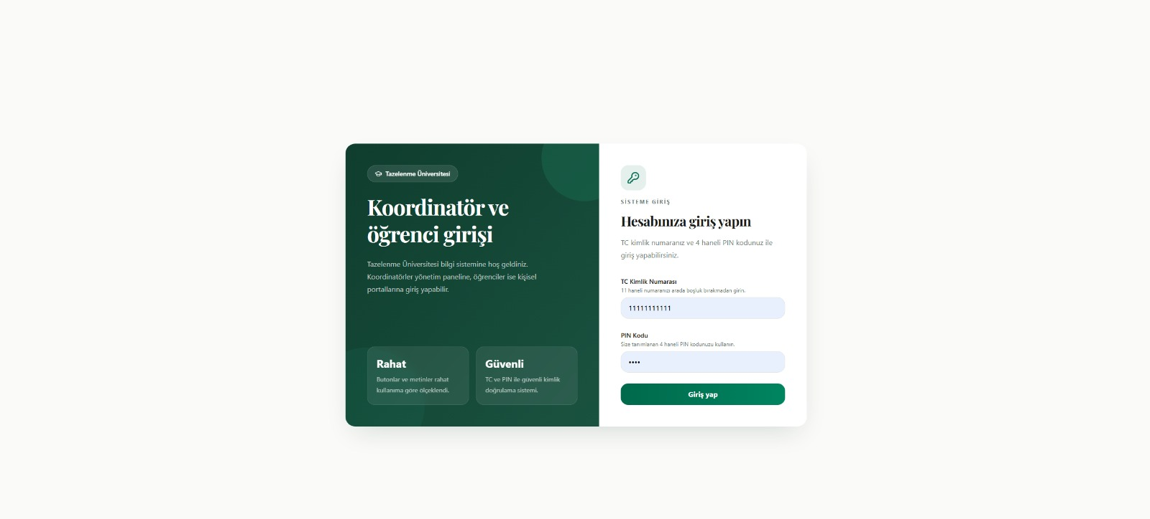
Figure 11. Login UI design placeholder.

7.6 Test
- Backend build should pass with npm run build.
- Frontend lint and production build should pass with npm run lint and npm run build.
- RFID scan test cases should cover unknown card, lost card, inactive session, non-enrolled student, first scan success, and repeated scan.
- Student privacy tests should verify that student endpoints return only the authenticated student's own courses and attendance.
- Report tests should verify the 70% pass/fail threshold and EXCUSED attendance handling.

8 References
- Bernd Bruegge and Allen H. Dutoit, Object-Oriented Software Engineering: Using UML, Patterns, and Java, 2nd Edition, Prentice-Hall, 2004.
- Hera App for Tazelenme University

9 Appendix A: Glossary
Term | Definition
Coordinator | Administrative user responsible for managing students, courses, cards, attendance, materials, and reports.
RFID Card | Physical card that contains a unique UID used for attendance scanning.
Attendance Session | A scheduled lesson occurrence for which attendance is recorded.
Isolation Risk | A student status indicating no attendance participation in the last three weeks.
PWA | Installable web application optimized for mobile devices.

