Project Title:
Advanced Network Architecture with DHCP and EIGRP Optimization

FINAL PROJECT
SY. 2024-2025 – 1 ST SEMESTER
NET 313 – Advance Networking

Submitted by:
Bulanadi, Ryan Andrew
Dabu, Luis Rafael
Garcia, Maria Theresa
Rodrigueza, Christine
Sismaet, Tselaux Mae

Submitted to:

Mr. Harren John L. Baclayo

Call Center Product Agency

DHCP Configuration

- Sale Department Office
Sale Office 1 (for Sale Representatives) with two printer.
Sale Office 2 (for Sale Team lead or Higher – Level position) with one printer
Pc’s
Team A Sales Office 1: 7 Pc’s (for the representative and team leads)
Team B Sale Office 2: 7 Pc’s (for the representatives and one team lead)

- Customer Services Department

Offices:
Customer Service Office 2 (for front line agents) with two printers
Customer Service Office 2 (for supervisor or team lead) with one printer
Pc’s
Customer Service Office 1: 7 Pc’s (for the agent and One Supervisor)
Customer Service Office 2: 7Pc’s (for the agent and One Supervisor)

- Manager Department

Offices: Main Hub
Manages Office 1 (for the main Manager)
Manages Office 2 (for an assistant or department manager)
Secretary Office: (for the secretary) with one printer
Pc’s
Manager Office 1: 1 Pc’s (for the main manager)
Manager Office 2: 1 Pc’s (for the assistance)

OUR NETWORK’S PLOT
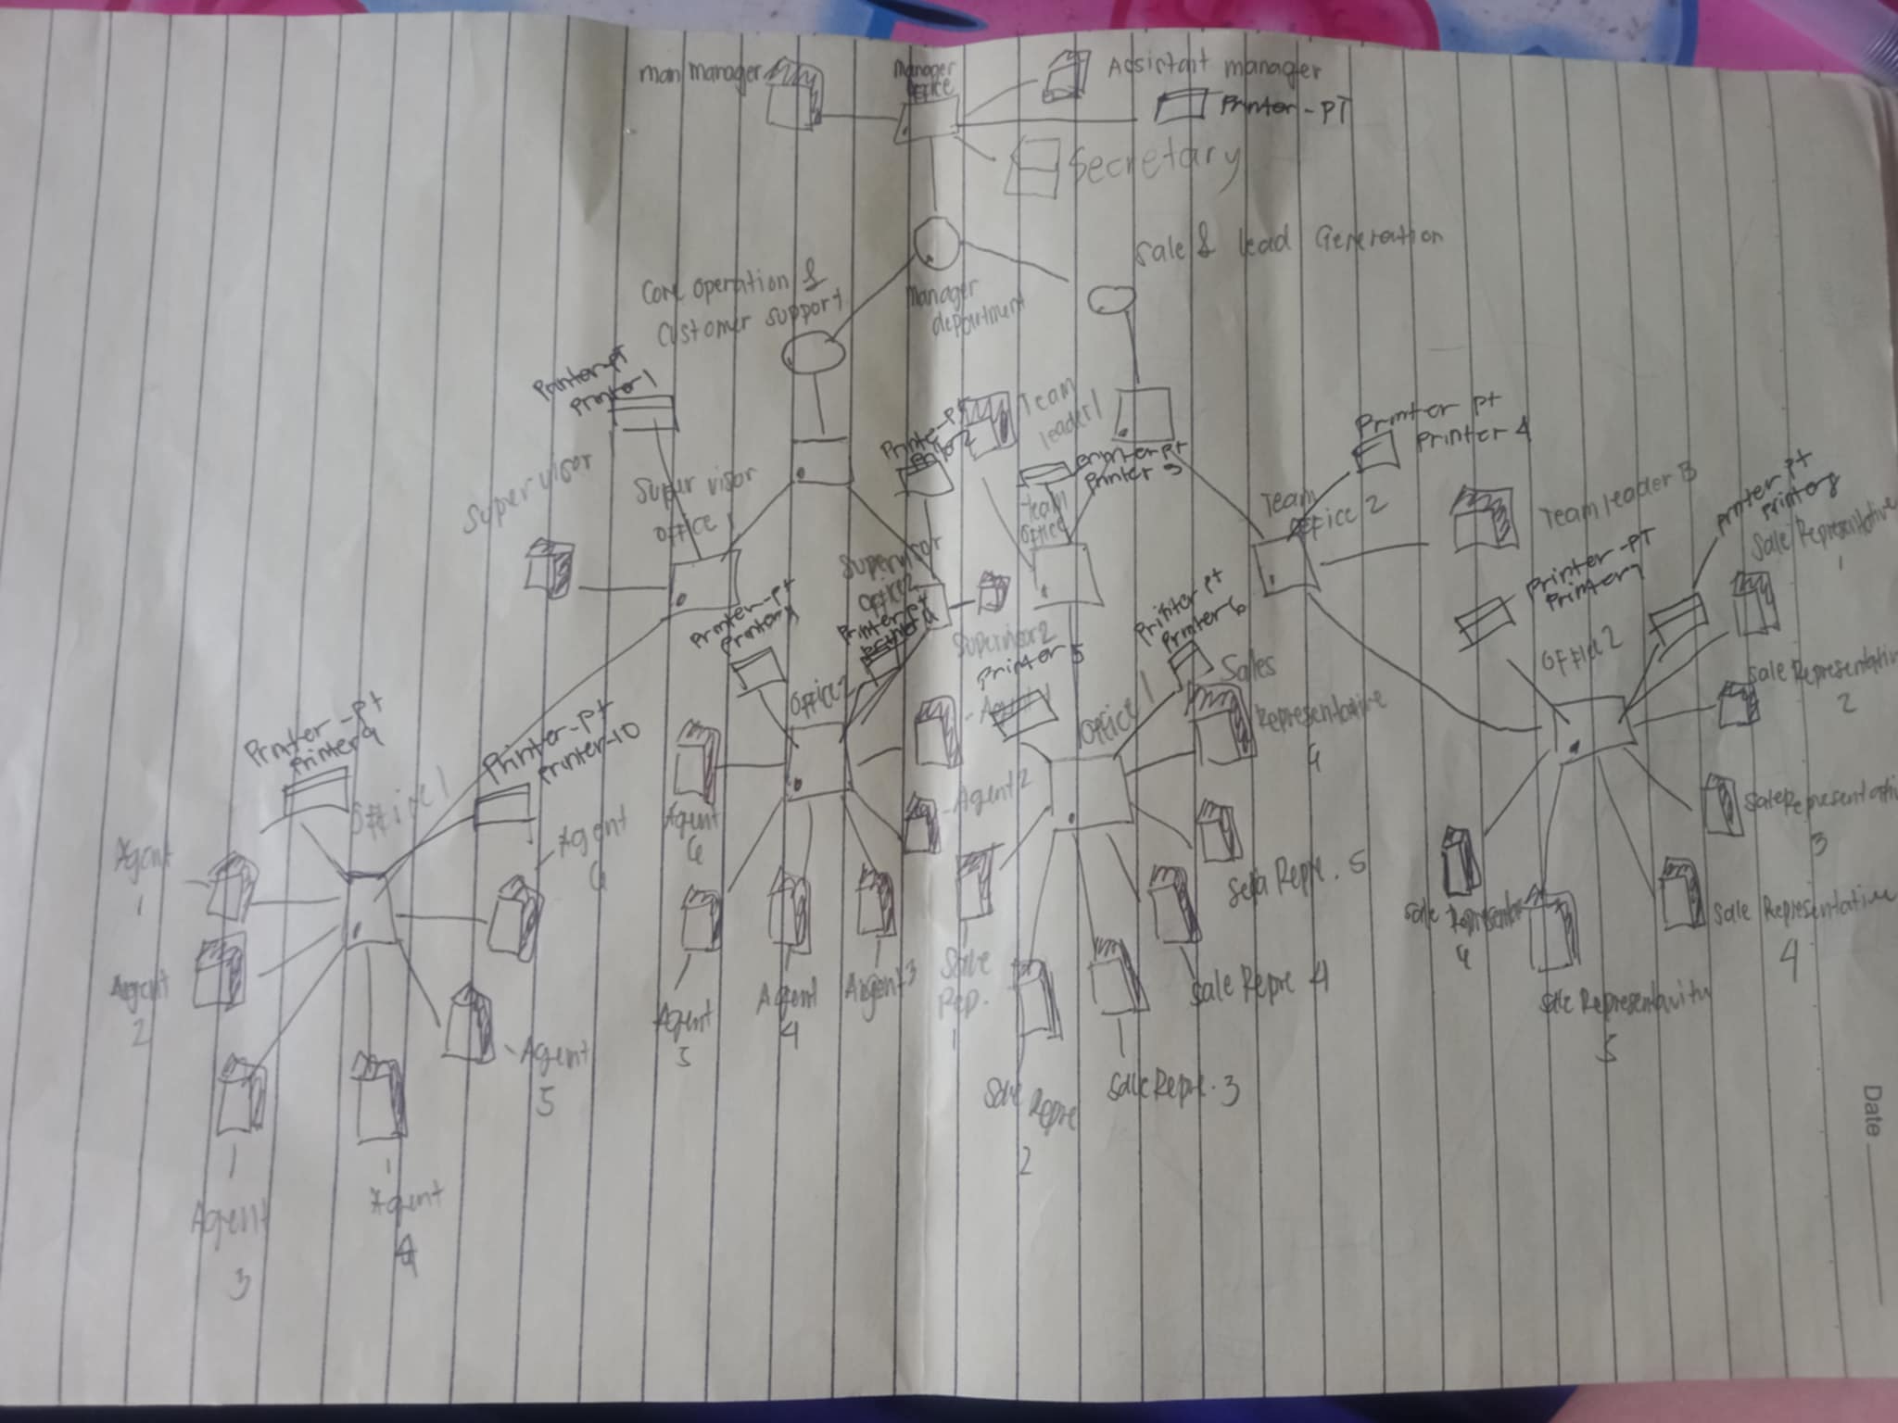

Part 1: Company and Network Requirements

COMPANY: O Shopping Home Channel’s Call Center Product Agency

Home Channel’s Call Center Product agency that has three departments:

- CORE OPERATIONS & CUSTOMER SUPPORT DEPARTMENT - it entertains the customer reports to the products released.
- SALES AND LEAD GENERATION DEPARTMENT - a department for product promotion and handles sales.
- MANAGER DEPARTMENT - Manages the whole operation for the better delivery of service and satisfaction.

For this to be successful, the networking requirements that this Call Center Product agency can offer are the following:

- Ensuring that the company can effectively accommodate the growth in employees as the business expands.
- Secured personal data within offices whether a customer or employee of the company.
- Easy access within the premises of offices NOT outside of it for better production and to aim the goal for each department.
- Performance in accommodating customer’s concern.

Goals set to attain network performance, scalability and security of said company:

- Performance: Identify strategies that enhance the network's connection speed.
- Security: Having a network that follows the CIA TRIANGLE (Confidentiality, Integrity, and Availability)
- Scalability: Ready for expansion of offices when generation sales are increased.

IP addressing needs, including static IPs for servers and DHCP for client devices.
- Static IPs are assigned to servers and other critical devices requiring a permanent, fixed address.
- DHCP is used for client devices that do not need a fixed address, ensuring ease of management and reducing configuration overhead.

Risk Management Plan

Concern: Preventing Hackers and Breaches.
Solutions:
- Use strong authentication methods like multi-factor authentication
- Network segmentation to limit access to sensitive areas.
- Regularly update security measures to stay ahead of threats.

Part 2: Network Design and Planning

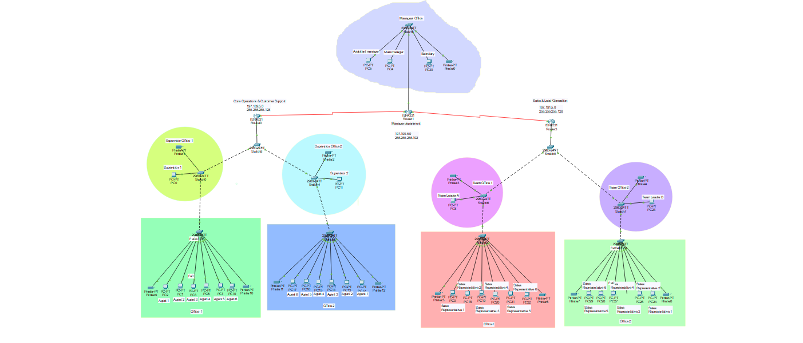

Why Star topology is suitable for our company?

Star Topology is what we find the BEST topology on what network architecture we are trying to develop.
And there are couple of reasons why:

1. Centralized Control
- It making easy to manage and control the network from a single point.
- This is particularly useful in small offices where simplicity is essential.

2. Ease of Installation and Maintenance
- In a star topology, all devices (nodes) are connected to a central hub or switch. This straightforward structure makes it easier to install and configure, even for small-scale setups.

3. Scalability
- Adding new devices to the network is simple, just connect them to the central hub without disrupting the existing setup.
- This is particularly useful for small offices that may expand gradually.

4. Simplicity of Design
- Star topology uses a switch to connect all devices, making the network simple to manage and oversee.
- Adding or removing devices is hassle-free since each device connects directly to the switch.

5. Dependability and Fault Detection
- Each device has its connection to the switch, so a failure in one connection doesn’t disrupt the rest of the network.
- Troubleshooting is straightforward as issues are typically isolated to a specific device or connection.

6. Enhanced Performance
- Data travels directly to its target device through the central switch, minimizing collisions and boosting network efficiency compared to bus or ring setups.
- The switch can be upgraded to support higher bandwidth or additional devices, making the network scalable for small offices.

7. Monitor Real-Time Operations
- It provides smooth and quality expertise of the network.
- Efficiency and enhance real-time data collection.

GROUP’S VLSM:
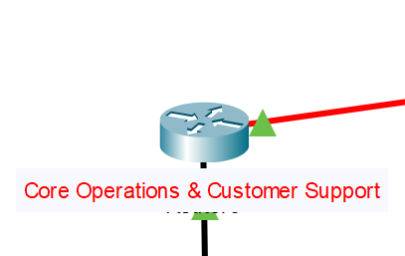
120 HOST - CORE OPERATIONS & CUSTOMER SUPPORT DEPARTMENT:
NETWORK ID: 197.189.5.0
BROADCAST ID: 197.189.5.127
SUBNET MASK: 255.255.255.128

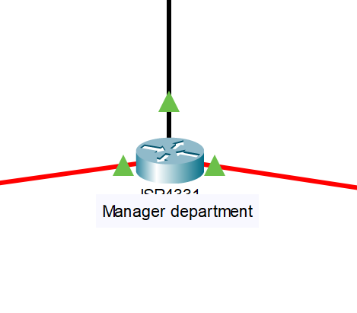
59 HOST - MANAGER DEPARTMENT:
NETWORK ID: 197.190.5.0
BROADCAST ID: 197.190.5.63
SUBNET MASK: 255.255.255.192

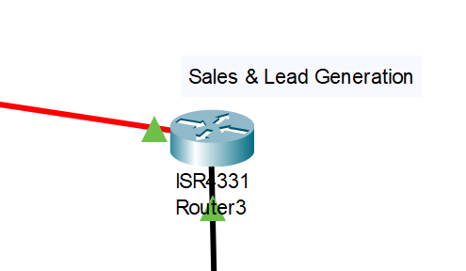
120 HOST - SALES AND LEAD GENERATION DEPARTMENT:

NETWORK ID: 197.191.5.0
BROADCAST ID: 197.191.5.127
SUBNET MASK: 255.255.255.128

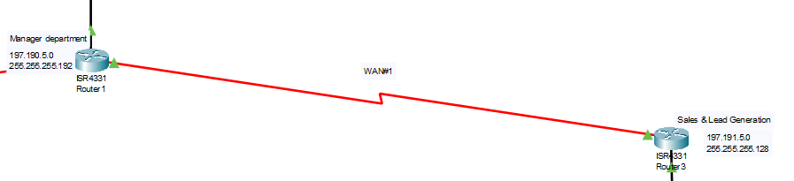
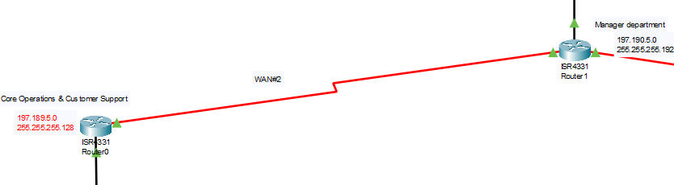

WAN #1:
NETWORK ID: 197.192.5.0
BROADCAST ID: 197.192.5.3
SUBNET MASK: 255.255.255.252
WAN #2:
NETWORK ID: 197.192.5.4
BROADCAST ID: 197.192.5.7
SUBNET MASK: 255.255.255.252

DNS-SERVER PER DEPARTMENT:

CORE OPERATIONS & CUSTOMER SUPPORT DEPARTMENT - 4.4.4.4
MANAGER DEPARTMENT - 5.5.5.5
SALES AND LEAD GENERATION DEPARTMENT - 7.7.7.7

Why did you choose your DHCP configuration?

DHCP configuration looks more suitable to our companies’ main focus, scalability. It is easy to manage this instead of static. It is easy to manage and ensures the connectivity of each end user within the departments.

Why Static is suitable for your network.

Even though we didn’t use static configuration, it is one of our considerations for the manager department due to its exclusivity in terms of IP address configuration. However, upon our research, it is much more secure to have DHCP configuration than static but again we find it useful when using it for the configuration of other devices than PCs, like printers and servers.

Security features implemented in OUR COMPANY.

1. Private Cloud Deployment
Our organization has established a private cloud within the managerial department to securely manage sensitive customer data. This setup ensures strong access controls and adherence to data protection standards.
2. Network Segmentation
To enhance security, we have segmented the network, isolating sensitive areas like the managerial department from the general traffic. This approach minimizes the risk of unauthorized access and contains potential threats.
3. Firewalls and Intrusion Prevention Systems (IPS)
Advanced firewalls and intrusion prevention systems are in place to monitor and regulate network traffic. These tools actively detect and block malicious activities, providing robust protection against cyber threats.
4. Backup and Disaster Recovery Plan
A comprehensive backup strategy, including regular offsite backups, is implemented to safeguard data. Additionally, a disaster recovery plan ensures the continuity of operations in the event of data breaches or loss.
5. Regular Security Audits and Updates
We conduct regular security assessments to uncover vulnerabilities and promptly apply updates to address potential risks, maintaining the overall integrity and safety of our systems.

Part 3: Configuration and Implementation

HOSTNAME AND PASSWORD PER DEPARTMENT

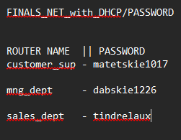

CORE OPERATIONS & CUSTOMER SUPPORT DEPARTMENT (ROUTER 1):

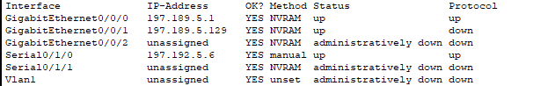

MANAGER DEPARTMENT (ROUTER 2):

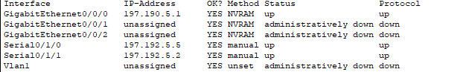

SALES AND LEAD GENERATION DEPARTMENT (ROUTER 3):

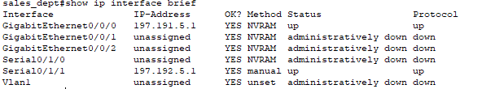

Part 4: Advanced Testing and Analysis

Documentation:

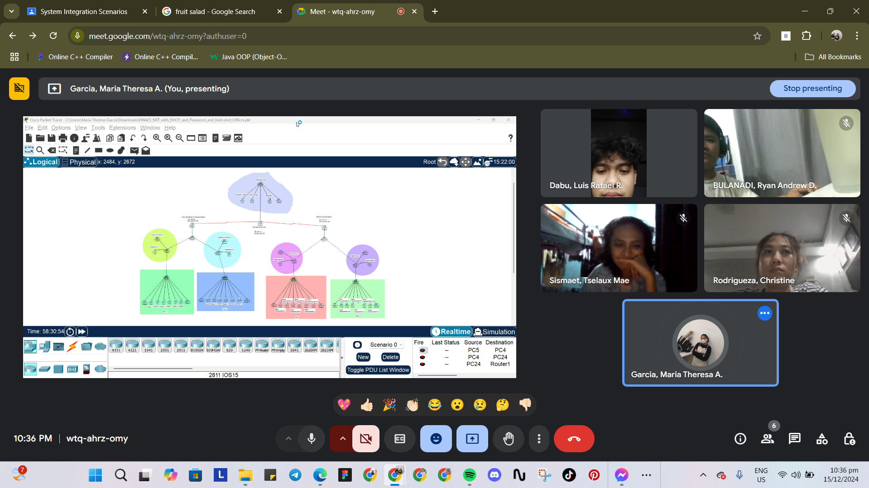
*Our screenshot while having the finish product of our cisco routing*
Deliverables
- Company Description: Explain your chosen business and its networking requirements.
- Network Design Document: Include topology diagrams and an explanation of your design decisions.
- Configuration Files: Provide full configurations for routers and switches.
- Testing Report: Include results of connectivity tests, failover simulations, and performance analyses.
CRITERIA | Weightage
Company and Network Needs | 15%
Network Design and Planning | 25%
Configuration Accuracy | 20%
Testing and Performance Analysis | 25%
Documentation | 15%

