**Introduction**

What is neural style transfer?

Neural style transfer is a technique that merges the content of one image with the style of another using deep neural networks. The objective is to create a new image that retains the essential content of the first image (content image) while adopting the artistic style of the second image (style image).

**Objectives:**

1. Extract content features from the content image using a VGG-19 neural network.
2. Extract style features from the style image using the same VGG-19 network.
3. Generate a combination image that minimizes a loss function, which is a weighted sum of content and style losses.
4. Iteratively update the combination image through gradient descent to achieve the final stylized image.

**Neural Network Significance**

Neural networks, particularly Convolutional Neural Networks (CNNs), have proven to be highly effective in image processing tasks due to their ability to capture hierarchical patterns in images. The VGG-19 network, a deep CNN, is especially significant for neural style transfer because of the following reasons:

1. **Hierarchical Feature Extraction:**
   * Lower layers capture basic features such as edges and textures.
   * Higher layers capture more complex patterns and object parts.
2. **Pre-trained on ImageNet:**
   * The VGG-19 network is pre-trained on the ImageNet dataset, which contains millions of images. This pre-training allows the network to have a rich representation of various visual features, making it an excellent choice for extracting meaningful content and style features.
3. **Content and Style Representation:**
   * Different layers of the VGG-19 network can be used to extract content and style features. For instance, deeper layers (e.g., block5_conv2) effectively capture the content of an image, while shallower layers (e.g., block1_conv1) capture the style of an image.
4. **Loading and Preprocessing Images:** The content and style images need to be loaded and pre-processed to match the input requirements of the VGG-19 model, which involves resizing and normalizing the images.

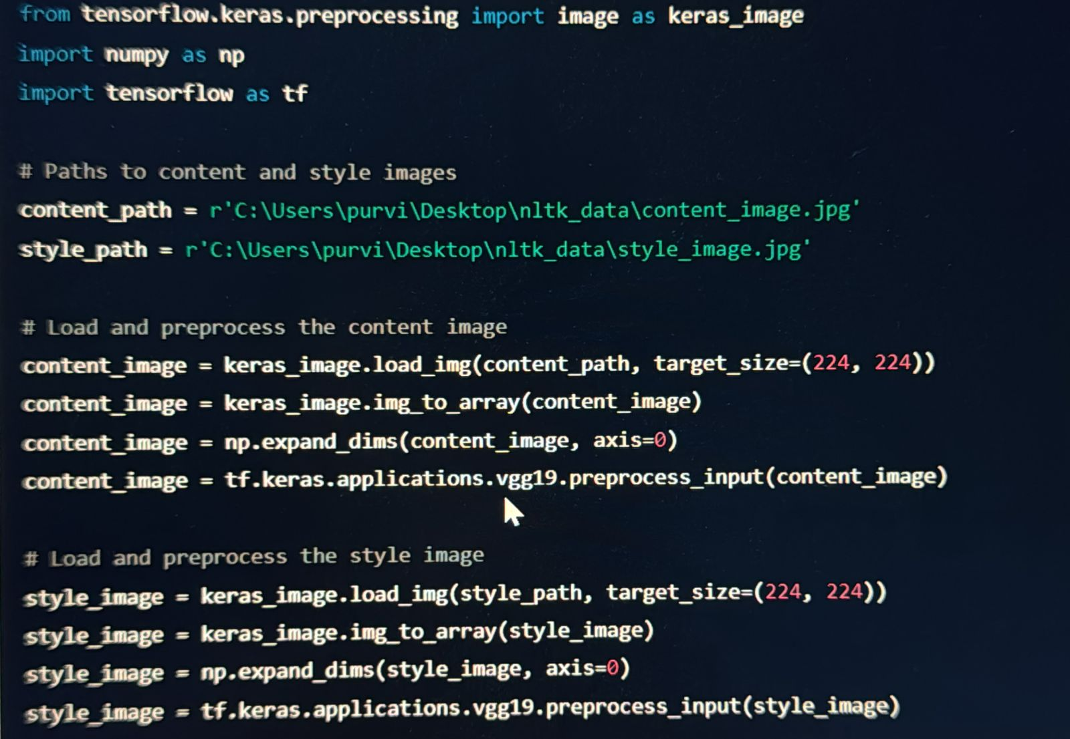

• **keras_image.load_img(content_path, target_size=(224, 224)):**

Loads the content image from the specified path and resizes it to 224x224 pixels.

• **keras_image.img_to_array(content_image):**

Converts the loaded image to a NumPy array with shape (224, 224, 3).

• **np.expand_dims(content_image, axis=0):**

Adds an extra dimension to the array, resulting in a shape of (1, 224, 224, 3). This represents a batch of one image, which is the expected input shape for the VGG-19 model.

• **tf.keras.applications.vgg19.preprocess_input(content_image):**

Normalizes the image array by subtracting the mean RGB values of the ImageNet dataset and scaling the pixel values. This preprocessing step ensures that the input to the VGG-19 model is consistent with the data it was trained on.

**5.Model Setup:**

We use the VGG-19 model pre-trained on ImageNet, excluding the top fully connected layers. Specific layers are chosen to extract content and style features.

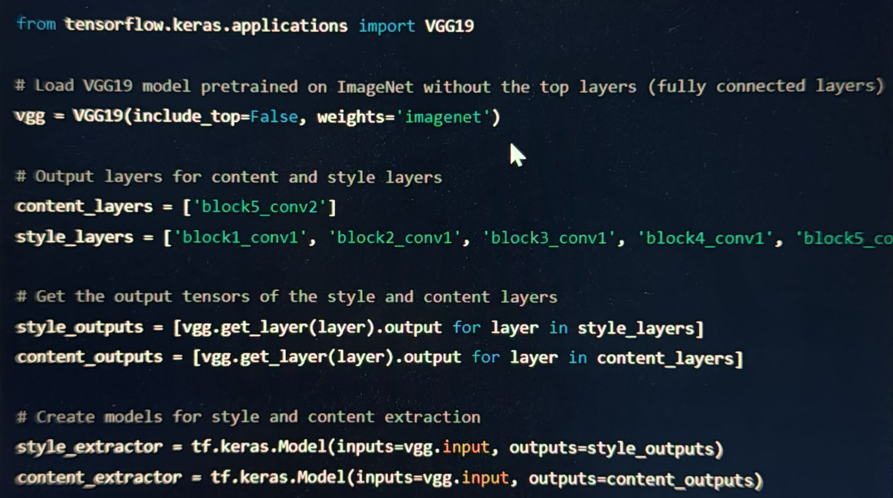

**6.Feature Extraction:**

Content features are extracted from the content image, and style features are extracted from the style image. For the style features, Gram matrices are computed to capture the style correlations.

7.**Initialization:**

The combination image, which will be iteratively updated, is initialized as a copy of the content image.

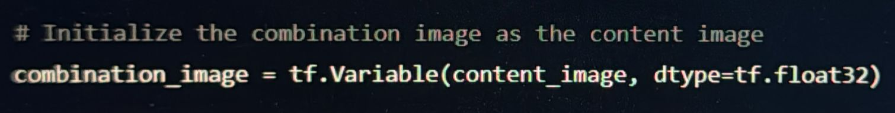

**8. Loss Functions:**

The total loss for the neural style transfer is a combination of content loss, style loss, and total variation loss.

* **Content Loss:** Measures the difference between the content features of the content image and the combination image.

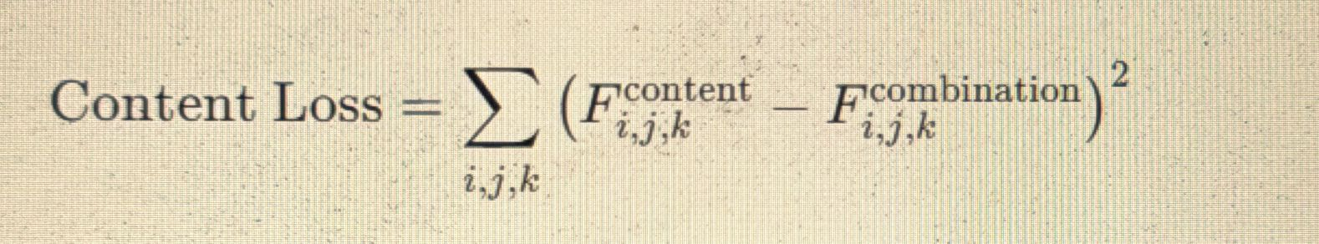

* **Style Loss:** Measures the difference between the Gram matrices of the style features of the style image and the combination image.

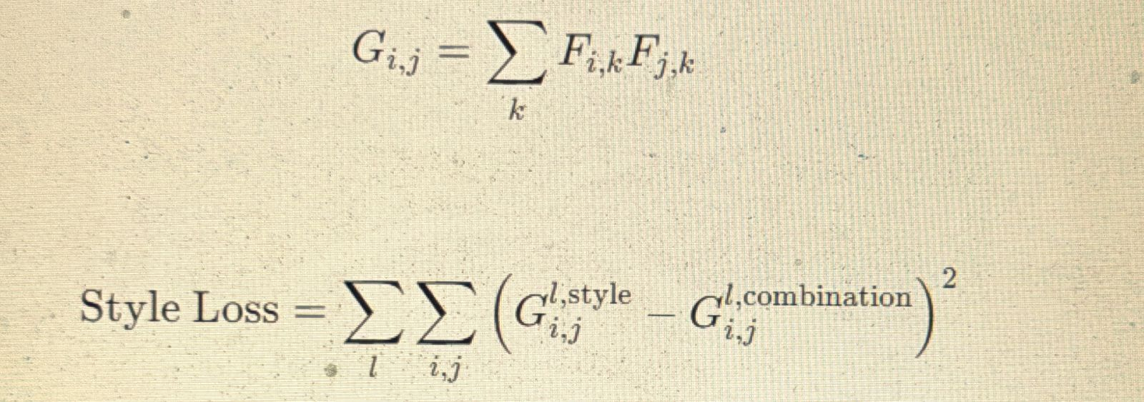

* **Total Variation Loss:** Encourages smoothness in the combination image.

**8. Optimization:**

Gradient descent is used to iteratively update the combination image. The total loss, combining content, style, and total variation losses, is minimized.

**Why Use Gradient Descent?**

1. **Efficient Parameter Handling:** Gradient descent effectively navigates the high-dimensional space of image pixels, making it suitable for neural style transfer.
2. **Iterative Improvement:** It iteratively updates the image, gradually reducing the loss to fine-tune the blend of content and style.
3. **Computational Feasibility:** Gradient descent finds a local minimum of the loss function, producing visually appealing results without requiring computationally infeasible global minimization.
4. **Automatic Differentiation:** TensorFlow's tf.GradientTape automates gradient computation, simplifying the optimization process.

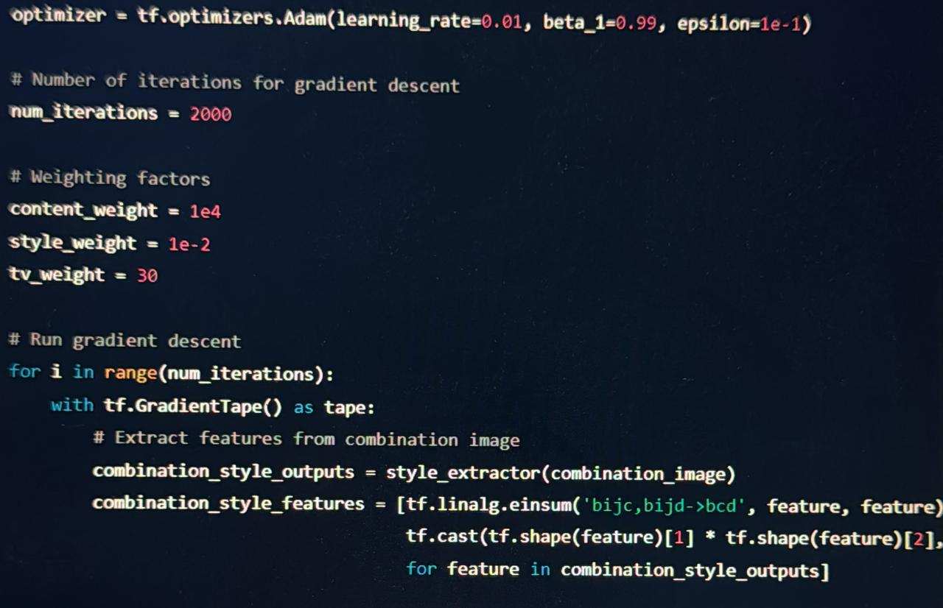

**9.Finalization:**

The combination image is converted back to a valid image format and saved.

**10.** **Visualizing Gram Matrices**

Gram matrices are used to capture style information across different layers of the VGG-19 model. They provide insights into how different style features correlate within a given layer.

* **Method:** Gram matrices are computed from the feature maps extracted at specified layers (e.g., 'block1_conv1').
* **Implementation:** Using matplotlib, Gram matrices are visualized as heatmaps, where intensity represents the strength of style correlations. A blue and green grid

  Description automatically generatedA screen shot of a computer screen

  Description automatically generated

**11.Visualizing Feature Maps**

Feature maps represent the activations of neurons at various layers of the VGG-19 model. They illustrate which features are most prominent in the input image at different scales and abstractions.

* **Method:** Feature maps are extracted and displayed using matplotlib, showcasing how content and style features evolve through the network layers.
* **Implementation:** Multiple feature maps can be visualized in a grid format, providing a comprehensive view of feature activations.

**12.Loss Curves Plotting**

Loss curves plot the evolution of content loss, style loss, and total variation loss over the optimization iterations. These curves provide insights into the convergence and effectiveness of the neural style transfer algorithm.

* **Method:** Loss values are computed and plotted against the number of iterations during gradient descent.
* **Implementation:** matplotlib is used to create line plots that visualize the decreasing trend of losses as the algorithm refines the stylized image.

**Conclusion**

Neural style transfer leverages deep learning to blend artistic styles with content from images, showcasing the power of convolutional neural networks in creative applications. This project demonstrated the iterative process of optimizing images through feature manipulation and loss minimization, highlighting its potential in generating novel visual content.

By combining theoretical insights with practical implementation using TensorFlow and VGG-19, this project provides a foundational understanding of neural style transfer and its application in digital art and image processing.