**FAA Motor Vehicles System**

**Program Operations Manual**

March 2018

# 1. MVS Login

Users may log into the FAA Motor Vehicle System (FAAMVS), by accessing the application from the FAA intranet at https://mvs.faa.gov.

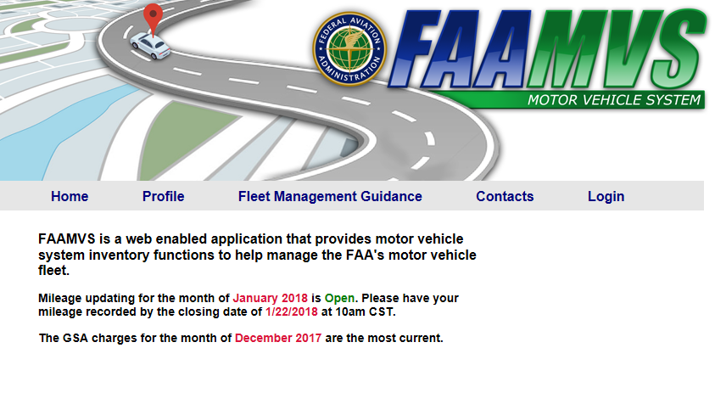

Click on the **Login** link on the upper right hand side of the display under the header. This will navigate to the FAAMVS Login process. Follow the steps outlined at the web link below for logging into FAAMVS via MyAccess.

<https://my.faa.gov/focus/articles/2014/10/The_Motor_Vehicle_Sy.html>

Once completed, User Authentication process should occur and the the MVS Application Home page or Rules of Behavior (ROB) will display. If Rules of Behavior display, you agree to by clicking on the “I Agree” button. The FAAMVS Secured Site Home Page.

**If you experience login issues, contact Tier 1 Help Desk Support at** [**9-amc-ami-faa-info-center@faa.gov**](mailto:9-amc-ami-faa-info-center@faa.gov) **as the first step to resolve**. FAAMVS user access information will be checked, verified, and updated as necessary.

If there is a problem with you PIV card, you will be directed to your local PIV card point of contact.

**Home Page**

Application homepage contains a top banner for FAAMVS. In the banner, a green menu bar contains the main options for the system.

Below you will find a brief description of each menu options:

**Home**: This button allows you to return to the authenticated home page from anywhere in the program.

**Profile**: The main function of this section is user profile management. It is used to add, change and delete users' profiles.

**Vehicles**: The main function of this tab is vehicle management. You can view inventory and make changes to vehicle info as well as the Delphi billing information associated with vehicles.

**GSA Charges**: Users are able to view billed GSA charges and a comparison of miles recorded in FAAMVS vs the billed charges.

**Reports**: Various reports concerning vehicles, custodians, users and charges may be found here.

**Report Mileage:** Users record mileage for GSA and FAA vehicles.

**Logoff**: Click this menu item to log off the system.

**Help**: Links to this guide

# 2. Profile

The purpose of the Profile Menu is for Users to maintain user profiles.

### Change Your Own Profile

This option allows users to modify their respective user profile. Users may modify user information by typing over existing information. The authorization level should only be modified to reflect the user’s level of responsibility. The individual user may only change authorization levels to a lower authorization level.

**Change Your User Profile Screen**

The screen displays User Info and Current Security details.

**User Info:**

First Name: Displays the First Name of the User. Over type the existing name if you wish to change it

Last Name: This field displays the Last Name of the User. Overtype it if you wish to change the Last Name

Routing: This field displays the current Routing or the functional area of the user. Overtype the existing value if you wish to change it

Phone: This field holds the Phone number of the user. Overtype it if you wish to change the Phone number. Type in the Phone number in the format of area code-xxx-xxxx

Phone Ext: This field holds the Extension number of the user (if any).

Email Address: The FAA email address of the user

**Current Security:**

Regular Users can be assigned to many Region and Cost Center combinations. A user’s security should reflect exactly what information they need to view.

**Add New User Profile Screen**

Complete all user information. Once the required information is entered, click on the Submit button to continue. User Security may be able to be added after basic user information is provided.

**Profile Search Screen**

This screen allows you to VIEW or CHANGE user profiles by searching for users by Last Name, First Name, Region and User Role. You will only be able to see users with your security level or below.

# 3. Vehicles

This component of the FAAMVS consists of the following MAIN functions, outlined according to their purpose. Clicking on the desired option leads the user to performing the function. The screen displays the following functions:

### Inventory

This option lets the user CHANGE, TERMINATE, or ADDa Vehicle. Clicking on the option will display the vehicles in Inventory.

**Vehicle Inventory Selection screen**

Click on the **TAG** if you wish to **Change** the details of the vehicle, **terminate** the vehicle, or **Delete** the vehicle.

**Selected Vehicle Edit Screen**

GSA vehicle will have fewer fields for updating a vehicle than FAA vehicle. Most of the fields requiring selection of codes, or values have pull-down menus for ease, and accuracy of selection.

This edit screen displays the same fields as the Add Vehicle screen for editing. Click Save Record when the desired entries have been updated.

### History

Click on this option if you wish to ADD, CHANGE or DELETE a vehicle’s history, i.e. accidents, unusual maintenance, or repairs, or any other information useful in documenting an important event in a vehicle’s ‘life’. Upon Adding, Changing, or Deleting the history, a confirmation screen is displayed.

### Site Vehicle Display

This option displays the detailed description data of the history records (if present), and mileage information for a vehicle, for the current month. Click on the vehicle TAG of the vehicle whose details you wish to see.

### Vehicle Search

Allows for searching and viewing of individual vehicles.

### Monthly Mileage Display

This option lets the user obtain the Monthly Mileage and Charges for a site Vehicle inventory for the current month, by COST CENTER, or for the Entire Site. The following screen is displayed to enable the user to choose Month, Vehicle Tag or the Cost Center, for which the details are desired.

The report is displayed in order of OBJECT CLASS within the COST CENTER. The TOTAL CHARGES for the individual OBJECT CLASS, and for the COST CENTER, are displayed at the end of every OBJECT CLASS, and COST CENTER. The display reflects CURRENT MONTH data, before it has been submitted to GSA.

### Check Vehicles

This option lets the user perform the following activities:

-Correct Cost Center Codes

-Find an invalid Cost Center

-Find out GSA Regional sites, Phone numbers, and Point-of-Contacts

The pull-down list gives the user the option to order records according to Invalid Tag, valid Tag, Cost Center, and invalid Cost Center.

Click on Vehicle Tag if you wish to change the Invalid details for the Vehicle (in the above screen, Vehicles with Invalid Locators are listed). The following screen will be displayed upon choosing the Vehicle Tag.

### User Memos

This option lets the user view a list of memos posted by different users. Use this option if you wish to create a memo. Clicking on this option displays a screen similar to the one given below.

### Month Status

This option displays a summary of the monthly status of the Vehicles. The following screen will be displayed when choosing this option.

**Data String Update**

This page is used to update Delphi billing information for cost centers and individual vehicles.

**View Custodians**

This page is used to view and update vehicle custodian data.

# 4. GSA Charges

This menu allows the user to view charges from GSA and compare the charges against the data that was input in MVS. The most current processed month is displayed to inform the user what month the latest GSA charges are represented in the system. Data is one month behind the current month when new data has been uploaded and is two months behind the current month when last month’s data has not yet been uploaded. Charges are typically uploaded between the 6th and the 12th of each month.

## Actual GSA Charges

## This allows you to view actual charges billed by GSA for every month available in the system. Data can be narrowed to a particular region, month/year and cost center by using the drop down lists.

## Compare Projected vs Actual GSA Charges

The user can view a comparison of data recorded in MVS against data billed by GSA. The data on this screen can be narrowed by region and then again by cost center.

# 5. Reports

This part of the application lets the user retrieve different types of information in form of reports.

### Accounting

The Accounting Report displays actual billed charges from GSA along with the Delphi billing information recorded in MVS. The cost center links in the table can be used to view vehicle detail for each given cost center and the information in the report may be narrowed by region, month/year and cost center.

### Alternate Fuel

This report contains information about all vehicles in MVS pertaining to the fuel type used. The report data may be narrowed by region, fuel type and vehicle owner (FAA/GSA).

### Budget Expense

This report contains billing totals from GSA that can be narrowed by fiscal year, region, line of business and cost center.

### Custodial Sites / Vehicles

This report displays the details pertaining to the vehicle custodians and the vehicles under them.

### Delphi Change

This report displays information that needs to be cross-referenced in Delphi. It may be narrowed by region and month/year.

### Delphi Detail

This report displays Delphi billing information and actual billing totals from GSA for each GSA vehicle. This report may be narrowed by region, month/year and cost center.

### FAA Monthly Usage

This report displays FAA mileage and charges reporting data and may be narrowed by region, month/year and cost center.

### GSA Local Input

This report displays GSA mileage reported in MVS. It may be narrowed by region, month/year and cost center.

### Monthly Mileage Compare

This report displays GSA vehicles that had mileage reported in MVS that was different than what was billed in GSA. It may be narrowed by region and month/year.

### Multiple Vehicle Charges

This report displays charges for GSA or FAA vehicles by fiscal year which may be sorted by Cost Center or Vehicle Tag number. Clicking on the tag will take you to the Single Vehicle Charges page for that vehicle.

### Single Vehicle Charges

This report displays charges for GSA or FAA vehicles by tag number. It displays all recorded charges with totals for each fiscal year.

### State Tag

This report displays all vehicle tags with state tags assigned and can be narrowed by region.

### User Profile

This option displays all current users with your level of access or below that are within your region/service area. The report may be narrowed by region.

### Zero End Mileage

This report displays vehicles with no end mileage recorded for a given month. Information may be narrowed by region, vehicle owner (FAA/GSA) and month/year.

# 6. Report Mileage

This tab is used to record GSA and FAA vehicle mileage and charges.

## Report GSA Mileage

This page is used for recording and viewing GSA vehicle mileage. Clicking on a tag number will cause a pop up to appear where mileage can be entered or modified.

## Report FAA Mileage

This page is used for recording and viewing FAA vehicle mileage. Clicking on a tag number will cause a pop up to appear where mileage can be entered or modified.

# 7. Logoff

Use this option to disconnect from the Motor Vehicles Management System.

# 8. Help

Use this option will bring you to this document.

**Document Control**

|  |  |  |
| --- | --- | --- |
| Version | Date | Description |
| 1.0 | 10/11/2000 | Initial creation.  By *FAA Western-Pacific Region* |
| 2.0 | 9/11/2013 | Updates for eAuth single sign-on including PIV authentication.  Add this document control table.  By Enterprise Services Center (ESC) |
| 3.0 | 10/15/2014 | Update manual to reflect current MVS functionality and displays. Some functionality removed during 10/2014 to mitigate application vulnerabilities. Other functionality moved from one menu area to another for ease of use.  By Enterprise Service Center (ESC) |
| 3.1 | 11/03/2014 | Update manual to reflect migration from eAuth to MyAccess authentication procedures.  By Enterprise Services Center (ESC) |
| 4.0 | 09/17/2015 | Made major update to document to record changes to GSA Charges, Reports and Report Mileage. |
| 5.0 | 03/06/2018 | Made changes to reflect current functionality and the new FAAMVS brand. |
|  |  |  |