Cameron
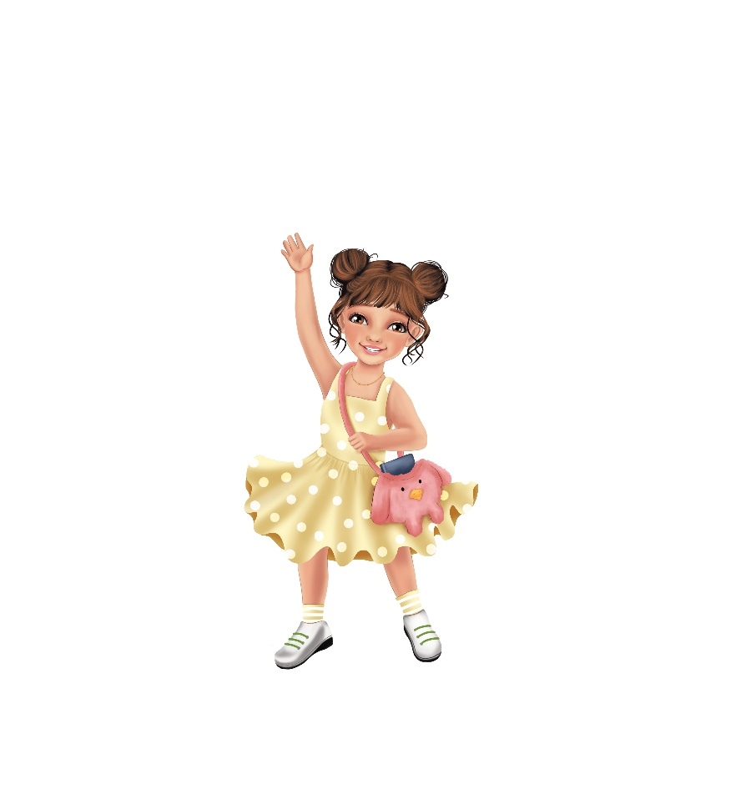
My imagination is vivid and free,
Full of innovation and possibility.
I express ideas in many ways—
Through drawing, thinking, and creative plays.
My purple mark is artistic and bright,
Turning vision into sight.
I design, I build, I dream, I start—
Creating beauty straight from my heart.

