Kash
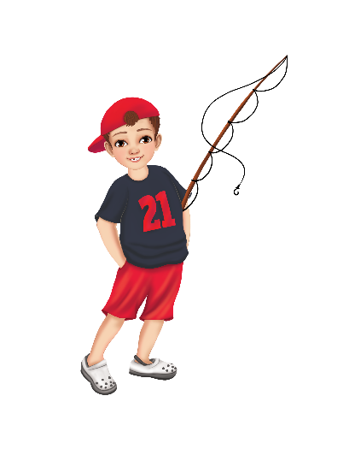
I listen closely, with attention and care,
I show empathy everywhere.
I hear your words, both big and small,
And validate the feelings behind them all.
My blue mark shows I understand,
I offer support and lend a hand.
Through active listening, calm and true,
I help others feel seen too.

