Tripp
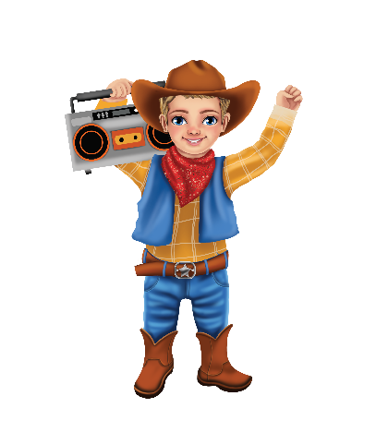
I bring laughter, joy, and light,
Helping moments feel more bright.
My humor spreads, both near and far,
Like a shining, playful star.
My red mark shows my energetic way,
I bring positivity every day.
With witty words and cheerful tone—
I help others feel less alone.

