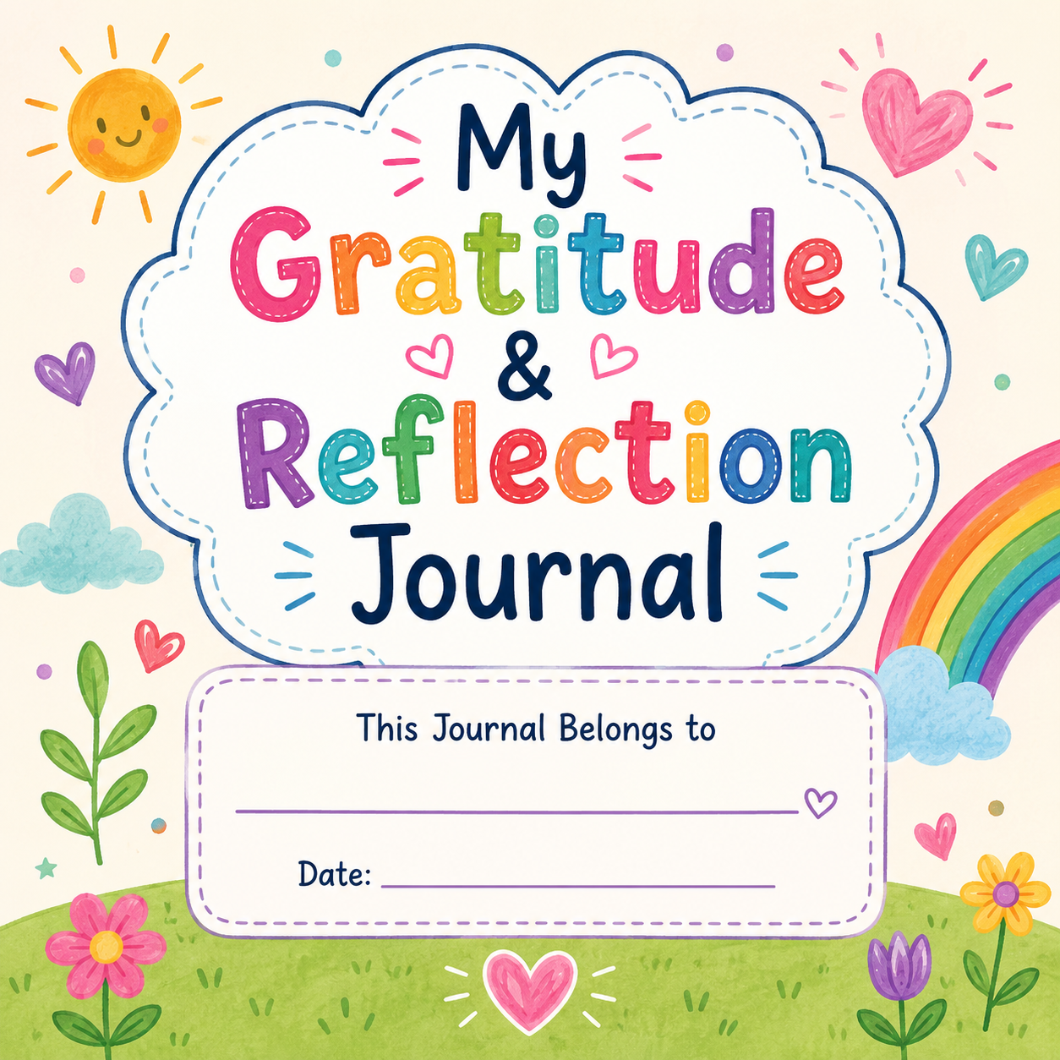
Teacher Notes (this page can be deleted before printing)
Suggested Use
This printable journal is designed to accompany Rider's Magic Mark. Teachers may print the entire journal or individual pages to support classroom discussions, social-emotional learning, morning meetings, literacy centers, writing activities, or family engagement.
Recommended for:
- Kindergarten
- First Grade
- Second Grade
- Third Grade

Welcome,
Hello, Friend!
Rider discovered that what makes us different also makes us special. Every person has gifts, talents, and a heart that can make the world brighter.
As you complete this journal, you'll think about kindness, gratitude, friendship, courage, and all the wonderful things that make YOU unique.
Remember...
Your differences are your strengths.
Your kindness matters.
Your light helps others shine.
Let's begin our journey together!

🌻 My Promise 🌻
I promise to...
Be Kind
Be Brave
Be Helpful
Celebrate Differences
Believe in Myself

Student Signature

Challenges for you!
🌱 "I am growing every day!" 🌱
Magic Mark Challenges
Scattered throughout.
Examples:
⭐ Smile at three people today.
⭐ Tell someone why they're special.
⭐ Help clean without being asked.
⭐ Draw a picture for someone.
⭐ Read a book with your family.
⭐ Thank your teacher.
⭐ Help a friend.
⭐ Pick up litter.
⭐ Give five compliments.

My Kindness Challenge
This week I...
□ Held the door
□ Helped someone
□ Shared
□ Used kind words
□ Smiled
□ Included someone
Color one star for each act.
⭐⭐⭐⭐⭐
What Makes Me Special?
🌟 "What makes me different makes me special!" 🌟
Draw yourself. Date:
I am special because...

My Grateful Heart Date:
Today I am thankful for... 🌈
Write about it.

Three Things That Made Me Smile
Date:

😊

😊

😊

Someone Who Makes My World Brighter 🚀
Draw someone who helps you. Date:

They are special because...

A Time I Was Brave 💪 Date:

Being brave made me feel:

Friendship Makes Us Shine Date:
✨ “You Are Special!” ✨

A good friend...
□ Helps
□ Listens
□ Includes Others
□ Shares
□ Encourages

I can be a good friend by...

My Family Date:
💛 “Let Your Light Shine!” 💛
I am thankful for my family because...

Draw your family.

My Teacher Date:
One thing my teacher helped me learn...

Thank you for...

My Happy Heart ❤️ 🧡 💛 💚 💙 💜 🩷 🤍 Date:
Finish the sentence.
Today my heart felt happy because...

Draw a picture
My Favorite Part of the Day
Draw your favorite moment. Date:
My favorite part of the day is:

I Can Encourage Others 💗
Write something encouraging. (you can do it!)

Draw a picture of you encouraging someone else.
Today I Tried Something New
🌈 “Celebrate What Makes You Unique!” 🌈
Date:
What did you try?

How did it make you feel?
Write or draw
I Am Growing🌱🌱🌱🌱🌱🌱
Date:
Today I learned...

I am proud because...

Celebrate Differences🪄🪄🪄🪄
Date:
One thing that makes me unique...

One thing that makes my friend unique...

I Shine Bright 🌟🌟 Date:
Finish these sentences (draw or write)
I am...

I can...

I will...

I believe...

Family Reflection 🎉 Date:
Ask someone at home.
"What is one thing you love about me?"
Write or draw their answer.
My Super Strength 🏆 Date:
Everyone has something they are good at.
My special strength is...

I use my strength when...

💛Something I Love About Myself💛
Date:
One thing I love about myself is...

I feel proud when I...

💚 Gratitude Prompts
Date:
My Thankful Tree
Draw a tree.
On the leaves write things you are thankful for. My roots are... My branches are... My leaves are...

Small Things That Make Me Happy
💓 💞 💝
Date:
A small thing that makes me happy is...

Draw a picture of what makes you happy…………

Someone I Am Thankful For 💜
Date:
I am thankful for...
because...

I can show them gratitude by...

My Gratitude Alphabet Date:
Write something you are thankful for:
A ___________
B ___________
C ___________
D ___________
E ___________
F ___________
G ___________
H ___________
I ___________
J ___________
K ___________
L ___________
M ___________
N ___________
O ___________
P ___________
Q ___________
R ____________
S ____________
T_____________
U ____________
V ____________
W ____________
X _____________
Y _____________
Z _____________

Kindness Starts With Me!!! 💜
Date:
A kind person...

I can show kindness by...

💜💜💜My Kindness Mission💜💜💜
Date:
Today I will...
□ Help someone
□ Give a compliment
□ Include someone
□ Listen carefully
□ Show patience
My kindness mission was...

A Friend Is Someone Who...
Date:
A good friend...

I can be a good friend by...

Ways I Can Include Others
Date:
I can help someone feel included by...

A Friendship Memory 💗
Date:
My favorite memory with a friend is...

What Makes a Great Friend?
Date:
A great friend shows...
□ Kindness
□ Honesty
□ Respect
□ Caring
□ Patience
Something else that makes a good friend:

My Brave Heart 💗💗
Date:
Something that makes me nervous is...

I can be brave by...

My Growth Garden 🌸 🌺🌸 🌺
Date:
Something I am learning...

Something I am practicing...

Something I improved...

